**Database Assessment**

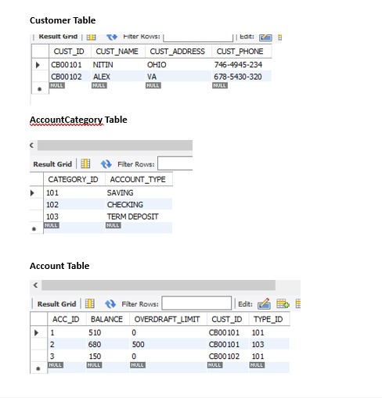

**Spring Boot Assessment**

As discussed - Pls write a Banking Web Application [ Rest Service ] to do following

1. Show Balance from a given account id. Show message if account doesn't exist.

2. Open A new Account for existing Customer

3. Open A new Account for New Customer

4. Transfer the money from one account to other.

5. Apply Spring Transaction on service 3 & service 4.

** You can use database reference from bank.sql file from below link.

<https://github.com/srinit16/binarylogicit/blob/main/bank.sql>

**React Assessment**

**This assessment is in continuation with backend coding assessment. Please create the frontend using react for banking application services.**

1. **Display Account Balance: [ 10 marks ]**
   1. **You must have text box to accept account id**
   2. **Submit Button**
   3. **It should display following message in Return “ Dear <CustomerName>, Your account balance is <amount>**
2. **Create a form to open new account for new and existing Customer. [ 40 marks ]**
   1. **A option button to check if customer is new or existing.**
   2. **New Customer display the form to seek following information** 
      1. **Customer Name**
      2. **Address**
      3. **Customer Phone Number**
      4. **Account to be Opened [ Saving , Checking or Term Deposit ]**
      5. **Initial Deposit**
      6. **Sign Up**

**It should display confirmation as “ Dear <CustomerName>, Your customer id is <Cust_ID>. Your account id is <account_number>**

* 1. **If Exisiting Customer**
     1. **Customer ID**
     2. **Account to be Opened [ Saving , Checking or Term Deposit ]**
     3. **Initial Deposit**
     4. **Sign Up**

**It should display confirmation as “Your account is opened with <account_number>”**