CELEBAL EXCELLENCE INTERNSHIP

ASSIGNMENT-07
Name:T.SRINITH REDDY
Objective: Perform incremental data processing using Delta Lake. Steps: 1. Load dataset into a Delta table. 2. Perform basic cleaning (handle nulls, remove duplicates). 3. Create a second dataset simulating new/incremental data. 4. Apply MERGE operation to update existing and insert new records. 5. Validate results (row count, duplicates). 6. Display final dataset and summary.
- Step-1
Loading DataSet
Renaming column names as it contains spaces in between
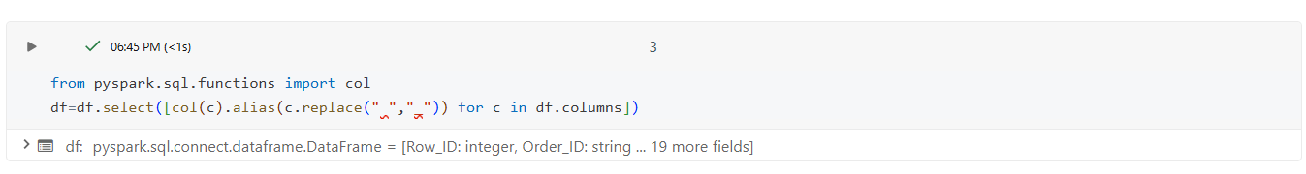
Save as Delta Table
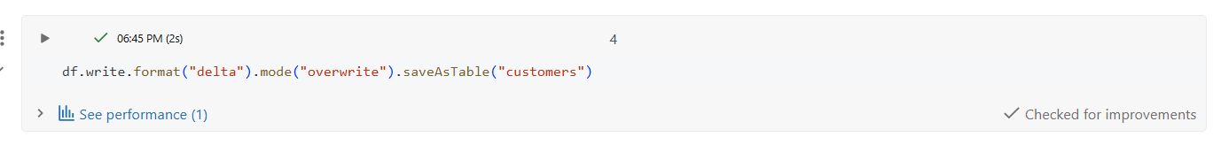
Verifying table
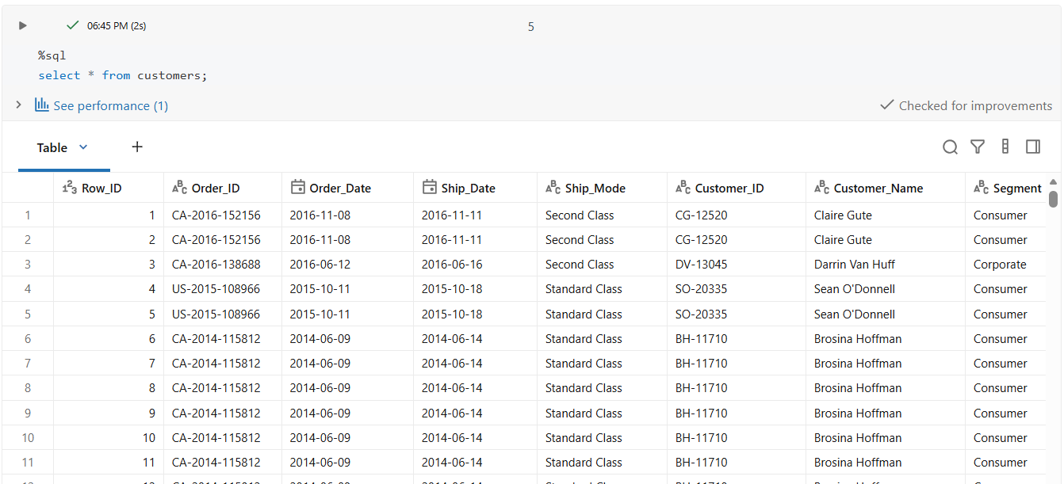
Checking table format using describe command
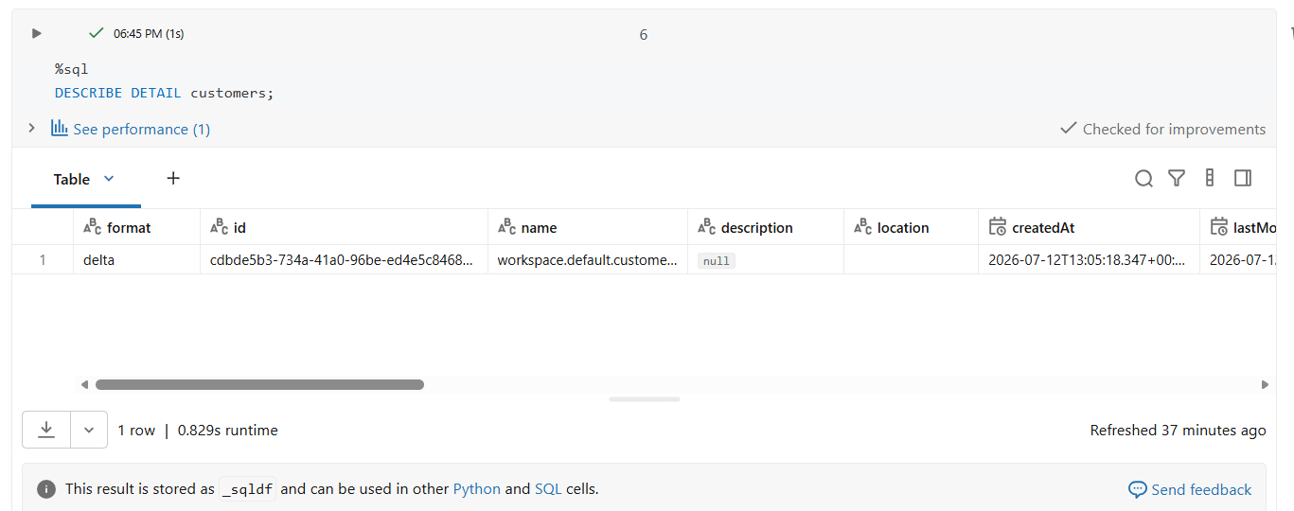
Reading the customers table
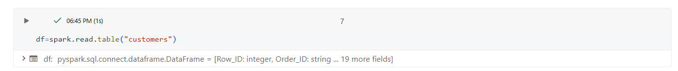
- Step-2 Basic cleaning
Removing duplicates from it
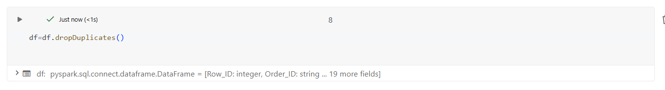
Checking null values
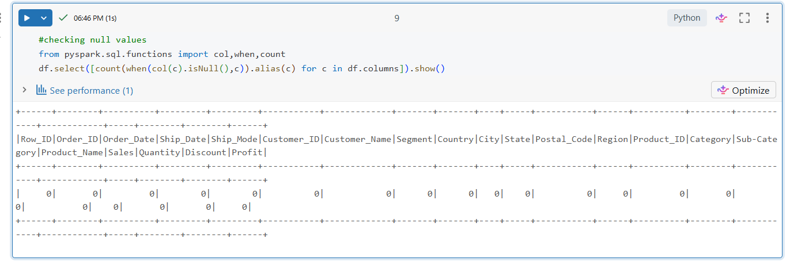
As there is no null values no null handling is done
Checking Schema for any datatype modifications
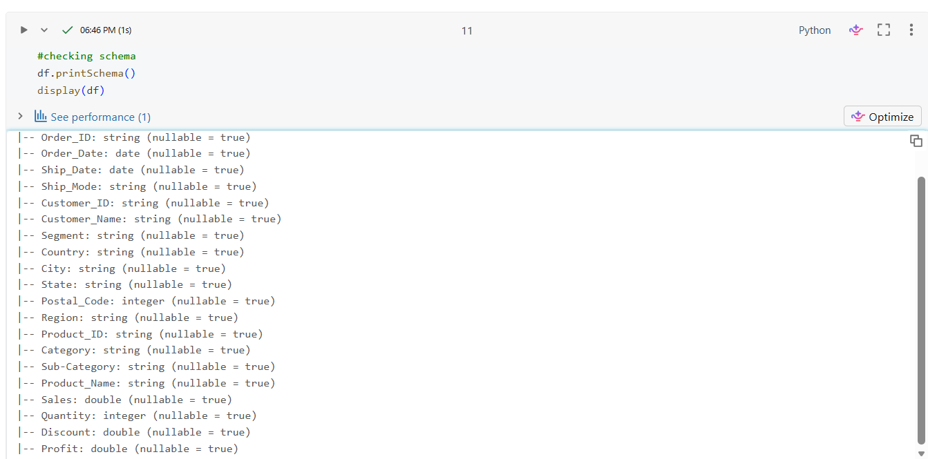
Converting quantity into double for better calculations
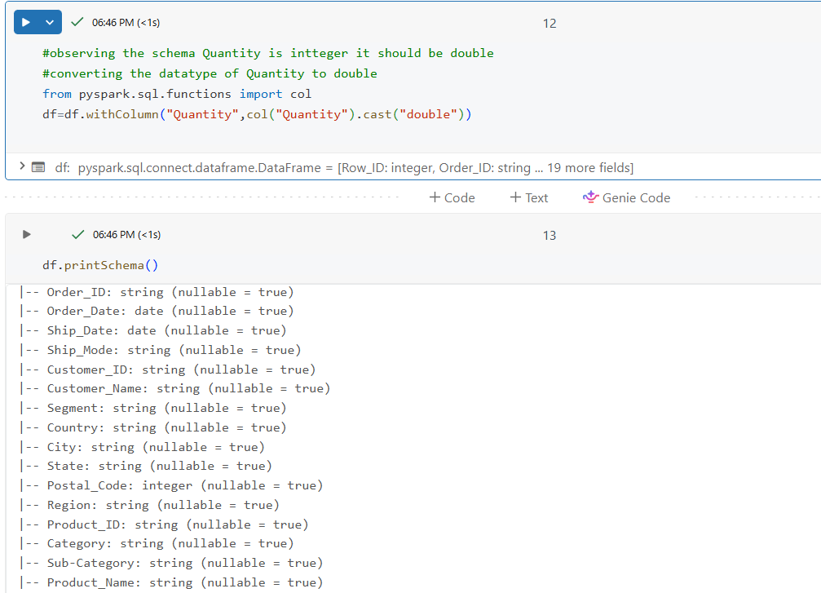
- Step-3 Creating incremental dataset
For incremental processing we required an updated dataset
Creating updated records from the dataset
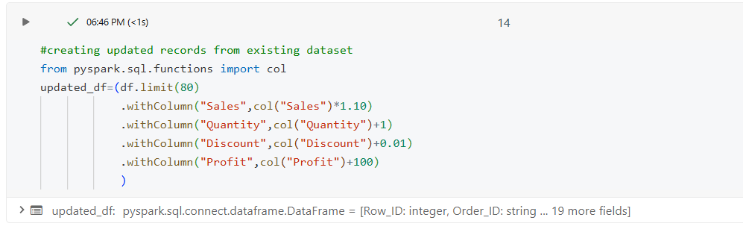
Creating new records
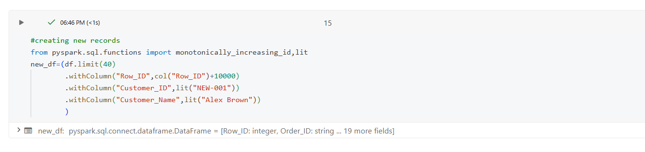
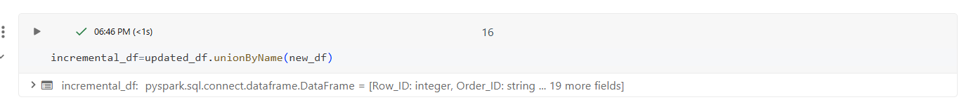
Now a new incremental_df is created with 120 reccords which contains 80 updated records and 40 new records
Write it as delta table
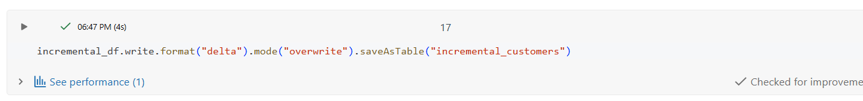
- Step-4
Using merge
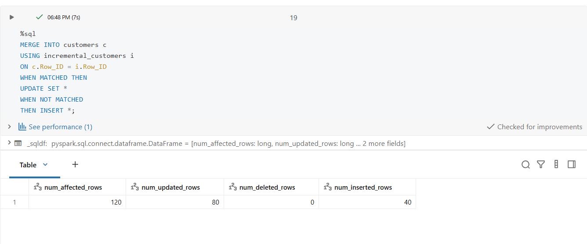
As we see all new and updated records are merged into our source dataset
- Step-5
Checking if there is any duplicate records present after merging
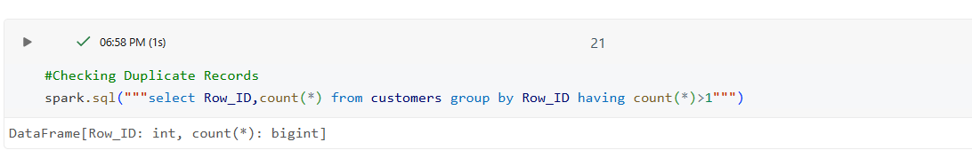
No,Duplicate records are present
Verfying new record
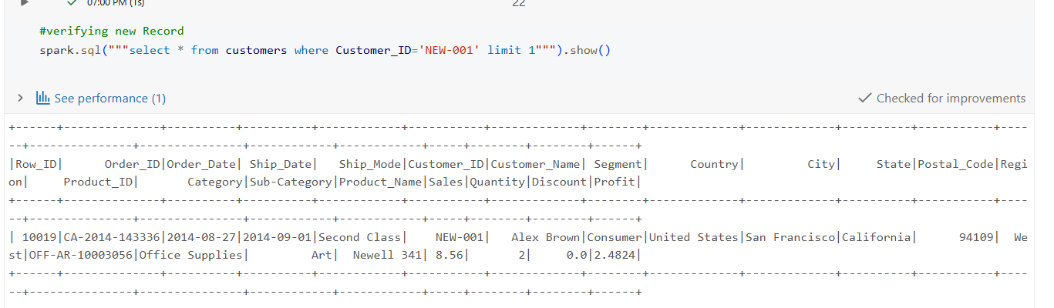
Verfying updated record
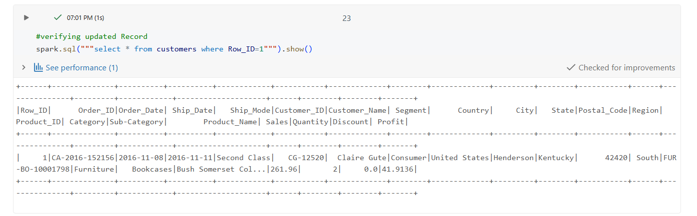
- Step-6
Displaying entire table
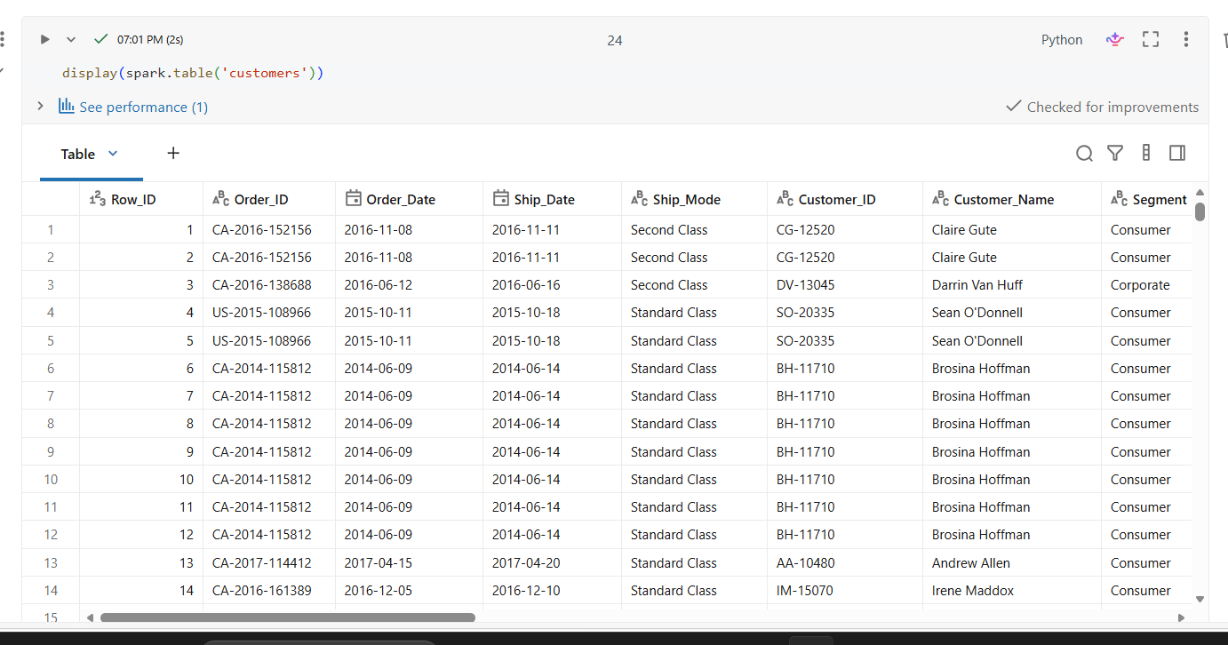
Summary
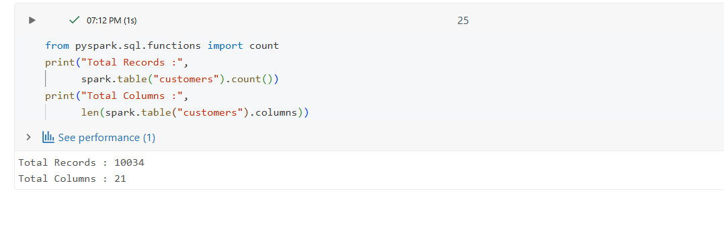
Saving it as final dataset
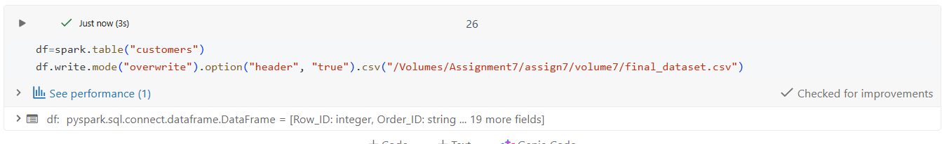
Brief Insights
- Successfully loaded the Superstore dataset into a Delta Lake table for reliable and ACID-compliant storage.
- Performed basic data cleaning by removing duplicate records. A null-value check confirmed there were no missing values requiring additional handling.
- Validated the dataset schema and corrected data types where necessary to ensure accurate processing and analysis.
- Simulated incremental data loading by creating a second dataset containing both updated and new records.
- Used the Delta Lake MERGE operation to:
Update existing records based on Row_ID.
Insert new records that were not present in the target table.
- Verified the merge by checking:
Total row count after processing.
Duplicate records using Row_ID.
Updated and newly inserted records.
- Exported the final processed Delta table as a CSV.

