Celebal Technologies Virtual Internship

Assignment 2 – SQL Queries

Name: Srinith Reddy

SECTION-A
Q1: Write a query to display all columns and rows from the customer's table.
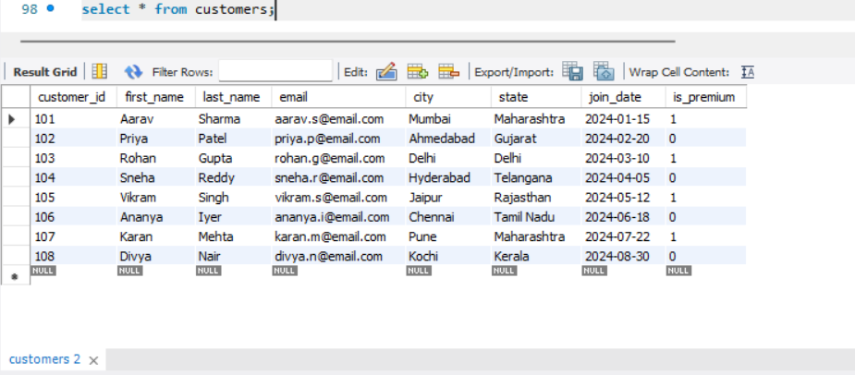
Q2: Retrieve only the first_name, last_name, and city of all customers.
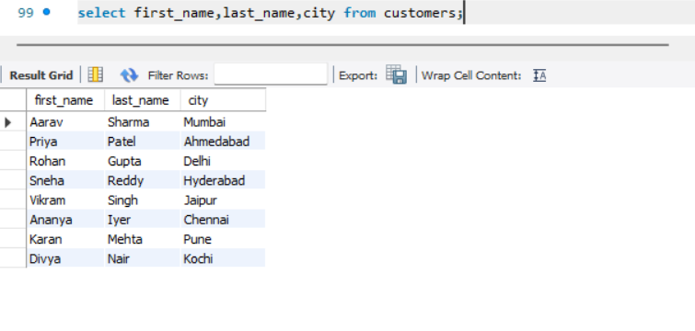
Q3: List all unique categories available in the products table.
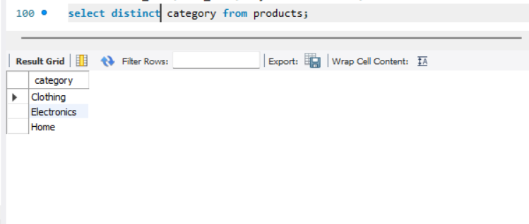
Q4: Identify the Primary Key of each table in the schema. Explain why a Primary Key must be unique and NOT NULL.
Ans:
Primary keys:
customers->customer_id
Products->product_id
orders->order_id
order_items->item_id
- Primary key is a column or set of columns that uniquely identifies each record in a table
- Primary key must be unique because no two rows should have same identifiers
- Primary key must be not null as every record must have identifier .If it has null values we cannot uniquely identify the record.
Q5: What constraints are applied to the email column in the customers table? What would happen if you tried to insert a duplicate email?
Ans: Constraints applied to email column are UNIQUE,NOT NULL.
If we try to insert record with duplicate email then database will reject insertion and throws error as UNIQUE constraint get violated
Q6: Try inserting a product with unit_price = -50. What happens and which constraint prevents it? Write both the INSERT statement and explain the error.
The product table has check constraint (unit_price>0) which says unit_price of every product must be greater than zero.

Section B
Q7: Retrieve all orders with status = 'Delivered'.
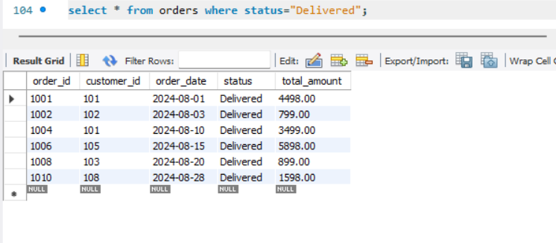
Q8: Find all products in the 'Electronics' category with a unit_price greater than ₹2000.
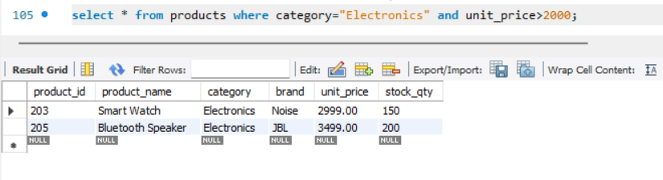
Q9: List all customers who joined in the year 2024 and belong to the state 'Maharashtra'.
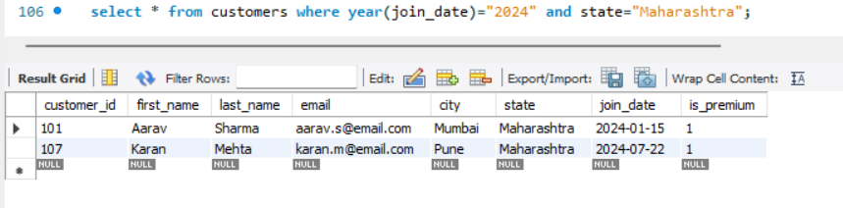
Q10: Find all orders placed between '2024-08-10' and '2024-08-25' (inclusive) that are NOT cancelled.
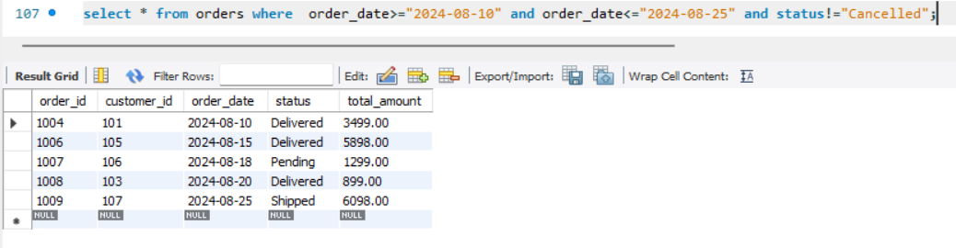
Q11: Explain what the index idx_orders_date does. How would it improve the performance of a query that filters orders by order_date? Write a sample query that would benefit from this index.
Ans:
- The index idx_orders_date is created on the order_date column of the orders table.
- An index helps database find records efficiently without checking entire table.
- When a query uses order_date,the database use index to locate matching rows
- 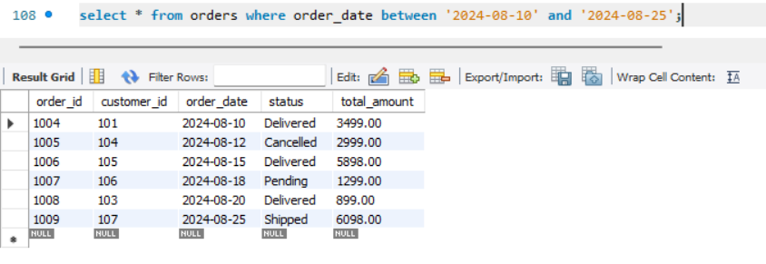
- These query runs based on order_date since index exists database can directly find with scanning entire table
Q12: If you run: SELECT * FROM customers WHERE YEAR(join_date) = 2024; — would the index on join_date be used? Explain why or why not, and rewrite the query to be index-friendly (SARGable)
Ans:
No,The year function is applied on every row before comparing values.so database doesnot scan based on index.
SARGable query:
SELECT *FROM customers WHERE join_date >= '2024-01-01' AND join_date < '2025-01-01';
This query directly compares indexed column without applying any function.

SECTION-C

Q13: Count the total number of orders in the orders table.
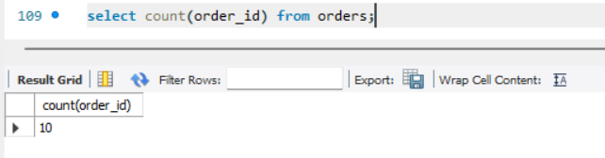
Q14: Find the total revenue (SUM of total_amount) from all 'Delivered' orders.
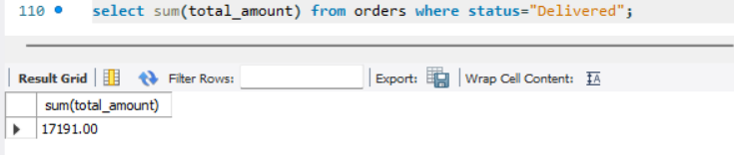
Q15: Calculate the average unit_price of products in each category.
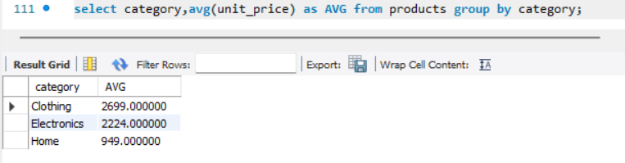
Q16: For each order status, find the count of orders and the total revenue. Sort the result by total revenue in descending order.
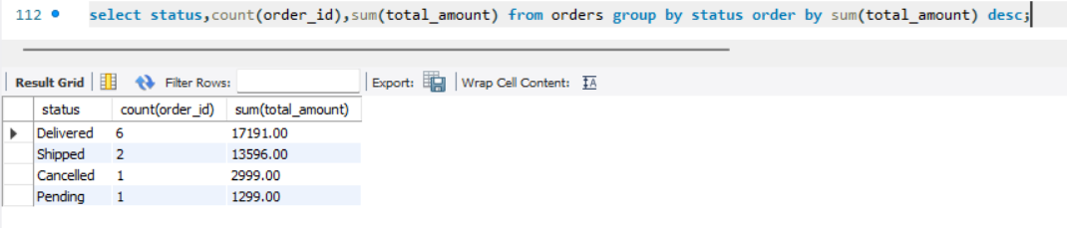
Q17: Find the most expensive (MAX) and cheapest (MIN) product in each category.
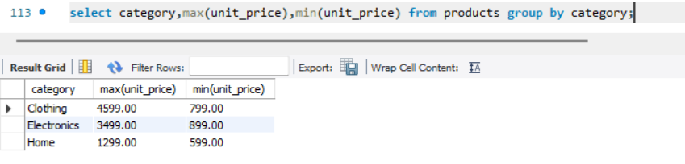
Q18: List all product categories where the average unit_price is greater than ₹2000. (Hint: Use HAVING clause)
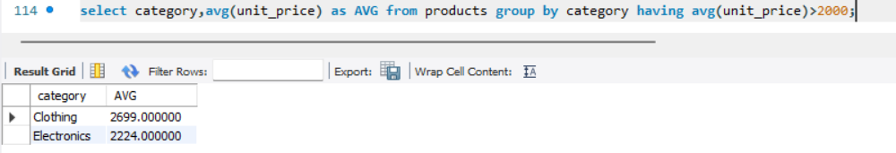

SECTION-D
Q19: Write an INNER JOIN query to display each order along with the customer's first_name and last_name. Show: order_id, order_date, first_name, last_name, total_amount.
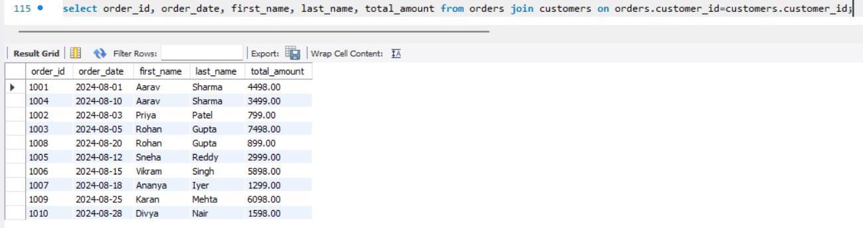
Q20: Using a LEFT JOIN, list ALL customers and their orders (if any). Customers with no orders should still appear with NULL values for order columns.
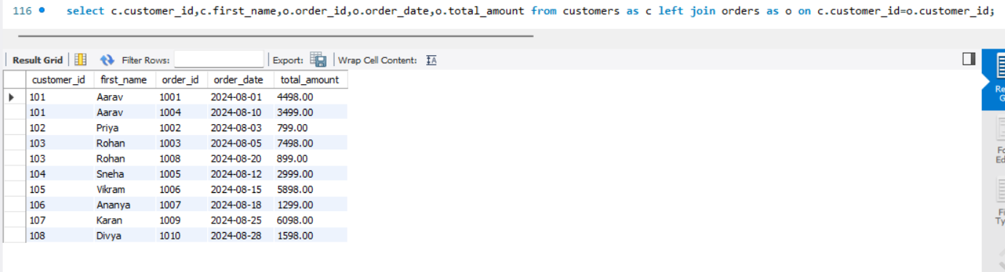
Q21: Write a query using JOINs across three tables (orders → order_items → products) to show: order_id, product_name, quantity, unit_price, and discount_pct for each order item.
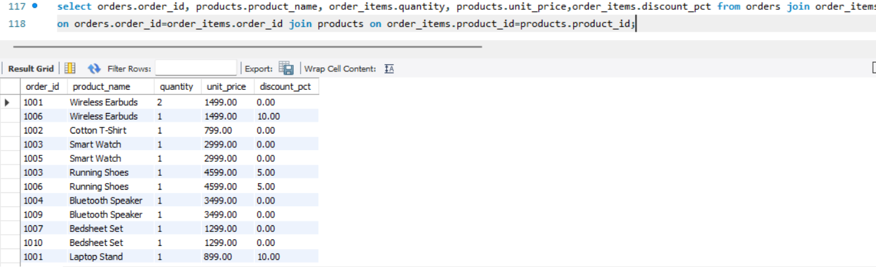
Q22: Explain the difference between LEFT JOIN and RIGHT JOIN with an example from this schema. When would you use a FULL OUTER JOIN?
LEFT JOIN:
A LEFT JOIN returns all rows from the left table and the matching rows from the right table. If there is no match, NULL values are returned for the columns from the right table.
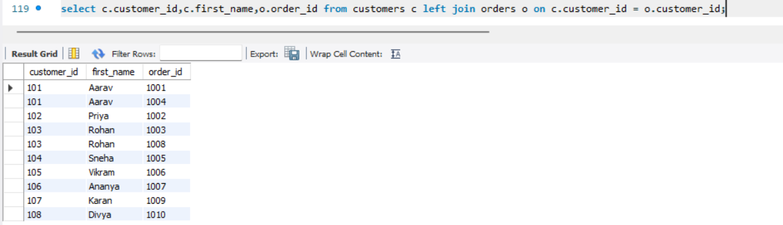
RIGHT JOIN:
A RIGHT JOIN returns all rows from the right table and the matching rows from the left table. If there is no match, NULL values are returned for the columns from the left table.
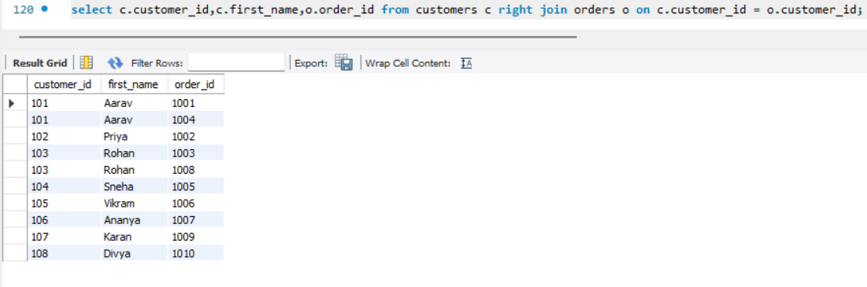
Difference:
- LEFT JOIN → keeps all rows from the left table.
- RIGHT JOIN → keeps all rows from the right table.
FULL OUTER JOIN:
A FULL OUTER JOIN returns all rows from both tables. Matching rows are combined, and non-matching rows from either table are returned with NULL values.
Use Case:
A FULL OUTER JOIN is useful when you want to see:
- Customers with orders
- Customers without orders
- Orders without matching customers
select c.customer_id,c.first_name,o.order_id from customers c full outer join orders o on c.customer_id = o.customer_id;
MySQL does not directly support FULL OUTER JOIN. It can be simulated using a combination of LEFT JOIN and RIGHT JOIN with UNION.

SECTION-E
Q24: Write a query using CASE to classify products into price tiers:
• 'Budget' → unit_price < 1000
• 'Mid-Range' → unit_price BETWEEN 1000 AND 3000
• 'Premium' → unit_price > 3000
Display: product_name, unit_price, price_tier.
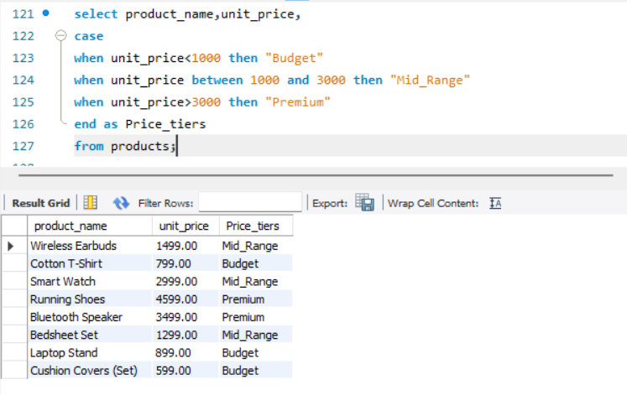
Q25: Using a CASE statement inside an aggregate function, count how many orders are 'Delivered' vs 'Not Delivered' (all other statuses). Display the result in a single row.

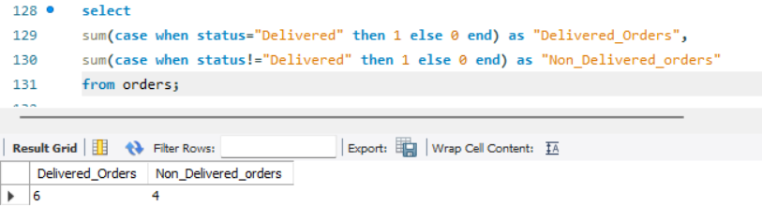
Q26: Explain each letter of ACID:
• A – Atomicity
• C – Consistency
• I – Isolation
• D – Durability
Give a real-world example (e.g., bank transfer) showing why each property is important.
Ans:
ACID properties help make sure that database transactions are completed correctly and safely.
Atomicity
Atomicity means a transaction should either complete fully or not happen at all.
Ex:
If ₹1000 is transferred from Account A to Account B, both actions should happen:
- ₹1000 is deducted from Account A
- ₹1000 is added to Account B
If one step fails, the whole transaction is cancelled.
Consistency
Consistency means the database should always remain correct and follow all rules.
Ex:
Before transfer:
Account A = ₹5000
Account B = ₹3000
After transferring ₹1000:
Account A = ₹4000
Account B = ₹4000
The total money remains the same and the data stays correct.
Isolation
Isolation means multiple transactions happening at the same time should not affect each other.
Ex:
If two people are using the same bank account at the same time, the database handles each transaction separately to avoid mistakes.
Durability
Durability means once a transaction is completed and saved, it will not be lost.
Ex:
After a money transfer is successful, the updated balance remains saved even if the system crashes or the power goes off.
Q27: Write a SQL transaction that does the following atomically:
1. Insert a new order (order_id=1011, customer_id=102, today's date, 'Pending', 1598.00)
2. Insert two order items for that order
3. Update the stock_qty of the purchased products
4. If any step fails, ROLLBACK the entire transaction. Otherwise, COMMIT.
Write the complete BEGIN...COMMIT/ROLLBACK block.
