CELEBAL EXCELLENCE INTERNSHIP

ASSIGNMENT-04

NAME:T.SRINITH REDDY
TASK-01
Azure Cloud Fundamentals and Data Pipeline Implementation using ADF
Resource Group:
A resource group is a container that holds azure resources like adf,storage accounts,vm’s,databases.
Creating Resource groups:
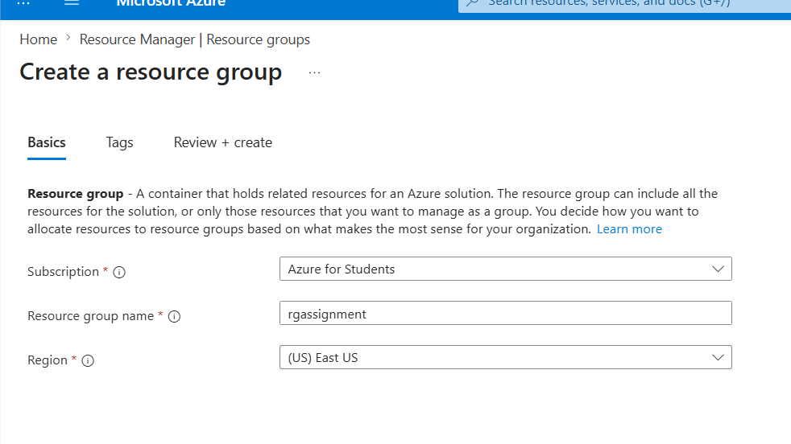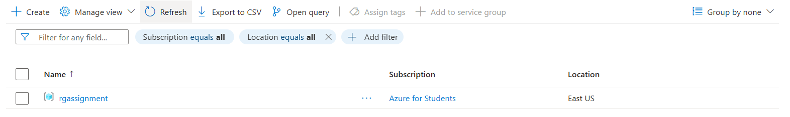
TASK-02
Storage setup
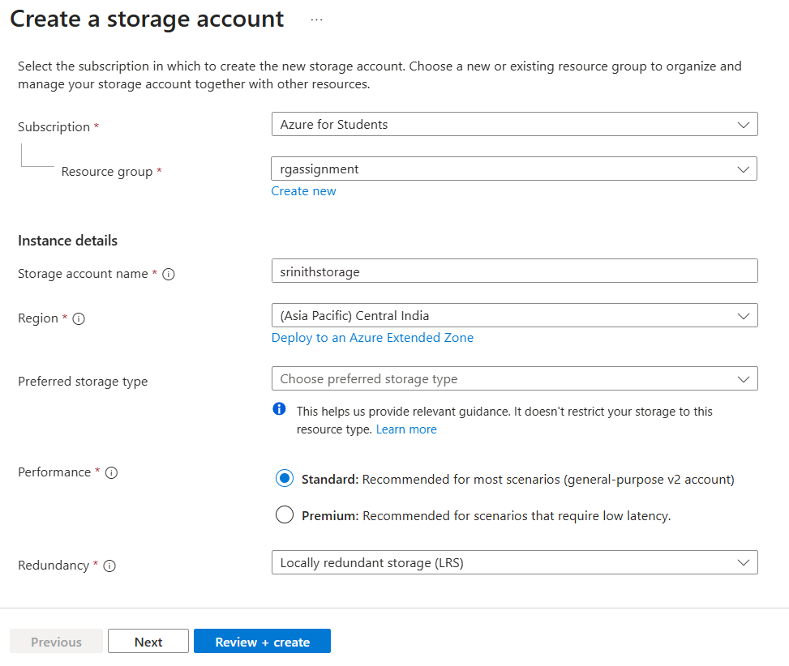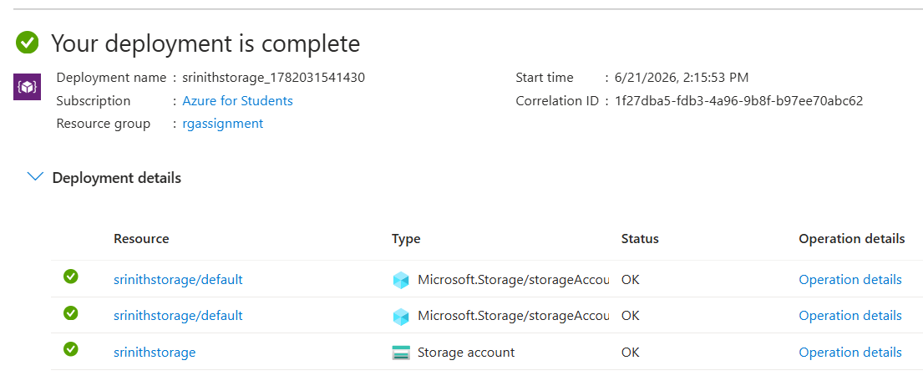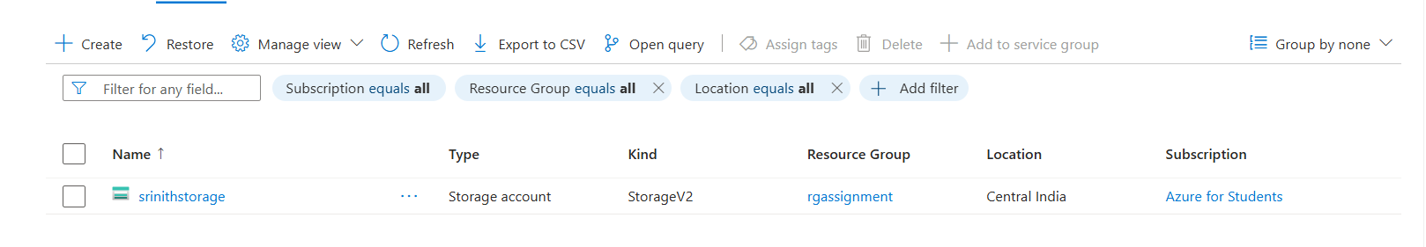
Creating Blob container:
In storage account go to data storage then containers create a container with name sourcedata
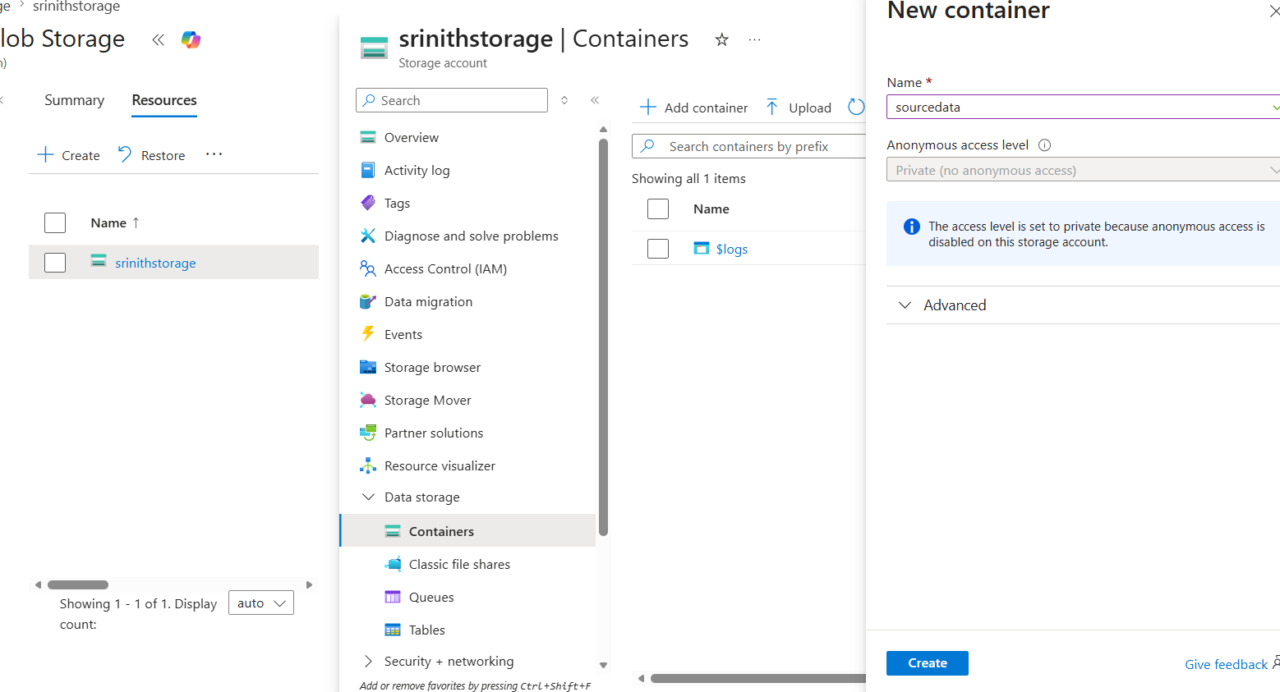

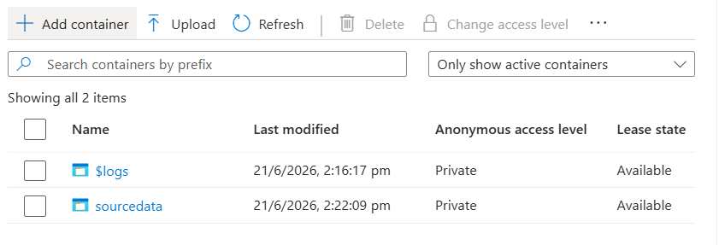
Uploading csv file into source data
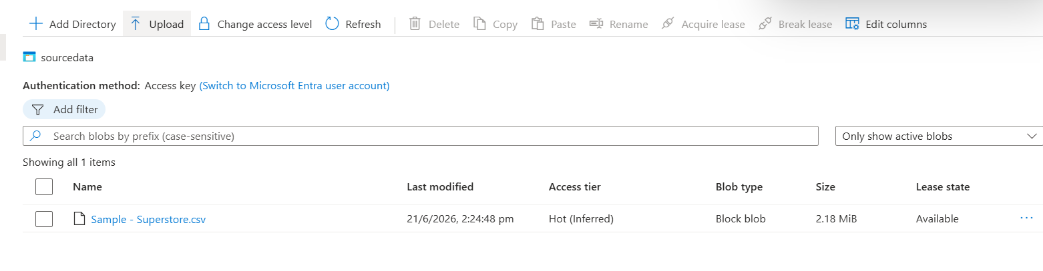
Task -03 Azure Data Factory Basics
ADF:
Azure Data Factory is a service that helps move and transform data from one place to another in an automated way.generally used to create manage and schedule pipelines
Go to data factory ,then create data factory by name srinithadf
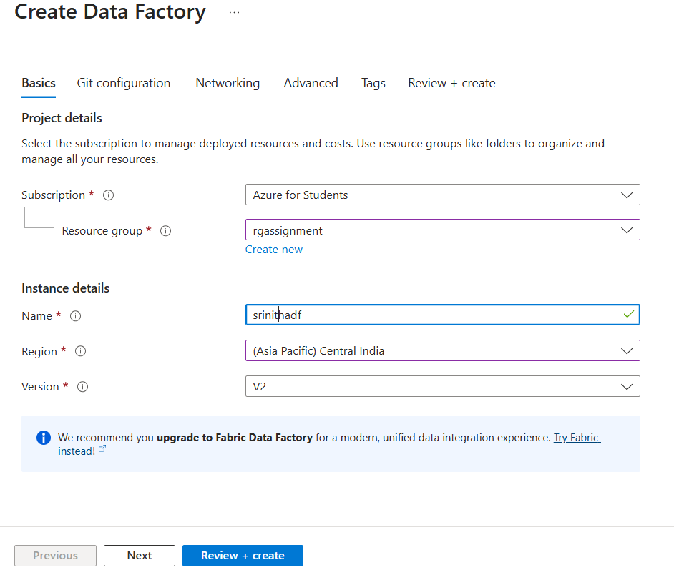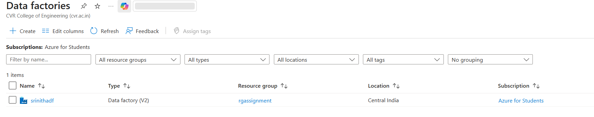
Launching ADF Studio
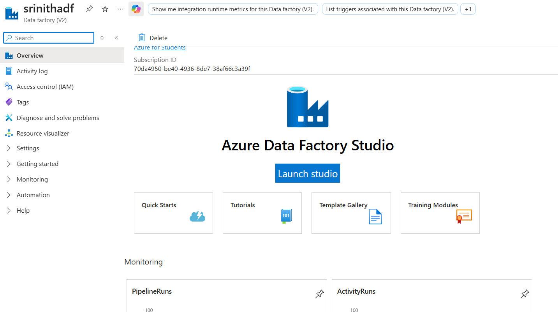
ADF sections
1.Author
Author in ADF is used to create pipelines,datasets,Dataflows,change Data Capture etc.
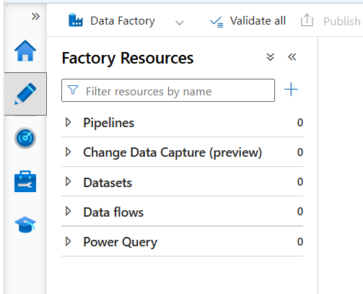
2.Monitor
Used to Monitor executions,check failures,view logs,Trigger runs etc..
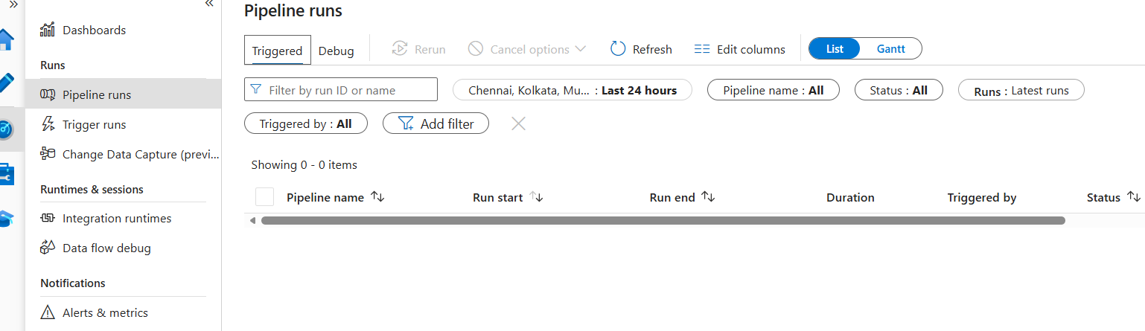
3.Manage
Used to Linked Services,Integration Runtime,Acess control
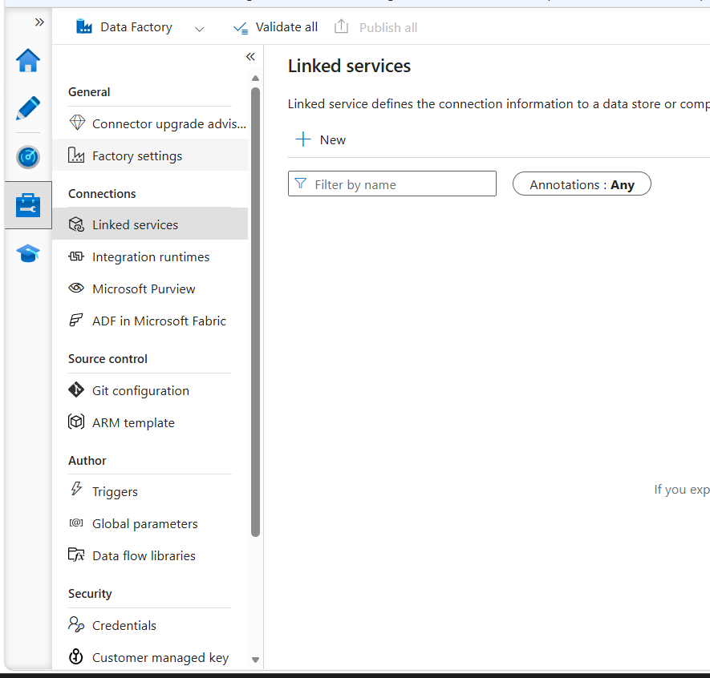
Creating a Linked Service
Linked Service is a connection string that stores information needed for adf to connect to datasource
Adf-> Linked Service-> Blob storage
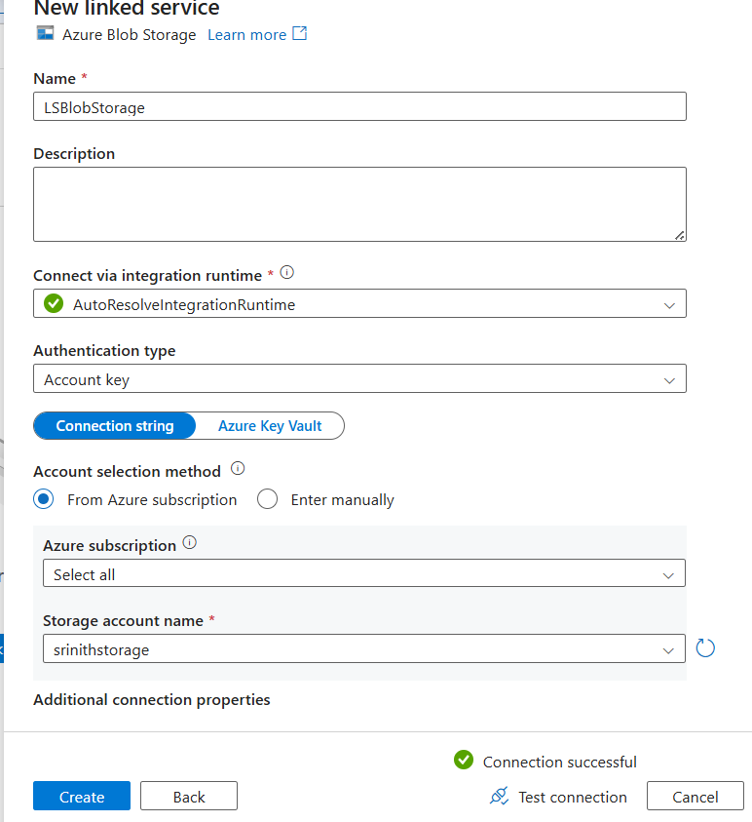
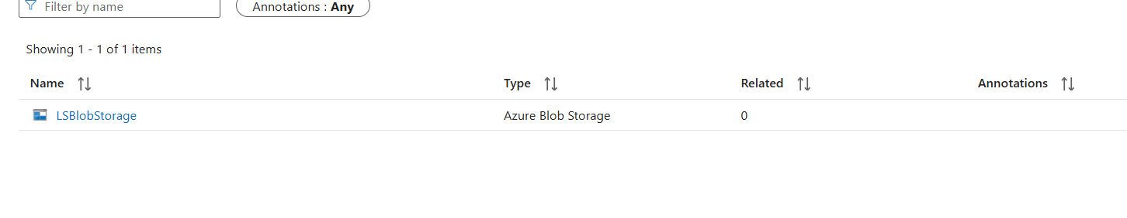
Creating a source dataset
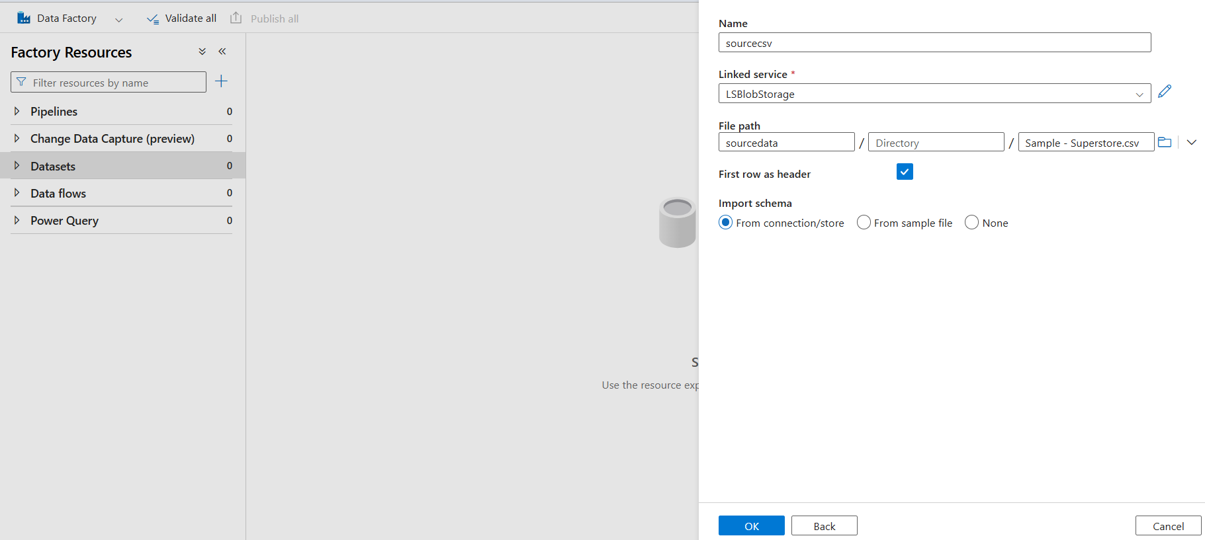
Creating a destination dataset
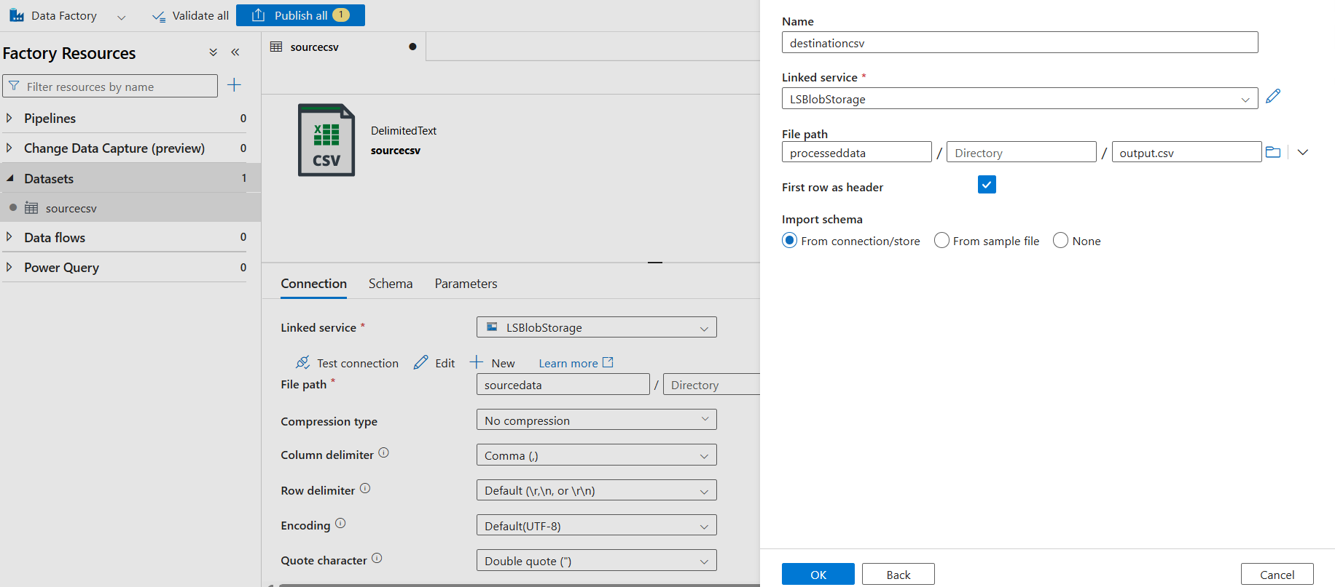
Creating GetMetaData Activity
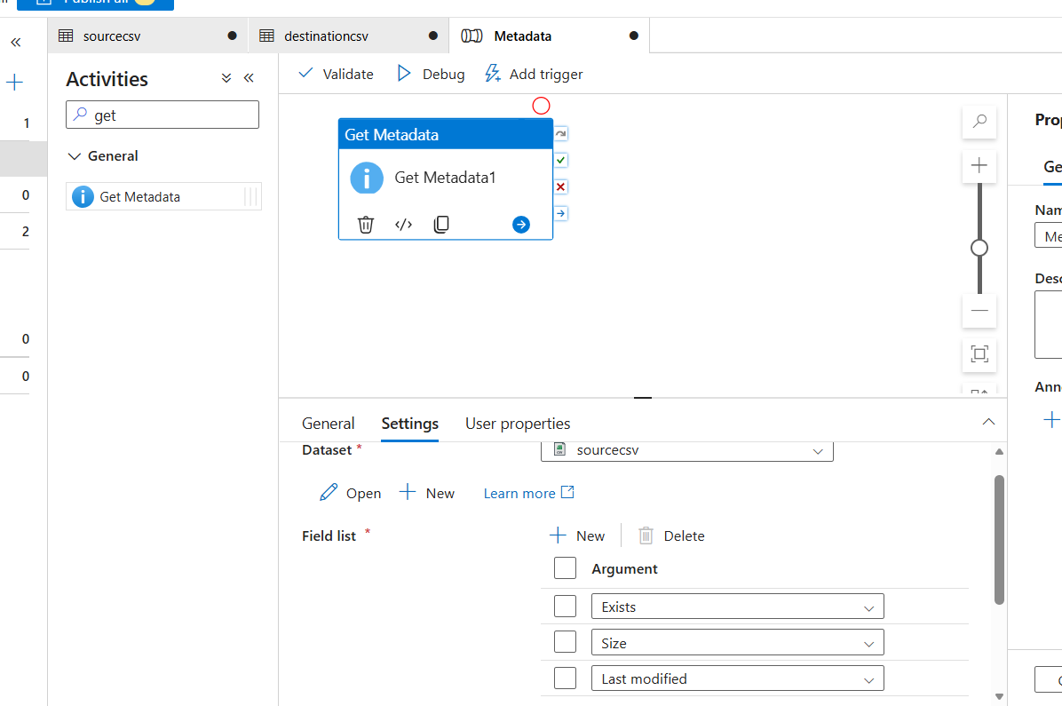
Adding copy data activity
TASK-04
Pipeline Design
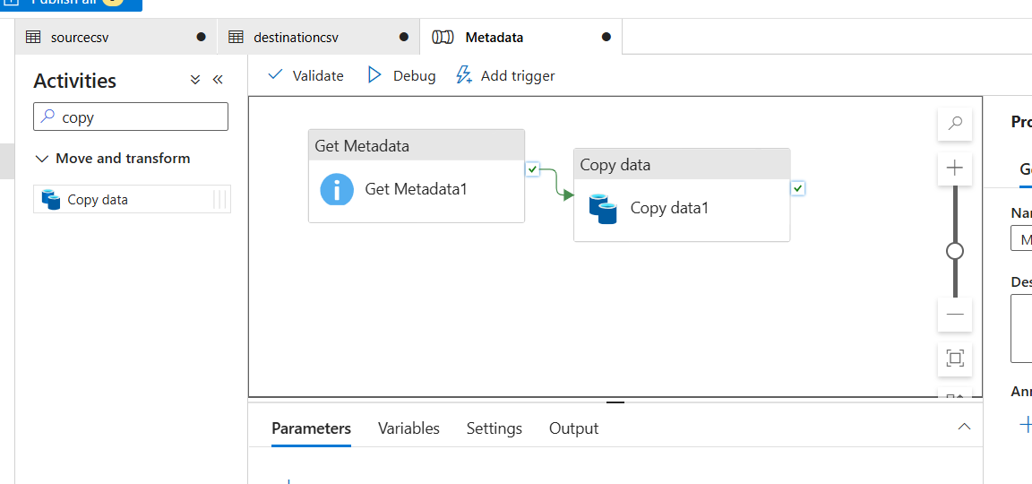
Pipeline Execution

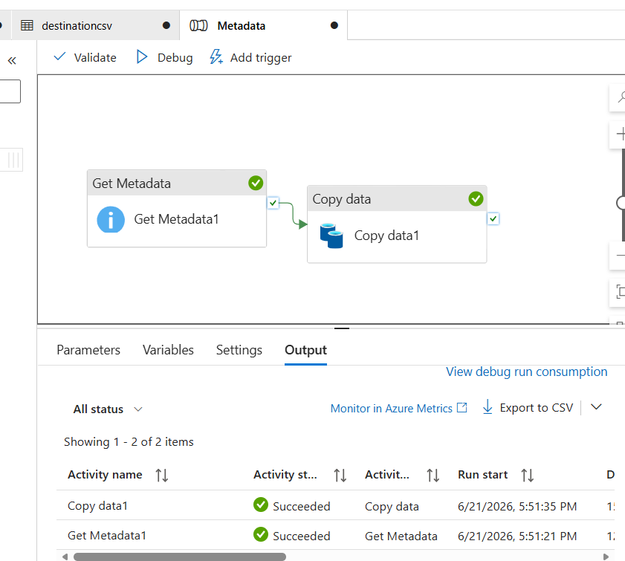
Adding Trigger
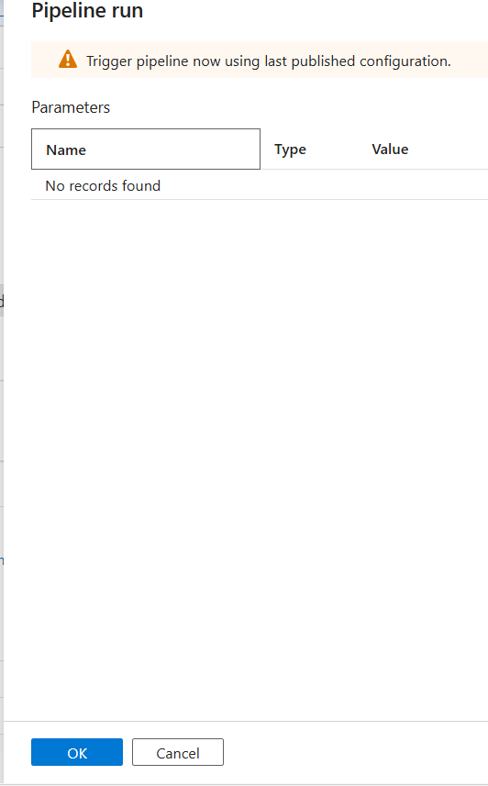
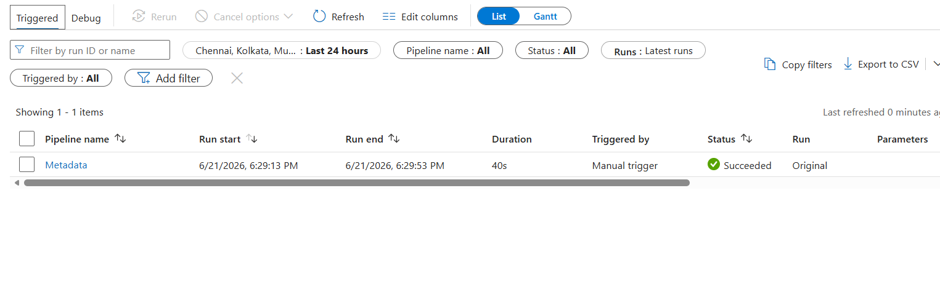
Verifiying output.csv
TASK-05
IAM Role Assignments
Identity Access Management : Controls who can access resources.
Assigning Reader role
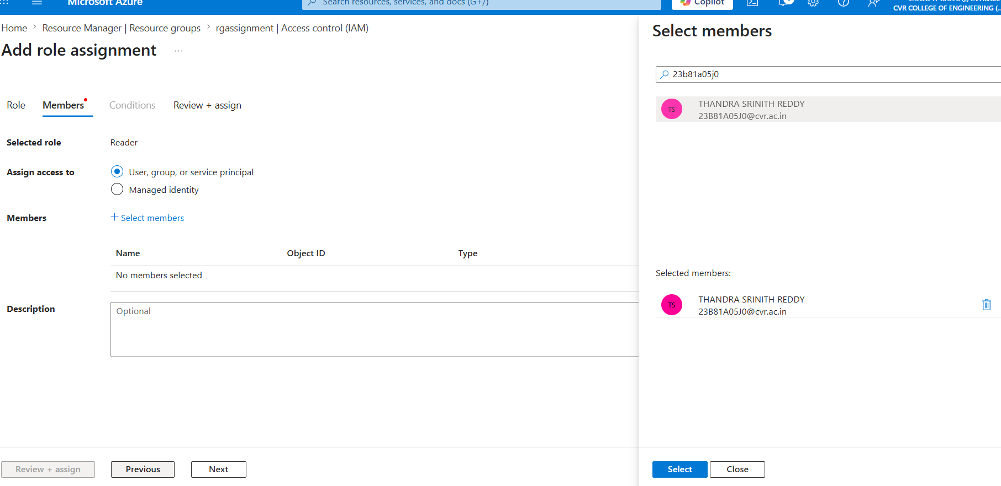
Assigning Contributor role
Due to subscription-level access restrictions in the Azure for Students environment, Contributor role assignment could not be completed.
Granting storage access to Azure Data Factory
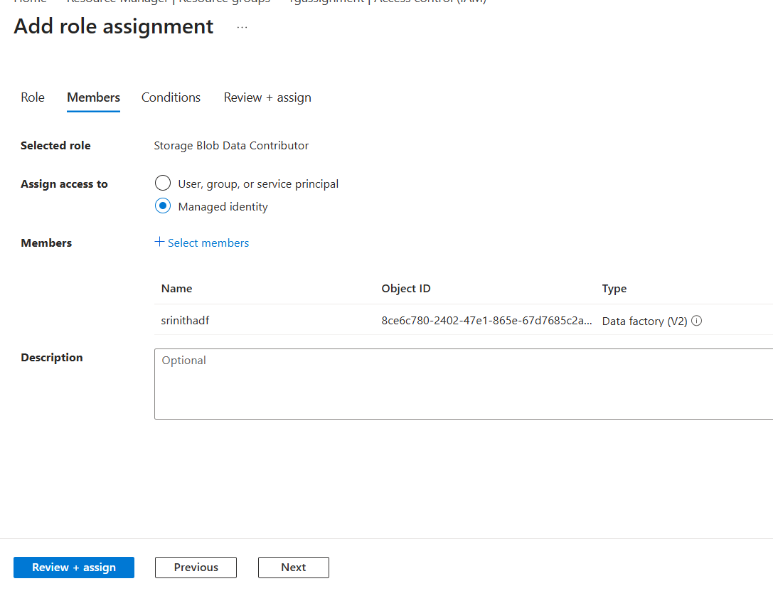
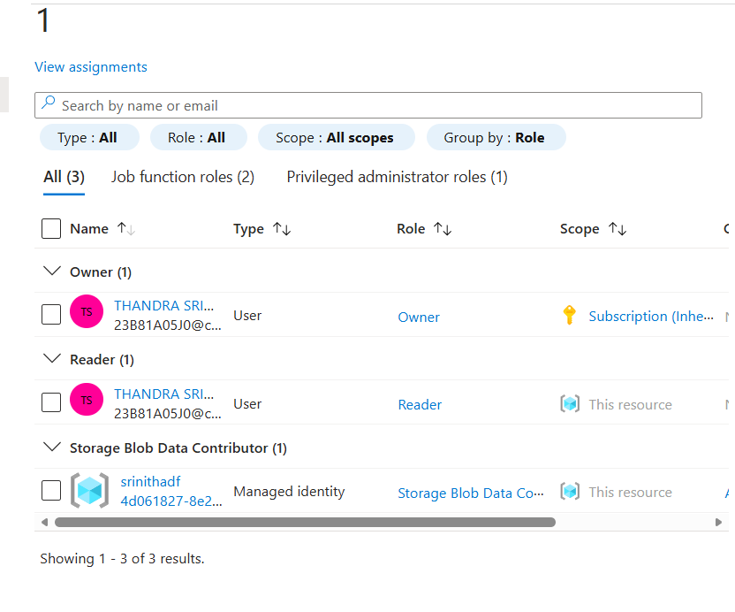

This allows ADF to Read and Write Blogs.

Build a complete pipeline that reads a CSV file from Blob Storage and processes it using Azure Data Factory.
Mini Project Architecture
1)Source File
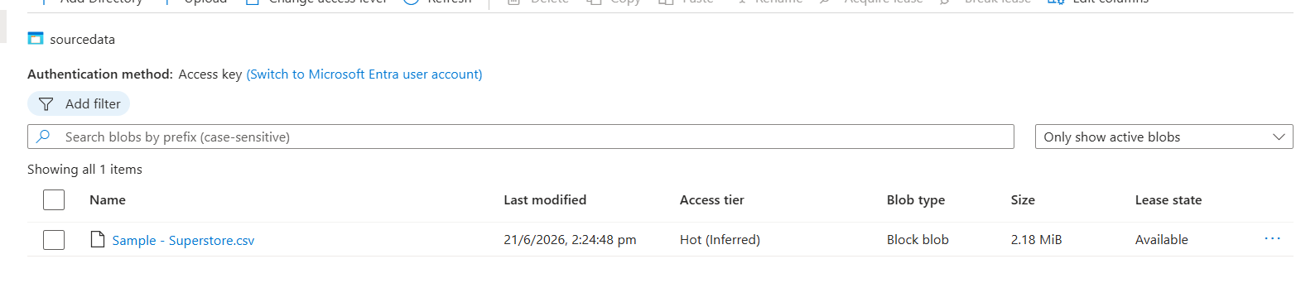

2)Linked Service
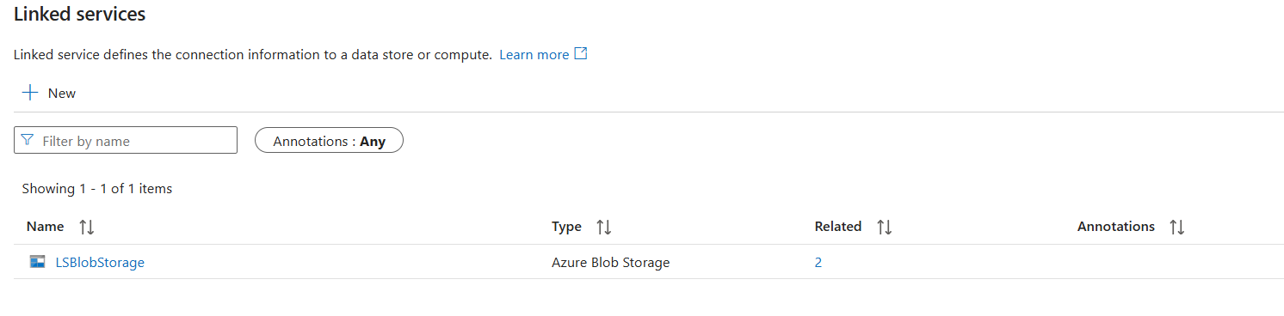
3)Verifying Datasets
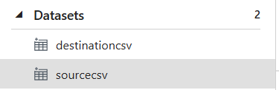
4)Meta Data Validation

{
"exists": true,
"size": 2287806,
"lastModified": "2026-06-21T08:54:48Z",
"effectiveIntegrationRuntime": "AutoResolveIntegrationRuntime (Central India)",
"executionDuration": 0,
"durationInQueue": {
"integrationRuntimeQueue": 9
},
"billingReference": {
"activityType": "PipelineActivity",
"billableDuration": [
{
"meterType": "AzureIR",
"duration": 0.016666666666666666,
"unit": "Hours"
}
]
}
}
5) Copy Data Validation
{
"dataRead": 2287806,
"dataWritten": 2287806,
"filesRead": 1,
.
.
.
}
6)Pipeline
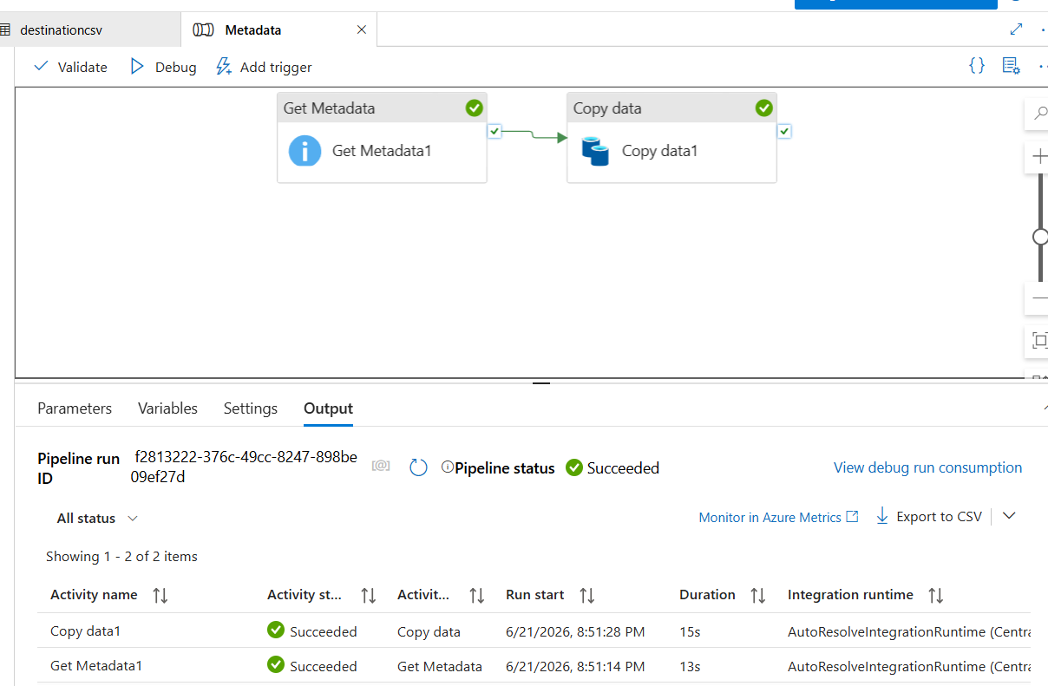
7)Output file
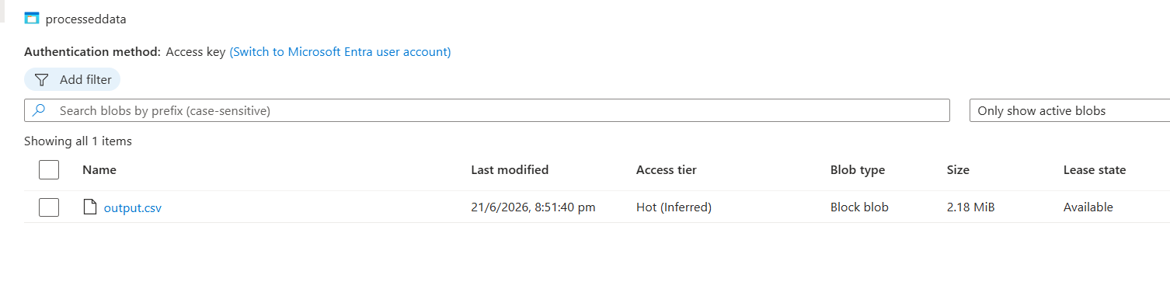
Data is successfully copied.

Key Learnings
- Learned how Azure Resource Groups help organize and manage cloud resources.
- Understood the use of Azure Storage Account and Blob Storage for storing files in the cloud.
- Gained hands-on experience with Azure Data Factory (ADF) for creating data pipelines.
- Learned how Linked Services and Datasets are used to connect and access data sources.
- Used Get Metadata activity to validate file information before processing.
- Used Copy Data activity to move data from a source location to a destination location.
- Learned how to monitor pipeline execution and verify successful runs.
- Understood the basics of IAM roles and access management in Azure.
- Successfully built and executed an end-to-end pipeline that copied a CSV file and validated its metadata.

