ASSIGNMENT -3

Task-2
- Import the Superstore dataset into a table named superstoreraw.
- Create these 3 tables from it:
a.customers
b.orders
c.products
- Insert data into these tables using SELECT DISTINCT.

#creating tables from superstore dataset
1.customers
The superstore dataset contains multiple records for same customers .To avoid duplicates customers table is created using “select distinct”.
2.products
`
Similarly, products table is created.
3.orders
Each row represents a unique order item, all records where inserted without using distinct.
Step 2: Perform Required Queries
Write and execute SQL queries for each of the following:
1.Find all orders where sales are greater than the average sales. (Subquery)
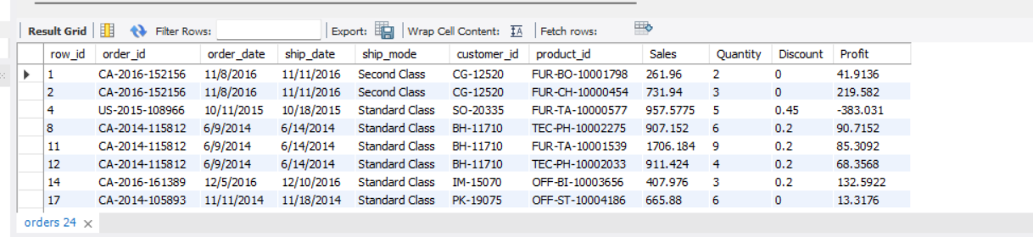
The query uses subquery to calculate avg sales and compare every record to get sales greater than avg sales.
2.Find the highest sales order for each customer. (Subquery)
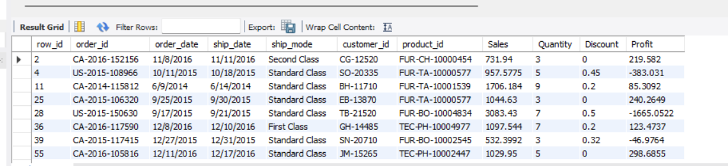
Above query is a correlated subquery,here inner query is executed for each customer in the customer in the outer query.
3.Calculate total sales for each customer. (CTE)
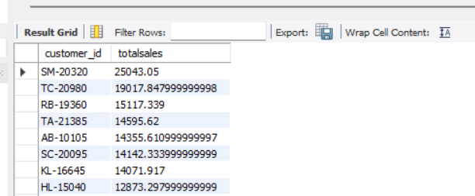
A Common Table Expression is used to create a temporary result that can be used in query.
In the above query CTE calculates total sales generated by each customer.

4.Find customers whose total sales are above average. (CTE + Subquery)
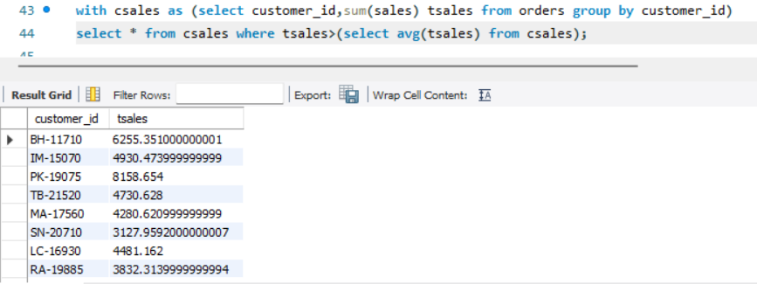

5.Rank all customers based on total sales. (Window Function)
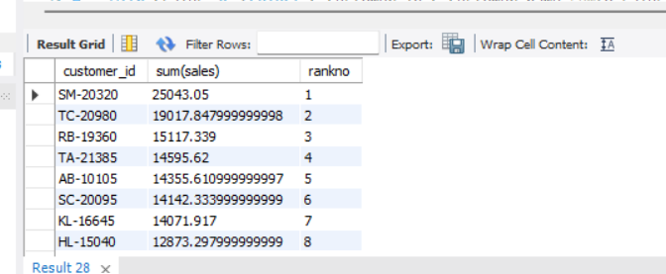
The RANK() window function assigns a rank to customers based on their total sales. Customers with the same total sales receive the same rank, and the next rank value is skipped accordingly.
6.Assign row numbers to each order within a customer. (Window Function + PARTITION BY)
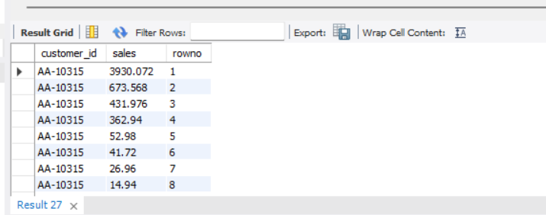
The ROW_NUMBER() window function assigns a unique sequential number to each row within a partition. In this query, orders are ranked for each customer based on sales in descending order, with the highest sales order receiving rank 1.

7.Display top 3 customers based on total sales. (Window Function)
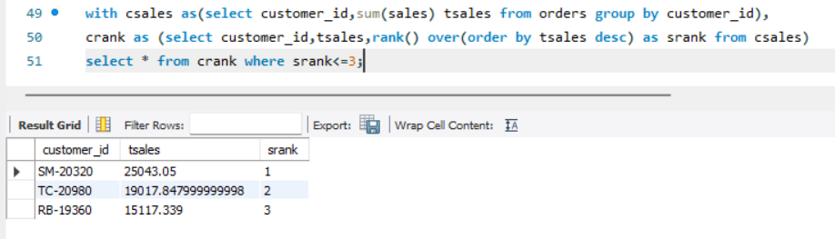
Q:Write one final query that shows:
- Customer Name
- Total Sales
- Rank
(Use JOIN + CTE + Window Function together)
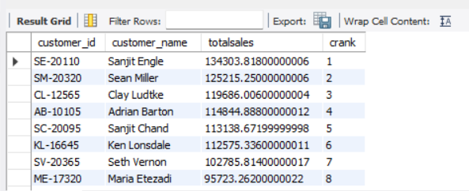
This query combines a join, Common Table Expression (CTE), and Window Function to perform customer sales analysis. The join combines customer and order data, the CTE calculates total sales for each customer, and the rank() function assigns rankings based on total sales.
Answer the following using SQL:
1.Who are the top 5 customers?
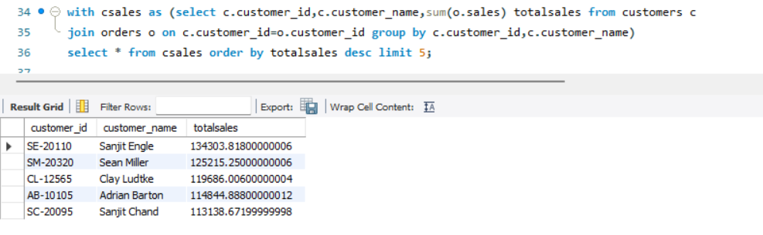

2.Who are the bottom 5 customers?
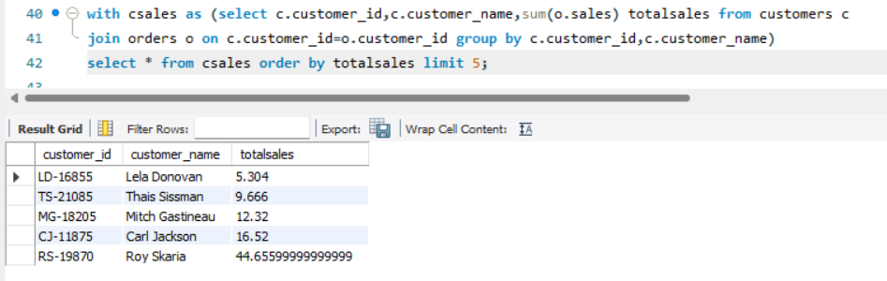
3.Which customers made only one order?
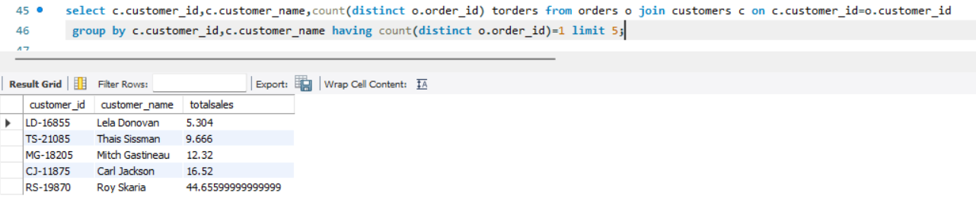
4.Which customers have above-average sales?
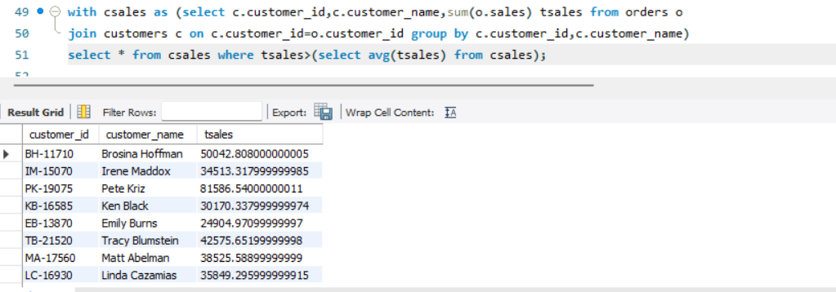
5.What is the highest order value per customer?


