CELEBAL VIRTUAL INTERNSHIP

ASSIGNMENT -3

NAME:T.SRINITH REDDY

#creating tables from superstore dataset
1.customers
The superstore dataset contains multiple records for same customers .To avoid duplicates customers table is created using “select distinct”.
2.products
`
Similarly, products table is created.
3.orders
Each row represents a unique order item, all records where inserted without using distinct.
QUERIES
Q:Orders above avg sales
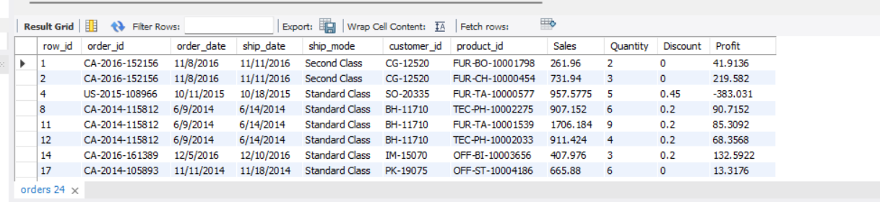
The query uses subquery to calculate avg sales and compare every record to get sales greater than avg sales.
Q:Highest order for each customer
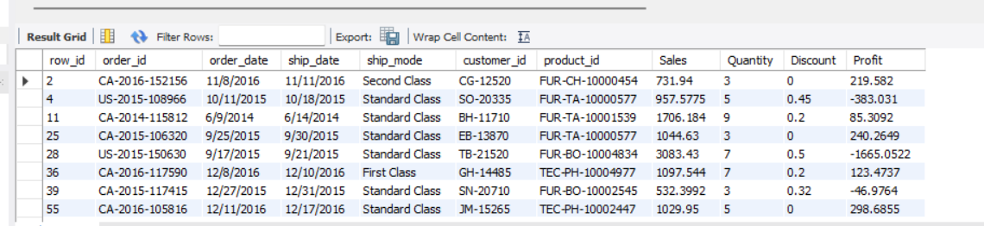
Above query is a correlated subquery,here inner query is executed for each customer in the customer in the outer query.
Q:Total sales per customer using CTE(Common Table Expression)
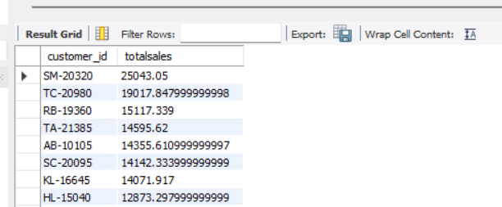
A Common Table Expression is used to create a temporary result that can be used in query.
In the above query CTE calculates total sales generated by each customer.
Window Functions
Q:Using ROW_NUMBER()
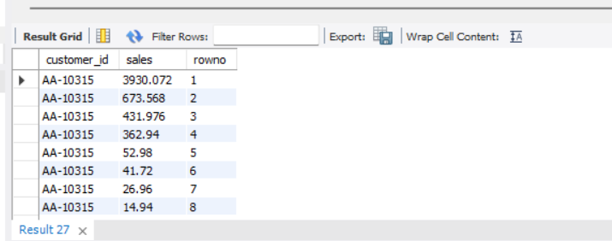
The ROW_NUMBER() window function assigns a unique sequential number to each row within a partition. In this query, orders are ranked for each customer based on sales in descending order, with the highest sales order receiving rank 1.
Q:Using RANK()
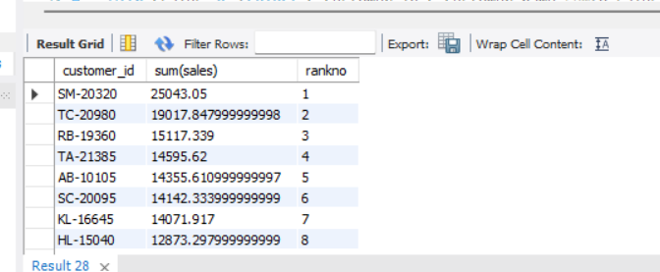
The RANK() window function assigns a rank to customers based on their total sales. Customers with the same total sales receive the same rank, and the next rank value is skipped accordingly.
Q:Using join,CTE,Window function
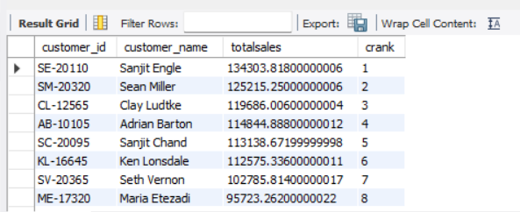
This query combines a join, Common Table Expression (CTE), and Window Function to perform customer sales analysis. The join combines customer and order data, the CTE calculates total sales for each customer, and the rank() function assigns rankings based on total sales.
Q:Top 10 customers with sales
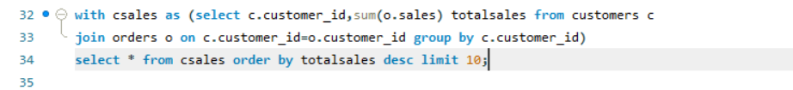
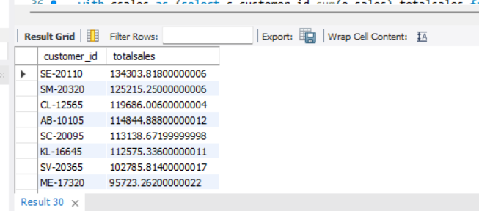
Q:Bottom 10 customers
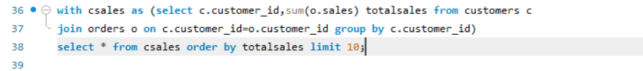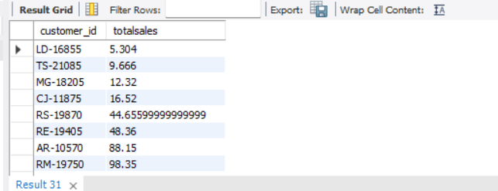
Q:Customers with single orders
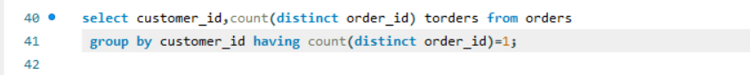
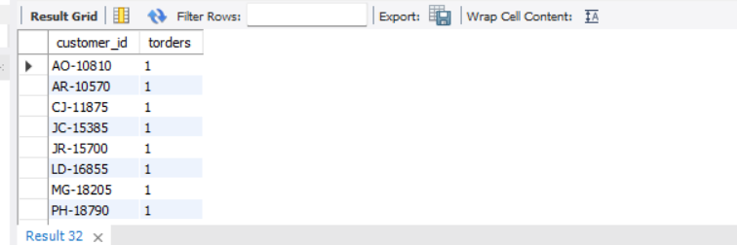
Q:Most profitable customers
