Celebal Excellence Virtual Internship

Assignment-06
Name:T.SRINITH REDDY
Q1) Explain the roles of the Driver, Cluster Manager, and Executor in a Spark application.
Ans)
Driver-> The Driver is the main program that creates the sparksession,plan the excecution tasks,and coordinates the entire spark application.
Cluster Manager->Cluster Manager allocates resources like CPU,Memory etc.. to sparkapplication and manages worker nodes.
Executor->Executors runs the tasks assigned by the driver ,process the data , and return the results to the driver.
Q2) How does Spark’s Lazy Evaluation strategy improve performance when chain-processing large datasets?
Ans)
Whenever user writes the transformations spark does not execute this transformations immediately.It records all transformations and creates a DAG .when a action is called then spark optimizes it by combining operations and avoiding unnecessary computations.These reduces disk i/o,minimizes data movement and improves performance.
Q3)Write a Spark command to read a CSV file located at "data/source.csv", ensuring the first row is treated as a header and inferSchema is enabled.
Ans)
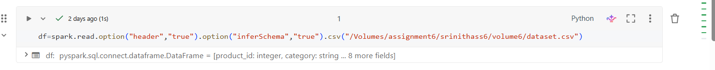
Header=true makes the first row as Headings(Column Names)
inferSchema=true automatically detects datatype of each column.
Q4) What is the difference between CSV and Parquet in terms of storage (row-based vs. columnar) and why does it matter for performance?
Ans)
CSV is a row based storage format where all columns of each row are stored together.
Parquet is a columnar storage format where values of the same column are stored together.
Parquet provides better compression,faster query performance,and reads only the required columns,making it more efficient for analytics than CSV.
Q5) Given a DataFrame df, write a query to select the columns product_id and price where the category is 'Electronics'
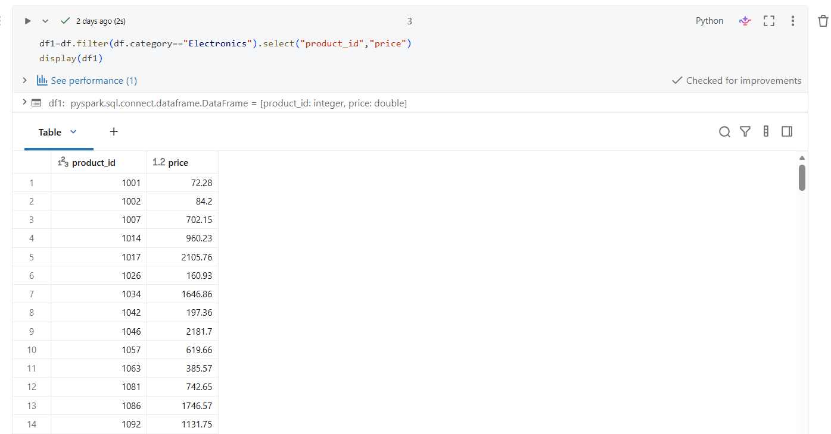
Q6) Write the code to "revise" a DataFrame by renaming the column old_name to new_name and casting the price column from a String to a Double.
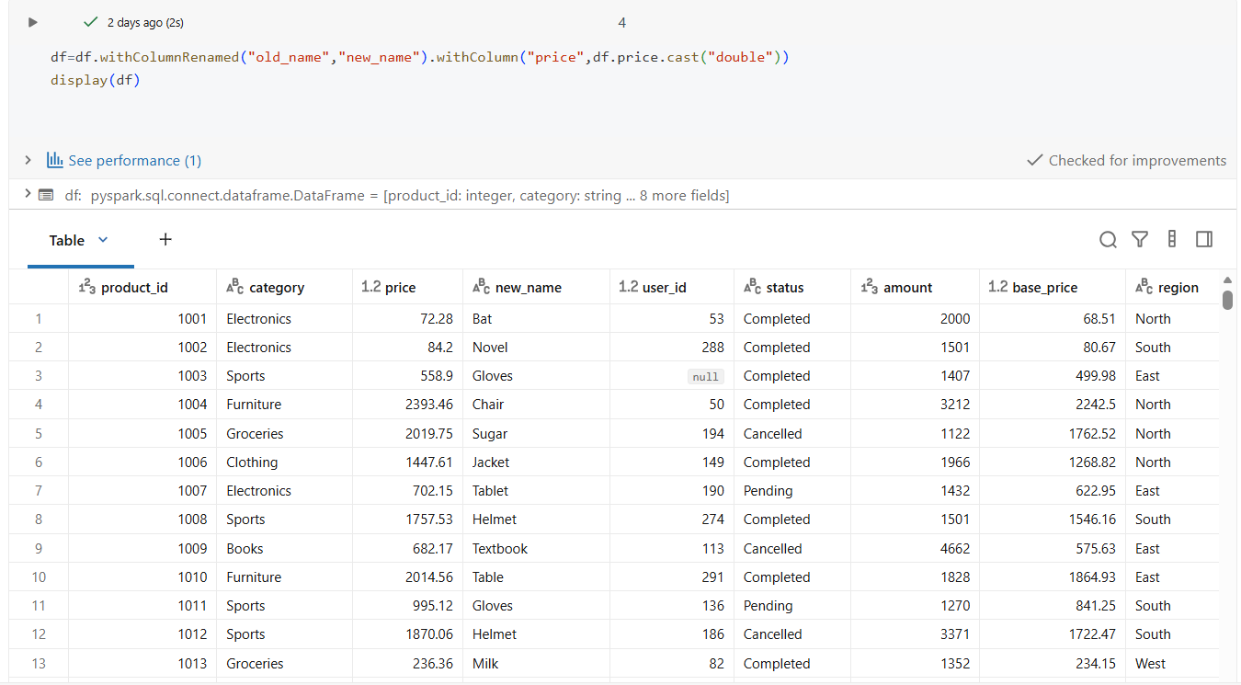
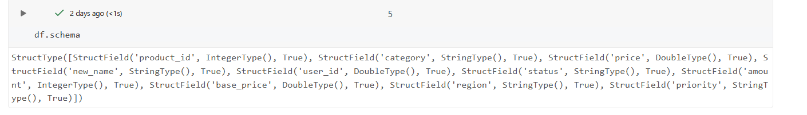
Q7) How does Spark use the Lineage Graph (DAG) to provide fault tolerance if a worker node fails?
Ans)
Sparks keeps track of all transformations using DAG .If a worker node fails and data is lost ,spark recomputes only the missing partitions using the lineage instead of recomputing the entire dataset.This provides efficient fault tolerance.
Q8) Write a query to filter a DataFrame df_orders for rows where the status is 'Completed' AND the amount is greater than 1000.
Ans)
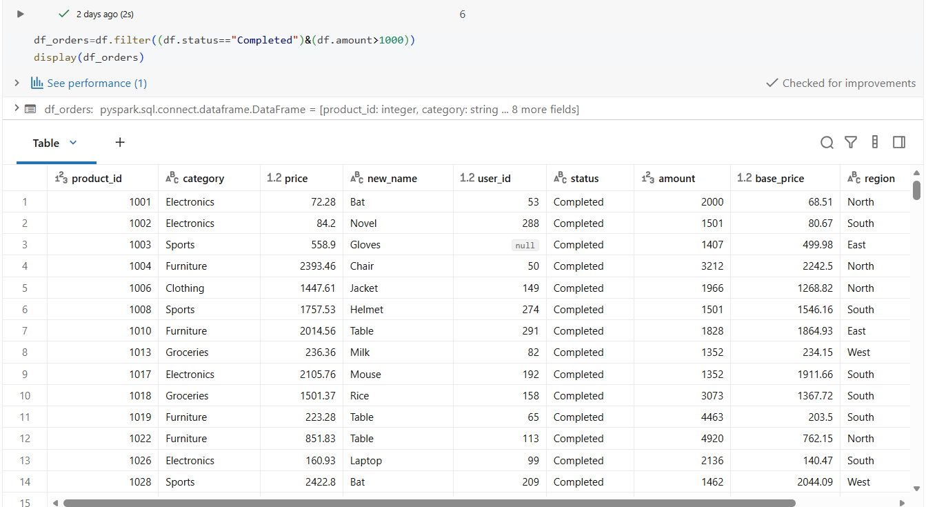
Q9) Explain the concept of Predicate Pushdown in Parquet and how it affects the amount of data loaded into memory.
Ans)
Predicate Pushdown allows spark to apply filter conditions while reading a parquet file.Instead of loading the entire dataset ,spark reads only the rows that satisfy the filter condition .This reduces memory usage,disk i/o and improves performance.
Q10) Write a code snippet to add a new column final_price which is the base_price multiplied by 1.18 (18% tax).
Ans)
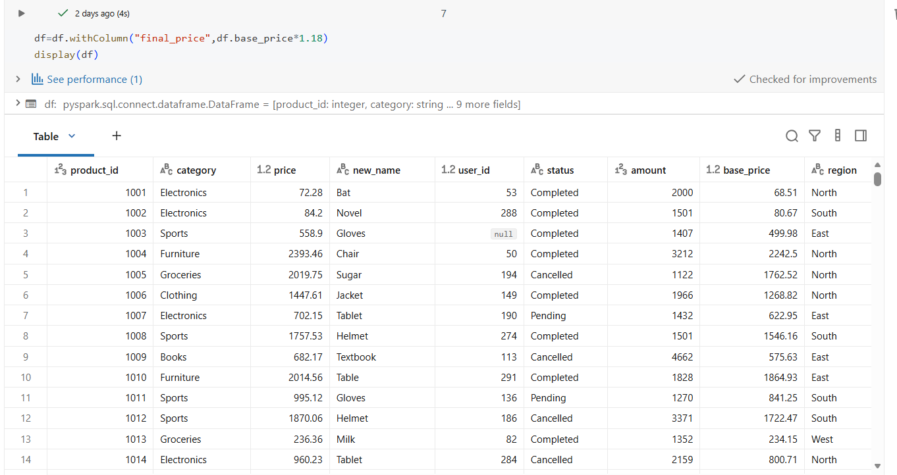
Q11) What is the difference between Transformations and Actions? Provide two examples of each.
Ans)
Transformations create a new DataFrame or RDD but are lazy ,meaning they are not executed immediately.
Ex: filter(),select()..
Actions trigger the execution of transformations and return a result or save data.
Ex:show(),collect()..
Q12) Write the Spark command to load a Parquet file from "path/to/input", filter out any rows where user_id is null, and save the result as a CSV at "path/to/output".
Ans)
As we already have csv file
1)read csv file
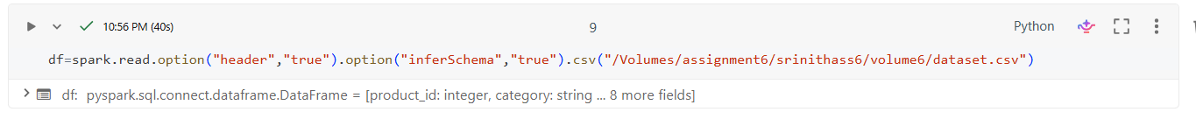
2)overwrite to parquet file
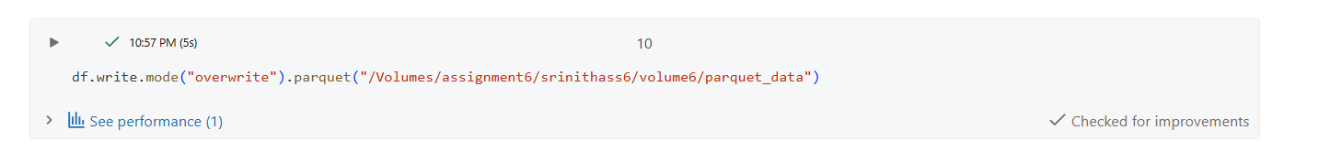
3)read it
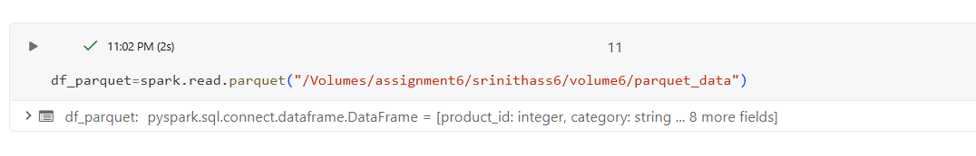
4)filter the data (userid!=null)
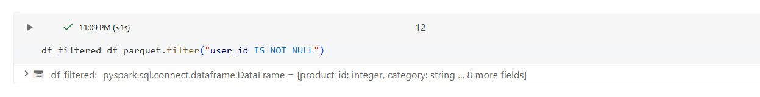
5)write it in csv file
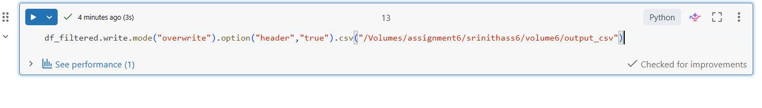
Verifying
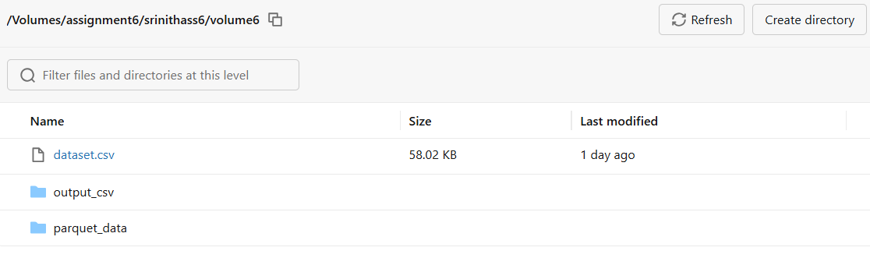
Q13) In Spark Architecture, what is the difference between Client Mode and Cluster Mode?
Ans)
Cluster Mode:The Driver runs on the local machine where application is submitted ,while Executors runs on the cluster.
Client Mode:Both the Driver and Executors run inside the cluster ,making it suitable for production environments because the application continues running even if the client disconnects.
Q14) Write a query to filter a dataset for rows where the region is 'North' OR the priority is 'High'.
Ans)
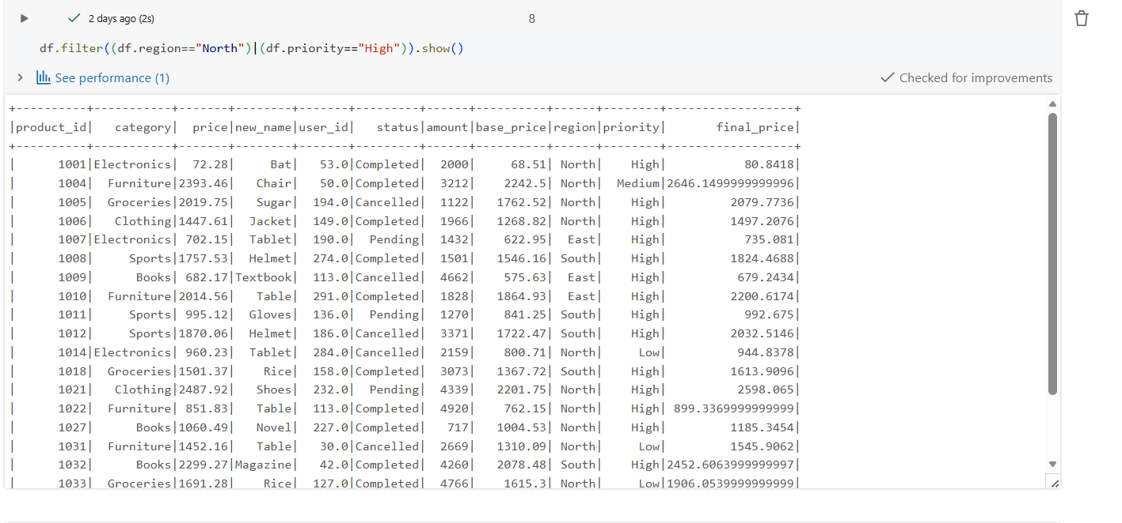
Q15) When exploring a dataset, why is it safer to use .show(5) instead of .collect() on a multi-terabyte dataset?
Ans)
.show(5) displays only the first five rows ,so it uses very little memory and is safe for large datasets.In contrast,.collect() brings the entire dataset to the Drivers memory which can cause memory overflow or crash the application when working with multi-terabyte data.
Shuffle
In Wide Transformations like groupBy() ,join() the data may be located in different partitions .
Spark perform shuffle to bring all rows of the same group together before computation
Ex: 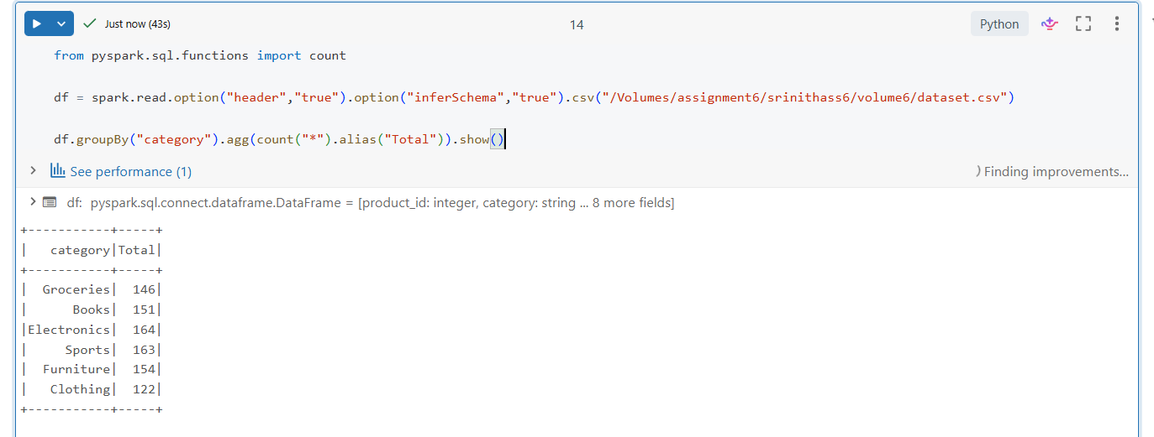
It perform shuffle so that rows of same category come together.

Insights
- Spark uses Lazy Evaluation to delay execution until an action is called.
- The Driver creates the DAG and schedules tasks.
- Executors perform computations on partitions.
- Parquet improves performance because it is columnar and supports Predicate Pushdown and Column Pruning.
- show() is preferred over collect() for large datasets because it retrieves only a few rows.
- Wide transformations such as groupBy() and join() involve shuffle, which is more expensive than narrow transformations.
- SparkSession is the main entry point for working with DataFrames and Spark SQL.

