Project Planning Phase
Project Planning Template (Product Backlog, Sprint Planning, Stories, Story points)

Date | 11 October 2026
Team ID
Project Name | Employee Raise Issue – Record Producer & Service Portal Integration Guide (ServiceNow)
Maximum Marks | 5 Marks

Product Backlog, Sprint Schedule, and Estimation (4 Marks)
Use the below template to create product backlog and sprint schedule
Sprint | Functional Requirement (Epic) | User Story Number | User Story / Task | Story Points | Priority | Team Members
Sprint-1 | Build & Configure | USN-9 | As an administrator, I can create the custom application, table, fields and auto-numbering. | 3 | High | Srinitha Siddenki
Sprint-1 |  | USN-10 | As an administrator, I can make the Number field read-only with a UI policy. | 1 | Medium | Srinitha Siddenki
Sprint-1 | Raise Issue | USN-4 | As an employee, I can fill Requester, Category, Subcategory, State and Short description through the record producer and submit. | 5 | High | Srinitha Siddenki
Sprint-1 |  | USN-5 | As an employee, I see only the subcategories that match my chosen category. | 3 | Medium | Srinitha Siddenki
Sprint-1 | Validation | USN-6 | As an employee, I am required to enter a short description when State is New. | 2 | High | Srinitha Siddenki
Sprint-2 | Build & Configure | USN-11 | As an administrator, I can create the portal, page and widgets and place them in a 6×6 container. | 5 | High | Srinitha Siddenki
Sprint-2 | Access Portal | USN-1 | As an employee, I can open the Requesting portal (/employee_request) and see the logo, banner and widgets. | 3 | High | Srinitha Siddenki
Sprint-2 |  | USN-2 | As an employee, I can read the Commercial widget to learn about the support services offered. | 2 | Low | Srinitha Siddenki
Sprint-2 | Raise Issue | USN-3 | As an employee, I can click the Raise Ticket widget to open the Raise Employee Issue form. | 3 | High | Srinitha Siddenki
Sprint-2 | Handle Issue | USN-7 | As a support agent, I can view new issue records with category, priority and assignment group. | 2 | High | Srinitha Siddenki
Sprint-2 |  | USN-8 | As a support agent, I can update State to In progress, Resolved or Closed. | 2 | Medium | Srinitha Siddenki
Sprint-2 | Testing & Validation | USN-13 | As an administrator, I can test the portal end to end (widgets, record producer, UI policies and dictionary dependency). | 3 | High | Srinitha Siddenki

Project Tracker, Velocity & Burndown Chart: (4 Marks)
Sprint | Total Story Points | Duration | Sprint Start Date | Sprint End Date (Planned) | Story Points Completed (as on Planned End Date) | Sprint Release Date (Actual)
Sprint-1 | 14 | 7 Days | 28 Sep 2026 | 04 Oct 2026
Sprint-2 | 20 | 7 Days | 05 Oct 2026 | 11 Oct 2026
Total | 34 | 14 Days | 28 Sep 2026 | 11 Oct 2026

Velocity:
Imagine we have a 10-day sprint duration, and the velocity of the team is 20 (points per sprint). Let’s calculate the team’s average velocity (AV) per iteration unit (story points per day)

For this project: Sprint-1 = 14 and Sprint-2 = 20 story points, so the total is 34 story points over 2 sprints (28 Sep to 11 Oct 2026).
Velocity = 34 / 2 = 17 story points per sprint.
Sprint duration = 7 days, so Average Velocity (AV) = Velocity / Sprint duration = 17 / 7 = 2.43 story points per day.

Burndown Chart:
A burn down chart is a graphical representation of work left to do versus time. It is often used in agile software development methodologies such as Scrum. However, burn down charts can be applied to any project containing measurable progress over time.
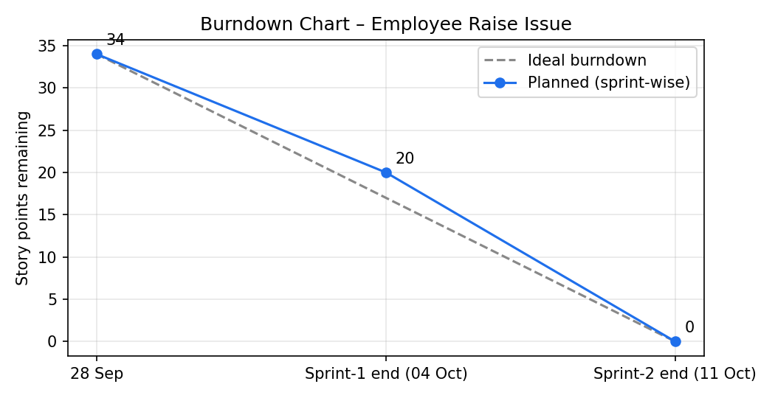
https://www.visual-paradigm.com/scrum/scrum-burndown-chart/
https://www.atlassian.com/agile/tutorials/burndown-charts

Reference:
https://www.atlassian.com/agile/project-management
https://www.atlassian.com/agile/tutorials/how-to-do-scrum-with-jira-software
https://www.atlassian.com/agile/tutorials/epics
https://www.atlassian.com/agile/tutorials/sprints
https://www.atlassian.com/agile/project-management/estimation
https://www.atlassian.com/agile/tutorials/burndown-charts

