DATA VISUALIZATION CASE STUDY
Course Code: 23CSE353
Descriptive Report
Decoding a Decade of Disruption:
Analyzing Startup Funding Trends in India (2015–2025)
Submitted by
SRINITHI K
CB.SC.U4CSE24655
B.Tech Computer Science and Engineering
Amrita Vishwa Vidyapeetham, Coimbatore
Tools used: Matplotlib, Seaborn, Plotly and Power BI
October 2026

1. Introduction
India has one of the largest startup ecosystems in the world, and it has gone through clear boom and slowdown phases since 2015. Raw deal records, however, do not show on their own how funding amounts, deal activity, sectors, cities and investors have changed over time. Data visualization is a practical way to see these changes, as long as the charts are designed honestly.
This case study analyzes Indian startup funding from January 2015 to June 2025 by combining two public Kaggle datasets into a single table of 4,144 funding deals. The analysis uses four visualization tools: Matplotlib, Seaborn, Plotly and Power BI. It includes nine charts in a Jupyter Notebook, a four-page interactive Power BI dashboard, one intentionally misleading chart and its ethically corrected version. The report follows the structure required by the case study: problem definition, data preparation, visualization and dashboard development, ethical analysis, recommendations and conclusion.

2. Problem Statement and Objectives

2.1 Problem Statement
How have funding amount, deal activity, sector mix, city concentration and investor participation in Indian startups changed from 2015 to 2025, and how reliably can these patterns be read from two public datasets that differ in source, labelling and completeness?

2.2 Analytical Objectives
- Examine how total funding and deal count changed year by year (2015–2025).
- Identify how the sector mix shifted over time.
- Find which cities are the main funding hubs and how concentrated funding is.
- Compare deal sizes across investment stages.
- Identify which sectors attracted the most funding in which years.
- Identify the most active investors and the composition of investment types.
- Show how a misleading chart can distort these findings, and redesign it ethically.

3. Dataset Description

3.1 Source and Coverage
Two publicly available datasets from Kaggle were used. They are merged into one dataset, and a Data Source column records which file each deal came from.
Table 1: Datasets used
Dataset | Source (Kaggle) | Coverage | Records
Dataset 1 | Indian Startup Funding by Sudalai Rajkumar | 2015–2020 | 3,044
Dataset 2 | Indian Startup Funding Dataset (2020–2025) by Vagdevi Titiksha G | 2020–2025 (Jan–Jun) | 1,100
Merged | Combined and standardized in the notebook | Jan 2015 – Jun 2025 | 4,144

3.2 Key Attributes and Data Types
Both files describe funding deals in India. After standardization they share eight attributes, plus the Data Source flag.
Table 2: Main attributes
Attribute | Type | Description
Startup | Text | Name of the funded company
Industry, SubVertical | Text | Sector and sub-sector of the startup
City | Text | City where the startup is located
Investors | Text | One or more investors in the deal
InvestmentType | Text | Funding round or instrument (Seed, Series A, Private Equity and so on)
InvestmentAmount_USD | Numeric | Deal amount in US dollars
Date | Datetime | Date of the funding deal
Data Source | Text | Which of the two datasets the deal came from

3.3 Initial Data Quality Assessment
An inspection of both files before cleaning showed the following issues:
- Missing amounts: 960 of 3,044 amounts in Dataset 1 were missing (979 after conversion). In the merged data, 3,165 of 4,144 deals (76%) have a disclosed amount, so about 24% do not.
- Other missing fields: Dataset 1 also lacked Industry (171), SubVertical (936), City (180), Investors (24) and InvestmentType (4) values. Dataset 2 had no missing values.
- Malformed dates: eight dates in Dataset 1 were typed incorrectly (for example 05/072018, 01/07/015 and 22/01//2015) and could not be parsed.
- Indian number format: amounts in Dataset 1 were stored as text with Indian-style commas (for example 20,00,00,000).
- Inconsistent labels: the same city, industry or round was spelled in several ways (Bangalore and Bengaluru, E-Tech and EdTech, SeriesA and Series A).
- Different sources: Dataset 2 appears to be a sample, and its industry and investment-type labels differ from Dataset 1. No duplicate rows were found in either file.

4. Data Preparation and Cleaning
All cleaning steps are documented and reproducible in the Jupyter Notebook. The main decisions were:
Table 3: Cleaning and preprocessing steps
Step | Action and justification
Standardize columns | Renamed the columns of both files to a common set of eight fields and dropped unneeded columns, so that the files could be combined.
Fix dates | Corrected the eight malformed dates and parsed all dates as day-first datetimes. Missing dates after cleaning: 0.
Convert amounts | Removed commas and whitespace and converted amounts to numbers. Undisclosed amounts were kept as missing, not zero, because an unknown amount is not the same as no funding.
Handle missing text | Filled missing text fields with “Not specified” so that records are kept for deal-count analysis.
Merge datasets | Concatenated the two files into 4,144 rows and added a Data Source column for traceability.
Create new fields | Added Year, Month and Amount_M (USD millions), plus City_Clean, Industry_Clean and Stage with standardized labels. For example Bangalore became Bengaluru, and Gurugram, Noida and New Delhi were grouped as Delhi NCR.
Correct an outlier | Rapido’s 2019 Series B was recorded as USD 3.9 billion, which was a rupee figure entered in the USD column. It was corrected to USD 54.9M and documented.
Export | Saved the cleaned data (4,144 rows, 16 columns) as a CSV file for Power BI.

Two rules guided the rest of the work. Charts about money use only the deals with a disclosed amount, while charts about activity use all 4,144 deals. Sector comparisons across the two sources use only industries present in both datasets, because the sources label industries differently.

5. Tool Selection and Visualization Approach

5.1 Tools Used
Table 4: Visualization tools and their roles
Tool | Used for | Why it was chosen
Matplotlib | Funding trend chart, misleading chart and corrected chart | Full control over axes, annotations and scale, which is needed to build and fix the misleading chart.
Seaborn | Sector, city, stage, heatmap and investor charts | Statistical charts (box plot, heatmap) with clean default styling.
Plotly | Interactive scatter plot and treemap | Hover detail makes it possible to explore more than 4,000 deals.
Power BI | Four-page interactive dashboard | Shareable dashboard with slicers, KPI cards and a decomposition tree.

The case study requires three tools, including Power BI or Tableau for the dashboard. This work uses four: Matplotlib and Seaborn for static Python charts, Plotly as the second Python library for interactive charts, and Power BI for the dashboard.

5.2 Visualization Approach
Each objective is matched with a chart type that suits the question. The trend uses a combined line and bar chart, sector mix uses a stacked bar chart, geography uses a bar chart, deal size uses a box plot on a log scale, sector-by-year intensity uses a heatmap, deal-level relationships use a scatter plot, composition uses a treemap and investor activity uses a bar chart. A zero baseline is used for bars. Where a logarithmic scale is needed (box plot, scatter plot and heatmap colours) it is stated on the chart.
Table 5: Visualization plan
No. | Chart | Type | Tool | Objective
1 | Funding vs deal count by year | Line + bar | Matplotlib | 1
2 | Sector funding over time | Stacked bar | Seaborn | 2
3 | Top 10 cities by funding | Horizontal bar | Seaborn | 3
4 | Deal size by stage | Box plot (log) | Seaborn | 4
5 | Industry × year funding | Heatmap (log) | Seaborn | 5
6 | Deal amount vs date by sector | Scatter (log) | Plotly | 5, 4
7 | Investment-type share of deals | Treemap | Plotly | 6
8 | Top 10 most active investors | Horizontal bar | Seaborn | 6
9 | Misleading chart and corrected chart | Bar | Matplotlib | 7

6. Visualizations and Key Findings
This section presents the eight analytical charts from the notebook with their main findings. The misleading chart is covered separately in Section 8.

6.1 Visualization 1: Year-wise Funding Trend (Matplotlib)
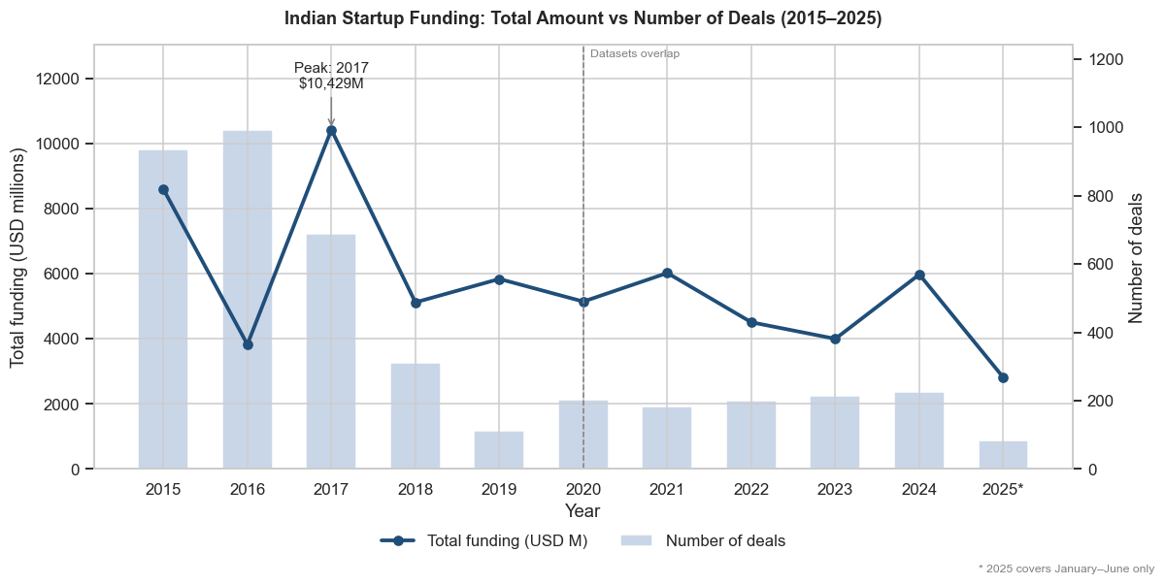
Figure 1: Total funding and number of deals by year (2015–2025)
- Funding is volatile, not steadily growing. It was USD 8,601M in 2015, fell to USD 3,828M in 2016, and reached its overall peak of USD 10,429M in 2017.
- The 2020 dip was mild at about 11.9%. Funding recovered to USD 6,025M in 2021, then fell about 33.6% to USD 4,002M in 2023 before rebounding about 49.4% to USD 5,980M in 2024.
- Deal count and funding do not move together. A small number of very large rounds drive the yearly totals, so deal count alone does not show market health.
- 2025 covers January to June only, and USD 2,813M had been raised by then (about 47% of 2024).

6.2 Visualization 2: Sector-wise Funding over Time (Seaborn)
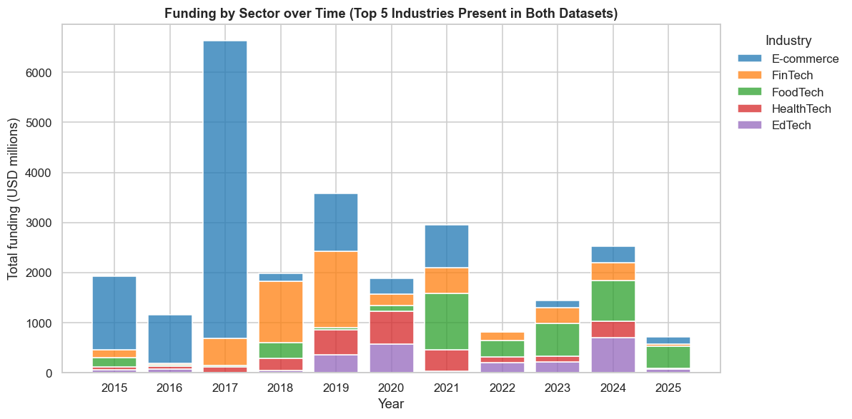
Figure 2: Funding by sector over time (top 5 industries present in both datasets)
- E-commerce is the largest funded sector overall, followed by FinTech, FoodTech, HealthTech and EdTech. These five hold 86% of disclosed funding in the comparable group.
- The leading sector changes: e-commerce leads from 2015 to 2017, FinTech in 2018 and 2019, HealthTech in 2020 and FoodTech every year from 2021 to 2025.
- Between 2015–2017 and 2023–2025, e-commerce lost the most share (−72.3 percentage points) and FoodTech gained the most (+25.3 pp), followed by EdTech (+13.0 pp).

6.3 Visualization 3: City-wise Total Funding (Seaborn)
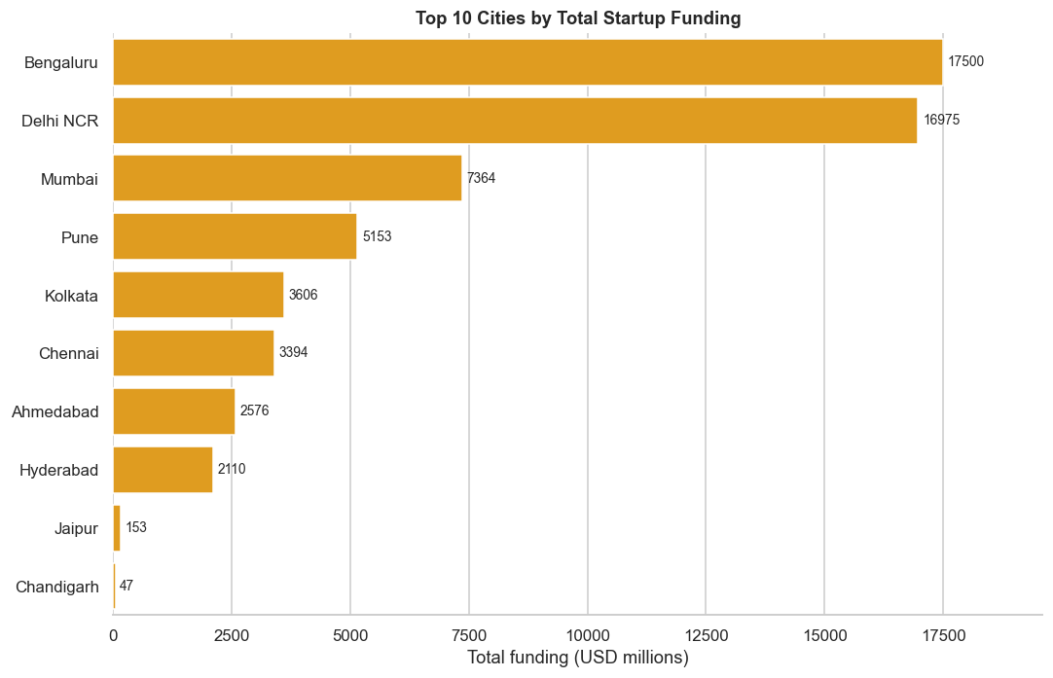
Figure 3: Top 10 cities by total startup funding
- Funding is concentrated. Bengaluru (29.6%), Delhi NCR (28.7%) and Mumbai (12.5%) together hold 70.8% of disclosed funding.
- Pune, Kolkata, Chennai, Ahmedabad and Hyderabad complete the top eight, which hold about 99.3% of funding. The remaining cities are negligible.
- Tier-2 cities rise from 2.0–5.9% of deals in 2015–2019 to about 12% in 2023–2024, but this coincides with the switch to the second dataset, so the evidence is weak.

6.4 Visualization 4: Deal Size by Investment Stage (Seaborn)
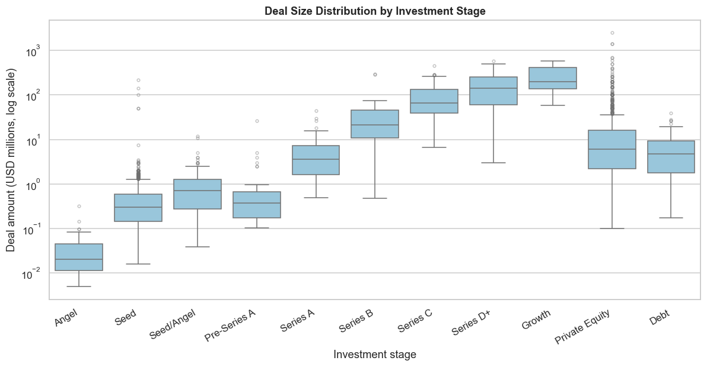
Figure 4: Deal size distribution by investment stage (log scale)
- Median deal size rises sharply across lifecycle stages: USD 0.02M at Angel, 0.30M at Seed, 3.56M at Series A, 21.3M at Series B, 65.9M at Series C, 140.4M at Series D+ and 197.4M at Growth.
- Private Equity does not follow this pattern. It has 1,076 deals but a median of only USD 6.0M, and it contains the largest deal in the data (Flipkart, USD 2,500M in 2017).
- Outliers pull averages up, so the median is a better summary than the mean for deal size.

6.5 Visualization 5: Industry × Year Funding Intensity (Seaborn)
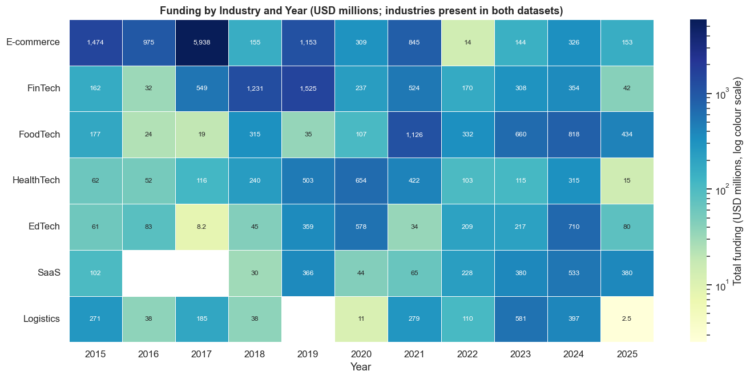
Figure 5: Funding by industry and year (USD millions, log colour scale)
- E-commerce in 2017 (USD 5,938M) is nearly four times the next-largest cell (FinTech in 2019, USD 1,525M). That peak is driven by three deals: two Flipkart rounds and one Paytm round.
- Peak years move from older to newer sectors: e-commerce in 2017, FinTech in 2019, HealthTech in 2020, FoodTech in 2021, Logistics in 2023, and EdTech and SaaS in 2024.
- Blank cells mean no disclosed funding, not zero funding.

6.6 Visualization 6: Deal Amount vs Date by Sector (Plotly)
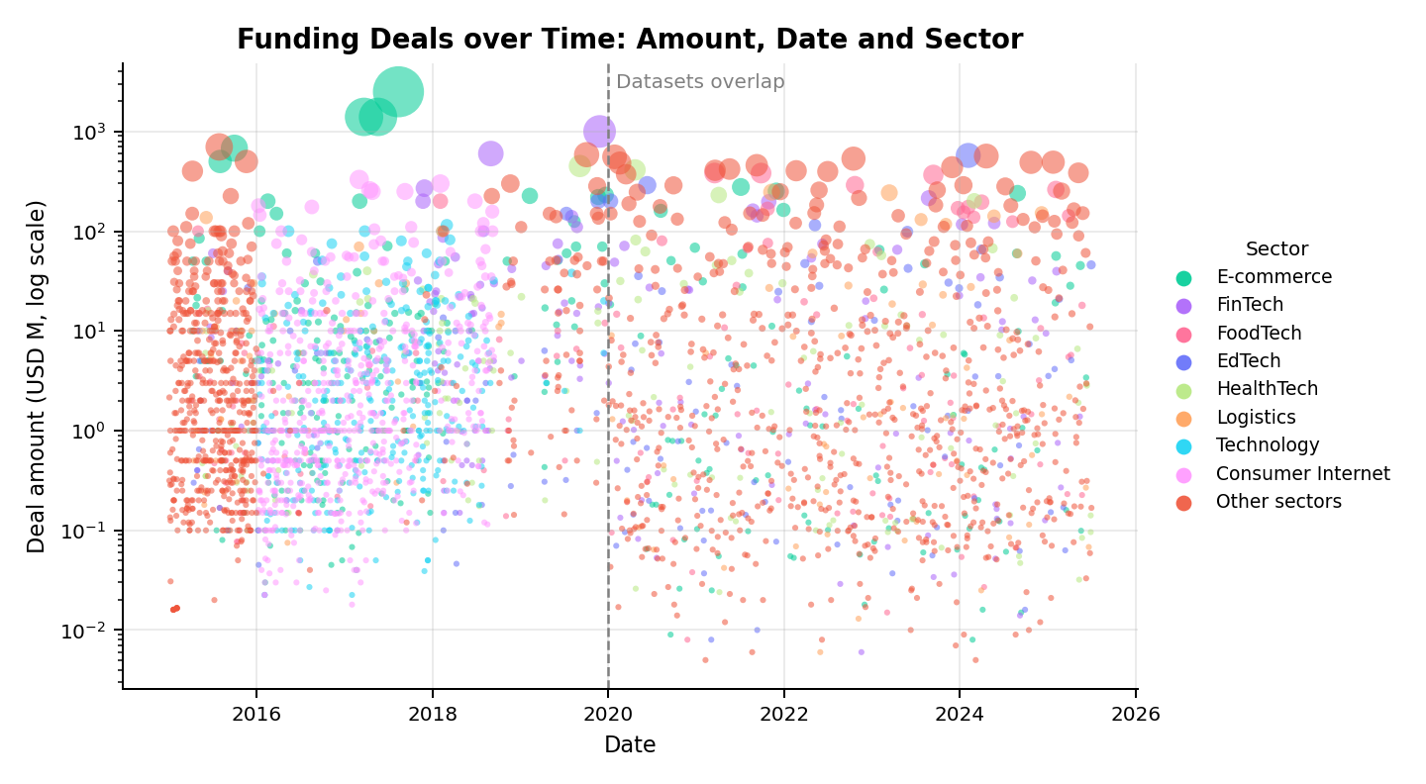
Figure 6: Funding deals over time by amount and sector (interactive in the notebook)
- The typical disclosed deal is small, with a median of about USD 1.0–1.6M in most years. Deals of USD 100M or more are only about 5% of funded deals (155 of 3,165), yet 8 to 21 of them occur every year.
- The median falls about tenfold from USD 12.0M in 2019 to USD 1.13M in 2020, which matches the dataset switch and should be read as a feature of the data, not a market collapse.
- Flipkart and Paytm account for 6 of the ten largest deals.

6.7 Visualization 7: Investment-Type Share of Deals (Plotly)
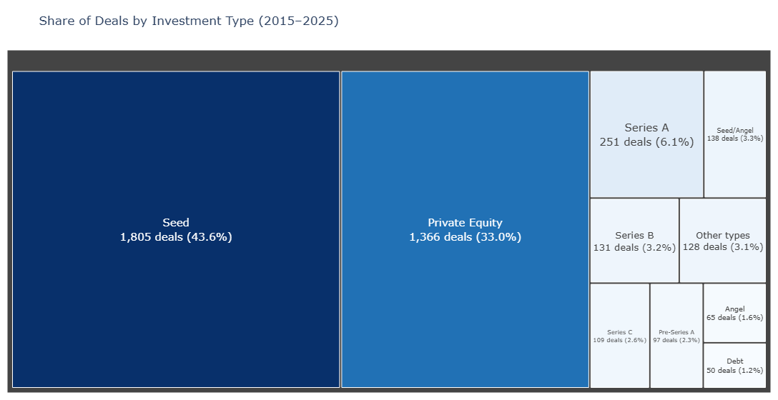
Figure 7: Share of deals by investment type (2015–2025)
- Seed is the largest type with 1,805 of 4,140 deals (43.6%). Seed and Private Equity together make up 76.6% of deals, and about half of all deals are early-stage rounds.
- Deal counts fall sharply at later stages: Series A has 251 deals, Series B 131 and Series C 109.
- The mix is driven by the data source. Private Equity is 44.8% of the 2015–2020 deals but only 0.5% of the 2020–2025 deals, so the combined treemap is a blend of two differently labelled sources.

6.8 Visualization 8: Most Active Investors (Seaborn)
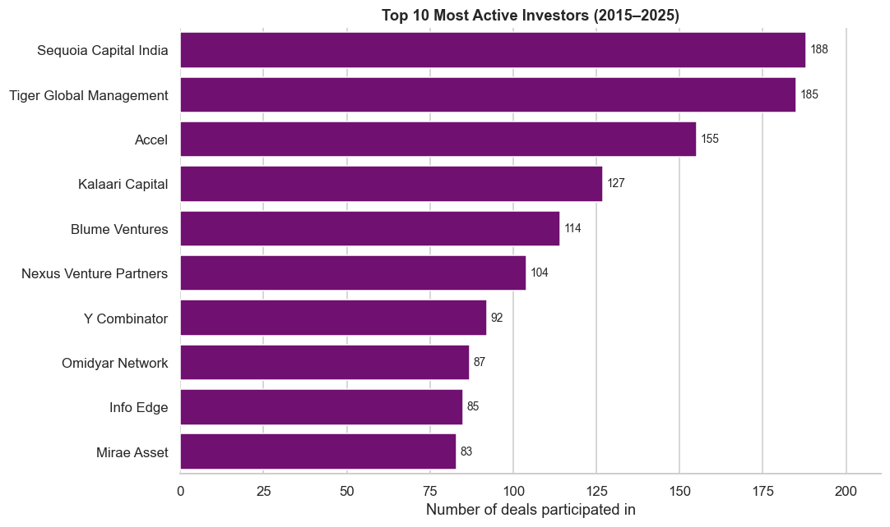
Figure 8: Top 10 most active investors (deals participated in)
- Sequoia Capital India (188 deals) and Tiger Global Management (185) lead almost level, followed by Accel (155), Kalaari Capital (127) and Blume Ventures (114).
- About 68% of the top-10 participations come from the 2020–2025 dataset, which holds only about 27% of all deals. Investors such as Mirae Asset (0 deals in the first dataset, 83 in the second) look active mainly because of the sample data.
- Each deal counts once for every listed investor, so the chart shows participation, not amount invested. The order of the top 10 should be treated as indicative.

7. Interactive Dashboard Design (Power BI)

7.1 Design and Structure
The Power BI dashboard is built on the cleaned CSV exported from the notebook and is submitted as a separate .pbix file. It has four pages. Each page uses the same filter panel so that viewers can explore any year, sector or city, and each objective is supported by at least one visual.
Table 6: Dashboard pages
Page | Content
1. Overview | KPI cards (Total Funding, Deal Count, Disclosed Deals, Avg Deal Size, Disclosed %), funding vs deal count trend, top eight cities, sector funding by year and a Key Insights box.
2. Deal Size and Sectors | Box plot of deal size by stage and the industry × year heatmap.
3. Deals and Investors | Scatter plot of deals, top active investors and the investment-type treemap.
4. Explore Breakdown | Decomposition tree for drilling down by industry, city, stage and year.

Slicers: Data Source, Year, Industry, City and Stage. They filter every visual on the page, and the Data Source slicer lets a viewer separate the two datasets to see how much a pattern depends on the source.
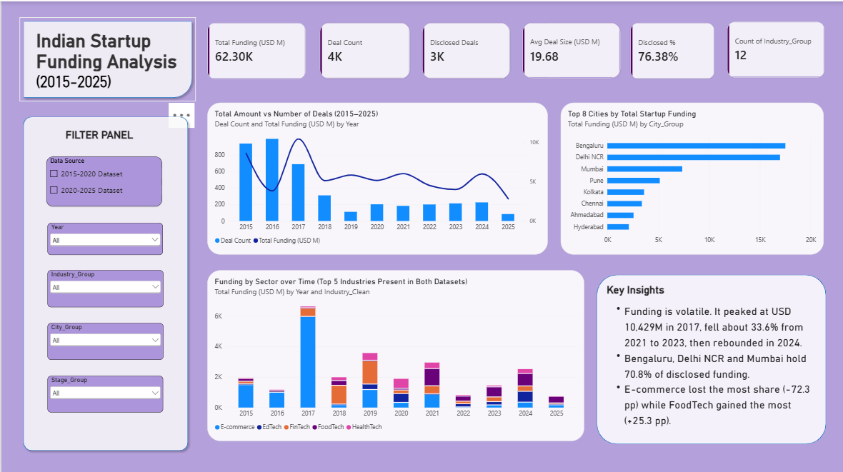
Figure 9: Dashboard page 1 – Overview
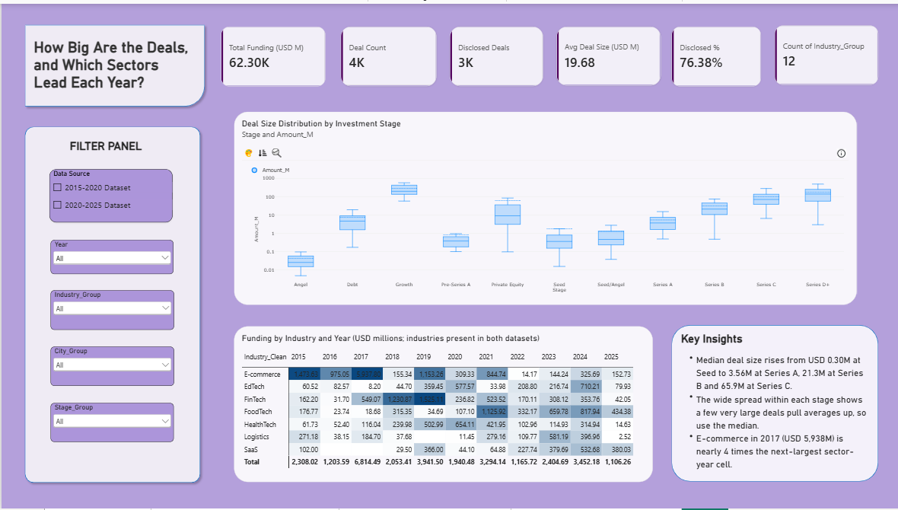
Figure 10: Dashboard page 2 – Deal Size and Sectors
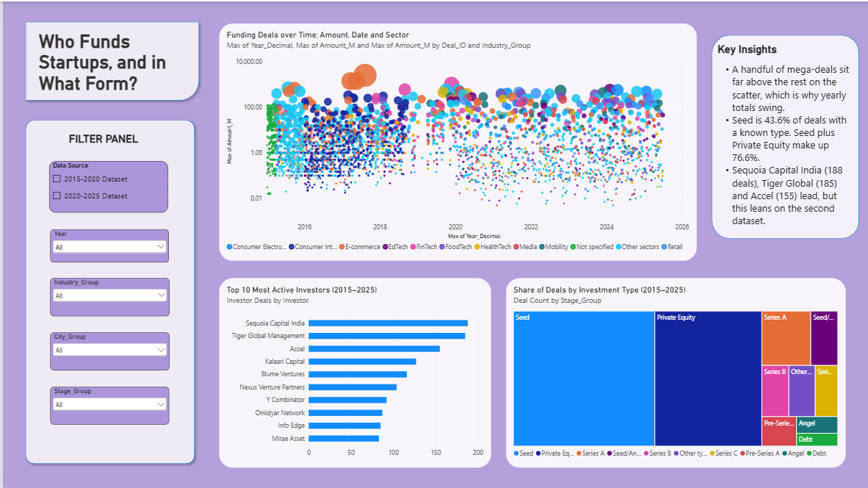
Figure 11: Dashboard page 3 – Deals and Investors
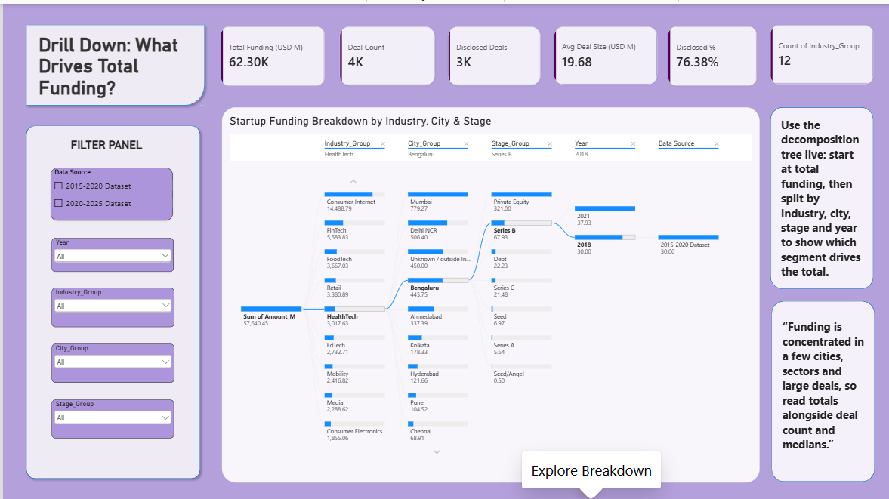
Figure 12: Dashboard page 4 – Explore Breakdown

7.2 Storytelling
The dashboard follows a what, so what, now what structure. What: funding is volatile, with a USD 10.4B peak in 2017, a fall of about 33.6% from 2021 to 2023 and a rebound in 2024, and sector leadership moved from e-commerce to newer sectors such as FoodTech. So what: yearly totals swing because of a few mega-deals and a change of data source, so they should be read together with deal count and medians. Now what: track median deal size and deal count alongside totals, and look beyond the three leading cities.
As an example of interaction, setting the Year slicer to 2017 and then to 2023 on the Overview page shows the sector mix change from e-commerce-dominated to a spread across newer sectors. The Industry slicer then shows one sector’s cities and stages.

8. Misleading Visualization
To show how a chart can mislead without using false numbers, one chart was built deliberately to distort. It uses the real funding totals for 2021 to 2024 from Figure 1. It is labelled in the notebook as an intentionally misleading example.
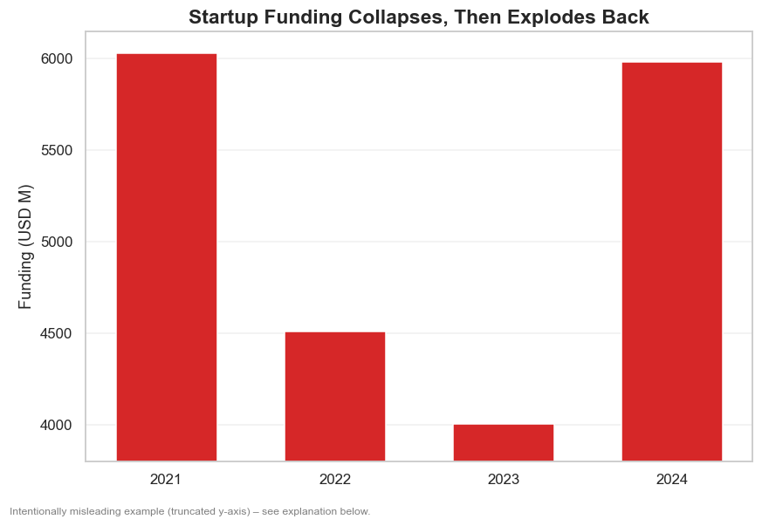
Figure 13: Intentionally misleading chart (truncated y-axis)

8.1 Techniques Used
- Truncated y-axis: the axis starts at USD 3,800M instead of zero, so bar heights no longer match funding amounts.
- Sensational title: “Startup Funding Collapses, Then Explodes Back” claims more than the data supports.
- No value labels: viewers cannot check the real amounts.
- Alarming colour: red suggests a crisis.
- Selected years: showing only 2021–2024 hides that 2017 funding (about USD 10.4B) was higher than any year in this window.

8.2 How the Chart Misleads
Bars are read by length, so a bar twice as tall is assumed to show twice the value. With the axis cut at USD 3,800M, the 2023 bar looks only about 9% as tall as the 2021 bar, although 2023 funding is really about 66% of 2021 funding. The 2024 bar looks roughly 11 times taller than 2023, although funding rose by only about 49%. The distortion can be measured with the lie factor, which is the effect shown in the graphic divided by the effect in the data.
Table 7: Distortion in the misleading chart
Period | Actual change | Change shown by bars | Lie factor
2021 → 2023 | −33.6% | −90.9% | 2.7
2023 → 2024 | +49.4% | +979.2% | 19.8

9. Ethical Redesign
The same four numbers were redrawn using ethical visualization principles.
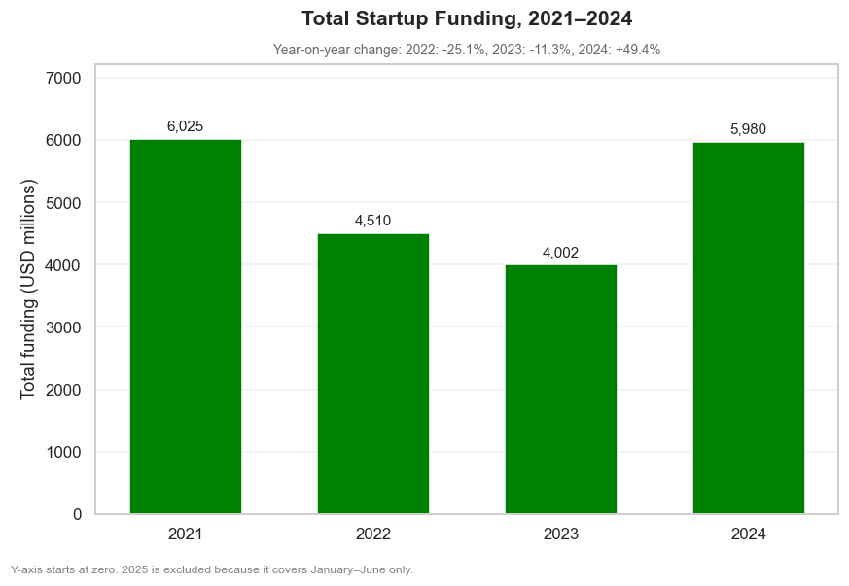
Figure 14: Corrected chart with a zero baseline and labelled values
- Zero baseline: bar lengths are proportional to funding.
- Neutral title: “Total Startup Funding, 2021–2024” describes what is shown without interpreting it.
- Value labels: every bar shows its exact amount.
- Changes stated as numbers: year-on-year change is given in percent (−25.1% in 2022, −11.3% in 2023, +49.4% in 2024), so viewers do not have to judge it by eye.
- Disclosure: a footnote explains the axis and why 2025 is excluded, since it covers only January to June.
With these changes the visual change matches the real change, so the lie factor is 1. The data now tells a more modest story: a slowdown after 2021, a low in 2023 and a rebound in 2024 that is still slightly below the 2021 level. Figure 1 shows the full 2015–2025 context.

9.1 Ethical Principles Followed Throughout
- Bar charts start at zero, and logarithmic scales are stated on the chart.
- Undisclosed amounts are never treated as zero.
- Data limitations are disclosed: the 2020 source boundary is marked and sector comparisons use only industries present in both datasets.
- Errors are corrected and documented (the Rapido currency error) instead of being left in or silently removed.
- Partial periods are labelled (2025 is January to June only).

10. Limitations
- About 24% of deals have no disclosed amount, so funding totals are lower bounds.
- The second dataset appears to be a sample with different labels, and some of its company names, sectors and cities do not match real companies. Comparisons across 2020 are therefore indicative, not exact. The direction of a change is more reliable than its exact size.
- The mix of investment types, the ranking of mid-sized cities and the investor ranking are partly artifacts of the data source.
- The same company can be classified differently across rows (for example Flipkart as E-commerce and Online Marketplace). Other currency errors may remain beyond the one that was corrected.
- Peak XV, the rebranded name of Sequoia Capital India, may be counted separately in the investor chart, which could understate Sequoia’s total.

11. Recommendations

11.1 For Investors and Analysts
- Judge funding trends using both total amount and deal count, because large single rounds can distort yearly totals.
- Use the median deal size by stage, not the average, because a few very large deals pull averages up.
- Look beyond the three leading cities. Tier-2 cities show a higher share of deals after 2020, though the evidence is weak.

11.2 For Founders and Policymakers
- Funding has shifted from e-commerce towards FoodTech, EdTech and HealthTech, so these are the more active sectors to watch.
- Funding concentration in a few cities suggests room for programmes that support startups elsewhere.

11.3 For Data Communication and Future Work
- Always start bar charts at zero, label axes and state partial periods such as 2025.
- Repeat the analysis with a complete, consistently labelled dataset for 2020–2025 to confirm the sector, city and investor patterns.
- Extend the work with funding-per-deal growth rates or a forecast, once data quality allows.

12. Conclusion
This case study combined two public datasets to examine Indian startup funding from 2015 to 2025 using Matplotlib, Seaborn, Plotly and Power BI. Funding is volatile rather than steadily growing, peaking at USD 10,429M in 2017, falling about 33.6% between 2021 and 2023 and rebounding in 2024. The sector mix shifted away from e-commerce towards FoodTech and other newer sectors. Funding is concentrated geographically, with Bengaluru, Delhi NCR and Mumbai holding 70.8%. Deal size rises sharply with funding stage, and a small group of investors, led by Sequoia Capital India, Tiger Global Management and Accel, takes part in the most deals.
The study also showed that chart design changes the story. A truncated axis made a 49% rise look about eleven times taller than the previous bar, and the redesigned chart removed that distortion. Because about 24% of amounts are undisclosed and the second dataset appears to be a sample, the findings are best read as indicative patterns rather than exact measurements.

13. References and Submitted Files
- Rajkumar, S. Indian Startup Funding. Kaggle dataset, 2015–2020.
- Titiksha G, V. Indian Startup Funding Dataset (2020–2025). Kaggle dataset.
- Documentation for Matplotlib, Seaborn, Plotly (Python) and Microsoft Power BI.
Submitted files: startup_funding_analysis.ipynb (Jupyter Notebook), startup_funding_cleaned.csv (cleaned dataset), dashboard.pbix (Power BI dashboard), the presentation slides, and this report.

