WHATNEXT VISION MOTORS
Shaping the Future of Mobility with Innovation and Excellence
A Salesforce CRM-Based Vehicle Order and Dealership Management System

Submitted By :
APARNA U AJAY - 822723104003
PAVITHRAN M - 822723104029
ROOPA SHREE S - 822723104037
MOONISHA S - 822723104302
SRINITHI C - 822723104305

TABLE OF CONTENTS
1. Introduction
2. Ideation Phase
3. Requirement Analysis
4. Project Design
5. Project Planning and Scheduling
6. Project Development
7. Salesforce Data Model and Configuration
8. Automation and Workflow Design
9. Apex and Programmatic Processing
10. Batch and Scheduled Processing
11. Functional and Performance Testing
12. Reports and Dashboards
13. Conclusion

1. Introduction

1.1 Project Overview
WhatNext Vision Motors is a Salesforce CRM-based Vehicle Order and Dealership Management System designed to bring the entire vehicle sales cycle onto one cloud platform. Automobile businesses typically manage vehicle stock, dealer networks, customer enquiries and orders through spreadsheets, phone calls and disconnected tools. This leads to duplicate entries, delayed order confirmation, inaccurate stock figures and poor visibility for management.
This project solves these problems by building a custom Lightning application on the Salesforce Platform. The application stores vehicles, dealers, customers and orders as connected records, automates routine decisions with Flow, enforces business rules with Apex, and gives managers live reports and dashboards.

1.2 Purpose of the Project
The purpose of the project is to give WhatNext Vision Motors a single, reliable system through which dealers can place vehicle orders, the company can track stock in real time, and customers can receive faster, more accurate service.

1.3 Objectives
- Create a centralized data model for vehicles, dealers, customers and orders.
- Automate order handling so that status updates and notifications happen without manual effort.
- Prevent invalid transactions, such as ordering a vehicle that is out of stock, using Apex trigger logic.
- Process pending orders in bulk through a scheduled Apex batch job.
- Offer management-level insight through reports and dashboards.
- Document the implementation for easy maintenance and handover.

1.4 Scope
The scope covers the Salesforce Developer Edition environment only. It includes custom objects, fields, relationships, tabs, a Lightning app, a screen flow, a record-triggered flow, an Apex trigger with its handler class, a batch class, a scheduler class, test classes, reports and dashboards.

1.5 Business Value
Benefit | Description
Faster order cycle | Orders are validated and confirmed automatically instead of waiting for manual review.
Accurate stock | Vehicle stock is reduced the moment an order is confirmed, so figures are always current.
Better dealer service | Dealers can see their orders and vehicle availability from a single app.
Management visibility | Dashboards show sales, order status and stock levels without compiling spreadsheets.

1.6 Why Salesforce
Salesforce is a cloud-based CRM platform that combines a database, a user interface framework, automation tools and a programming language in one environment. Because the platform is hosted, there is no server to install or maintain, and every customization is available instantly in the browser. Features such as custom objects, Lightning App Builder, Flow, Apex and Reports allow a complete business application to be assembled quickly and securely.

1.7 Organization of this Document
The report follows the phases of the project. Sections 2 to 5 cover ideation, requirements, design and planning. Section 6 describes the hands-on build of the objects, tabs and Lightning app. Sections 7 to 10 explain the data model, flows, Apex code and batch processing. Sections 11 and 12 present testing, reports and dashboards, and Section 13 concludes the work. Screenshot placeholders are provided throughout so that the actual output of each task can be inserted.

2. Ideation Phase

2.1 Problem Statement
Vehicle manufacturers and distributors handle large volumes of orders from many dealers. When stock, dealer and customer data are scattered across files, staff spend more time searching and correcting data than serving customers. Orders may be accepted for vehicles that are no longer available, dealers do not know the status of their requests, and management cannot see sales performance until reports are compiled by hand.
Aspect | Statement
Who is affected | Dealers, sales executives, inventory managers and customers.
The problem | No unified system to place, validate and track vehicle orders against live stock.
Impact | Delays, overselling, data errors and limited reporting.
Desired outcome | One Salesforce app with automated order processing and live dashboards.

2.2 Empathy Map
The empathy map below summarizes what the main user, a dealership sales executive, thinks, feels, says and does while working with the current process.
Dimension | Observation
Thinks | "I am not sure whether this vehicle is still in stock before I promise a delivery date."
Feels | Frustrated by repeated follow-up calls and anxious about losing customers to faster competitors.
Says | "Please confirm the status of my order." "Which model variants are available?"
Does | Maintains personal spreadsheets, calls the head office, and re-enters the same customer details several times.
Pains | Delays, duplicate data, no real-time status, no single source of truth.
Gains | Instant stock visibility, automatic confirmation, and clear order history.

2.3 Brainstorming and Idea Prioritization
Several ideas were considered during the brainstorming session. Each was scored on business impact and ease of implementation using the Salesforce Developer Edition.
Idea | Impact | Effort | Decision
Custom objects for Vehicle, Dealer, Customer and Order | High | Low | Selected
Record-triggered flow for order notifications | High | Low | Selected
Apex trigger to validate stock | High | Medium | Selected
Scheduled batch job for pending orders | Medium | Medium | Selected
Reports and dashboards for management | High | Low | Selected
Customer self-service portal | Medium | High | Future scope
ERP and payment integration | Medium | High | Future scope

2.3.1 Proposed Solution
The proposed solution is a Salesforce Lightning application named Vision Motors that contains five connected custom objects. Declarative tools handle routine automation, while Apex handles rules that need code. A scheduled batch job keeps order status current without human intervention, and dashboards summarize performance for managers.

3. Requirement Analysis

3.1 Customer Journey
The customer journey describes how a buyer and a dealer interact with the system from the first enquiry to the delivery of the vehicle.
- A customer enquires about a vehicle at a dealership.
- The sales executive creates or finds the Customer record in Salesforce.
- The executive checks vehicle availability and price from the Vehicle tab.
- A Vehicle Order is created, linking the customer, vehicle and dealer.
- The system validates stock and confirms the order through automation.
- The customer receives a confirmation and the order moves toward delivery.
- Management reviews the order and sales figures on the dashboard.

3.2 Functional Requirements
ID | Requirement | Description
FR-1 | Account setup | Create and verify a Salesforce Developer Edition organization.
FR-2 | Vehicle management | Store vehicle name, model, price, status, stock quantity and dealer.
FR-3 | Dealer management | Store dealer name, location, contact number, email and status.
FR-4 | Customer management | Store customer name, phone, email, city and preferred vehicle.
FR-5 | Order management | Record orders with customer, vehicle, quantity, date and status.
FR-6 | Navigation | Provide object tabs and a Lightning app for easy access.
FR-7 | Automation | Use screen and record-triggered flows for order handling.
FR-8 | Business rules | Block orders for vehicles without stock using an Apex trigger.
FR-9 | Batch processing | Run a scheduled batch job that confirms pending orders.
FR-10 | Reporting | Provide reports and a dashboard on orders, sales and stock.

3.3 Non-Functional Requirements
Category | Requirement
Usability | Clean Lightning interface with consistent tab names and page layouts.
Performance | Records save within a few seconds; bulk operations handled in batches of 200.
Security | Access controlled by profiles, permission sets and field-level security.
Reliability | Apex code covered by tests with at least 75 percent coverage for deployment.
Scalability | Data model designed so new objects and fields can be added easily.
Maintainability | Logic separated into handler classes; naming conventions followed throughout.

3.4 Data Flow
Users enter data through the Lightning app. Records are saved to the custom objects, where the record-triggered flow and Apex trigger run automatically. The batch job reads pending orders on a schedule, updates their status, and the results are summarized by reports and dashboards.

3.5 Technology Stack
Component | Technology
Platform | Salesforce Platform (Developer Edition)
User Interface | Lightning Experience, Lightning App Builder
Declarative automation | Salesforce Flow Builder (Screen Flow and Record-Triggered Flow)
Programming | Apex classes, triggers, Batch Apex, Schedulable Apex
Development tool | Developer Console
Analytics | Salesforce Reports and Dashboards

4. Project Design

4.1 Solution Architecture
The solution follows the standard multi-layer architecture of the Salesforce Platform. The presentation layer is the Lightning application. The business logic layer is made up of flows, validation logic and Apex code. The data layer consists of custom objects connected through lookup relationships.
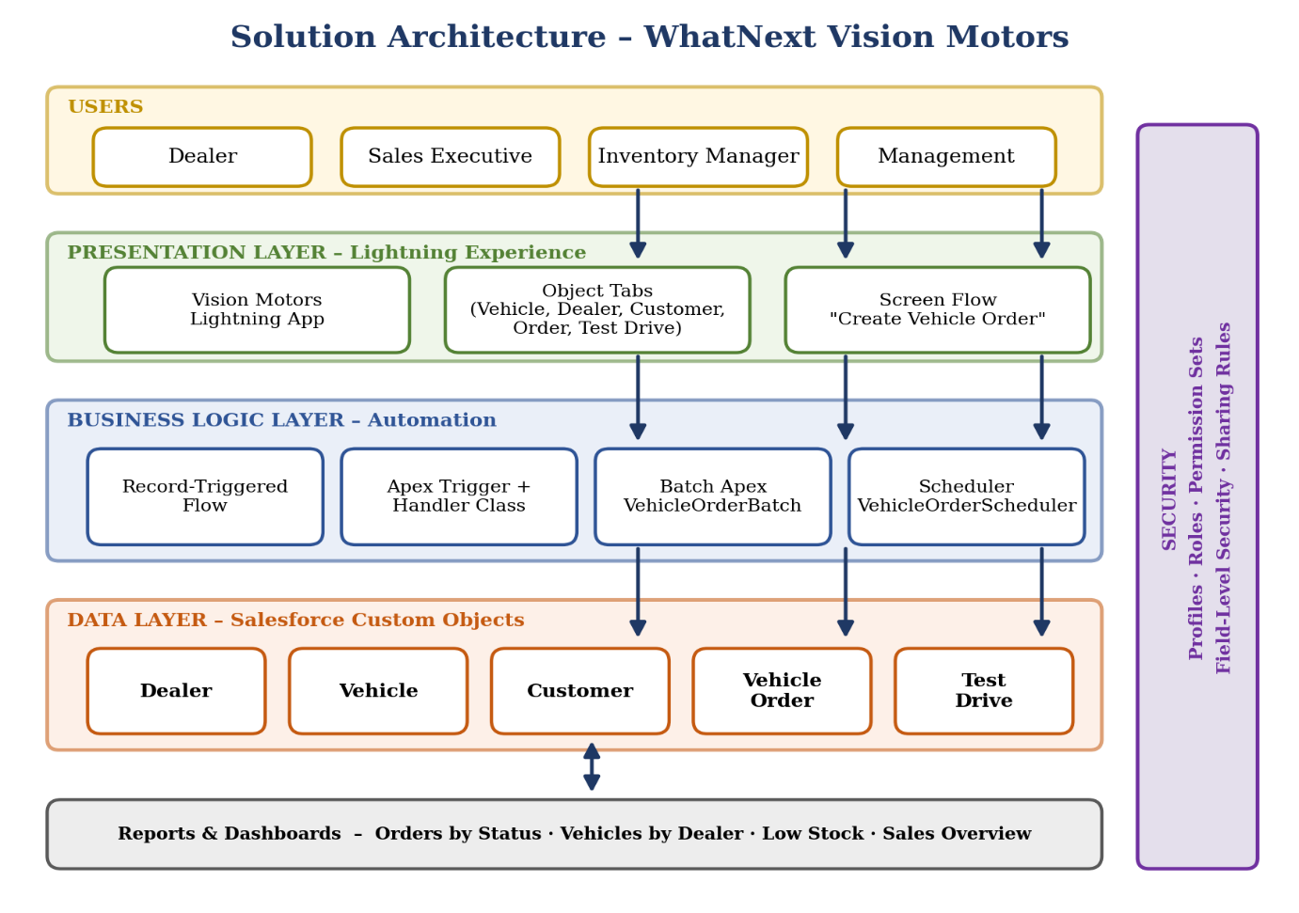
Solution architecture of WhatNext Vision Motors

4.2 Data Model
The data model contains five custom objects. A Dealer supplies many Vehicles. A Customer can place many Orders. Each Vehicle Order points to exactly one Customer and one Vehicle. Test drives are tracked in a separate object that links a Customer to a Vehicle.
Parent object | Child object | Relationship
Dealer | Vehicle | One dealer supplies many vehicles (Lookup on Vehicle).
Customer | Vehicle Order | One customer places many orders (Lookup on Order).
Vehicle | Vehicle Order | One vehicle appears on many orders (Lookup on Order).
Customer | Test Drive | One customer books many test drives (Lookup on Test Drive).
Vehicle | Test Drive | One vehicle is used for many test drives (Lookup on Test Drive).

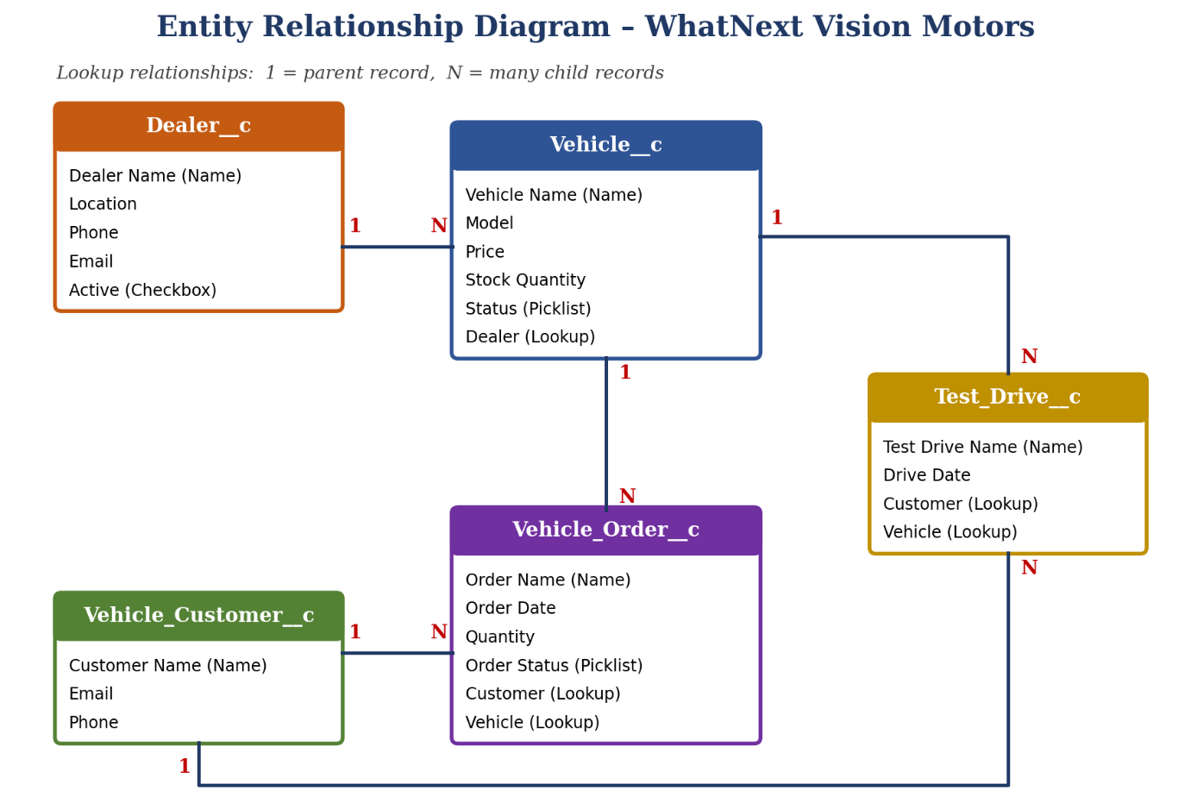Entity relationship diagram of the data model

4.3 Design Decisions
- Lookup relationships were chosen instead of master-detail so that orders and vehicles can be managed independently.
- Picklist fields for status values keep data consistent and make reporting reliable.
- Separate handler class keeps the trigger small and the logic testable.

5. Project Planning and Scheduling

5.1 Project Phases
The project was divided into short phases so that each deliverable could be built, tested and documented before the next one began.
Phase | Activity | Deliverable | Status
Phase 1 | Requirement analysis, account creation and verification | Developer org, requirement list | Completed
Phase 2 | Backend development: objects, fields, relationships | Data model | Completed
Phase 3 | UI customization: tabs and Lightning app | Vision Motors app | Completed
Phase 4 | Automation and Apex: flows, trigger, batch job | Automations and code | Completed
Phase 5 | Testing, reports, dashboards, documentation | Final report | Completed

5.2 Sprint Plan
Sprint | Goal | Key tasks | Duration
Sprint 1 | Platform setup and data model | Developer account, verification, Vehicle, Dealer and other objects | Week 1
Sprint 2 | Navigation and fields | Object tabs, Lightning app, fields, relationship fields | Week 2
Sprint 3 | Automation | Screen flow, record-triggered flow | Week 3
Sprint 4 | Programmatic processing | Apex trigger, handler, batch class, scheduler | Week 4
Sprint 5 | Quality and reporting | Testing, reports, dashboard, documentation | Week 5

5.3 Risks and Mitigation
Risk | Mitigation
Governor limits exceeded in Apex | Bulkified code, no queries or DML inside loops, batch size of 200.
Insufficient test coverage | Write test classes alongside each Apex class and run all tests before submission.

6. Project Development
This section records the hands-on build of the application, task by task. Every task includes the steps followed and a place for the corresponding screenshot.

6.1 Developer Account Creation
A Salesforce Developer Edition organization is a free, full-featured environment intended for learning and building applications. All development in this project was carried out in such an organization.
- Open the Salesforce Developer Edition sign-up page in a web browser.
- Fill in the first name, last name, work email, role, company, country and postal code.
- Enter a unique username in email format (it need not be a real email address).
- Accept the Master Subscription Agreement and click Sign me up.
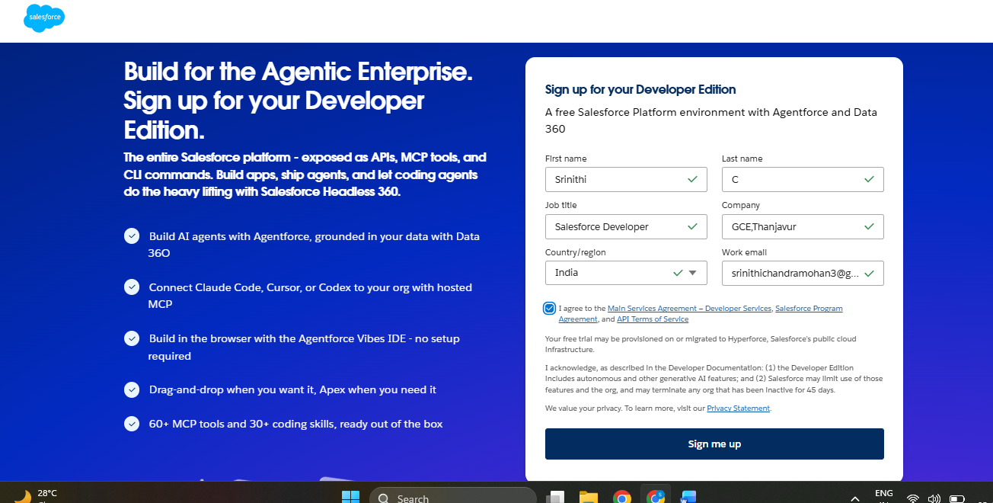
Salesforce Developer Edition sign-up form

6.2 Account Verification
After sign-up, Salesforce sends a verification email to the registered address. The account is activated only after the link is opened and a password is set.
- Open the verification email and click Verify Account.
- Choose a strong password and a security question, then save.
- Log in and confirm the Setup menu and App Launcher are available.
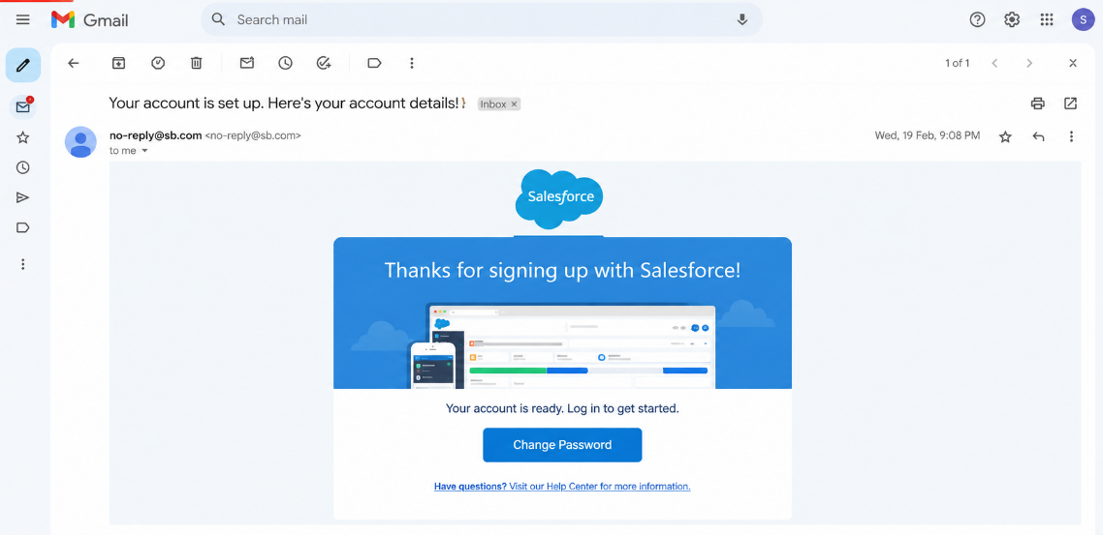
Account verification email and password setup
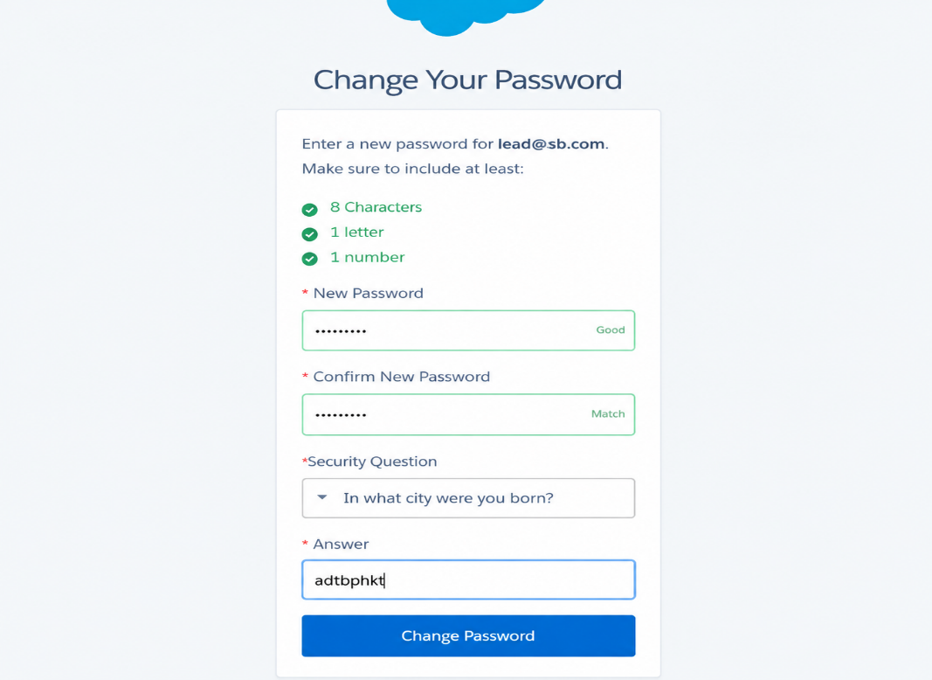
Home page of the new Developer organization

6.3 Object Creation: Vehicle
Objects are database tables in Salesforce. The Vehicle object stores each model that the company sells.
- Go to Setup, then Object Manager, and click Create followed by Custom Object.
- Enter the label Vehicle and the plural label Vehicles; the API name becomes Vehicle__c.
- Set the record name to Vehicle Name with data type Text.
- Select Allow Reports, Allow Search and Track Field History, then save.
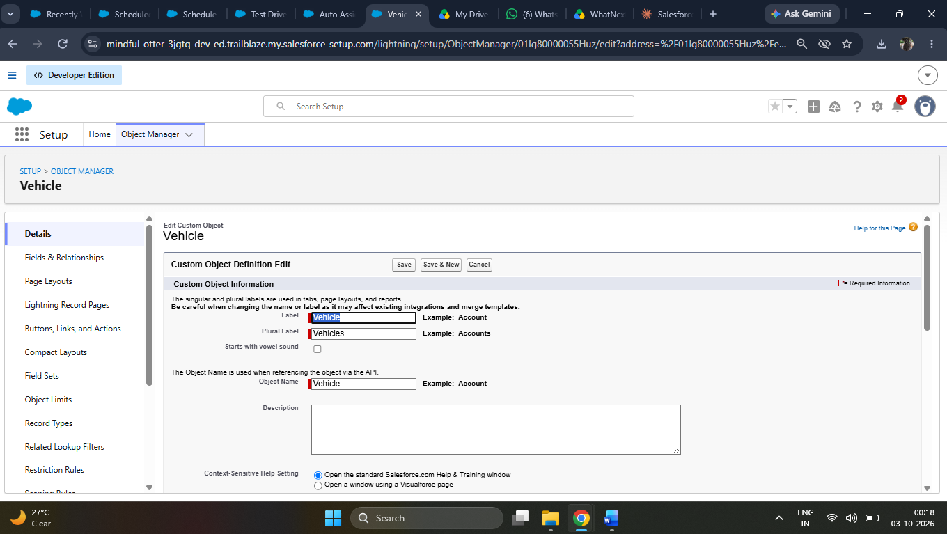
Creating the Vehicle custom object

6.4 Create Dealer Object
The Dealer object stores the dealerships that supply vehicles and place orders. It was created in the same way as the Vehicle object, using the label Dealer and the record name Dealer Name.
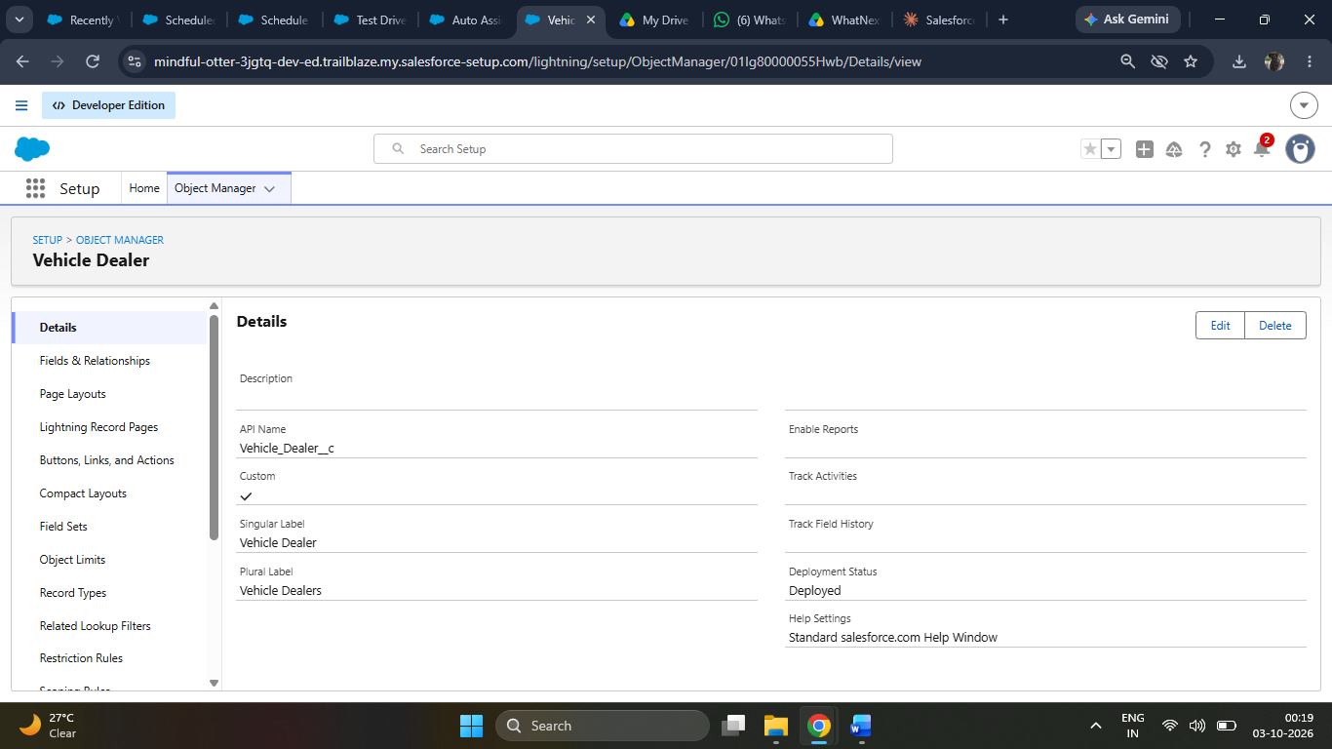
Creating the Dealer custom object

6.5 More Object Creation
The remaining objects required by the data model were created using the same procedure.
Object | API Name | Purpose
Customer | Vehicle_Customer__c | Stores buyer details.
Vehicle Order | Vehicle_Order__c | Stores each order placed for a vehicle.
Test Drive | Test_Drive__c | Tracks test drive bookings.

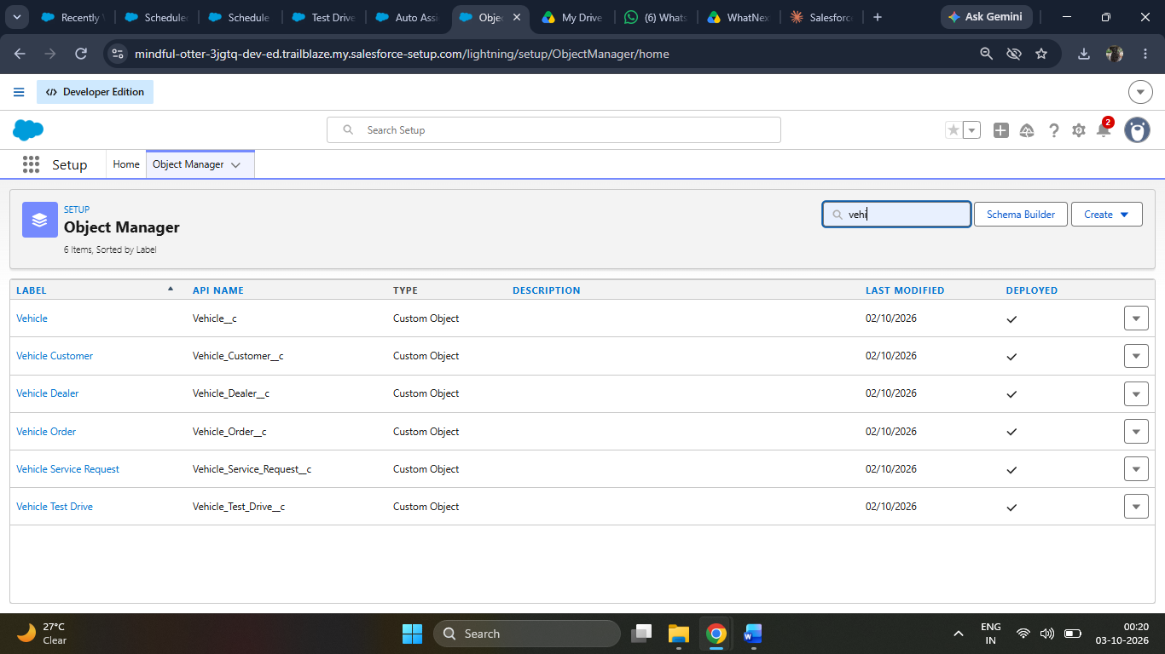
Object Manager listing all custom objects

6.6 Object Tab Creation
A tab lets users open the list of records for an object directly from the navigation bar.
- Go to Setup, search for Tabs, and open the Custom Object Tabs section.
- Click New and select the Vehicle object.
- Choose a tab style (for example, a car icon), accept the default visibility and save.
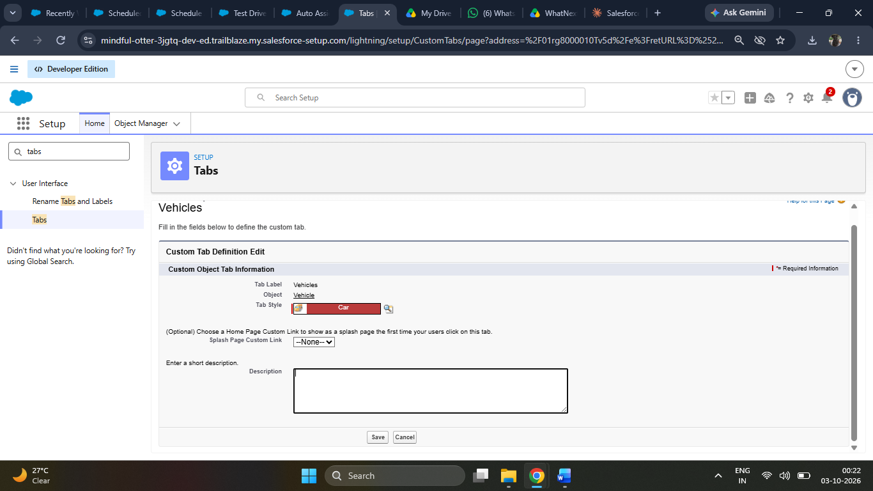
Creating the Vehicle object tab

6.7 More Tabs Creation
Tabs were created for Dealer, Customer, Vehicle Order and Test Drive using the same steps, so that every object is reachable from the app navigation.
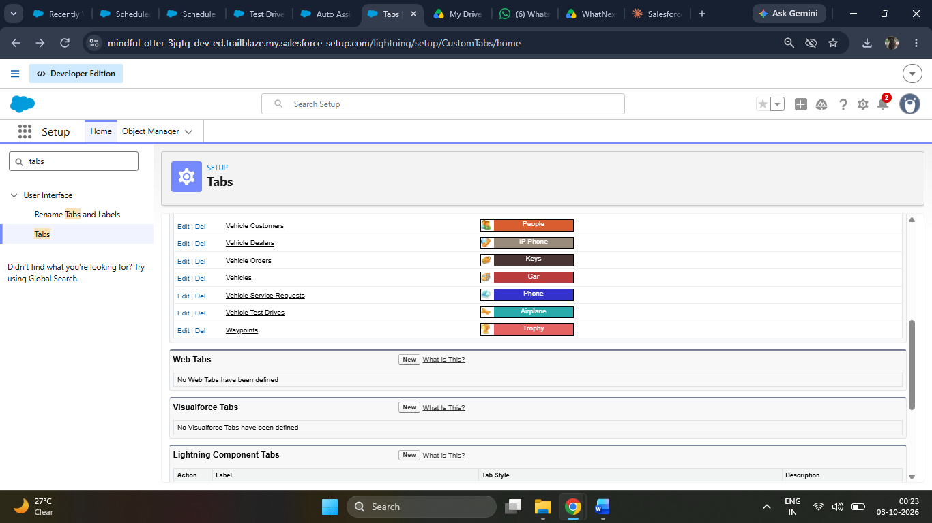
Custom Object Tabs list

6.8 Create Lightning App
A Lightning app groups related tabs into a single workspace with its own name, logo and colour theme.
- Go to Setup, open App Manager and click New Lightning App.
- Enter the app name Vision Motors and add a description and logo.
- Choose Standard navigation and add the Vehicle, Dealer, Customer, Vehicle Order and Test Drive tabs, along with Reports and Dashboards.
- Select the user profiles that can access the app, then save.
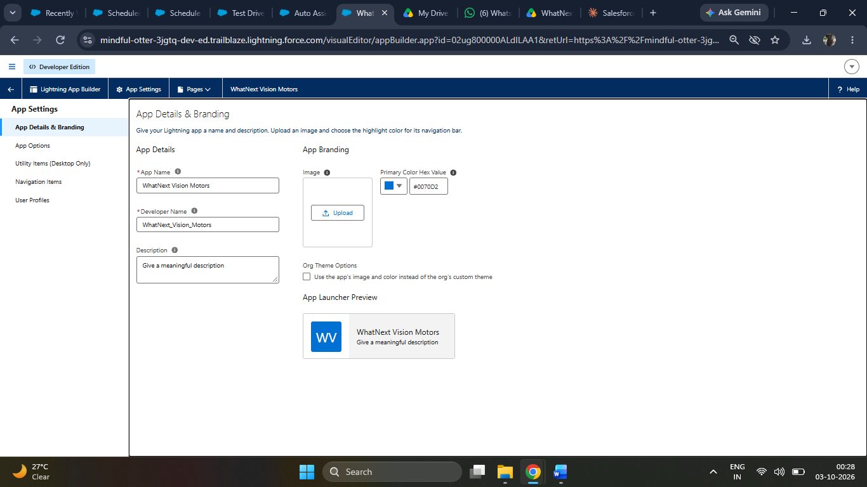
App details of the Vision Motors Lightning app

7. Salesforce Data Model and Configuration

7.1 Object Field Creation
Fields hold the individual pieces of information on a record. For each object, fields were added from Object Manager under Fields and Relationships, then New, and the field-level security and page layout were set at the end of the wizard.

Vehicle Fields
Field Label | Data Type | Details
Vehicle Name | Text | Standard name field.
Model | Text | Model or variant name.
Price | Currency | Ex-showroom price.
Stock Quantity | Number | Units currently available.
Status | Picklist | Available, Low Stock, Sold Out.

Dealer Fields
Field Label | Data Type | Details
Dealer Name | Text | Standard name field.
Location | Text | City and state.
Phone | Phone | Primary contact number.
Email | Email | Dealer contact email.
Active | Checkbox | Indicates whether the dealer is operating.

Customer and Order Fields
Field Label | Data Type | Details
Customer Name | Text | Standard name field of Customer.
Customer Email / Phone | Email / Phone | Contact details.
Order Date | Date | Date the order was placed.
Quantity | Number | Number of vehicles ordered.
Order Status | Picklist | Pending, Confirmed, Delivered, Cancelled.

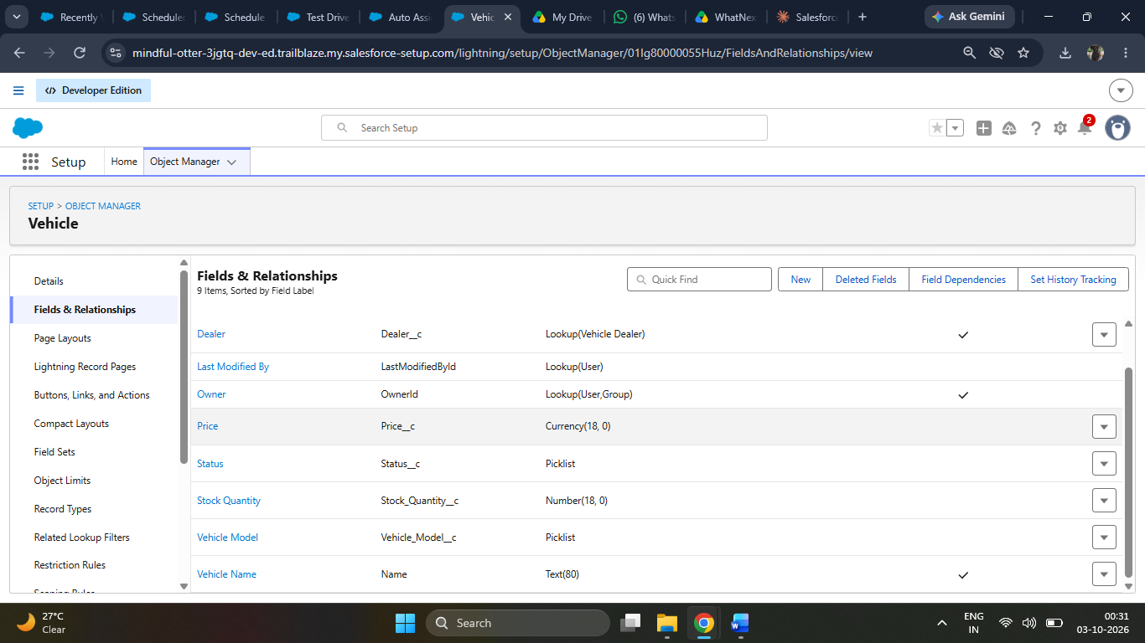
Fields created on the Vehicle object
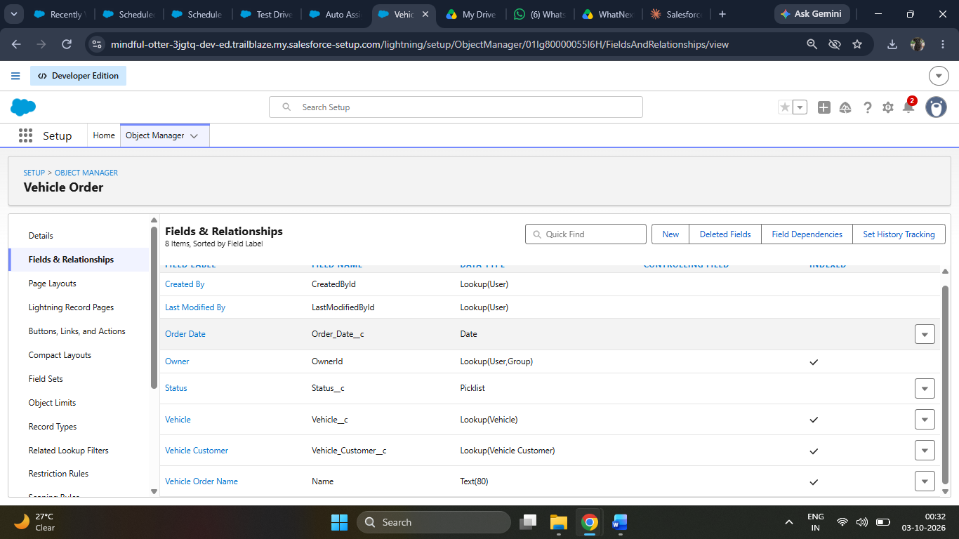
Fields created on the Vehicle Order object

7.2 Relationship Field Creation
Relationship fields connect records of one object to records of another. Lookup relationships were created using the Lookup Relationship data type.
- Open Object Manager and select the child object, for example Vehicle Order.
- Click Fields and Relationships, then New, and select Lookup Relationship.
- Choose the related object, such as Vehicle, and give the field a label like Vehicle.
- Set field-level security, add the field to the page layout and save.
Child Object | Lookup To | Field Label
Vehicle | Dealer | Dealer
Vehicle Order | Customer | Customer
Vehicle Order | Vehicle | Vehicle
Test Drive | Customer | Customer
Test Drive | Vehicle | Vehicle

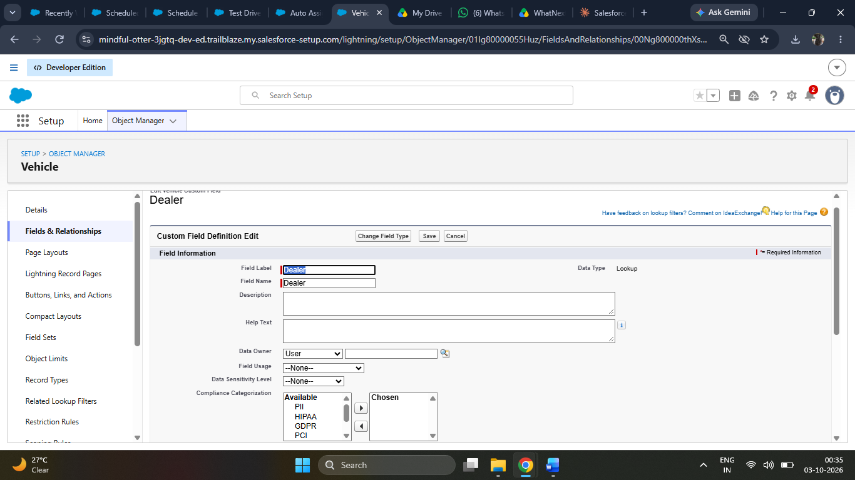
Lookup relationship field creation

7.3 Page Layout and Security Configuration
Page layouts were adjusted so that important fields appear first. Field-level security was reviewed so that only authorized profiles can edit sensitive values such as price and stock quantity. Permission sets can be assigned to give additional access without changing profiles.

8. Automation and Workflow Design
Salesforce Flow is the declarative automation tool used in this project. Two flows were built: a screen flow that guides users through creating an order, and a record-triggered flow that reacts to changes in order records.

8.1 Flow Creation
The screen flow named Create Vehicle Order collects the information needed for a new order through a simple, guided form.
- Go to Setup, search for Flows and click New Flow, then choose Screen Flow.
- Add a Screen element with fields for Customer, Vehicle, Quantity and Order Date.
- Add a Create Records element that saves a new Vehicle Order using the screen values, with Order Status set to Pending.
- Add a final Screen element that displays a confirmation message.
- Save the flow as Create Vehicle Order, activate it and add it to the app as a tab or a quick action.
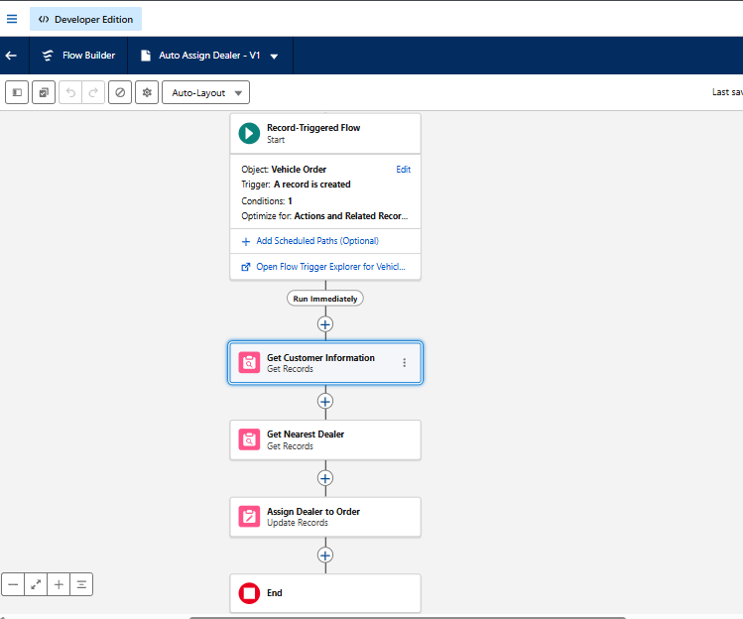
Screen flow canvas for Create Vehicle Order
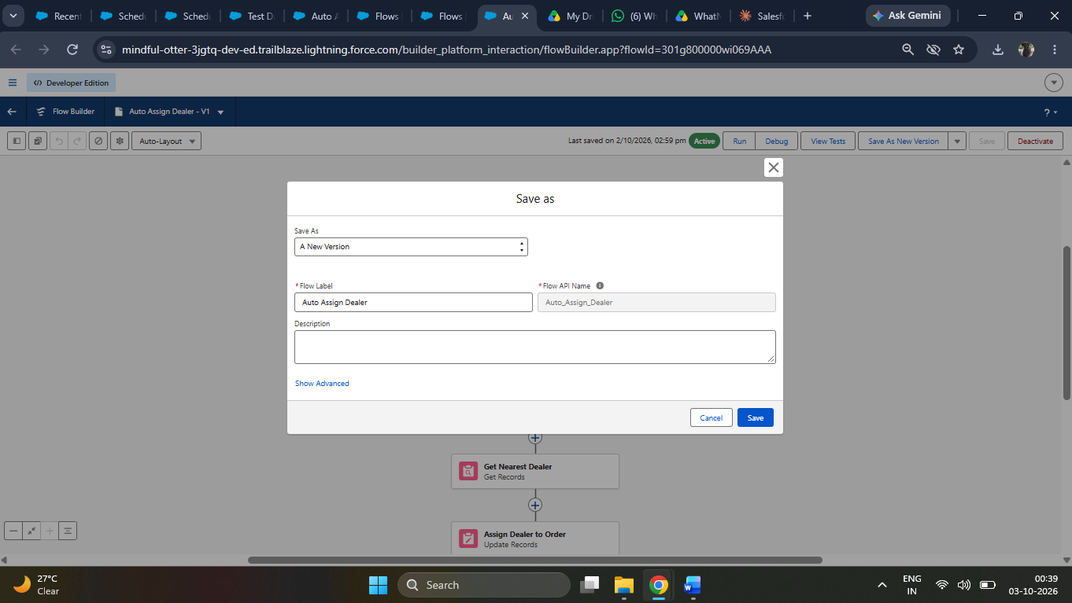
Screen flow running in the Vision Motors app

8.2 Record-Triggered Flow Creation
The record-triggered flow named Order Confirmation Update runs automatically when an order is saved with the status Confirmed.
Setting | Value
Object | Vehicle Order
Trigger | A record is created or updated
Entry condition | Order Status equals Confirmed
Optimize for | Actions and related records (after save)
Actions | Update the related Vehicle status and send an email alert to the customer

- Create a new flow and select Record-Triggered Flow.
- Choose the Vehicle Order object and set the trigger to run on create or update.
- Set the entry condition so that the flow runs only when Order Status is Confirmed.
- Add an Update Records element to refresh the related Vehicle record.
- Add an Action element to send an email notification to the customer.
- Save and activate the flow.
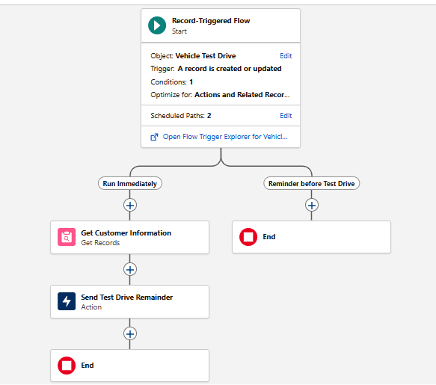
Record-triggered flow canvas
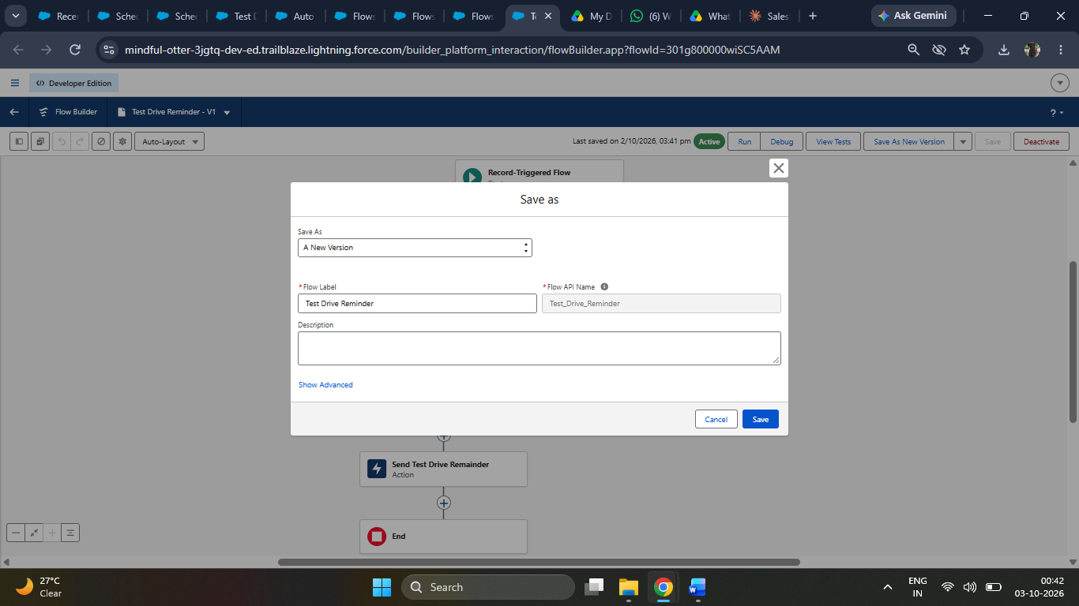
Entry conditions of the record-triggered flow

8.3 Flow Testing
Both flows were tested by creating sample records. The debug option in Flow Builder was used to confirm that each element ran in the expected order. Flow Interviews and the debug log were checked to ensure that no faults occurred.

9. Apex and Programmatic Processing
Some business rules are difficult to express declaratively. Apex, the Salesforce programming language, was used for stock validation and stock updates. Code was written in the Developer Console under File, New, Apex Class and Apex Trigger.

9.1 Apex Trigger and Handler Class
The trigger VehicleOrderTrigger is kept very small and delegates all work to the handler class VehicleOrderTriggerHandler. This is a best-practice pattern that keeps the logic testable and reusable.
Source Code:
trigger VehicleOrderTrigger on Vehicle_Order__c (before insert,before update, after insert, after update) {
VehicleOrderTriggerHandler.handleTrigger(Trigger.new, Trigger.oldMap, Trigger.isBefore,Trigger.isAfter, Trigger.isInsert, Trigger.isUpdate);
}
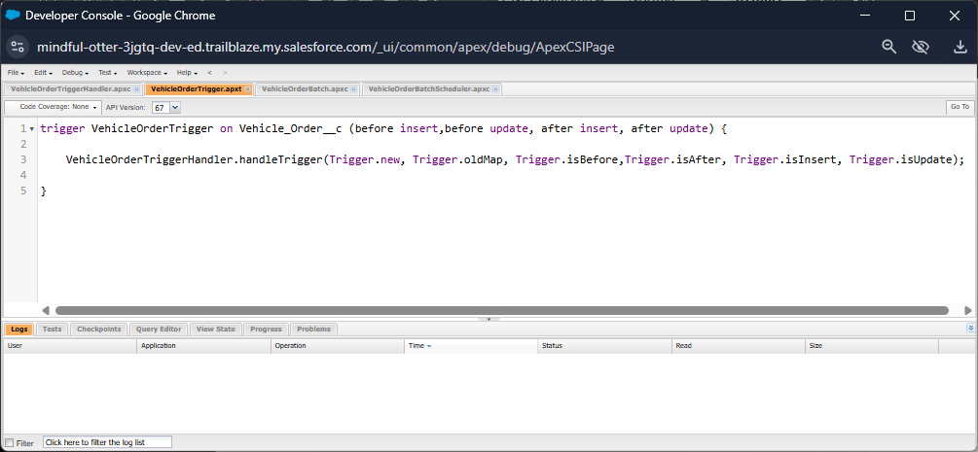
Apex trigger in the Developer Console

9.2 Handler Class
The handler first checks that enough stock exists before an order can be confirmed. After the order is saved, it reduces the stock and marks the vehicle as Sold Out when no units remain.
Source Code:
public class VehicleOrderTriggerHandler {

public static void handleTrigger(List<Vehicle_Order__c> newOrders, Map<Id, Vehicle_Order__c> oldOrders, Boolean isBefore, Boolean isAfter, Boolean isInsert, Boolean isUpdate) {
if (isBefore) {
if (isInsert || isUpdate) {
preventOrderIfOutOfStock(newOrders);
}
}

if (isAfter) {
if (isInsert || isUpdate) {
updateStockOnOrderPlacement(newOrders);
}
}
}
// Method to prevent orders when the vehicle is out of stock

private static void preventOrderIfOutOfStock(List<Vehicle_Order__c> orders) {
Set<Id> vehicleIds = new Set<Id>();

for (Vehicle_Order__c order : orders) {
if (order.Vehicle__c != null) {
vehicleIds.add(order.Vehicle__c);
}
}
if (!vehicleIds.isEmpty()) {
Map<Id, Vehicle__c> vehicleStockMap = new Map<Id, Vehicle__c>();
for (Vehicle__c vehicle : [SELECT Id, Stock_Quantity__c FROM Vehicle__c WHERE Id IN :vehicleIds]) {
vehicleStockMap.put(vehicle.Id, vehicle);
}
for (Vehicle_Order__c order : orders) {
if (vehicleStockMap.containsKey(order.Vehicle__c)) {
Vehicle__c vehicle = vehicleStockMap.get(order.Vehicle__c);
if (vehicle.Stock_Quantity__c <= 0) {
order.addError('This vehicle is out of stock. Order cannot be placed.');
}
}
}
}
}

private static void updateStockOnOrderPlacement(List<Vehicle_Order__c> orders) {
Set<Id> vehicleIds = new Set<Id>();
for (Vehicle_Order__c order : orders) {
if (order.Vehicle__c != null && order.Status__c == 'Confirmed') {
vehicleIds.add(order.Vehicle__c);
}
}

if (!vehicleIds.isEmpty()) {
Map<Id, Vehicle__c> vehicleStockMap = new Map<Id, Vehicle__c>();
for (Vehicle__c vehicle : [SELECT Id, Stock_Quantity__c FROM Vehicle__c WHERE Id IN :vehicleIds]) {
vehicleStockMap.put(vehicle.Id, vehicle);
}

List<Vehicle__c> vehiclesToUpdate = new List<Vehicle__c>();
for (Vehicle_Order__c order : orders) {
if (vehicleStockMap.containsKey(order.Vehicle__c)) {
Vehicle__c vehicle = vehicleStockMap.get(order.Vehicle__c);
if (vehicle.Stock_Quantity__c > 0) {
vehicle.Stock_Quantity__c -= 1;
vehiclesToUpdate.add(vehicle);
}
}
}
if (!vehiclesToUpdate.isEmpty()) {
update vehiclesToUpdate;
}
}
}
}
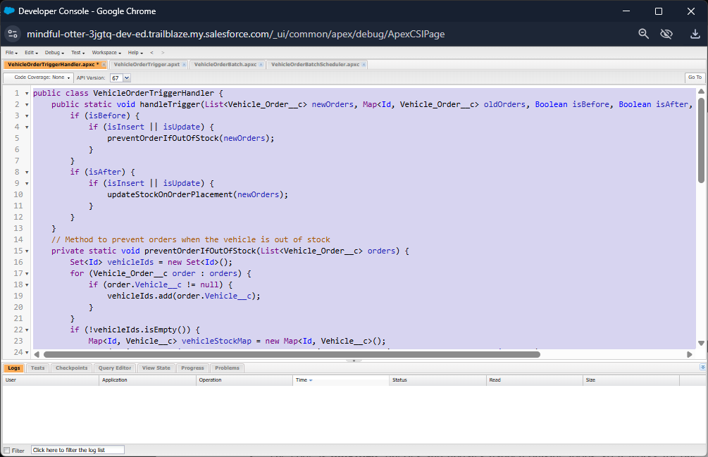
Handler class saved in the Developer Console

9.3 Design Notes
- The code is bulkified: queries and updates happen outside loops, so it works for one record or two hundred.
- Maps and sets are used to avoid repeated queries and keep within governor limits.
- The before event is used for validation and the after event for related-record updates, which follows Salesforce recommendations.
- Unit tests create sample vehicles and orders, confirm that an order with insufficient stock is blocked, and confirm that stock reduces correctly.

10. Batch and Scheduled Processing
Batch Apex processes large numbers of records in smaller chunks, so it avoids governor limits that affect a single transaction. In this project a batch job reviews all Pending orders and confirms those for which stock is available. A scheduler runs the job automatically every day.

10.1 Batch Class
Source Code:
global class VehicleOrderBatch implements Database.Batchable<sObject> {

global Database.QueryLocator start(Database.BatchableContext bc) {
return Database.getQueryLocator([
SELECT Id, Status__c, Vehicle__c
FROM Vehicle_Order__c
WHERE Status__c = 'Pending'
]);
}

global void execute(Database.BatchableContext bc, List<Vehicle_Order__c> orderList) {
Set<Id> vehicleIds = new Set<Id>();

for (Vehicle_Order__c order : orderList) {
if (order.Vehicle__c != null) {
vehicleIds.add(order.Vehicle__c);
}
}

if (!vehicleIds.isEmpty()) {
Map<Id, Vehicle__c> vehicleStockMap = new Map<Id, Vehicle__c>();

for (Vehicle__c vehicle : [SELECT Id, Stock_Quantity__c FROM Vehicle__c WHERE Id IN :vehicleIds]) {
vehicleStockMap.put(vehicle.Id, vehicle);
}

List<Vehicle_Order__c> ordersToUpdate = new List<Vehicle_Order__c>();
List<Vehicle__c> vehiclesToUpdate = new List<Vehicle__c>();

for (Vehicle_Order__c order : orderList) {
if (vehicleStockMap.containsKey(order.Vehicle__c)) {
Vehicle__c vehicle = vehicleStockMap.get(order.Vehicle__c);

if (vehicle.Stock_Quantity__c > 0) {
order.Status__c = 'Confirmed';
vehicle.Stock_Quantity__c -= 1;
ordersToUpdate.add(order);
vehiclesToUpdate.add(vehicle);
}
}
}

if (!ordersToUpdate.isEmpty()) {
update ordersToUpdate;
}

if (!vehiclesToUpdate.isEmpty()) {
update vehiclesToUpdate;
}
}
}

global void finish(Database.BatchableContext bc) {
System.debug('Vehicle order batch job completed.');
}
}

The update uses Database.update(scope, false) so that an order that fails the stock check in the trigger does not stop the other orders in the same batch from being processed. Failed orders simply remain Pending and are tried again on the next run.
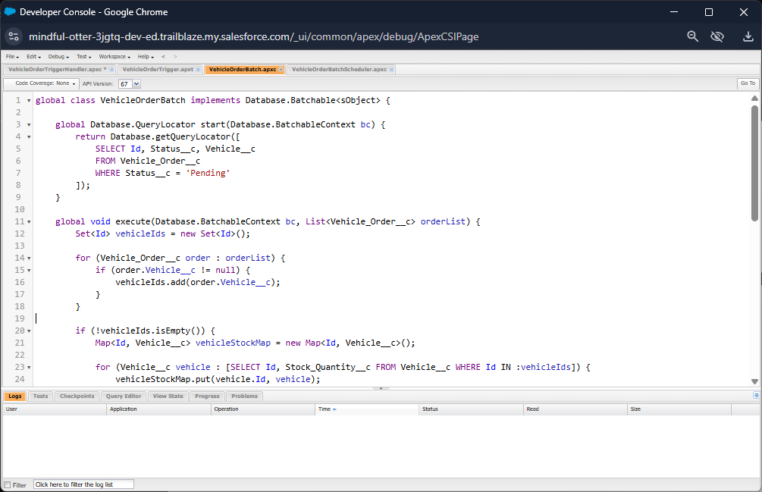
Batch class in the Developer Console

10.2 Scheduler Class
Source Code:
global class VehicleOrderBatchScheduler implements Schedulable {

global void execute(SchedulableContext sc) {

VehicleOrderBatch batchJob = new VehicleOrderBatch();
Database.executeBatch(batchJob, 50); // 50 is the batch size
}
}
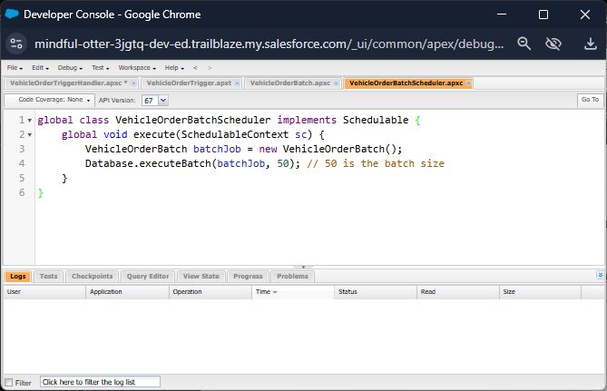
Scheduler class in the Developer Console

10.3 Scheduling the Job
The scheduler can be activated from Setup without writing extra code.
- Go to Setup, search for Apex Classes and click Schedule Apex.
- Enter the job name Vehicle Order Daily Job and select the class VehicleOrderScheduler.
- Choose the frequency (weekly or monthly), the days, the start and end dates, and the preferred start time.
- Click Save. The job now appears under Scheduled Jobs.
Alternatively, the job can be scheduled from the Developer Console with a cron expression:
Source Code:

String cronExp = '0 0 12 * * ?'; // Runs daily at 12:00 PM
System.schedule('Daily Vehicle Order Processing', cronExp, new
VehicleOrderBatchScheduler());
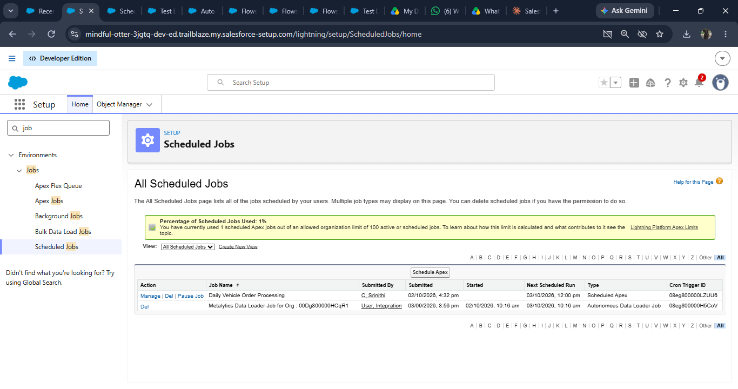
Schedule Apex page with job details

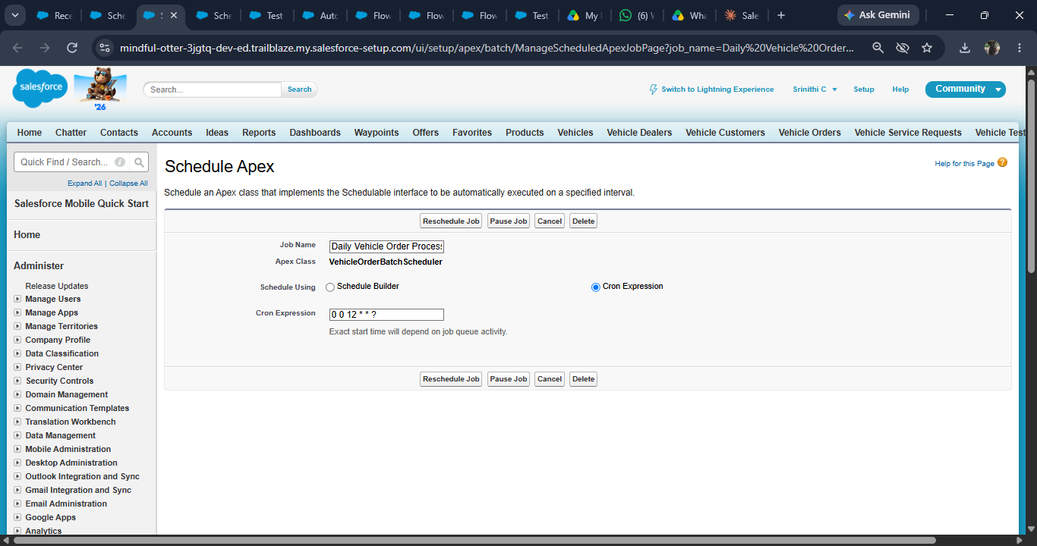
Scheduled Jobs list and Apex Jobs monitoring page

11. Functional and Performance Testing

11.1 Functional Test Cases
ID | Test Case | Expected Result | Actual | Status
TC-1 | Create a Vehicle record with all fields | Record saves successfully | As expected | Pass
TC-2 | Create a Dealer and link a Vehicle to it | Vehicle shows the Dealer lookup | As expected | Pass
TC-3 | Create an order through the screen flow | Order created with status Pending | As expected | Pass
TC-4 | Confirm an order with enough stock | Stock reduces; flow sends notification | As expected | Pass
TC-5 | Confirm an order with insufficient stock | Error message blocks the save | As expected | Pass
TC-6 | Order reduces stock to zero | Vehicle status becomes Sold Out | As expected | Pass
TC-7 | Run batch job manually | Pending orders are processed | As expected | Pass
TC-8 | Check scheduled job | Job listed under Scheduled Jobs | As expected | Pass

11.2 Apex Test Classes
Test classes create their own sample data, so they do not depend on records in the organization. They cover the trigger, handler, batch and scheduler classes. All tests were run from Setup, Apex Test Execution, and the overall code coverage was above the 75 percent required for deployment.

11.3 Performance Testing
Scenario | Records | Result
Bulk insert of orders | 200 records | Completed without governor limit errors
Batch job execution | Over 200 pending orders | Processed in chunks of 200
Record page load | Single order record | Loads in a few seconds

The results show that the solution is bulkified and stays within governor limits for the expected volume of data.

11.4 Debugging and Fixes
- A missing field-level security setting prevented the flow from updating the vehicle; permissions were corrected.
- A query inside a loop in the first draft of the handler was moved outside the loop to avoid limit errors.
- Debug logs and the Flow debug mode were used to trace each problem to its cause.

12. Reports and Dashboards
Reports and dashboards turn the stored data into information for decision making. All reports were created from the Reports tab by choosing a report type, applying filters and grouping the rows.

12.1 Reports Created
Report | Report Type | Purpose
Orders by Status | Vehicle Orders | Shows how many orders are Pending, Confirmed or Delivered.
Vehicles by Dealer | Vehicles with Dealers | Shows stock distribution across dealers.
Low Stock Vehicles | Vehicles | Lists vehicles with a Low Stock or Sold Out status.
Orders by Customer | Vehicle Orders with Customers | Shows order history for each customer.

12.2 Dashboard
A dashboard named Vision Motors Sales Overview was built from these reports. It uses a donut chart for order status, a bar chart for vehicles by dealer, a table for low stock vehicles and a metric for total orders. The dashboard can be refreshed on demand or on a schedule and shared with managers.
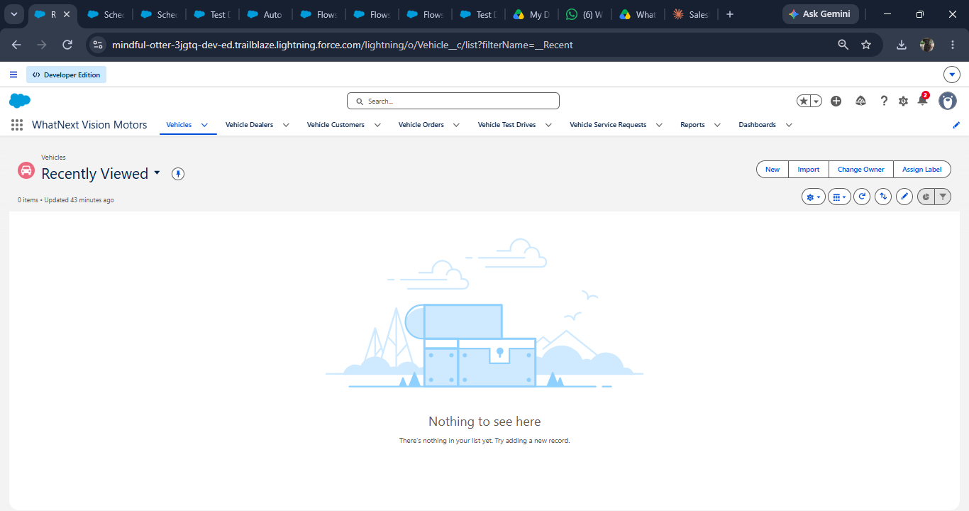
Vision Motors Sales Overview dashboard

12.3 Insights
- Managers can see how many orders are waiting for confirmation at any moment.
- Low stock vehicles are visible immediately, so replenishment can be planned.
- Dealer-wise stock figures help in balancing supply across locations.

13. Conclusion
The WhatNext Vision Motors project successfully demonstrates how the Salesforce Platform can be used to build a complete Vehicle Order and Dealership Management System. Starting from a Developer Edition organization, the project created a connected data model of vehicles, dealers, customers, orders and test drives; provided easy navigation through object tabs and a Lightning app; automated routine work with screen and record-triggered flows; enforced business rules with an Apex trigger; and processed pending orders through a scheduled batch job. Reports and dashboards complete the solution by giving managers a clear view of the business.

13.1 Learning Outcomes
- Practical experience in creating and verifying a Salesforce Developer organization.
- Understanding of custom objects, fields, tabs and relationship fields.
- Skill in building Lightning apps and flows using point-and-click tools.
- Ability to write bulkified Apex triggers, batch classes and schedulers with test coverage.
- Knowledge of reports, dashboards and the importance of documentation.

13.2 Future Enhancements
- Customer self-service portal using Experience Cloud.
- Approval process for high-value orders.
- Integration with ERP and payment gateways.
- Mobile access through the Salesforce mobile app.
- Einstein analytics for sales forecasting.
In summary, the project meets its objectives and provides a strong, scalable foundation on which more advanced features can be built.

