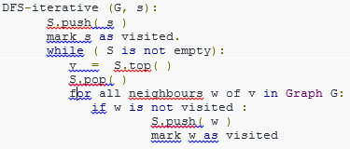 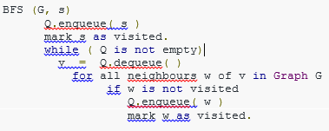

**Complexity BFS DFS : O(V+E)**

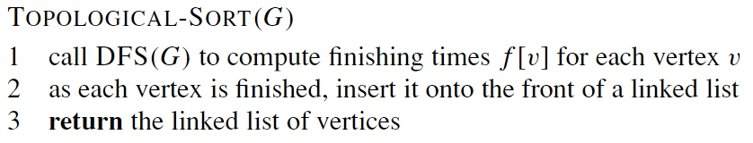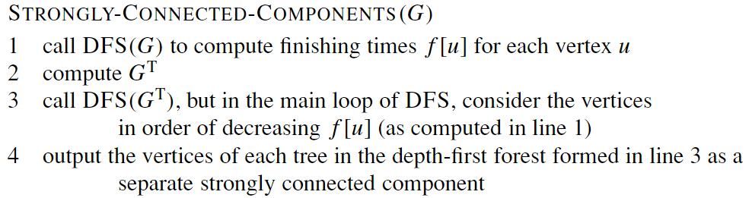

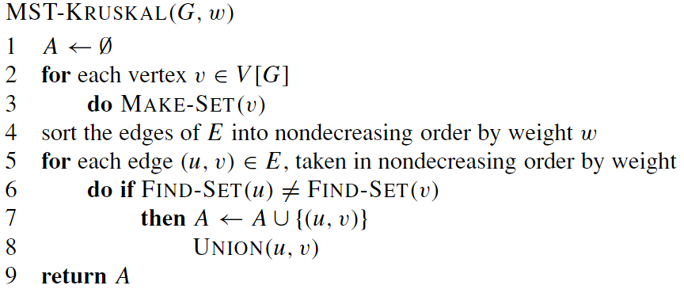 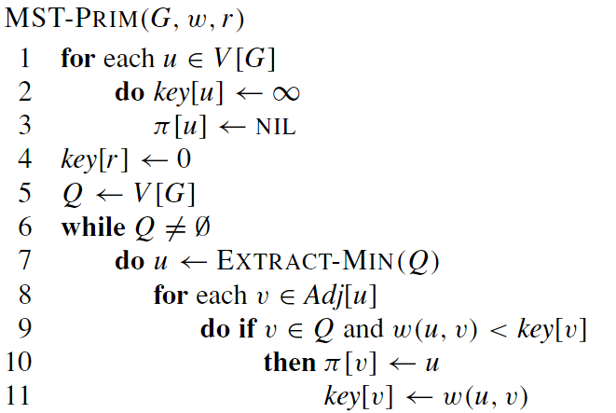

O(E lg V) Binary-> O(E lg V) Fibonacci -> O(E + V lg V)

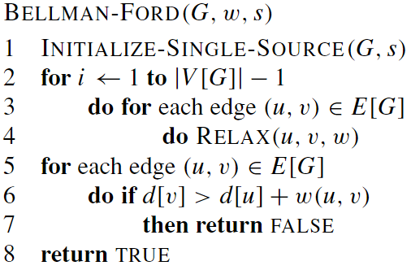 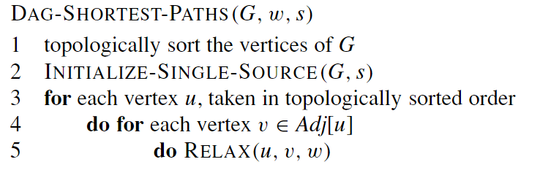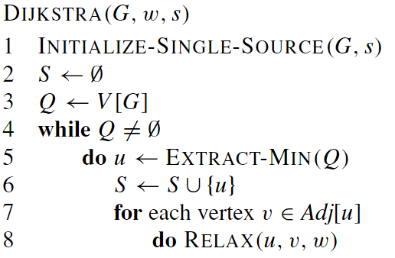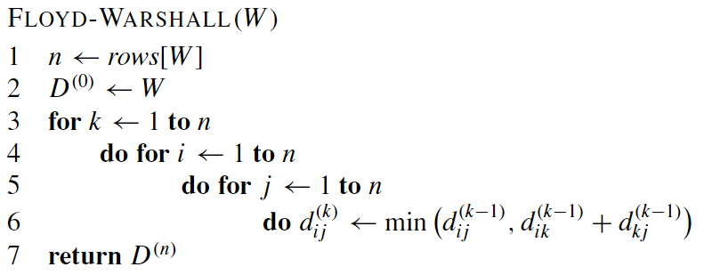

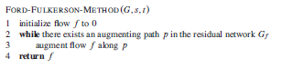

1. Circulation –

* Remove lower bound +supply -demand edgeWeight: upper-lower
* Ford fulkerson
* Check constraints and replace demand
* Replace lower bound - supply +demand Capacity+LB Flow+LB

1. Consumer Product

