EXPERIMENT 4: - Create a simple cloud software application for Library book reservation system for SIMATS library using any Cloud Service Provider to demonstrate SaaS include the necessary fields such as Title of the book, author, publications,

Step 1: - Go to ZOHO.com

Step 2: - Create an account and log into the account

Step 3: - Create an application for the respective requirement

Step 4: - Create the login form for the user or student

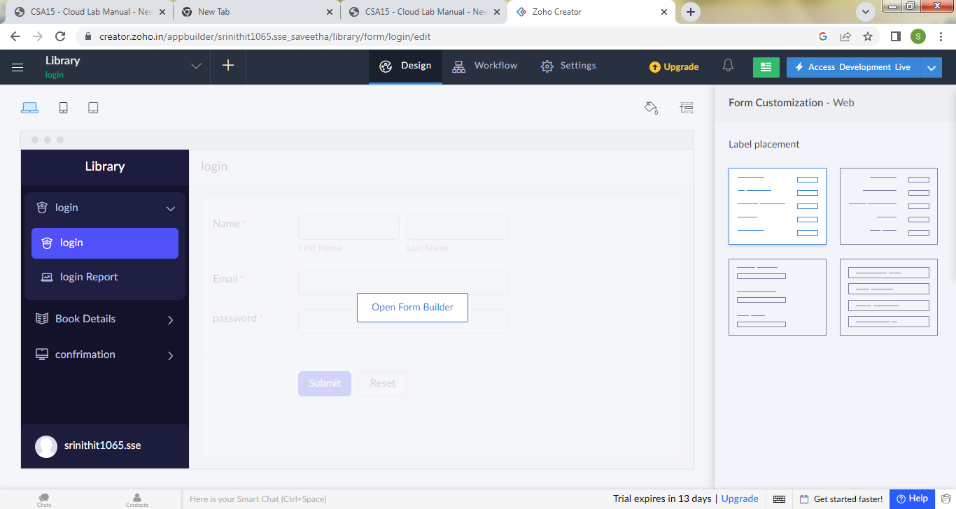

Step 5: - Create next form for book details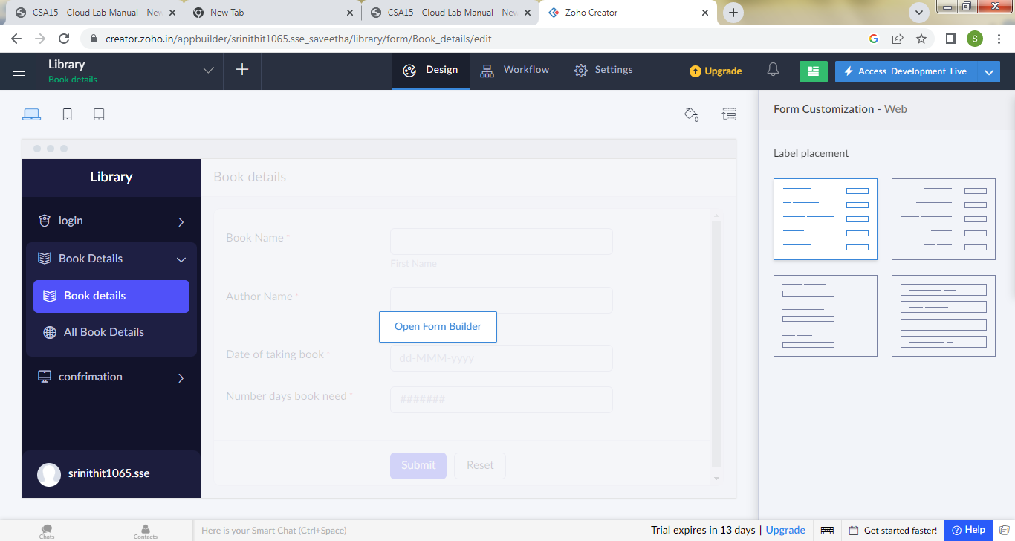

Step 6: - Create a form for confirmation

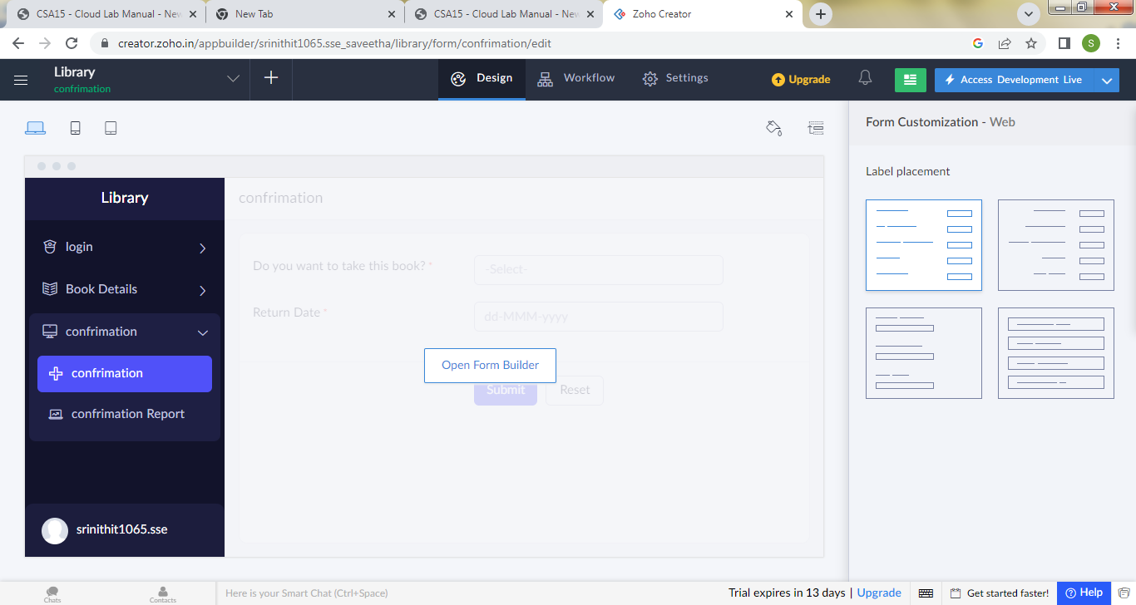

Step7: - Click the Access development live to view the output

Step8: - Click the report to view the data added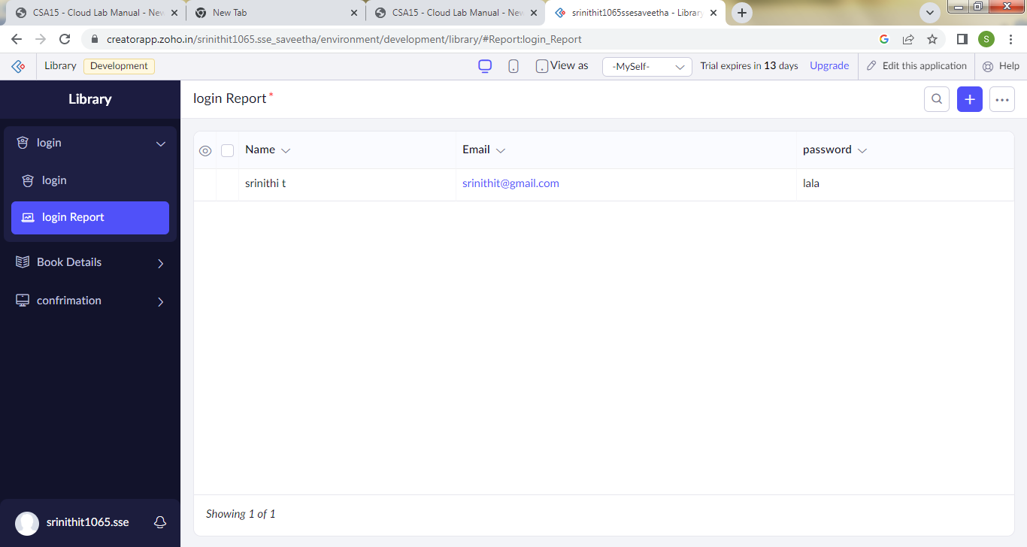

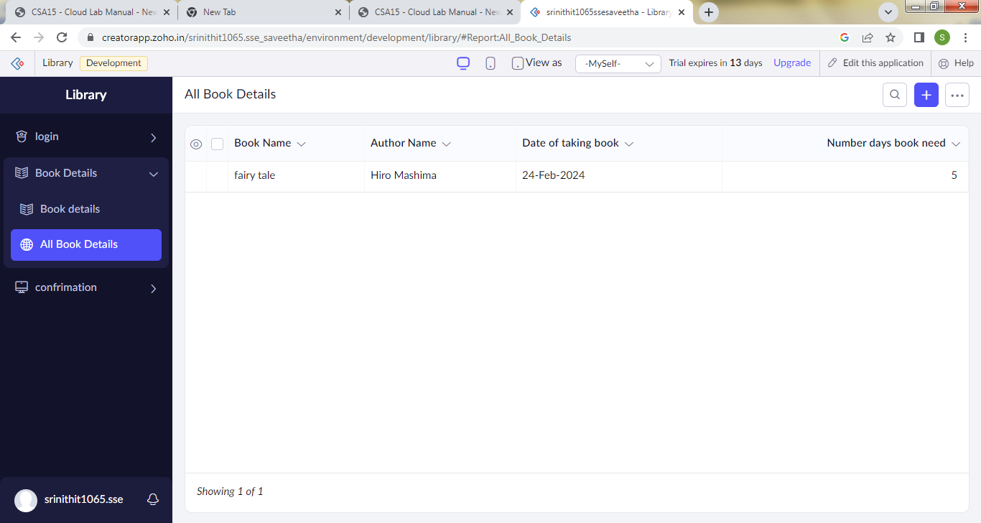

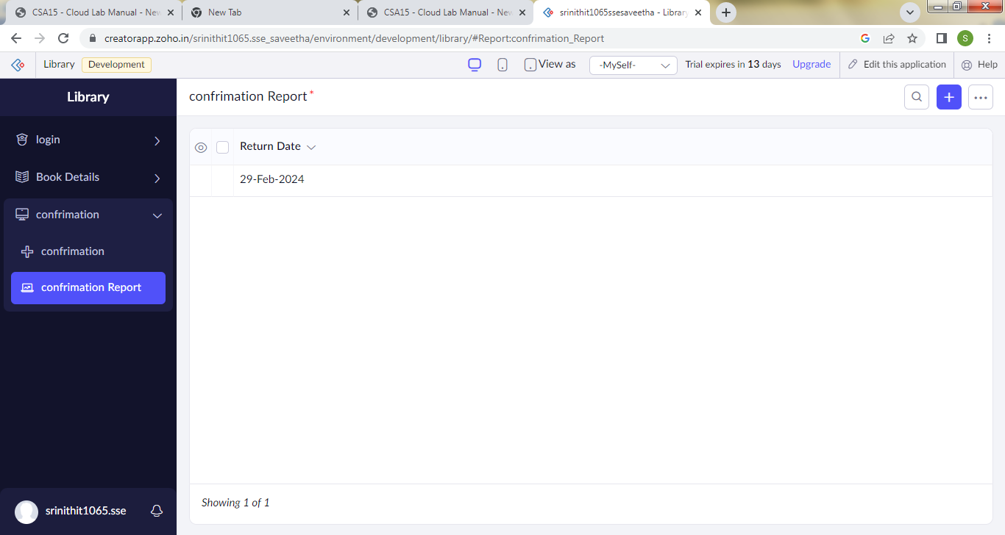

Step 9: - Click the mobile icon to view the output in mobile format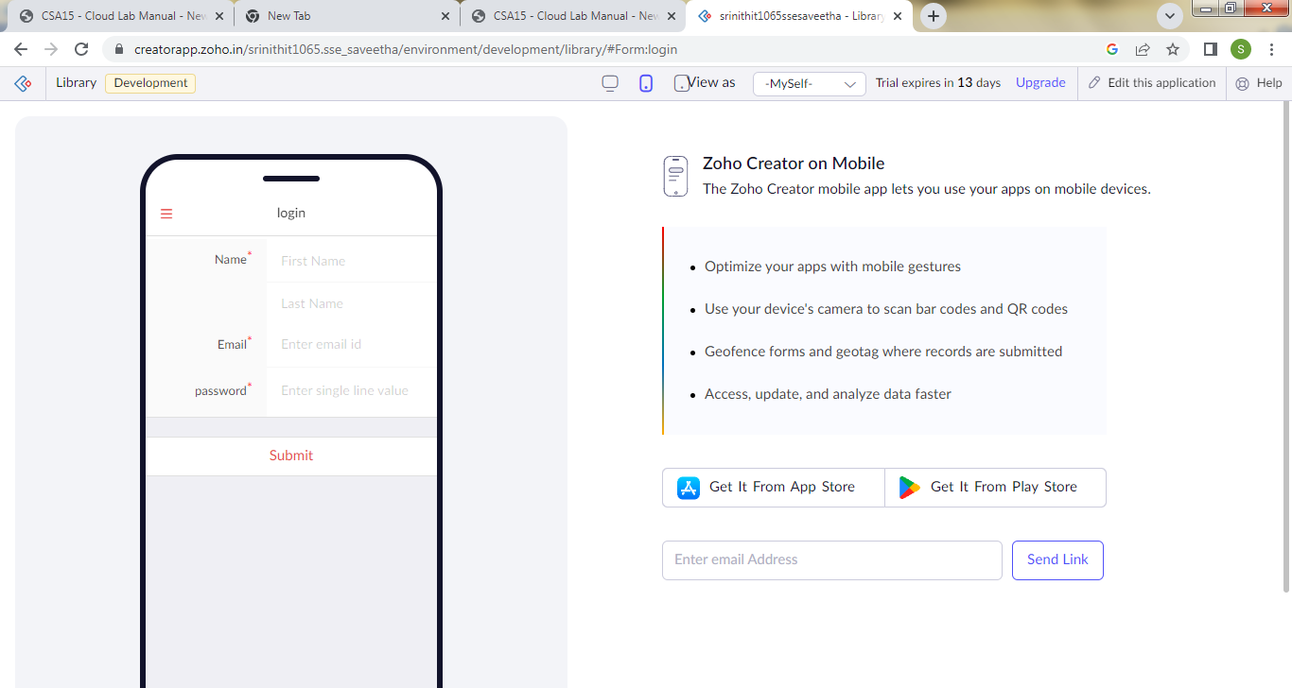

Step 10: - Click the tablet icon to view the output in tablet format

