“Airport Ground Operations Using Linux IPC”
A Project Report Submitted in the partial fulfillment of the requirements for the award of the degree of

BACHELOR OF TECHNOLOGY
In

DEPARTMENT OF COMPUTER SCIENCE ENGINNERING

By

G JAHNAVI 2520030483

M SRI NITHYA 2520030447

P YASASRI 2520030373

Under the Esteemed Guidance of

Dr. K. Anusha
Assistant Professor
Department of Computer Science and Engineering




K L (Deemed to be) University DEPARTMENT OF COMPUTER SCIENCE ENGINEERING
&

DEPARTMENT OF COMPUTER SCIENCE AND INFORMATION TECHNOL

Declaration

The Project Report entitled “Airport Ground Operations Using Linux IPC” is a record of bonafide work of G JAHNAVI – 2520030483, M SRI NITHYA – 2520030447, and P YASASRI – 2520030373, submitted in partial fulfillment of the requirements for the award of B.Tech in Computer Science and Engineering at K L (Deemed to be) University. The work described in this report has been carried out by the undersigned students.
This report presents our own implementation and study of Linux inter-process communication for simulated airport ground operations.

G JAHNAVI 2520030483

M SRI NITHYA 2520030447

P YASASRI 2520030373

K L (Deemed to be) University

DEPARTMENT OF COMPUTER SCIENCE ENGINEERING

CERTIFICATE

This is to certify that the mini-project report entitled “Airport Ground Operations Using Linux IPC” is a bonafide work carried out by G JAHNAVI (2520030483), M SRI NITHYA (2520030447), and P YASASRI (2520030373).
The report is submitted in partial fulfillment of the requirements for the award of the degree of BACHELOR OF TECHNOLOGY in Computer Science and Engineering, K L (Deemed to be) University, during the academic year 2026–2027. The designated signatories may verify and sign below.

Signature of the Guide

Signature of the Course Coordinator Signature of the HOD

ACKNOWLEDGEMENT
We express our sincere gratitude to our guide and course coordinator, Dr. K. Anusha, for valuable guidance, encouragement, and feedback during the development of this Operating Systems mini-project.

We thank the Department of Computer Science and Engineering and its faculty for providing the academic foundation and facilities necessary to explore Linux processes, pipes, FIFOs, and application-level monitoring.

We are grateful to our teammates for their collaboration in developing and documenting the airport operations simulation and its SKYPORT interface.

Finally, we thank our families, friends, and classmates for their encouragement and support throughout the project.

G JAHNAVI 2520030483

M SRI NITHYA 2520030447

P YASASRI 2520030373
Abstract

Airport ground operations require several independent activities to coordinate: receiving flight requests, allocating gates, handling baggage, publishing announcements, and responding to emergencies. This project, Airport Ground Operations Using Linux IPC, models these activities as communicating processes on Linux. Its principal objective is to demonstrate operating-system concepts through a working simulation rather than a purely theoretical example.

The core implementation uses C programs and Linux/POSIX system calls. Unnamed pipes support communication between the Flight process and the Airport Controller, while named pipes (FIFOs) allow other independently running components to exchange operational messages. The controller manages a limited set of gates, accepts incoming requests, queues flights when gates are occupied, and promotes waiting requests when capacity becomes available. Automatic flight requests are generated at approximately fifteen-second intervals; manual requests can also be submitted.

A React/Vite frontend branded SKYPORT offers passenger-oriented and operations-oriented views. A Node.js bridge connects the browser interface to the C simulation. The system demonstrates process creation, file descriptors, blocking I/O, IPC, queue management, and resource allocation. It is an educational airport simulation, not a production aviation control system. Screenshots and measured performance results should be inserted only after verification against the running implementation.

Index

S. No. | Chapter | Topics / Subtopics | Page No.
 | Acknowledgement |  | i
 | Abstract |  | ii
1 | Introduction |  | 1–5
 |  | 1.1 Background of the Project
 |  | 1.2 Problem Statement
 |  | 1.3 Scope of the Project
 |  | 1.4 Objectives of the Project
 |  | 1.5 Importance of the Application
 |  | 1.6 Target Users / Audience
2 | OS Concepts and Background Study |  | 6–12
 |  | 2.1 Operating System Concepts Related to the Project
 |  | 2.2 Existing Methods / Algorithms
 |  | 2.3 Proposed Approach
 |  | 2.4 Advantages of the Proposed Approach
3 | System Requirements |  | 13–17
 |  | 3.1 Hardware Requirements
 |  | 3.2 Software Requirements
 |  | 3.3 Operating System Environment – Ubuntu / WSL
 |  | 3.4 Development Tools and Compilers
4 | Technology and Tools Used |  | 18–22
 |  | 4.1 C / C++ Programming
 |  | 4.2 GCC Compiler
 |  | 4.3 Linux System Calls
 |  | 4.4 POSIX Threads / Synchronization
 |  | 4.5 Linux Commands and Utilities
 |  | 4.6 Other Tools / Libraries Used
5 | System Architecture and Design |  | 23–29
 |  | 5.1 Overall System Architecture
 |  | 5.2System Workflow
 |  | 5.3 Flowchart / Data Flow
 |  | 5.4 Module Description
 |  | 5.5 Input and Output Design
6 | Implementation |  | 30–45
 |  | 6.1 Module-wise Implementation
 |  | 6.2 Algorithm / Pseudocode
 |  | 6.3 Core C / C++ Implementation
 |  | 6.4 Linux System Calls / APIs Used
 |  | 6.5 Process / Thread Implementation
 |  | 6.6 IPC / Synchronization Implementation
 |  | 6.7 Memory Management Implementation
 |  | 6.8 Optional User Interface Implementation
7 | Execution and Demonstration |  | —
 |  | 7.1 Compilation in Ubuntu
 |  | 7.2 Execution Commands
 |  | 7.3 Sample Inputs and Outputs
 |  | 7.4 Screenshots of Execution
 |  | 7.5 Demonstration of OS Concepts
8 | Conclusion |  | —
 |  | 8.1 Summary of the Project
 |  | 8.2 Objectives Achieved
 |  | 8.3 Results Achieved
 |  | 8.4 Skills and Learning Outcomes
9 | References |  | —
 |  | 9.1 Books
 |  | 9.2 Research Papers
 |  | 9.3 Linux / GNU Documentation
 |  | 9.4 Online Resources

CHAPTER 1 — INTRODUCTION

1.1 Background of the Project
Airports rely on multiple activities that proceed in parallel. A flight arrival triggers gate allocation, baggage handling, passenger information, and sometimes priority or emergency coordination. In an operating system, such independent activities can be modeled as separate processes that exchange messages. Linux provides both unnamed pipes for related processes and named FIFOs for processes that may start independently.

1.2 Problem Statement
Develop a practical Linux-based simulation that coordinates incoming flight requests with a finite number of gates and downstream services, while making inter-process communication visible to users. The challenge is to avoid treating each activity as an isolated program: a request must be received, assigned or waitlisted, communicated to services, and reflected in the user interface.

1.3 Scope of the Project
The project models automatic and manual arrivals, controller decisions, gate occupancy, a waiting queue, baggage updates, announcements, and emergency-related messaging. It operates on Ubuntu/WSL using C processes and a local web interface. It does not integrate real airline data, airport equipment, or certified safety systems.

1.4 Objectives of the Project
The objectives are to demonstrate Linux process-based IPC; exchange structured messages through unnamed pipes and FIFOs; allocate scarce gate resources; maintain a waiting queue; expose events through a Node.js bridge; and present operational status clearly in SKYPORT.

1.5 Importance of the Application
The simulation translates abstract OS topics into observable events. Students can watch the consequences of process communication, blocking reads, resource contention, and queue promotion rather than studying system calls in isolation.

1.6 Target Users / Audience
The intended audience is Operating Systems students, instructors, lab evaluators, and developers learning Linux process coordination. The passenger-oriented screen is a demonstration view, not a commercial passenger service.

CHAPTER 2 — OS CONCEPTS AND BACKGROUND STUDY

2.1 Operating System Concepts Related to the Project
A process is an executing program with its own address space and open file descriptors. fork() creates a child process. pipe() creates a pair of file descriptors for one-way byte-stream communication between related processes. mkfifo() creates a named pipe in the filesystem so separate processes can communicate. read() and write() transfer bytes; close() releases descriptors. Correctly handling partial reads, writes, and interrupted system calls helps preserve complete structured messages.

2.2 Existing Methods / Algorithms
A single monolithic program could implement the same simulation with function calls, but it would not demonstrate IPC. Other possible mechanisms include sockets, shared memory, and message queues. This project selects pipes and FIFOs because their producer–consumer behavior and file-descriptor semantics are directly relevant to the OS lab.

2.3 Proposed Approach
The Flight process produces requests, the Airport Controller evaluates gate availability, and service processes handle assigned work. When gates are occupied, the controller records pending flights and promotes requests after release. The bridge exposes requests and event information to the React interface.

2.4 Advantages of the Proposed Approach
Separate processes clarify responsibility, while Linux pipes provide a tangible example of data transfer between processes. The design makes queueing and limited-resource allocation easy to demonstrate, and the browser interface improves visibility during evaluation.

CHAPTER 3 — SYSTEM REQUIREMENTS

3.1 Hardware Requirements
A laptop or desktop capable of running Windows with WSL or a native Ubuntu environment is sufficient. A modern multi-core processor, at least 4 GB RAM, and available disk space for GCC, Node.js, dependencies, and source files are practical development recommendations, not measured minimums.

3.2 Software Requirements
Ubuntu/WSL, GCC, standard C/POSIX headers, Node.js with npm, a modern browser, React, Vite, and a code editor such as Visual Studio Code. The frontend and bridge run locally for demonstration.

3.3 Operating System Environment — Ubuntu / WSL
WSL maps Windows drives under /mnt, such as /mnt/c/Users/srini/Downloads/airport_ipc_upgrade. Linux source and executables are built and run from the Ubuntu shell; the React development server can run from Windows PowerShell.

3.4 Development Tools and Compilers
GCC compiles the C programs. Ubuntu shell commands navigate folders and run executables. Node.js executes the bridge. npm starts the Vite development server. VS Code is used to edit source and interface files.

CHAPTER 4 — TECHNOLOGY AND TOOLS USED

4.1 C / C++ Programming
The simulation is written primarily in C. Structures defined in a shared header carry flight requests and responses, ensuring consistent field layouts across communicating components.

4.2 GCC Compiler
GCC builds the Linux executables. For example, gcc -Wall -Wextra flight.c -o flight compiles the Flight process. The full build may require additional source files or flags; use the project build instructions for the controller and service modules.

4.3 Linux System Calls
Important calls include fork(), pipe(), mkfifo(), open(), read(), write(), and close(). Their return values must be checked, and the program should handle errors such as EINTR and closed pipes.

4.4 POSIX Threads / Synchronization
The demonstrated architecture is process-oriented, not primarily thread-based. POSIX threads and semaphores are relevant alternatives, but should not be reported as implemented without source-code evidence. Coordination is achieved by message exchange and controller decisions.

4.5 Linux Commands and Utilities
Useful commands include pwd, ls, cd, nano, gcc, ./controller, and Ctrl+C to terminate a foreground process. Windows paths must be translated to /mnt/c/... when entered in WSL.

4.6 Other Tools / Libraries Used
React and CSS provide the SKYPORT interface; Vite supplies the frontend development server; Node.js provides the local bridge between browser requests and the Linux simulation.

CHAPTER 5 — SYSTEM ARCHITECTURE AND DESIGN

5.1 Overall System Architecture
The architecture has three layers: (1) React SKYPORT presentation; (2) Node.js bridge for local HTTP/event communication; and (3) Linux C processes that implement airport coordination. Within the Linux layer, the Flight process communicates with the Controller using unnamed pipes, while service modules use named FIFOs according to their responsibilities.

5.2 System Workflow
A flight request is generated automatically or submitted manually. The Controller receives the request, checks available gates, assigns a gate when possible, or places the flight on a waiting queue. Assigned flights trigger service updates. When a gate is released, the next eligible waiting request is promoted. The bridge relays events to the dashboard.

5.3 Flowchart / Data Flow
Automatic Flight Generator → unnamed pipe → Airport Controller → [gate available?] → Yes: assign gate and notify services; No: enqueue flight. Gate release → promote queued flight. Browser ↔ Node.js Bridge ↔ controller/event channels. This text flow is illustrative; a verified diagram can be inserted here.

5.4 Module Description
Flight: generates periodic requests and receives controller responses. Controller: receives requests and coordinates allocation. Gate: represents finite gate resources and their release. Baggage: receives processing updates. Announcement: publishes flight-related messages. Emergency: supports emergency-oriented signaling. Bridge: transports web requests and events. SKYPORT: displays passenger and operations views.

5.5 Input and Output Design
Typical manual input is a flight identifier and scheduled time, e.g., AI-777 at 17:30. Automatic inputs use identifiers such as AI-502 and labels such as AUTO-001. Outputs include APPROVED, WAITLISTED, PROMOTED, gate identifiers, baggage status, and announcements. Exact strings depend on the active build.

CHAPTER 6 — IMPLEMENTATION

6.1 Module-wise Implementation
The Flight process repeatedly sleeps for fifteen seconds, prepares a FlightMessage, sends it to the Controller, and waits for a FlightResponse. The Controller handles the gate state and waiting list. Service processes receive messages through FIFOs. The Node bridge accepts web requests and publishes operational events.

6.2 Algorithm / Pseudocode
REPEAT: wait 15 seconds; create automatic request; write complete request to controller pipe; read complete response; print response. CONTROLLER: on request, if a gate is free then reserve it and send approval; otherwise enqueue and report waitlisted. On gate release, mark available and assign the next waiting flight, if any.

6.3 Core C / C++ Implementation
The Flight module uses write_full() and read_full() helper loops to handle partial transfers and EINTR interruptions. Its request.kind is set to 1, the flight identifier cycles through a fixed list, and the time field carries an AUTO sequence marker. Actual complete source listings should be appended from the verified repository rather than reconstructed.

6.4 Linux System Calls / APIs Used
pipe() returns read and write descriptors for a byte stream. fork() allows child processes to inherit descriptors. mkfifo() creates filesystem-visible channels for independent services. read() and write() perform communication, and close() prevents descriptor leaks. sleep() delays automatic request generation.

6.5 Process / Thread Implementation
The system uses independent Linux processes. The Controller and Flight process coordinate through file descriptors, while gate, baggage, announcement, and emergency modules perform distinct tasks. The architecture demonstrates process communication rather than a multithreaded shared-memory design.

6.6 IPC / Synchronization Implementation
Unnamed pipes are suitable for a Controller–Flight relationship established through process creation. Named FIFOs allow other programs to open well-known paths. The controller acts as the decision point for shared gate capacity; queue order and message timing affect visible state transitions.

6.7 Memory Management Implementation
C structures store request and response data in process memory. The operating system isolates each process address space; data must therefore be serialized through IPC rather than accessed directly across processes. The project is not a custom memory allocator or virtual-memory manager.

6.8 Optional User Interface Implementation
The SKYPORT React application provides a landing page, passenger view, and System Control Center. A Node.js bridge exposes local API endpoints, including manual flight submission. A successful POST response indicates acceptance by the bridge, while the controller log and live events verify processing.

CHAPTER 7 — EXECUTION AND DEMONSTRATION

7.1 Compilation in Ubuntu
Open Ubuntu/WSL, navigate to /mnt/c/Users/srini/Downloads/airport_ipc_upgrade, and run the project build commands. The Flight process alone can be rebuilt using gcc -Wall -Wextra flight.c -o flight. Rebuilding an executable does not replace a currently running process; restart the controller after compilation.

7.2 Execution Commands
Ubuntu terminal 1: cd /mnt/c/Users/srini/Downloads/airport_ipc_upgrade then ./controller. Ubuntu terminal 2: cd to the same project directory then node bridge/server.js. Windows PowerShell: cd C:\Users\srini\OSSP_PROJECT\frontend then npm run dev. Open the Vite URL displayed, usually http://localhost:5173.
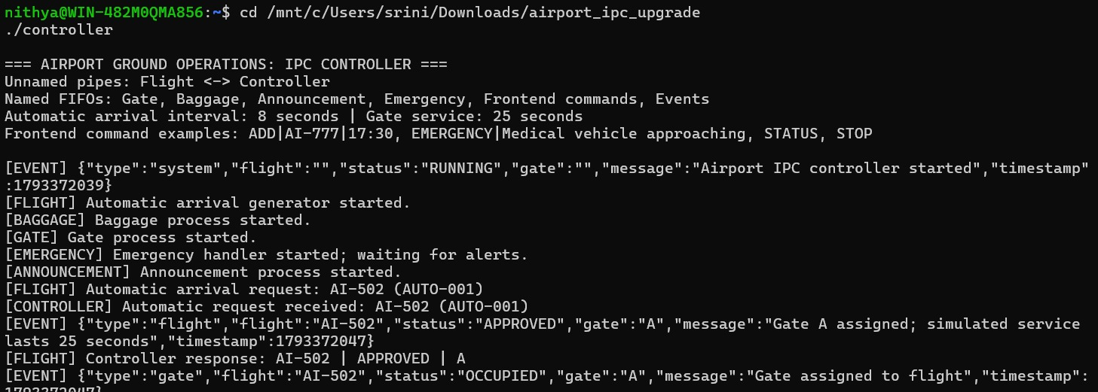

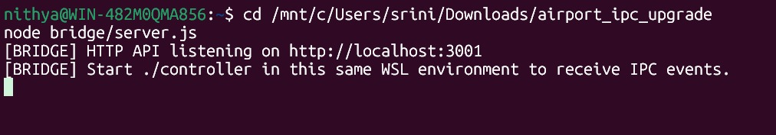

7.3 Sample Inputs and Outputs
Example manual submission: POST http://localhost:3001/api/flights with JSON {"flight":"AI-777","time":"17:30"}. A previously observed bridge response was {"accepted":true,"flight":"AI-777","time":"17:30"}; the controller logged that AI-777 was added to the waiting queue. Example automatic output: [FLIGHT] Automatic arrival request: UK-831 (AUTO-045).

7.4 Screenshots of Execution

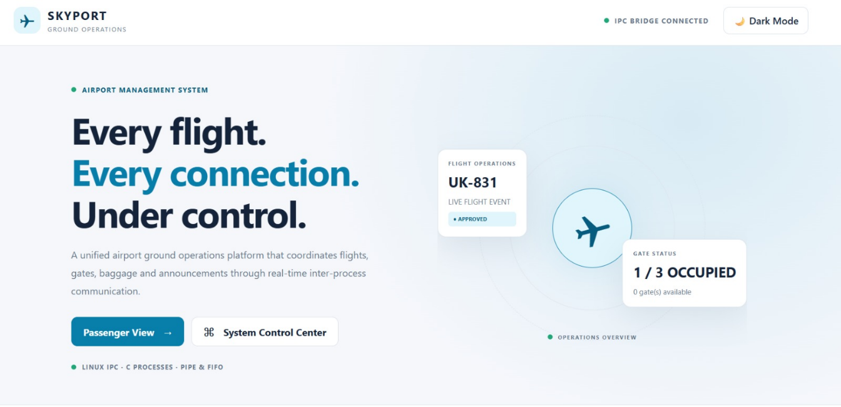

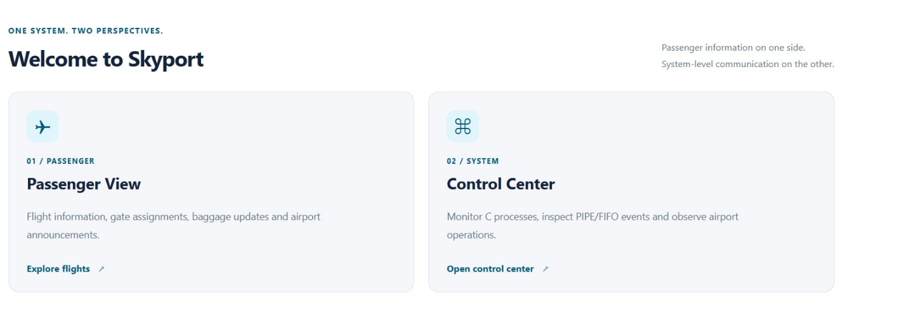

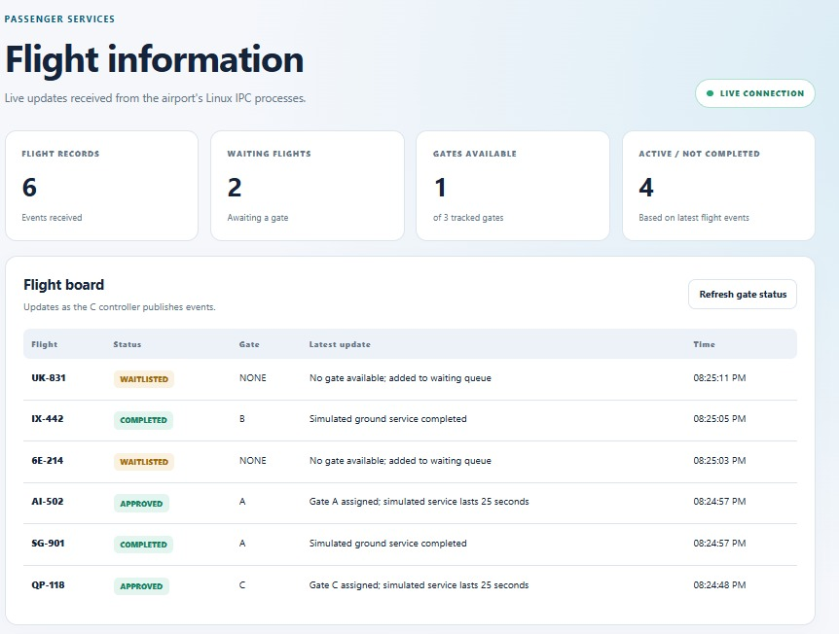

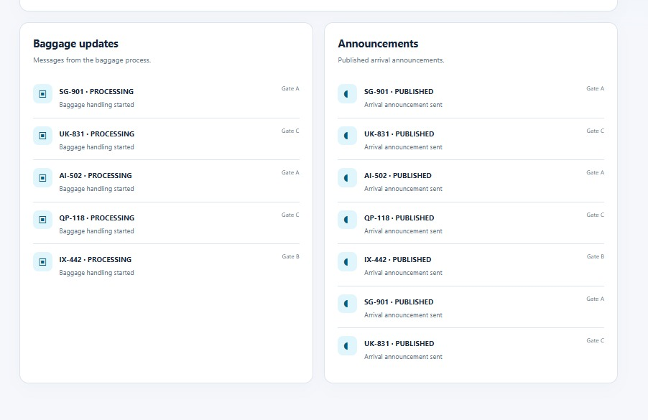

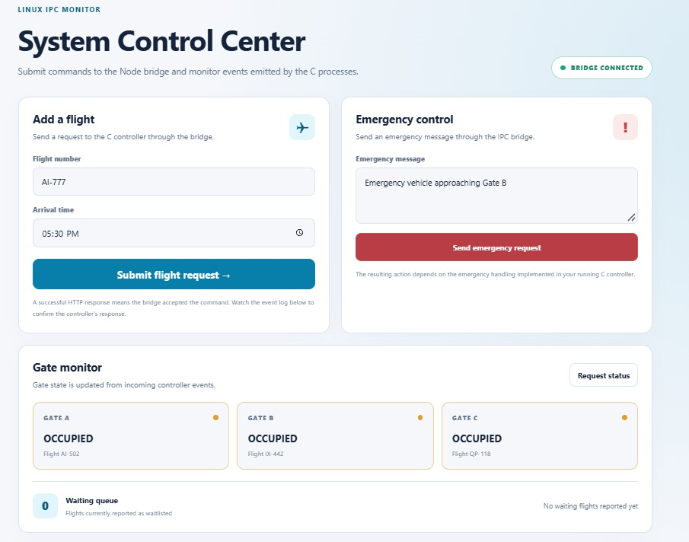

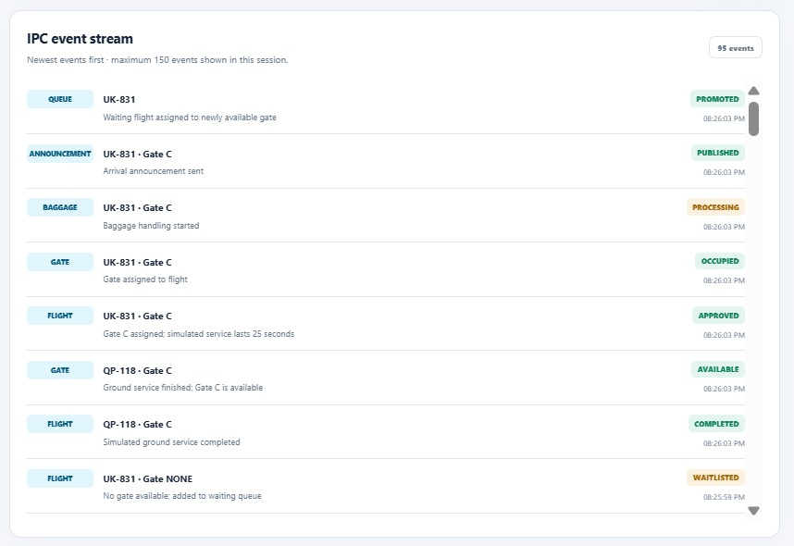

7.5 Demonstration of OS Concepts
Show that flight requests originate in one process and reach the Controller through unnamed pipes. Show gate occupation, a WAITLISTED request, and a subsequent PROMOTED event. Explain how service processes use FIFOs. Submit a manual request from the browser and correlate the UI with the Controller log.

CHAPTER 8 — CONCLUSION

8.1 Summary of the Project
Airport Ground Operations Using Linux IPC demonstrates how multiple Linux processes can cooperate to simulate airport activities. It combines actual C-based IPC with a browser-based monitoring interface.

8.2 Objectives Achieved
The implementation demonstrates request transmission, controller responses, gate allocation, waiting-queue behavior, service notifications, and frontend-to-simulation communication. These outcomes should be confirmed during the final live demonstration.

8.3 Results Achieved
Observed logs included automatic arrival requests, manual flight acceptance, waiting-queue insertion, gate release, and queue promotion. No numerical throughput, latency, or reliability benchmark is claimed without measurement.

8.4 Skills and Learning Outcomes
The project strengthens understanding of Linux processes, pipes, FIFOs, file descriptors, structured messages, queue management, GCC compilation, WSL execution, and the integration of an OS simulation with a React interface.

CHAPTER 9 — REFERENCES

9.1 Books
Silberschatz, Galvin, and Gagne, Operating System Concepts, Wiley. Stevens and Rago, Advanced Programming in the UNIX Environment, Addison-Wesley.

9.2 Research Papers
No research paper was specifically verified for this implementation. Add papers only after checking bibliographic details and relevance.

9.3 Linux / GNU Documentation
Linux manual pages: man 2 pipe; man 2 fork; man 3 mkfifo; man 2 read; man 2 write; man 2 open; man 2 close. GNU GCC documentation: https://gcc.gnu.org/onlinedocs/.

9.4 Online Resources
React documentation: https://react.dev/ ; Vite documentation: https://vite.dev/ ; Node.js documentation: https://nodejs.org/docs/latest/api/ ; Linux man-pages project: https://man7.org/linux/man-pages/.

