1. INSTALL MASTER EC2 /UNUNTU / …
   1. ADD THE SCRIPT FOR INSTALL - ANSIBILE, PYTHON
2. INSTALL SALVE *AS REQUIRED*
   1. ADD THE SCRIPT FOR INSTALL - PYTHON
3. ADDING THE SLAVE IP’S INTO HOST (UNDER /etc/ansible)
4. ROLES TOMCAT INSTALLTION

ansible-galaxy init tomcat

Now under cd tomcat/tasks (vi main.yaml)

---

# tasks file for tomcat

- name: Upgrade all packages

yum:

name: '*'

state: latest

- name: Java installation

yum:

name: java-1.8.0-openjdk

state: present

- name: Tomcat download

get_url:

url: https://downloads.apache.org/tomcat/tomcat-9/v9.0.46/bin/apache-tomcat-9.0.46.tar.gz

dest: /opt

mode: '0777'

- name: Extract into /opt

ansible.builtin.unarchive:

src: /opt/apache-tomcat-9.0.46.tar.gz

dest: /opt

remote_src: yes

mode: '0777'

- name: Starting server

shell: nohup /opt/apache-tomcat-9.0.46/bin/startup.sh &

Now create a yaml file and pass the role.

- hosts: all

remote_user: ec2-user

become: yes

roles:

- tomcat

Now run this above yaml. It will install tomcat in slaves.

1. COPY SERVER.XML FILE FROM SLAVE TO MASTER AND CHANGE THE CONNECTOR PORT IN WITH {{tomcat_port}} and edit the file name as server.xml.j2.

Now edit the yaml file and all the below tasks along with role

- hosts: all

remote_user: ec2-user

become: yes

vars:

tomcat_port: 9090

roles:

- tomcat

tasks:

- name: Template

template:

src: /home/ubuntu/server.xml.j2

dest: /opt/apache-tomcat-9.0.46/conf/server.xml

mode: '0777'

- name: Shuting server

shell: nohup /opt/apache-tomcat-9.0.46/bin/shutdown.sh &

- name: Starting server

shell: nohup /opt/apache-tomcat-9.0.46/bin/startup.sh &

1. Now run this yaml. It will change the port of Tomcat.
2. Create Jenkins role.

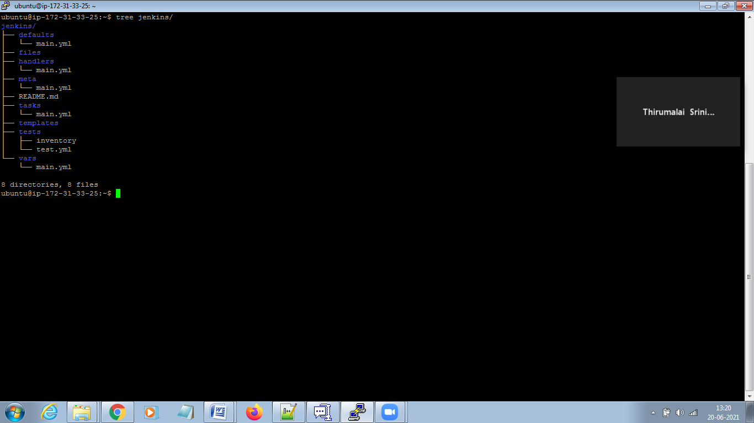

Under Jenkins/tasks (vi main.yaml)

---

# tasks file for jenkins

- name: Add jenkins repo install

yum_repository:

name: jenkins

description: jenkins repo

baseurl: http://pkg.jenkins.io/redhat

gpgkey: http://pkg.jenkins.io/redhat/jenkins.io.key

- name: install java and jenkins

yum:

name: "{{item}}"

state: present

loop:

- java

- jenkins

- name: jenkins start

service:

name: jenkins

state: started

- name: changing port

lineinfile:

path: /etc/sysconfig/jenkins

regexp: '^JENKINS_PORT='

line: JENKINS_PORT={{port}}

notify:

- restart Jenkins

Under Jenkins/vars (vi main.yaml)

---

# vars file for jenkins

port: 7070

Under Jenkins/handlers (vi main.yaml)

---

# handlers file for jenkins

- name: restart jenkins

service:

name: jenkins

state: restarted

Now create a role:

- hosts: all

remote_user: ec2-user

become: yes

roles:

- Jenkins

Now run this role. It will create Jenkins and change the port.

Adhoc-command for changing the port.

ansible-playbook test.yaml -e "tomcat_port=8080"