In this project we have added new model to detect signal time from video based traffic
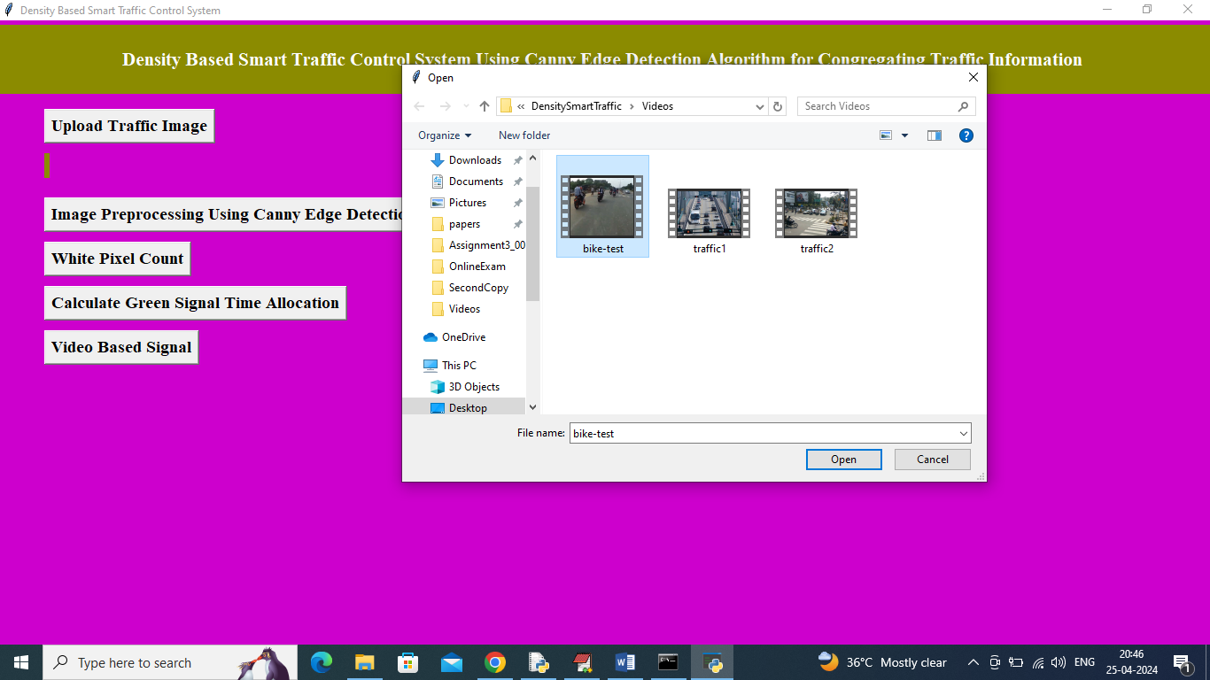
In above screen click on last button called ‘Video Based Signal’ button to upload video file and then click ‘Open’ button to get below output
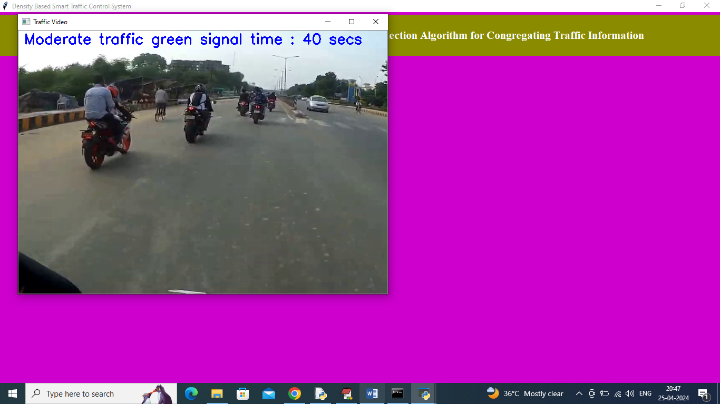
In above screen from video moderate traffic detected
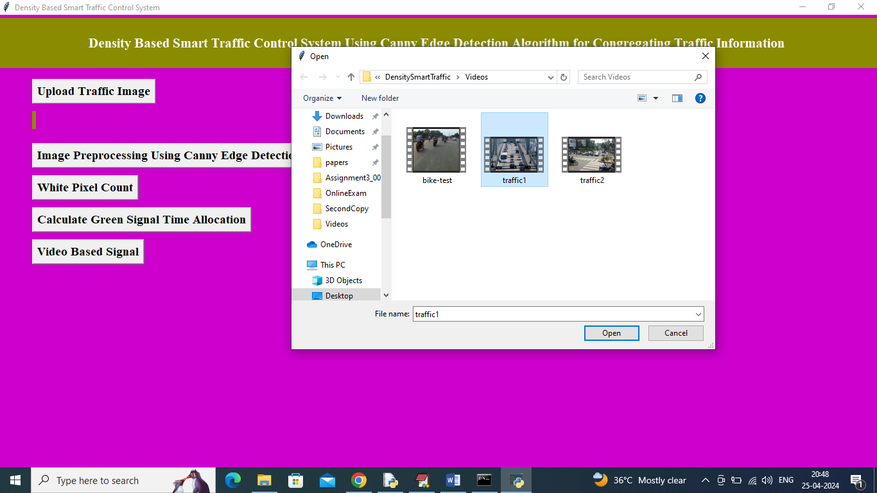
In above screen uploading another video and below is the output
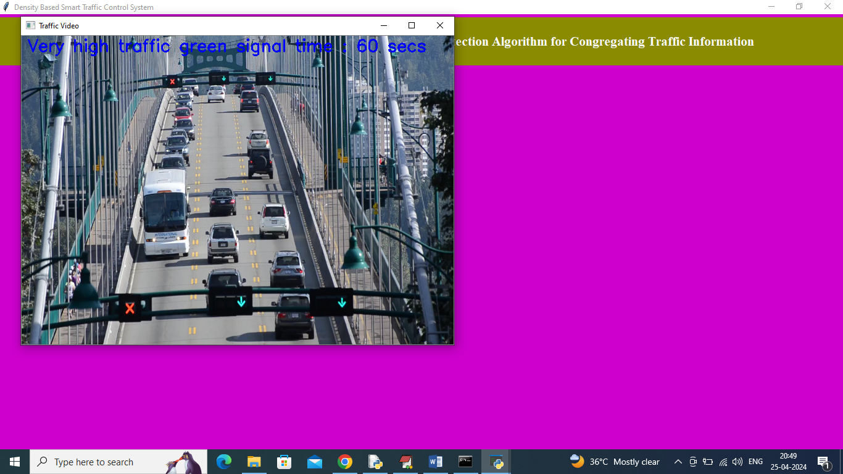
In above screen very high traffic detected
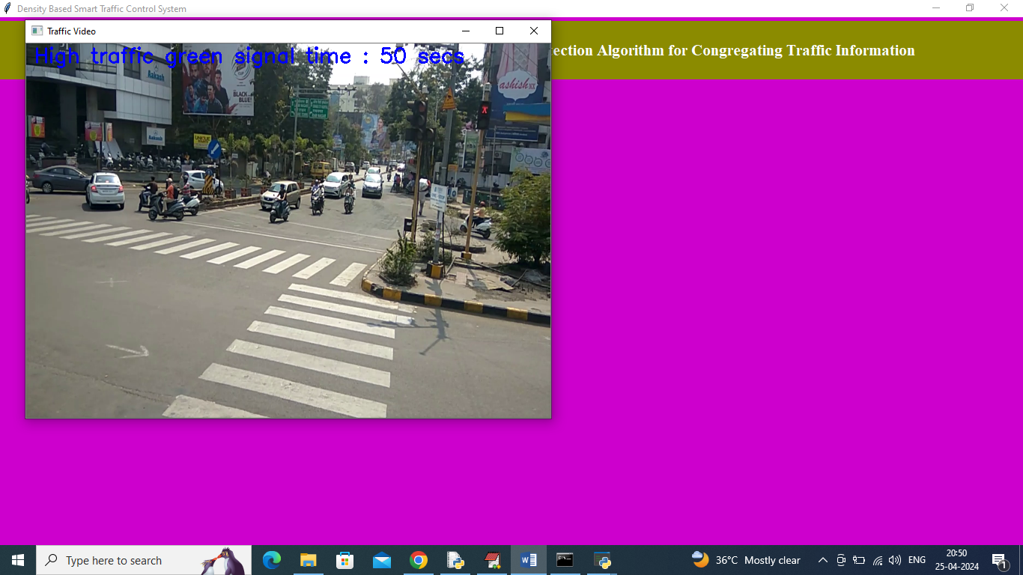
In above screen high traffic detected. Similarly you can upload and test any other videos

