**CS 6630: Project Proposal - Corporate Dashboard**

Team Members: Srinivaas Ganesan and Vipin Jose

**Basic Info**

Project Title: Corporate Dashboard

**Team Members**

1. Srinivaas Ganesan, u1060709, u1060709@utah.edu

2. Vipin Jose, u1077193, u1077193@utah.edu

**Project Repository**

https://github.com/vipinjose90/dataviscourse-pr-corporatedashboard

**Background and Motivation**

In our prior professional experience, Excel was used to review financials and the limited visualizations it provides were used to analyze information. Given the differences in nature of data and the information that is sought from them, Excel was not sufficient in most cases, but we still used it. Also, creating dynamic views in Excel is very difficult and require (simple) programming work-around that can be difficult (as Excel is not primarily meant for programming). Using our knowledge of d3 we would like to work on a way to present a dashboard and use it to show that this can help better assimilate data compared to Excel.

**Project Objectives**

We would like to use the knowledge we have in d3 to create an effective corporate dashboard that helps visualize data efficiently. We will use concepts covered in class, assignments and also some other d3 based visualizations to study the month-on-month variation in financials for a corporate.

**Data**

We are planning to generate the data ourselves. The corporation is structured as a matrix with skillsets (Software testing, Enterprise software, Analytics, Data Warehousing) and Industry sectors (Finance, Healthcare, Manufacturing, Technology). We model a typical services company where employees work for a client and are billed for the same. Each employee belongs to one or more ‘projects’ and also has one skillset. Employees belong to a project and projects belong to a customer. Customers belong to an Industry sector. The matrix view comes from the fact that employees also belong to a skillset.

**Data Processing**

Since we are generating the data this step is not required. We simulate a typical services company where few key customers contribute much of the revenue and a large number of small customers contribute less revenue.

**Visualization Design**

**Tab 1** Visualization of company level financials and practice level financials. Tab1 gives a quick snapshot of the company highlighting month on month variations. By selecting a practice, one can filter to see those financials only. This will also have some additional information and manual notes which present one to the visualization.

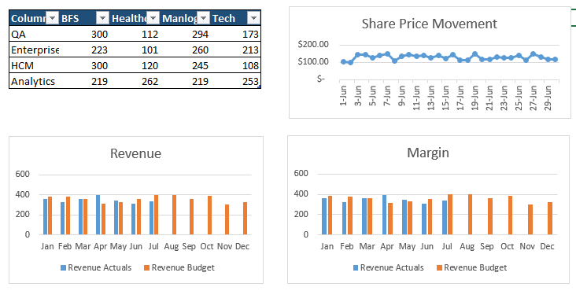

**Tab 2**

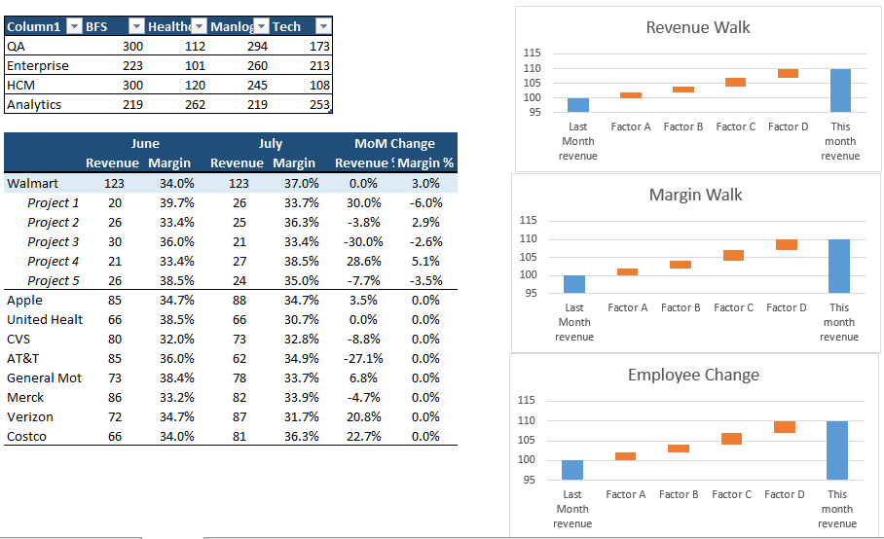

*Tab 2* gives a practice level and project level overview. The first table shows the summary of financials for the matrix structure. Click on any of them populates the projects in the second table shown. Clicking on a customer will show projects under that customer. At any of these three levels (practice, client, project) click populates the three figures on the right. First gives a revenue walk explaining why revenue increased/decreased with the reasons marked (more bill days, exchange gains, new employees added, utilization etc.) Margin walk will explain the increase/decrease in margin.

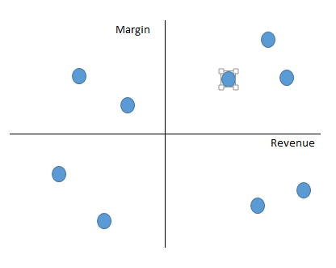

**Tab3** is similar to tab2, but it gives a better project level view. A chart similar to the one above segregates projects based on the margin and revenue. Note that the mid lines denote average revenue per project and margins for the entire company. Clicking on any project will populate the three transition charts to its right and will also give some project specific information.

**Tab4** Employee utilization view. This presents a tree level view of all employees in the company and shows the revenue they bring to the company. Any underperformers are highlighted in this. We plan to use a zoom-able tree structure with the CEO at the top and entry level associates at the leaves level.

**PROCESS BOOK**

As we are generating data for the project significant time was spent in data generation. We simulated the financials of a company with onsite/offshore model where few employees work from client locations in onsite and remote employees work from offshore. The story if that of a company trying to increase its profitability by reducing onsite-offshore mix, subcontractor dependence and employee utilization. Our visualization will show if the individual projects were able to achieve the goals set by the management and also highlight projects where there is scope for improvement.

We simulated a company with 100 clients, 3800 to 5000 employees (employees increase roughly by 100 every month) and 300 projects.

We have added a prototype for the views we discussed in our original outline.

**DESIGN EVOLUTION**

As we started working on this we made several changes based on peer feedback, consultation with TAs and our own thought process.

1. The summary table was changed into a summary matrix. Initially we proposed a summary table with key highlights but when we designed it we saw that there were too many numbers and tough to see what is what. TA Carolina wanted to include some visual cue to see which is the biggest and so we moved from table to a snapshot.

This was the original table idea implemented in d3

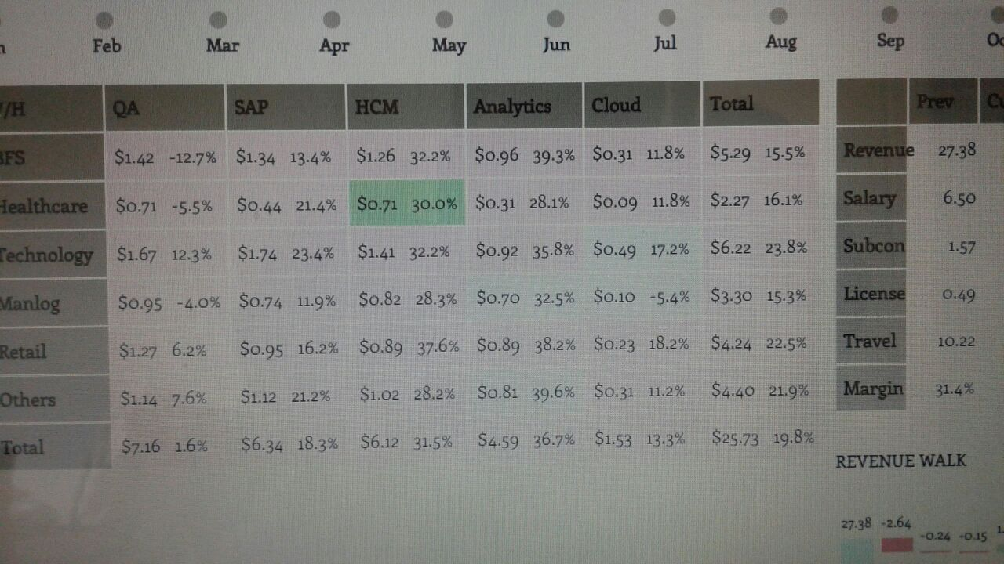

As you can see there are so many numbers and tough to see what is what!. Hence we captured the matrix nature of the organization by drawing a matrix. Below is the redesigned image.

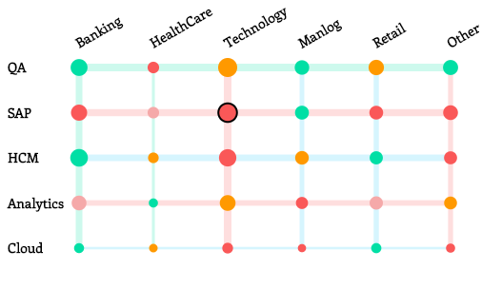

Here the verticals are shown as vertical bars and horizontals as horizontal bars. The width of each bar denotes the share of its revenue in company revenue. So, QA with a very thick bar has a big share in revenue of the corporate. The intersections are shown as circles. And circle radius denotes share of the BU (Business Unit) in overall organization.

Revenue and Margin are two things one would like to track and one immediate question is the revenue more than last month and is the margin more than last month. This leaves with 4 combinations (Revenue up, margin up; Revenue up, margin down; Revenue down, margin up; Revenue down, Margin down). These four combinations are encoded with the colors green, orange, light red, red. So one can immediately say the BU’s performance by seeing the color. We feel this matrix is much better than the original table idea.

REVENUE WALK

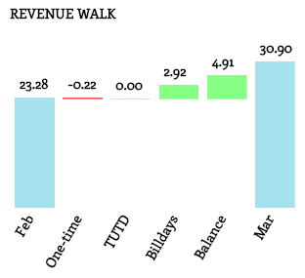

When a BU shows a revenue uptick month on month we would like to show the major contributors for that change. We cull out four main contributors for these: Billdays, True up true down, One-time adjustments and balance change in revenue. Each BU adds people for its work and this increase results in increased revenue. But there are other factors too.

1. Billdays: As a service organization that bills by the hour, months with more days give more time to bill. Since March has 31 days there will definitely be more revenue compared to Feb. Such a increase cannot be attributed to the BU but it is an external factor. So it’s calculated separately and shown as Billdays.
2. One-time: Accounting errors can sometimes cause revenue shifts. Sometimes managers miss billing deadlines which can cause this month’s revenue to flow in the next month. These are all one-time events and do not show the true financial of the practice. Hence they are culled out and shown as one-time
3. TUTD: Projects can be Time and material or Fixed Bid. In Time and material an associate works for x hours at an agreed upon rate y and the client is billed x*y. In a fixed bid project the client pays for a piece of work to be done in a certain time period. If the client pays $100,000 for a work to be done over 10 months, the accounting team recognizes $10,000 every month. But in between if the project manager feels he needs more time, say 11 months,