**CS 6630: Project Proposal - Corporate Dashboard**

Team Members: Srinivaas Ganesan and Vipin Jose

**Basic Info**

Project Title: Corporate Dashboard

**Team Members**

1. Srinivaas Ganesan, u1060709, u1060709@utah.edu

2. Vipin Jose, u1077193, u1077193@utah.edu

**Project Repository**

https://github.com/vipinjose90/dataviscourse-pr-corporatedashboard

**Background and Motivation**

In our prior professional experience, Excel was used to review financials and the limited visualizations it provides were used to analyze information. Given the differences in nature of data and the information that is sought from them, Excel was not sufficient in most cases, but we still used it. Also, creating dynamic views in Excel is very difficult and require (simple) programming work-around that can be difficult (as Excel is not primarily meant for programming). Using our knowledge of d3 we would like to work on a way to present a dashboard and use it to show that this can help better assimilate data compared to Excel.

**Project Objectives**

We would like to use the knowledge we have in d3 to create an effective corporate dashboard that helps visualize data efficiently. We will use concepts covered in class, assignments and also some other d3 based visualizations to study the month-on-month variation in financials for a corporate.

**Data**

We are planning to generate the data ourselves. The corporation is structured as a matrix with skillsets (Software testing, Enterprise software, Analytics, Data Warehousing) and Industry sectors (Finance, Healthcare, Manufacturing, Technology). We model a typical services company where employees work for a client and are billed for the same. Each employee belongs to one or more ‘projects’ and also has one skillset. Employees belong to a project and projects belong to a customer. Customers belong to an Industry sector. The matrix view comes from the fact that employees also belong to a skillset.

**Data Processing**

Since we are generating the data this step is not required. We simulate a typical services company where few key customers contribute much of the revenue and a large number of small customers contribute less revenue.

**Visualization Design**

**Tab 1** Visualization of company level financials and practice level financials. Tab1 gives a quick snapshot of the company highlighting month on month variations. By selecting a practice, one can filter to see those financials only. This will also have some additional information and manual notes which present one to the visualization.

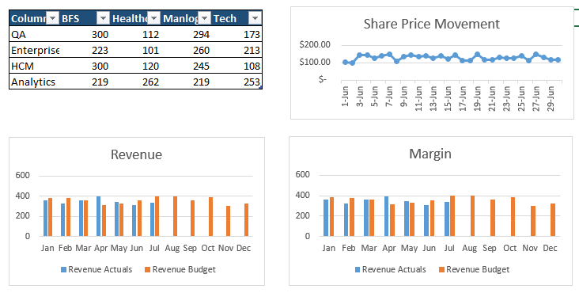

**Tab 2**

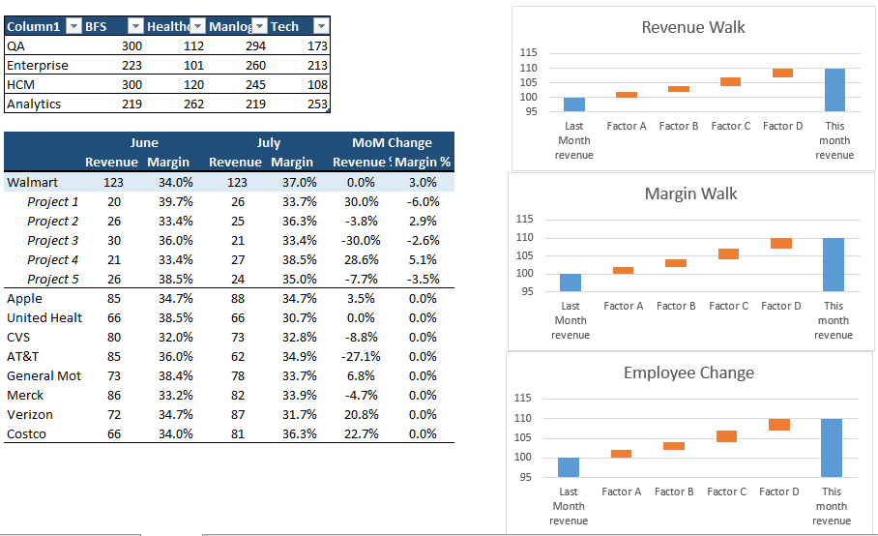

*Tab 2* gives a practice level and project level overview. The first table shows the summary of financials for the matrix structure. Click on any of them populates the projects in the second table shown. Clicking on a customer will show projects under that customer. At any of these three levels (practice, client, project) click populates the three figures on the right. First gives a revenue walk explaining why revenue increased/decreased with the reasons marked (more bill days, exchange gains, new employees added, utilization etc.) Margin walk will explain the increase/decrease in margin.

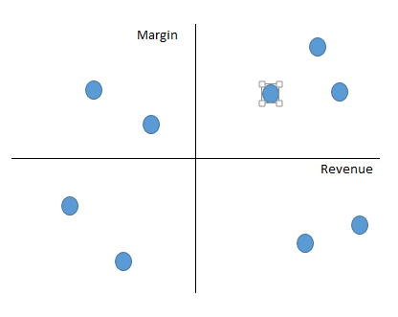

**Tab3** is similar to tab2, but it gives a better project level view. A chart similar to the one above segregates projects based on the margin and revenue. Note that the mid lines denote average revenue per project and margins for the entire company. Clicking on any project will populate the three transition charts to its right and will also give some project specific information.

**Tab4** State wise information. Each project belongs to a US state. So we will include spatial information to highlight how regions are performing. This will help see if some regional manager needs to be replaced.

**Tab5** Employee utilization view. This presents a tree level view of all employees in the company and shows the revenue they bring to the company. Any underperformers are highlighted in this. We plan to use a zoom-able tree structure with the CEO at the top and entry level associates at the leaves level.

**Must-Have Features**

Tab1,2,3 are essential features.

**Optional Features**

Tab 4 and Tab 5 are nice to have features.

**Project Schedule**

Week 1: Research on different ways to implement our target visualizations, find the best layout

for visualization. Survey other visualizations with similar purpose.

Week 2 - 4: Implement the main parts of the visualization

Week 5 - 6: clean and improve the main views, implement extra views.

Week 6: Finalize the report

**References**

[1] Stack Exchange Dataset

https://ia600500.us.archive.org/22/items/stackexchange/readme.tx