**Difference between document , window and screen object :**

**Document Object :**

A document instance represents the entire HTML document within a web browser window.

Accessing and altering the content, structure, and design of a web page is done through it.

**Features of Document Object :**

The document object provides a logical arrangement of the HTML elements on a website, allowing programmers to explore, alter, and alter the content dynamically.

We can pick specific elements based on their IDs, classes, or other attributes with the help of methods in the document object.

Document properties such as document.title, document.URL, and document.body provide information about the document's title, URL, and body, respectively.

We can create, modify, or delete elements, attributes, and text content on a webpage through the document object.

**Example :**

document.title = "Doc Object Demo"

document.getElementById("PageContent")

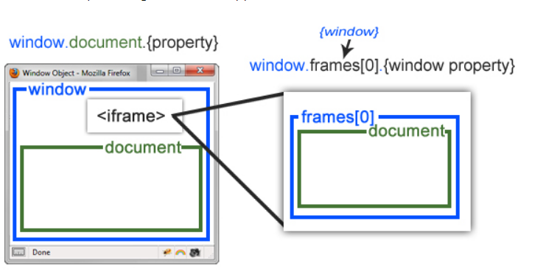

**Window Object :**

The window object is the global object and it is the top most object in the hierarchy of the DOM.

The frame represents a browser window or frame that displays the contents of the webpage.

The window object is created whenever a window appears on the screen.

**Features of Window Object :**

Variables and functions declared without the var, let, or const keyword become properties of the window object in JavaScript.

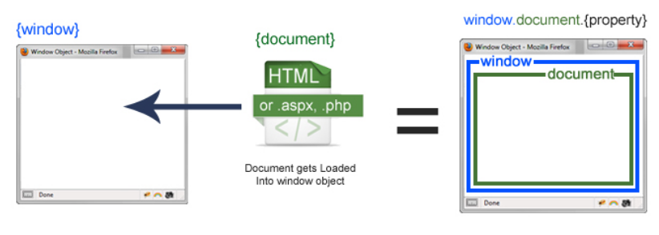

The window object provides properties like window.innerWidth, window.innerHeight, and window.navigator to provide information about the browser's dimensions, navigator object, and other related details.

Methods such as window.open(), window.close(), and window.location allow developers to control browser navigation, open new windows or tabs, and manipulate the current URL.

The window object provides functions such as setTimeout(), setInterval(), and clearTimeout() to manage time-based operations and execute code asynchronously.

**Example :**

window.open("https://www.gmail.com");

**Screen Object :**

It contains the information related to properties of the user's screen

We can access the details of width, height, color depth, and pixel depth of the screen.

By modifying the layout according to the screen size and resolution, we can create responsive web designs with the help of the screen object

**Example :**

window.screen.height

window.screen.width

window.screen.pixelDepth