**1. Answer Option: A**

Solution »

From the figure, it is clear that only conclusion 1 follows.

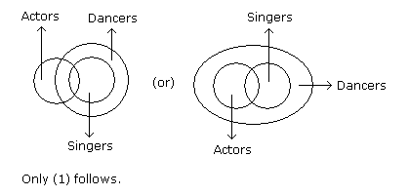

**2. Answer Option: E**

Solution »

From the image, we can infer that both (1) and (2) follow.

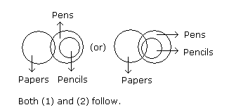

**3. Answer Option: D**

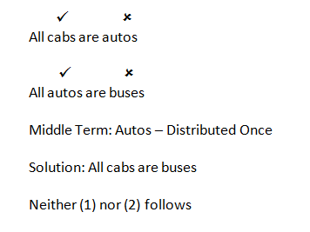

**4. Answer Option: A**

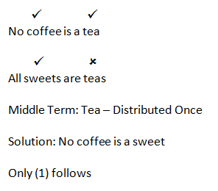

**5. Answer Option: B**

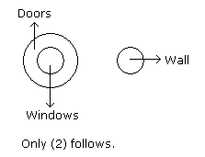

**6. Answer Option: A**

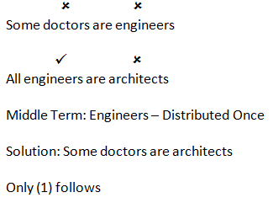

**7. Answer Option: E**

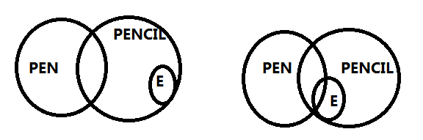

**8. Answer Option: D**

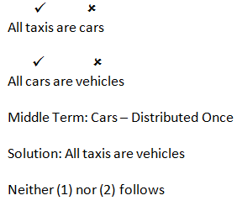

**9. Answer Option: A**

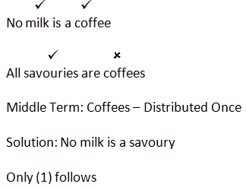

**10. Answer Option: D**

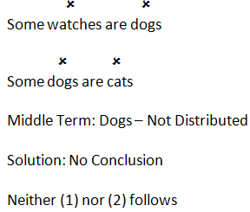

**11. Answer Option: A**

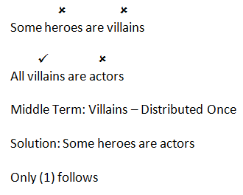

**12. Answer Option: E**

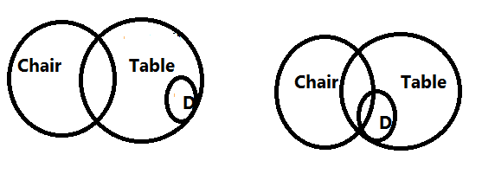

**13. Answer Option: D**

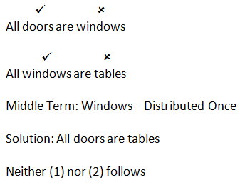

**14. Answer Option: A**

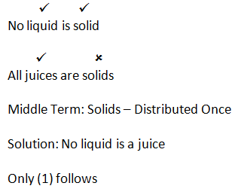

**15. Answer Option: D**

