CHILD EDUCATION

INTRODUCTION

Early childhood is a period of enormous growth and development. Children are developing more rapidly during the period from birth to age 5 than at any other time in their lives, shaped in large part by their experiences in the world. These early years of development are critical for providing a firm foundation in cognitive, language, and motor development, as well as social, emotional, regulatory, and moral development (NRC and IOM, 2000). Stimulating, nurturing, and stable relationships with parents and other caregivers are of prime importance to children’s healthy development, and the absence of these factors can compromise children’s development.

The individuals who comprise the early childhood care and education (ECCE) workforce are important providers of these early experiences. They form meaningful bonds with the children in their care, and their interactions, behaviors, and teaching practices all influence children’s development, as well as their later school readiness (NRC, 2001; Peisner-Feinberg et al., 2001; Pianta and Stuhlman, 2004). Moreover, they are affecting the development of an increasing proportion of U.S. children. Current estimates indicate that more than half of the 25.5 million U.S. children under age 6 spend time in the regular care of someone other than a parent in a typical week (Federal Interagency Forum on Child and Family Statistics, 2011; Iruka and Carver, 2006). These arrangements can include center-based child care, preschool, family child care centers, or informal care arrangements with friends, family, and neighbors, both paid and unpaid. The term “early childhood care and education” is inclusive of all these arrangements.

Policy-maker and public perception of ECCE is frequently at odds with the weighty responsibilities of this workforce, who influence so many facets of children’s development both in the short and long terms (Karoly et al., 2005). As the authors of From Neurons to Neighborhoods concluded:

The time is long overdue for society to recognize the significance of out-of-home relationships for young children, to esteem those who care for them when their parents are not available, and to compensate them adequately as a means of supporting stability, and quality in these relationships for all children, regardless of their families’ income and irrespective of their developmental needs. (NRC and IOM, 2000, p. 7)

Ten years since the publication of that report, most teachers and caregivers continue to receive low wages and to have low status, and are often described as “babysitters” or as “watching” children. Teachers in publicly funded preschool settings have fared somewhat better, but even these positions are viewed as low-status roles compared with elementary and secondary educators. The results of these circumstances include high turnover and few career opportunities in the field (Kagan et al., 2008).

The primary purpose of the early care or educational setting plays a role in shaping the perceptions and expectations for the workforce. Bellm and Whitebook (2006) describe two types of ECCE services—those with an educational focus and those whose primary function is to provide a safe setting that meets the basic needs of children of working parents. These purposes shape the terminology that describes the workforce (e.g., teachers versus caregivers), as well as policies and regulations at the local, state, and federal levels (Bellm and Whitebook, 2006).

Real differences between settings on degree of focus on educational goals relative to caring for children’s basic needs exist. However, opportunities to nurture healthy development and early learning occur in all of these settings, and some argue that children in all settings should experience effective practices regardless of the primary purpose of the care arrangement (NAEYC, 2009). Some have also argued that a workforce that can implement research-based practices is essential, not only because these high-quality experiences are beneficial to children, but also more importantly because the low-quality experiences that are so prevalent actually can harm children’s development and contribute to a widening achievement gap prior to kindergarten (Pianta et al., 2009).

**Why is education important?**

We have enlisted the 9 reasons why education is important for you and the society we live in.

1. Realizing your true potential

A good education helps you recognize yourself and your strengths. As you learn about the world and yourself, you come across things that interest you. You find things you are good at and figure out how you can contribute and help the world grow.

Education gives you opportunities to explore yourself, your surroundings and empowers you to understand the ways of the world. It gives you the freedom to live a life of your choice.

2. Sharpening critical skills

Education helps you develop critical skills like decision-making, mental agility, [problem-solving](https://ischoolconnect.com/blog/top-10-best-online-courses-for-2020/), and logical thinking. People face problems in their professional as well as personal lives. In such situations, their ability to make rational and informed decisions comes from how educated and self-aware they are.

Education also breeds creativity and innovation. When you take time to understand how the world works presently, only then can you come up with solutions and alternatives for existing problems.

3. More opportunities

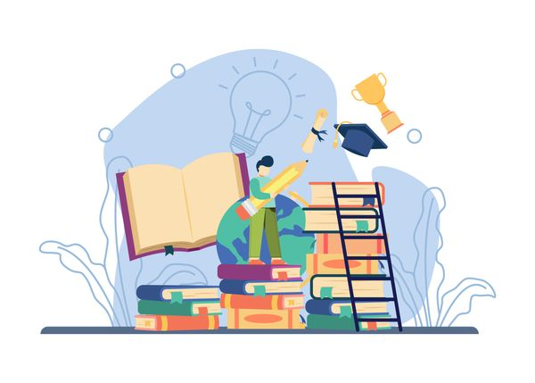Investing in getting a good education will increase your confidence and help you achieve more.

Education opens up new avenues. When you invest in educating yourself about a particular subject, you broaden your perspective in that area. As a result, you get opportunities to test and enhance your skillset. When you attend college or become a part of an organization, you get to meet the right people. You become a part of a community and also discover new things about yourself.

Moreover, as you [educate yourself](https://ischoolconnect.com/blog/10-best-countries-to-study-abroad-and-work/), you are learning something new every day without even realizing it. Your accolades in college and otherwise are indicative of your competence and can open doors for you.

4. Financial stability

Yet another benefit of having a strong educational background is financial stability. Students who graduate from [esteemed colleges](https://ischoolconnect.com/en/explore-schools/?limit=10&page=1&sort_key=best_rank) have a higher chance of landing well-paying jobs. The more knowledge you gain, the more skilled you become, and hence more opportunities open for you. If you are good at something and know your way around it, rest assured you will be compensated well.

[](https://ischoolconnect.com/blog/50-difficult-words-with-meaningwords-for-ielts-toefl-more/)

5. Supporting a developed society

Education is imperative when it comes to building a modern society. When people learn about things like culture, history, and science, they can view problems from a much-informed perspective. Education teaches values and helps in the development of society as a whole. It gives people a chance to mold themselves into more responsible members of the society.

Educated individuals are also more likely to get [well-paying jobs](https://ischoolconnect.com/blog/top-10-stem-courses-of-the-year/) and engage in effective trade and commerce practices. These in turn contribute to driving more capital to the economy. Hence, education drives growth in countries and supports a developing society.

6. Giving back to the community

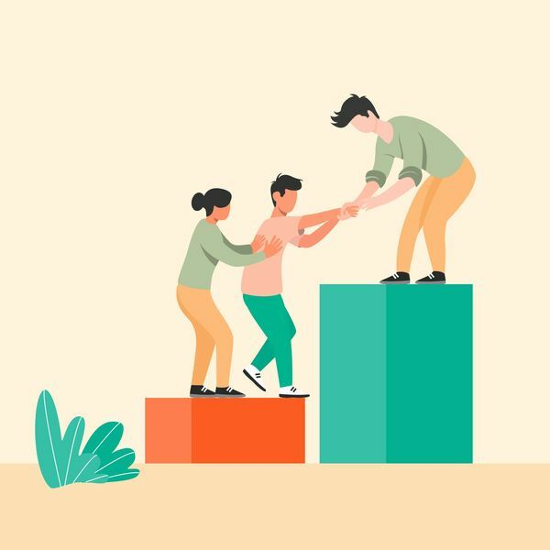Education brings people together. You need people to show you new possibilities.

When people can afford a stable life for themselves, they are more likely to take initiative to solve local problems. Education enables people to be self-dependent. It also teaches people the need for a stable and secure community. As a result, people join hands to [help the less fortunate](https://ischoolconnect.com/blog/top-10-ngos-in-india-for-volunteering-study-abroad-aspirants/) and solve the community’s most pressing issues.

The importance of education is at the forefront when it comes to social issues. No matter if it is the education of maintaining clean neighborhoods, practicing good sanitation, or knowing your rights. People can lift other people only by exposing them to new possibilities by educating them.

7. Blurring geographical boundaries

The importance of education is especially pronounced when we want to communicate with people from [different cultures across the world](https://ischoolconnect.com/blog/category/choosing-the-right-country/). When we have a wide knowledge base, it is easy for us to find common ground with someone from a different place.

Digital mediums of learning and spreading information have played an instrumental role in bridging this gap. They have allowed more people to connect, interact and learn. This new way of teaching and learning has blurred geographical boundaries and contributed to sharing insights and opinions, broadening the horizons of all involved.

8. Equal opportunities

Education helps us create equal opportunities. People from different genders, religions, castes, races, and cultures have multiple possibilities laid out in front of them because of education. They in turn strive to create more opportunities for others, even if only within their community. Education has made filling an irrational rift possible by making merit the only criterion for judgment.

Education makes people more tolerant of others. It makes them more open-minded, so they can accept different views and opinions. This further opens the gates for equal opportunities and a better standard of living for everyone.

9. As a tool for empowerment

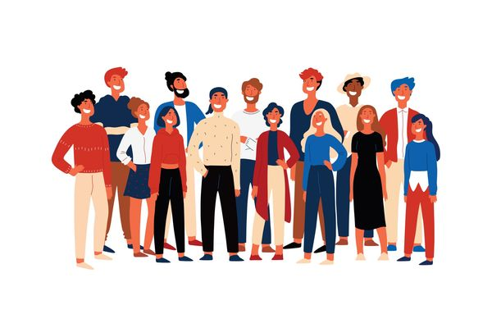Empowering someone with knowledge is the best way you can help them.

As mentioned above, education is the most powerful tool in the world. Minority sections are usually left unseen and ignored despite their potential. Educating these sections of the society not only initiates their growth but also the growth of the society. Because empowered people empower people.

For instance, increased education rates in women have led more women to join the workforce across various industries and stand up against the inequality they face. More and more women are being empowered through education, which has helped in the creation of a more inclusive and empathetic society. There is still a long way to go, but the importance of education in empowering sections of society cannot be overlooked.

**Key takeaways**

* Nelson Mandela once said, “Education is the most powerful weapon in the world,” and it sure is.
* Education can change the world. If you think about it, having an education shaped you as a human being.
* You are aware of yourself, you realize your place in the world, and you can dream of achieving big things.
* This is why the importance of education cannot be stressed enough.

HISTORY

Early education in India commenced under the supervision of a [*guru*](https://en.wikipedia.org/wiki/Guru) or *prabhu*.[[1]](https://en.wikipedia.org/wiki/History_of_education_in_the_Indian_subcontinent#cite_note-Prabhu24-1) Initially, education was open to all and seen as one of the methods to achieve Moksha in those days, or enlightenment. As time progressed, due to a decentralised social structure, the education was imparted on the basis of varna and the related duties that one had to perform as a member of a specific caste.[[1]](https://en.wikipedia.org/wiki/History_of_education_in_the_Indian_subcontinent#cite_note-Prabhu24-1) The [*Brahmans*](https://en.wikipedia.org/wiki/Brahmans) learned about scriptures and religion while the [*Kshatriya*](https://en.wikipedia.org/wiki/Kshatriya) were educated in the various aspects of warfare.[[1]](https://en.wikipedia.org/wiki/History_of_education_in_the_Indian_subcontinent#cite_note-Prabhu24-1) The [*Vaishya*](https://en.wikipedia.org/wiki/Vaishya) caste learned commerce and other specific vocational courses. The other caste [*Shudras*](https://en.wikipedia.org/wiki/Shudras), were men of working class and they were trained on skills to carry out these jobs.[[1]](https://en.wikipedia.org/wiki/History_of_education_in_the_Indian_subcontinent#cite_note-Prabhu24-1) The earliest venues of education in India were often secluded from the main population.[[1]](https://en.wikipedia.org/wiki/History_of_education_in_the_Indian_subcontinent#cite_note-Prabhu24-1) Students were expected to follow strict monastic guidelines prescribed by the *guru* and stay away from cities in [*ashrams*](https://en.wikipedia.org/wiki/Ashram).[[2]](https://en.wikipedia.org/wiki/History_of_education_in_the_Indian_subcontinent#cite_note-Prabhu25-2) However, as population increased under the [Gupta empire](https://en.wikipedia.org/wiki/Gupta_empire) centres of urban learning became increasingly common and Cities such as [Varanasi](https://en.wikipedia.org/wiki/Varanasi) and the [Buddhist](https://en.wikipedia.org/wiki/Buddhist) centre at [Nalanda](https://en.wikipedia.org/wiki/Nalanda) became increasingly visible.[[2]](https://en.wikipedia.org/wiki/History_of_education_in_the_Indian_subcontinent#cite_note-Prabhu25-2)

Education in India is a piece of education traditional form was closely related to religion.[[3]](https://en.wikipedia.org/wiki/History_of_education_in_the_Indian_subcontinent#cite_note-Blackwell88-3) Among the [Heterodox](https://en.wikipedia.org/wiki/Heterodox) schools of belief were the [Jain](https://en.wikipedia.org/wiki/Jain) and Buddhist schools.[[4]](https://en.wikipedia.org/wiki/History_of_education_in_the_Indian_subcontinent#cite_note-Blackwell90-4) Heterodox Buddhist education was more inclusive and aside of the monastic orders the Buddhist education centres were urban institutes of learning such as Taxila and Nalanda where grammar, medicine, philosophy, logic, metaphysics, arts and crafts etc. were also taught. Early secular Buddhist institutions of higher learning like Taxila and Nalanda continued to function well into the common era and were attended by students from [China](https://en.wikipedia.org/wiki/China) and [Central Asia](https://en.wikipedia.org/wiki/Central_Asia).[[3]](https://en.wikipedia.org/wiki/History_of_education_in_the_Indian_subcontinent#cite_note-Blackwell88-3)

On the subject of education for the nobility Joseph Prabhu writes: "Outside the religious framework, kings and princes were educated in the arts and sciences related to government: politics (*danda-nıti*), economics (*vartta*), philosophy (*anvıksiki*), and historical traditions (*itihasa*). Here the authoritative source was [Kautilya](https://en.wikipedia.org/wiki/Kautilya" \o "Kautilya)’s *[Arthashastra](https://en.wikipedia.org/wiki/Arthashastra" \o "Arthashastra)*, often compared to [Niccolò Machiavelli](https://en.wikipedia.org/wiki/Niccol%C3%B2_Machiavelli)’s [*The Prince*](https://en.wikipedia.org/wiki/The_Prince) for its worldly outlook and political scheming."[[1]](https://en.wikipedia.org/wiki/History_of_education_in_the_Indian_subcontinent#cite_note-Prabhu24-1) The [*Rigveda*](https://en.wikipedia.org/wiki/Rgveda) (1700-1500 BCE) mentions female poets called *brahmavadinis*, specifically [Lopamudra](https://en.wikipedia.org/wiki/Lopamudra" \o "Lopamudra) and [Ghosha](https://en.wikipedia.org/wiki/Ghosha" \o "Ghosha).[[5]](https://en.wikipedia.org/wiki/History_of_education_in_the_Indian_subcontinent#cite_note-Raman236-5) By 800 BCE women such as [Gargi](https://en.wikipedia.org/wiki/Gargi) and [Maitreyi](https://en.wikipedia.org/wiki/Maitreyi" \o "Maitreyi) were mentioned as scholars in the religious *[Upnishads](https://en.wikipedia.org/wiki/Upnishads" \o "Upnishads)*.[[5]](https://en.wikipedia.org/wiki/History_of_education_in_the_Indian_subcontinent#cite_note-Raman236-5) [Maya](https://en.wikipedia.org/wiki/Maya_(mother_of_Buddha)), mother of the historic [Buddha](https://en.wikipedia.org/wiki/Buddha), was an educated queen while other women in India contributed to writing of the [*Pali canon*](https://en.wikipedia.org/wiki/Pali_canon).[[5]](https://en.wikipedia.org/wiki/History_of_education_in_the_Indian_subcontinent#cite_note-Raman236-5) Out of the composers of the [Sangam literature](https://en.wikipedia.org/wiki/Sangam_literature) 154 were women.[[6]](https://en.wikipedia.org/wiki/History_of_education_in_the_Indian_subcontinent#cite_note-Raman237-6) However, the education and society of the era continued to be dominated by educated male population.[[7]](https://en.wikipedia.org/wiki/History_of_education_in_the_Indian_subcontinent#cite_note-Raman236-237-7)

### Traditional schools

Male education in India commenced under the supervision of a guru in traditional schools called [gurukuls](https://en.wikipedia.org/wiki/Gurukul). The gurukuls were supported by public donation and were one of the earliest forms of public school offices. However these Gurukuls catered only to the Upper castes of the Indian society and the overwhelming masses were denied any formal education.[[22]](https://en.wikipedia.org/wiki/History_of_education_in_the_Indian_subcontinent#cite_note-22)

Indigenous education was given higher importance from early time to colonial era.

In every Hindoo village which has retained anything of its form, I am assured that the rudiments of knowledge are sought to be imparted; that there is not a child, except those of the outcasts (who form no part of the community), who is not able to read, to write, to cipher; in the last branch of learning they are confessedly most proficient.

In 19th century India, "English education" meant "modern education". Most taught a curriculum similar to public schools. Britain at the time through English as a medium of instruction, especially those sponsored by missionaries. Some taught the curriculum through vernacular languages with English as a second language. The term "pre-modern" was used for three kinds of schools. The Arabic and Sanskrit schools taught Muslim or Hindu sacred literature, while the Persian schools taught Persian literature. The vernacular schools across India taught reading and writing the vernacular language and arithmetic.[[25]](https://en.wikipedia.org/wiki/History_of_education_in_the_Indian_subcontinent#cite_note-25)

As a result of decades of lobbying by the likes of [William Wilberforce](https://en.wikipedia.org/wiki/William_Wilberforce#Evangelical_Christianity), and [Charles Grant](https://en.wikipedia.org/wiki/Charles_Grant_(British_East_India_Company)), the [1813 renewal of East India Company's charter](https://en.wikipedia.org/wiki/Charter_Act_of_1813) carried a duty to educate, and assist previously excluded Christian missionaries to educate the population, in addition to the Company's corporate activities.[[26]](https://en.wikipedia.org/wiki/History_of_education_in_the_Indian_subcontinent#cite_note-BritSurv-26) The Company's officers were divided as to how to implement this imposed duty, with the orientalists, who believed that education should happen in Indian languages (of which they favored classical or court languages like Sanskrit or Persian), while the utilitarians (also called anglicists) like [Lord William Bentinck](https://en.wikipedia.org/wiki/Lord_William_Bentinck), and [Thomas Macaulay](https://en.wikipedia.org/wiki/Thomas_Babington_Macaulay,_1st_Baron_Macaulay), strongly believed that traditional India had nothing to teach regarding modern skills; the best education for them would happen in English. Macaulay called for an educational system - now known as [Macaulayism](https://en.wikipedia.org/wiki/Macaulayism" \o "Macaulayism) - that would create a class of anglicised Indians who would serve as cultural intermediaries between the British and the Indians

Recent world-wide trends

[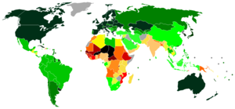](https://en.wikipedia.org/wiki/File:Education_index_UN_HDR_2007_2008.PNG)

World map indicating Education Index (2007/2008 [Human Development Report](https://en.wikipedia.org/wiki/Human_Development_Report))

* 0.950 and over
* 0.900–0.949
* 0.850–0.899
* 0.800–0.849
* 0.750–0.799
* 0.700–0.749
* 0.650–0.699
* 0.600–0.649
* 0.550–0.599
* 0.500–0.549
* 0.450–0.499
* 0.400–0.449
* 0.350–0.399
* under 0.350
* not available

Today, there is some form of [compulsory education](https://en.wikipedia.org/wiki/Compulsory_education) in most countries. Due to population growth and the proliferation of compulsory education, [UNESCO](https://en.wikipedia.org/wiki/UNESCO) has calculated that in the next 30 years more people will receive formal education than in all of human history thus far.

Illiteracy and the percentage of populations without any schooling have decreased in the past several decades. For example, the percentage of population without any schooling decreased from 36% in 1960 to 25% in 2000.

Among developing countries, illiteracy and percentages without schooling in 2000 stood at about half the 1970 figures. Among developed countries, figures about illiteracy rates differ widely. Often it is said that they decreased from 6% to 1%. Illiteracy rates in less economically developed countries ([LEDCs](https://en.wikipedia.org/wiki/LEDC)) surpassed those of more economically developed countries ([MEDCs](https://en.wikipedia.org/wiki/MEDC)) by a factor of 10 in 1970, and by a factor of about 20 in 2000. Illiteracy decreased greatly in LEDCs, and virtually disappeared in MEDCs. Percentages without any schooling showed similar patterns.

Percentages of the population with no schooling varied greatly among LEDCs in 2000, from less than 10% to over 65%. MEDCs had much less variation, ranging from less than 2% to 17%.

Since the mid-20th century, societies around the globe have undergone an accelerating pace of change in economy and technology. Its effects on the workplace, and thus on the demands on the educational system preparing students for the workforce, have been significant. Beginning in the 1980s, government, educators, and major employers issued a series of reports identifying key skills and implementation strategies to steer students and workers towards meeting the demands of the changing and increasingly digital workplace and society. [**21st century skills**](https://en.wikipedia.org/wiki/21st_century_skills) are a series of higher-order [skills](https://en.wikipedia.org/wiki/Skills), abilities, and learning dispositions that have been identified as being required for success in 21st century society and workplaces by educators, business leaders, academics, and governmental agencies. Many of these skills are also associated with [deeper learning](https://en.wikipedia.org/wiki/Deeper_Learning), including analytic reasoning, complex problem solving, and teamwork, compared to traditional knowledge-based academic skills.

#### **Primary school attendance remains a challenge in many developing countries**

The previous visualization showed the important progress that countries around the world have made regarding access to education, as measured by enrollment rates. Here we focus on evidence of access to education, as measured by school attendance. The difference lies in the source of information regarding participation: enrollment figures come from official records, while attendance estimates comes from asking households directly.

In the majority of developing countries, net enrollment rates are higher than attendance rates. This reflects the fact that many children who are officially enrolled, do not regularly attend school. The visualization, from the UNESCO report [Measuring Exclusion From Primary Education (2005)](http://www.uis.unesco.org/Library/Documents/oosc05-en.pdf), shows the relationship between these two measures. The source reports that “among the 59 countries with comparable data, in 24 countries participation rates drop by five percentage points for the primary school-age group when household surveys are used instead of administrative data.”[4](https://ourworldindata.org/global-education#note-4)

The interactive map shows recent primary school attendance estimates for a selection of (mainly) low and middle income countries in Africa, where the gaps between attendance and enrollment are largest. As we can see, low attendance rates are an important problem in sub-Saharan Africa – more so than enrollment figures suggest. In Niger, Chad and Liberia, estimates suggest that less than half of the school-aged children attend primary school.

###### ***Children in school: administrative data compared to household survey data, primary school ages – Figures A1 and A2 in UNESCO (2005)***[***5***](https://ourworldindata.org/global-education#note-5)

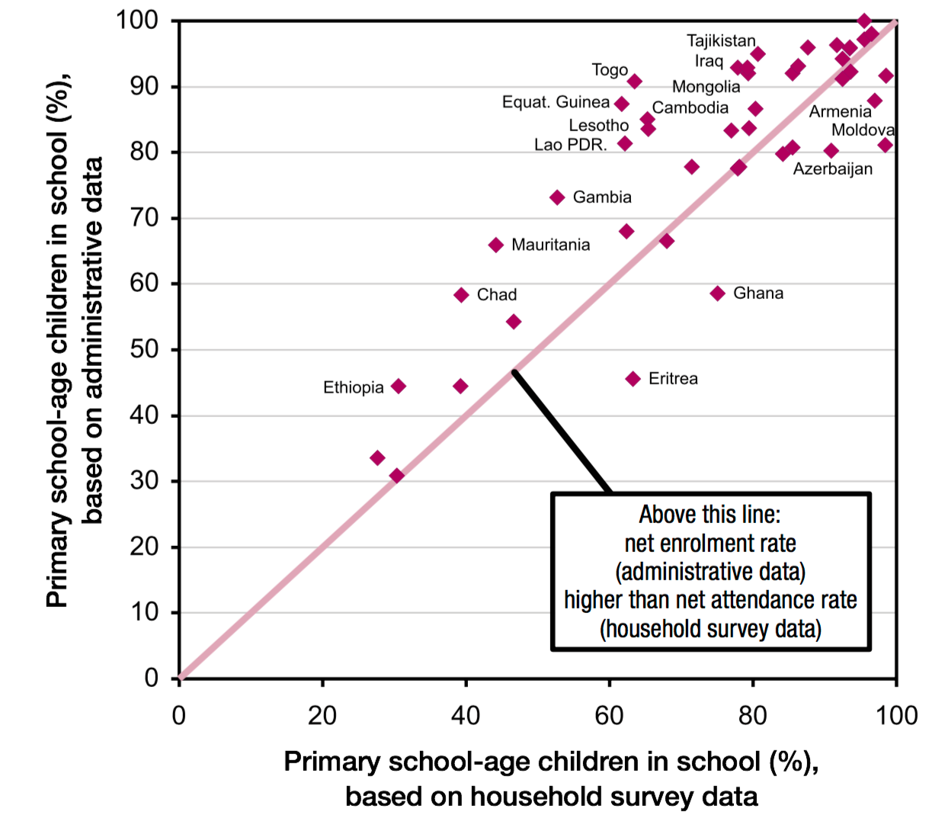

#### **Out-of-school children**

The chart shows the number of the world’s young population who are out of school across primary- and secondary-school-age. For 1998 it is estimated that 381 million children were out of school. Until 2014 this number fell to 263 million, despite an [increase in the global young population](https://ourworldindata.org/peak-child).  
For 2014 it can be seen that at the primary school age the number of girls that are out of school is higher than for boys. At the secondary school age the reverse is true, more boys than girls are out of secondary school.

# **[Number of out-of-school children, World, 1998 to 2014](https://ourworldindata.org/grapher/number-of-out-of-school-children" \t "_blank)**

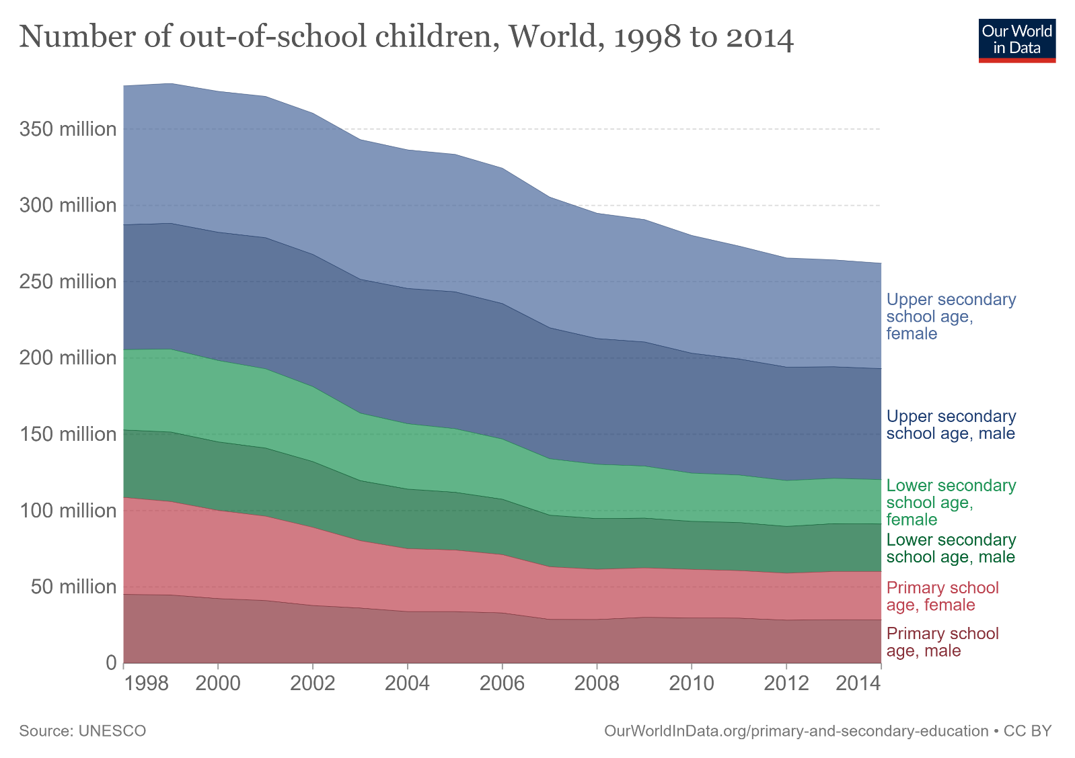

|  |  |  |  |  |  |  |  |  |  |  |  |
| --- | --- | --- | --- | --- | --- | --- | --- | --- | --- | --- | --- |
| ***Number of educational institutions, by level and control of institution: Selected years, 2009–10 through 2019–20*** | | | | | | | | | | | |
| **Level and control of institution** | **2009–10** | **2010–11** | **2011–12** | **2012–13** | **2013–14** | **2014–15** | **2015–16** | **2016–17** | **2017–18** | **2018–19** | **2019–20** |
| **Public schools** | **98,817** | **98,817** | **98,328** | **98,454** | **98,271** | **98,176** | **98,277** | **98,158** | **98,469** | **98,755** | **98,469** |
| Prekindergarten, elementary, and middle | 70,142 | 70,427 | 70,291 | 70,007 | 70,050 | 70,113 | 69,931 | 69,612 | 70,112 | 70,261 | 70,039 |
| Secondary and high | 23,499 | 23,728 | 23,195 | 23,348 | 23,311 | 23,441 | 23,472 | 23,379 | 23,318 | 23,567 | 23,529 |
| Other, ungraded, and not applicable/not reported | 5,176 | 4,662 | 4,842 | 5,099 | 4,910 | 4,622 | 4,874 | 5,167 | 5,039 | 4,927 | 4,901 |
| **Private schools1** | **33,366** | **–** | **30,861** | **–** | **33,619** | **–** | **34,576** | **–** | **32,461** | **–** | **30,492** |
| Prekindergarten, elementary, and middle | 21,611 | – | 19,884 | – | 22,698 | – | 22,115 | – | 20,245 | – | 18,870 |
| Secondary and high | 3,405 | – | 3,329 | – | 3,413 | – | 3,672 | – | 3,644 | – | 3,626 |
| Other, ungraded, and not applicable/not reported | 8,350 | – | 7,648 | – | 7,509 | – | 8,789 | – | 8,572 | – | 7,996 |

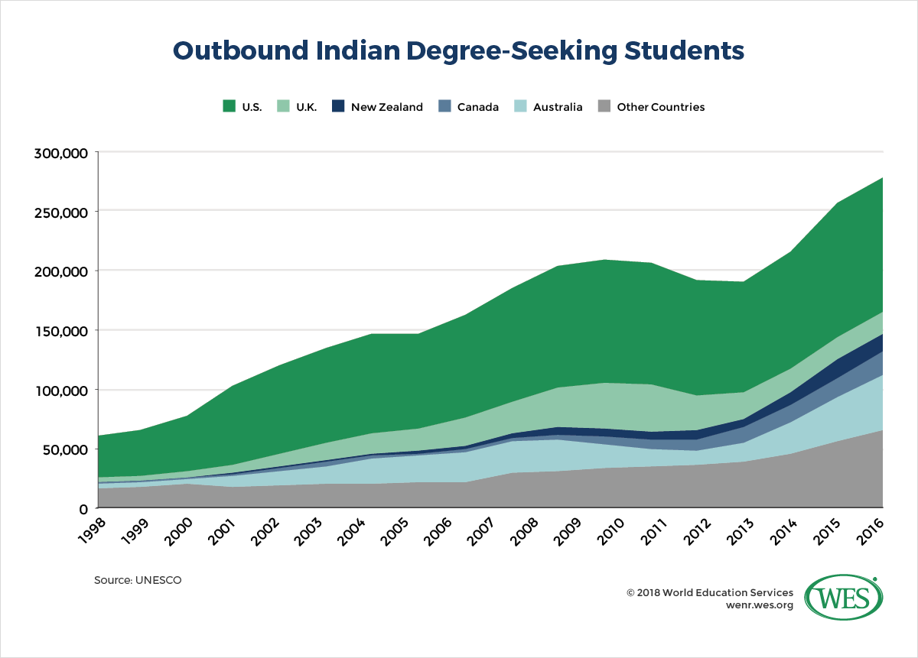

STATE WISE EDUCATIONAL INSTITUTIONS

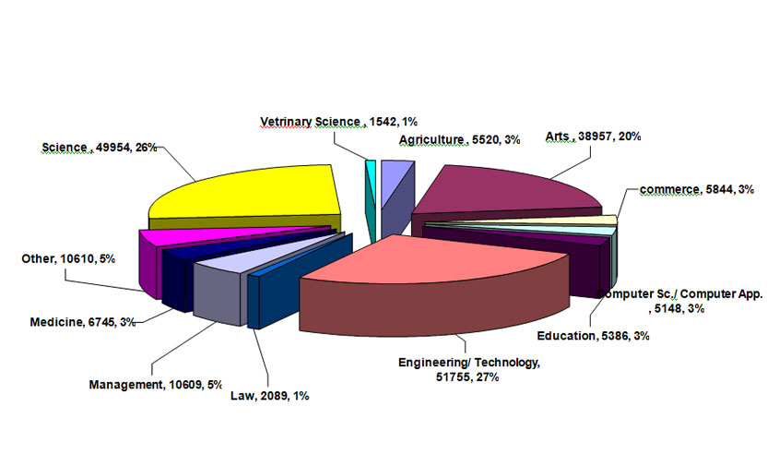

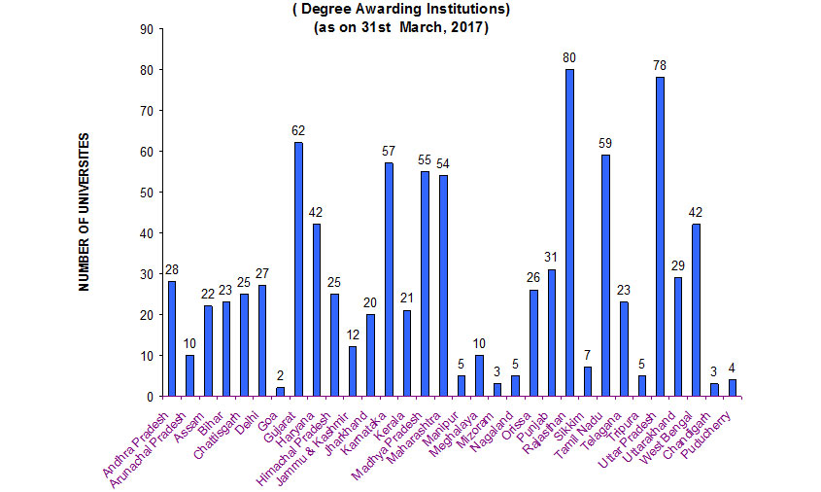

ADVANTAGES OF EDUCATION

# **Benefits of Education Are Societal and Personal**

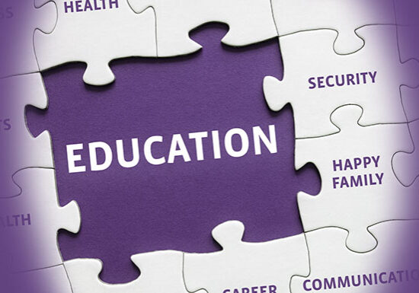



The benefits of education are many. Not only will you personally benefit from receiving education when it comes to income, [career advancement](https://www.uopeople.edu/programs/certificate/health-science/), skill development, and employment opportunities, but your society and community receive[benefits of education](https://www.uopeople.edu/blog/universal-human-rights/) as well.

Societies with higher rates of degree completion and levels of education tend to be healthier, have higher rates of economic stability, lower crime, ad [greater equality](https://www.uopeople.edu/blog/world-education-day-honors-human-rights/). For more surprising benefits of education, read on.

###### **Light bulb and idea bubbles on chalkboard**

###### **Photo by**[Pixabay](https://www.pexels.com/@pixabay?utm_content=attributionCopyText&utm_medium=referral&utm_source=pexels" \t "_blank)**from**[Pexels](https://www.pexels.com/photo/analysis-blackboard-board-bubble-355952/?utm_content=attributionCopyText&utm_medium=referral&utm_source=pexels" \t "_blank)

## Benefits of Education are Societal and Personal

Those who get an education have higher incomes, have more opportunities in their lives, and tend to be healthier. Societies benefit as well. Societies with high rates of education completion have lower crime, better overall health, and civic involvement.

Poverty Reduction

Lack of access to education is considered the root of poverty. Not getting an education can lead to a cycle of poverty. However, [access to education can mean getting out of that cycle](https://www.globalpartnership.org/data-and-results/education-data).

### 1. Healthier Lifestyle

People with better education tend to [live longer](https://www.healthaffairs.org/doi/full/10.1377/hlthaff.2011.0746) and have healthier lifestyles. According to [research](https://www.telegraph.co.uk/science/2017/08/31/gaining-degree-could-help-live-longer/), people with higher education have a one-third lower risk of heart disease. Degree holders are also [less likely to smoke and more likely to get regular exercise](https://www.cdc.gov/nchs/data/hus/hus11.pdf).

### 2. Experimentation and Diversity are a Benefit of Education:

A personal benefit to getting an education is the opportunity to grow as an individual, experiment with what you are passionate about, and find yourself. You will be exposed to a diverse set of people and ideas which expand the mind.

Connecting Across Borders

The new world of digital education is helping those who get an education to connect across the globe with people from other cultures. Students can collaborate together across borders, increasing the cultural awareness and worldliness of the individuals.

### 3. Socializing and [Networking](https://www.uopeople.edu/blog/12-networking-tips-for-students-who-want-to-get-the-best-jobs/) are Personal Benefits of Education

Education provides students with the space and the opportunities to meet like-minded individuals, either on a peer or mentor basis. In school, students meet leaders in their field, top professionals, and make contacts through extracurricular activities as well.

### 4. Pursuing Your Passion

###### **University of the People student following passion for education**

###### **Photo by**[Burst](https://www.pexels.com/@burst?utm_content=attributionCopyText&utm_medium=referral&utm_source=pexels)**from**[Pexels](https://www.pexels.com/photo/adult-book-book-series-college-545062/?utm_content=attributionCopyText&utm_medium=referral&utm_source=pexels" \t "_blank)

When you feel passionate about something, you want to immerse yourself in that topic. Education gives you the space to do so. In addition, you may find new passions or new areas of interest within your field of study.

Sense of Accomplishment

Finishing any degree — whether it is a high school degree or higher education — is an accomplishment. Graduating gives students a huge sense of accomplishment and gives them the confidence needed to go out into the world and make something of themselves.

### 5. Personal Development of Skills

Students are required to go through many types of assignments, discussions, courses, and more during their time in education. Therefore, they end up with a wonderful skill set that translates into the workforce.

In addition, from extracurriculars, students learn arts, sports, and more that help them personally in life and to connect with others.

More Productivity

Those with an education have had more on their plate and succeeded through it. They know how to manage their time and talents and be productive. After graduation, students can carry that productive energy into the workforce.

Better Communication

Students are required to turn in written assignments, work in groups, participate in discussions, or present in front of others. This leads to excellent written [communication](https://www.uopeople.edu/blog/effective-communication-techniques/), [speaking skills](https://www.uopeople.edu/blog/how-to-improve-english-speaking-skills/), and group communication.

Critical Thinking Skills

People with an education can think, and think well. They are taught to ask questions, reflect, and analyze — all critical skills for later success.

Identification of Skills

Some have skills that they haven’t yet discovered, and haven’t had the opportunity to expand upon. Education stretches the mind, exposes students to new topics, and pushes students to do better. As a result, students may find skills they didn’t even know they had.

Greater Sense of Discipline

Students are given increasing amounts of responsibility with each year of education they complete. It is the student’s job to manage their time and create their own success, leading to self-discipline abilities for those who succeed.

### 6. More Employment is a Benefit of Education

Degree holders have access to more jobs. For graduates of bachelor’s programs or higher, the unemployment rate is [cut in half](https://www.bls.gov/opub/ted/2018/unemployment-rate-2-1-percent-for-college-grads-3-9-percent-for-high-school-grads-in-august-2018.htm?view_full).

### 7. Career Entry and Advancement

###### **Photo by**[Godisable Jacob](https://www.pexels.com/@godisable-jacob-226636?utm_content=attributionCopyText&utm_medium=referral&utm_source=pexels" \t "_blank)**from**[Pexels](https://www.pexels.com/photo/woman-wearing-black-graduation-coat-sits-on-stairs-901962/?utm_content=attributionCopyText&utm_medium=referral&utm_source=pexels" \t "_blank)

College degrees prepare students for a career, or for advancement within their current field. Higher education gives the training and skills necessary for success in a specific area. In addition, many positions require a degree for entry. Some may not even look at a resume where the applicant has no degree.

### 8. Economic Growth

When an entire society is educated, productivity increases, average income increases, and unemployment decreases. This leads to the economic growth and stability of a society as a whole. It starts with education.

Higher Income as a Benefit of Education

Those with education beyond high school tend to have higher salaries than high school degree holders. Those with no degrees make the lowest salaries on average. For full-time workers in 2017, [weekly average wages](https://www.bls.gov/opub/ted/2017/high-school-graduates-who-work-full-time-had-median-weekly-earnings-of-718-in-second-quarter.htm) for those with no degree was $515, followed by high school graduates at $717, and $1,189 for bachelor’s degree holders. Those with graduate degrees made an average of $1,451.

### 9. Environmental Benefits

Climate change is a large part of the conversation today, and society needs to work together to find ways to reduce impact on the earth. Educated individuals that enter the workforce will put their knowledge of climate change into company policies, leading to increased sustainability.

### 10. Societal Benefits

###### **Four children huddled in a circle**

###### **Photo by**[Archie Binamira](https://www.pexels.com/@chiecharon?utm_content=attributionCopyText&utm_medium=referral&utm_source=pexels)**from**[Pexels](https://www.pexels.com/photo/four-toddler-forms-circle-photo-754769/?utm_content=attributionCopyText&utm_medium=referral&utm_source=pexels" \t "_blank)

A society that is well educated feels a higher sense of unity and trust within the community. Educated societies lift up the weak and bring a feeling of togetherness among all parts.

Promotes Equality and Empowerment

Education provides everyone with a sense of empowerment; the idea that they have the choice to change their own life and choose their path. Women with an education have better decision making capabilities and are more likely to take charge of their own lives.

Promotes Good Citizenship and Civic Involvement

Those with an education tend to be more aware of [current political issues](https://files.eric.ed.gov/fulltext/EJ1029882.pdf), and are more likely to [vote](https://files.eric.ed.gov/fulltext/EJ1029882.pdf). Higher degree holders are twice as likely to volunteer, and [3.5](https://www.aplu.org/projects-and-initiatives/college-costs-tuition-and-financial-aid/publicuvalues/publicuvalues-resources/q4/GradsSociety.pdf) times more likely to donate money than high school graduates.

Reduces Crime

Education teaches people the difference between right and wrong, and also exposes children and young adults to experiences of others. Understanding right and wrong and having empathy reduce tendency to commit crimes. Education of a society decreases overall arrests- just one year increase of average education levels of a state decrease state-wide arrests by 11%.

Reduces Gender-Based Violence

In communities with high rates of education for both genders, gender-based violence is [lower](https://www.epdc.org/sites/default/files/documents/EPDC-PolicyBrief-EduInequalityViolentConflict-v4.pdf). Educated persons are more likely to support gender equality, and are more likely to take efforts to stop and prevent gender-based or domestic violence. Communities that value education for both genders are[less likely](https://www.one.org/us/blog/violence-gender-education/) to have instances of terrorist attacks on girls schools.

Reduces Child Marriage

Girls with secondary or higher education are [three times](https://www.girlsnotbrides.org/wp-content/uploads/2017/09/Child-Marriage-and-Education-Girls-Not-Brides-August-2017.pdf) less likely to marry before the age of 18. Putting education first in a society allows for girls to be seen as people who can get an education and make their own decisions, rather than just a future wife and mother.

Reduces Maternal Death Rates

Maternal death rates drop significantly in societies with high education rates. Women with no education at all are [2.7](https://bmcpublichealth.biomedcentral.com/articles/10.1186/1471-2458-11-606) times as likely to die during birth as women with 12 years of education. Women with one to six years of education are twice as likely to suffer maternal mortality. This is because educated mothers are more likely to use health services, even in low socioeconomic settings. Lack of education is also a stressor for women during childbirth. The more stressors a woman has during pregnancy, the higher the likelihood for negative outcomes.

## Benefits of Higher Education

###### **University of the People students with backpacks going to study**

###### **Photo by**[Matthis Volquardsen](https://www.pexels.com/@einfoto?utm_content=attributionCopyText&utm_medium=referral&utm_source=pexels" \t "_blank)**from**[Pexels](https://www.pexels.com/photo/people-walking-on-a-hallway-2305097/?utm_content=attributionCopyText&utm_medium=referral&utm_source=pexels" \t "_blank)

### 1. Career Preparation

Some people know exactly what they want to do once they enter the workforce, and some people may need higher education to get to where they need to be. A college degree is a required prerequisite for a growing number of jobs. Even if you aren’t sure what you want to do after graduation, it is a great benefit to go to college. Higher education will help narrow your interest and refine your skill set, showing you exactly what you are good at and what field you may want to enter.

### 2. Broader Practical Benefits

Getting a higher education has some practical benefits too. When you look at [income research](https://www.bls.gov/opub/ted/2017/high-school-graduates-who-work-full-time-had-median-weekly-earnings-of-718-in-second-quarter.htm), the evidence is clear that college graduates make much more than their high school degree counterparts. College grads tend to be healthier as well, with [lower risk of heart disease](https://www.telegraph.co.uk/science/2017/08/31/gaining-degree-could-help-live-longer/), tendency towards [healthy eating and exercise](https://www.cdc.gov/nchs/data/hus/hus11.pdf), [smoke less](https://www.cdc.gov/nchs/data/hus/hus11.pdf) and [live longer](https://www.healthaffairs.org/doi/full/10.1377/hlthaff.2011.0746). College graduates also tend to have higher rates of participation in political and community affairs, [volunteerism](https://www.aplu.org/projects-and-initiatives/college-costs-tuition-and-financial-aid/publicuvalues/publicuvalues-resources/q4/GradsSociety.pdf) and charitable donations.

### 3. Personal Development

Students go through a lot of personal development in college. Things such as critical thinking skills, time management, perseverance, communication, and presentation skills are all great assets not only for future work but for personal life as well. College grads get further in life, not just because of the degree they’ve earned, but the experiences they went through.

### 4. Pursuing a Passion and Desired Field

Pursuing your passion in the form of a college degree is the path that some people take and there is nothing wrong with that. If you really love music, studying music, then find a way to make a career out of it. College will help you get a deeper and more theoretical understanding of your passion and will also open your eyes to possible career paths and mentors.

### 5. Cognitive and Communication Skills

College students study hard and they study often. They are taught to think alternatively and creatively to solve a problem. As a result, college students have the high[cognitive ability](https://www.uopeople.edu/blog/cognitive-science-explains-why-students-dont-like-school/). Courses often require [group work](https://www.uopeople.edu/blog/5-benefits-of-group-work-in-online-courses-and-degrees/) and presentations, resulting in better[interpersonal communication](https://www.uopeople.edu/blog/interpersonal-communication-tips-to-boost-your-career/) skills for grads.

### 6. Social Experiences

Don’t forget that college isn’t all studying. The friends you make during college will be the friends you have for life. They can also act as a social net, lifting you up when you are down and encouraging you to do your best in your studies, your profession, and in your life. Learning to live with others and work well with others enhances your social skills as well.

RESEARCH METHODOLOGY

Sample and Survey

A Questionnaire was framed and conducted to collect samples for the study. Purposive Random Sampling techniques were applied, and the sample consists of both LITERATE AND ILLETERATE PERSONS. Most of the data was collected from students and employees who regularly use vehicles. The data consists of both LITERATE AND ILLETERATE PERSONS based on which an assumption that users can differentiate and form a rational perception on LITERACY was made. A total of 331 respondents filled the questionnaire during the survey with varied demographics like age, income etc. out of which 7 were rejected due to incomplete data and biased responses.

Tools Used

Data Collection :

A survey questionnaire was prepared comprising 32 questions which were responsible for identifying various aspects of the research.

Data Analysis:

Various charts like Bar Chart, Pie Chart, Column chart were used for data analysis.

QUESTIONARIES

SURVEY AREA

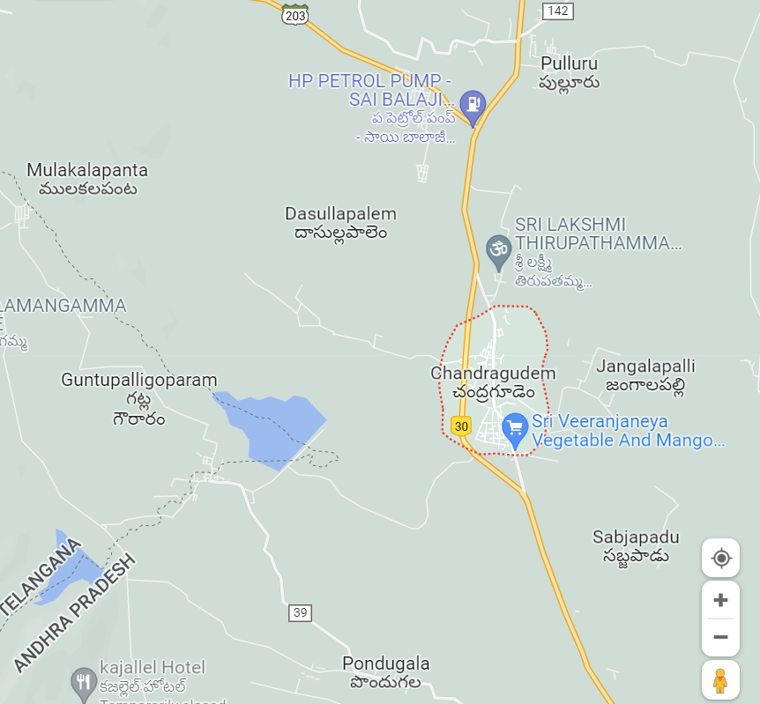

This survey was conducted by our team members on child education awareness program project in chandragudam which is located in Ntr.District.In this survey we have observed some issues and we are mentioning those issues below.

PROBLEMS IDENTIFIED

We observed many problems in chandragudam on child education but we are mentioning only some problems.

\* No proper availability of welfare schemes to students for education .

\*Lack of awareness about education to childrens.

\* Lack of government support towards education.

\*Suspending some students with no reasons.

\*No proper availability of information on education to parents.