Popularity



## Top 10 Artists by popularity

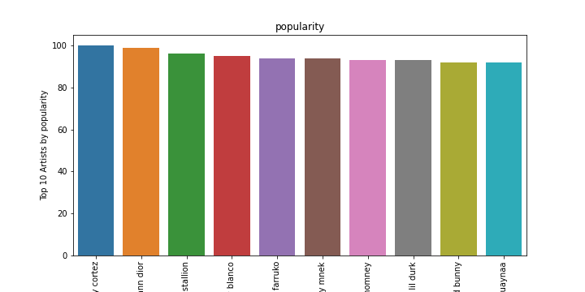

Figure 1: Top 10 Artists by popularity

Top 10 Artists by popularity:

bad bunny jhay cortez

kgoldn iann dior

cardi b megan thee stallion

justin bieber benny blanco

sech daddy yankee j balvin rosal a farruko

joel corry mnek

ritt momney

drake lil durk

j balvin tainy dua lipa bad bunny

lele pons guaynaa

## Top 10 Artists by danceability

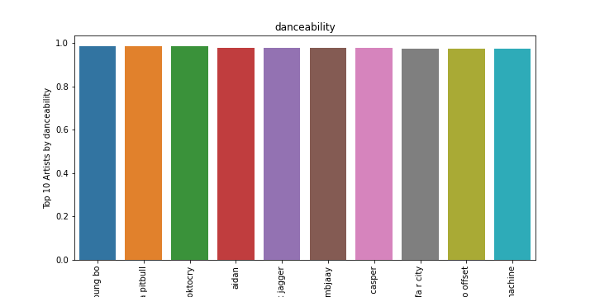

Figure 2: Top 10 Artists by danceability

Top 10 Artists by danceability:

pitbull trina young bo

young boss trina pitbull

itsoktocry

aidan

the jacksons mick jagger

ambjaay

dj casper

juicy j wiz khalifa r city

quality control lil yachty quavo offset

punkin machine

## Top 10 Artists by energy

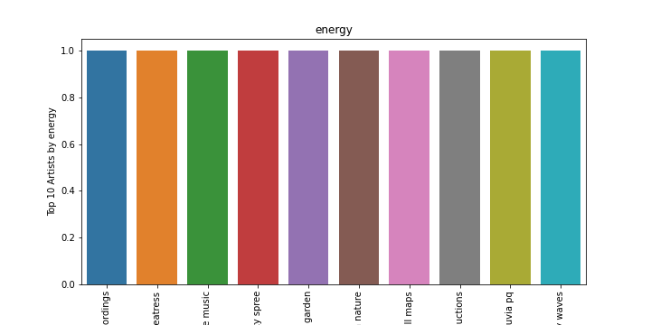

Figure 3: Top 10 Artists by energy

Top 10 Artists by energy:

outside broadcast recordings

creatress

nature sounds nature music

tranquility spree

rain sounds sleep sounds of nature zen music garden

the relaxing sounds of swedish nature

swell maps

thunderbound productions

lluvia pq

lullaby waves

## Top 10 Artists by loudness

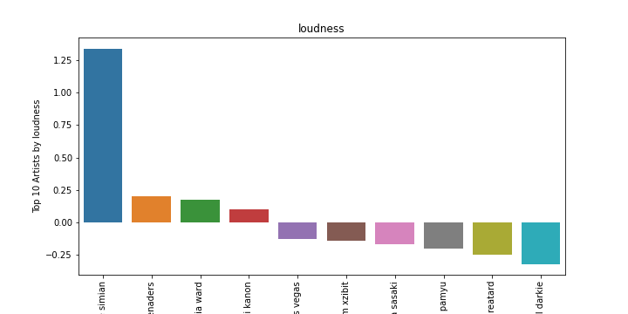

Figure 4: Top 10 Artists by loudness

Top 10 Artists by loudness:

justice simian

lord beginner cyril blake s calypso serenaders

diplo french montana lil pump zhavia ward

atmozfears demi kanon

fear and loathing in las vegas

dr dre eminem xzibit

iroha sasaki

kyary pamyu pamyu

jay reatard

lil darkie

## Top 10 Artists by speechiness

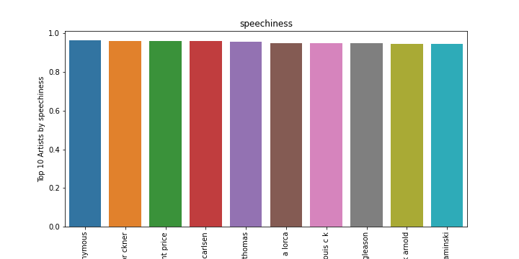

Figure 5: Top 10 Artists by speechiness

Top 10 Artists by speechiness:

alcoholics anonymous

ernest hemingway christian br ckner

michael jackson rod temperton vincent price

georgette heyer brigitte carlsen

mel brooks marlo thomas

federico garc a lorca

louis c k

jerry reed jackie gleason

sinclair lewis frank arnold

dale carnegie till hagen stefan kaminski

## Top 10 Artists by acousticness

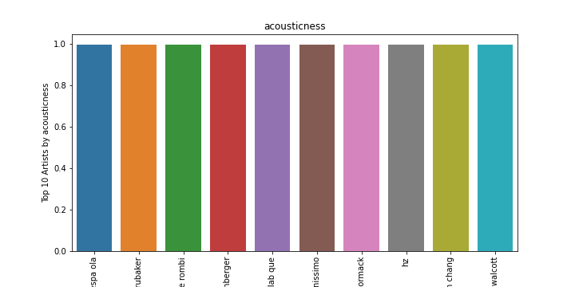

Figure 6: Top 10 Artists by acousticness

Top 10 Artists by acousticness:

banda espa ola

philip glass bruce brubaker

philippe rombi

pyotr ilyich tchaikovsky carol rosenberger

georges bizet katia lab que marielle lab que

piano pianissimo

john mccormack

hz

jacques ibert hae won chang

meredith monk collin walcott

## Top 10 Artists by instrumentalness

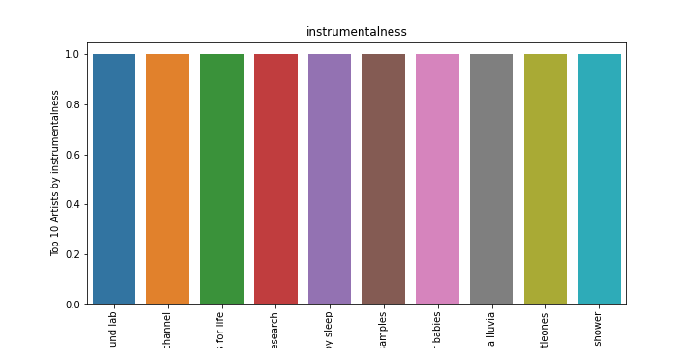

Figure 7: Top 10 Artists by instrumentalness

Top 10 Artists by instrumentalness:

the white noise zen meditation sound lab

relaxation channel

sounds for life

erik eriksson lullabies for deep meditation baby sweet dream white noise research

erik eriksson white noise for babies white noise baby sleep

high altitude samples

erik eriksson white noise baby sleep white noise for babies

loopable verter la lluvia

littleones

sleep baby sleep meditation spa white noise therapy rain spa rain shower

## Top 10 Artists by liveness

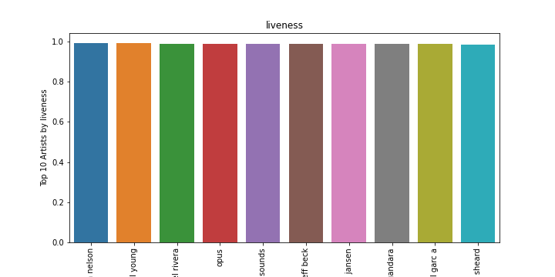

Figure 8: Top 10 Artists by liveness

Top 10 Artists by liveness:

jonathan nelson

the band neil young

fania all stars celia cruz ismael rivera

opus

waterfall sounds

stevie ray vaughan and double trouble with jeff beck

eric clapton john jansen

jes s adri n romero marcela gandara

franco de vita noel schajris leonel garc a

karen clark sheard

## Top 10 Artists by valence

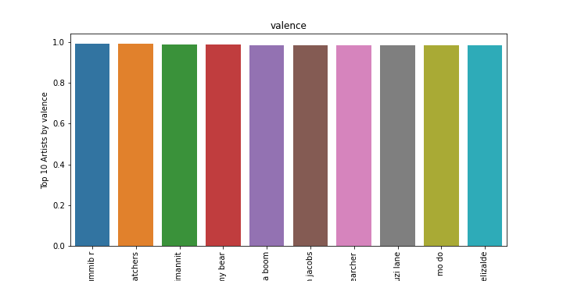

Figure 9: Top 10 Artists by valence

Top 10 Artists by valence:

gummib r

the bodysnatchers

jorma ik valko pirte t pelimannit

gummy bear

banda boom

william jacobs

soulsearcher

suzi lane

mo do

francisco el chico elizalde

## Top 10 Artists by tempo

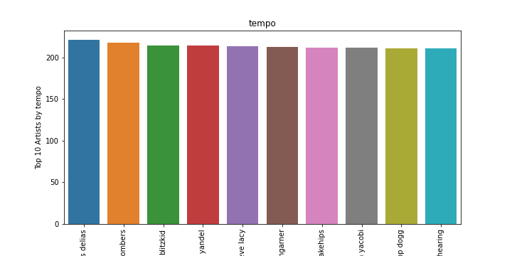

Figure 10: Top 10 Artists by tempo

Top 10 Artists by tempo:

anestis delias

the jive bombers

blitzkid

tony dize yandel

goldlink steve lacy

samantha bumgarner

banks snakehips

neneh yacobi

the pussycat dolls snoop dogg

peggy lee george shearing

## Top 10 Artists by duration_ms

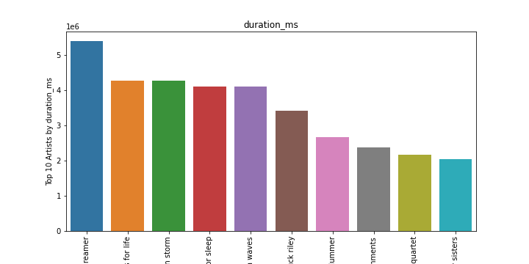

Figure 11: Top 10 Artists by duration_ms

Top 10 Artists by duration_ms:

sound dreamer

sounds for life

lightning thunder and rain storm

ocean waves for sleep

one hour gulf coast ocean waves

chuck riley

christopher plummer

environments

glenn gould symphonia quartet

bombay sisters

## Distribution of popularity

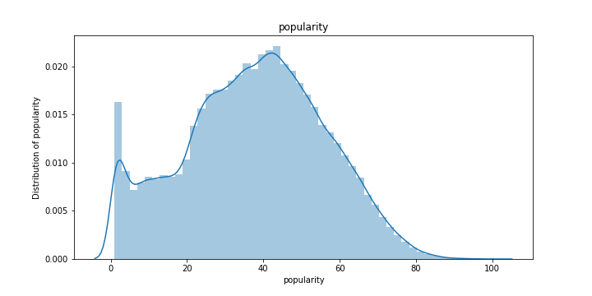

Figure 12: Distribution of popularity

## Distribution of danceability

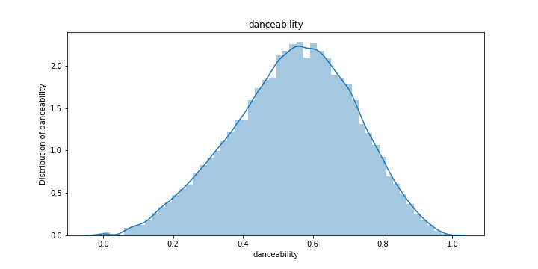

Figure 13: Distribution of danceability

## Distribution of energy

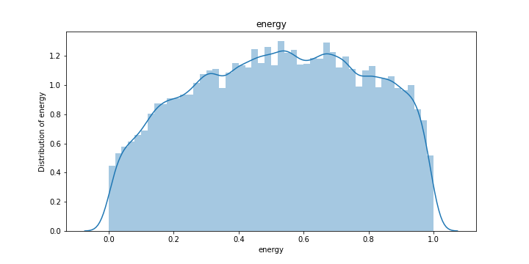

Figure 14: Distribution of energy

## Distribution of loudness

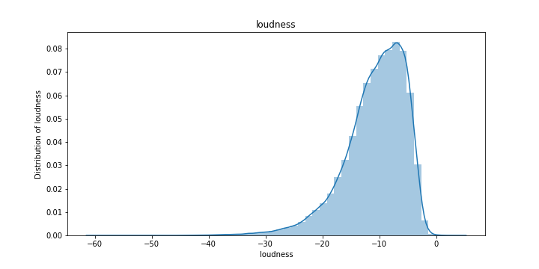

Figure 15: Distribution of loudness

## Distribution of speechiness

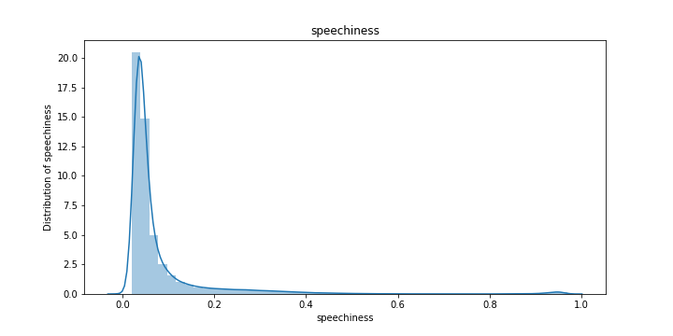

Figure 16: Distribution of speechiness

## Distribution of acousticness

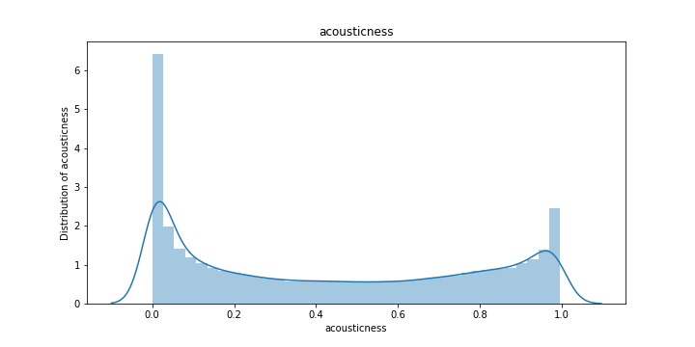

Figure 17: Distribution of acousticness

## Distribution of instrumentalness

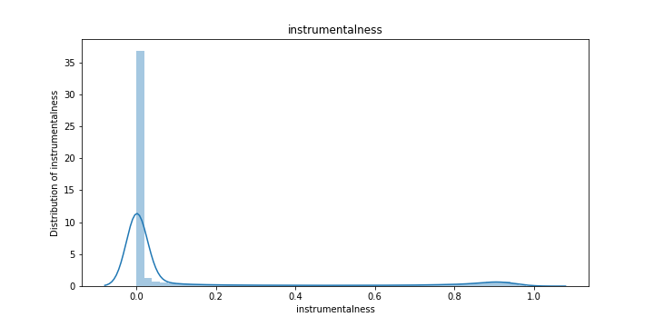

Figure 18: Distribution of instrumentalness

## Distribution of liveness

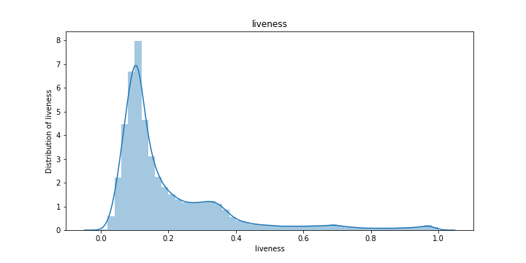

Figure 19: Distribution of liveness

## Distribution of valence

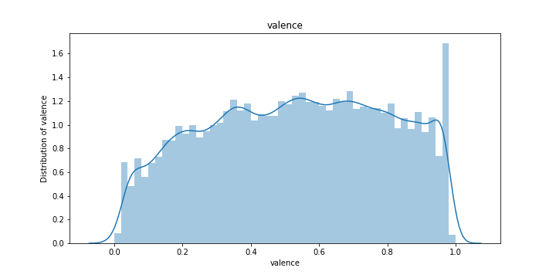

Figure 20: Distribution of valence

## Distribution of tempo

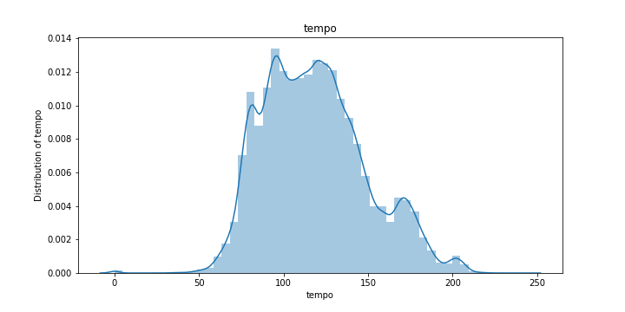

Figure 21: Distribution of tempo

## Distribution of duration_ms

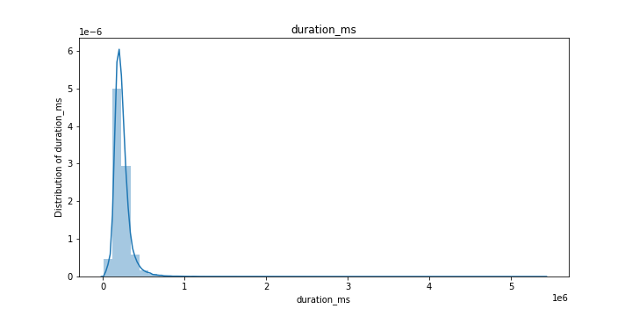

Figure 22: Distribution of duration_ms