Popularity

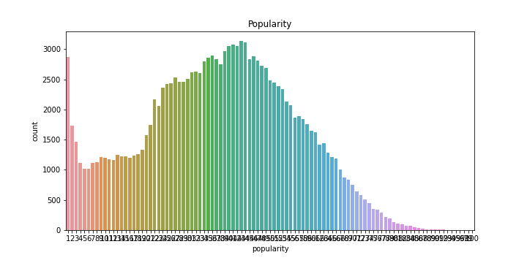

## Top 10 Artists by popularity

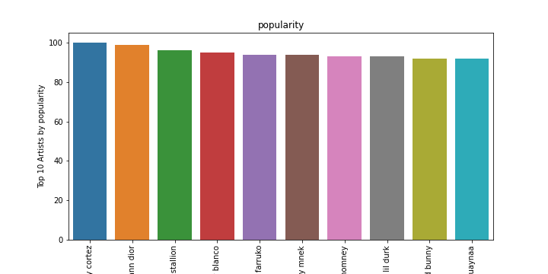

Figure 1: Top 10 Artists by popularity

Top 10 Artists by popularity:

bad bunny jhay cortez

kgoldn iann dior

cardi b megan thee stallion

justin bieber benny blanco

sech daddy yankee j balvin rosal a farruko

joel corry mnek

ritt momney

drake lil durk

j balvin tainy dua lipa bad bunny

lele pons guaynaa

## Top 10 Artists by danceability

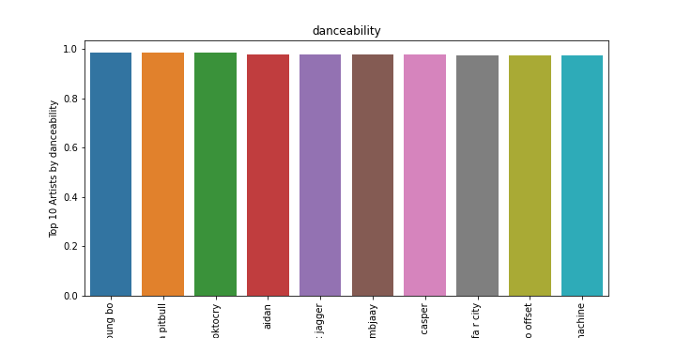

Figure 2: Top 10 Artists by danceability

Top 10 Artists by danceability:

pitbull trina young bo

young boss trina pitbull

itsoktocry

aidan

the jacksons mick jagger

ambjaay

dj casper

juicy j wiz khalifa r city

quality control lil yachty quavo offset

punkin machine

## Top 10 Artists by energy

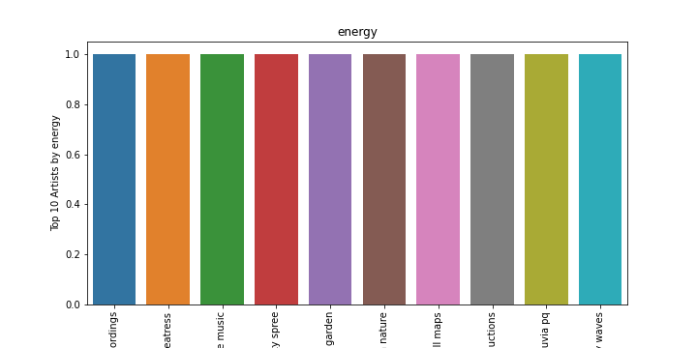

Figure 3: Top 10 Artists by energy

Top 10 Artists by energy:

outside broadcast recordings

creatress

nature sounds nature music

tranquility spree

rain sounds sleep sounds of nature zen music garden

the relaxing sounds of swedish nature

swell maps

thunderbound productions

lluvia pq

lullaby waves

## Top 10 Artists by loudness

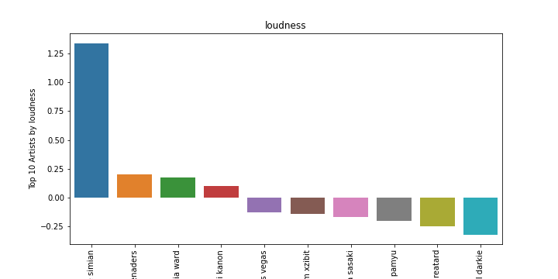

Figure 4: Top 10 Artists by loudness

Top 10 Artists by loudness:

justice simian

lord beginner cyril blake s calypso serenaders

diplo french montana lil pump zhavia ward

atmozfears demi kanon

fear and loathing in las vegas

dr dre eminem xzibit

iroha sasaki

kyary pamyu pamyu

jay reatard

lil darkie

## Top 10 Artists by speechiness

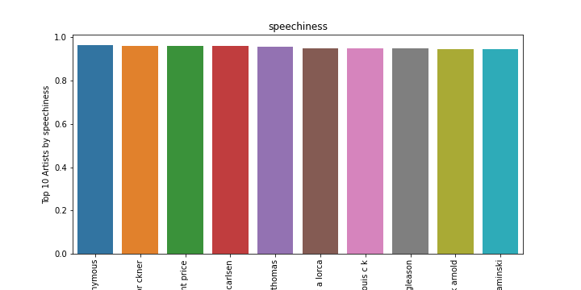

Figure 5: Top 10 Artists by speechiness

Top 10 Artists by speechiness:

alcoholics anonymous

ernest hemingway christian br ckner

michael jackson rod temperton vincent price

georgette heyer brigitte carlsen

mel brooks marlo thomas

federico garc a lorca

louis c k

jerry reed jackie gleason

sinclair lewis frank arnold

dale carnegie till hagen stefan kaminski

## Top 10 Artists by acousticness

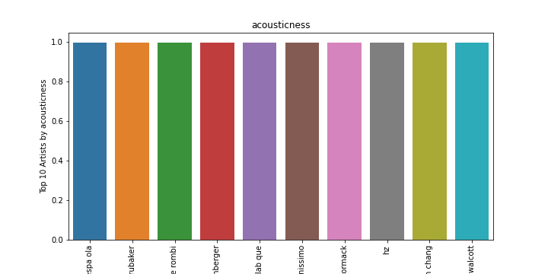

Figure 6: Top 10 Artists by acousticness

Top 10 Artists by acousticness:

banda espa ola

philip glass bruce brubaker

philippe rombi

pyotr ilyich tchaikovsky carol rosenberger

georges bizet katia lab que marielle lab que

piano pianissimo

john mccormack

hz

jacques ibert hae won chang

meredith monk collin walcott

## Top 10 Artists by instrumentalness

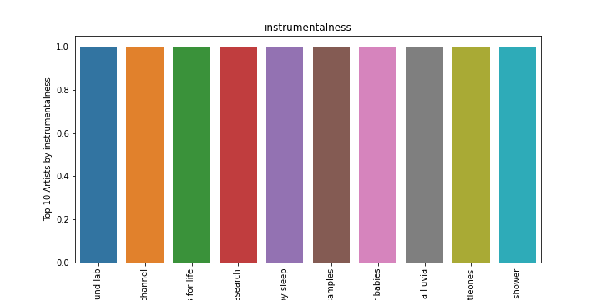

Figure 7: Top 10 Artists by instrumentalness

Top 10 Artists by instrumentalness:

the white noise zen meditation sound lab

relaxation channel

sounds for life

erik eriksson lullabies for deep meditation baby sweet dream white noise research

erik eriksson white noise for babies white noise baby sleep

high altitude samples

erik eriksson white noise baby sleep white noise for babies

loopable verter la lluvia

littleones

sleep baby sleep meditation spa white noise therapy rain spa rain shower

## Top 10 Artists by liveness

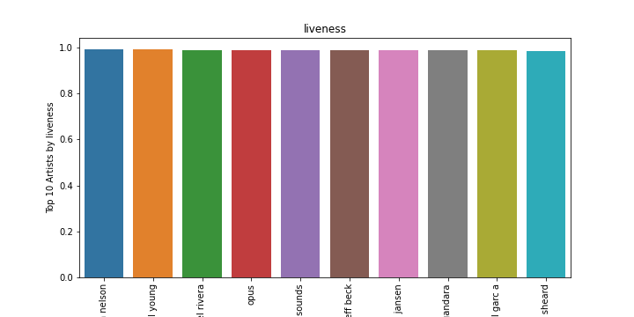

Figure 8: Top 10 Artists by liveness

Top 10 Artists by liveness:

jonathan nelson

the band neil young

fania all stars celia cruz ismael rivera

opus

waterfall sounds

stevie ray vaughan and double trouble with jeff beck

eric clapton john jansen

jes s adri n romero marcela gandara

franco de vita noel schajris leonel garc a

karen clark sheard

## Top 10 Artists by valence

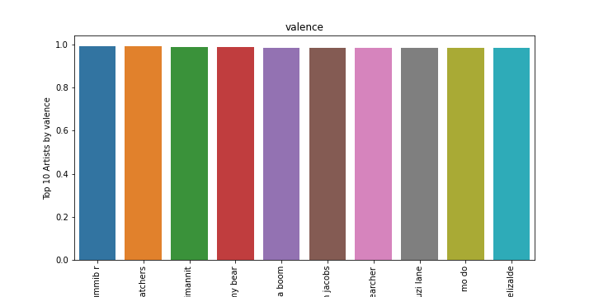

Figure 9: Top 10 Artists by valence

Top 10 Artists by valence:

gummib r

the bodysnatchers

jorma ik valko pirte t pelimannit

gummy bear

banda boom

william jacobs

soulsearcher

suzi lane

mo do

francisco el chico elizalde

## Top 10 Artists by tempo

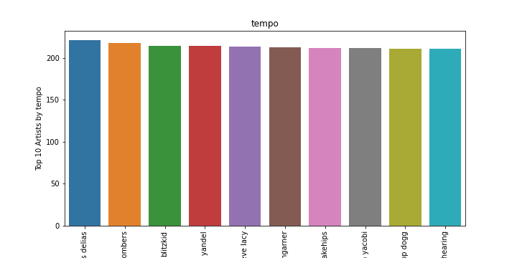

Figure 10: Top 10 Artists by tempo

Top 10 Artists by tempo:

anestis delias

the jive bombers

blitzkid

tony dize yandel

goldlink steve lacy

samantha bumgarner

banks snakehips

neneh yacobi

the pussycat dolls snoop dogg

peggy lee george shearing

## Top 10 Artists by duration_ms

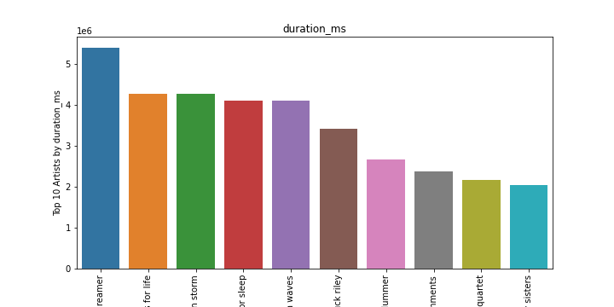

Figure 11: Top 10 Artists by duration_ms

Top 10 Artists by duration_ms:

sound dreamer

sounds for life

lightning thunder and rain storm

ocean waves for sleep

one hour gulf coast ocean waves

chuck riley

christopher plummer

environments

glenn gould symphonia quartet

bombay sisters

## Distribution of popularity

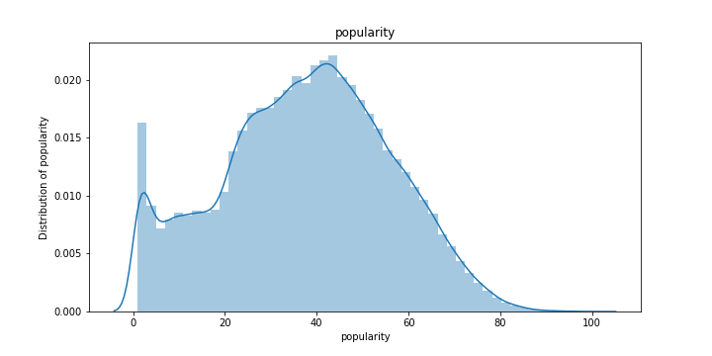

Figure 12: Distribution of popularity

Skewness of popularity: -0.0724307283204734

Kurtosis of popularity: -0.5774394765700799

Percentage of popularity that is explained by the model: -28.60966330825228%

popularity is left skewed

popularity is light kurtic

Explained variance of popularity is -28.60966330825228%

## Distribution of danceability

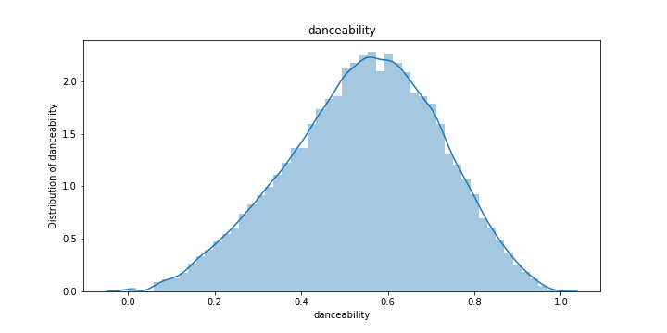

Figure 13: Distribution of danceability

Skewness of danceability: -0.2332403180897672

Kurtosis of danceability: -0.3692113402376007

Percentage of danceability that is explained by the model: -15.740514712749246%

danceability is left skewed

danceability is light kurtic

Explained variance of danceability is -15.740514712749246%

## Distribution of energy

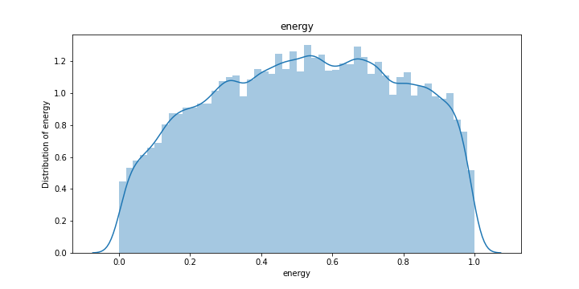

Figure 14: Distribution of energy

Skewness of energy: -0.08641531352668883

Kurtosis of energy: -1.0328792058992973

Percentage of energy that is explained by the model: -51.27057997436907%

energy is left skewed

energy is light kurtic

Explained variance of energy is -51.27057997436907%

## Distribution of loudness

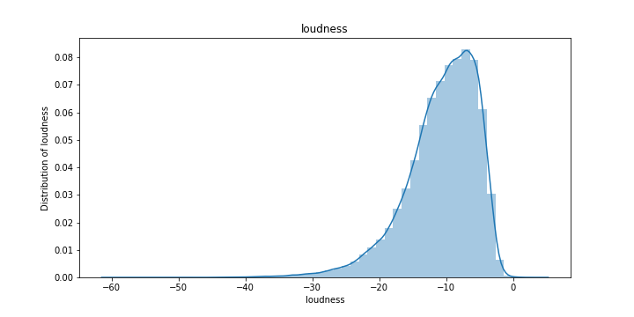

Figure 15: Distribution of loudness

Skewness of loudness: -1.216257809849677

Kurtosis of loudness: 2.5604318337575265

Percentage of loudness that is explained by the model: 201.985744688893%

loudness is left skewed

loudness is heavy kurtic

Explained variance of loudness is 201.985744688893%

## Distribution of speechiness

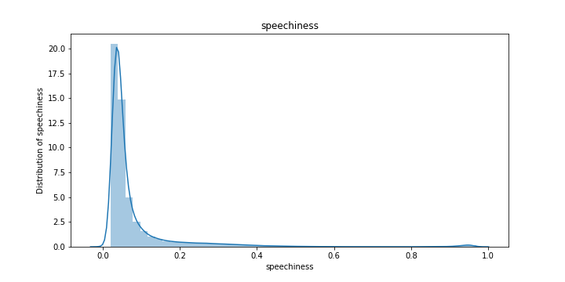

Figure 16: Distribution of speechiness

Skewness of speechiness: 4.8694295799595535

Kurtosis of speechiness: 29.337968264800978

Percentage of speechiness that is explained by the model: 2652.4656349493025%

speechiness is right skewed

speechiness is heavy kurtic

Explained variance of speechiness is 2652.4656349493025%

## Distribution of acousticness

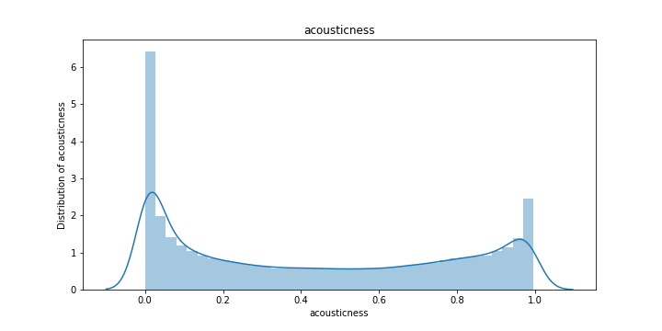

Figure 17: Distribution of acousticness

Skewness of acousticness: 0.20892748505975192

Kurtosis of acousticness: -1.5032406189363299

Percentage of acousticness that is explained by the model: -72.97949624614685%

acousticness is right skewed

acousticness is light kurtic

Explained variance of acousticness is -72.97949624614685%

## Distribution of instrumentalness

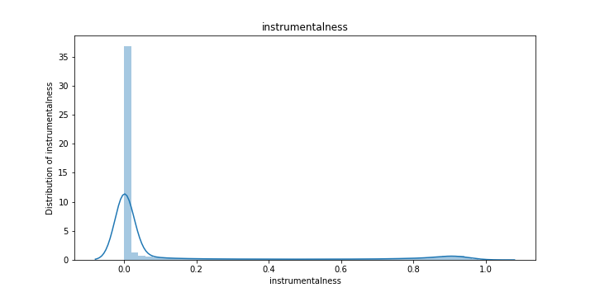

Figure 18: Distribution of instrumentalness

Skewness of instrumentalness: 2.0225386415059474

Kurtosis of instrumentalness: 2.4542122551437915

Percentage of instrumentalness that is explained by the model: 327.24374057642575%

instrumentalness is right skewed

instrumentalness is heavy kurtic

Explained variance of instrumentalness is 327.24374057642575%

## Distribution of liveness

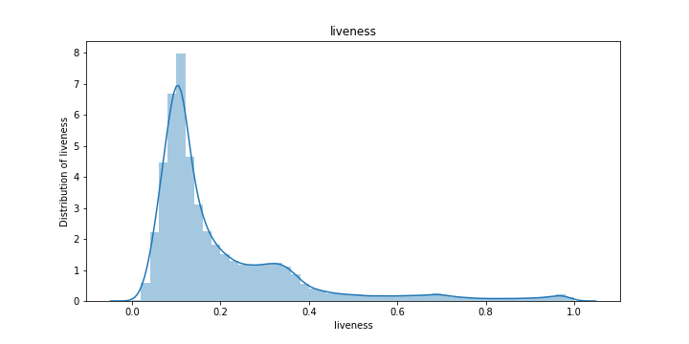

Figure 19: Distribution of liveness

Skewness of liveness: 2.2224756941442005

Kurtosis of liveness: 5.300170261164924

Percentage of liveness that is explained by the model: 511.9784236113334%

liveness is right skewed

liveness is heavy kurtic

Explained variance of liveness is 511.9784236113334%

## Distribution of valence

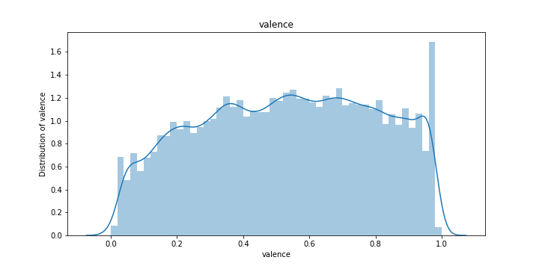

Figure 20: Distribution of valence

Skewness of valence: -0.09477946320331519

Kurtosis of valence: -1.066468772176684

Percentage of valence that is explained by the model: -52.87428127657876%

valence is left skewed

valence is light kurtic

Explained variance of valence is -52.87428127657876%

## Distribution of tempo

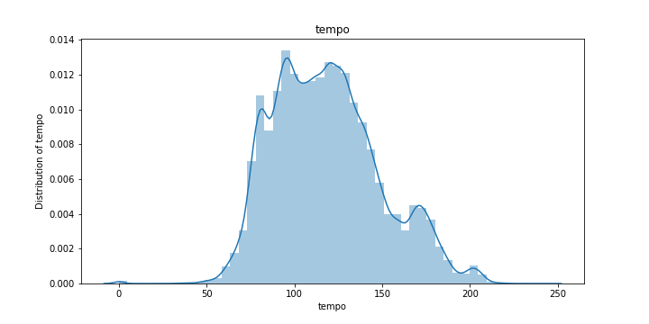

Figure 21: Distribution of tempo

Skewness of tempo: 0.44681716825094814

Kurtosis of tempo: -0.10811402656240299

Percentage of tempo that is explained by the model: 4.576577764069656%

tempo is right skewed

tempo is light kurtic

Explained variance of tempo is 4.576577764069656%

## Distribution of duration_ms

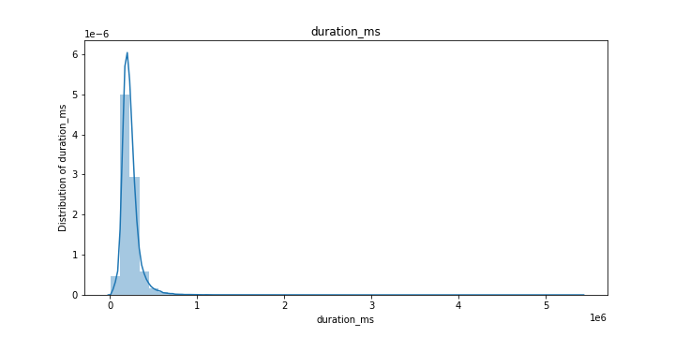

Figure 22: Distribution of duration_ms

Skewness of duration_ms: 8.12009293172125

Kurtosis of duration_ms: 168.7821012898458

Percentage of duration_ms that is explained by the model: 11735.900525481758%

duration_ms is right skewed

duration_ms is heavy kurtic

Explained variance of duration_ms is 11735.900525481758%

## Correlation Matrix

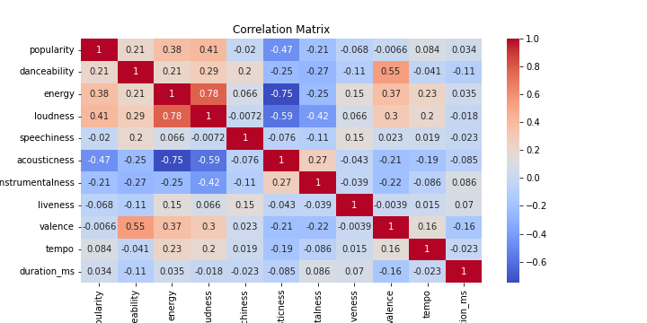

Figure 24: Correlation Matrix

Top 5 most correlated attributes with 'popularity':

loudness 0.409011  
energy 0.381045  
danceability 0.207804  
tempo 0.083886  
duration_ms 0.034130  
Name: popularity, dtype: float64

## Outliers in Attributes

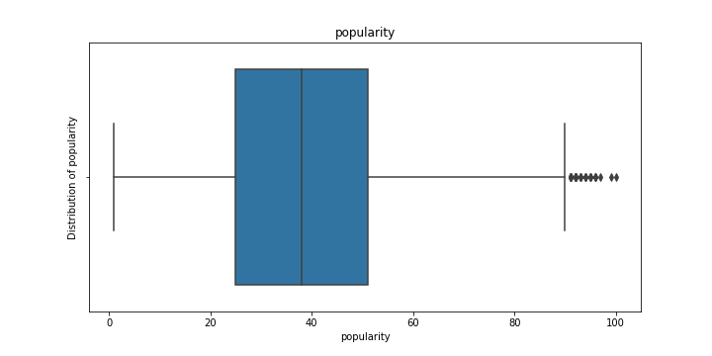

Figure 25: Outliers in popularity

IQR of popularity: 26.0

Lower bound of popularity: -14.0

Upper bound of popularity: 90.0

Number of outliers in popularity: 0

Number of rows after removing outliers: 142711

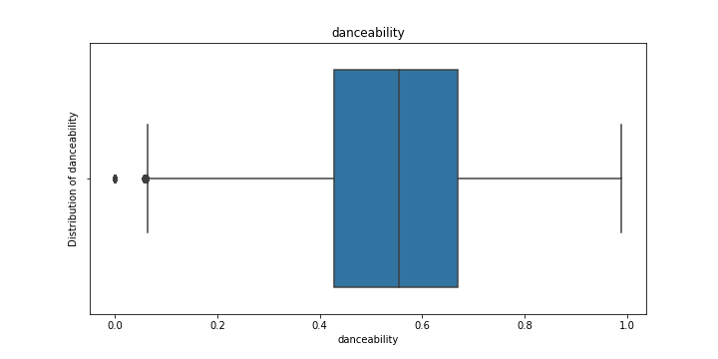

Figure 26: Outliers in danceability

IQR of danceability: 0.24299999999999994

Lower bound of danceability: 0.06250000000000017

Upper bound of danceability: 1.0345

Number of outliers in danceability: 0

Number of rows after removing outliers: 142561

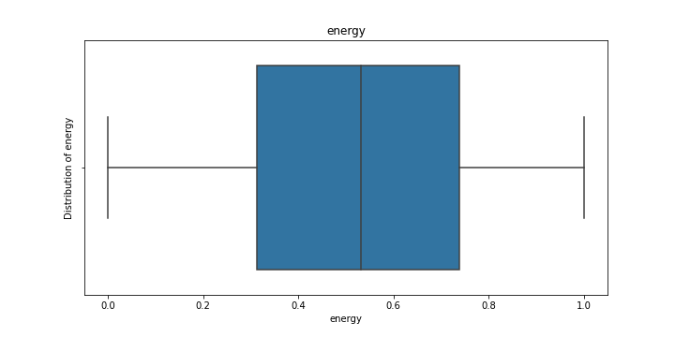

Figure 27: Outliers in energy

IQR of energy: 0.4270000000000001

Lower bound of energy: -0.3285000000000002

Upper bound of energy: 1.3795000000000002

Number of outliers in energy: 0

Number of rows after removing outliers: 142561

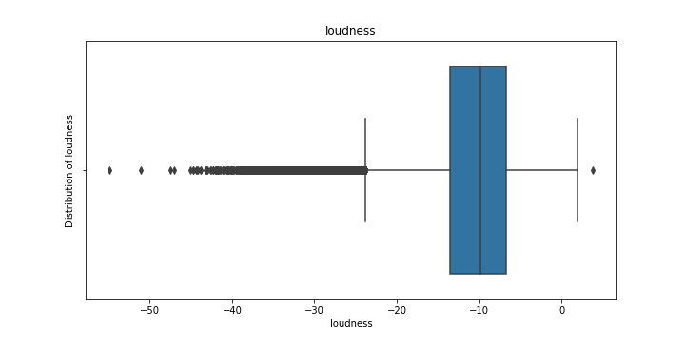

Figure 28: Outliers in loudness

IQR of loudness: 6.840000000000001

Lower bound of loudness: -23.829

Upper bound of loudness: 3.5310000000000015

Number of outliers in loudness: 0

Number of rows after removing outliers: 139009

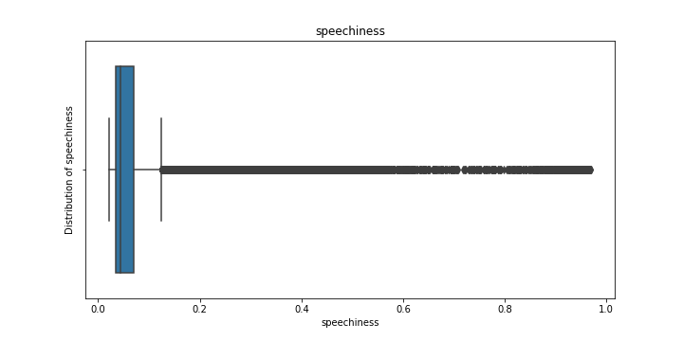

Figure 29: Outliers in speechiness

IQR of speechiness: 0.0364

Lower bound of speechiness: -0.020800000000000006

Upper bound of speechiness: 0.1248

Number of outliers in speechiness: 0

Number of rows after removing outliers: 120608

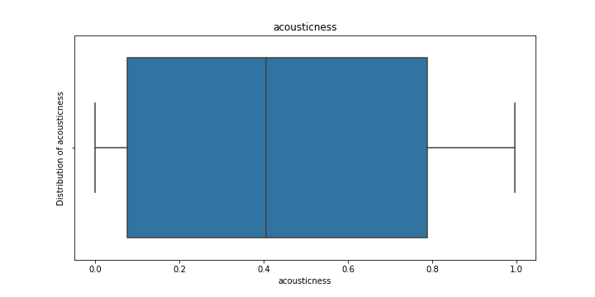

Figure 30: Outliers in acousticness

IQR of acousticness: 0.7127

Lower bound of acousticness: -0.99275

Upper bound of acousticness: 1.85805

Number of outliers in acousticness: 0

Number of rows after removing outliers: 120608

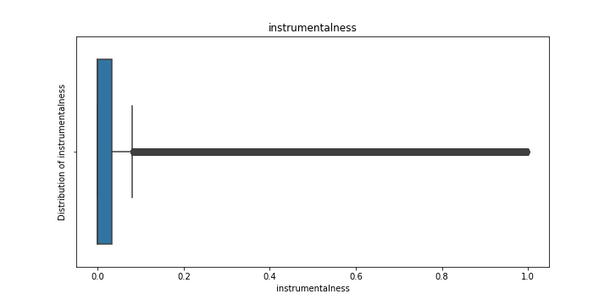

Figure 31: Outliers in instrumentalness

IQR of instrumentalness: 0.0321

Lower bound of instrumentalness: -0.04815

Upper bound of instrumentalness: 0.08024999999999999

Number of outliers in instrumentalness: 0

Number of rows after removing outliers: 94869

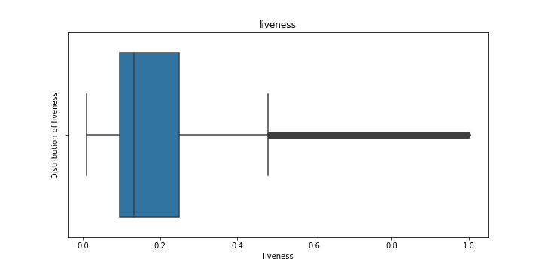

Figure 32: Outliers in liveness

IQR of liveness: 0.1543

Lower bound of liveness: -0.13674999999999998

Upper bound of liveness: 0.48045

Number of outliers in liveness: 0

Number of rows after removing outliers: 88920

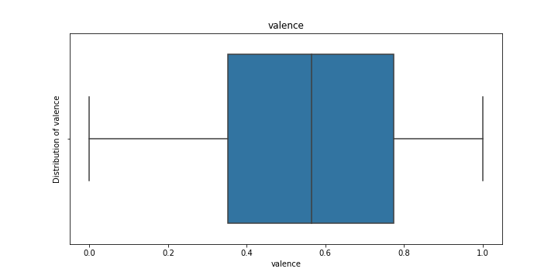

Figure 33: Outliers in valence

IQR of valence: 0.42200000000000004

Lower bound of valence: -0.281

Upper bound of valence: 1.407

Number of outliers in valence: 0

Number of rows after removing outliers: 88920

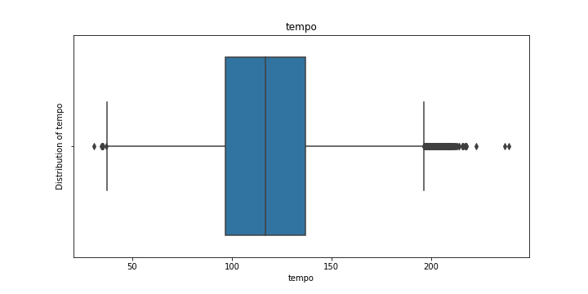

Figure 34: Outliers in tempo

IQR of tempo: 39.83800000000001

Lower bound of tempo: 37.203999999999986

Upper bound of tempo: 196.556

Number of outliers in tempo: 0

Number of rows after removing outliers: 88007

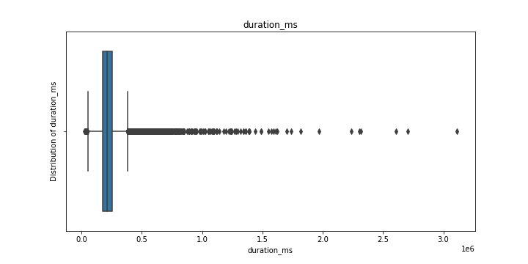

Figure 35: Outliers in duration_ms

IQR of duration_ms: 82566.5

Lower bound of duration_ms: 51023.75

Upper bound of duration_ms: 381289.75

Number of outliers in duration_ms: 0

Number of rows after removing outliers: 84653