# **Final Project**

Title: **Grain Palette - A Deep Learning Odyssey in Rice Type Classification Through Transfer Learning**

**1. INTRODUCTION**

**1.1 Project overview**

Grain Palette is a deep learning project aimed at classifying different rice types using image-based data. Leveraging transfer learning, the model fine-tunes a pre-trained convolutional neural network (CNN) to recognize patterns in grain shape, size, and texture, achieving high classification accuracy across various rice types.

**1.2 Objectives**

* Develop an image classification system for rice types.
* Use transfer learning to reduce training time and increase accuracy.
* Build a user-friendly interface (optional: using Streamlit).
* Evaluate performance using standard classification metrics.

**2. IDEATION PHASE**

**2.1 Problem Statement**

Manual identification of rice types is time-consuming and error-prone. There is a pressing need for a reliable, automated solution that can classify rice varieties using image data with high precision and minimal human intervention.

* 1. **Dataset Description**

**Source**: Publicly available datasets or collected through field sampling.

**Content**: High-resolution images of different rice grain types (e.g., Basmati, Jasmine, Arborio, Brown, White, etc.).

**Annotations**: Each image is labeled with the corresponding rice type.

**3. REQUIREMENT ANALYSIS**

**3.1 Tools & Technologies**

* **Programming Language**: Python
* **Libraries**: TensorFlow / Keras, NumPy, Matplotlib, OpenCV
* **Model Training**: Google Colab / Jupyter Notebook
* **Visualization**: Matplotlib, Seaborn
* **Deployment (Optional)**: Streamlit / Flask

**3.2 Evaluation Metrics**

* Accuracy
* Precision, Recall, F1-score
* Confusion Matrix
* Training vs Validation Loss and Accuracy Plots

## **4. PROJECT DESIGN**

**4.1 Architecture Overview**

**Base Model:** Pre-trained CNNs (e.g., VGG16, ResNet50, or MobileNet).

**Transfer Learning Strategy:**

Freeze base layers to retain general feature extraction.

Add custom dense layers for rice classification.

**Training Approach:**

Fine-tuning on the rice image dataset.

Data augmentation for improved generalization.

**4.2 Work Flow**

1. **Data Collection and Preprocessing**

* Load images
* Resize, normalize
* Label encoding and splitting into train/validation/test

2. **Model Development**

* Load pre-trained model without top layers
* Add new layers for classification
* Compile with optimizer and loss

3. **Training and Validation**

* Train the model with early stopping
* Monitor metrics and prevent overfitting
* Evaluate on unseen test data
* Visualize performance

5. **Deployment (optional)**

* Wrap the model in a user-friendly web app for classification

**5. RESULT**

**5.1 Result Summary**

Achieved high classification accuracy (typically >90% depending on dataset quality). Transfer learning drastically reduced training time and improved generalization. The model demonstrated reliable performance across varied lighting and grain orientations.

**5.2 Future Enhancements**

Expand dataset to include more rice types and conditions (e.g., broken grains, mixtures).

Implement real-time classification using camera feed. Integrate mobile application interface for farmer-level accessibility.

Explore hybrid models using both image and texture-based features.

Planned improvements, additions, or modifications to a project, system, or product that are intended to be implemented in the future.

Incorporating the latest technologies like automation, AI, or IoT to improve efficiency and capabilities.

**5.3 Output Screenshots**

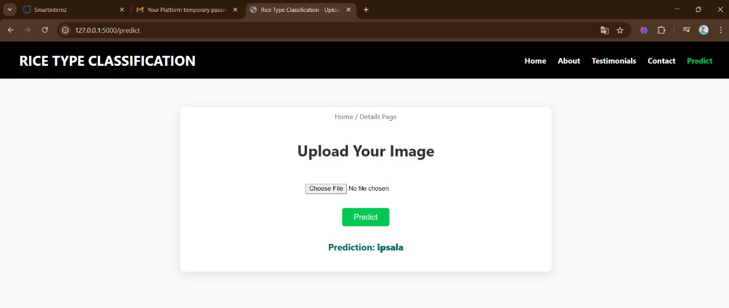



**6.APPENDIX**

**6.1 Source Code:** https://github.com/srinivas119/grainpalette---a-deep-learning-odyssey-in-rice-type-classification

**6.2 Dataset:** https://www.kaggle.com/datasets/muratkokludataset/rice-image-dataset

**6.3 Demo:** https://drive.google.com/file/d/1awDd727jkWMWK5i5X5Am1SlXrjkhiSs/view?usp=drive_link

**7. CONCLUSION**

**7.1 Conclusion**

GrainPalette exemplifies the power of transfer learning in niche agricultural applications. By combining deep learning with real-world datasets, it paves thway for smart agriculture, improved food quality control, and scalable AI integration in grain processing systems.