Create the vm1 and instance1 of the instance



By creating vm instances as same configuragation

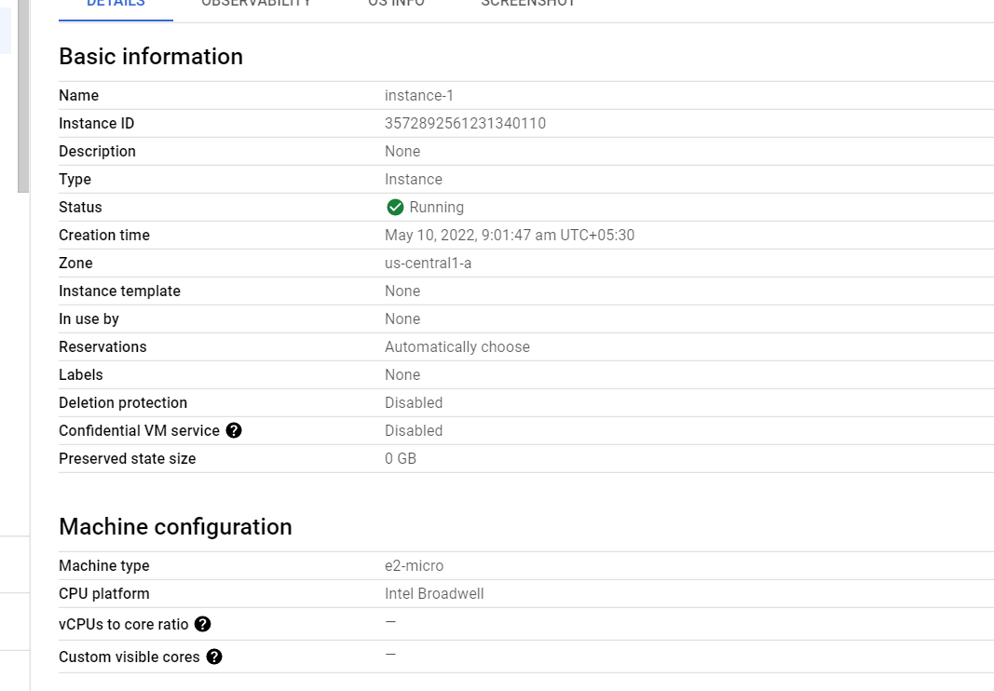

Create the ssh keys of the virtual machine

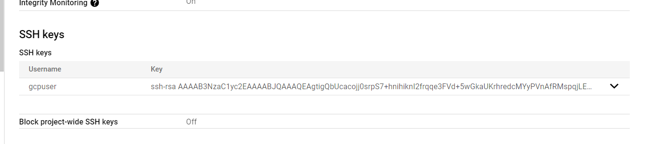

Connect the server with putty and ping the commands what commands you want.

