E2E Framework – Installation Guide
Test Automation

© ValueLabs
Plot No.41 • HITEC City
Phase II • Cyberabad • 500081
Phone +91 40 6623 9000• Fax 6623 9100

Document Information
Reference | ValueLabs_E2E_Framework_Installation_Guide | Version No. | 2.2
Release Date | 28 Apr, 2014 | Total No. of pages | 29
 | Name | Designation | Date
Prepared by |  |  | 28 Apr, 2014
Reviewed By
Approved by

Document Amendment Record
S. No. | Rev. From | Rev. To | Date of Change | Changes Made

Table of Contents
1. Introduction 5
1.1. Purpose 5
1.2. Scope 5
1.3. Intended Audience 5
1.4. Document Organization 5
2. Prerequisites 6
2.1. Java 1.6 (or) Later 6
2.2. Framework Installation 7
2.2.1. Dir Structure 11
2.3. Framework required jars 11
2.3.1. Mandatory jars 11
2.3.2. Optional jars 11
3. Components Installation 13
3.1. Installing Bugzilla, MySQL, Testlink 13
3.1.1. Bugzilla & MySQL Installation 13
3.1.2. PHP Installation (for TestLink) 21
3.1.3. TestLink Installation 22
3.2. Installing Jenkins 24
3.3. Installing only MySQL 26
3.4. Installing only Testlink 26
3.4.1. Configure Apache to run PHP as a Module 26
3.4.2. Restart Apache 26
3.4.3. Configure TestLink with Apache 27

Table of Figures
Figure 1: Command Prompt 6
Figure 2: Welcome window 9
Figure 3: Select Destination Folder window 10
Figure 4: Server Configuration window 10
Figure 5: Server Configuration – Root Password 11
Figure 6: Server Configuration – Bugs Password 11
Figure 7: Server Configuration – Administrator and Email details 12
Figure 8: Server Configuration – Scheduled Tasks 13
Figure 9: Command console window 14
Figure 10: Finish window 14
Figure 11: Console window with instructions 15
Figure 12: Jenkins Dashboard 21
Figure 13: Jenkins New Job 21
Figure 14: Process Test Link Setup screen 24

Introduction
The purpose of this document is to provide detailed information on directory structure and key work usage of E2E Framework.

Purpose
The purpose of this document is to provide detailed information on installation procedure of E2E Framework.

Scope
This document limits its scope in providing information about installation steps of E2E Framework.

Intended Audience
The intended audience for this document is all end users using this framework.

Document Organization
S. No. | Chapter | Contents
 | Introduction | Purpose, scope and intended audience of the document
 | Prerequisites | Details of prerequisites for installation
 | Framework Installation | Describes the procedure to install framework
 | Components Installation | Describes the procedure to install components

Prerequisites

Java 1.6 (or) Later
To check whether Java is installed or not in the system, following steps are performed.
Go to command prompt
Type Java -version
JDK version in the system is displayed.
Figure 1: Command Prompt
If Java is not installed in the system, the following message is displayed.
‘Java’ is not recognized as an internal or external command, operable program or batch file.
If Java 1.6 or later is not installed, then it can be downloaded and installed from the below link.
http://www.oracle.com/technetwork/java/javase/downloads/index.html
Set the JAVA_HOME environmental variable to ‘JDK’ directory of JDK Installation and PATH variable to %JAVA_HOME%\bin

Framework Installation
- Double click on the setup icon.
- Click on 'Run'.
- Click on 'Next'.
- Select 'I accept the agreement'.

- Click on 'Next'.

- Enter the 'Unlock Code' and 'Private Key' and click on 'Next'.

- Browse the location on the machine where the Framework need to be installed and click on 'Next'.

- Click on 'Install'.
- Click on 'Finish'.

- Command prompt request input for installing type of Framework. All required files related to Appium and Selenium will get installed by default.

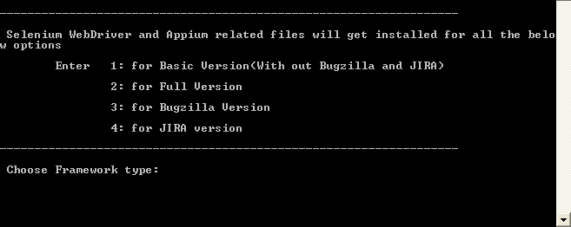
- You need to enter 1 for Base Framework , 2 for Full Version, 3 for Bugzilla, 4 for JIRA after entering valid input you will get the following screen
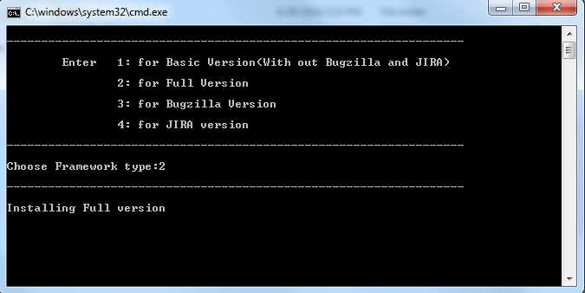
- Cmd prompt will download jars required for Framework. You will get the following screen.
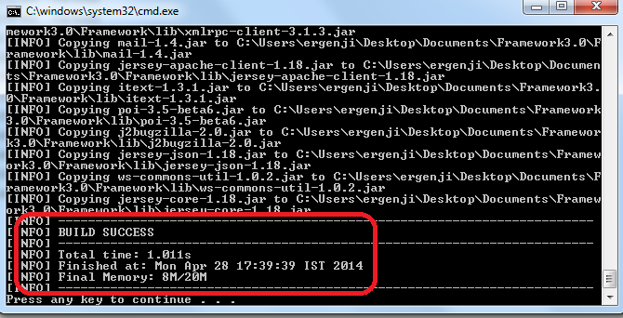

Dir Structure
Directory structure of the framework is maintained as shown below.
Framework directory contains the required jar files and place holders for any .class and jar files to be added in future.
Properties directory is content holder for property configuration and information regarding the application to be tested.
TestInputs directory is content holder for configuration files and testdata files.
TestReports directory is content holder for writing Results to HTML files and Excel sheets.
Screenshots directory contains the screenshots generated when running tests.

Framework required jars
Place all the JARS under the lib folder of Framework folder

Mandatory jars
Selenium standalone server
You can download the selenium-server-standalone from the selenium official page .
OJDBC
This JAR for reading the TestData sheets, You can download the Ojdbc14 jar file from the oracle site or this link .

Optional jars
All the following JARS need to be placed in the lib folder only when you use specific functionality.
JDBC-MSSQL
This JAR is connecting Microsoft SQL Server , you can download this JAR from this link.
JDBC-MYSQL
This JAR is for connecting the Mysql data base, you can download from this link .
TestLink
This JAR is for connecting TestLink, you can download this JAR from this link.
JIRA-API-REST-CLIENT
This JAR is for connecting JIRA, you can download this JAR from this link.

Components Installation

Installing Bugzilla, MySQL, Testlink

Bugzilla & MySQL Installation
Download Bugzilla installer from here. Welcome window is displayed on running the downloaded exe file as shown below.
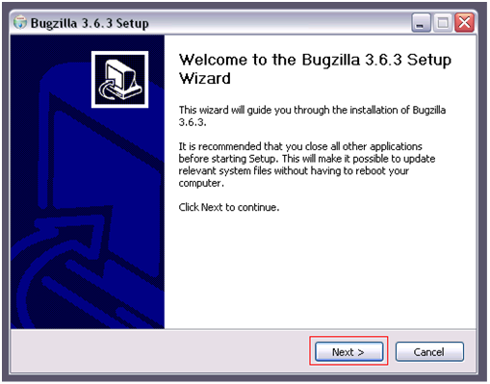
Figure 2: Welcome window
- Click Next to continue with the installation.
Figure 3: Select Destination Folder window
- Specify the installation location for Bugzilla program files.
- Click Next after specifying location for Bugzilla.
Figure 4: Server Configuration window
- Specify the value for Port numbers of Apache & MySQL.
Figure 5: Server Configuration – Root Password
- Provide password for ‘root’ user of the database.
Figure 6: Server Configuration – Bugs Password
- Provide password for user account created for database of Bugzilla – ‘bugs’.
- Click Next after specifying required fields.
Figure 7: Server Configuration – Administrator and Email details
- Specify required fields.
- After specifying the required fields click Next.
Figure 8: Server Configuration – Scheduled Tasks
- Specify the Windows user name and password.
- After specifying the required fields click Install.
A new command console window is displayed to verify successful completion (status) of setup without any errors.
Figure 9: Command console window
Figure 10: Finish window
- Click Finish to complete installation.

Verify Setup
- Run checksetup.cmd file available in Bugzilla installation directory.
- If batch console shows that any Perl modules are missing, command window is displayed as shown below.
Figure 11: Console window with instructions
- Run batch file, BugzillaCmdPrompt.cmd from installation directory, and install the required modules as per instructions in the above console.
- Modules listed below are important.
- JSON-RPC
- Test-Taint
- Modules listed below are not necessary.
- TheSchwartz
- mod_perl
- Daemon_Generic
  - Ignore if installation is not possible.
- Install required modules and access the URL - http://localhost:<Bugzilla_port_no_apache>.
- Default <Bugzillaportno> is 80, if not changed during installation, login to Bugzilla using admin credentials provided. Now the user can access Bugzilla.

Steps for Modifying Bugzilla (if user needs customisation)
Following steps are to be performed in order to get customised preferences over Bugzilla.
- Modify Configuration file
- Stop and delete existing services
- Create new Services

Modify the Configuration file
- Open dir <Bugzilla_Installation_folder>/apache/conf
- Create a copy of “httpd.conf” and rename it to “Bugzilla.conf”
- Default port on which Bugzilla runs is '80'. Change the port number in Bugzilla.conf file.
- Search for Listen in the file. Change port by changing the value of Listen which is 80, to desired port number.

Stop and delete existing services
- Open a new command prompt and run the following commands.
sc stop Bugzilla.Apache
sc delete Bugzilla.Apache
sc stop Bugzilla.MySQL
sc delete Bugzilla.MySQL

Create New Services
- Navigate to <Bugzilla_Installation_folder>/apache/bin.
- Run following command to create a service with name Bugzilla.
$httpd.exe -k install -n “Bugzilla” –f <Bugzilla_Installation_folder>/Apache/conf/ Bugzilla.conf”
- Once Bugzilla service is created start the service by following command.
$sc start Bugzilla
- In command prompt, navigate to <Bugzilla_Installation_folder>/mysql/bin.
- Run the following command to create a service with name MySQL.
$ mysqld.exe --install “MySQL”
- Once MySQL service is created start the service by following command.
$ sc start mysql

PHP Installation (for TestLink)
Implement the following steps to install PHP.
- Download PHP from here.
- Extract downloaded ZIP file to a specific folder.
- In Run, type 'sysdm.cpl' and click Enter.
- A dialogue box is displayed with System Properties.
- Click 'Advanced' tab and click 'Environment Variables' at bottom of the window.
- In User variables, if there is any variable with name PATH, click PATH and click Edit.
- Copy location where PHP files are extracted.
- In variable value field, paste the copied location at the beginning and place a semi-colon (“;”).
- Click Ok.
- In User variables, if a variable with name PATH is not available, click NEW.
- Type PATH into variable name field.
- Copy the location where PHP files are extracted.
- In variable value field, paste the copied location at the beginning and place a semi-colon (“;”) and click Ok.
- Close dialogue box of System Properties. Open folder where the PHP files are extracted. A file PHP.ini.development is available in that folder.
- Copy the specified file and rename it to PHP.ini.
- In PHP.ini, uncomment the following lines (remove ';' at the start of line to uncomment them).
extension_dir=”ext”
extension=php_mysql.dll
extension=php_soap.dll
extension=php_xmlrpc.dll
Replace the above value of 'ext' with '<Path_to_your_PHP_Extraction>/ext'. Add the line.
date.timezone = "Asia/Kolkata"

TestLink Installation
Implement the steps discussed below to install test link.
- Download the testlink version 1.9.3 from here. Extract the folder contents of the Tar to a specific location.

Configure TestLink with Apache
- Open <Bugzilla_Installation_folder>/Apache/conf
- Create a copy of httpd.conf and rename it to TestLink.conf
- In TestLink.conf file, add the following lines.
PHPIniDir <Path_to_PHP_Folder>
LoadModule php5_module "<Path_to_PHP_Folder>/php5apache2_2.dll"
- Search for <IfModule mime_module>, and add the following line before </IfModule>
AddType application/x-httpd-php.php
- Search for DocumentRoot and replace its value with the dir, where testlink tar file is extracted.
DocumentRoot C:\Testlink-1.9.3\Testlink
- Search for Directory where a tag similar to the below tag is available.
<Directory “C:\Path\to\a folder”>
- Replace “C:\Path\to\a folder” with the path of directory where testlink is extracted.
- Default port on which Bugzilla runs is '80'. If you want to change the port number, you can change it in the Testlink.conf file.
- Search for Listen in the file, and change the port by changing the value of Listen which is 80, to your desired port number.
- Save TestLink.conf file.

Create new Service
- Navigate to <Bugzilla_Installation_folder>/apache/bin.
- Run the following command to create a service with name Testlink.
- $httpd.exe -k install -n “Testlink” -f “<Bugzilla_Installation_folder>/Apache/conf/ testlink.conf”
- Once Testlink service is created start the service by following command.
$sc start Testlink
- Enable XML-RPC by editing config.inc, located in TestLink root folder.
$tlCfg->api->enabled = TRUE; $g_attachments->order_by = "ORDER BY id ASC ";
- After installing the required modules, once access the URL.
http://localhost:<testlink_port_no_apache>
- Home page for Testlink appears requesting for installation.

Click New Installation link
- Accept license agreement and click on 'Continue'.
- User should be able to see the following message at the bottom of the screen
- Your system is prepared for TestLink configuration (no fatal problem found).
- Click Continue.
- User is shown following screen.
- Provide the required fields and click on 'Process Testlink Setup!'
Testlink installation is completed and user can use testlink with credentials.
admin / admin

Creating a Project in Testlink
- Log in to the testlink application.
- Click Test Project Management link under Test Project section.
- Click Create, enter project related details and hit Create.
- Click Test Specification link in the main menu.
- Add the test cases to the test suite added to your project.

Creating a Test plan
- Click Test Plan Management link under the Test Plan section in the main menu.
- Click Create, enter test plan name and hit Create.

Adding test cases to test plan
- Click Add/Remove TestCases under Test plan contents section in home page.
- Select the test cases and hit Add / Remove selected.

Steps to retrieve DEV KEY
- Click My Settings link available at the top of the page.
- Click Generate a new key.
- Generated key is called API Key, used to access Testlink.
- Port numbers used for Testlink and Bugzilla in .conf file must be different.
- Remember Password of Root user given during the installation of Bugzilla.

Installing Jenkins
- Download jenkins.war file from http://jenkins-ci.org/
- Run jenkins.war file from command prompt on any non reserved port
Example
java -jar jenkins.war -- httpPort=8070 --ajp13Port=4545
Following steps are to be followed when creating a Job in Jenkins.
- Navigate to Jenkins DashBoard Page with the URL - http://<jenkins_machine>:<port>
Figure 12: Jenkins Dashboard
- On DashBoard page, click New Job link.
Figure 13: Jenkins New Job
- Provide a name to the Job and select the radio Build a free-style software project and click Ok.
- The user is redirected to a Job Configuration page.
- Click Add Build Step, and call the Framework.bat file
Example
call C:\Framework\Framework.bat
- Click “Save”

Installing only MySQL
- Download MySQL from here.
- Follow the Instructions Wizard and complete installation it in your machine.

Installing only Testlink
- Below software's are required for installing testlink in your machine.
- Database MySQL 4.1.x and higher (5.x is recommended)
- Web server (Apache 1.3.x or 2.x and higher, IIS 3 and higher, etc.).
- PHP 5.2 and 5.3
- If MySQL is not installed please see here.
- Download Apache from here http://www.apache.org/dist/httpd/binaries/win32/ and deploy it in machine.
- If PHP is not installed please see here.

Configure Apache to run PHP as a Module
This guide assumes you are using apache 2.2. To configure Apache to run PHP, the httpd.conf file needs to be modified. This file is located in the apache installation directory under the conf folder. Open the httpd.conf file in EditRocket and implement the following steps.
- Add the following line after all of the LoadModule statements
LoadModule php5_module "c:/php/php5apache2_2.dll"
- Search for AddType, and add the following after the last AddType line
AddType application/x-httpd-php .php
- Add PHP location to the end of httpd.conf file
Example
At the end of the file, add the following.
PHPIniDir "c:/php"

Restart Apache
Now, the apache web server needs to be restarted. This can be done either via the Apache service located in the services control panel or via the Start -> All Programs -> Apache . . . -> Control Apache Server menu option.
- Download the testlink version 1.9.3 from here.
- Extract the folder contents of the Tar to a specific location.

Configure TestLink with Apache
- Copy the extracted testlink folder to the htdocs folder.
- C:\Program Files\Apache Software Foundation\Apache2.2\htdocs
- Open the httpd.conf file
- Search for 'Listen' in the file, and change the port by changing the value of 'Listen' which is 80, to your desired port number
- Save httpd.conf file.
- Enable XML-RPC by editing config.inc, located in TestLink root folder.
$tlCfg->api->enabled = TRUE;
$g_attachments->order_by = " ORDER BY id ASC ";
- After installing the required modules, once access the URL -http://localhost:<testlink_port_no_apache>
The home page for Testlink is displayed with request for installation.
- Click 'New Installation' link.
- Accept the license agreement and click 'Continue'.
User can view the following message at the bottom of the screen.
System is prepared for TestLink configuration (no fatal problem found)
- Click 'Continue'.
The following screen is displayed.
Figure 14: Process Test Link Setup screen
- Provide the required fields and click 'Process Testlink Setup!'
Testlink installation is completed and user can use testlink with credentials.
admin / admin

Creating a Project in Testlink
- Log in to the testlink application
- Click Test Project Management link under Test Project section.
- Click Create, enter the project related details and hit Create.
- Click Test Specification link in the main menu
- Add test cases to the test suite added to the project.

Creating a Test plan
- Click Test Plan Management link under Test Plan section in the main menu.
- Click Create, enter test plan name and hit Create.

Adding test cases to test plan
- Click Add/Remove TestCases under Test plan contents section in home page.
- Select the test cases and hit Add / Remove selected.

Steps to retrieve DEV KEY
- Click on My Settings link available at the top of the page.
- Click Generate a new key.
- Generated key is called API Key, used to access Testlink.

