Technical Document
for Car Rental System

Version | Description of Change | Author | Date
1.0 | Initial Draft | Team2 | 14-OCT-2019

CONTENTS
1 High level architecture & Design 4
2 Detail the various components of the application 4
Search Service: 4
3 Tech stack 4
4 Identify the learning involved 5
5 Technologies architecture enhancements not included because of time constraint 5
6 SQL Schema and ERD 5

High level architecture & Design
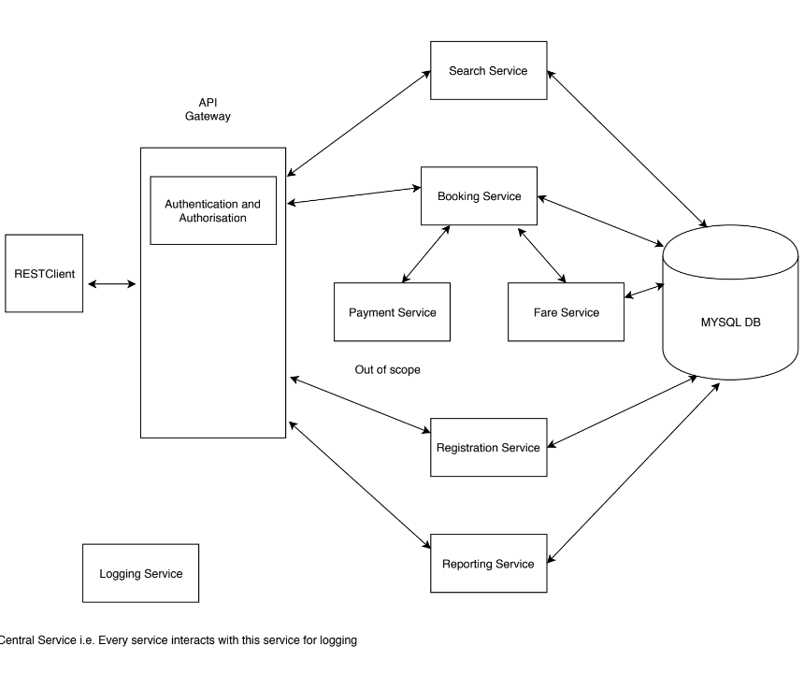

Detail the various components of the application

Search Service:
It is a service which provides APIs for the customer to perform below functionalities:
- Search cars based on his/her search criteria like by location*, by startDate and endDate* , by carType (micro, mini, sedan or suv) etc.,
- Search available rental locations based on the city

Booking Service:
It is a service which provides below APIs for the customer to perform below functionalities
- Book a car
- Cancel the booking

Fare Calculator Service:
It is a service which provides APIs for the customer to provide the estimated fare based on the car selected and the pricePerDay set by the vendor.

Reporting Service:
It is a service which provides APIs for the admin/vendor to perform below functionalities:
- Generate monthly reports of a customer/vendor
- Generate monthly report for a car
- Generate monthly report for a location

Registration Service:
It is a service which provides for the admin/customer to perform below functionalities:
- To create accounts for a customer and vendor.
- Manage cars of a vendor
- Enables admin to manage vendors, locations.

Authentication service(Login service):
It is a service which provides APIs for admin, customer and vendor to login/logout into the car rental system.

Logging Service
Every Service will write log messages to JMS queue and Logging Service will get those messages and stores in files.

Tech stack
- Java 8
- Deployment with Java8 and Java 12
- Spring and Spring boot modules(latest)
web
Data-JPA
Spring security
embeded tomcat
- Docker (latest)
- Kubernetes(Google cloud)
- Mysql 5.6
- Swagger API
- Junit( Mockito )
- Spring Test frame work

Identify the learning involved
- Java 8 features
- Java 9 Modularity
- Spring Security, Spring cloud
- Docker
- Kubernetes(Google cloud)
- Spring Data-JPA
- Swagger API
- RichardSon Maturity model

Technologies architecture enhancements not included because of time constraint
Enhancing Booking Service to handle huge requests by maintaining a JMS queue
SSO

SQL Schema and ERD
CREATE TABLE `carRentalSystem`.`CRS_USERS` (
`ID` INT NOT NULL AUTO_INCREMENT,
`USERNAME` VARCHAR(45) NOT NULL,
`PASSWORD` VARCHAR(45) NOT NULL,
`NAME` VARCHAR(45) NULL,
`GENDER` ENUM('M', 'F') NULL,
`AGE` INT NULL,
`ADDRESS` VARCHAR(140) NULL,
`PHONE_NUMBER` VARCHAR(14) NOT NULL,
`ROLE` ENUM('CUSTOMER', 'VENDOR', 'ADMIN') NULL,
`REG_DATE` DATETIME NULL,
PRIMARY KEY (`ID`),
UNIQUE INDEX `USERNAME_UNIQUE` (`USERNAME` ASC));

CREATE TABLE `carRentalSystem`.`CRS_CITIES` (
`ID` INT NOT NULL AUTO_INCREMENT,
`NAME` VARCHAR(45) NOT NULL,
`CREATED_ON` DATETIME NULL,
PRIMARY KEY (`ID`));

CREATE TABLE `carRentalSystem`.`CRS_LOCATIONS` (
`ID` INT NOT NULL AUTO_INCREMENT,
`LOCATION_NAME` VARCHAR(45) NOT NULL,
`ADDRESS` VARCHAR(140) NULL,
`CITY_ID` INT NULL,
PRIMARY KEY (`ID`),
INDEX `fk_CRS_LOCATIONS_1_idx` (`CITY_ID` ASC),
CONSTRAINT `fk_CRS_LOCATIONS_1`
FOREIGN KEY (`CITY_ID`)
REFERENCES `carRentalSystem`.`CRS_CITIES` (`ID`)
ON DELETE NO ACTION
ON UPDATE NO ACTION);

CREATE TABLE `carRentalSystem`.`CRS_VEHICLES` (
`ID` INT NOT NULL AUTO_INCREMENT,
`MODEL_NAME` VARCHAR(45) NULL,
`REG_NUMBER` VARCHAR(100) NULL,
`COLOR` VARCHAR(45) NULL,
`TYPE` VARCHAR(45) NOT NULL,
`PRICE_PER_DAY` INT NOT NULL,
`IS_ACTIVE` VARCHAR(45) NOT NULL,
`LOCATION_ID` INT NOT NULL,
`USER_ID` INT NOT NULL,
`REG_DATE` DATETIME NULL,
PRIMARY KEY (`ID`),
INDEX `fk_CRS_VEHICLES_1_idx` (`LOCATION_ID` ASC),
INDEX `fk_CRS_VEHICLES_2_idx` (`USER_ID` ASC),
CONSTRAINT `fk_CRS_VEHICLES_1`
FOREIGN KEY (`LOCATION_ID`)
REFERENCES `carRentalSystem`.`CRS_LOCATIONS` (`ID`)
ON DELETE NO ACTION
ON UPDATE NO ACTION,
CONSTRAINT `fk_CRS_VEHICLES_2`
FOREIGN KEY (`USER_ID`)
REFERENCES `carRentalSystem`.`CRS_USERS` (`ID`)
ON DELETE NO ACTION
ON UPDATE NO ACTION);

CREATE TABLE `carRentalSystem`.`CRS_BOOKINGS` (
`ID` INT NOT NULL,
`USER_ID` INT NOT NULL,
`VEHICLE_ID` INT NOT NULL,
`LOCATION_ID` INT NOT NULL,
`ESTIMATED_FARE` INT NOT NULL,
`FINAL_FARE` INT NULL,
`FROM_DATE` DATETIME NOT NULL,
`BOOKING_STATUS` ENUM('ACTIVE', 'COMPLETED', 'CANCELLED', 'BOOKED') NOT NULL,
`TO_DATE` DATETIME NOT NULL,
PRIMARY KEY (`ID`),
INDEX `fk_CRS_BOOKINGS_1_idx` (`USER_ID` ASC),
INDEX `fk_CRS_BOOKINGS_2_idx` (`VEHICLE_ID` ASC),
INDEX `fk_CRS_BOOKINGS_3_idx` (`LOCATION_ID` ASC),
CONSTRAINT `fk_CRS_BOOKINGS_1`
FOREIGN KEY (`USER_ID`)
REFERENCES `carRentalSystem`.`CRS_USERS` (`ID`)
ON DELETE NO ACTION
ON UPDATE NO ACTION,
CONSTRAINT `fk_CRS_BOOKINGS_2`
FOREIGN KEY (`VEHICLE_ID`)
REFERENCES `carRentalSystem`.`CRS_VEHICLES` (`ID`)
ON DELETE NO ACTION
ON UPDATE NO ACTION,
CONSTRAINT `fk_CRS_BOOKINGS_3`
FOREIGN KEY (`LOCATION_ID`)
REFERENCES `carRentalSystem`.`CRS_LOCATIONS` (`ID`)
ON DELETE NO ACTION
ON UPDATE NO ACTION);

