









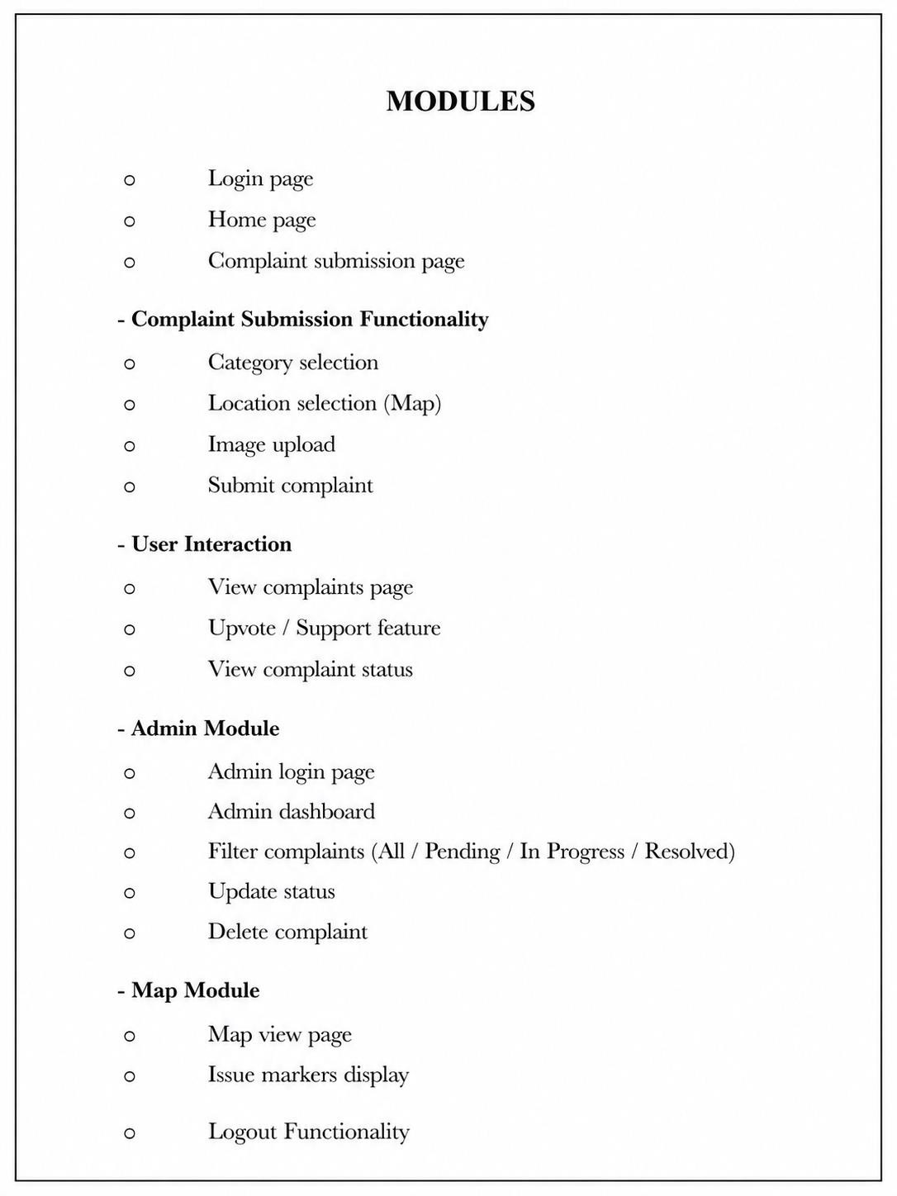





Sample Code: index.html
<!DOCTYPE html>
<html>
<head>
<title>Civic Helper</title>
<link rel="stylesheet" href="{{ url_for('static', filename='style.css') }}">
</head>
<body>

<!-- 🔝 Header -->
<div class="header">
<div class="logo">Civic Helper</div>

<div class="top-buttons">
<a href="/login"><button>🔐 Admin</button></a>
</div>
</div>

<div class="container">
<h2>Submit Complaint</h2>

<form action="/submit" method="POST" enctype="multipart/form-data">

<label>Category</label>
<select name="category">
<option>Road</option>
<option>Water</option>
<option>Garbage</option>
<option>Electricity</option>
</select>

<label>Description</label>
<textarea name="description" required></textarea>

<label>Location</label>
<input type="text" name="location" required>

<input type="hidden" name="lat" id="lat">
<input type="hidden" name="lng" id="lng">

<label>Upload Image</label>
<input type="file" name="image">

<!-- 🗺 Map button -->
<!-- <a href="/map">
<button type="button" class="map-btn">🗺 View Map</button>
</a> -->

<!-- Submit -->
<button type="submit">Submit</button>

</form>

<h3>Select Location on Map</h3>
<div id="map" style="height:300px;"></div>
</div>

<h3>Existing Issues</h3>

<table>
<tr>
<th>Category</th>

<th>Description</th>
<th>Location</th>
<th>Status</th>
<th>Image</th>
<th>Votes</th>
<th>Support</th>
</tr>

{% for row in complaints %}
<tr>
<td>{{ row.category }}</td>
<td>{{ row.description }}</td>

<td>
{{ row.location }}<br>
{% if row.lat and row.lng %}
<a href="https://www.google.com/maps?q={{ row.lat }},{{ row.lng }}" target="_blank"> View on Map 📍
</a>
{% else %} No location
{% endif %}
</td>

<td>
<span class="status {{ row.status }}">
{{ row.status }}
</span>
</td>

<td style="text-align:center;">
{% if row.image %}

<a href="{{ url_for('static', filename='uploads/' + row.image) }}" target="_blank">
<img src="{{ url_for('static', filename='uploads/' + row.image) }}" width="100">
</a>
{% else %}
<span>No Image</span>
{% endif %}
</td>

<td>{{ row.votes }}</td>

<td>
<form onsubmit="return handleVote({{ row.id }})" action="/upvote/{{ row.id }}" method="POST">
<button type="submit">👍</button>
</form>
</td>
</tr>
{% endfor %}
</table>

<script src="{{ url_for('static', filename='script.js') }}"></script>

<link rel="stylesheet" href="https://unpkg.com/leaflet/dist/leaflet.css"/>
<script src="https://unpkg.com/leaflet/dist/leaflet.js"></script>

<script>
var map = L.map('map').setView([17.6868, 83.2185], 12);

L.tileLayer('https://{s}.tile.openstreetmap.org/{z}/{x}/{y}.png', { attribution: '© OpenStreetMap'
}).addTo(map);

var marker;

map.on('click', function(e) { var lat = e.latlng.lat;
var lng = e.latlng.lng;

document.getElementById("lat").value = lat; document.getElementById("lng").value = lng;

if (marker) { map.removeLayer(marker);
}

marker = L.marker([lat, lng]).addTo(map)
.bindPopup("Selected Location").openPopup();
});
</script>

</body>
</html>

admin.html
<!DOCTYPE html>
<html>
<head>
<title>Admin Dashboard</title>
<link rel="stylesheet" href="{{ url_for('static', filename='style.css') }}">
</head>
<body>
<a href="/logout"><button>Logout</button></a>
<div class="container">
<h2>Admin Dashboard</h2>

<!-- ✅ FILTER BUTTONS ADDED HERE -->
<div style="margin-bottom:15px;">
<a href="/admin?status=All"><button>All</button></a>
<a href="/admin?status=Pending"><button>Pending</button></a>
<a href="/admin?status=In Progress"><button>In Progress</button></a>
<a href="/admin?status=Resolved"><button>Resolved</button></a>
</div>

<table>
<tr>
<th>ID</th>
<th>Category</th>
<th>Description</th>
<th>Location</th>
<th>Status</th>
<th>Image</th>
<th>Action</th>
</tr>

{% for row in data %}
<tr>
<td>{{ row['id'] }}</td>
<td>{{ row['category'] }}</td>
<td>{{ row['description'] }}</td>
<td>
{{ row['location'] }}<br>
{% if row['lat'] and row['lng'] %}
<a href="https://www.google.com/maps?q={{ row['lat'] }},{{ row['lng'] }}" target="_blank"> View on Map 📍
</a>
{% else %}

No location
{% endif %}
</td>

<!-- Status -->
<td>
<span class="status {{ row['status'] }}">
{{ row['status'] }}
</span>
</td>

<!-- Image -->
<td style="text-align:center;">
{% if row['image'] %}
<a href="{{ url_for('static', filename='uploads/' + row['image']) }}" target="_blank">
<img src="{{ url_for('static', filename='uploads/' + row['image']) }}" width="100">
</a>
{% else %}
<span>No Image</span>
{% endif %}
</td>

<!-- Actions -->
<td>
<!-- Update -->
<form action="/update/{{ row['id'] }}" method="POST">
<select name="status" class="status {{ row['status'] }}">
<option value="Pending" {% if row['status']=='Pending' %}selected{% endif
%}>Pending</option>
<option value="In Progress" {% if row['status']=='In Progress' %}selected{% endif %}>In Progress</option>
<option value="Resolved" {% if row['status']=='Resolved' %}selected{% endif
%}>Resolved</option>

</select>
<button type="submit">✔</button>
</form>

<!-- Delete -->
<form action="/delete/{{ row['id'] }}" method="POST" style="margin-top:5px;" onsubmit="return confirm('Are you sure you want to delete this issue?')">
<button type="submit" style="background:red; color:white;">Delete</button>
</form>
</td>
</tr>
{% endfor %}
</table>

<a href="/">Back</a>
</div>

</body>
</html>

login.html
<!DOCTYPE html>
<html>
<head>
<title>Admin Login</title>
<link rel="stylesheet" href="{{ url_for('static', filename='style.css') }}">
</head>
<body>

<!-- 🔝 Header -->
<div class="header">
<div class="logo">Civic Helper</div>

<div class="top-buttons">
<a href="/"><button>🏠 Home</button></a>
</div>
</div>

<div class="login-container">
<h2>Admin Login</h2>

<form method="POST">
<input type="text" name="username" placeholder="Username" required>
<input type="password" name="password" placeholder="Password" required>

<button type="submit">Login</button>
</form>
</div>

</body>
</html>

map.html
<!DOCTYPE html>
<html>
<head>
<title>Map View</title>

<!-- Leaflet CSS -->
<link rel="stylesheet" href="https://unpkg.com/leaflet/dist/leaflet.css"/>

<style>
body {
font-family: Arial;

}

#map {
height: 90vh;
}
</style>
</head>
<body>

<h2>Issue Map</h2>
<a href="/"><button>Back</button></a>

<div id="map"></div>

<!-- Leaflet JS -->
<script src="https://unpkg.com/leaflet/dist/leaflet.js"></script>

<script>
// Initialize map
var map = L.map('map').setView([17.6868, 83.2185], 12);

// Load tiles L.tileLayer('https://{s}.tile.openstreetmap.org/{z}/{x}/{y}.png', {
attribution: '© OpenStreetMap'
}).addTo(map);

// Get data from Flask
var complaints = {{ complaints | tojson }};

// Loop through complaints complaints.forEach(function(c) {

// Only show if coordinates exist if (c.lat && c.lng) {

L.marker([c.lat, c.lng]).addTo(map)
.bindPopup(
"<b>" + c.category + "</b><br>" +
c.description + "<br>" + "Status: " + c.status
);

}
});
</script>

</body>
</html>

Script.js
function handleVote(id) {
let voted = JSON.parse(localStorage.getItem("voted")) || [];

if (voted.includes(id)) {
alert("You already voted for this issue!"); return false;
}

voted.push(id);
localStorage.setItem("voted", JSON.stringify(voted)); return true;
}

Style.css

from flask import Flask, render_template, request, redirect, url_for, session import sqlite3
import os
from werkzeug.utils import secure_filename

ALLOWED_EXTENSIONS = {'png', 'jpg', 'jpeg'}

def allowed_file(filename):
return '.' in filename and filename.rsplit('.', 1)[1].lower() in ALLOWED_EXTENSIONS

app = Flask( name ) app.secret_key = "secret123"

DB = "database.db"

# 🔌 Database connection def get_conn():
conn = sqlite3.connect(DB) conn.row_factory = sqlite3.Row return conn

# 🗄️ Initialize DB def init_db():
conn = get_conn() conn.execute("""
CREATE TABLE IF NOT EXISTS complaints (
id INTEGER PRIMARY KEY AUTOINCREMENT,
category TEXT, description TEXT, location TEXT, status TEXT,
votes INTEGER DEFAULT 0,

image TEXT, lat REAL, lng REAL
)
""")
conn.commit() conn.close()

init_db()

# 🏠 Home @app.route('/') def home():
conn = get_conn() complaints = conn.execute(
"SELECT * FROM complaints ORDER BY id DESC"
).fetchall() conn.close()
return render_template("index.html", complaints=complaints)

# 📩 Submit complaint @app.route('/submit', methods=['POST']) def submit():
category = request.form['category'] description = request.form['description'] location = request.form['location']

# ✅ ADD THIS (lat/lng) lat = request.form.get('lat') lng = request.form.get('lng')

# 📸 Image

image = request.files.get('image') filename = None

if image and image.filename != "": if allowed_file(image.filename):
filename = secure_filename(image.filename) image.save(os.path.join("static/uploads", filename))
else:
return "Invalid file type!"

conn = get_conn()

# 🔍 Duplicate check existing = conn.execute(
"SELECT * FROM complaints WHERE location=? AND category=?", (location, category)
).fetchone()

if existing: conn.close() return redirect('/')

# ✅ INSERT WITH lat/lng conn.execute(
"INSERT INTO complaints (category, description, location, status, votes, image, lat, lng) VALUES (?,
?, ?, ?, ?, ?, ?, ?)",
(category, description, location, "Pending", 0, filename, lat, lng)
)

conn.commit() conn.close()

return redirect('/')

# 🛠 Admin @app.route('/admin') def admin():
if not session.get('admin'): return redirect('/login')

status = request.args.get('status')

conn = get_conn()

if status and status != "All": data = conn.execute(
"SELECT * FROM complaints WHERE status=? ORDER BY id DESC", (status,)
).fetchall() else:
data = conn.execute(
"SELECT * FROM complaints ORDER BY id DESC"
).fetchall()

conn.close()
return render_template("admin.html", data=data)

# 00000 Update status @app.route('/update/<int:id>', methods=['POST']) def update(id):
status = request.form.get('status')

conn = get_conn() conn.execute(

"UPDATE complaints SET status=? WHERE id=?", (status, id)
)
conn.commit() conn.close()

return redirect(url_for('admin'))

# 👍 Upvote
@app.route('/upvote/<int:id>', methods=['POST']) def upvote(id):
conn = get_conn() conn.execute(
"UPDATE complaints SET votes = votes + 1 WHERE id=?", (id,)
)
conn.commit() conn.close()

return redirect('/')

# 🗑 Delete
@app.route('/delete/<int:id>', methods=['POST']) def delete(id):
conn = get_conn()

row = conn.execute(
"SELECT image FROM complaints WHERE id=?", (id,)
).fetchone()

if row:

filename = row['image']

if filename:
path = os.path.join("static", "uploads", filename)

print("Trying to delete:", path) # debug

if os.path.exists(path): os.remove(path) print("Deleted:", filename)
else:
print("File not found:", path)

conn.execute("DELETE FROM complaints WHERE id=?", (id,)) conn.commit()
conn.close()

return redirect(url_for('admin'))

# 🗺 Map view @app.route('/map') def map_view():
conn = get_conn()
complaints = conn.execute("SELECT * FROM complaints").fetchall() conn.close()

complaints = [dict(row) for row in complaints]

return render_template("map.html", complaints=complaints)

@app.route('/login', methods=['GET', 'POST']) def login():

if request.method == 'POST':
username = request.form['username'] password = request.form['password']

if username == "admin" and password == "admin123": session['admin'] = True
return redirect('/admin') else:
return "Invalid credentials"

return render_template("login.html")

@app.route('/logout') def logout():
session.pop('admin', None) return redirect('/')

# 🚀 Run
if name == ' main ': app.run(debug=True)

app.py
from flask import Flask, render_template, request, redirect, url_for, session import sqlite3
import os
from werkzeug.utils import secure_filename

ALLOWED_EXTENSIONS = {'png', 'jpg', 'jpeg'}

def allowed_file(filename):
return '.' in filename and filename.rsplit('.', 1)[1].lower() in ALLOWED_EXTENSIONS

app = Flask( name ) app.secret_key = "secret123"

DB = "database.db"

# 🔌 Database connection def get_conn():
conn = sqlite3.connect(DB) conn.row_factory = sqlite3.Row return conn

# 🗄️ Initialize DB def init_db():
conn = get_conn() conn.execute("""
CREATE TABLE IF NOT EXISTS complaints (
id INTEGER PRIMARY KEY AUTOINCREMENT,
category TEXT, description TEXT, location TEXT, status TEXT,
votes INTEGER DEFAULT 0,
image TEXT, lat REAL, lng REAL
) """)
conn.commit() conn.close()

init_db()

# 🏠 Home @app.route('/') def home():
conn = get_conn() complaints = conn.execute(
"SELECT * FROM complaints ORDER BY id DESC"
).fetchall() conn.close()
return render_template("index.html", complaints=complaints)

# 📩 Submit complaint @app.route('/submit', methods=['POST']) def submit():
category = request.form['category'] description = request.form['description'] location = request.form['location']

# ✅ ADD THIS (lat/lng) lat = request.form.get('lat') lng = request.form.get('lng')

# 📸 Image
image = request.files.get('image') filename = None

if image and image.filename != "": if allowed_file(image.filename):
filename = secure_filename(image.filename) image.save(os.path.join("static/uploads", filename))
else:
return "Invalid file type!"

conn = get_conn()

# 🔍 Duplicate check existing = conn.execute(
"SELECT * FROM complaints WHERE location=? AND category=?", (location, category)
).fetchone()

if existing: conn.close() return redirect('/')

# ✅ INSERT WITH lat/lng conn.execute(
"INSERT INTO complaints (category, description, location, status, votes, image, lat, lng) VALUES (?,
?, ?, ?, ?, ?, ?, ?)",
(category, description, location, "Pending", 0, filename, lat, lng)
)

conn.commit() conn.close()

return redirect('/')

# 🛠 Admin @app.route('/admin') def admin():
if not session.get('admin'): return redirect('/login')

status = request.args.get('status')

conn = get_conn()

if status and status != "All": data = conn.execute(
"SELECT * FROM complaints WHERE status=? ORDER BY id DESC", (status,)
).fetchall() else:
data = conn.execute(
"SELECT * FROM complaints ORDER BY id DESC"
).fetchall()

conn.close()
return render_template("admin.html", data=data)

# 00000 Update status @app.route('/update/<int:id>', methods=['POST']) def update(id):
status = request.form.get('status')

conn = get_conn() conn.execute(
"UPDATE complaints SET status=? WHERE id=?", (status, id)
)
conn.commit() conn.close()

return redirect(url_for('admin'))

# 👍 Upvote
@app.route('/upvote/<int:id>', methods=['POST'])

def upvote(id):
conn = get_conn() conn.execute(
"UPDATE complaints SET votes = votes + 1 WHERE id=?", (id,)
)
conn.commit() conn.close()

return redirect('/')

# 🗑 Delete
@app.route('/delete/<int:id>', methods=['POST']) def delete(id):
conn = get_conn()

row = conn.execute(
"SELECT image FROM complaints WHERE id=?", (id,)
).fetchone()

if row:
filename = row['image']

if filename:
path = os.path.join("static", "uploads", filename)

print("Trying to delete:", path) # debug

if os.path.exists(path): os.remove(path) print("Deleted:", filename)

else:
print("File not found:", path)

conn.execute("DELETE FROM complaints WHERE id=?", (id,)) conn.commit()
conn.close()

return redirect(url_for('admin'))

# 🗺 Map view @app.route('/map') def map_view():
conn = get_conn()
complaints = conn.execute("SELECT * FROM complaints").fetchall() conn.close()

complaints = [dict(row) for row in complaints]

return render_template("map.html", complaints=complaints)

@app.route('/login', methods=['GET', 'POST']) def login():
if request.method == 'POST':
username = request.form['username'] password = request.form['password']

if username == "admin" and password == "admin123": session['admin'] = True
return redirect('/admin') else:
return "Invalid credentials"

return render_template("login.html")

@app.route('/logout') def logout():
session.pop('admin', None) return redirect('/')

# 🚀 Run
if name == ' main ': app.run(debug=True)

SCREENSHOTS

