An Adaptive Radius Escalation and Response-Aware Blood Donor Coordination System

Negalurmath V S  Department of Information Technology  V.S.B. Engineering College  Karur, India  negalurmathv@gmail.com | Franklin Jino R E  Department of Information Technology  V.S.B. Engineering College  Karur, India  franklinjinoe@gmail.com | Srinivas R  Department of Information Technology  V.S.B. Engineering College  Karur, India  srinivas280205@gmail.com
Sivaprakash A  Department of Information Technology  V.S.B. Engineering College  Karur, India  asivaprakash24@gmail.com | Udhayamoorthi T  Department of Information Technology  V.S.B. Engineering College  Karur, India  thanganrjudhaya@gmail.com | Yuveshwaran S  Department of Information Technology  V.S.B. Engineering College  Karur, India  yuveshyk97@gmail.com

Abstract—Finding nearby blood donors does not guarantee that enough people will agree to help. Some donors may not respond, while others may withdraw after accepting a request. This paper presents LifeLink, a web application that follows donor responses and automatically adjusts the search when more help is needed. The requester enters the hospital location, urgency and number of donors required. The system first contacts a limited group of nearby donors and expands the search in stages when suitable donors are unavailable or too few respond. Donors can offer help or decline, and the requester selects those who are willing. New alerts pause when enough donors are selected and resume if a selected donor withdraws, unless the requester has paused the search. The application prevents repeated invitations for the same request and prevents a donor from being selected for two active requests. Search progress is saved so that coordination can continue after a server restart. Offers to help, selections and reported donations are recorded separately. Eighteen automated checks passed. A local benchmark using 100 synthetic donors and 30 measured workflows recorded a median of 61.2 milliseconds for evaluating candidates and saving ten invitations. These results describe tested functions and local processing. A separate simulation against an initial-alert proxy showed equal target success with fewer invitations under stated assumptions. LifeLink provides a practical, rule-based method for tracking emergency donor requests without requiring a trained prediction model.
Index Terms—Blood donor coordination, donor responses, emergency requests, location-based search, rule-based systems.
I. INTRODUCTION
A digital blood-donor platform can retrieve people whose registered blood groups and locations match a request. This retrieval step does not establish that enough people have agreed to help or that the same person has not been selected elsewhere. Invitations may be unseen, responses may be delayed and a selected donor may withdraw. The coordination problem therefore continues after an initial candidate list has been generated.
This work develops LifeLink, a rule-based extension to an existing MongoDB, Express, React and Node.js application. The requester confirms the hospital as the search centre and specifies a donor target. A persistent controller invites bounded batches, evaluates actual feedback and widens the search when necessary. It pauses new alerts after sufficient selections and resumes after withdrawal while preserving an explicit manual pause.
The contribution is the integration of feedback, durable state and concurrency protection within a working donor application. It includes separate invitation, willingness, selection and donation states; unique outreach identities; and exclusive donor commitments. Adaptive means that observed conditions change the next coordination decision. No learned response score is required, and no claim is made that staged geographic expansion is universally novel.
II. RELATED WORKS
A. Donor Discovery and Matching
Kanna Deepa et al. [1] describe blood-type matching, location-based discovery, response prediction and donor notifications. This base paper provides the immediate project context. Its published description does not set out the complete persisted sequence of response-window expiry, requester selection targets, withdrawal recovery and exclusive commitments that LifeLink implements.
Fahim et al. [2] developed an Android application that broadcasts blood requests to a volunteer network and informs the requester about willing donors. Donor feedback is therefore an established feature in prior work. LifeLink extends this interaction with explicit selection states, automatic search decisions and database protection against conflicting selections.
Li et al. [3] reviewed 37 studies and surveyed 952 young adults about blood-donation applications. Their work covers finding, attracting and retaining donors, and indicates interest in app-based participation. Acceptance of an application, however, does not establish successful coordination during an urgent request; LifeLink evaluates that workflow separately.
Kamble et al. [4] present a serverless donor-finding application using cloud services, stored geographic coordinates and an interactive map. Their design supports nearby discovery. LifeLink uses hospital-centred distance as an initial filter and then makes further decisions from actual donor responses and the remaining selection target.
Nicholas et al. [5] developed an Android application using Kotlin and Node.js to distribute blood requests to donors with matching blood groups. This provides a relevant example of targeted request communication. LifeLink builds on the same practical need while retaining a visible record of invitations, selections and withdrawals.
Nayak et al. [6] describe nearby donor discovery, accept-or-reject responses and contact sharing after donor agreement. Their system also records donation status. These features overlap with LifeLink and are acknowledged as prior work. The present contribution concerns how response states control bounded search expansion and donor commitments across requests.
Maji et al. [7] present a 2026 location-aware Android system with a configurable travel radius, donor recommendations, camp scheduling, slot booking and approval workflows. Geographic search and workflow support are therefore established approaches. LifeLink focuses on a single request's changing donor target, automatic pause and recovery after withdrawal.
Saha et al. [8] introduce a 2026 preprint on extracting blood requests from multilingual social-media messages. Their Cognitive Blood Request System addresses request discovery and structured information extraction. LifeLink begins with a user-confirmed structured request and coordinates subsequent donor responses; it does not implement language-model extraction. The cited work is identified as a preprint.
McElfresh et al. [9] study algorithmic matching through the Facebook Blood Donations tool using simulations and a field pilot. They distinguish donor actions, such as making appointments, from confirmed donations. Their work supports treating alert allocation as an empirical question. LifeLink retains the same distinction between an offer, a selection and a reported donation.
B. Geographic Planning and Donor Engagement
Ruby et al. [10] use geographic information systems to examine three years of hospital-based mobile blood drives and identify locations that had not been served. Their work demonstrates the importance of spatial coverage. LifeLink operates at the request level, and its evaluation separates dense and sparse donor populations instead of assuming that one radius suits every setting.
Harrell et al. [11] evaluate Facebook's blood-donation tool through a staggered rollout in the United States and longitudinal evidence from Brazil and India. The study links digital outreach to donation behaviour. It motivates evaluating actual participation, while LifeLink's present evidence remains limited to functional tests and cannot establish a comparable population effect.
McElfresh et al. [12] compare altruistic and promotional search-ad messages while tracking appointments and donations. Their results show why message exposure and later participation must be measured separately. LifeLink similarly avoids treating a saved notification as proof that a donor has read it, agreed to attend or donated.
Ramondt et al. [13] conduct a randomized field trial of blood-bank Facebook engagement and report behavioural changes without corresponding improvements in every attitude measure. The study supports measuring observable outcomes rather than relying only on stated intention. LifeLink therefore records willingness and reported donation as different events.
Hasan et al. [14] evaluate a mobile educational intervention among 382 donors deferred for low haemoglobin, reporting a higher return rate in the intervention group. This is evidence about retention after deferral, rather than immediate request fulfilment. It also reinforces that an available app user may still need professional eligibility assessment.
Bawazir et al. [15] examine hospital recruitment records and mobile and app-supported donation campaigns. Their retrospective study highlights the operational role of community outreach and collection services. For LifeLink, this means that software launch alone is insufficient: a useful prototype demonstration must state how donors are registered and how hospital participation would be established.
C. Follow-Up and Accountability
Boonyarat et al. [16] report a 2026 prospective implementation of stepwise follow-up for donors with abnormal results, low haemoglobin or adverse reactions. Their protocol moves through messaging, consultation, telephone and mail. It establishes that structured follow-up already exists in blood services, although its postdonation purpose differs from LifeLink's coordination of candidates for an active request.
D. Research Gap and Scope of the Contribution
The reviewed work establishes prior art in location matching, donor feedback, targeted outreach and staged follow-up. The gap addressed here is a specific software coordination problem: maintaining a requested number of selected donors when responses are delayed, candidates withdraw or several requests compete for the same person. LifeLink combines hospital-centred radius stages, response windows, explicit selection, withdrawal recovery, persistent scheduling and unique donor commitments in one rule-based workflow.
This is an integration and functional-verification contribution, rather than a claim to have invented geolocation or follow-up. The literature does not justify declaring that all previous systems lack these features. Published abstracts and accessible descriptions support the comparisons above; unreported implementation details are not treated as confirmed absences. Broader comparative evaluation is still required to determine when the proposed policy performs better than fixed staging or broad broadcast.
III. PROPOSED METHODOLOGY
Fig. 1 shows the complete application flow. Requester and donor inputs enter the authenticated web interface. The coordinator and periodic worker use saved database state to manage invitations and donor commitments. Private updates return progress to participants, while ended or exhausted searches produce explicit outcomes.
A. Request Model and Search Policy
Each request stores a hospital point, blood group, blood-unit requirement, donor target, urgency and deadline. The donor target is the number of people being coordinated and is independent of the requested blood units. The default radius sequence is R = [5, 10, 20, 50] km. Normal requests begin at 5 km with a 300-second response window and a batch limit of 10; urgent requests begin at 10 km with 120 seconds and 20; critical requests begin at 20 km with 45 seconds and 50. These are configurable prototype settings, not clinically validated limits or an optimal policy.
The controller first handles terminal status, deadline and pause state. It then counts selected donors and usable willing offers. Enough selected donors cause an automatic pause. Enough willing offers cause a wait for requester selection. Otherwise, candidates are filtered for availability, group compatibility, consent preferences, bans, location freshness, previous invitations, active commitments and the daily alert budget. Remaining candidates are ordered by straight-line distance from the hospital.
If a radius contains unused eligible candidates, the controller creates a bounded batch and saves the next evaluation time. It can use another local batch before widening. If a stage has no remaining eligible unalerted candidate, it advances immediately without waiting through an empty response window. After the final 50-km stage is exhausted, automatic search stops and the interface exposes the blood-bank directory. This outcome describes the registered eligible candidate pool rather than the absence of any possible donor in the region.
B. Location Quality and Candidate Distance
A location record includes latitude, longitude, source, acquisition time and, for a device fix, estimated accuracy, consistent with the information exposed by the W3C Geolocation specification [17]. The default maximum age is 24 hours and the device accuracy threshold is 1000 m. Unknown, stale or invalid fixes are excluded. Recent manual points are permitted but labelled self-reported. Client-supplied location can be spoofed, and an accurate fix may become outdated as a donor moves. The application does not claim continuous background tracking or verified physical presence.
Distance is calculated using the Haversine relationship: a = sin squared(delta latitude / 2) + cos(latitude 1) cos(latitude 2) sin squared(delta longitude / 2), and d = 2 x 6371 x asin(sqrt(a)). Angles are in radians and d is in kilometres. The distance is an approximate straight-line measure, not an estimated journey time. Hospital confirmation prevents the requester's phone position from silently becoming the destination.
C. Donor Lifecycle and Commitments
The donor states are notified, willing, declined, no_response, selected, withdrawn and completed. A timed-out invitation may still accept a late offer while the request remains active. Willingness enables requester selection but does not prove attendance or donation. Selection creates a unique active commitment for that donor. If two requests compete, the database permits only one commitment to be acquired.
A selected donor who withdraws releases the commitment. Automatic search resumes from the urgency-specific initial stage, but earlier recipients remain excluded and a manual pause is retained. Fulfilment, cancellation and expiry stop further coordination and release all commitments. Completion requires the requester to identify which selected donors actually donated; unmarked selected donors receive no donation credit. The record remains requester-reported rather than hospital-verified.
D. Persistent and Concurrent Execution
Request stage, radius, policy snapshot, deadline and next evaluation time reside in MongoDB. A periodic worker loads due requests instead of relying on an in-memory timer for each request. A request revision is written first inside each mutation transaction, serialising worker, requester and donor operations. Related invitation, notification and budget changes are committed together using MongoDB transactions [18]. The service initialises the unique indexes before enabling coordination.
The outreach identity is the pair (request, donor). The commitment identity is the donor. MongoDB unique indexes [19] enforce these identities and protect separate invariants: no duplicate invitation within a request and no concurrent active selection across requests. A shared UTC-day donor counter is updated in the invitation transaction so concurrent requests cannot each independently spend the same remaining alert budget. Transactions require a replica-set or supported sharded deployment; the implementation does not silently degrade to inconsistent standalone writes.
E. Evaluation Procedure
Algorithm 1 summarises the controller. Scheduled evaluation and participant actions write the request within a transaction. The worker may be recreated without changing the procedure because the next stage and evaluation time are stored with the request. A due evaluation rechecks status before inviting anyone; a stale timer is not authority to continue an ended request.
Algorithm 1 Persistent request evaluation
1. Lock request revision in a transaction.
2. If ended, return; if overdue, expire and release.
3. If paused or not due, return.
4. Mark unanswered invitations past their window.
5. If the selection target is met, pause new alerts.
6. If usable offers meet the target, await selection.
7. Filter candidates and rank hospital distance.
8. If unused local candidates exist, invite a batch.
9. Save inbox, budget and next evaluation time.
10. Otherwise widen to the next bounded radius.
11. At the final empty stage, record exhaustion.
12. Commit and refresh participants.
F. Implementation and Interface
The existing MERN application supplies account management, request history, maps and notification infrastructure. The extension adds authenticated coordination routes, the coordinator service, a persistent worker, outreach and commitment models, and an escalation log. Coordinated requests are isolated from the legacy escalation job and legacy mutation endpoints to prevent double processing.
The requester interface contains a hospital-based form, live progress and a donor response list. The form separates donor count from blood units and requires confirmation of the hospital point. The progress view shows the current radius, saved invitations, willing offers, selections and decision history. Donors can offer help, decline or withdraw. Contact disclosure occurs after active selection, while donor positions remain private and only approximate distances are shown.
Each invitation has a persistent inbox item because Socket.IO does not guarantee durable delivery by default [20]. Authenticated participant rooms restrict live events to the intended users [21]. Reconnection and periodic polling reload database state. The interface states that a saved invitation does not mean the donor has seen it. SMS OTP delivery is outside the implemented scope, and a production database connection failure cannot substitute a temporary database.
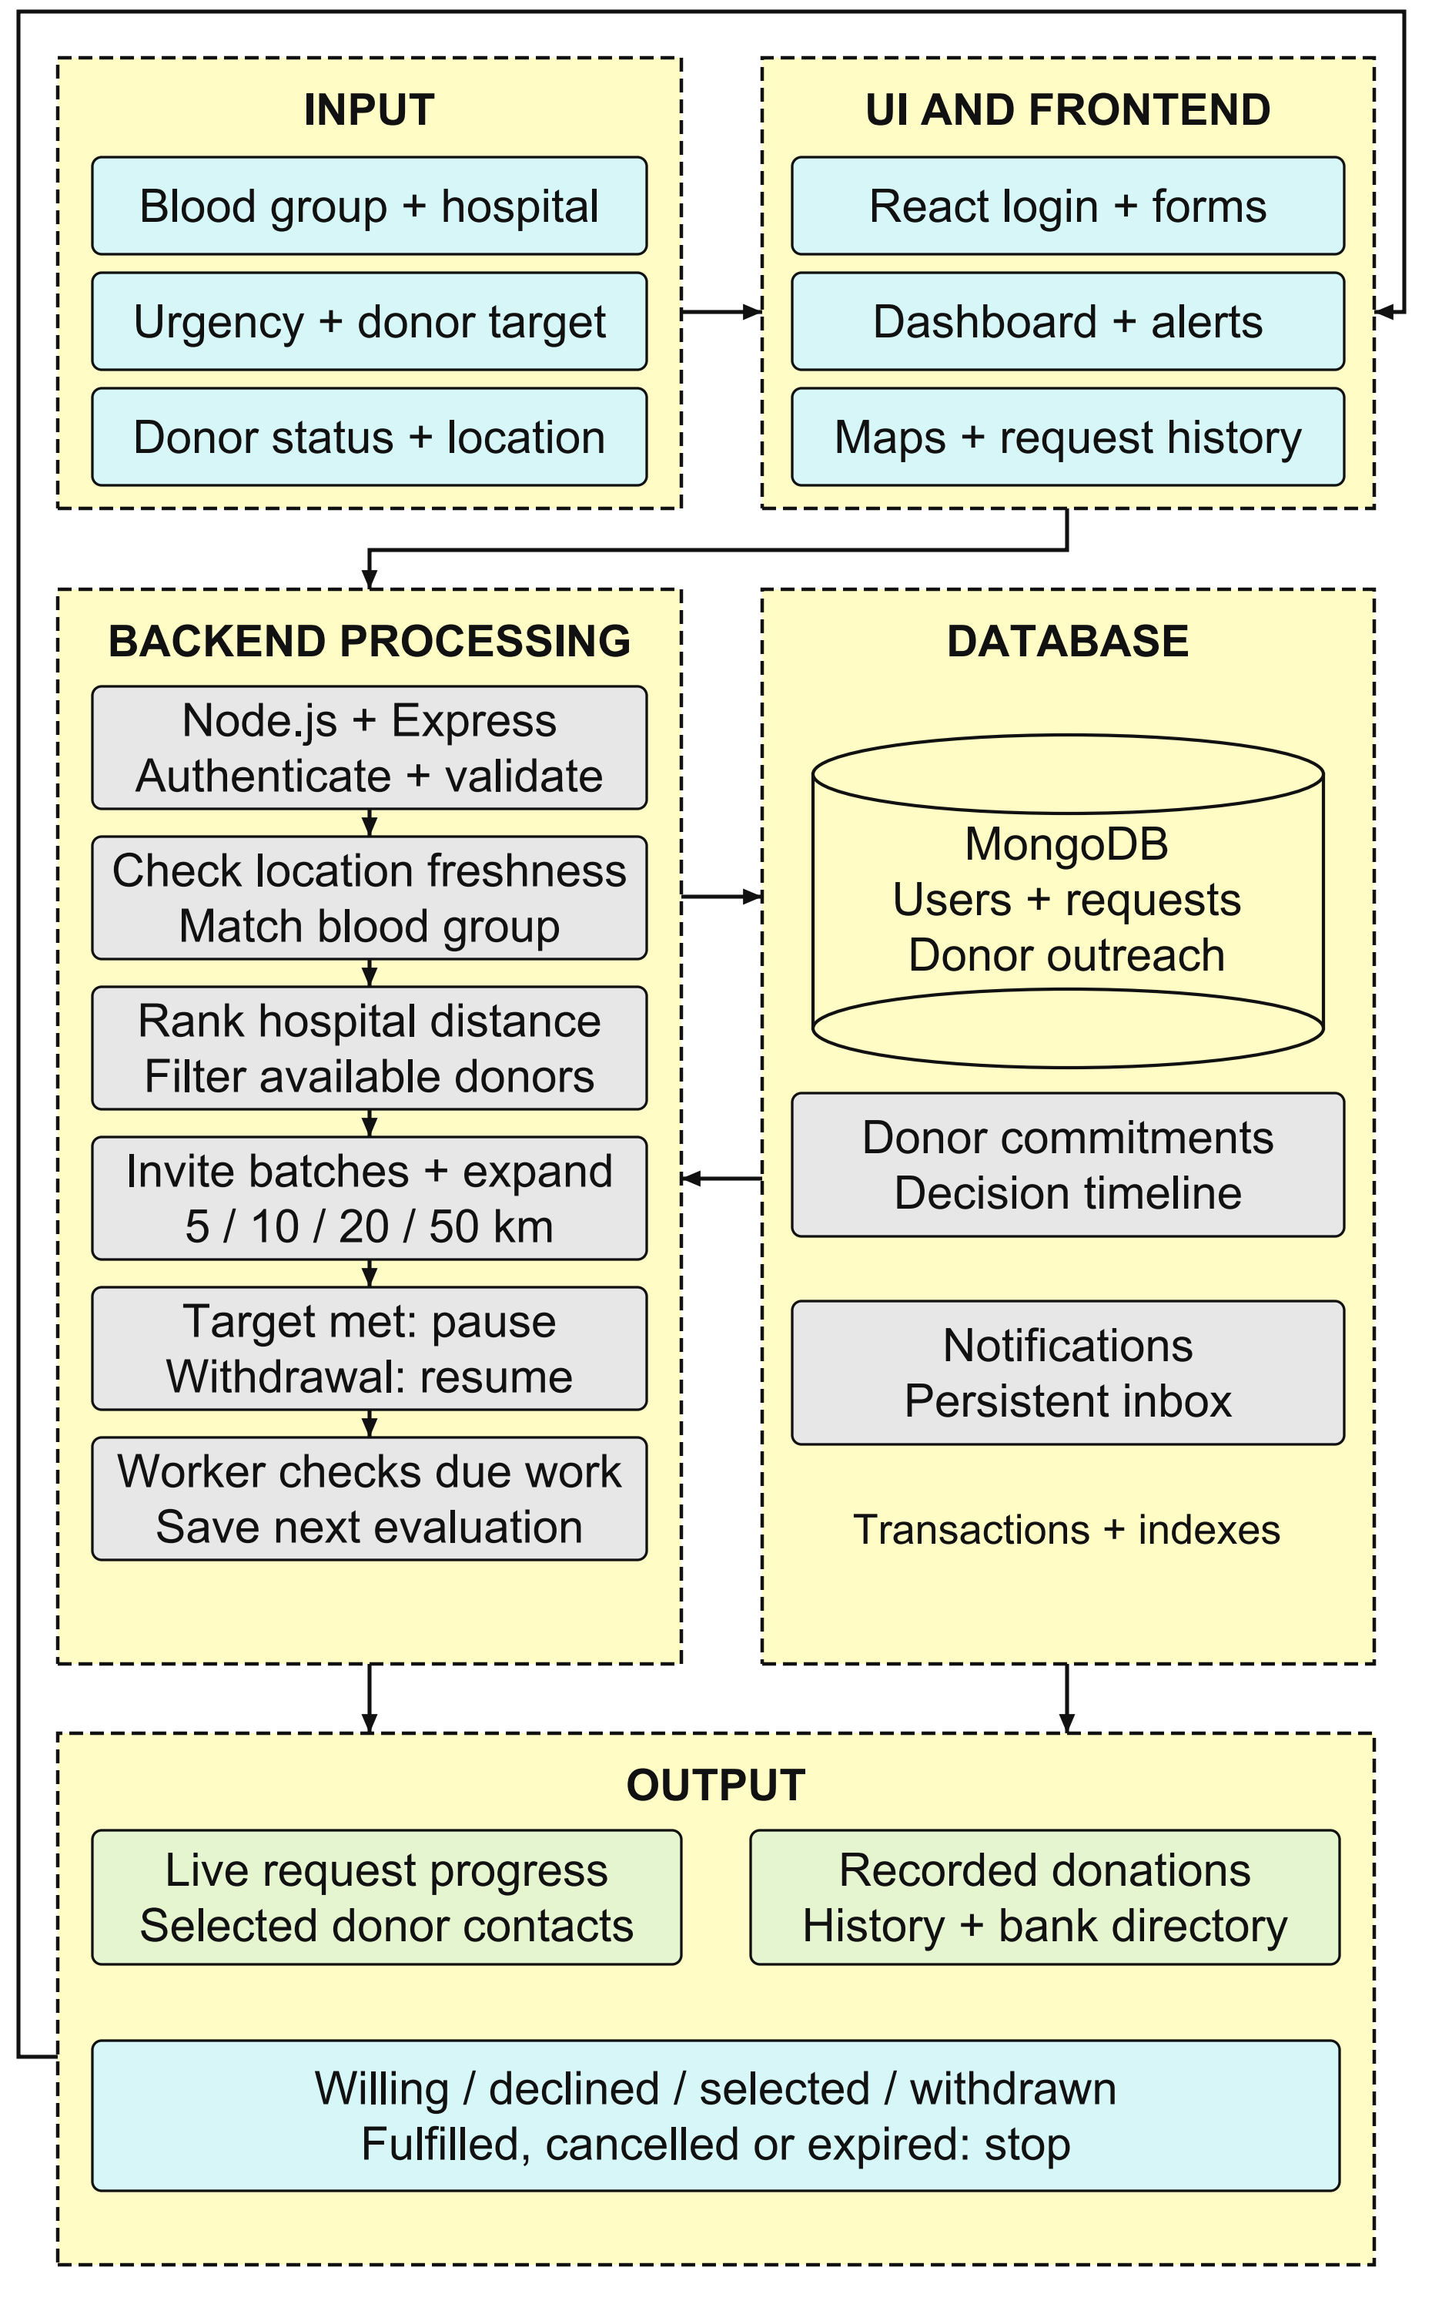
Fig. 1. System Architecture
IV. RESULT AND DISCUSSION
A. Functional Correctness
The current backend test suite was rerun against an isolated temporary MongoDB replica set. All 18 automated test cases passed, with no failures or skipped cases. Table I groups these cases by responsibility. The observed test-case pass rate is 18/18, or 100%; this is correctness on the listed tests, not predictive accuracy, field reliability or proof that every possible input is handled correctly.
TABLE I. AUTOMATED FUNCTIONAL VERIFICATION
Test area | Behaviour checked | Passed / total
Access control | Session identity, invalid sessions, ownership and endpoint protection | 4 / 4
Privacy | Feed redaction and contacts disclosed only after selection | 2 / 2
Location and eligibility | Location validation and candidate filters | 2 / 2
Search and lifecycle | Expansion, pause, withdrawal, busy offers, expiry and completion | 6 / 6
Consistency and limits | Duplicate prevention, competing selections and daily cap | 3 / 3
Worker recovery | Saved progress and durable notification dispatch | 1 / 1
Total | All automated test cases | 18 / 18

The checks include concurrent attempts to create invitations and select donors, the shared daily alert cap, stale-location rejection, manual-pause preservation and release of commitments at expiry. They also verify that willingness alone does not create a completed donation. A separately recorded browser workflow exercised requester and donor interaction, replacement after withdrawal, history and a 390-pixel mobile layout using controlled test accounts.
B. Local Performance Measurement
A reproducible benchmark ran five warm-up workflows followed by 30 measured workflows. Each workflow used one requester and 100 synthetic, available O+ donors with fresh device locations approximately 1.00–1.99 km from a synthetic hospital. The normal policy invited a batch of ten donors. Database records were reset between workflows; fixture creation and assertions were excluded from timings. Operations ran sequentially, with one workflow active at a time.
Measurements used 13th Gen Intel(R) Core(TM) i5-13420H, 15.7 GiB memory, Windows 10.0.26300, Node.js v24.22.1, Mongoose 8.23.0 and MongoDB 8.2.1. The temporary single-node replica set and the service ran on the same computer. Each sample timed a direct awaited service call, including its database work. Median and nearest-rank 95th-percentile (P95) values are reported in Table II; each row contains 30 samples.
TABLE II. MEASURED LOCAL SERVICE LATENCY
Operation | Runs | Median ms | P95 ms
Create request | 30 | 8.38 | 12.45
Evaluate and invite | 30 | 61.21 | 83.11
Record willingness | 30 | 10.17 | 16.62
Select donor | 30 | 15.96 | 21.77
Withdraw and resume | 30 | 11.17 | 14.51
Complete request | 30 | 12.19 | 15.51
Load progress | 30 | 6.91 | 10.49

Create request saves the request and initial decision. Evaluate and invite filters the 100 records and saves ten outreach records, ten inbox items, donor budget updates and a decision log. Record willingness saves an offer; select donor acquires a commitment and pauses new alerts. Withdraw and resume releases that commitment and queues another evaluation. Complete request records the explicitly selected replacement donor and releases commitments. Load progress reads the final requester view and timeline.
C. Interpretation and Remaining Evaluation
Candidate evaluation and invitation creation had the largest median (61.21 ms) and P95 (83.11 ms), consistent with its greater number of database reads and writes. Withdrawal and search resumption had a median of 11.17 ms. This measures saving the resumed state, not obtaining a replacement donor. The periodic worker checks due requests every five seconds, so scheduling delay must be added before any new evaluation. Network delivery, configured response windows and human actions add further delay.
These measurements establish a local baseline for the implemented operations under one small, controlled workload. They do not demonstrate production throughput, performance with many simultaneous requests, location-detection accuracy or time to obtain blood. The raw timing samples, environment metadata and benchmark script are retained with the project so that the experiment can be repeated.
The supplied base paper [1] describes matching and prioritized alerts but provides no reproducible numeric benchmark, dataset, timing distribution or evaluated response-prediction accuracy. Its interface displays summary claims without an experimental protocol. Those labels cannot be used as measured baseline values. Accordingly, the following comparison uses a defined initial-alert proxy; it is not a reconstruction or measurement of the base paper's prediction model.
D. Controlled Policy Comparison
The discrete-event simulation used 1,000 fixed seeds for each of six scenarios and applied the same candidate records, response delays and withdrawal schedule to both policies: 6,000 paired trials. The target was two selected donors remaining available at a 30-minute deadline. The proxy baseline invited all eligible candidates within 50 km once. This choice defines a broad initial-alert comparator because the base paper does not disclose its alert batch size or learned model. It does not reproduce that paper's implementation.
Each trial contained 100 synthetic donors, or 25 in the sparse scenario. Distances were uniform within 0.1–8 km for dense trials, 15–50 km for sparse trials, and 0.1–50 km otherwise. Availability was 75%, reduced to 12% in low-availability trials. Willingness was 30%, or zero in no-response trials; response delay was uniform from 30 to 480 seconds after invitation, and requester selection took 15 seconds. In withdrawal trials, each donor had a 50% chance of becoming unavailable at 480 seconds, using the same absolute schedule for both policies.
LifeLink used the implemented normal settings of 5/10/20/50 km, a 300-second wait and batches of ten; critical trials started at 20 km, waited 45 seconds and used batches of fifty. Empty stages were skipped, reaching the target paused invitations, and a selected-donor withdrawal restarted the stages without inviting previous recipients again. The experiment used one request at a time, assumed fresh locations and did not model competing requests or daily-budget pressure.
TABLE III. CONTROLLED SIMULATION RESULTS
Scenario | Success B / P (%) | Mean alerts B / P
Dense city | 100.0 / 100.0 | 74.9 / 14.7
Sparse region | 99.1 / 99.1 | 18.8 / 13.5
Low availability | 89.3 / 89.3 | 12.1 / 9.2
No responses | 0.0 / 0.0 | 75.1 / 57.6
Withdrawal | 100.0 / 100.0 | 75.0 / 17.6
Critical | 100.0 / 100.0 | 75.0 / 72.9
B denotes the initial-alert proxy baseline and P denotes LifeLink's proposed rules. Both achieved 81.4% aggregate target success across the equally weighted scenarios. Mean invitations were 55.14 for B and 30.92 for P, a 43.9% reduction in this model. Both recorded zero duplicate invitations by construction; duplicate prevention in the real application is separately tested. Critical trials showed only a small invitation reduction because their wider, faster search approached broadcast behaviour.
Equal target success does not establish equivalence across other deadlines or populations. The 30-minute horizon and broad synthetic donor pool allow staging to catch up; earlier deadlines may favour broad initial alerts. A lower invitation count in no-response trials partly reflects the deadline being reached before every candidate is contacted. This simulation tests a stated policy tradeoff, not clinical benefit, measured response-prediction accuracy or superiority over the base paper's undisclosed model. The third fixed-staging comparator and field validation remain future work.
E. Limitations and Future Work
The system depends on registration, current availability, location quality, network access and a running worker. A recent manually confirmed location is not verified presence, and phone contact is not proof of attendance. Hospital request verification, clinical screening and transfusion decisions remain external responsibilities. The prototype is a coordination aid; it is not an independent emergency or clinical service.
Immediate engineering work includes the remaining legacy privacy audit, account-removal cleanup, shared posting limits, completed-only leaderboard migration, geographic indexing, pagination and production deployment verification. The full three-policy comparison, broader workloads and explicit radius-expansion demonstrations remain future work. SMS OTP, independent hospital verification and any learned response predictor are deferred extensions. A future predictor would need suitable consented data and a fair comparison with the transparent rule-based baseline.
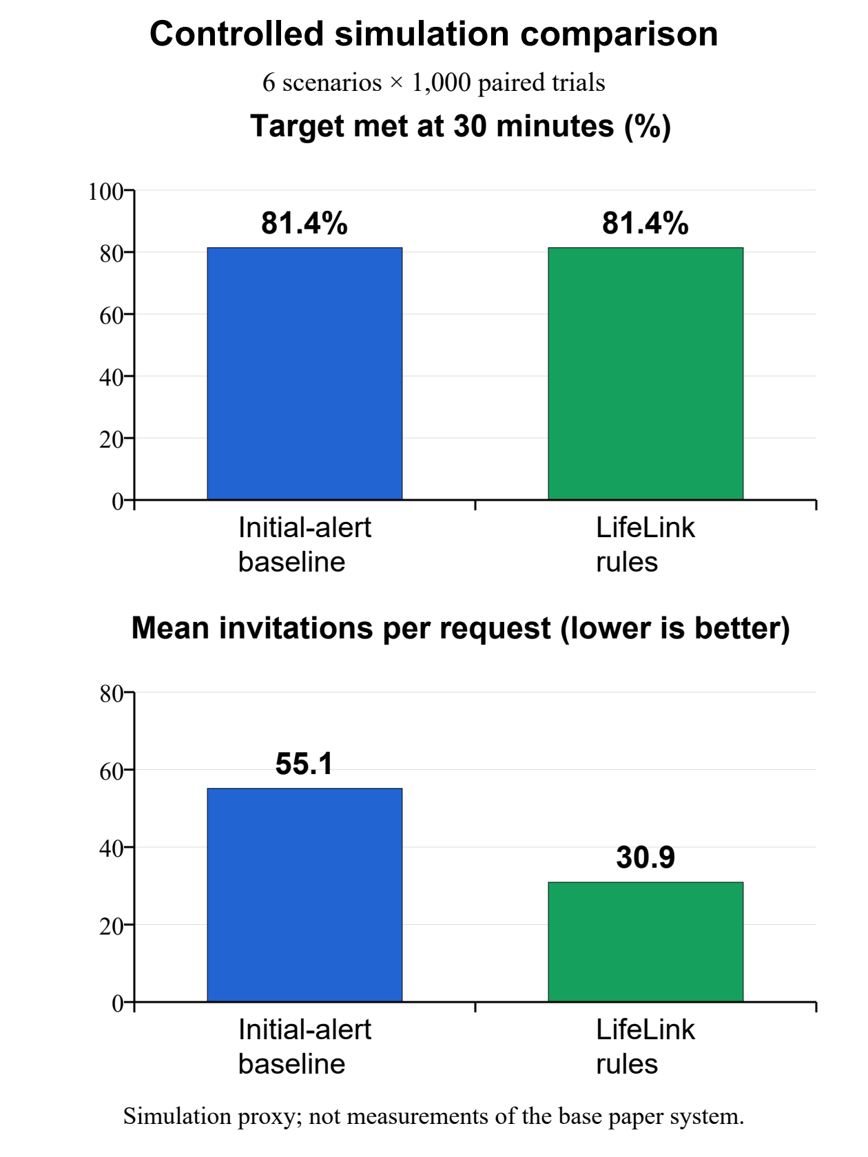
Fig. 2. Initial-alert proxy and LifeLink rules under the stated simulation assumptions.
V. CONCLUSION
LifeLink combines hospital-centred search, explicit donor responses, exclusive commitments and persistent follow-up in a working MERN application. All 18 automated tests passed, and a 30-trial local benchmark measured seven service operations. A controlled simulation produced equal target success and fewer invitations than a one-round alert proxy under the stated assumptions. The Phase-I outcome is a functioning and evaluated software prototype. Future work will test concurrent demand, shorter deadlines, real donor behaviour and production deployment; clinical effectiveness remains unestablished.
REFERENCES
[1] Kanna Deepa, Aarthy C, and N. Udaya Kumar, "AI-Based Donor Connect Platform using Blood Type Matching and Real-Time Emergency Location Detection," International Journal of Engineering & Extended Technologies Research, vol. 8, no. 2, pp. 859-865, Mar.-Apr. 2026, doi: 10.15662/IJEETR.2026.0802042.
[2] M. Fahim, H. I. Cebe, J. Rasheed, and F. Kiani, "mHealth: Blood donation application using Android smartphone," in Proc. 6th Int. Conf. Digital Information and Communication Technology and Its Applications (DICTAP), 2016, pp. 35–38, doi: 10.1109/DICTAP.2016.7543997.
[3] L. Li, M. Valero, R. Keyser, A. M. Ukuku, and D. Zheng, "Mobile applications for encouraging blood donation: A systematic review and case study," Digital Health, vol. 9, Art. no. 20552076231203603, 2023, doi: 10.1177/20552076231203603.
[4] V. Kamble, G. Chaudhari, and P. Thakur, "Location based blood donor finding system," International Journal for Research in Applied Science and Engineering Technology, Jun. 2024, doi: 10.22214/ijraset.2024.63514.
[5] J. Nicholas, X. Najoan, and J. Robot, "Pengembangan aplikasi mobile pencarian pendonor darah [Development of a mobile application for blood donor search]," Jurnal Teknik Informatika, vol. 20, no. 1, Feb. 2025. [Online]. Available: https://ejournal.unsrat.ac.id/v3/index.php/informatika/article/view/56690
[6] K. G. Nayak, M. A. Reddy, M. M. Chouwan, D. S. Jadav, and M. A. Reddy, "Blood donation matcher," Advanced International Journal for Research, vol. 7, no. 1, Jan.–Feb. 2026, doi: 10.63363/aijfr.2026.v07i01.2818.
[7] G. Maji, S. Ghosh, S. Banerjee, A. Banerjee, and P. Ghosh, "Location aware blood management system for donation camps and emergency demands," Transactions of the Indian National Academy of Engineering, vol. 11, pp. 489–503, 2026, doi: 10.1007/s41403-026-00584-4.
[8] A. Saha, M. F. S. Naznin, Z. U. H. Abdullah, A. B. Asad, K. G. S. Bithi, and A. B. M. A. A. Islam, "CBRS: Cognitive blood request system with bilingual dataset and dual-layer filtering for multi-platform social streams," arXiv:2604.16665, ver. 2, May 2026, preprint, doi: 10.48550/arXiv.2604.16665.
[9] D. C. McElfresh et al., "Matching algorithms for blood donation," Nature Machine Intelligence, vol. 5, no. 10, pp. 1108–1118, Oct. 2023, doi: 10.1038/s42256-023-00722-5.
[10] K. N. Ruby, W. H. Dzik, J. J. Collins, H. Tang, S. Ela, and R. S. Makar, "Using geographic information system (GIS) technology to evaluate a hospital-based mobile blood donation program," Transfusion, vol. 65, no. 9, pp. 1630–1639, Sep. 2025, doi: 10.1111/trf.18332.
[11] S. Harrell, A. M. Simons, and P. Clasen, "Promoting blood donation through social media: Evidence from Brazil, India and the USA," Social Science & Medicine, vol. 315, Art. no. 115485, Dec. 2022, doi: 10.1016/j.socscimed.2022.115485.
[12] D. C. McElfresh, J. Bennett, K. Enriquez, and T. D. Pham, "Measuring the effectiveness of online search ads on blood donor recruitment and donation," Transfusion, vol. 64, no. 6, pp. 1016–1024, Jun. 2024, doi: 10.1111/trf.17850.
[13] S. Ramondt, P. Kerkhof, and E.-M. Merz, "Boosting blood donations through Facebook engagement: Randomized controlled field trial," Journal of Medical Internet Research, vol. 27, Art. no. e64740, May 2025, doi: 10.2196/64740.
[14] M. I. Hasan, S. S. Noordin, R. Hami, N. Ishak, and A. Achuthan, "The effectiveness of iron education through a mobile application on donor return after deferral for low hemoglobin," Blood Transfusion, vol. 20, no. 6, pp. 446–453, Nov. 2022, doi: 10.2450/2022.0018-22.
[15] W. M. Bawazir et al., "Evaluating strategic blood donor recruitment initiatives: Insights from King Fahd armed forces hospital experience," Transfusion and Apheresis Science, vol. 64, no. 3, Art. no. 104119, Jun. 2025, doi: 10.1016/j.transci.2025.104119.
[16] R. Boonyarat, P. Sripara, N. Boonmawongsa, B. Benjangkaprasert, and W. Mahama, "A stepwise telemedicine follow-up system for blood donors in a university blood bank: Prospective implementation study," JMIR Formative Research, vol. 10, Art. no. e95132, Jul. 2026, doi: 10.2196/95132.
[17] World Wide Web Consortium, "Geolocation," W3C specification. [Online]. Available: https://www.w3.org/TR/geolocation/. Accessed: Oct. 27, 2026.
[18] MongoDB, "Transactions," MongoDB Manual. [Online]. Available: https://www.mongodb.com/docs/manual/core/transactions/. Accessed: Oct. 27, 2026.
[19] MongoDB, "Unique Indexes," MongoDB Manual. [Online]. Available: https://www.mongodb.com/docs/manual/core/index-unique/. Accessed: Oct. 27, 2026.
[20] Socket.IO, "Delivery guarantees," Socket.IO 4.x Documentation. [Online]. Available: https://socket.io/docs/v4/delivery-guarantees/. Accessed: Oct. 27, 2026.
[21] Socket.IO, "Rooms," Socket.IO 4.x Documentation. [Online]. Available: https://socket.io/docs/v4/rooms/. Accessed: Oct. 27, 2026.

