

AN ADAPTIVE RADIUS ESCALATION AND RESPONSE-AWARE BLOOD DONOR COORDINATION SYSTEM

A PROJECT PHASE I REPORT

Submitted by

SRINIVAS R | (922523205155)
SIVAPRAKASH A | (922523205152)

in partial fulfillment for the award of the degree
of
BACHELOR OF TECHNOLOGY
in
INFORMATION TECHNOLOGY

V.S.B. ENGINEERING COLLEGE, KARUR-639111 (AN AUTONOMOUS INSTITUTION)
ANNA UNIVERSITY :: CHENNAI 600 025

DECEMBER 2026

ANNA UNIVERSITY :: CHENNAI 600 025
BONAFIDE CERTIFICATE

Certified that this project report titled “AN ADAPTIVE RADIUS ESCALATION AND RESPONSE-AWARE BLOOD DONOR COORDINATION SYSTEM” is the bonafide work of “ SRINIVAS R (922523205155), SIVAPRAKASH A (922523205152)” who carried out under my supervision.

SIGNATURE SIGNATURE
Mrs. P.AROCKIA MARY, MTech.,Ph.D. Mrs. BENILA, BE.,M Tech

HEAD OF THE DEPARTMENT SUPERVISOR
Assistant Professor
Department of Information Technology Department of Information Technology
V.S.B. Engineering College V.S.B. Engineering College
Karur-639111. Karur-639111.

Submitted for Anna University Project Viva-Voce held on

INTERNAL EXAMINER EXTERNAL EXAMINER

ACKNOWLEDGEMENT

First and foremost, we express our thanks to our parents for providing us with a very nice environment for doing this project. We wish to express our sincere thanks to our founder and Chairman Shri. V. S. BALSAMY B.Sc., L.L.B., for his endeavour in educating us in this premier institution.

We extend our gratitude to Dr. C. VENNILA, M.E., Ph.D., Principal and Dr. T. S. KIRUBHASHANKAR M.E., Ph.D., Vice Principal, V.S.B.
ENGINEERING COLLEGE, KARUR for their high degree of encouragement and moral support during this project.

We express our indebtedness to Mr. K. MANIVANNAN, M.Tech., (Ph.D.), Head of the Department, Department of Information Technology for his guidance throughout the course of our project.

We are grateful to our Project Supervisor Mr.V.S. NEGALURMATH , BE.,M Tech
Assistant Professor, Department of Information Technology for her valuable support.

Our sincere thanks to all the faculty members of V.S.B. Engineering College and our friends for their help in the successful completion of this project work.

Finally, we bow before God, the almighty who always had a better plan for us. We give our praise and glory to almighty god for successful completion of our project.


DEPARTMENT OF INFORMATION TECHNOLOGY
Vision of the Institution:
We endeavour to impart futuristic technical education of the highest quality to the student community and to inculcate discipline in them to face the world with self-confidence and thus we prepare them for life as responsible citizens to uphold human values and to be of service at large. We strive to bring of the Institution as an Institution of academic excellence of international standard.
Mission of the Institution:
We transform persons into personalities by the state-of the art infrastructure, time consciousness, quick response and the best academic practices through assessment and advice.
Vision of the Department:
To provide professional computing training to make competent IT engineers and thus prepare the students to work in the emerging trends of information technology field.
Mission of the Department:
- Producing quality IT engineers with good technical knowledge by effective teaching.
- Making competent engineers to adapt to the dynamic needs of industries.
- Developing extensive learning skills in studies.
- Inculcating strong ethical values and professionalism to serve society with responsibility.

Program Educational Objectives (PEOs)

PEO 1: To make graduates to be proficient in utilizing the fundamental knowledge of various streams in engineering and technology.
PEO 2: To enrich graduates with the core competencies necessary for applying knowledge of computers and technologies in the context of business enterprise.
PEO 3: To enable graduates think logically and to pursue lifelong learning to understand technical issues related to computing systems and to provide optimal solutions.
PEO 4: To enable graduates, develop hardware and software system by understanding the importance of social, business and environmental needs in the social context.

Program Outcomes (POs)

PO1. Engineering knowledge: Apply the knowledge of mathematics, science, engineering fundamentals, and an engineering specialization to the solution of complex engineering problems.
PO2. Problem analysis: Identify, formulate, review research literature, and analyze complex engineering problems reaching substantiated conclusions using first principles of mathematics, natural sciences, and engineering sciences.
PO3. Design/development of solutions: Design solutions for complex engineering problems & design system components or processes that meet the specified needs with appropriate consideration for the public health and safety, and the cultural, societal, and environmental considerations.
PO4. Conduct investigations of complex problems: Use research-based knowledge and research methods including design of experiments, analysis and interpretation of data, and synthesis of the information to provide valid conclusions.
PO5. Modern tool usage: Create, select, and apply appropriate techniques, resources, and modern engineering and IT tools including prediction and modeling to complex engineering activities with an understanding of the limitations.
PO6. The engineer and society: Apply reasoning informed by the contextual knowledge to assess societal, health, safety, legal and cultural issues and the consequent responsibilities relevant to the professional engineering practice.
PO7. Environment and sustainability: Understand the impact of the professional engineering solutions in societal and environmental contexts, and demonstrate the knowledge of, and need for sustainable development.
PO8. Ethics: Apply ethical principles and commit to professional ethics and responsibilities and norms of the engineering practice.
PO9. Individual and team work: Function effectively as an individual, and as a member or leader in diverse teams, and in multidisciplinary settings.
PO10. Communication: Communicate effectively on complex engineering activities with the engineering community and with society at large, such as, being able to comprehend and write effective reports and design documentation, make effective presentations, and give and receive clear instructions.

PO11. Project management and finance: Demonstrate knowledge and understanding of the engineering and management principles and apply these to one’s own work, as a member and leader in a team, to manage projects and in multidisciplinary environments.
PO12. Life-long learning: Recognize the need for, and have the preparation and ability to engage in independent and life-long learning in the broadest context of technological change.

Program Specific Outcome (PSOs)

PSO1: Apply the mathematical and the computing knowledge to identify and provide solutions for computing problems.
PSO2: Design and develop computer programs in the areas related to algorithms, networking, web design and data analytics of varying complexity.
PSO3: Apply standard Engineering practices and strategies in software project using open- source environment to deliver a quality product for business success.

ABSTRACT
Emergency blood-request platforms can identify nearby candidates, but a list of matching donors does not establish that sufficient people have agreed to help. Non-response, withdrawal and competing requests require a continuing coordination process. This project develops LifeLink, a MERN web application that adds feedback-driven coordination to an existing donor network. The requester confirms the hospital location and a target number of donors. A rule-based controller searches configurable stages of 5, 10, 20 and 50 km, invites bounded batches, and evaluates responses after an urgency-dependent interval. Empty candidate pools cause immediate expansion. Willingness, selection, withdrawal and completed donation are stored separately. New alerts pause when the selection target is reached; withdrawal releases a donor commitment and resumes the search unless the requester has manually paused it. MongoDB transactions and unique indexes protect invitation and commitment records, while persistent stage and evaluation fields support worker recovery. Authenticated participant views disclose contact details after selection and retain a decision timeline. The functional verification record comprises 18 automated backend checks and an isolated browser workflow covering request creation, donor responses, withdrawal, completion and mobile layout. Comparative policy evaluation remains planned. The Phase-I outcome is a functioning coordination prototype rather than an established improvement in donor availability, clinical outcomes or emergency response time.

TABLE OF CONTENTS
CHAPTER NO. | TITLE | PAGE NO.
 | ABSTRACT | VII
 | LIST OF FIGURES | XI
 | LIST OF ABBREVIATIONS | XII
1. | INTRODUCTION | 1
 | 1.1 Project Overview | 2
 | 1.2 Problem Statement | 2
 | 1.3 Objectives and Scope | 3
2. | LITERATURE SURVEY | 4
 | 2.1 Base Paper and Existing Approach | 5
 | 2.2 Identified Coordination Gap | 5
3. | SYSTEM ANALYSIS | 7

CHAPTER NO. | TITLE | PAGE NO.
 | 3.1 Existing System | 8
 | 3.2 Proposed Response Aware System | 8
 | 3.3 Functional Requirements | 9
4. | SYSTEM SPECIFICATION | 11
 | 4.1 Hardware Requirements | 12
 | 4.2 Software Requirements | 13
5. | IMPLEMENTATION | 15
 | 5.1 Modules Used | 16
 | 5.2 Module Descriptions | 16
 | 5.3 Response and Selection Workflow | 17
6. | SYSTEM DESIGN | 18
 | 6.1 System Architecture | 19
 | 6.2 Request and Donor State Design | 19

CHAPTER NO. | TITLE | PAGE NO.
 | 6.3 Escalation Policy and Algorithm | 21
7. | SYSTEM TESTING | 25
 | 7.1 Functional Verification | 26
 | 7.2 Comparative Evaluation Design | 26
8. | FEASIBILITY STUDY | 28
9. | CONCLUSION AND FUTURE ENHANCEMENT | 31
 | APPENDIX | 33
 | REFERENCES | 41

LIST OF FIGURES
FIGURE | NAME OF THE FIGURE | PAGE NO.
3.1 | Overview of response aware donor coordination | 9
6.1 | LifeLink system architecture | 19
6.2 | Donor response and commitment lifecycle | 20
6.3 | Feedback driven search decision flow | 22
6.4 | Principal coordination data relationships | 23
D.1 | Requester progress screen | 38
D.2 | Donor selection and withdrawal screen | 39

LIST OF ABBREVIATIONS
NO. | ABBREVIATION | EXPANSION
1 | MERN | MongoDB Express React Node.js
2 | API | Application Programming Interface
3 | GPS | Global Positioning System
4 | JWT | JSON Web Token
5 | HTTP | Hypertext Transfer Protocol
6 | HTTPS | HTTP Secure
7 | UI | User Interface
8 | UTC | Coordinated Universal Time
9 | CRUD | Create Read Update Delete
10 | OTP | One Time Password
11 | SMS | Short Message Service
12 | CSV | Comma Separated Values
13 | DFD | Data Flow Diagram

INTRODUCTION

CHAPTER 1
INTRODUCTION
1.1 Project Overview
LifeLink is a web-based donor network for coordinating requests for blood. A requester describes the need, confirms a hospital location and specifies how many donor candidates must be coordinated. Registered donors provide a blood group, availability and a location that may be acquired from the device or confirmed manually. The application organises the resulting interaction through explicit request and donor states.
The starting point is an existing MERN application developed as a functional portfolio project. Its registration, request feed, history, maps and notification facilities provide the application foundation. The Phase-I extension adds persistent, response-aware control after invitations have been created. Reusing this foundation allows the project to focus on an identifiable coordination problem instead of treating a new interface as the innovation.
1.2 Problem Statement
Finding a compatible registered person and securing a willing, available participant are different tasks. A donor may not see an invitation, may decline, or may withdraw after being selected. A second requester may also attempt to select the same donor. Without explicit follow-up, the requester cannot distinguish a delivered alert from a genuine commitment and may continue contacting people even when enough donors have already been selected.
A useful system must therefore answer four practical questions: who has been invited, who offered help, who is currently committed, and what action should occur when the target remains unmet. These questions require persistent state, bounded rules and understandable feedback. They do not inherently require a trained prediction model.
1.3 Objectives and Scope
The primary objective is to implement a rule-based coordination agent that evaluates actual donor feedback. It must search around the confirmed hospital, expand when necessary, avoid repeated invitations for the same request, and pause unnecessary alerts when the donor target is met. It must also separate a willingness response from a completed donation and release commitments when a request ends.
The Phase-I scope includes requester and donor interfaces, urgency-dependent search settings, persistent MongoDB records, participant-specific notifications, location metadata and functional verification. Hospital verification, SMS OTP delivery, learned response prediction and proof of clinical benefit are outside the implemented scope. The target is the number of people being coordinated; it is not a direct conversion from clinical blood units.
1.4 Project Contributions
The contribution is an integrated follow-up workflow: deterministic escalation, an explicit donor lifecycle, exclusive commitments and a decision history within the existing application. The word adaptive refers to decisions triggered by observed responses, availability and request status. The system does not claim that staged radius expansion is a new idea in all prior literature or that its default settings are optimal.

LITERATURE SURVEY

CHAPTER 2
LITERATURE SURVEY
2.1 Base Paper and Existing Approach
The base paper is "AI-Based Donor Connect Platform using Blood Type Matching and Real-Time Emergency Location Detection" by Kanna Deepa, Aarthy C and N. Udaya Kumar [1]. It describes donor registration, compatibility filtering, location-based search, predicted response ranking and notifications. Its implementation discussion uses HTML, CSS and JavaScript with Flask and MySQL, and refers to GPS, Google Maps and an SMS or mobile notification service.
Its matching objective prioritises candidates using an estimated response probability and geographic proximity. This provides the conceptual starting point for connecting a blood request with suitable nearby candidates. LifeLink does not reproduce a trained prediction model from the paper. It implements the coordination extension using its existing React, Express, Node.js and MongoDB stack.
2.2 Identified Coordination Gap
The published description does not provide a detailed persisted protocol for response windows, requester selection targets, donor withdrawal and exclusive commitments across competing requests. The project treats these details as an extension opportunity. This is a statement about the detail available in the paper, not a claim that every implementation of that work lacks follow-up or that no other donor platform implements escalation.
The proposed system addresses this gap by retaining one outreach record for each request-donor pair and linking response changes to later search decisions. Search expansion is conditional rather than a scheduled resend to the same recipients. A selected donor is also represented by a commitment record that can be released explicitly.
2.3 Location and Data Foundations
The W3C Geolocation specification describes permission-controlled access to location, including a measurement time and an accuracy estimate [2]. LifeLink stores these attributes rather than assuming that every saved coordinate is a current GPS fix. A manual location is marked as self-reported. No location source is treated as proof that the donor is physically present at the recorded point.
MongoDB transactions and unique indexes provide the relevant persistence mechanisms [3], [4]. The application uses them to make related invitation, notification and counter changes atomic and to enforce unique active donor commitments. The coordination rules are application logic; database constraints provide an additional protection against concurrent requests.
2.4 Communication and Research Position
Socket.IO distinguishes ordered events from guaranteed delivery [5]. Accordingly, the application treats socket messages as refresh signals and keeps the invitation and inbox record in the database. Authenticated per-user rooms limit which connected participants receive private updates [6]. The research position is therefore a transparent, testable coordination protocol supported by established web and database mechanisms.

SYSTEM ANALYSIS

CHAPTER 3
SYSTEM ANALYSIS
3.1 Existing System
The base-paper system identifies and prioritises candidate donors using blood type, availability, distance and predicted response. The original LifeLink application already provides the surrounding MERN product features, including accounts, request posting, maps, notifications and history. These are two separate baselines: the paper provides research context, while the existing application supplies reusable working software.
The original application includes a simple escalation job for stale broadcasts, so it would be inaccurate to describe LifeLink as having no escalation at all. The extension introduces a separate hospital-centred coordinator with persisted stages, unique outreach records and explicit lifecycle control. Coordinated requests are excluded from the legacy job so the two mechanisms cannot process the same request.
3.2 Proposed Response Aware System
A new request records the hospital point, urgency, donor target, expiry and the initial search stage. The coordinator filters available compatible candidates using recent location metadata, prior invitations, commitments, preferences and an alert budget. It then invites a bounded batch and saves the next evaluation time. If the current radius has no remaining eligible unalerted candidates, it expands immediately to the next configured radius.
A donor chooses whether to offer help or decline. The requester selects willing donors, creating exclusive commitments. Enough selected donors cause an automatic pause. If a selected donor withdraws, the commitment is released and the search resumes unless it was manually paused. Completion requires explicit identification of donors who actually donated; it cannot be inferred from willingness or selection.
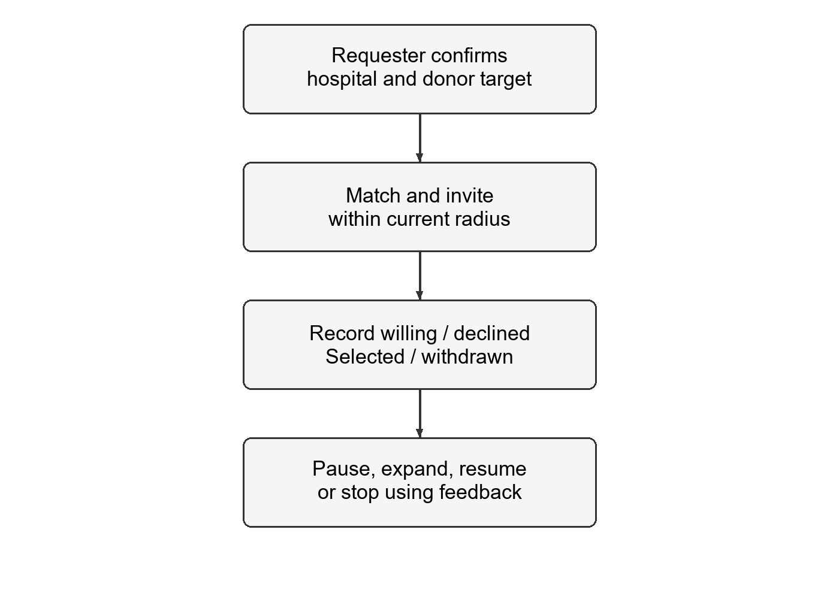
Figure 3.1 Overview of response aware donor coordination
3.3 Functional Requirements
The system shall validate request fields and the hospital point; store a separate donor target and blood-unit count; restrict actions to authorised participants; prevent repeated invitations for a request; maintain a bounded search radius; persist stage and decision records; and expose willing donors for requester selection. It shall stop when a request is completed, cancelled or expired and shall provide a blood-bank-directory link when automated search is exhausted.

3.4 Nonfunctional Requirements and Constraints
The interface must communicate state changes without implying that an invitation was seen or a donation completed. It must support mobile layouts and allow manual location entry when device location is unavailable. Precise donor coordinates are not part of participant views; approximate distance is sufficient for coordination. Contact details become available after selection within the active request.
Database integrity is necessary because simultaneous operations are normal, not exceptional. The request is written first within each transaction to serialise owner, donor and worker changes. A unique request-donor index prevents duplicate outreach. A separate unique donor index prevents two active commitments. A saved evaluation time allows a restarted worker to identify due work without relying on an in-memory timer per request.
3.5 Advantages and Practical Limits
The proposed workflow makes follow-up decisions visible and explainable. A requester can inspect who offered, who was selected and why the search widened. Batching and suppression prevent the same request from repeatedly alerting the same donor, while pause and withdrawal rules coordinate the transition between finding candidates and maintaining sufficient commitments.
These are properties of the implemented workflow, not measured reductions in emergency response time. The prototype depends on registered users, truthful availability, location freshness, network access and an operating backend worker. It cannot guarantee that a person will respond, attend a hospital or remain clinically eligible. The full legacy-route privacy review and completed-only ranking migration are separate release tasks.
SYSTEM SPECIFICATION

CHAPTER 4
SYSTEM SPECIFICATION
4.1 Hardware Requirements
Development and demonstration require an ordinary computer capable of running the web application and a local test database. The recommendations below are development targets rather than measured minimum hardware requirements. No graphics-processing unit or machine-learning training equipment is required.
Component | Development target | Purpose
Computer | Modern multicore CPU; approximately 8 GB RAM | Run browser, Node.js and development tools
Client device | Current browser on phone or computer | Requester and donor interaction
Location source | Device fix or manually confirmed point | Approximate hospital-distance matching
Network | Internet or controlled local network | API and participant updates
Special hardware | No GPU requirement | Rules do not train or serve an ML model

4.2 Software Requirements
Component | Technology | Role
Frontend | React 19 and Vite 8 | Requester and donor screens
Backend | Node.js and Express | Authenticated REST routes and rules
Database | MongoDB and Mongoose | Persistent state and transactions
Communication | Socket.IO | Authenticated participant refresh events
Maps | Leaflet and OpenStreetMap | Hospital point and search-area display
Verification | Node test runner and browser automation | Functional and integration checks

4.3 Deployment and Persistence
The coordinator requires MongoDB Atlas or another replica-set deployment because related changes use transactions. Production refuses a temporary in-memory database fallback. A development fallback may be useful for demonstrations but does not preserve data after it is stopped. The browser and API must use the correct backend URL, and HTTPS is required for normal browser location permissions outside localhost.
The application has previously been hosted with a Vercel frontend and Render backend. The Phase-I coordination changes have been developed and tested locally; this report does not assert that the updated release is deployed. Continuous evaluation also requires the backend to remain running. A sleeping or suspended service cannot provide continuous processing.
4.4 Principal Data Collections
Collection | Principal record | Constraint or responsibility
User | Availability and location metadata | Shared daily invitation budget
Broadcast | Hospital, target and search state | Saved deadline and next evaluation
DonorOutreach | One invitation lifecycle | Unique request and donor pair
DonorCommitment | Active selected donor | Unique donor across requests
EscalationLog | Decision event | Time, radius, count and reason
Notification | Participant inbox item | Persistent alert; not a read receipt

IMPLEMENTATION

CHAPTER 5
IMPLEMENTATION
5.1 Modules Used
The implementation separates account access, location capture, request creation, candidate search, donor responses, requester selection, commitment release and decision logging. The React components communicate with authenticated Express routes. The coordinator service owns the state-changing rules, while a background job finds due requests and calls the same service.
User records contain a blood group, availability, notification preferences and location metadata. Request records contain hospital coordinates, a target, status, radius, stage, deadline and next evaluation time. DonorOutreach records represent invitations and responses; DonorCommitment records represent exclusive active selection. EscalationLog and Notification records retain decisions and inbox items.
5.2 Module Descriptions
Request creation validates the hospital, district, group, urgency and integer target. The donor target and blood units each range from one to ten and remain independent fields. An account cooldown is applied transactionally and the new route also has a posting-rate limit. A snapshot of the search configuration is stored with the request so later environment changes do not silently alter active requests.
Candidate matching excludes the requester, previously invited people, active commitments, banned or unavailable accounts, incompatible groups, opted-out users and donors who have reached the daily budget. Unknown or old locations are excluded. A device fix additionally needs an acceptable accuracy estimate. Manual locations are permitted as recent self-reported points and are labelled accordingly.
The persistent worker polls for due or expired coordinated requests. It respects the saved pause status and deadline, then evaluates selected and usable willing offers before deciding whether to invite another batch. It can use remaining unalerted candidates at the current radius before expanding. When no further candidate exists at 50 km, it records exhaustion without claiming that no donor exists outside the registered eligible pool.
5.3 Response and Selection Workflow
The response states are notified, willing, declined, no_response, selected, withdrawn and completed. A late response may move an active invitation from no_response to willing or declined. Selection requires a current willing offer and an available account. The commitment insert enforces a unique donor constraint, so two requesters cannot both acquire the same donor.
The application pauses new invitations when the selection target is met. Withdrawal from a selected offer releases its commitment and queues a new evaluation from the urgency-specific initial stage. It does not repeat earlier invitations. A manual pause is retained. Fulfilment, cancellation and expiry stop the request and release its commitments.
5.4 Notifications and Completion
An invitation and its persistent notification are committed with the outreach record. Private Socket.IO events prompt connected participants to refresh their data. They are best-effort signals rather than proof of delivery or reading. The browser also reloads state on reconnect and uses a polling fallback. The new coordinator uses in-app notifications; SMS OTP delivery is excluded.
Completion is an explicit requester action. The requester checks the selected people who actually donated. Only these outreach records become completed, and other selected people are released without donation credit. This is a requester-reported event, not independent verification by a hospital. Legacy response-based leaderboards must not be interpreted as verified donation totals.

SYSTEM DESIGN

CHAPTER 6
SYSTEM DESIGN
6.1 System Architecture
LifeLink uses a presentation layer, authenticated API, coordination service and persistent data layer. React renders the requester and donor experience. Express validates API access and delegates changes to the coordinator. MongoDB stores the durable state, and authenticated Socket.IO rooms provide participant updates. Leaflet displays hospital locations and search areas without exposing exact donor coordinates.
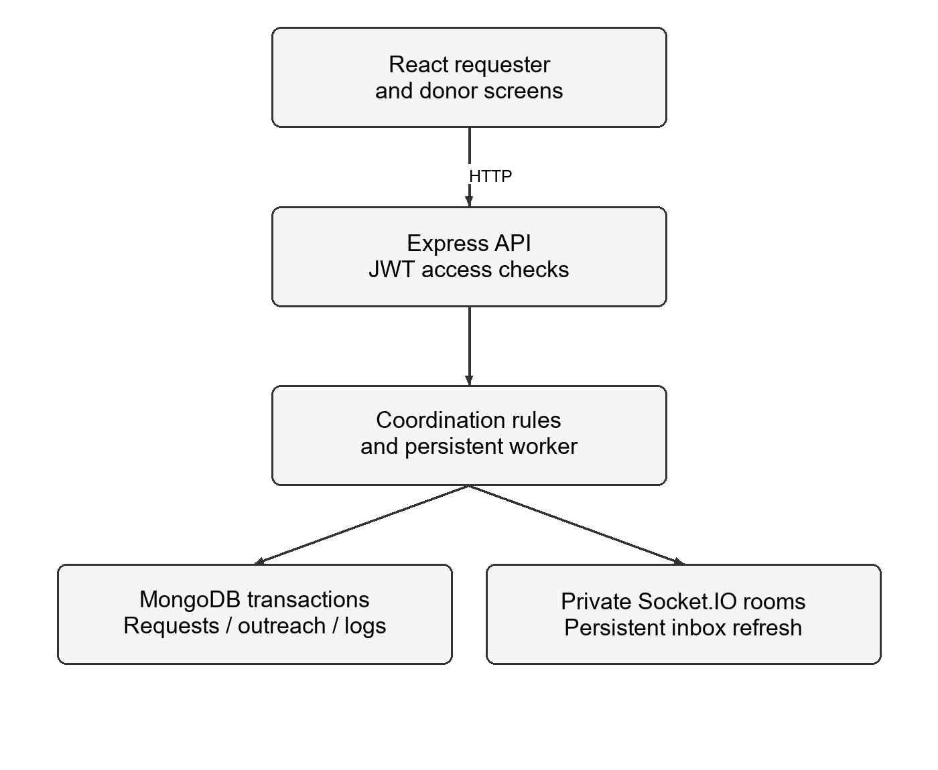
Figure 6.1 LifeLink system architecture
6.2 Request and Donor State Design
Request lifecycle and search activity are distinct. A request is active, fulfilled, cancelled or expired. Its search may be searching, paused_manual, paused_target, exhausted or stopped. An exhausted automated search can still contain willing candidates who may be selected, and a requester may explicitly resume to consider newly available candidates. A terminal request disallows further donor actions.
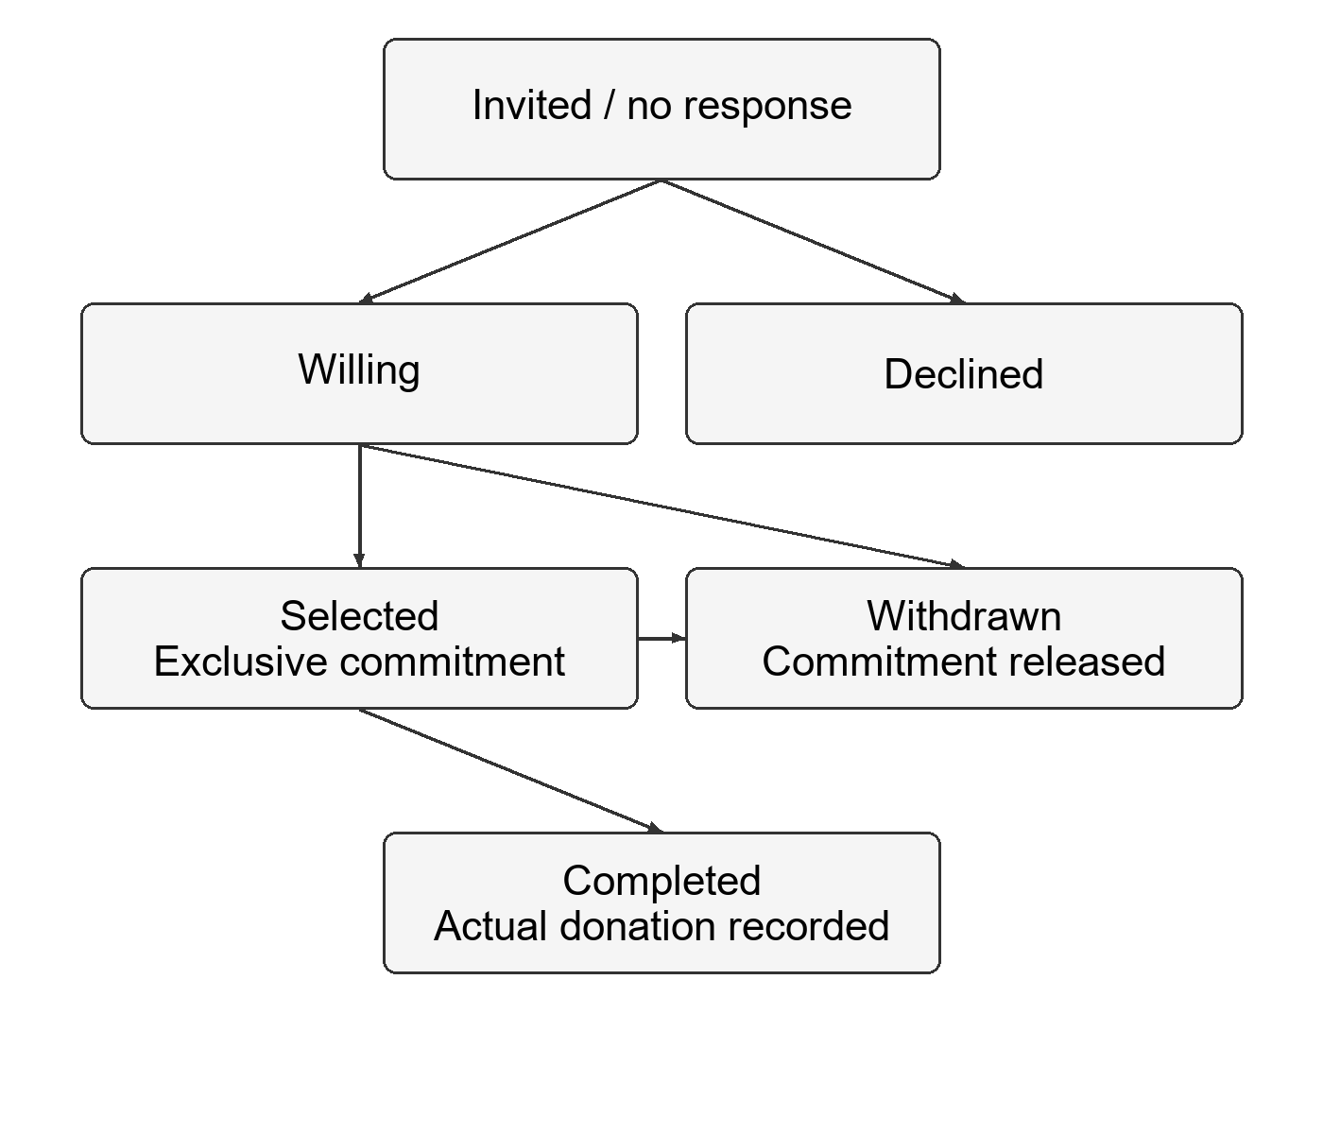
Figure 6.2 Donor response and commitment lifecycle

6.3 Escalation Policy and Algorithm
Let the ordered radius sequence be R = [5, 10, 20, 50] km. Each urgency has an initial stage, wait interval and batch limit. Normal starts at 5 km, waits 300 seconds and permits ten new invitations per batch. Urgent starts at 10 km with 120 seconds and twenty invitations. Critical starts at 20 km with 45 seconds and fifty invitations. These defaults are configurable hypotheses for evaluation rather than a clinically validated emergency policy.
The controller first checks expiry and pause state. If enough donors are selected, it pauses. If enough usable willing offers exist, it waits for requester selection. Otherwise it filters and ranks candidates by straight-line distance from the hospital. Empty stages are skipped immediately. A nonempty batch causes a saved response-window wait before the next evaluation. No donor is invited twice for the same request.
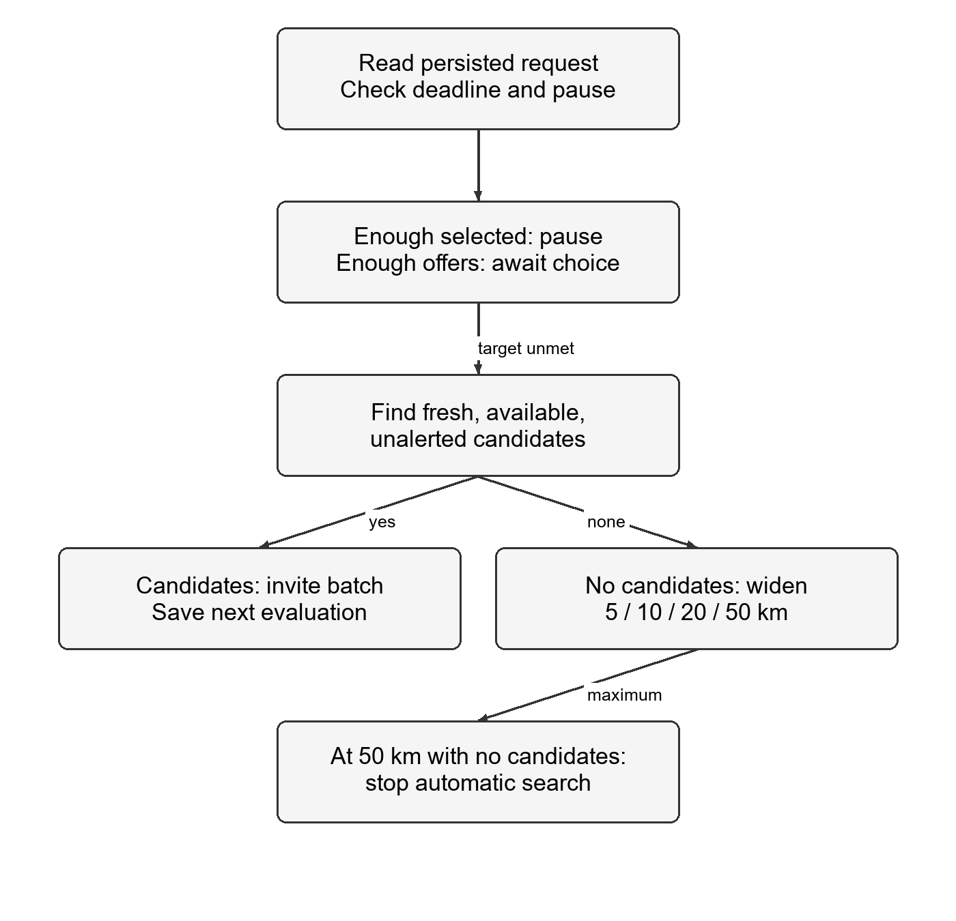
Figure 6.3 Feedback driven search decision flow
6.4 Data Relations and Invariants
The request-donor pair is the identity of an outreach record. The donor alone is the identity of an active commitment. A shared donor alert counter is updated inside the invitation transaction to prevent two requests from independently exceeding the daily budget. The UTC-day budget is separate from the per-request uniqueness rule.
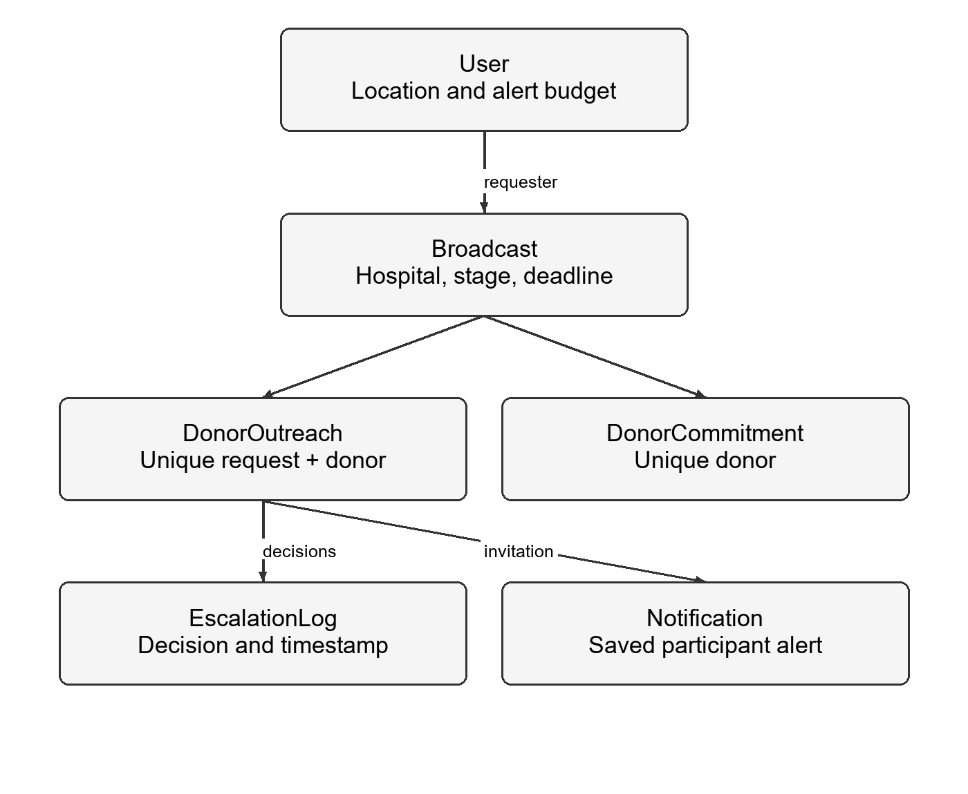
Figure 6.4 Principal coordination data relationships
6.5 Algorithm Pseudocode
EVALUATE(request, now)
begin transaction; write request revision
if request is terminal: return
if deadline <= now: expire and release; return
if paused or evaluation not due: return
update overdue invitations to no_response
if selected >= target: pause; return
if selected + usable willing >= target: wait; return
candidates = filter fresh available unalerted donors
repeat
batch = nearest candidates inside current radius
if batch exists:
save outreach, inbox, counters and next evaluation
record decision; commit; return
if radius is 50 km: record exhaustion; return
advance radius and record reason
until stopped

SYSTEM TESTING

CHAPTER 7
SYSTEM TESTING
7.1 Functional Verification
The functional baseline was checked using an isolated temporary MongoDB replica set. The test command runs the foundation and coordination suites together. The verification record contains 18 automated backend checks: three foundation checks and fifteen coordination checks. They exercise access validation, redaction, location validation, escalation, concurrent mutations, commitments, expiry and participant views.
Verification area | Recorded checks | Outcome
Foundation | 3 authentication and redaction checks | Passed
Coordination | 15 state, location and concurrency checks | Passed
Backend total | 18 automated checks | 18 passed; 0 failed
Browser workflow | Requester, donor and backup donor scenario | Passed in isolated local test
Policy comparison | Broadcast versus fixed versus adaptive | Planned; no results reported

A separate browser workflow used a requester, a donor and a backup donor against the built frontend and a local API. It checked hospital-pin confirmation, manual and simulated device location, notification links, willing and selected states, contact disclosure, withdrawal and replacement, explicit completion, History, the bank-directory fallback and a 390-pixel mobile layout. The accounts and location fixes were test fixtures; no real donation was observed.
7.2 Comparative Evaluation Design
The next evaluation compares three notification policies on identical seeded donor populations: A, broadcast to all compatible donors within 50 km; B, fixed staged expansion; and C, the proposed feedback-driven policy. The simulation must specify donor availability, response probabilities, response delays, withdrawal events, requester selection behaviour and a deadline. These assumptions must be held constant across the policies for each random seed.
Metric | Definition | Reporting condition
Target success | Trials meeting selection target before deadline / all trials | Report all trials
Time to target | First time at which selected count reaches target | Report failures separately
Alerts sent | New donor invitations per request | Count unique recipients
Duplicate alerts | Repeated invitations to the same donor for one request | Expected invariant is zero
Withdrawal recovery | Time from selected-donor withdrawal to target restoration | Applicable withdrawal trials only

Scenarios will include dense and sparse populations, low availability, no responses, withdrawals and normal versus critical urgency. Many fixed-seed trials will be reported with success rates and conditional timing statistics. Unsuccessful requests must not disappear from the results: time-to-target is undefined on failure and should be accompanied by the failure count. Withdrawal recovery is measured only for trials in which an initially selected donor withdraws.
No comparative policy results are reported at this stage. The functional tests establish the tested state and consistency properties; they do not establish lower alert volume, faster recruitment or improved patient outcomes. Critical broadcast behaviour will be considered if controlled results show that it better meets the critical deadline.

FEASIBILITY STUDY

CHAPTER 8
FEASIBILITY STUDY
8.1 Technical Feasibility
The coordinator can be implemented using the existing MERN application without a training dataset or model-serving service. Its decisions use a small configurable rule set, while MongoDB holds durable work state. The tests demonstrate that a local replica set can exercise the required transaction and uniqueness behaviour. This makes the design feasible as a Phase-I software prototype.
The main technical constraints are data quality and runtime availability. A recent device location may still differ from the donor's actual position, and a manually selected location is an assertion by the user. Straight-line distance is not hospital travel time. The current candidate scan is suitable for a prototype; a larger deployment needs geographic indexing, bounded retrieval and load testing.
8.2 Economic Feasibility
The application reuses an existing frontend, backend and database model, reducing the amount of new implementation work. The rule-based extension does not require dedicated GPU hardware or paid model inference. Development can use local test infrastructure. These observations describe technical resource needs and are not an audited cost-benefit analysis.
An operational service may incur hosting, persistent database, monitoring, backup, notification and support costs. Free-tier services may impose sleep behaviour or resource limits. Therefore, no zero-cost production claim or financial savings percentage is made. A deployment budget should be prepared after the expected user population and uptime requirements are known.

8.3 Operational Feasibility
The requester workflow uses a small set of actions: create the hospital-based request, choose willing people, and record completion or cancellation. Donors choose whether they can help and may withdraw when circumstances change. Clear labels explain the difference between an invitation, willingness, selection and donation. A location fallback supports users who cannot provide a device fix.
8.4 Privacy and Operational Responsibilities
A donor network also needs recruitment, consent, current contact information and a process for handling misleading requests. Software coordination alone cannot establish whether a requester has a genuine clinical requirement. Phase-I does not implement verified hospital accounts, clinical document review or SMS OTP delivery. Those items require a separate design and operational policy.
Exact donor positions are withheld from participant views, and active selection controls contact disclosure in the coordinated workflow. Remaining legacy endpoints and account deletion or ban interactions still require a release review. The project should therefore be demonstrated with controlled accounts and clearly marked sample data until those release tasks are complete.
8.5 Maintainability and Deployment Risks
Configuration snapshots make an active request explainable even if defaults later change. Decision logs support debugging of a particular expansion or pause. Automated tests provide a regression baseline for future interface and backend changes. A release process must also test coordinated frontend/backend deployment, reconnect behaviour, database backups, expiry under downtime and the cleanup of commitments when accounts become unavailable.

CONCLUSION AND FUTURE ENHANCEMENT

CHAPTER 9
CONCLUSION AND FUTURE ENHANCEMENT
9.1 Conclusion
LifeLink extends an existing donor application with a persistent, response-aware coordination workflow. The hospital is the search centre, and actual donor feedback determines whether the system waits, pauses, widens the search or resumes after withdrawal. Donor offers, selections and completed donations are represented separately. Unique invitations and exclusive commitments address two common consistency problems in simultaneous requests.
The Phase-I outcome is a functioning local prototype supported by automated backend verification and a controlled browser workflow. The evidence concerns implemented rules, state transitions and privacy behaviour in the tested environment. It does not establish clinical effectiveness, real-user adoption or comparative superiority over broad broadcast. Those distinctions make the project's contribution testable and defensible.
9.2 Future Enhancement
The immediate next stage is a reproducible simulation and demonstration dataset that makes radius expansion and withdrawal recovery observable. Results should compare the proposed policy with fixed staging and broad broadcast using the same donor scenarios. This evidence will support tuning of wait intervals, batch limits and the initial critical radius.
Release preparation also includes completed-only leaderboards and badges, a full legacy-route privacy audit, account-removal cleanup, shared request throttling and production deployment tests. Geographic indexes and pagination will be needed for scale. Hospital or blood-bank participation, request review, consent records and abuse reporting are potential operational extensions.
APPENDIX

APPENDIX A
COORDINATION CONFIGURATION
The following defaults are taken from the implemented policy service. Active requests save their own configuration snapshot. Wait times and batch sizes are adjustable prototype settings, not medically validated thresholds.
Setting | Default | Purpose
Radius sequence | 5, 10, 20, 50 km | Maximum automatic search range
Normal | 5 km; 300 s; batch 10 | Initial stage, wait and limit
Urgent | 10 km; 120 s; batch 20 | Initial stage, wait and limit
Critical | 20 km; 45 s; batch 50 | Initial stage, wait and limit
Daily invitation cap | 10 per donor per UTC day | Shared budget across requests
Location freshness | 24 hours | Exclude old location fixes
Device accuracy limit | 1000 metres | Exclude imprecise device fixes
Posting cooldown | 300 seconds per account | Limit repeated request creation

A.1 Important State Invariants
Each request-donor pair has at most one outreach record. Each donor has at most one active commitment. A willing response is not a completed donation. A manual pause is preserved after withdrawal. Terminal requests release commitments. A saved inbox item is distinct from a confirmed delivery or read receipt.

APPENDIX B
DATABASE AND SERVICE EXCERPTS
The excerpts below are from the Phase-I backend. They illustrate database-level identities and transaction boundaries. Supporting imports, validation and route handlers are implemented in the application; the excerpts are not a standalone server.
const mongoose = require('mongoose');
const schema = new mongoose.Schema({
request: { type: mongoose.Schema.Types.ObjectId, ref: 'Broadcast', required: true },
donor: { type: mongoose.Schema.Types.ObjectId, ref: 'User', required: true },
state: { type: String, enum: ['notified', 'willing', 'declined', 'no_response', 'selected', 'withdrawn', 'completed'], default: 'notified' },
deliveryState: { type: String, enum: ['pending', 'attempted', 'acknowledged', 'failed'], default: 'pending' },
deliveryAttempts: { type: Number, default: 0, min: 0 },
notifiedAt: Date,
approximateDistanceKm: Number,
locationSource: String,
locationRecordedAt: Date,
respondedAt: Date,
selectedAt: Date,
withdrawnAt: Date,
completedAt: Date,
completedBy: { type: mongoose.Schema.Types.ObjectId, ref: 'User' },
}, { timestamps: true });
schema.index({ request: 1, donor: 1 }, { unique: true });
schema.index({ donor: 1, notifiedAt: 1 });
module.exports = mongoose.model('DonorOutreach', schema);
const mongoose = require('mongoose');
// Active commitments only. Release explicitly; do not rely on delayed TTL deletion.
const schema = new mongoose.Schema({
donor: { type: mongoose.Schema.Types.ObjectId, ref: 'User', required: true, unique: true },
request: { type: mongoose.Schema.Types.ObjectId, ref: 'Broadcast', required: true },
expiresAt: { type: Date, required: true },
}, { timestamps: true });
module.exports = mongoose.model('DonorCommitment', schema);
B.1 Transaction Boundary
async function transaction(work) {
const session = await mongoose.startSession();
try {
let result;
await session.withTransaction(async () => { result = await work(session); });
return result;
} catch (err) {
if (err.code === 11000) fail(409, 'This donor is already committed or this action was
already recorded. Refresh and try again.');
throw err;
} finally { await session.endSession(); }
}

APPENDIX C
POLICY AND LOCATION EXCERPTS
Candidate location is validated before distance matching. The implementation retains the distinction between manual and device location, and rejects unknown, stale or insufficiently accurate device fixes.
function freshLocation(location, now, policy) {
if (!validCoordinates(location) || !['manual', 'device'].includes(location.source)) return
false;
const age = now - new Date(location.updatedAt);
if (!location.updatedAt || !Number.isFinite(age) || age < 0 || age >
policy.locationMaxAgeSeconds * 1000) return false;
return location.source === 'manual' || (Number.isFinite(location.accuracyMeters) &&
location.accuracyMeters >= 0 && location.accuracyMeters <= policy.maxAccuracyMeters);
}
C.1 Distance Calculation
function distanceKm(a, b) {
const rad = n => n * Math.PI / 180;
const h = Math.sin(rad(b.lat - a.lat) / 2) ** 2 + Math.cos(rad(a.lat)) *
Math.cos(rad(b.lat)) * Math.sin(rad(b.lng - a.lng) / 2) ** 2;
return 6371 * 2 * Math.asin(Math.sqrt(Math.min(1, Math.max(0, h))));
}
C.2 Hospital Centre and Configuration
The hospital point is provided and confirmed by the requester. A phone-location shortcut is appropriate only when the requester is physically at that hospital. A critical request starts at the configured wider stage; this default remains subject to comparative evaluation.

APPENDIX D
FUNCTIONAL PROTOTYPE SCREENS
The following captures use controlled test accounts and sample contact values. They show the functional verification baseline, including automatic pause after enough donors are selected and a donor-facing withdrawal action. These are interface demonstrations, not observations of real blood donation.

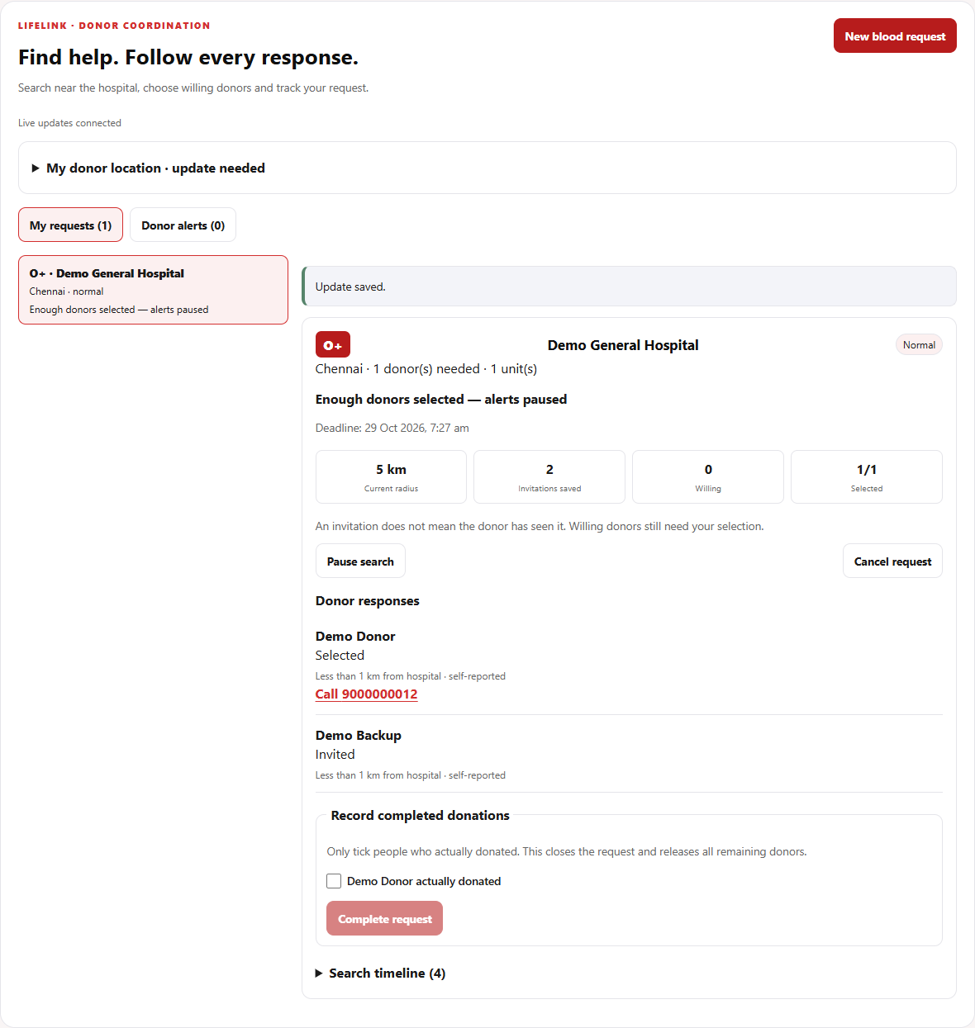
Figure D.1 Requester progress screen with selected and invited donors

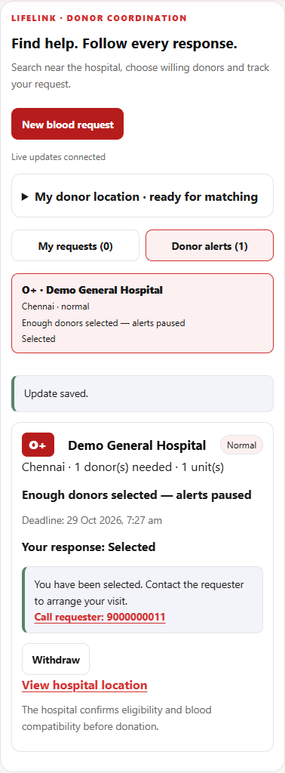
Figure D.2 Donor selection and withdrawal screen on a mobile layout
D.1 Verification Commands
node --test backend/tests/foundation.test.js
backend/tests/coordination.test.js

cd frontend
npm ci
npm run build
npx eslint src/components/coordination
The first command is written across two lines for print layout and should be entered as one command. The browser integration script uses a temporary local database and simulated device location; its reproduction instructions are maintained with the project documentation.
REFERENCES

REFERENCES
[1] Kanna Deepa, Aarthy C, and N. Udaya Kumar, "AI-Based Donor Connect Platform using Blood Type Matching and Real-Time Emergency Location Detection," International Journal of Engineering & Extended Technologies Research, vol. 8, no. 2, pp. 859-865, Mar.-Apr. 2026, doi: 10.15662/IJEETR.2026.0802042.
[2] World Wide Web Consortium, "Geolocation," W3C specification. [Online]. Available: https://www.w3.org/TR/geolocation/. Accessed: Oct. 27, 2026.
[3] MongoDB, "Transactions," MongoDB Manual. [Online]. Available: https://www.mongodb.com/docs/manual/core/transactions/. Accessed: Oct. 27, 2026.
[4] MongoDB, "Unique Indexes," MongoDB Manual. [Online]. Available: https://www.mongodb.com/docs/manual/core/index-unique/. Accessed: Oct. 27, 2026.
[5] Socket.IO, "Delivery guarantees," Socket.IO 4.x Documentation. [Online]. Available: https://socket.io/docs/v4/delivery-guarantees/. Accessed: Oct. 27, 2026.
[6] Socket.IO, "Rooms," Socket.IO 4.x Documentation. [Online]. Available: https://socket.io/docs/v4/rooms/. Accessed: Oct. 27, 2026.
Reference and Implementation Notes
Reference [1] provides the academic baseline. References [2]-[6] document the location, persistence and communication mechanisms used in the implementation. The existing MERN project and its test record provide the implementation evidence discussed in this report. No simulation success-rate or real-user performance figures have been substituted for experimental results.

