Create an Author component

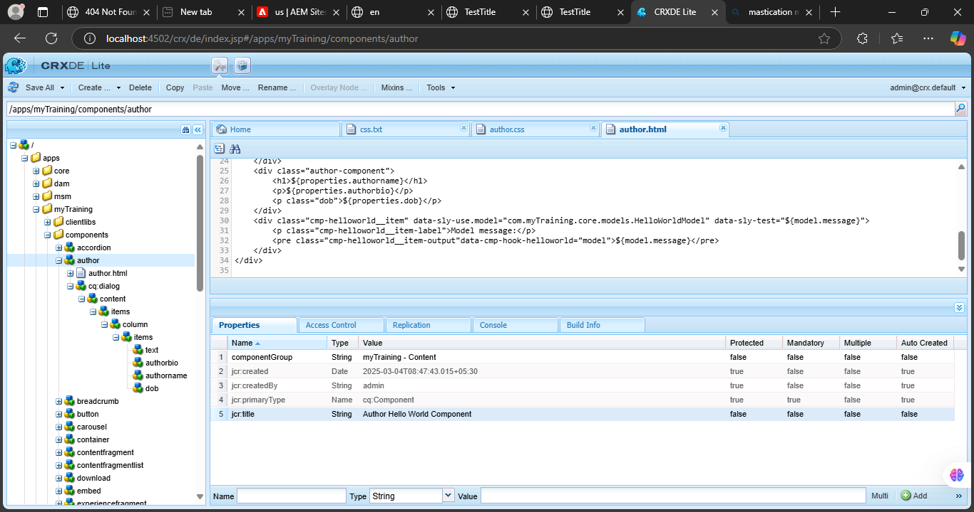

Author Name-single line text field ,Author Bio-multiline text field and Dob-date picker.

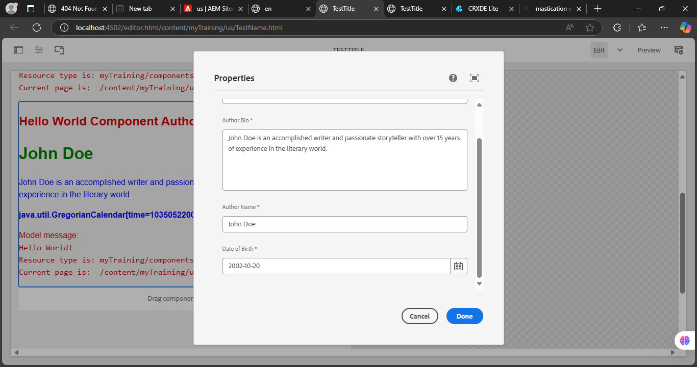

Fetch these value directly using htl properties tag

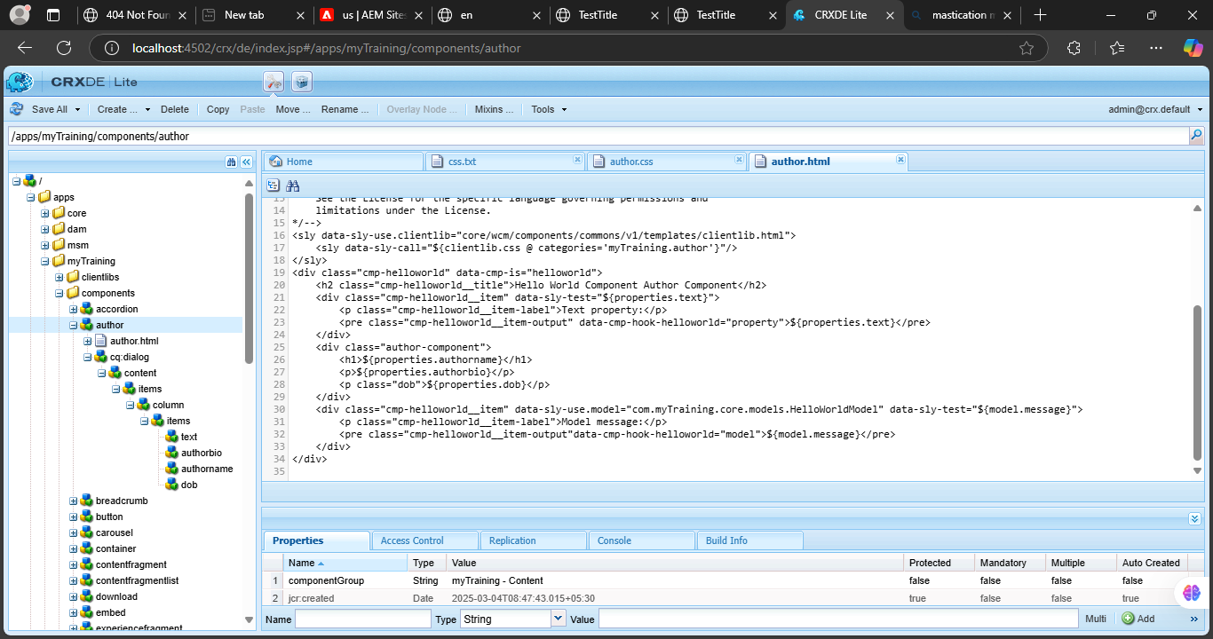

What is Dialog validation how to use them?

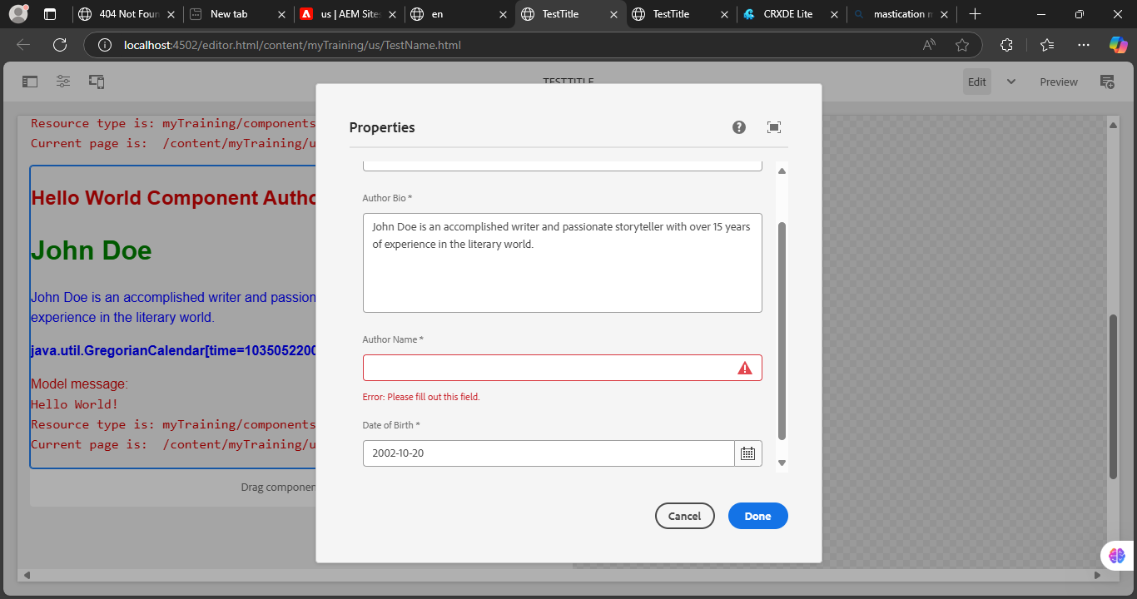

What is client lib?

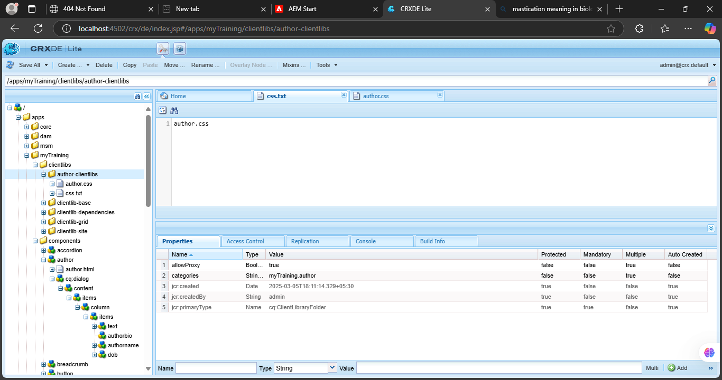

Implement client lib make authorName h1, Make author bio normal body text and Bold the dob.

