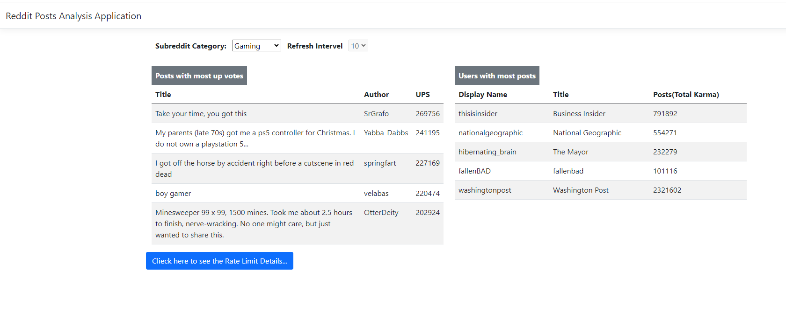



1. Subreddit category selection. (Exists with 4 sub categories and Choices can be extended to load all available subreddit categories as an enhancement)
2. Interval time to refresh (Exists with read only mode. Functionality Can be extended for User selection.)
3. Most up votes data based on subreddit category selection. Post data will be refreshed for every 10 secs. (Data can be stored part of enhancement)
4. User data with most posts. (New columns can be added based on API response data part of an enhancement)
5. Redditt API call Data for developer analysis.

**Core Technologies Used**

Visual studio 2022, .Net framework 8.0, .Net core, Web Api, C#, Jquery, JSON, CHTML.