VEGGALAM PAVANI 19N31A05N6

OS-Input and out puts of all experiments

Experiment no1;

A.FIRST COME FIRST SERVE

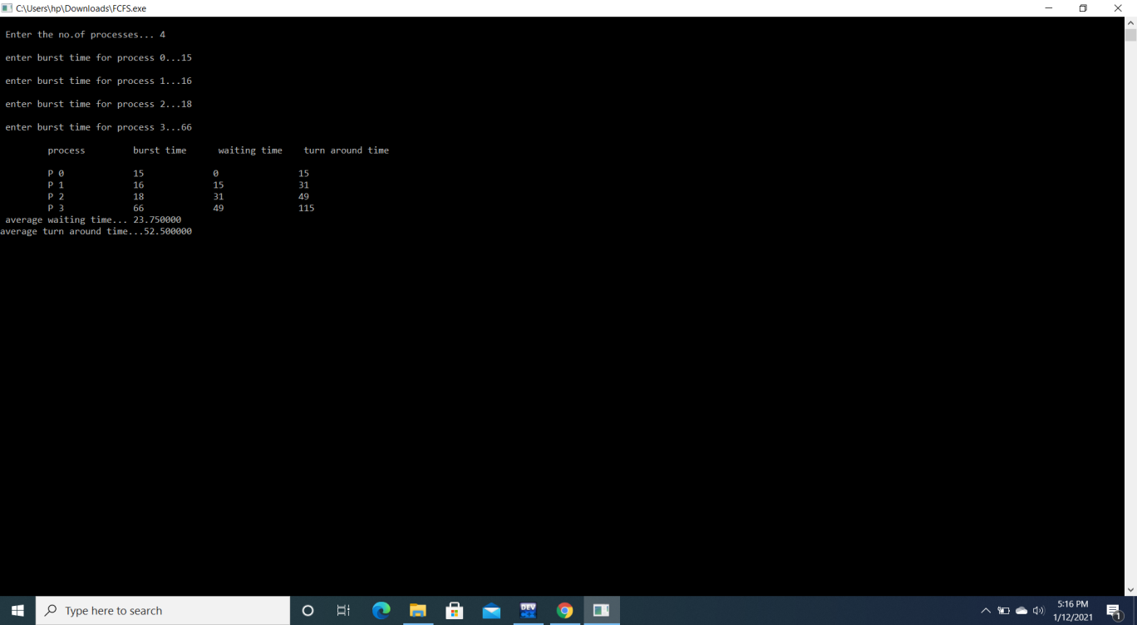

B) SHORTEST JOB FIRST

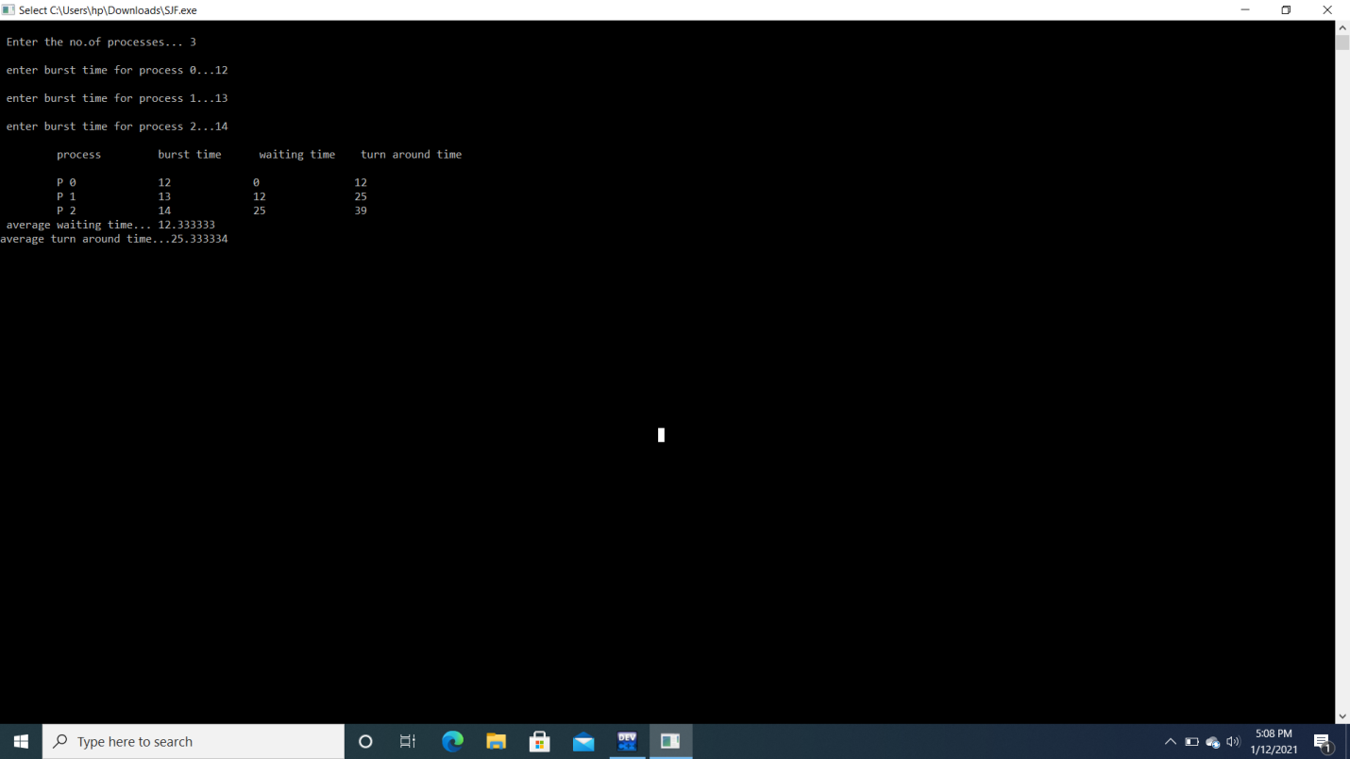

EXPERIMENT -2

A)ROUND ROBIN SCHEDULING ALGORITHM

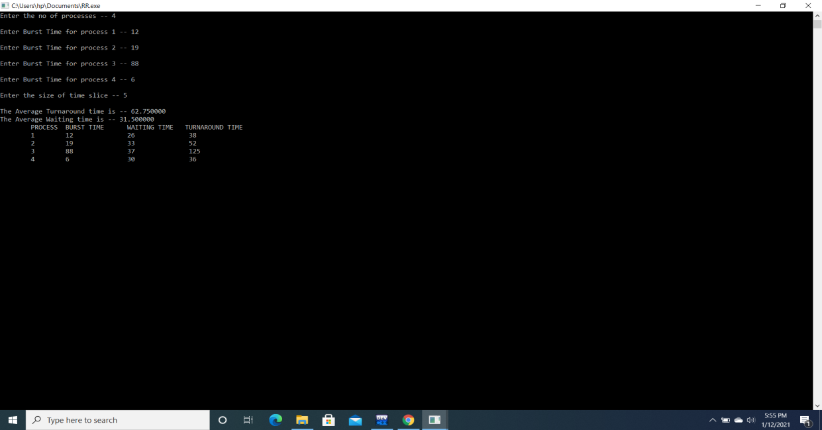

B)PRIORITY SCHEDULING ALGORITHM

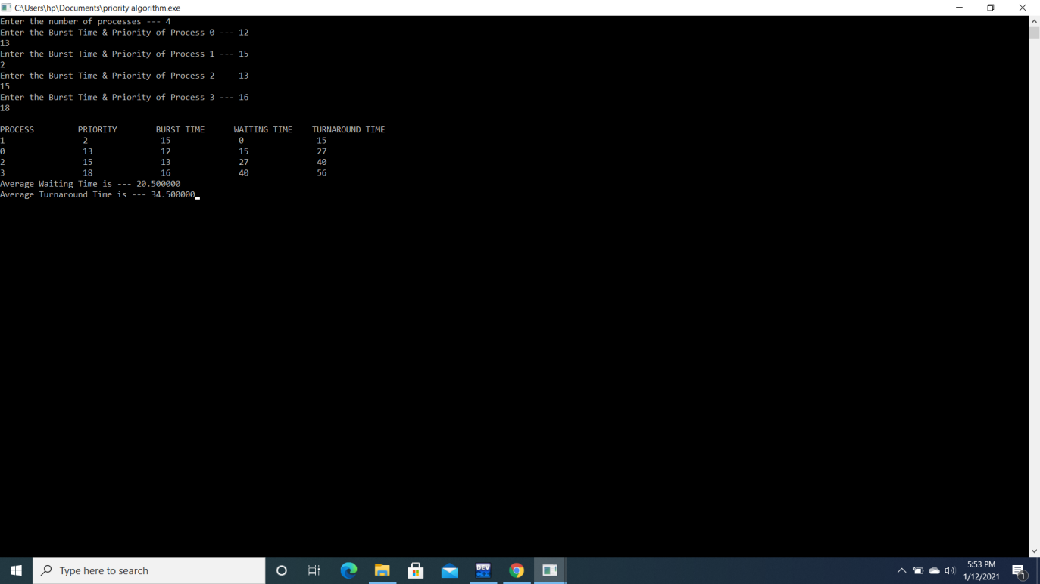

EXPERIMENT NUMBER -3

PRODUCER CONSUMER PROBLEM USING SEMAPHORES

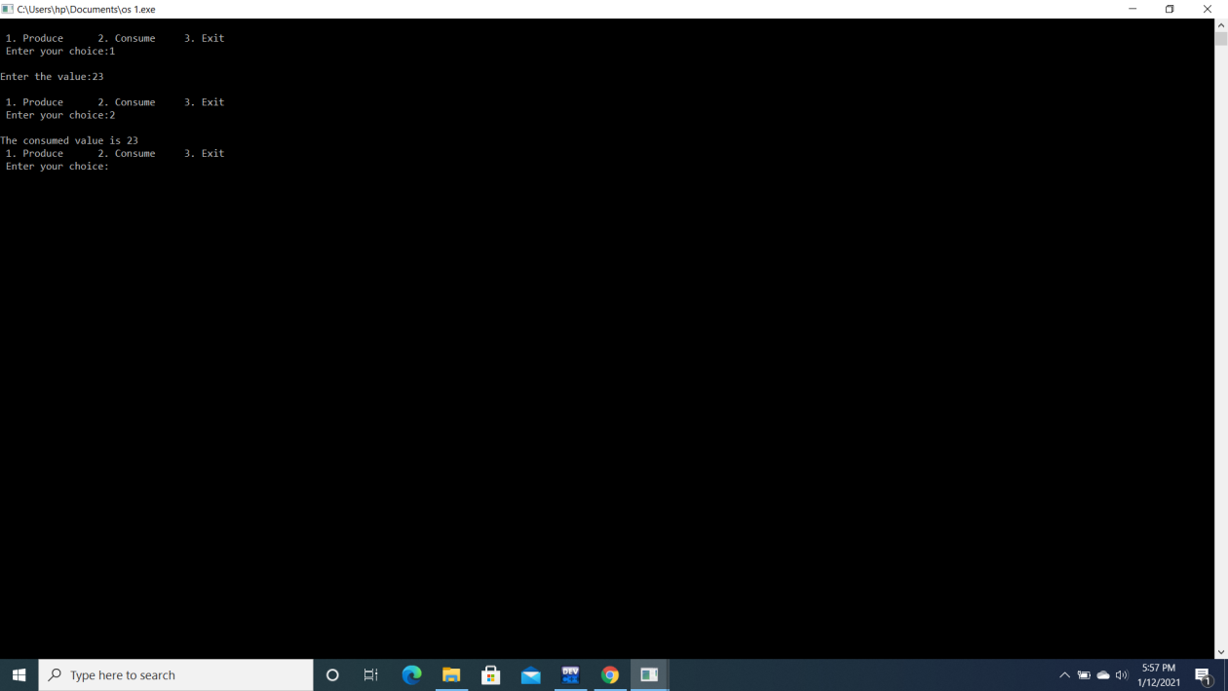

EXPERIMENT NUMBER-4

MEMORY MANAGEMENT TECHNIQUES

A)MULTIPROGRAMMING WITH FIXED NUMBER OF TASKS

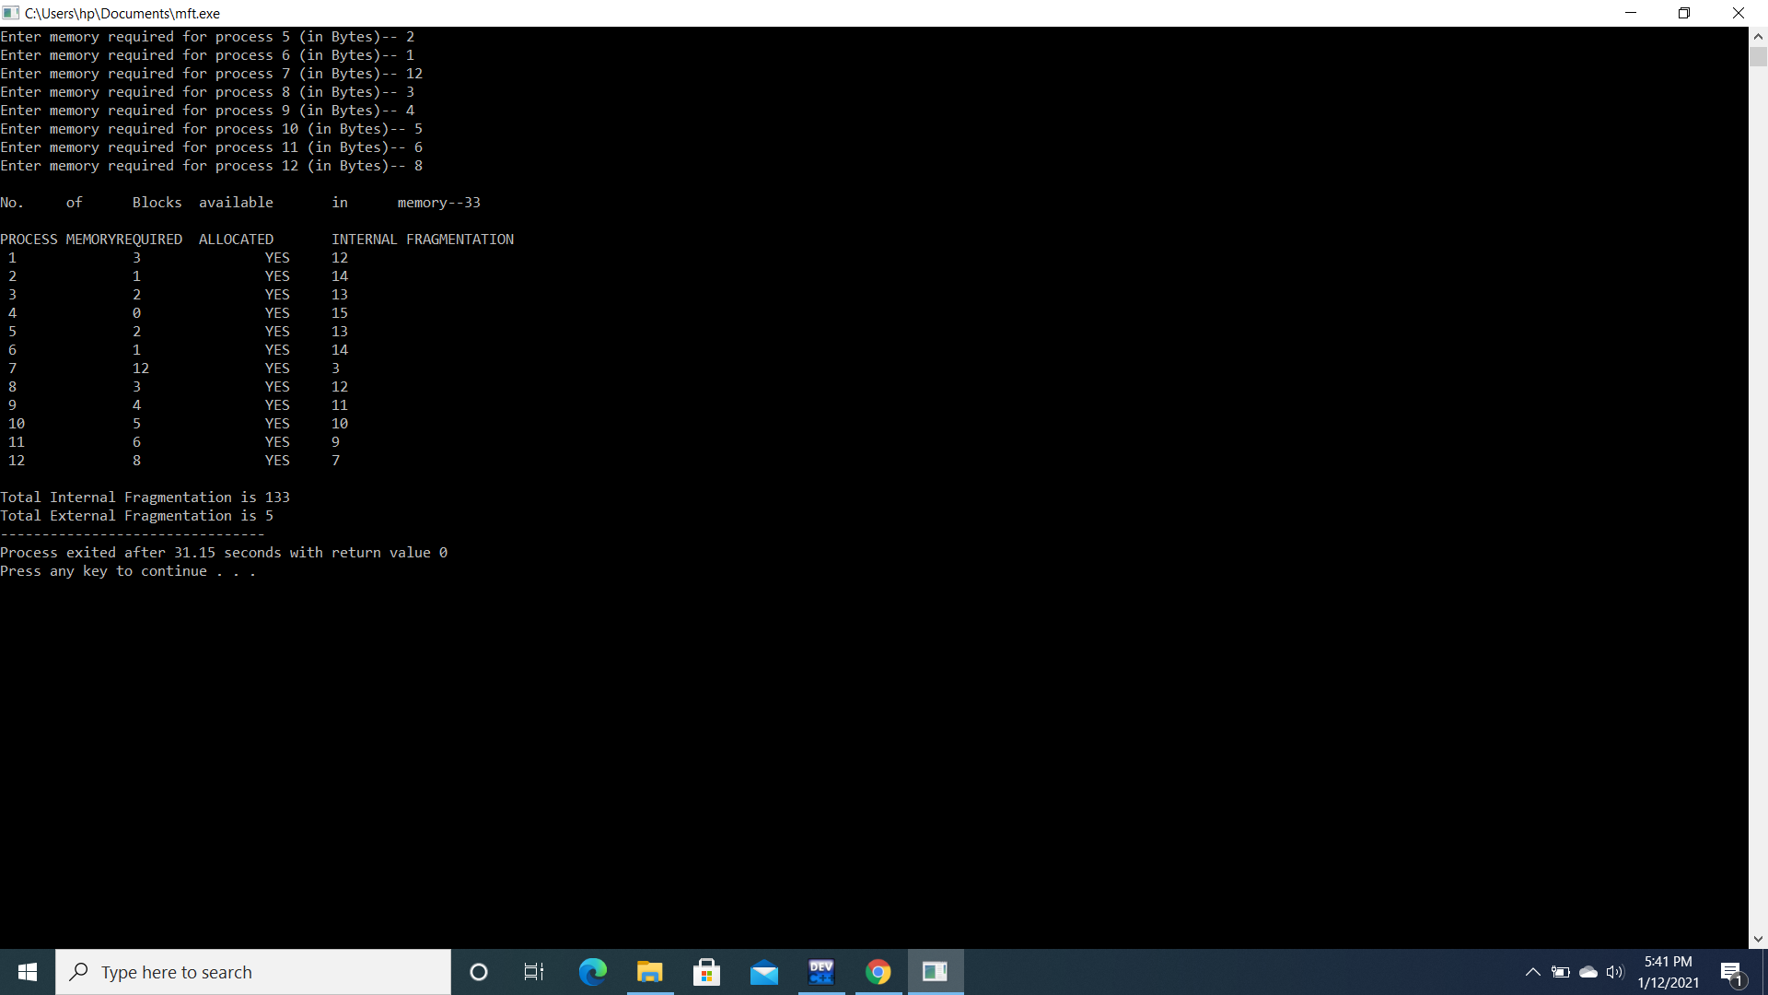

B)MULTIPROGRAMMING WITH VARIABLE NUMBER OF TASKS

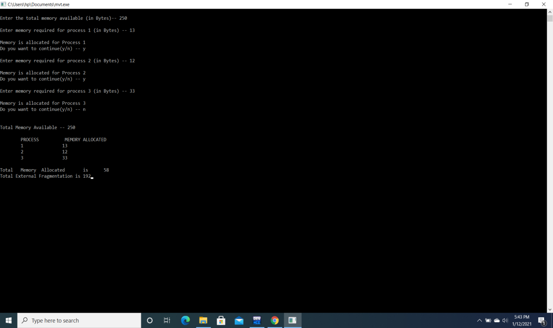

EXPERIMENT NO -5

CONTIGUOUS MEMORY ALLOCATION

A)WORST FIT

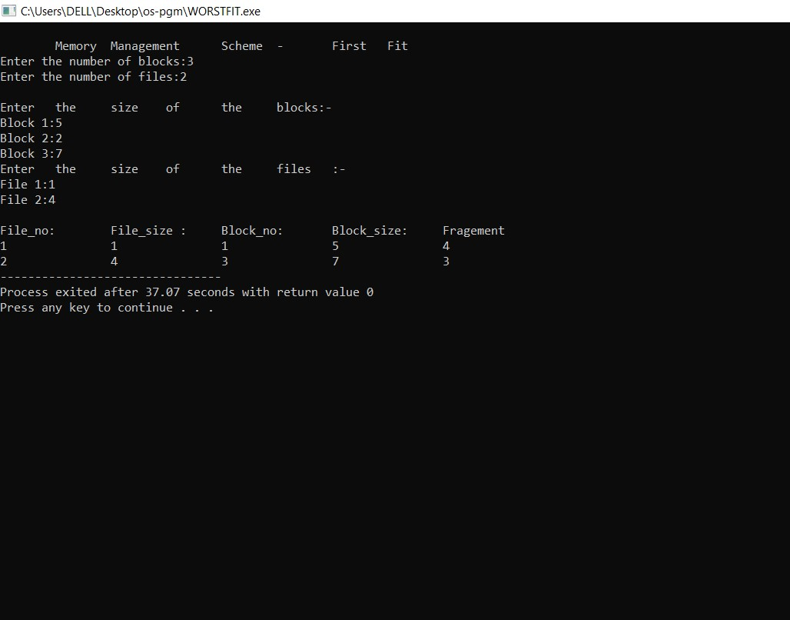

B)BEST FIT

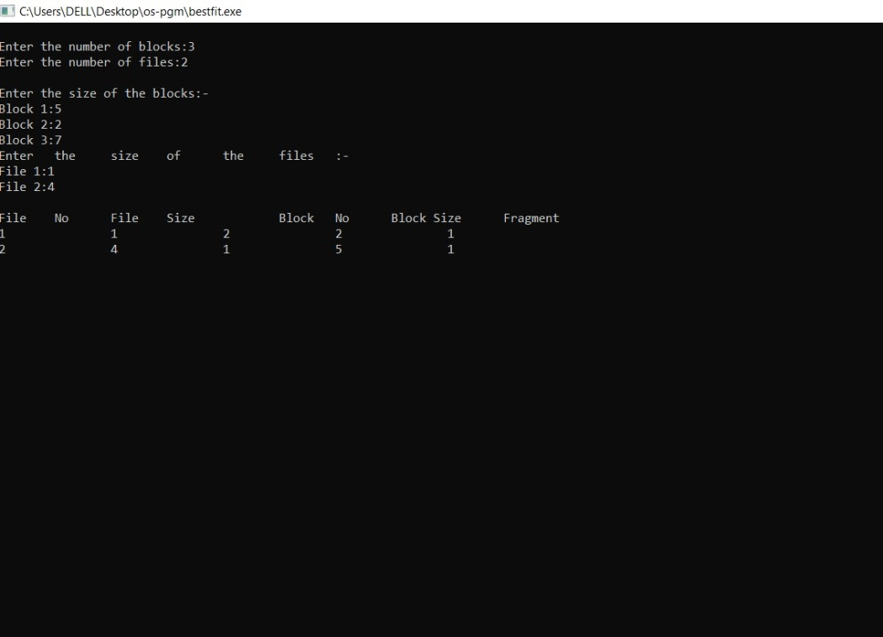

C)FIRST FIT

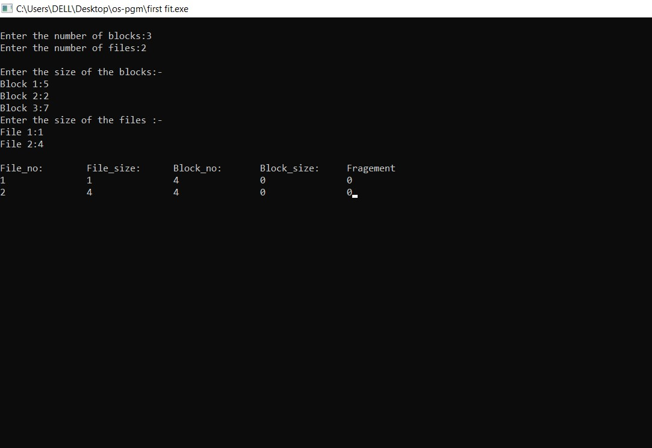

EXPERIMENT -6

1. FIRST IN FIRST OUT(FIFO) 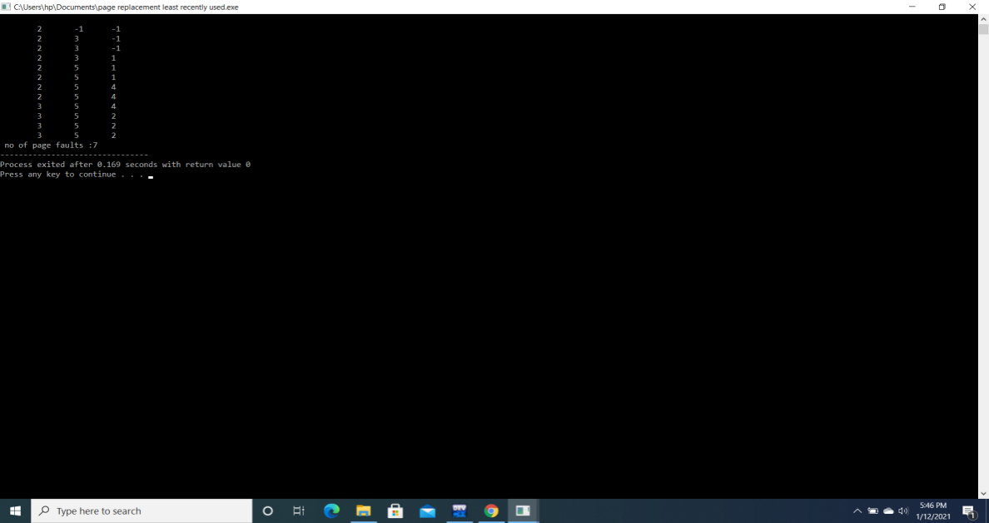

B)LEAST RECENTLY USED(LRU)

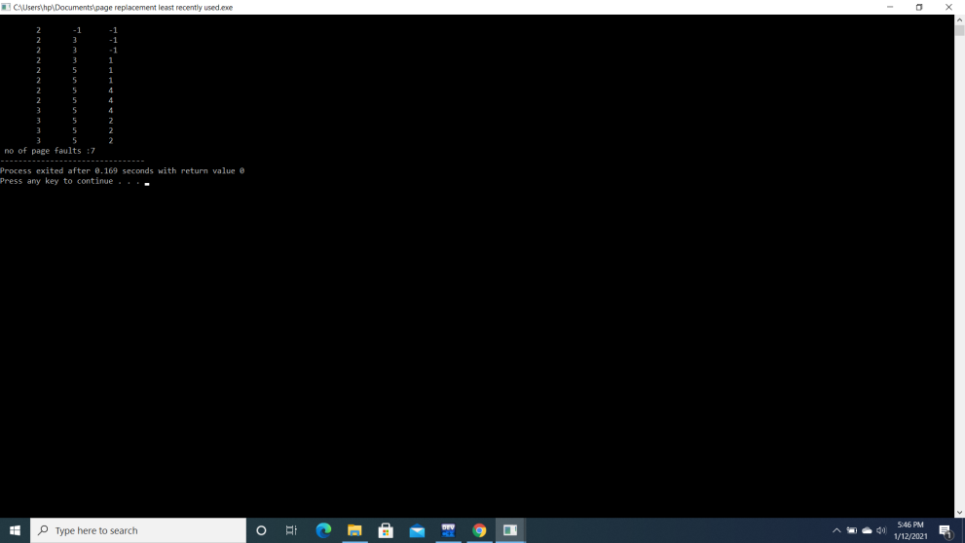

C)OPTIMAL

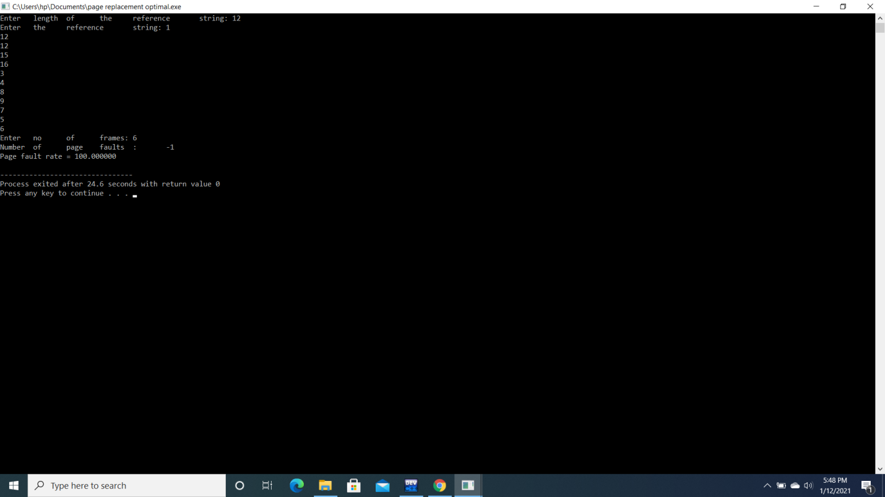

7) DIRECTORY IMPLEMENTATION

A)SINGLE LEVEL DIRECTORY

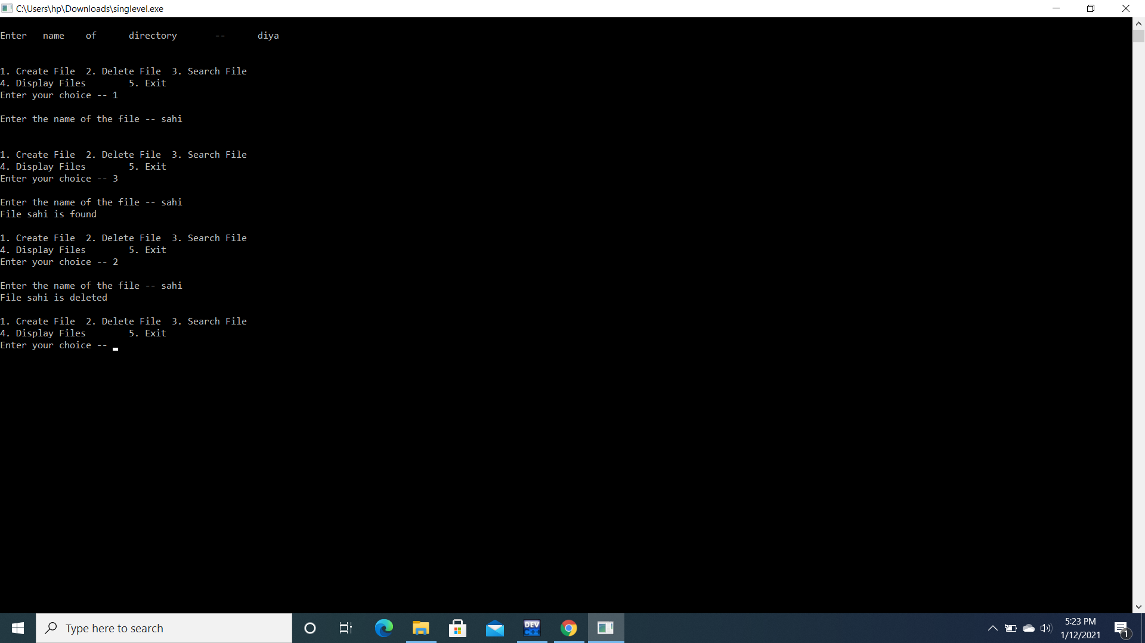

B)TWO LEVEL DIRECTORY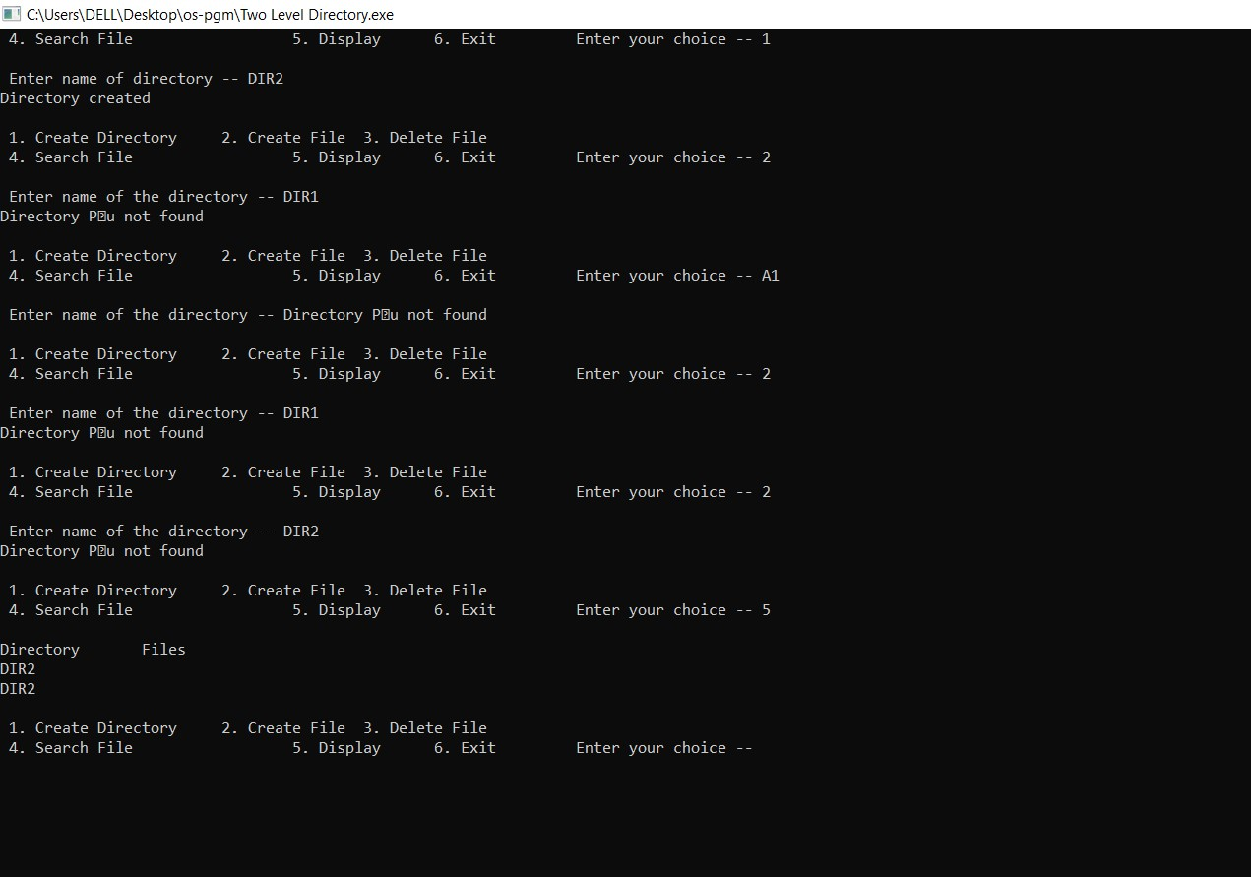

EXPERIMENT NO-8

DISCHARGE SCHEDULING ALGORITHM

A)FCFS

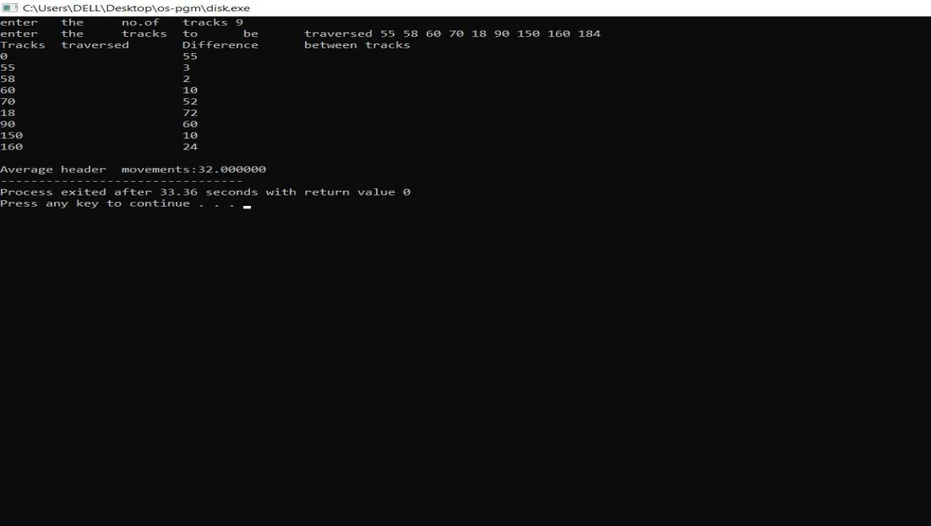

B)c-Scan

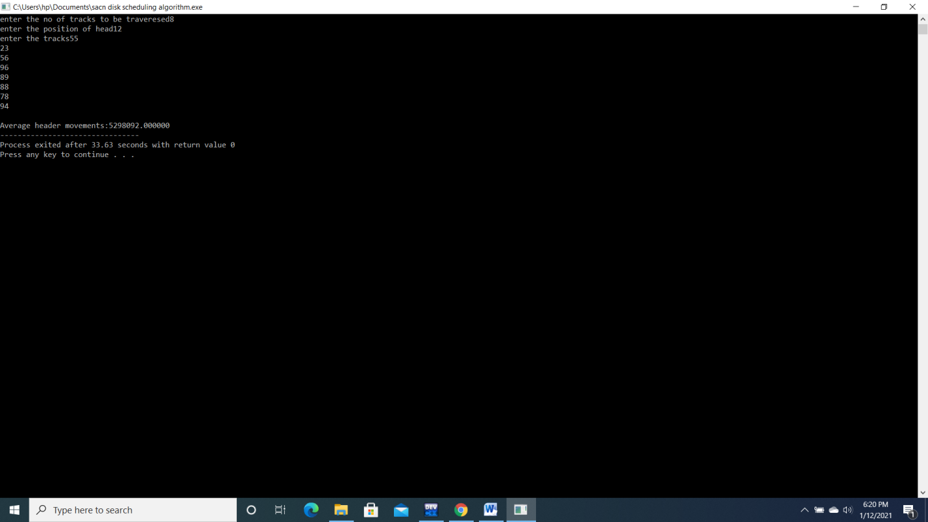

C)SCAN

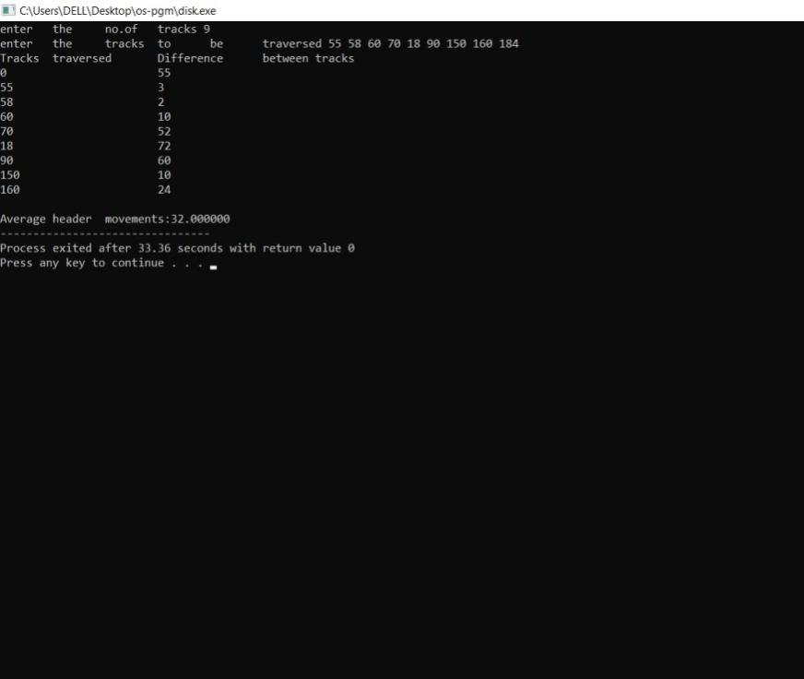

EXPERIMENT NO -9

DEAD LOCK AVOIDANCE

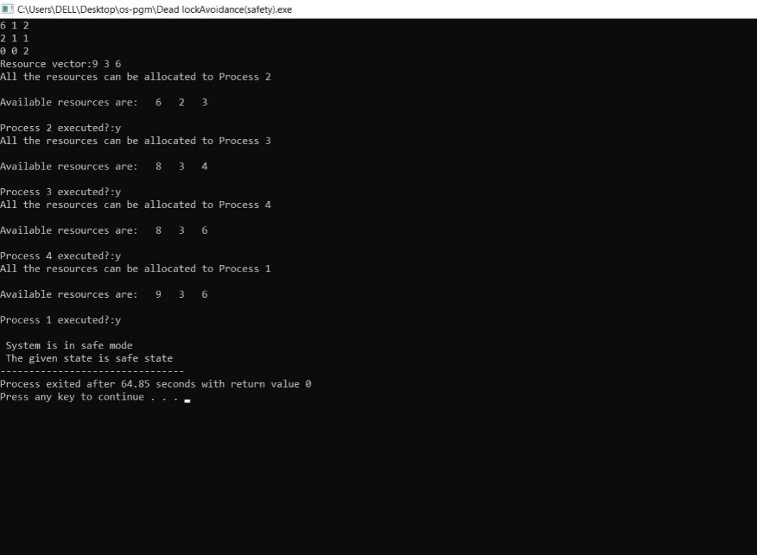

EXPERIMENT NO- 10

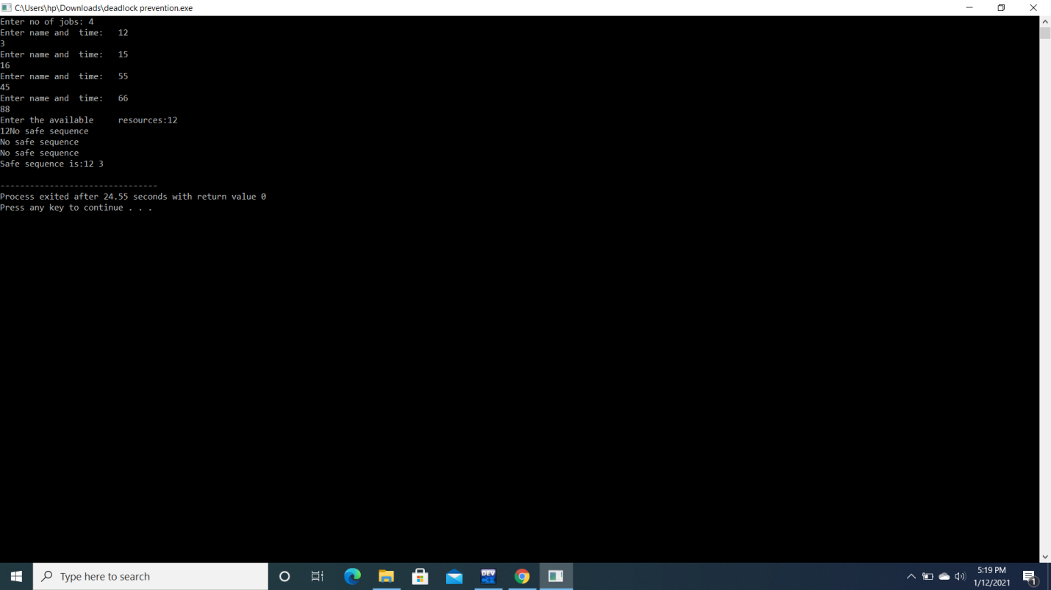

EXPERIMENT 11

FILE ALLOCATION STRATEGIES

A)SEQUENTIAL

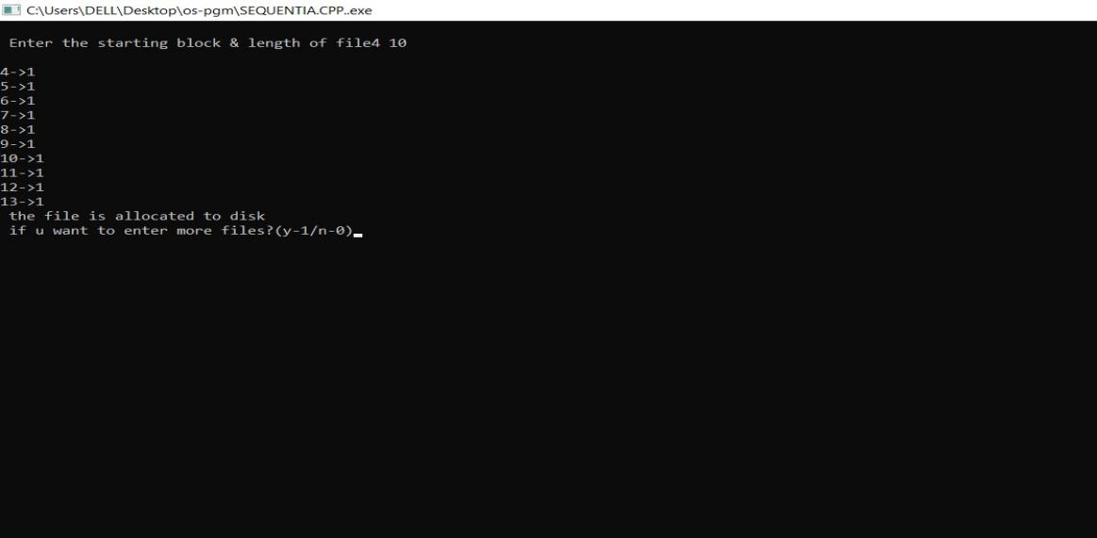

B)INDEXED

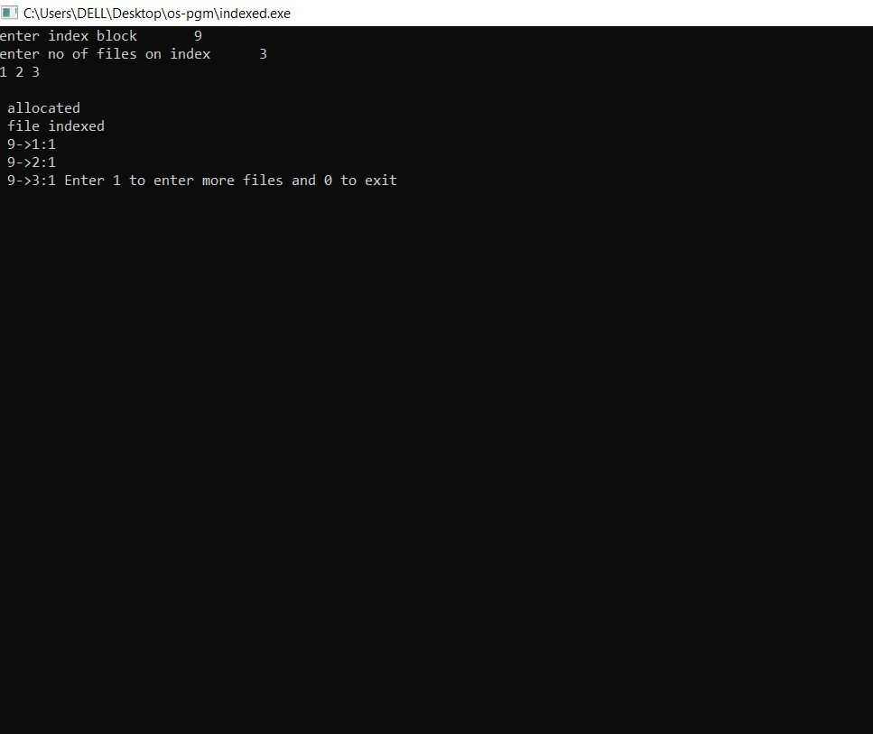

C)LINKED

