**Name: Srinivas Sanjeevkumar Chenn**

**Division: A**

**Roll Number: 48**

**Subject: Operating System (OS) LAB**

**Lab Assignment 2**

**Producer-Consumer Problem**

1. **Producer consumer using mutex**

#include <pthread.h>

#include <semaphore.h>

#include <stdlib.h>

#include <stdio.h>

#define MaxItems 5

#define BufferSize 5

sem_t empty;

sem_t full;

int in = 0;

int out = 0;

int buffer[BufferSize];

pthread_mutex_t mutex;

void *producer(void *pno)

{

int item;

for(int i = 0; i < MaxItems; i++) {

item = rand();

sem_wait(&empty);

pthread_mutex_lock(&mutex);

buffer[in] = item;

printf("Producer %d: Insert Item %d at %d\n", *((int *)pno),buffer[in],in);

in = (in+1)%BufferSize;

pthread_mutex_unlock(&mutex);

sem_post(&full);

}

}

void *consumer(void *cno)

{

for(int i = 0; i < MaxItems; i++) {

sem_wait(&full);

pthread_mutex_lock(&mutex);

int item = buffer[out];

printf("Consumer %d: Remove Item %d from %d\n",*((int *)cno),item, out);

out = (out+1)%BufferSize;

pthread_mutex_unlock(&mutex);

sem_post(&empty);

}

}

int main()

{

pthread_t pro[5],con[5];

pthread_mutex_init(&mutex, NULL);

sem_init(&empty,0,BufferSize);

sem_init(&full,0,0);

int a[5] = {1,2,3,4,5};

for(int i = 0; i < 5; i++) {

pthread_create(&pro[i], NULL, (void *)producer, (void *)&a[i]);

}

for(int i = 0; i < 5; i++) {

pthread_create(&con[i], NULL, (void *)consumer, (void *)&a[i]);

}

for(int i = 0; i < 5; i++) {

pthread_join(pro[i], NULL);

}

for(int i = 0; i < 5; i++) {

pthread_join(con[i], NULL);

}

pthread_mutex_destroy(&mutex);

sem_destroy(&empty);

sem_destroy(&full);

return 0;

}

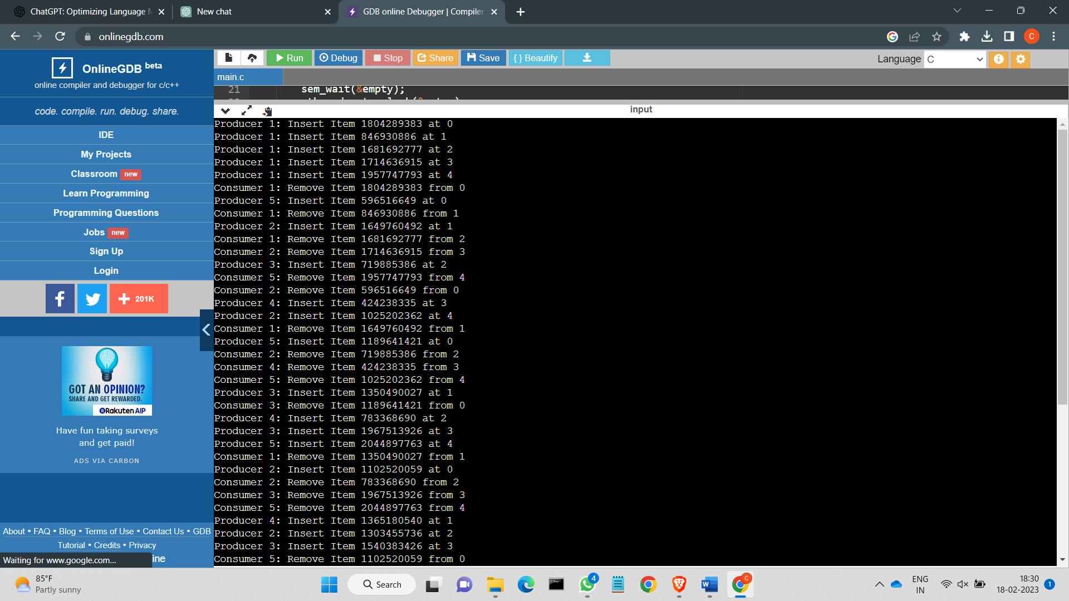

1. **Producer consumer using semaphore**

#include <stdio.h>

#include <stdlib.h>

#include <pthread.h>

#include <semaphore.h>

#include <unistd.h>

#define buffersize 20

sem_t empty;

sem_t full;

int in = 0, out = 0;

int buffer[buffersize];

void *producer()

{

int data, temp;

temp = rand()%3;

while(1)

{

data = rand()%100;

sleep(temp);

sem_wait(&empty);

buffer[in] = data;

printf("\n\nProducer Inserted Data %d at %d",data,in);

in = (in+1)%buffersize;

sem_post(&full);

}

}

void *consumer()

{

int temp, data;

temp = rand()%5;

while(1)

{

sleep(temp);

sem_wait(&full);

data = buffer[out];

printf("\n\nConsumer Consumed Data %d from %d",data,out);

out = (out+1)%buffersize;

sem_post(&empty);

}

}

int main()

{

pthread_t prod, cons;

sem_init(&empty, 0, buffersize);

sem_init(&full, 0, 0);

pthread_create(&prod, NULL, &producer, NULL);

pthread_create(&cons, NULL, &consumer, NULL);

pthread_join(prod, NULL);

pthread_join(cons, NULL);

return 0;

}

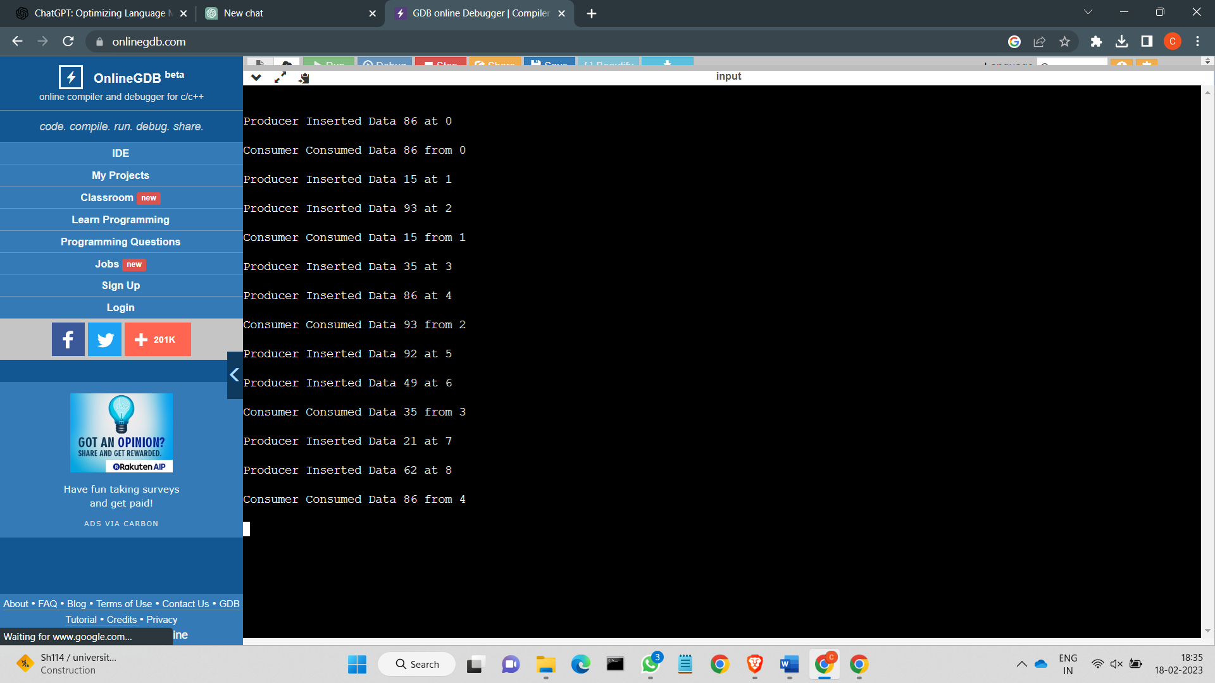

**Reader-Writer Problem**

1. **Reader writer using mutex**

#include <pthread.h>

#include <semaphore.h>

#include <stdio.h>

sem_t wrt;

pthread_mutex_t mutex;

int cnt = 1;

int numreader = 0;

void *writer(void *wno)

{

sem_wait(&wrt);

cnt = cnt*2;

printf("Writer %d modified cnt to %d\n",(*((int *)wno)),cnt);

sem_post(&wrt);

}

void *reader(void *rno)

{

pthread_mutex_lock(&mutex);

numreader++;

if(numreader == 1) {

sem_wait(&wrt);

}

pthread_mutex_unlock(&mutex);

printf("Reader %d: read cnt as %d\n",*((int *)rno),cnt);

pthread_mutex_lock(&mutex);

numreader--;

if(numreader == 0) {

sem_post(&wrt);

}

pthread_mutex_unlock(&mutex);

}

int main()

{

pthread_t read[10],write[5];

pthread_mutex_init(&mutex, NULL);

sem_init(&wrt,0,1);

int a[10] = {1,2,3,4,5,6,7,8,9,10};

for(int i = 0; i < 10; i++) {

pthread_create(&read[i], NULL, (void *)reader, (void *)&a[i]);

}

for(int i = 0; i < 5; i++) {

pthread_create(&write[i], NULL, (void *)writer, (void *)&a[i]);

}

for(int i = 0; i < 10; i++) {

pthread_join(read[i], NULL);

}

for(int i = 0; i < 5; i++) {

pthread_join(write[i], NULL);

}

pthread_mutex_destroy(&mutex);

sem_destroy(&wrt);

return 0;

}

**Output –**

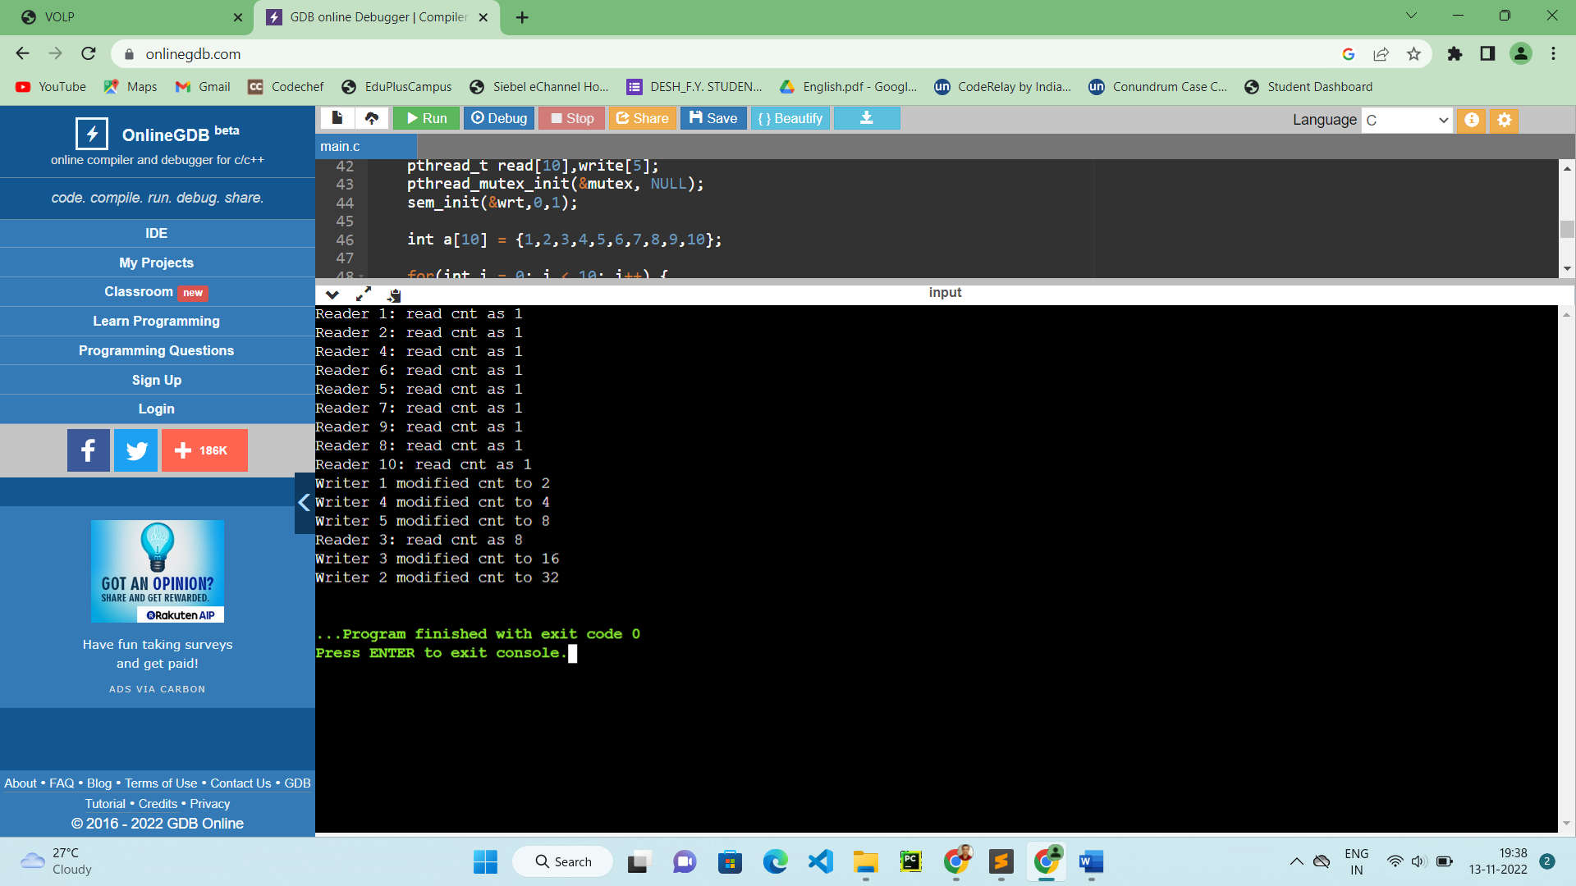

1. **Reader writer using semaphore**

#include <stdio.h>

#include <stdlib.h>

#include <pthread.h>

#include <semaphore.h>

sem_t read_sem, write_sem;

int readcount = 0;

int data = 0;

void *reader(void *arg) {

int reader_id = *((int *)arg);

while (1) {

sem_wait(&read_sem);

readcount++;

if (readcount == 1) {

sem_wait(&write_sem);

}

sem_post(&read_sem);

printf("Reader %d read data: %d\n", reader_id, data);

sem_wait(&read_sem);

readcount--;

if (readcount == 0) {

sem_post(&write_sem);

}

sem_post(&read_sem);

sleep(1);

}

return NULL;

}

void *writer(void *arg) {

int writer_id = *((int *)arg);

while (1) {

sem_wait(&write_sem);

data++;

printf("Writer %d wrote data: %d\n", writer_id, data);

sem_post(&write_sem);

sleep(1);

}

return NULL;

}

int main() {

pthread_t reader_threads[5], writer_threads[5];

int i;

sem_init(&read_sem, 0, 1);

sem_init(&write_sem, 0, 1);

int reader_ids[5];

int writer_ids[5];

for (i = 0; i < 5; i++) {

reader_ids[i] = i + 1;

writer_ids[i] = i + 1;

pthread_create(&reader_threads[i], NULL, reader, (void *)&reader_ids[i]);

pthread_create(&writer_threads[i], NULL, writer, (void *)&writer_ids[i]);

}

for (i = 0; i < 5; i++) {

pthread_join(reader_threads[i], NULL);

pthread_join(writer_threads[i], NULL);

}

sem_destroy(&read_sem);

sem_destroy(&write_sem);

return 0;

}

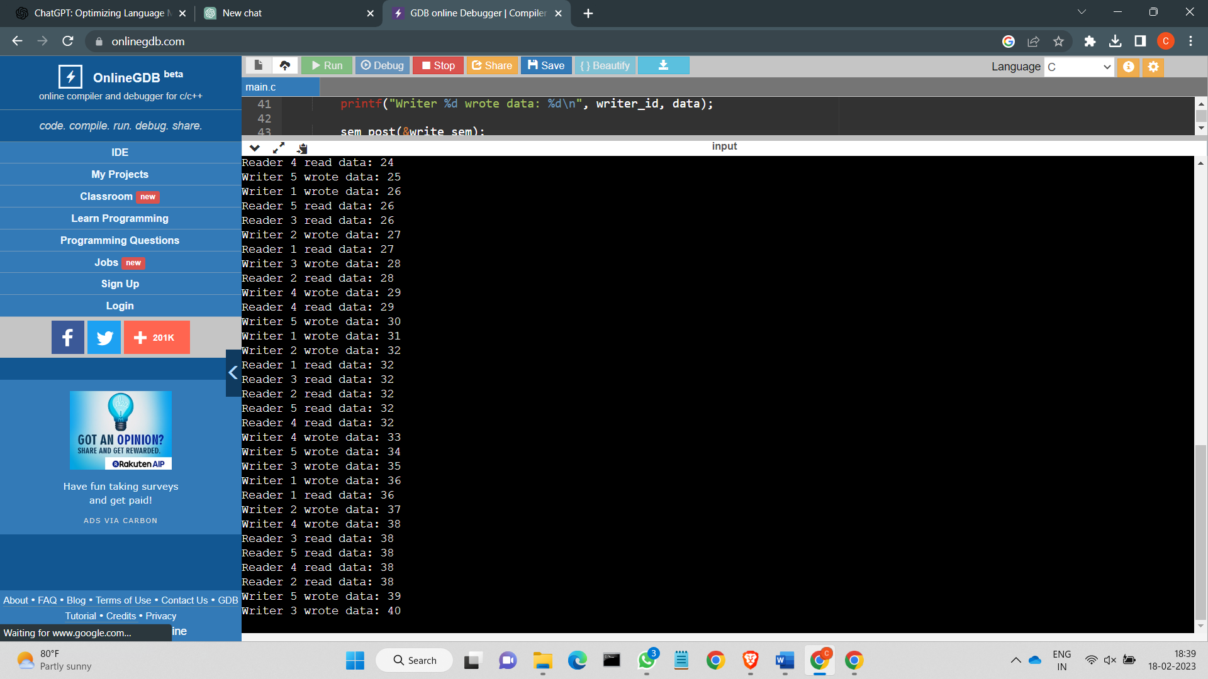

**Dining Philosopher Problem**

#include <pthread.h>

#include <semaphore.h>

#include <bits/stdc++.h>

#include <iostrem.h>

#include <stdio.h>

#define N 5

#define THINKING 2

#define HUNGRY 1

#define EATING 0

#define LEFT (phnum + 4) % N

#define RIGHT (phnum + 1) % N

int state[N];

int phil[N] = { 0, 1, 2, 3, 4 };

sem_t mutex;

sem_t S[N];

void test(int phnum)

{

if (state[phnum] == HUNGRY

&& state[LEFT] != EATING

&& state[RIGHT] != EATING)

{

state[phnum] = EATING;

sleep(2);

printf("Philosopher %d takes fork %d and %d\n",

phnum + 1, LEFT + 1, phnum + 1);

printf("Philosopher %d is Eating\n", phnum + 1);

sem_post(&S[phnum]);

}

}

void take_fork(int phnum)

{

sem_wait(&mutex);

state[phnum] = HUNGRY;

printf("Philosopher %d is Hungry\n", phnum + 1);

test(phnum);

sem_post(&mutex);

sem_wait(&S[phnum]);

sleep(1);

}

void put_fork(int phnum)

{

sem_wait(&mutex);

state[phnum] = THINKING;

printf("Philosopher %d putting fork %d and %d down\n",

phnum + 1, LEFT + 1, phnum + 1);

printf("Philosopher %d is thinking\n", phnum + 1);

test(LEFT);

test(RIGHT);

sem_post(&mutex);

}

void* philosopher(void* num)

{

while (1) {

int* i = num;

sleep(1);

take_fork(*i);

sleep(0);

put_fork(*i);

}

}

int main()

{

int i;

pthread_t thread_id[N];

sem_init(&mutex, 0, 1);

for (i = 0; i < N; i++)

sem_init(&S[i], 0, 0);

for (i = 0; i < N; i++) {

pthread_create(&thread_id[i], NULL,

philosopher, &phil[i]);

printf("Philosopher %d is thinking\n", i + 1);

}

for (i = 0; i < N; i++)

pthread_join(thread_id[i], NULL);

}

**Output –**

