**Name: Srinivas Sanjeevkumar Chenna**

**Division: A**

**Roll Number: 48**

**Subject: Operating System (OS) LAB**

**Lab Assignment 4**

**Write a shell script :**

**1. For Calculator uding command line arguments**

**Code:**

#!/bin/bash

if [ $# -ne 3 ]

then

echo "Usage: $0 num1 operator num2"

exit 1

fi

num1=$1

operator=$2

num2=$3

case $operator in

+)

result=$((num1 + num2))

;;

-)

result=$((num1 - num2))

;;

\*)

result=$((num1 * num2))

;;

/)

result=$((num1 / num2))

;;

*)

echo "Invalid operator: $operator"

exit 1

;;

esac

echo "$num1 $operator $num2 = $result"

**Output:**

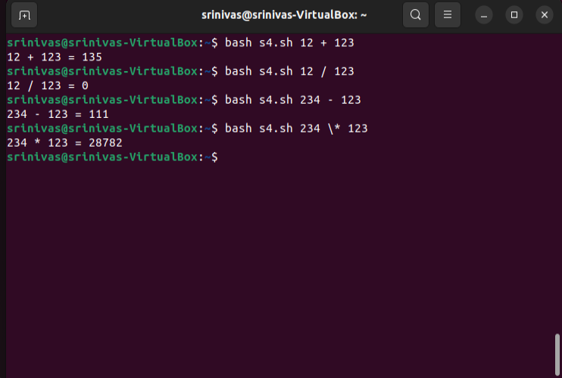

**2. To reverse the given string**

**Code:**

#!/bin/bash

echo "Enter a string: "

read str

len=${#str}

rev=""

for (( i=$len-1; i>=0; i-- ))

do

rev="$rev${str:$i:1}"

done

echo "The reversed string is: $rev"

**Output:**

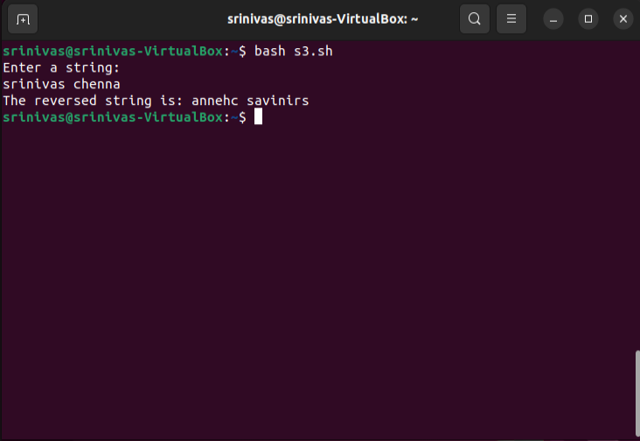

**3. To execute linux commands using case statement.**

**Code:**

v#!/bin/bash

echo "Enter a Linux command:"

read cmd

case $cmd in

"ls")

ls

;;

"pwd")

pwd

;;

"echo")

echo "Enter a message:"

read msg

echo $msg

;;

"whoami")

whoami

;;

*)

echo "Invalid command"

;;

esac

**Output:**

**4. To print the pyramid of \***

**Code:**

Code:

#!/bin/bash

echo "Enter the number of rows for the pyramid: "

read rows

for (( i=1; i<=rows; i++ ))

do

for (( j=1; j<=rows-i; j++ ))

do

echo -n " "

done

for (( k=1; k<=2*i-1; k++ ))

do

echo -n "*"

done

echo

done

**Output:**

**5.To write a function for factorial of a number**

**Code:**

#!/bin/bash

factorial() {

if [ $1 -eq 0 ]

then

echo 1

else

prev=$(factorial $(( $1 - 1 )))

echo $(( $1 * $prev ))

fi

}

echo "Enter a number: "

read num

fact=$(factorial $num)

echo "The factorial of $num is $fact"

**Output:**

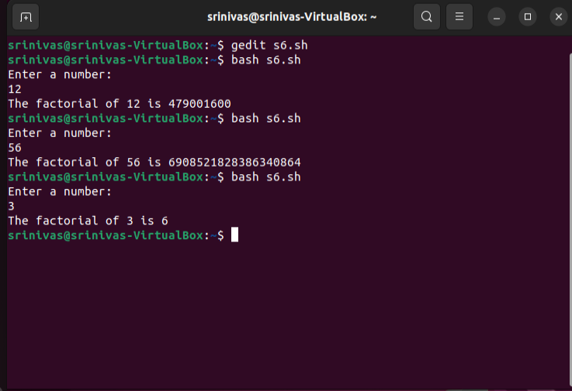

**6. To sort the given elements using any sorting method.**

**Code:**

#!/bin/bash

echo "enter the total number of elements: "

read n

echo "enter the elements: "

for ((i = 0; i<5; i++))

do

read arr[$i]

done

echo "Array in original order"

echo ${arr[*]}

# Performing Bubble sort

for ((i = 0; i<5; i++))

do

for((j = 0; j<5-i-1; j++))

do

if [ ${arr[j]} -gt ${arr[$((j+1))]} ]

then

# swap

temp=${arr[j]}

arr[$j]=${arr[$((j+1))]}

arr[$((j+1))]=$temp

fi

done

done

echo "Array in sorted order :"

echo ${arr[*]}

**Output:**

