**Name: Srinivas Sanjeevkumar Chenna**

**Division: A**

**Roll Number: 48**

**Subject: Operating System (OS) LAB**

**Lab Assignment 7**

**Implement following Disk Scheduling Algorithms**

**1. FCFS**

**Code:**

#include<iostream>

using namespace std;

int main(){

int s;

cout<<"enter the number of tracks: ";

cin >> s;

int a[s];

int b[s];

int chp;

int sum = 0;

for(int i = 0; i<s; i++){

cout<< "enter the request sequence track["<<i+1<<"] : ";

cin >> a[i];

}

cout<< "enter the current head ponter : ";

cin >> chp;

for(int i = 0; i<s; i++){

sum += abs(chp - a[i]);

chp = a[i];

}

cout<<"total number of tracka travel is : "<<sum;

cout<<"\n average tracka travel in each instance : "<<sum/s;

return 0;

}

**Output:**

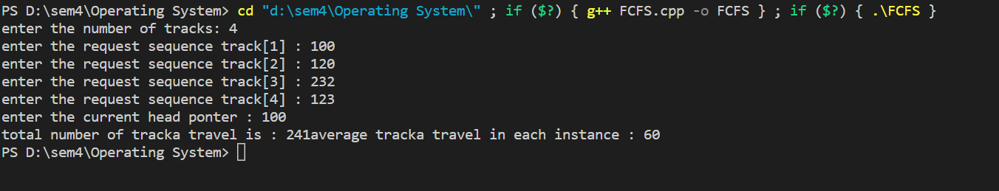

**2. SSTF**

**Code:**

#include<iostream>

using namespace std;

int main(){

int s;

cout<<"enter the number of tracks: ";

cin >> s;

int a[s];

int chp;

cout<< "enter the current head ponter : ";

cin >> chp;

int sum = 0;

for(int i = 0; i<s; i++){

cout<< "enter the request sequence track["<<i+1<<"] : ";

cin >> a[i];

}

for(int i = 0; i<s; i++){

int min = 10000;

int j, pos;

for(j = 0; j<s; j++){

if(min > abs(a[j] - chp)){

min = abs(a[j] - chp);

pos = j;

}

}

sum += abs(a[pos] - chp) ;

chp = a[pos];

a[pos] = 1000000000;

}

cout<<"total number of tracka travel is : "<<sum;

cout<<"\n average tracka travel in each instance : "<<sum/s;

return 0;

}

**Output:**

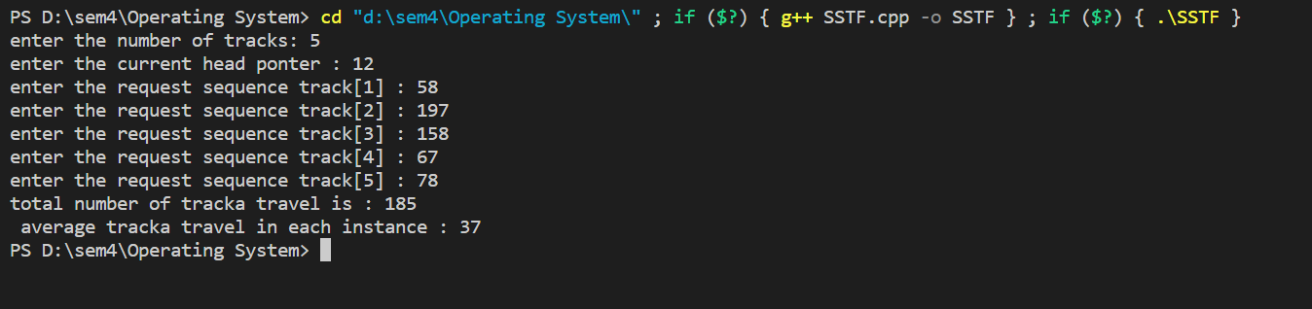

**3. SCAN**

**Code:**

#include<iostream>

#include <bits/stdc++.h>

using namespace std;

int main(){

int t;

cout<<"enter the number of tracks: ";

cin >> t;

int n;

cout<<"enter no. of requests: ";

cin>>n;

vector<int> request(n);

for(int i=0;i<n;i++){

cout<< "enter the request sequence track["<<i+1<<"] : ";

cin>>request[i];

}

int chp;

cout<< "enter the current head ponter : ";

cin >> chp;

sort(request.begin(), request.end());

int index=0;

for(int i=0;i<n;i++){

if(request[i]>=chp){

index=i;

break;

}

}

int dir;

cout<<"Enter the direction 0 -> clockwise & 1->anticlockwise: ";

cin>>dir;

int n_tracks=0;

if(dir==0){

for(int i=index;i<n;i++){

n_tracks+=(request[i]-chp);

chp=request[i];

}

for(int i=index-1;i>=0;i--){

n_tracks+=(chp - request[i]);

chp=request[i];

}

}

else{

for(int i=index-1;i>=0;i--){

n_tracks+=(chp - request[i]);

chp=request[i];

}

for(int i=index;i<n;i++){

n_tracks+=(request[i]-chp);

chp=request[i];

}

}

cout<<"Total no. of track(sum): "<<n_tracks<<endl;

cout<<"avarage number travell each instance: "<<n_tracks/n<<endl;

return 0;

}

**Output:**

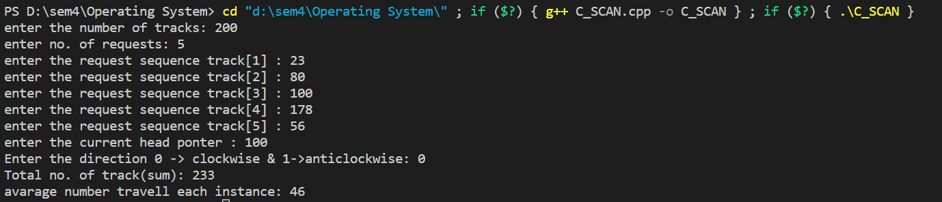

**4. C SCAN**

**Code:**

#include <bits/stdc++.h>

using namespace std;

int size;

int disk_size = 200;

void CSCAN(int arr[], int head)

{

int seek_count = 0;

int distance, cur_track;

vector<int> left, right;

vector<int> seek_sequence;

left.push_back(0);

right.push_back(disk_size - 1);

for (int i = 0; i < size; i++) {

if (arr[i] < head)

left.push_back(arr[i]);

if (arr[i] > head)

right.push_back(arr[i]);

}

std::sort(left.begin(), left.end());

std::sort(right.begin(), right.end());

for (int i = 0; i < right.size(); i++) {

cur_track = right[i];

seek_sequence.push_back(cur_track);

distance = abs(cur_track - head);

seek_count += distance;

head = cur_track;

}

head = 0;

seek_count += (disk_size - 1);

for (int i = 0; i < left.size(); i++) {

cur_track = left[i];

seek_sequence.push_back(cur_track);

distance = abs(cur_track - head);

seek_count += distance;

head = cur_track;

}

cout << "Total number of seek operations = "

<< seek_count << endl;

cout << "Seek Sequence is" << endl;

for (int i = 0; i < seek_sequence.size(); i++) {

cout << seek_sequence[i] << endl;

}

}

// Driver code

int main()

{

cin >> size;

int arr[size];

for(int i = 0; i<size ; i++){

cin >> arr[i];

}

int head ;

cout << " enter Initial position of head: " << endl;

cin>> head;

CSCAN(arr, head);

return 0;

}

**Output:**

