CS637: Database-Backed Websites

Project Report

Submitted By
Abhigna Kumar Vaddepally – 02098709
Venkata Srinivasa Reddy Gade - 02124940

Motor Vehicle Collisions and Crashes

- Overview

  - We have collected a dataset of motor vehicle collisions occurred in New York City. The detail description of the dataset is given below.
  - After downloading the dataset, we imported this data into Google Colab (Python Notebook) and implemented some pre-processing operations on the dataset.
  - Then, this new dataset is imported into MySQL Database Server.
  - Node.js was used to run the back-end server.
  - HTML, CSS, and JavaScript was used for the front-end.
  - Implemented SARIMA (Seasonal Auto Regressive Integrated Moving Average) model for time series analysis and forecasting. This can be used to predict future accident counts.
  - Hosted our website on Google Cloud – Click Here.

- Description of the Dataset

  - The Motor Vehicle Collisions dataset contains details on the crash events.
  - Each row represents a crash event. The Motor Vehicle Collisions data tables contain information from all police reported motor vehicle collisions in NYC.
  - Dataset is provided by the Police Department (NYPD).
  - This dataset has 2.03 million rows. Each row is a Motor Vehicle Collision. And it has 29 columns.
  - The dataset used in this project comprises the following columns:
    - Crash Date: Date of the accident.
    - Crash Time: Time of the accident.
    - Borough: Borough where the accident occurred.
    - Zip Code: Zip code of the accident location.
    - Latitude: Latitude of the accident location.
    - Longitude: Longitude of the accident location.
    - Location: Coordinates of the accident (Latitude, Longitude).
    - On Street Name: Street where the accident occurred.
    - Cross Street Name: Cross street at the accident location.
    - Off Street Name: Off-street location of the accident.
    - Number of Persons Injured: Count of individuals injured.
    - Number of Persons Killed: Count of individuals killed.
    - Number of Pedestrians Injured: Count of pedestrians injured.
    - Number of Pedestrians Killed: Count of pedestrians killed.
    - Number of Cyclist Injured: Count of cyclists injured.
    - Number of Cyclist Killed: Count of cyclists killed.
    - Number of Motorist Injured: Count of motorists injured.
    - Number of Motorist Killed: Count of motorists killed.
    - Contributing Factor Vehicle 1 to 5: Factors contributing to the accident from vehicles.
    - Collision ID: Unique identifier for the collision.
    - Vehicle Type Code 1 to 5: Type of vehicles involved in the accident.

- File Structure

The project is organized into the following structure:

- Project Folder

- node_modules: Directory containing Node.js modules installed via npm.
- .env: Configuration file for environment variables.
- app.js: Main Node.js application file.
- app.yaml: Configuration file for deploying the application on Google Cloud Platform (GCP).
- package.json: Configuration file for npm dependencies and project metadata.
- package-lock.json: Automatically generated file specifying the exact versions of npm dependencies.
- public: Directory containing static files served by the application.
    - contact.html: HTML file for the contact page.
    - dataset.html: HTML file for displaying the dataset information.
    - index.html: Main HTML file for the homepage.
    - lanlon.csv: CSV file containing latitude and longitude data for accidents.
    - maps.html: HTML file for displaying accident locations on Google Maps.
    - problems.html: HTML file addressing problem statements.
    - script.js: JavaScript file containing client-side scripts.
    - solutions.html: HTML file presenting potential solutions and recommendations.
    - styles.css: Cascading Style Sheets (CSS) file for styling HTML pages.
System Diagram

Home Page (index.html)
Web Browser

Requests the Web App
Sends the requested HTML file
API Requests
Preprocessed Data is stored in the Database
Routes are implemented to retrieve the data
All are front end files are accessed by the server
Predictions are sent to Database
Machine Learning Model
Filtered Data is sent to Machine Learning Model
HTML, CSS, JavaScript
Dataset Preprocessing
MySQL Database
NodeJS (Backend Server)
- Front End

- HTML

1. index.html
This is the main entry point for our web application. It includes the following:
- Header Section:
  - Meta tags for character set, viewport settings, etc.
  - <title> tag for setting the title of the webpage.
  - Links to external stylesheets (styles.css).
- Body Section:
  - Navigation bar (<nav>) with links to different pages of our application.
  - Introduction and overview of the project.
  - Making of website and technologies used.
2. contact.html
This page is designed to provide contact information for users to reach out. It includes:
- Header Section:
  - Similar meta tags and title as the index.html page.
  - Links to external stylesheets (styles.css).
- Body Section:
  - This contains our contact information - Phone number, GitHub, LinkedIn.
3. dataset.html
This page is to present details about the dataset used in your project. It includes:
- Header Section:
  - Similar meta tags and title as the index.html page.
  - Links to external stylesheets (styles.css).
- Body Section:
  - Tables or lists to display key information about the dataset, such as column names, data types, etc.
  - Source of the dataset.
  - Descriptions or statistics related to the dataset.
4. maps.html
This page is dedicated to visualizing accident locations on maps. It includes:
- Header Section:
  - Similar meta tags and title as the index.html page.
  - Links to external stylesheets (styles.css).
- Body Section:
  - Embedded maps using JavaScript libraries like Google Maps/Leaflet.
  - Markers/heatmaps to represent accident locations.

5. problems.html and solutions.html
These pages are used to present problem statements and proposed solutions. They include:
- Header Section:
  - Similar meta tags and title as the index.html page.
  - Links to external stylesheets (styles.css).
- Body Section:
  - Descriptions and details about problems and challenges.
  - Proposed solutions or recommendations.
  - Charts/Graphs to visualize data related to problems and solutions.

- CSS

- Global Styles:

- Sets the font family for the entire body.
- Removes default margin and padding.
- Sets a light gray background color.

- Header Styles:

- Styles for the header element.
- Dark background color (#333), white text color (#fff), and padding.
- Text is centered within the header.

- Navigation Styles:

- Styles for the navigation element.
- Dark background color (#444), overflow hidden, and text centered.

- Styles for navigation links.
- Displayed as inline-block for a horizontal layout.
- White text color, padding, and no text decoration.

- Hover styles for navigation links.
- Light gray background color (#ddd) and dark text color (#333) on hover.

- Responsive Navigation Styles:

- Initially hides the menu icon.

- Media query for screens with a maximum width of 600px.
- Hides navigation links, except for the first child.
- Displays the menu icon on smaller screens.
- Converts the menu icon to an absolute position when the navigation is responsive.
- Adjusts styles for responsive navigation links.

- Section Styles:

- Adds padding to section elements.

- Footer Styles:

- Styles for the footer.
- Dark background color (#333), white text color (#fff), padding.
- Positioned at the bottom of the page.

- Styles for links within the footer paragraph.

- Custom Styles:

- Custom styles for the class .Intro.
- Center-aligns text and adds padding.

- Custom styles for the class .aim.
- Center-aligns text and adds padding.

These styles provide a clean and responsive design for the website, ensuring a consistent and visually appealing layout across different devices. The use of media queries helps adapt the navigation for smaller screens, improving the user experience.

- JavaScript

The JavaScript code in script.js is responsible for toggling the navigation menu's visibility on smaller screens, enabling a responsive design. Here's a detailed explanation of the code:
- function toggleNav(): This function is called when the user clicks the menu icon on smaller screens. It toggles the visibility of the navigation menu.
- var x = document.querySelector("nav");: This line selects the <nav> element in the HTML document and assigns it to the variable x. The querySelector method selects the first element that matches the specified CSS selector.
- if (x.className === ""): Checks if the className property of the selected <nav> element is an empty string. The className property represents the class attribute of the HTML element.
- x.className = "responsive";: If the className is an empty string, it sets the class to "responsive". This class contains styles that make the navigation menu suitable for smaller screens, such as displaying the links in a vertical list.
- else { x.className = ""; }: If the className is already "responsive", it resets it to an empty string. This action reverts the styles applied for smaller screens, making the navigation menu behave as it does on larger screens.
In summary, the toggleNav function ensures that when the user clicks the menu icon, it toggles the responsive design of the navigation menu, allowing for better usability on smaller screens.

- Back End

- NodeJS

Given below is the explanation of app.js file:
- Import Statements:
  - Import necessary modules: express for building the web server, mysql2 for MySQL database interaction, dotenv for handling environment variables.
- Express App Configuration:
  - Create an instance of the Express application.
  - Load environment variables from a .env file into process.env using dotenv.config().
- MySQL Connection Setup:
  - Establish a connection to the MySQL database using the configuration specified in the .env file.
- Middleware and Routing:
  - Utilize middleware to handle JSON data and serve static files.
  - Define various routes using app.get and app.post to handle specific HTTP requests.
- Routes:
  - Implement routes to perform actions such as retrieving table names, fetching dataset records, etc.
  - Each route corresponds to a specific endpoint and performs operations on the MySQL database.
- Server Initialization:
  - Start the server on a specified port using app.listen.
- Database Connection Closure on SIGINT:
  - Ensure proper closure of the database connection when the server receives a SIGINT signal (e.g., when manually stopping the server).
  - This is important for graceful termination and resource cleanup.
In summary, app.js is the main entry point for the server, responsible for configuring the Express application, establishing a connection to the MySQL database, defining routes to handle various HTTP requests, and initializing the server to listen on a specific port. It provides the backend logic for the project, incorporating database interactions.

- MySQL Database (Planet Scale)

We have use Planet Scale which is a cloud-native database service for MySQL, offering features like scalability, high availability, and ease of management. Our MySQL database is hosted in the cloud on Planet Scale.
- Database name - CS637Project
- Table name – updated_dataset_2
- Number of Columns – 26
- Number of Rows – 1 million

- Python

- Preprocessing of the Dataset

- Importing Libraries and Dataset:
  - The script begins by importing the necessary library, pandas, and loading the dataset from a CSV file.
- Checking Dataset Dimensions:
  - The shape of the dataset (number of rows and columns) is printed to understand its size.
- Handling NULL Values:
  - Rows with NULL values in the 'LOCATION' and 'ON STREET NAME' columns are removed. This step helps ensure that the dataset contains complete location information.
- Handling Irrelevant Columns:
  - Columns that are deemed irrelevant for the analysis ('CONTRIBUTING FACTOR VEHICLE 3', 'CONTRIBUTING FACTOR VEHICLE 4', 'CONTRIBUTING FACTOR VEHICLE 5') are dropped.
- Handling Missing Values in Specific Columns:
  - Rows with NULL values in the 'CONTRIBUTING FACTOR VEHICLE 1' column are dropped. This column likely contains important information about the primary contributing factor to the collision.
- Handling NULL Values with ‘fillna’:
  - NULL values in numeric columns ('ZIP CODE', 'NUMBER OF PERSONS INJURED', 'NUMBER OF PERSONS KILLED') are filled with zeros, to represent missing or unknown values.
- String Manipulation on a Column:
  - Whitespaces at the beginning and end of values in the 'ON STREET NAME' column are removed. This step ensures consistency and removes any unintentional spaces.
- Saving the Preprocessed Dataset:
  - The final preprocessed dataset is saved to a new CSV file. This new dataset is stored in the MySQL Database, and it is used for the machine learning model.

In summary, the preprocessing focuses on cleaning the dataset by handling missing values, dropping irrelevant columns, and ensuring consistency in the format of specific columns. These preprocessing steps are essential for preparing the data for downstream tasks such as machine learning modeling.

- Implementation of Machine Learning Model

We have implemented a python script for time series forecasting using the Seasonal Auto Regressive Integrated Moving Average (SARIMA) model. Here is a detailed explanation of the steps:

- Importing Libraries and Loading Data:
  - The code begins by importing necessary libraries, including pandas for data manipulation, statsmodels for time series analysis, and matplotlib for plotting. The dataset is loaded from a CSV file containing preprocessed information about motor vehicle collisions.
- Date Conversion and Indexing:
  - The 'CRASH DATE' column is converted to datetime format to facilitate time-based analysis. The dataset is then indexed based on the crash dates.
- Resampling Daily Accident Counts:
  - The dataset is resampled at a daily frequency, counting the number of accidents that occurred each day. This creates a time series of daily accident counts.
- Visualization of Time Series:
  - The code then plots the time series of daily accident counts over time, providing a visual representation of the data distribution.
  - Following is the graph which is plotted by using the preprocessed dataset.

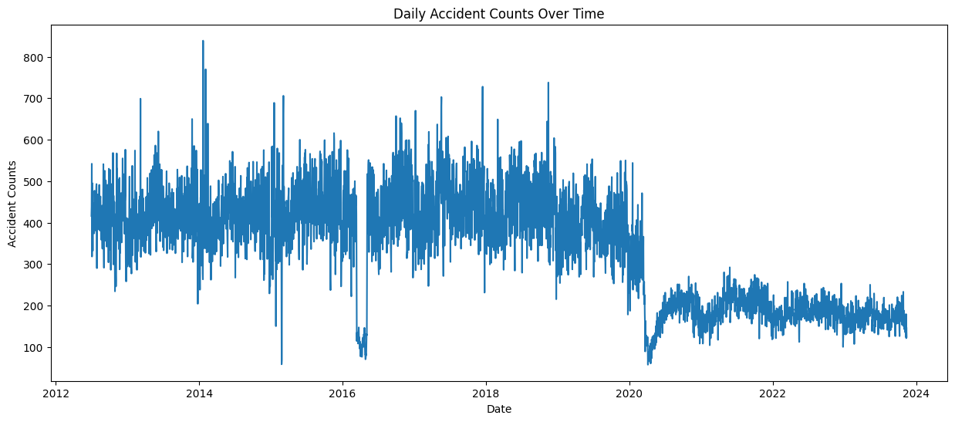

- Defining SARIMA Model:
  - SARIMA parameters (order and seasonal_order) are defined. These parameters determine the order of the AutoRegressive (AR), Integrated (I), and Moving Average (MA) components of the SARIMA model.
- Fitting SARIMA Model:
  - The SARIMA model is instantiated (sarima_model) and fitted to the time series data (daily_accidents) using the specified parameters. The result is stored in sarima_result.
- Generating Forecast:
  - A forecast is generated using the trained SARIMA model. The number of forecast steps is specified by the forecast_steps variable.
- Plotting Actual vs. Forecasted Values:
  - The code plots the actual daily accident counts alongside the forecasted values. This visualization helps assess the accuracy of the SARIMA model in predicting future trends.
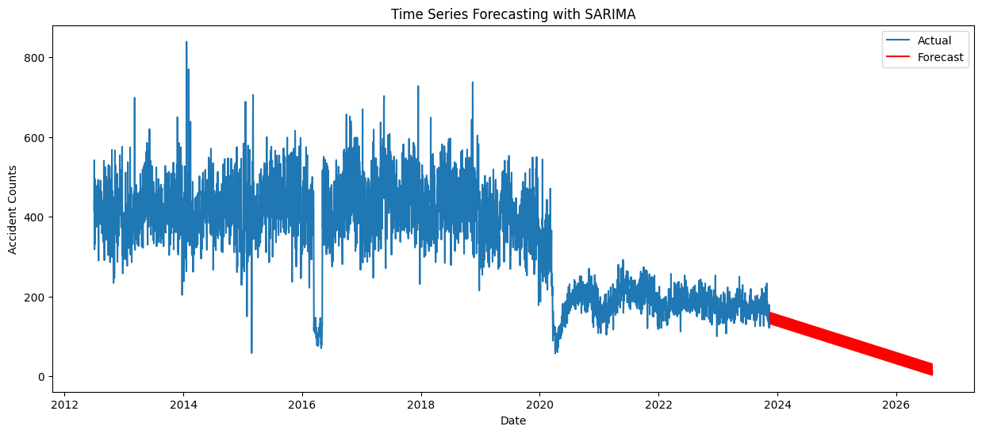

The SARIMA model is a sophisticated time series forecasting method that considers seasonality, trends, and other temporal patterns in the data. This code demonstrates the application of SARIMA to predict future accident counts based on historical data, providing insights for traffic safety planning and management.

- Hosting of the Website

- We have hosted our website on Google Cloud Platform (GCP).
- URL - https://elite-flow-407105.ue.r.appspot.com/

