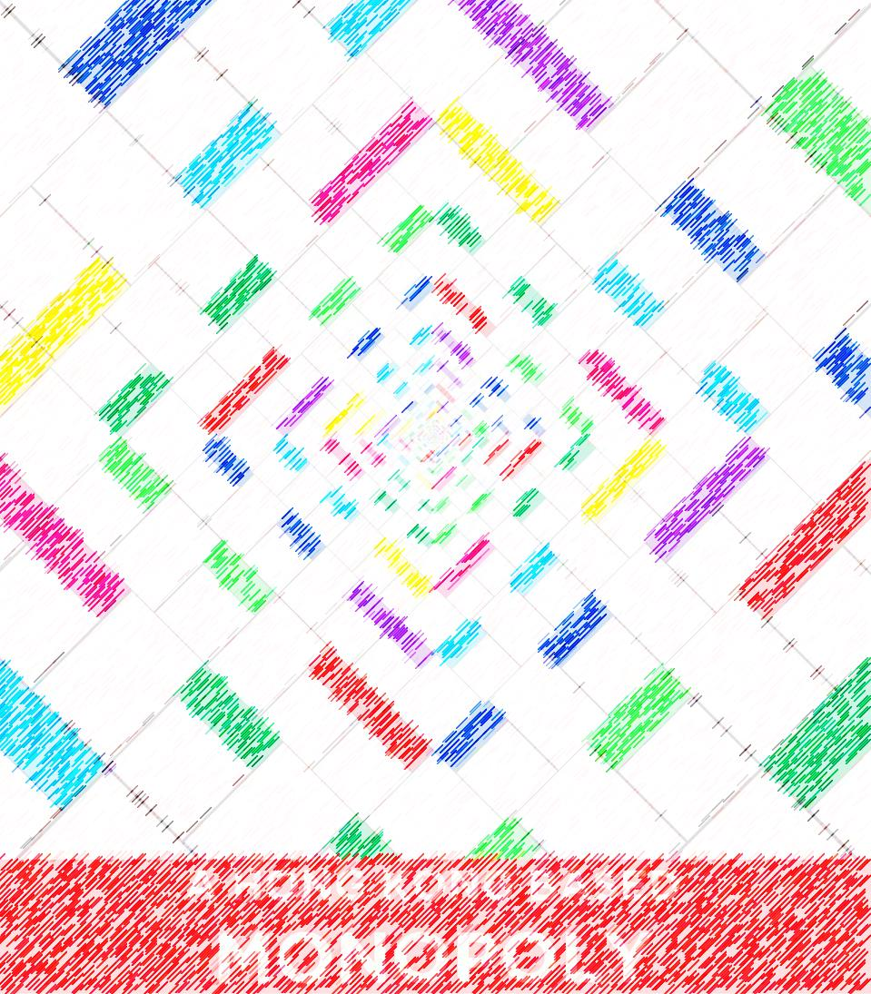

**GROUP 2**

**SHYLA KUMAR Rohit (54581876) Major- Undeclared (School of Creative Media)**

**SIVAKUMAR Srinivas (54486977) Major- Undeclared (Department of Electronic Engineering)**

**YOGISH Suhas (54486977) Major- Undeclared (Department of Electronic Engineering)**

**SABHARWAL Rohan(54592018) Major- Undeclared (School of Energy and Environment)**

The classic board game with a revolutionary twist.

**MONOPOLY IN HONG KONG**

**Introduction**

**Our Motivation and Objectives**

We began our group project with one central idea, bringing Monopoly, a classic board game of the previous generation, from the physical realm to a computer screen. We intended to introduce the intricacies of real estate development to the succeeding generation in the most fun way possible so they too could learn about buying, selling, renting and taxes as we had. Children are influenced by the games they play, so we had to be careful while deciding on a theme to go with our game. We decided to use this to our advantage and further the cause of Mother Earth by choosing an environmental theme. Hence, we introduced an additional dimension to each player’s portfolio- carbon emission permits. This specific dimension was introduced to single out the greenhouse effect and its leading contributor carbon dioxide and portrays them as negative aspects of a player’s game. Thus, players must be tactful in money management and pollution control in order to win the game.

**Design and Structure**

The board is modeled after the original but since there is no physical money or property cards to play with, we designed a user interface on the right hand side of the screen with all the relevant game statistics and information. This includes all the mechanism users require to play the game, such as buttons to roll a virtual dice, buy a property or end their turn. The user interface also tracks how each player is fairing as they venture into the corporate world, throwing out players who go bankrupt and declaring a final winner. An interesting feature on our main board is that all the properties are based in Hong Kong and color-coordinated with the Mass Transit Railway (MTR) system’s map coloration. For example, Kowloon Tong which is on the light green line on MTR map is represented as a light green station on our board. In addition to that, we replaced the idea of the four stations with four of the most recognizable places in Hong Kong, the Student Residence, Disneyland, the Airport and the International Financial Center.

**Key Aspects**

The sideward text on the original monopoly board makes it impossible to read unless viewed from a different angle but since we cannot expect our users to sit in a circle around a computer screen to play this game, we decided to program our board to rotate as the player reached a different side of it. We implemented this functionality into our program using the translate and rotate functions. As dictated by convention, the game is played by four players. When it’s a player’s turn, he has three choices, to roll the dice, buy the location or end his turn, in that specific move order where buying the location is optional. Thus, there is a chronological order to be followed by users. We have happily retained all the classic aspects that made the game so enjoyable in the first place. The concepts of Chance, Community Chest and Jail are all key elements of our program.

**Challenges**

As we proceeded on our task of digitizing the most classic board game of all time, we faced a plethora of difficulties ranging from the ideas we wished to implement, to the logic behind rotating our main screen for each player’s convenience without rotating other parts of the screen. The problems we faced were not only responsible for our weeks of sleepless nights but also for our short-lived periods of amnesia in the language of Java.

**How do we convey a message?**

The biggest problem we faced was communicating a relevant message through the digital board to our users. Monopoly, in its fundamental nature, is a simulation of a fast pacing, ever growing economic playground, implementing various economic theories with the integration of taxation and other financial devices. Therefore, the issue of spreading a message through the medium of the game became a thought provoking matter. The criteria that we were to incorporate aspects of our diversified streams into the program, also posed a challenge.

We settled on the idea of introduction the “Cap and Trade” policy into the rubrics of our game. As it is an economic taxation tool and also a scheme commonly used by governments to promote the added benefits a corporation would be entitled to, if they underwent a carbon-less lifecycle, we believed that it would be the perfect tool to implement into this licensed game.

Furthermore, in reality, it is a proven concept. It has succeeded in reducing or carbon large amounts of carbon emission from several European countries. Thus, we decided to implement this concept to convey our message of environment-friendliness and raise awareness for global warming.

**The Challenge of Convenience**

One the most influential driving forces behind the entire concept of digitization is convenience. Every service provided today has been designed in such a way that the user can utilize every feature with minimalistic effort. When it came to our version of Monopoly, another troubling issue we faced was this accessibility factor; how do we maximize its handiness. One of the proposed ideas was to rotate the game board such that the side of the board with the talus of the player always faces the current user.

This was easily implementable as Processing considers the canvas as a graph sheet and thus implements the rotate function by rotating the entire graph sheet and not just a particular part of it. Thus, by utilizing this function alongside the translate method to change the origin of the graph; we were able to successful implement user convenience into our program.

**The Logic behind the functioning of the “Jail”**

The Processing logic behind the main functionality of the game was slightly tedious, but not mind numbingly difficult, but when it came to the programming of certain squares of the digital board, the same cannot be said. The most cumbersome of them all was the logic behind the “Jail” component of monopoly. It had to be so encoded that when a player’s token gets sent to jail, either at the “Go To Jail” square of the board or through the Community Chest or Chance card, the player would thus be restricted from participating in the game for three turns and all the buttons would be disabled.  
Implementing this level of logic into one square of the game initially proved to be a very problematic task as suspending a particular user from the three other users was quite a logical conundrum.

To counter the above problem, we implemented the simple concept of counter variable arrays, commonly referred to flag arrays. Thus when the player ended up in Jail, the corresponding counter variable would be thus incremented and a conditional statement suspending the buttons for three turns would be executed. For other players, this flag variable would still have the null value thus, failing this conditional statement.

**The Pop-Up Window for Chance and Community Chest**

We wished to have a window pop-up when a player lands on Chance or Community Chest to display the result of their luck in a draw. However, this was made harder than envisioned due to the nature of the draw method in Processing. Since the function redraws on the canvas at a rate specified by the frame rate function, the pop-up window never lasted long enough for a user to read what was on it. Initially, we thought we could solve this problem using the delay function in Processing, however, for some odd reason, the function failed to fulfill its purpose.

Therefore, we called upon the millis function to save our pop-up window from being overlapped. The millis function returns the system clock value in milliseconds and using this we programmed the game to wait for 5000 milliseconds to pass before breaking out of the block of code that drew the pop-up window.

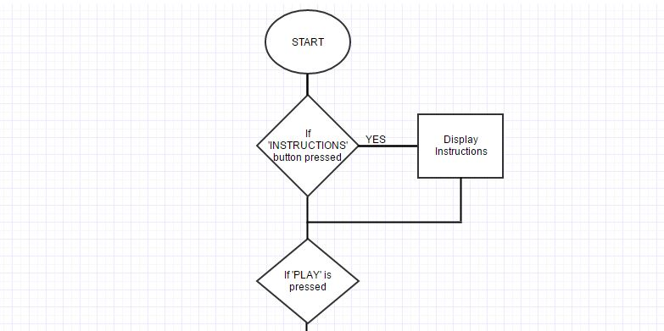**Framework of the Computer Program**

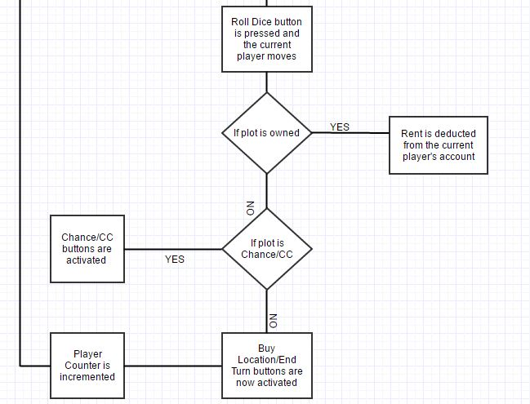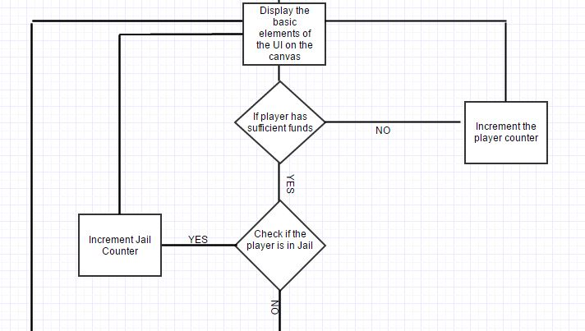

**Results and Illustrations.**

Here are a few screenshots of how each function works during gameplay.

1. The Starting Point:
   1. When the game begins, Player 1 starts at GO.
   2. Each player has 1000k in their account and 10 carbon ton permits.

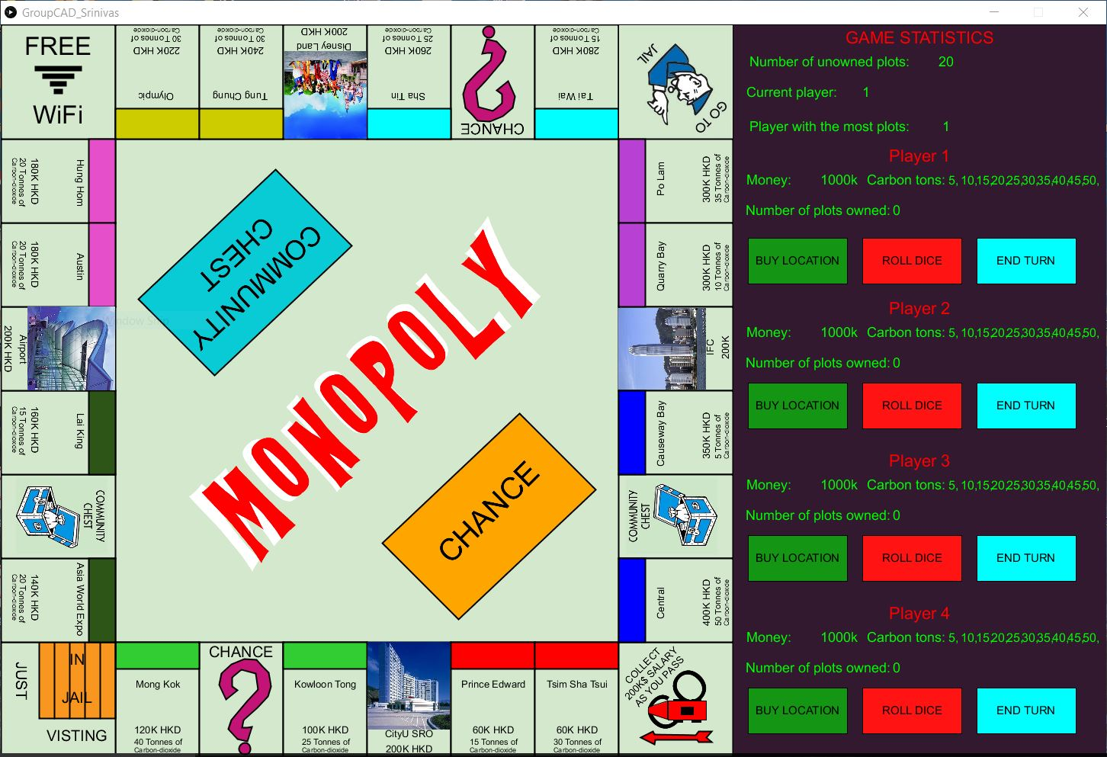

1. Rounds of the game.
   1. When it’s a particular player’s turn the player must first roll the die by clicking on the red button situated on the user interface.
   2. The player’s icon is then moved based on the outcome of the die.
   3. The player may then buy the property he/she landed on by clicking on the green button situated on the user interface.
   4. After buying the property, the amount and carbon ton tax permit will be deducted from the player’s account automatically.
   5. 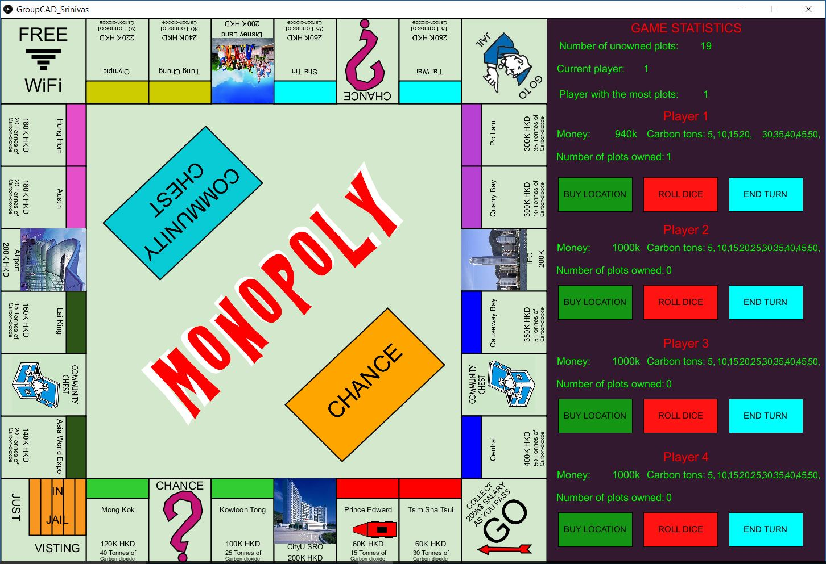The player must then end his turn by clicking on the cyan button situated on the user interface.
2. Chance & Community Chest
   1. When a player lands on either ‘Chance’ or ‘Community Chest’, the respective button on the board is activated.
   2. The player must click on the button to view what task has been assigned to them.
   3. For example, when the player lands on ‘Chance’ and clicks on the button, a chance card is displayed with a task stating ‘Advance to GO (Collect 200K)’. The player’s car is then automatically moved to GO and 200K is deposited into the account.
   4. The same process is applied to ‘Community Chest’.

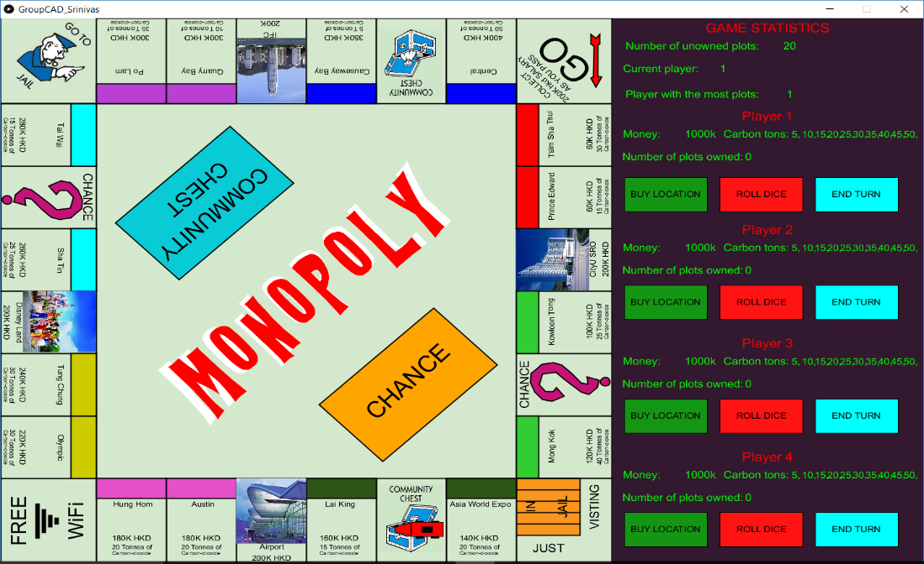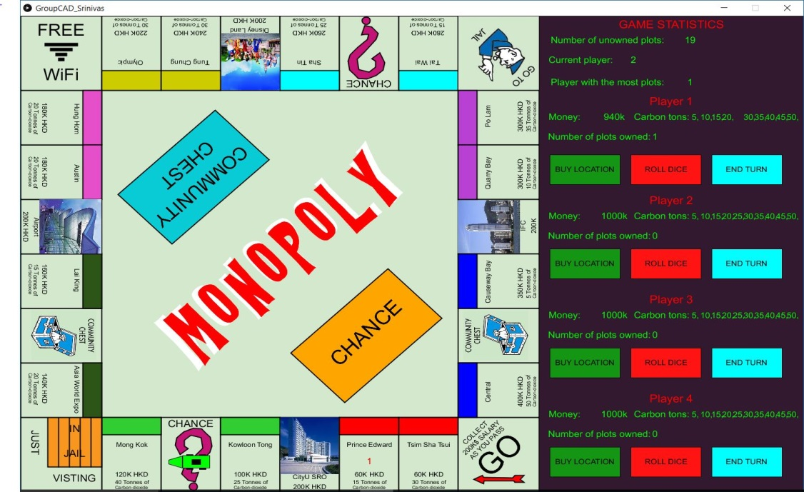

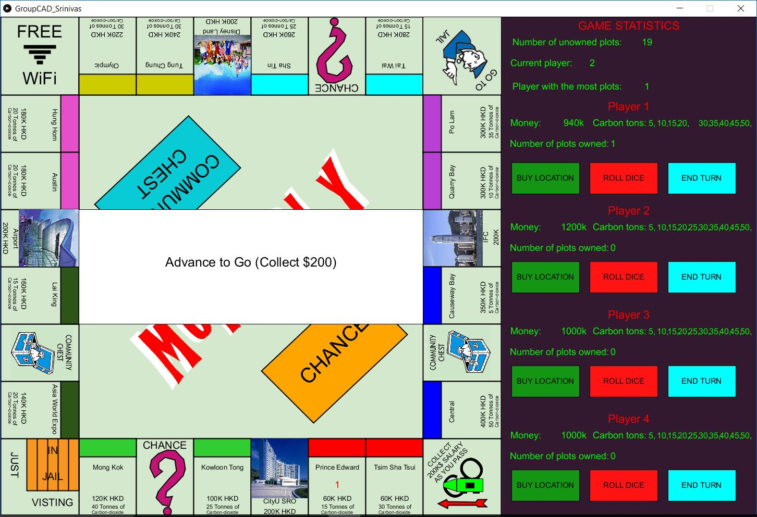

1. Go to Jail.
   1. When a player lands on the ‘Go to Jail’ plot or gets a Chance/Community Chest card as seen in Fig.5.0, the player’s car is automatically taken to the ‘In Jail’ plot.
   2. The player will then miss 3 turns.

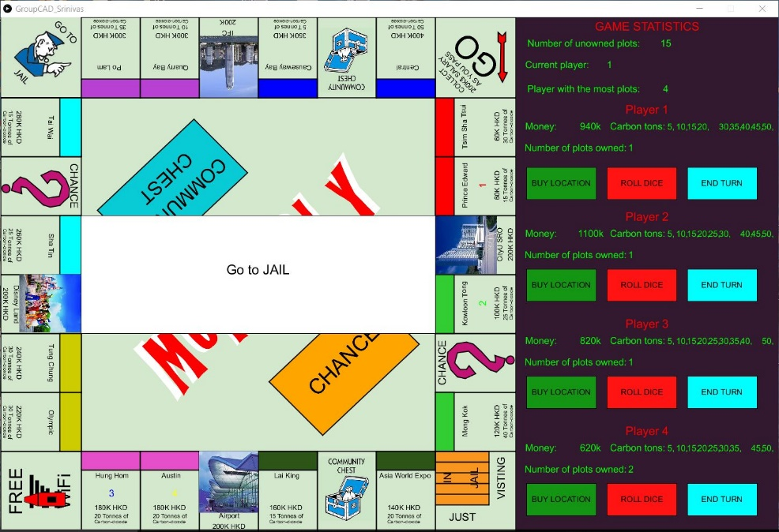

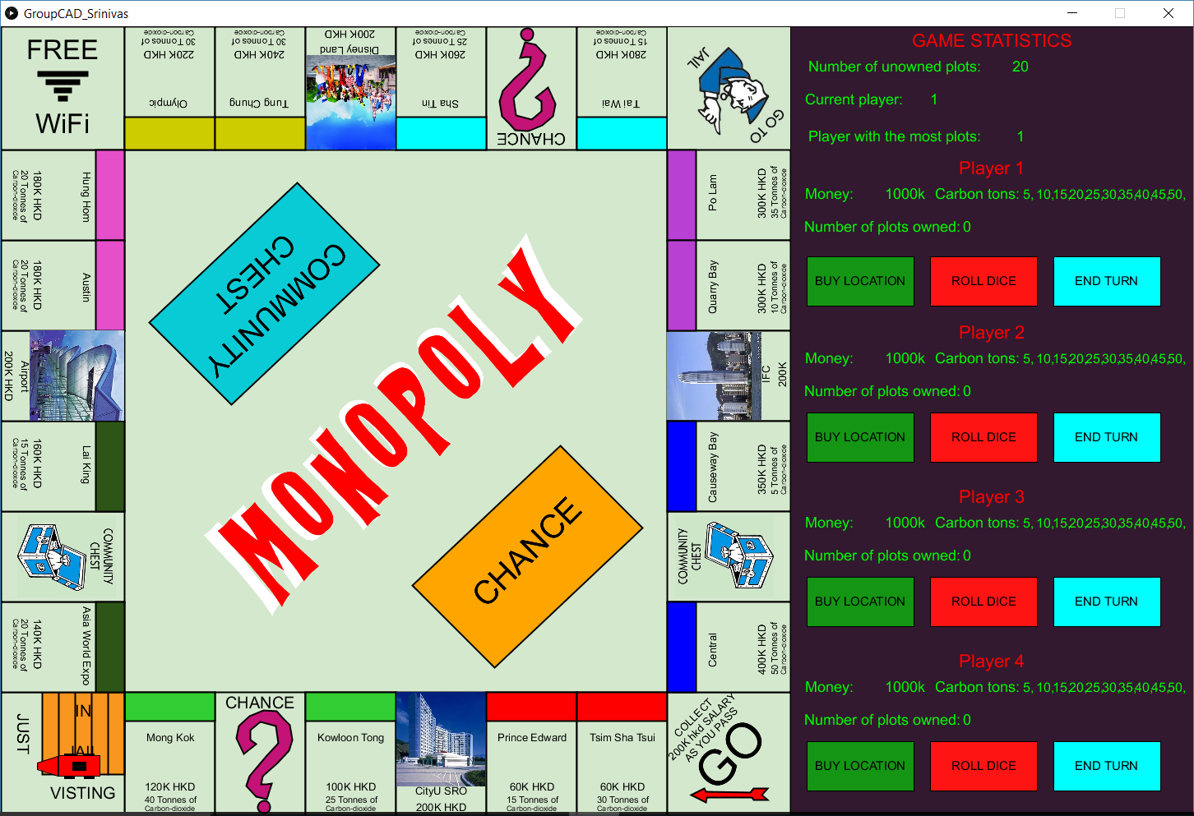

**Discussion**

We have used the Minim library in our program, it can be downloaded from the Sketch section of Processing’s IDE.

**Conclusion**

Creating an interactive game allows the programmers to challenge themselves on what the user may attempt to do during this game and be able to provide full service to satisfy the user; hence, to think outside of the box. The programmer can also think of how it can be user-friendly by allowing the user to easily visualize and understand the concept of the game. From this project, we were able to intertwine both art and computer, where we utilized the computer software to facilitate the design procedure which was the initial aim of this course.

All of us greatly enjoyed working together on this assignment and despite the problems the faced, we are proud to say that we conquered them together. We were thrilled to see the fruits of our own hard work and will cherish these memories for a long time to come.

**Backgrounds of the team and division of labor**

We worked on every aspect of the project together so it would be unfair to give credit for an entire division of work to a single member. However, the table below best describes how we went about working as a team and our areas of study.

|  |  |  |
| --- | --- | --- |
| **Name(SID)** | **Department** | **Contribution to the project** |
| SHYLA KUMAR Rohit(54581876) | School of Creative Media (Major Undeclared) | Design of the UI, board, project poster and report. |
| SIVAKUMAR Srinivas(54486977) | Department of Electronic Engineering (Major Undeclared) | Logic of the game and design of the board. |
| YOGISH Suhas(54482837) | Department of Electronic Engineering (Major Undeclared) | Logic of the game and project poster. |
| SABHARWAL Rohan(54592018) | School of Energy and Environment (Major Undeclared) | Pricing, Cap an’ Trade system and presentation. |

**References:**

Darrow, C. D. (2006). Monopoly: the property trading board game. Eastwood, N.S.W.: Hasbro / Parker.

Darrow, C. B. (1934). *Monopoly:Parker Brothers Real Estate Trading Game.* Retrieved from http://www.hasbro.com/common/instruct/monins.pdf

*How cap and trade works: Learn how this key mechanism works to reduce emission*.(n.d*).* Retrieved from <https://www.edf.org/climate/how-cap-and-trade-works>.

Mass Transit Railway. (n.d). *MTR Railway Network*. Retrieved from http://www.mtr.com.hk/en/customer/services/our_network_introduction.html

Mass Transit Railway. (n.d). *MTR Train Services*. Retrieved from http://www.mtr.com.hk/en/customer/services/domestic_train_services.html

Mass Transit Railway. (n.d). *Cross Boundary Train Services*. Retrieved from http://www.mtr.com.hk/en/customer/services/cbs_introduction.html

Mass Transit Railway. (n.d). *Cross Boundary Train Services*. Retrieved from http://www.mtr.com.hk/en/customer/services/cbs_introduction.html

*What is a Cap-and-Trade System?*.(n.d)*.*Retrieved from *http://www.conserve-energy-future.com/what-is-cap-and-trade-system.php.*