OVER THE HORIZON
THE DUAL-PLANET ODYSSEY
Master Game Design Document & Technical Specification
Version: 1.0.0 (Master Release Specification)
Author: Game Design & Engineering Team
Lead Platforms: PC (Steam / Steam Deck), Nintendo Switch 2, PlayStation 5, Xbox Series X|S
Engine: Unreal Engine 5 (Forward Shading / Custom Chaos Vehicle Subsystem)
Document Classification: Confidential / Production Architecture

1. Executive Summary & Core Pillars
OVER THE HORIZON is a premium exploration, off-road traversal, and planetary physics game. Set across two miniature celestial bodies locked in mutual orbit, the game blends the tactile, meditative driving mechanics of over the hill with the celestial wonders of Super Mario Galaxy and the visual elegance of classic French comic art (Moebius / Ligne Claire).
[CORE VISION] Players experience two fundamentally different worlds, each governed by its own visual style, physics model, and gameplay rules, with a grand campaign mode linking them together via interplanetary mass-driver slingshots and polar wormholes.

1.1 Core Game Pillars
• Pillar 1: Tactical Spherical Traversal — Mastering 360-degree radial gravity, vehicle weight transfer, and terrain deformation where the horizon curves continuously before you.
• Pillar 2: Dynamic Environmental Life — Seasons (Spring, Summer, Autumn, Winter) and continuous Day/Night cycles that actively reshape physical routes, freezing rivers into ice highways or flooding canyons into torrents.
• Pillar 3: Cross-World Synergy — Resource and technology arbitrage between two distinct planetary biomes, linking an alpine overland civilization with ancient desert monoliths.
• Pillar 4: Contemplative Wonder & Discovery — Zero artificial time pressure in free exploration, paired with intricate condition-based Easter eggs and cozy campfire atmosphere.

1.2 Target Platforms & Performance Targets
Platform | Target Resolution | Target Framerate | Special Hardware Features
PC (Steam / EGS) | 1080p - 4K Ultra | 60 - 120 FPS | Full Ultra-Wide 21:9 support, Ray-Traced Ambient Occlusion
Steam Deck / ROG Ally | 800p / 1080p | 60 FPS Locked | Custom controller gyro steering, verified battery optimization (3.5+ hrs)
PlayStation 5 | Dynamic 4K (FSR 3.1) | 60 FPS | DualSense Adaptive Trigger terrain resistance, 3D Tempest Audio
Nintendo Switch 2 / Xbox Series X|S | 1080p / 4K | 60 FPS | Forward-Shading optimized, quick-resume instant state saving

2. Visual Art Direction & Dual-Aesthetic Pipeline
OVER THE HORIZON features a dual-aesthetic architecture. Rather than forcing a single graphical identity across the solar system, each planet utilizes a dedicated shader and asset pipeline that mirrors its underlying gameplay philosophies.

2.1 Planet Oakhaven: Alpine Low-Poly Diorama
Planet Oakhaven is rendered using low-poly faceted 3D geometry with flat shading, warm golden-hour lighting, and an optical tilt-shift lens effect. Surfaces showcase clean geometric polygons without noisy photorealistic textures, giving every mountain ridge and pine tree the tactile appearance of a handcrafted miniature toybox.
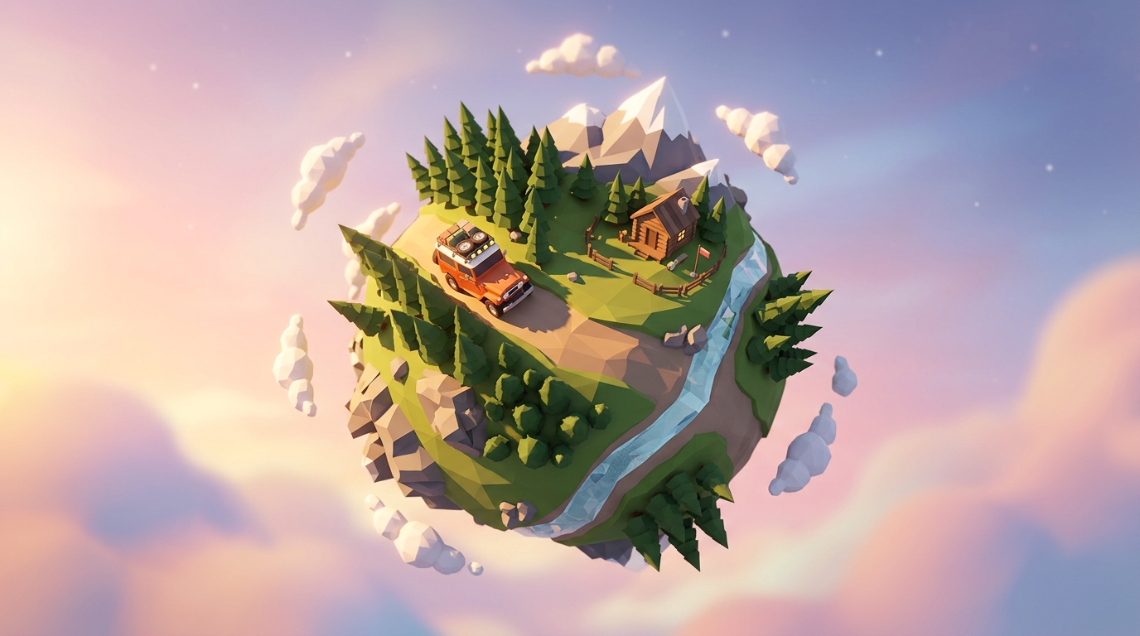
Figure 2.1: Planet Oakhaven — Low-Poly Alpine Diorama with Vintage Overland 4x4 Rig

2.2 Planet Solaria: French Ligne Claire / Moebius Comic Aesthetic
Planet Solaria embodies the timeless European graphic novel tradition (Ligne Claire, as pioneered by Hergé and Moebius). The rendering pipeline relies on real-time Sobel edge-detection post-processing to generate uniform black ink outlines, combined with flat pastel color fills and screen-space stipple screentones across shadow gradients.
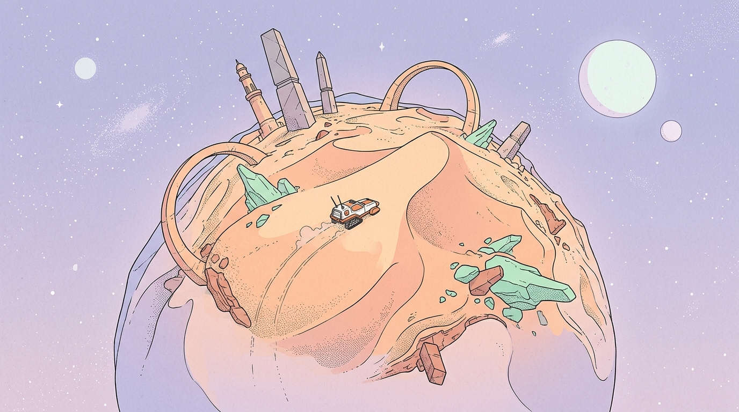
Figure 2.2: Planet Solaria — Ligne Claire / Moebius Desert World with Ancient Monoliths and Tracked Rover

2.3 The Hybrid Synthesis (Dual-World Fusion)
For transitional orbital zones, celestial gates, and high-tier vehicle chassis, the two visual styles merge seamlessly into a unified Hybrid Aesthetic: low-poly faceted 3D geometry outlined with crisp comic book ink lines and rendered in gentle pastel palettes.
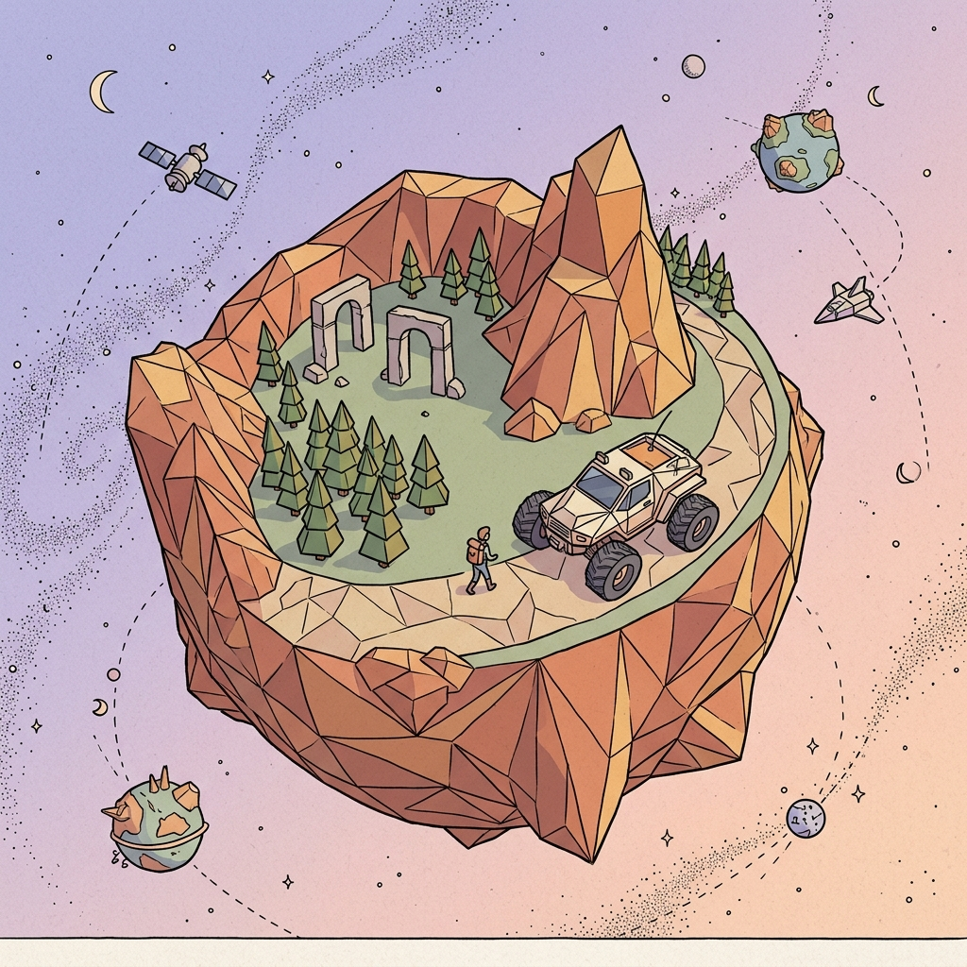
Figure 2.3: The Hybrid Visual Synthesis — Faceted Low-Poly Models Outlined with Moebius Ink Lines

2.4 Alternative Aesthetic Studies & Inspirations
During pre-production, extensive visual RnD was conducted across comic, painterly, stop-motion, and digital craft styles. These concept studies inform the seasonal variations and special event lighting throughout the game:
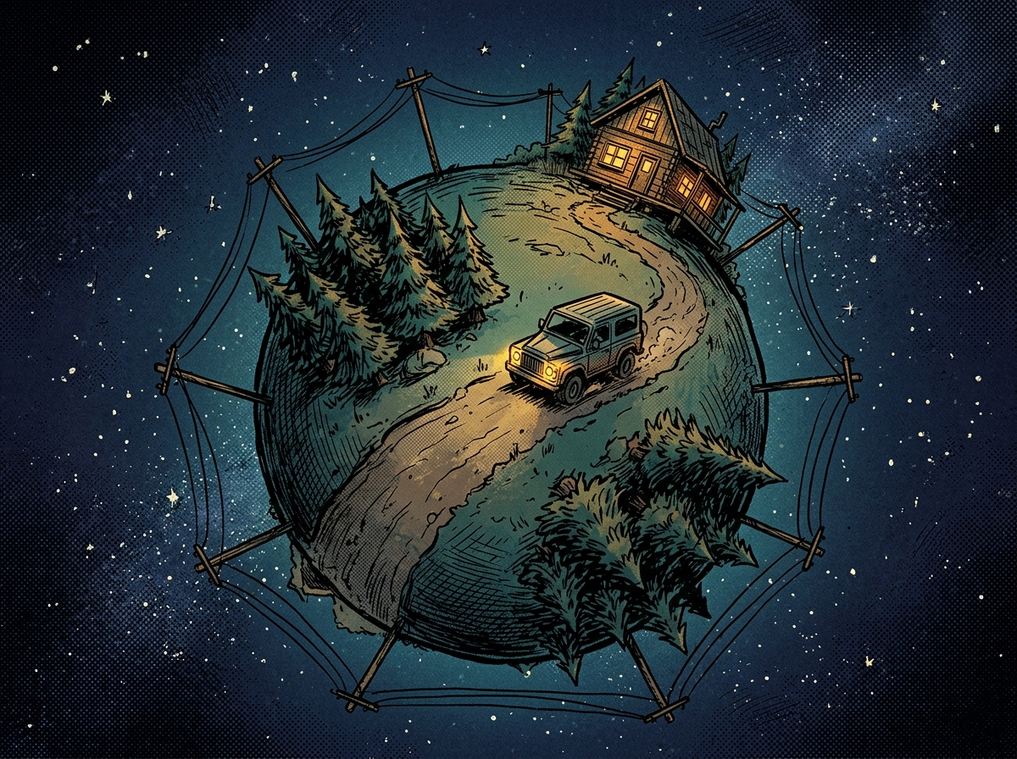  Study A: Indie Graphic Novel Midnight Ink |   Study B: Tactile Claymation Stop-Motion
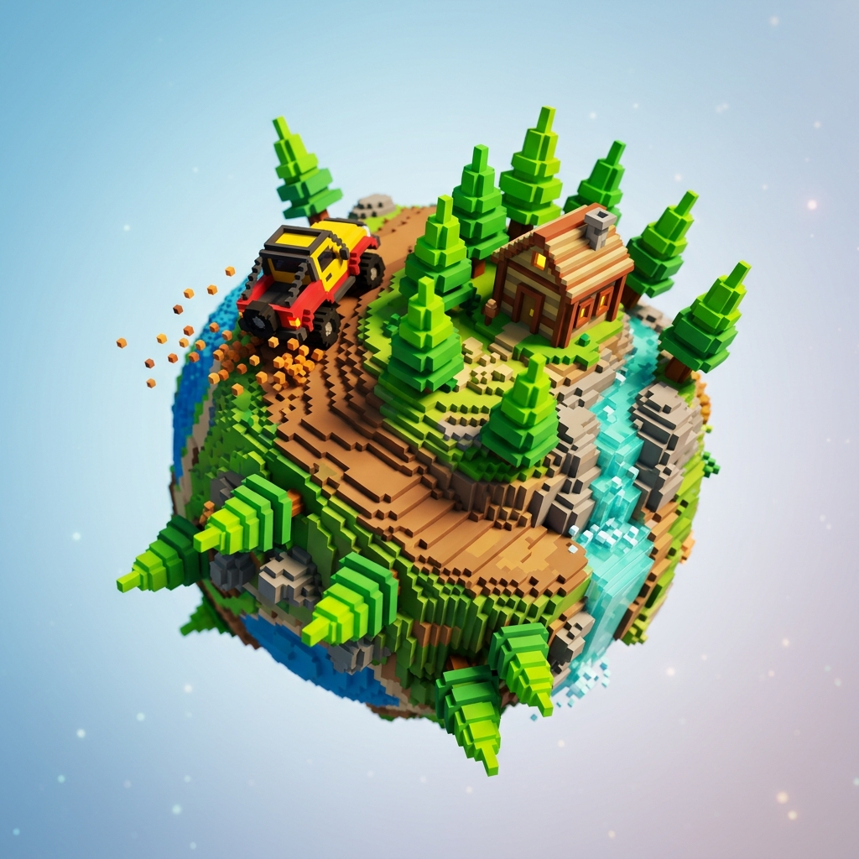  Study C: Micro-Voxel 3D Digital Toybox |   Study D: Layered Cardboard & Papercraft Pop-Up

3. Spherical World Topology & Mathematical Formulations
Traditional video game physics engines operate under the assumption of a flat Cartesian plane with a constant downward vector (Z = -9.8 m/s²). In OVER THE HORIZON, every physical calculation is re-engineered around radial spherical topology.
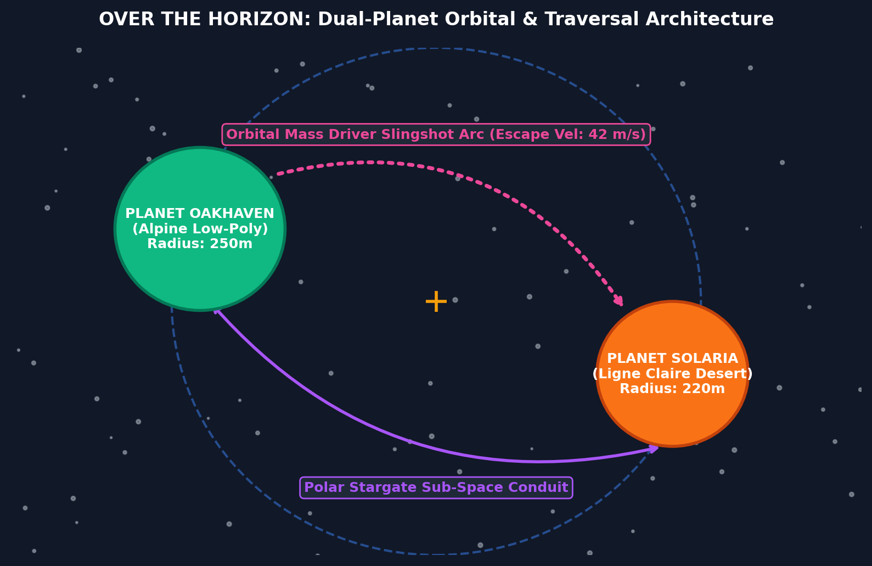
Figure 3.1: Dual-Planet Orbital System & Traversal Conduit Map

3.1 Mathematical Formulations of Radial Gravity
For any physical actor located at position p in world space, the gravitational attraction toward a planetary core at center c is governed by:
[GRAVITY FORMULATION] F_gravity(p) = - G * (M_planet * m_actor / ||p - c||^2) * normalize(p - c)
Where G = 6.674e-11 N·m²/kg² (scaled for game feel to g_surface = 9.81 m/s² at radius R_planet = 250m).
Inside the planetary crust (p < R_planet), gravity decays linearly toward zero at the core to prevent mathematical singularities: g(r) = g_0 * (r / R_planet).

3.2 Raycast Suspension & Normal Orientation Math
Each vehicle executes 4 independent raycasts from its chassis toward the ground. The suspension spring-damper force at wheel i is modeled as:
[SUSPENSION EQUATION] F_suspension_i = (k_spring * (L_rest - L_current) - d_damper * v_compression) * n_surface_i
The vehicle's desired orientation quaternion q_target aligns its local UP vector with the surface normal:
n_avg = normalize(sum(n_surface_i, i=1..4))
q_align = Quaternion.FromToRotation(transform.up, n_avg)
q_final = Slerp(transform.rotation, q_align * transform.rotation, dt * slerp_speed)

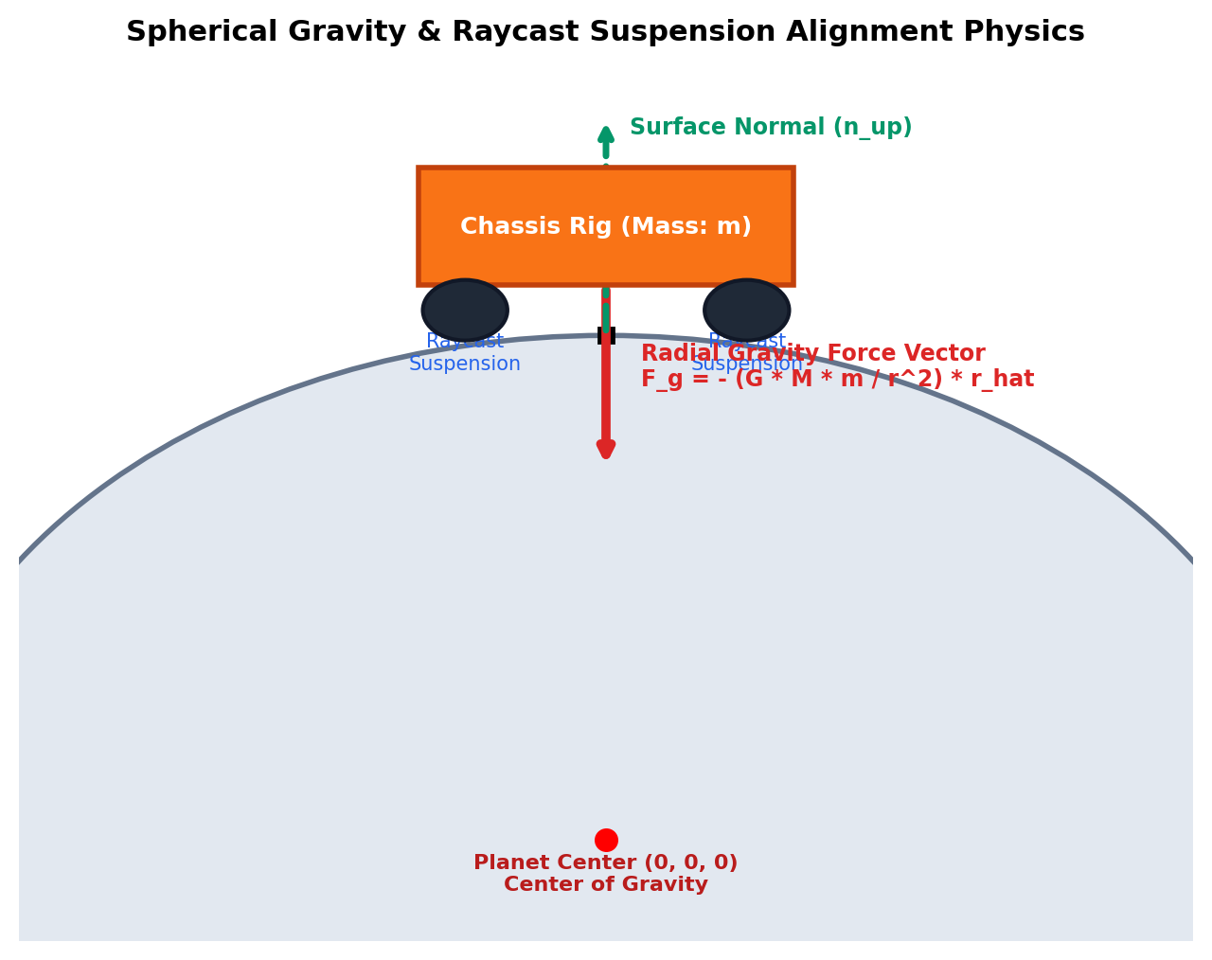
Figure 3.2: Spherical Gravity & Raycast Suspension Physics Alignment Architecture

3.3 Orbital Mass Driver & Slingshot Trajectory
To transition between Oakhaven and Solaria, vehicles drive onto an electromagnetic Mass Driver rail at high speed. Escape velocity v_esc and orbital transfer velocity v_trans are calculated via the Vis-Viva equation:
[ORBITAL MECHANICS] v_escape = sqrt(2 * G * M_planet / R_surface) ==> Scaled Game Value: 42.0 m/s (151.2 km/h)
v_transfer = sqrt(G * M_system * (2/r - 1/a))
During transit, vehicles enter a micro-gravity ballistic state where players can fire directional cold-gas thrusters to correct their atmospheric entry angle on the target planet.

4. The Atmosphere Dial & Dynamic Environmental Systems
Rather than treating weather and time as static skybox decorations, OVER THE HORIZON integrates them as active mechanical drivers of terrain physics. Furthermore, players are equipped with the 'Atmosphere Dial'—allowing continuous real-time scrubbing of time and seasons in Sandbox mode, and photo-mode free camera control.

4.1 The 4-Season Dynamic Terrain Matrix
Season | Oakhaven Terrain Modifications | Solaria Terrain Modifications | Global Physics Impact
Spring  (Bloom & Thaw) | Snowmelt floods canyon streams into roaring rivers. Deep mud bogs appear along low-lying paths. Winches and traction boards required. | Mild electrostatic breezes. Rare bioluminescent desert flora blooms, revealing hidden pathways between sandstone arches. | Tire friction μ_mud = 0.35. Vehicle water-wading depth limits strictly enforced.
Summer  (Arid Heat) | Hard-packed dry trails allow top-speed rallying. Riverbeds dry up into accessible gravel shortcuts. Mountain passes fully open. | Blazing solar scorch. High-noon heat drains rover battery cooling systems; solar canopy recharges kinetic KERS at 2.5x speed. | Tire friction μ_dry = 0.95. Engine thermals rise; desert quicksand hazards expand.
Autumn  (Golden Mist) | Wet fallen foliage creates slippery blind spots. Dense evening fog drops visibility to 15 meters; headlights and foglamps crucial. | High-velocity dust storms sweep across dunes. Magnetic sand storms scramble mini-map radar and require acoustic sonar navigation. | Tire friction μ_wet = 0.55. Wind drag vector F_wind exerts lateral forces on light vehicles.
Winter  (Crystalline Frost) | Rivers and alpine lakes freeze into solid mirror-ice highways. Deep snowdrifts block low mountain passes. Snow chains required. | Frigid desert nights freeze sand into hard glass flats ideal for ultra-high-speed drifting. Ancient heating runes activate. | Tire friction μ_ice = 0.12 (standard tires) vs μ_ice = 0.78 (studded snow chains).

4.2 Time of Day Progression Cycle
A standard in-game planetary day spans 24 real-world minutes (configurable in settings from 12 to 60 minutes). The 6 distinct lighting and gameplay phases include:
• Dawn (05:00 - 08:00): Low sun angle, long purple/orange cast shadows, heavy ground mist, cold-start engine physics.
• Morning (08:00 - 12:00): Crisp clear daylight, optimal solar generation, dry road surfaces.
• High Noon (12:00 - 14:00): Harsh vertical shadows, maximum solar radiation on Solaria, mirage optical distortion over dunes.
• Golden Hour (17:00 - 19:30): Deep warm amber glow, elongated shadows, high-contrast rim lighting (signature visual showcase).
• Twilight (19:30 - 21:00): Deep cyan and violet sky dome, automatic vehicle headlight activation, cabin chimney smoke lights up.
• Midnight (21:00 - 05:00): Pitch black darkness illuminated solely by vehicle high-beams, starry cosmic dome, aurora borealis.

4.3 Dynamic Weather Conditions & Physical Object Occlusion
OVER THE HORIZON features real atmospheric precipitation and dust storms simulated with strict physical occlusion: weather particles can NEVER penetrate or pass through solid geometry, vehicle roofs, or indoor cabin structures.
• Clear Skies: Optimal solar charging on Solaria, minimal ambient dust motes, unlimited visibility.
• Heavy Rain & Thunderstorms: High-speed downward rain streaks. Drops immediately splash into fine mist upon hitting cabin roofs, bridges, or vehicle hoods and vanish (COLLISION_HIDE_ON_CONTACT). Tire friction on dirt drops to μ = 0.35.
• Blizzard / Powder Snow: Fluffy drifting snowflakes moving with turbulent wind currents. Snow accumulates and slides off angled cabin eaves and vehicle windshields (COLLISION_RIGID), never clipping through roofs.
• Magnetic Sandstorms: High-velocity lateral dust currents across dunes, creating radar noise and requiring sonar navigation.
• Physical Occlusion Architecture: Structures utilize GPUParticlesCollisionBox3D and GPUParticlesCollisionSDF3D volumes. Standing inside a cabin or under a stone arch provides 100% weather shelter.

5. Complete Vehicle Specifications & Physics Profiles
OVER THE HORIZON features 6 distinct, handcrafted vehicles. Each vehicle is engineered with custom mass distributions, center of gravity offsets, gearbox ratios, suspension travel, and dedicated traversal gadgets.
Vehicle | Class & Look | Mass (kg) | Top Speed | Handling Profile | Special Traversal Gadget
1. TrailScout 74  (Oakhaven Starter) | Vintage 1970s 4x4 Overland Rig | 1,850 kg | 110 km/h | Balanced 50/50 weight, low center of mass, 45° rock climbing crawl gear. | Front Winch & Tow Rope: Anchors to trees/rocks to self-recover up sheer cliffs.
2. Lumberjack 6x6  (Oakhaven Heavy) | Heavy 6-Wheel Utility Flatbed | 4,600 kg | 75 km/h | High momentum, slow braking, high tipping risk, immune to mud bogs. | Deployable Bridging Planks: Drops physical wooden ramps across chasms.
3. FrostBite Half-Track  (Oakhaven Winter) | Coupe with Front Skis & Rear Treads | 2,200 kg | 125 km/h | Drift-heavy, glides across deep powder snow and frozen lakes. | Tire Chains & Ice Spikes: Zero slip on ice; heated cabin for blizzard rescues.
4. DuneStrider Buggy  (Solaria Starter) | Open-Frame Desert Dune Buggy | 980 kg | 145 km/h | Featherweight, huge suspension travel, massive airtime off sand dunes. | Solar Wing & Kinetic KERS: Recharges via drifting; 3-second nitro boost.
5. Crawler-09  (Solaria Surveyor) | Twin-Cabin Articulated Tracked Rig | 5,200 kg | 60 km/h | Zero-turn tank steering, ultra-low center of mass, impossible to flip. | Relic Scanner & Storm Anchor: Deploys ground spikes to lock down in 100mph storms.
6. Aero-Skimmer  (Solaria Advanced) | Retro 1980s Turbine Hovercraft | 1,200 kg | 160 km/h | Frictionless glide 1m above ground; ignores rocks, water, and quicksand. | Vertical Jump Thrusters: Launches 5 meters vertically to clear canyon gaps.

6. Game Modes, Mission Design & Economy
To guarantee the game remains continuously engaging and never repetitive, OVER THE HORIZON separates its core mechanics into 4 dedicated game modes, each with unique win/loss conditions, scoring loops, and mechanical goals.
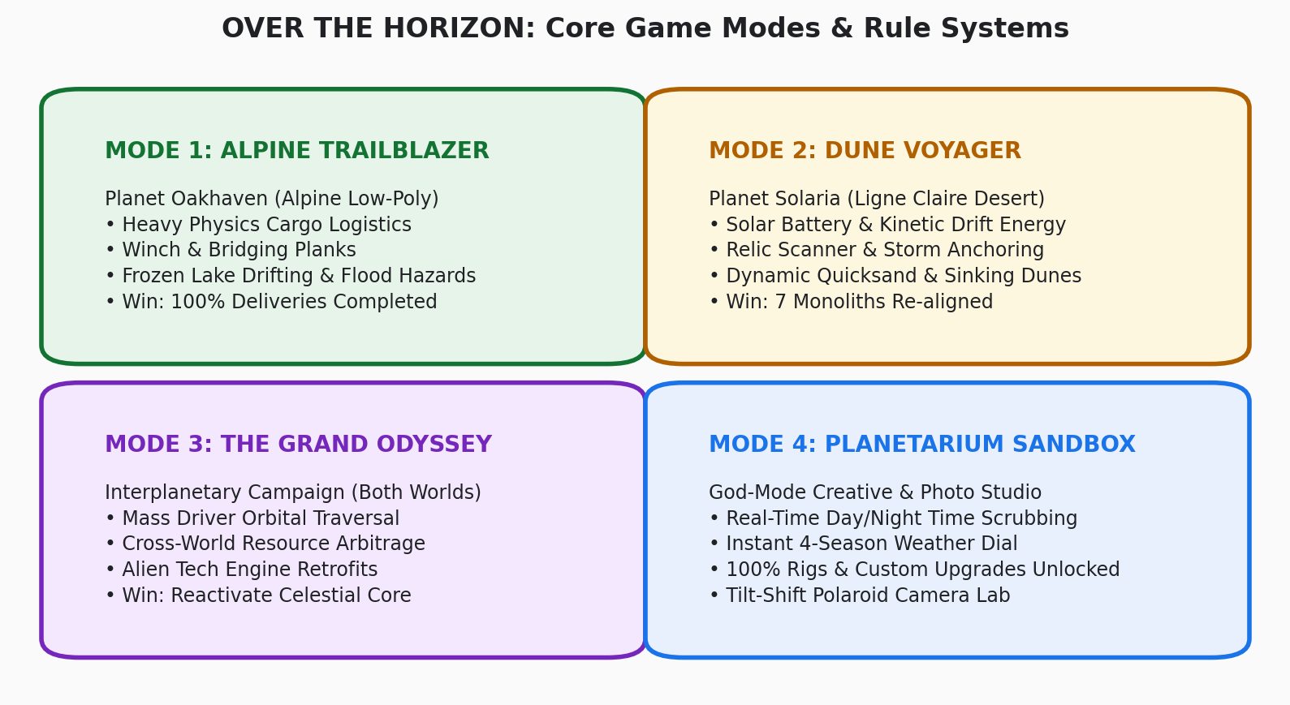
Figure 6.1: Core Game Modes & Rule Systems State Machine

6.1 Mode 1: Alpine Trailblazer (Oakhaven Rules)
• Core Objective: Complete physics-based cargo contracts across Oakhaven's rugged terrain without destroying delicate goods.
• Cargo Physics Rules: Cargo items (scientific sensor arrays, hot spring thermoses, glass observatory lenses) possess true physical mass. If the vehicle tips over 45 degrees or impacts obstacles at over 25 km/h, cargo straps snap and goods spill down the mountainside.
• Fail Condition: Cargo destruction drops below 50% integrity or vehicle total hydraulic lockout.
• Win Condition: Complete all regional logistics supply lines to establish the Alpine Research Outpost.

6.2 Mode 2: Dune Voyager (Solaria Rules)
• Core Objective: Race against dynamic sandstorms to reach and re-align 7 ancient alien solar monoliths.
• Solar Battery Rules: The rover's power core constantly discharges at 1% per 10 seconds. Driving in sunlight generates +2% per second. Drifting on sand dunes activates the KERS generator. If battery hits 0% during a midnight sandstorm, the vehicle freezes into emergency life-support mode.
• Fail Condition: Complete energy depletion during an electrostatic storm.
• Win Condition: All 7 planetary monoliths aligned, unlocking the Polar Stargate.

6.3 Mode 3: The Grand Odyssey (Interplanetary Campaign)
• Core Objective: Re-establish the ancient cosmic tether connecting Oakhaven and Solaria.
• Interplanetary Economy & Arbitrage: Resources harvested on one planet hold immense value on the other:
- Fresh Glacier Ice from Oakhaven pays 5,000 Credits at Solaria's desert nomad bazaar.
- Photovoltaic Relic Coils from Solaria upgrade Oakhaven's 4x4 engine to an electric-hybrid crawler capable of climbing 70° rock faces.
• Dual-World Traversal: Players seamlessly catapult between planets using the Orbital Mass Driver or drive through the Polar Stargate.

6.4 Mode 4: Planetarium Sandbox & Photo Studio
• Features: Instant access to all 6 vehicles and all upgrades. 100% unlocked from the beginning.
• God-Mode Tools: Real-time scrubbing of time-of-day, instant toggle of Spring/Summer/Autumn/Winter, wind velocity slider, and free-flight drone camera.
• Photo Lab: Take diorama snapshots with adjustable tilt-shift focal planes, vintage lens filters, film grain, and in-game sticker frames.

7. Secrets & Cryptic Easter Eggs
OVER THE HORIZON features 5 masterfully hidden Easter eggs that require specific temporal, meteorological, and mechanical alignments to solve. These are intentionally cryptic and serve as legendary community discoveries.

7.1 Easter Egg 1: 'The Solitary Flame' (Homage to Reference Art)
• Prerequisites: Planet Oakhaven, Autumn Season, exact in-game time 00:00 (Midnight), Heavy Mist weather.
• Discovery Path: Tune vehicle CB radio to Channel 7 to detect faint audio static. Follow signal strength to the North Ridge chasm. Deploy the Lumberjack 6x6 bridging planks or use the TrailScout winch to swing across a collapsed timber trestle.
• The Mystery: Inside a pitch-black cliffside cabin, an antique gas burner glows bright blue with a lit cigarette resting on the grate. Beside it sits an analogue cassette deck with the prompt 'PRESS PLAY'.
• Reward: Unlocks the 'Midnight Cigarette' secret lo-fi soundtrack cassette on the vehicle's in-dash stereo and vintage amber interior dashboard lighting.

7.2 Easter Egg 2: 'The Red Legend' (Funselektor Tribute)
• Prerequisites: Planet Oakhaven, Winter Season, Sub-zero blizzard.
• Discovery Path: At the South Pole, a roaring summer waterfall freezes into a massive hollow ice wall. Equip the FrostBite Half-Track and ram the structural fault in the ice at over 80 km/h.
• The Mystery: Behind the frozen falls lies a hidden crystal cavern preserving the iconic red Group-B rally car from art of rally.
• Reward: Honking the horn 3 times plays the authentic twin-turbo antilag backfire sound and unlocks the 'Art of Rally Red' livery and lightweight rally wheels.

7.3 Easter Egg 3: 'The Whispering Monolith Alignment'
• Prerequisites: Planet Solaria, Summer Solstice, exact Solar Noon (12:00 PM).
• Discovery Path: In Sandbox mode or during campaign orbital alignment, position companion planet Oakhaven directly between Solaria and the Sun to cast a total solar eclipse.
• The Mystery: In the sudden shadow, all 7 stone arches emit luminous stipple laser beams across the sand, intersecting at an unmarked dune. Drive Crawler-09 to the convergence point and activate the Relic Resonance Scanner.
• Reward: A massive subterranean alien pyramid rises from the dunes, revealing a zero-gravity driving track inside its hollow core.

7.4 Easter Egg 4: 'The Micro-Moon Castaway'
• Prerequisites: Grand Odyssey Mode, Orbital Mass Driver.
• Discovery Path: During launch countdown on the Mass Driver rail, override steering trim to an eccentric 73° ascent angle.
• The Mystery: The vehicle bypasses Solaria and crash-lands onto an unmapped 20-meter asteroid drifting in the orbital void. On it sits an astronaut in a deckchair under a beach umbrella with a campfire and a radio playing Morse code.
• Reward: Unlocks the 'Cosmic Gold' electroplated wheel rims and low-gravity physics modifier in Sandbox mode.

7.5 Easter Egg 5: 'The Zero-G Core Inversion'
• Prerequisites: Either planet, Spring Season.
• Discovery Path: Locate a bottomless vertical sinkhole at the lowest point of the grand canyon. Attach winch cable to a heavy boulder and rappel straight down.
• The Mystery: As the vehicle plummets toward coordinates (0, 0, 0), gravity smoothly transitions through zero. The vehicle floats weightlessly inside a vast geode cavern lined with glowing purple quartz before being propelled upward by a geyser on the exact antipodal hemisphere!
• Reward: Unlocks the 'Hollow Core Warp' shortcut permanently.

8. Technical Architecture & Unreal Engine 5 Code
The technical foundation of OVER THE HORIZON is implemented in Unreal Engine 5 using C++ for core physics substepping and HLSL for post-process shaders.

8.1 C++ Spherical Gravity Actor Component Header
// USphericalGravityComponent.h - Custom Radial Planetary Gravity
#pragma once
#include "CoreMinimal.h"
#include "Components/ActorComponent.h"
#include "USphericalGravityComponent.generated.h"
UCLASS(ClassGroup=(Physics), meta=(BlueprintSpawnableComponent))
class OVERTHEHORIZON_API USphericalGravityComponent : public UActorComponent
{
GENERATED_BODY()
public:
USphericalGravityComponent();
UPROPERTY(EditAnywhere, BlueprintReadWrite, Category="Planetary Physics")
FVector PlanetCenter = FVector::ZeroVector;
UPROPERTY(EditAnywhere, BlueprintReadWrite, Category="Planetary Physics")
float GravityAcceleration = 981.0f; // cm/s^2
UPROPERTY(EditAnywhere, BlueprintReadWrite, Category="Planetary Physics")
float PlanetRadius = 25000.0f; // 250 meters in Unreal units
virtual void TickComponent(float DeltaTime, ELevelTick TickType, FActorComponentTickFunction* ThisTickFunction) override;
private:
UPrimitiveComponent* PrimitiveComponent;
};

8.2 C++ Spherical Gravity Actor Component Implementation
// USphericalGravityComponent.cpp
#include "USphericalGravityComponent.h"
#include "GameFramework/Actor.h"
#include "Components/PrimitiveComponent.h"
USphericalGravityComponent::USphericalGravityComponent()
{
PrimaryComponentTick.bCanEverTick = true;
PrimaryComponentTick.TickGroup = TG_PrePhysics;
}
void USphericalGravityComponent::TickComponent(float DeltaTime, ELevelTick TickType, FActorComponentTickFunction* ThisTickFunction)
{
Super::TickComponent(DeltaTime, TickType, ThisTickFunction);
if (!PrimitiveComponent)
{
PrimitiveComponent = Cast<UPrimitiveComponent>(GetOwner()->GetRootComponent());
}
if (PrimitiveComponent && PrimitiveComponent->IsSimulatingPhysics())
{
FVector CurrentLocation = PrimitiveComponent->GetComponentLocation();
FVector GravityDirection = (PlanetCenter - CurrentLocation);
float Distance = GravityDirection.Size();
if (Distance > KINDA_SMALL_NUMBER)
{
GravityDirection /= Distance; // Normalize
// Radial Gravity Force: F = m * g
FVector GravityForce = GravityDirection * GravityAcceleration * PrimitiveComponent->GetMass();
PrimitiveComponent->AddForce(GravityForce, NAME_None, false);
// Re-orient Actor Up Vector to Surface Normal
FVector UpVector = -GravityDirection;
FQuat TargetRotation = FRotationMatrix::MakeFromZX(UpVector, GetOwner()->GetActorForwardVector()).ToQuat();
FQuat NewRotation = FMath::QInterpTo(GetOwner()->GetActorQuat(), TargetRotation, DeltaTime, 12.0f);
GetOwner()->SetActorRotation(NewRotation);
}
}
}

8.3 HLSL Post-Process Sobel Ink Edge Detection Shader
// SobelEdgeDetection.hlsl - Real-Time Ligne Claire Ink Line Post-Process
float2 TexCoords = GetDefaultSceneTextureUV(Parameters, 14); // SceneDepth
float2 TexelSize = View.ViewSizeAndInvSize.zw;
// 3x3 Sobel Convolution Kernels
float Gx[9] = {-1, 0, 1, -2, 0, 2, -1, 0, 1};
float Gy[9] = {-1, -2, -1, 0, 0, 0, 1, 2, 1};
float EdgeDepthX = 0.0;
float EdgeDepthY = 0.0;
int idx = 0;
for (int y = -1; y <= 1; y++)
{
for (int x = -1; x <= 1; x++)
{
float2 Offset = float2(x, y) * TexelSize * EdgeWidth;
float SampleDepth = SceneTextureLookup(TexCoords + Offset, 14, false).r;
EdgeDepthX += SampleDepth * Gx[idx];
EdgeDepthY += SampleDepth * Gy[idx];
idx++;
}
}
float EdgeMagnitude = sqrt(EdgeDepthX * EdgeDepthX + EdgeDepthY * EdgeDepthY);
float Outline = step(EdgeThreshold, EdgeMagnitude);
// Output: Composite Ink Black Outlines onto Scene Color
float3 SceneColor = SceneTextureLookup(TexCoords, 0, false).rgb;
return lerp(SceneColor, float3(0.04, 0.04, 0.06), Outline);

9. UI/UX & Controller Haptics Specification
• Diegetic Minimalist HUD: Speedometer and battery/fuel gauges are integrated directly into vehicle dashboard cockpits. A subtle 360° compass ring floats in the lower screen bezel, projecting waypoint beacons over the curved horizon.
• Atmosphere Dial UI: Swiping up on the gamepad touchpad or pressing [Tab] opens a circular golden-ratio dial. Players rotate the right stick to scrub time and seasons with smooth haptic clicks.
• PS5 DualSense Adaptive Triggers:
- Mud Resistance: Throttle trigger stiffens progressively as tires sink into spring mud.
- Ice Slip: Trigger resistance suddenly drops to zero when tires lose grip on winter ice, signaling wheel spin.
- Winch Cable Tension: Left trigger pulses with heavy vibrational tension when the winch cable approaches breaking load.

10. Audio & Sound Design
• Dynamic Acoustic Landscape: An adaptive musical score combining lo-fi synth pads, warm acoustic fingerpicked guitar, and vintage Mellotron tones.
• Seasonal Audio Layers: Winter introduces crisp footstep crunches and whistling alpine gusts; Spring features roaring glacial water melt and bird calls; Autumn brings rustling dry leaves and distant thunder.
• Authentically Sampled Engines: True-to-life field recordings of vintage inline-6 and V8 naturally aspirated engines, mechanical gear shifts, and whistling turbochargers.

11. Production Roadmap & Milestones
The 18-month production timeline is divided into 4 tightly scoped milestones designed to ensure rock-solid physics verification and visual polish.
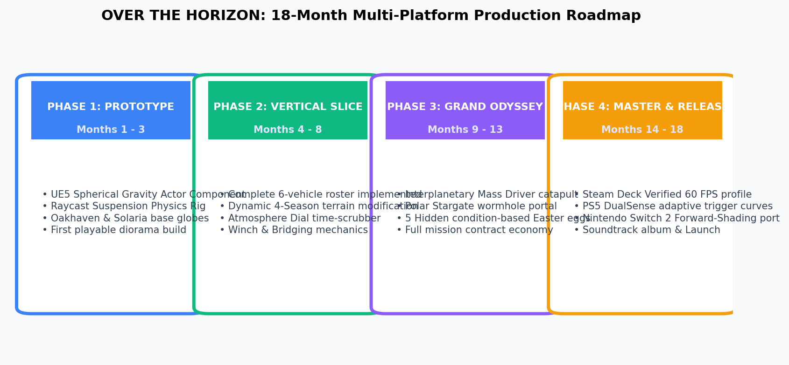
Figure 11.1: 18-Month Multi-Platform Production Roadmap & Milestone Schedule
Phase | Timeline | Core Deliverables | Exit Criteria
Phase 1: Prototype | Months 1 - 3 | UE5 radial gravity physics component, 4-wheel raycast suspension rig, whitebox Oakhaven & Solaria spherical test tracks. | Playable 60 FPS prototype with stable vehicle orientation across 360° sphere.
Phase 2: Vertical Slice | Months 4 - 8 | All 6 vehicles modeled and tuned, dynamic 4-season terrain shader modifications, Atmosphere Dial UI, winch mechanics. | Complete vertical slice featuring 5 playable cargo and storm contracts on both planets.
Phase 3: Grand Odyssey | Months 9 - 13 | Orbital Mass Driver slingshot catapult, Polar Stargate, cross-world trade economy, all 5 complex Easter eggs implemented. | Seamless interplanetary transitions with zero loading screens; full game loop verification.
Phase 4: Master Release | Months 14 - 18 | Steam Deck Verified certification, PS5 DualSense haptics, Nintendo Switch 2 port, localized into 12 languages. | Zero blocking crash bugs, gold master disc/build burn, day-one patch validation.

