msrbooknest Knowledge Transfer Guide
  - Architecture design functional flows and quality attributes
Project handover | 3 October 2026 | Local Docker MVP
This guide explains the active msrbooknest bookstore path for developers and support staff taking over the system. It covers how the React storefront, Keycloak identity, Spring Boot services, MySQL, and Kafka fit together; how customers register, shop, and place orders; and which quality controls are in place or still need work.
The current MVP uses Keycloak for OAuth 2.0 / OpenID Connect and a Kafka checkout workflow with a local payment simulator. The main Docker Compose stack does not run the older custom-OTP Auth service, the original static storefront, or the separate enterprise-bookstore module.

At a glance
Area | Current implementation
Customer UI | React + Vite app, built into an Nginx image at http://localhost:5173.
Identity | Keycloak realm booknest; browser Authorization Code flow with PKCE S256; realm roles CUSTOMER and ADMIN.
Backend | Catalog, Cart, Order, and Payment are separate Spring Boot services using Spring Security, JPA, and Hibernate.
Checkout | Order outbox and Kafka events coordinate payment outcome and inventory finalization.
Email | Keycloak verification uses a link. Local Compose routes email to Mailpit at http://localhost:8025; Gmail SMTP is not configured.
Payment | The Payment service currently simulates success for supported methods; no real payment provider is connected.
Edge routing | There is no API Gateway. The browser calls Catalog, Cart, and Order directly on local ports.

System boundary
The active runtime is defined by docker-compose.yml. Treat docs/architecture.md as the fuller architecture note, and use the code paths named in this guide when changing service contracts. The word “current” describes repository behavior; production recommendations are called out separately.

System architecture
The storefront uses OIDC for customer identity, synchronous HTTP for read and cart operations, and Kafka for the asynchronous payment portion of checkout. Each backend service owns its tables, even though local Compose runs them on one MySQL server.
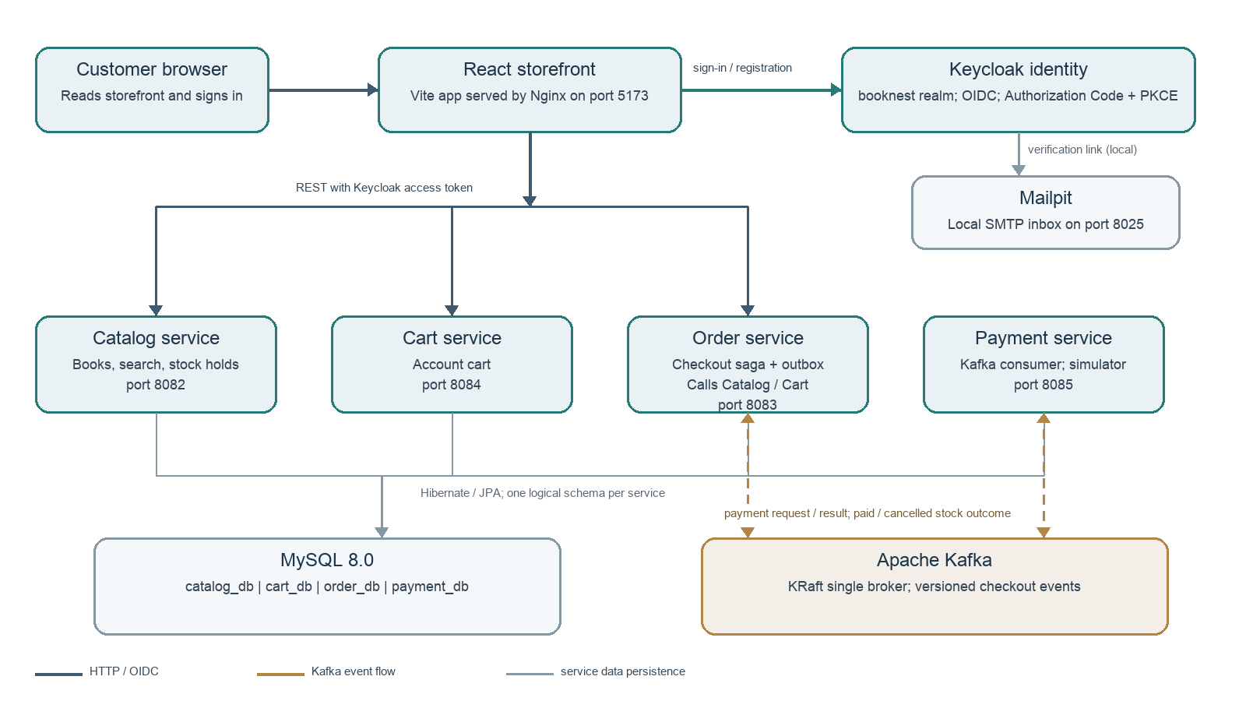
Figure 1. Local runtime and primary paths. Dark lines show browser HTTP or identity traffic, gray lines show data persistence, and amber dashed lines show checkout events.
- Browser path. React gets an access token from Keycloak and sends it to Catalog, Cart, or Order. Order calls Catalog for an inventory hold and Cart when checkout uses the saved server cart.
- Order path. Order records a pending order and an outbox row together, then publishes to Kafka. Payment records a simulated transaction and publishes its result. Order updates status and emits a stock-finalization event for Catalog.
- Data path. Each service persists through its own JPA repositories and schema. Kafka is the asynchronous boundary; services do not share Java entities or directly read another service schema.

Runtime components and trust boundaries
Component | Local port | Role and ownership
React storefront | 5173 | customer-web-react; public pages, catalog controls, guest/account cart, checkout, order history.
Keycloak | 8180 | booknest realm; user accounts, credential checks, role claims, OIDC tokens, email verification.
Catalog service | 8082 | Book and stock data; schema catalog_db; product APIs and stock reservation lifecycle.
Cart service | 8084 | Account carts keyed by authenticated identity; schema cart_db.
Order service | 8083 | Order and item snapshots; schema order_db; checkout state and transactional outbox.
Payment service | 8085 | Payment transaction records; schema payment_db; current adapter is a simulator.
MySQL | 3306 | One local MySQL 8 instance with service-specific schemas and a shared development credential.
Kafka | 9092 / 29092 | Single-node KRaft broker; host and Compose-network listeners respectively.
Mailpit | 8025 / 1025 | Local web inbox and SMTP sink for Keycloak verification links.

Identity and authorization flow
01 Start. React initializes keycloak-js with check-sso and PKCE method S256. Sign-in and registration redirect to Keycloak using the public booknest-web client.
02 Verify. The realm requires email verification. In local Compose, Keycloak sends a clickable verification link to Mailpit; this is not a numeric OTP. The custom theme labels registration as mobile number and sign-in as email or mobile number.
03 Token. Keycloak issues the OIDC access token with realm roles. React keeps the token in memory and refreshes it before API requests when it is near expiry.
04 Authorize. Spring Security resource servers validate JWTs using the configured issuer and JWK set. Role claims are mapped to ROLE_CUSTOMER / ROLE_ADMIN. Catalog reads are public; cart and order flows require authentication; administrative operations require ADMIN.
The realm enforces at least 10 characters and one special character for passwords. The custom theme also normalizes 10-digit Indian mobile numbers for registration and login. Local email capture is configured for development; external Gmail SMTP remains a separate configuration task.

Customer and operator flows

Main API surface
Service | Representative endpoints | Access and behavior
Catalog | GET /api/products; /api/products/search; /api/products/suggestions; GET /api/products/{id} | Public browsing. Admin endpoints under /api/admin/products support search, create, update, and delete.
Cart | GET /api/cart; POST /api/cart/items; PATCH /api/cart/items/{bookId}; DELETE /api/cart/items/{bookId}; DELETE /api/cart | Authenticated account cart; identity is taken from the validated token.
Order | POST /api/orders; GET /api/orders/me | Create checkout and read the current customer’s order history. GET /api/orders and fulfillment PATCH routes require ADMIN.
Payment | POST /api/payments/process; POST /api/payments/refund | Admin-protected API surface. The normal order flow is consumed from Kafka, not a browser call to this controller.

Registration and sign-in
01 Open identity. The React account action starts Keycloak login or registration; the storefront does not create its own password or access token.
02 Register. Keycloak collects the configured profile fields. Mobile number is the account username; email verification is required. The custom login theme supplies mobile validation and the password-policy hint.
03 Verify and return. The user follows the email verification link, then returns to Keycloak sign-in. The local verification message is visible in Mailpit; Gmail delivery requires an SMTP provider configured in the realm.

Browse, cart, and account
01 Browse. React loads the Catalog product list, then applies text, shelf, and price sorting controls in the browser. Catalog also exposes search and suggestion endpoints.
02 Guest cart. Before sign-in, the cart is stored in browser localStorage. After sign-in, the app loads the server cart and copies guest items into it.
03 Signed-in cart. Cart operations go to Cart service and are keyed by the verified token identity. On sign-out, the UI copies the cart to guest storage and clears the server cart.
04 Operator. An ADMIN token enables catalog maintenance and order listing / fulfillment transitions. Checkout payment and inventory statuses remain managed by the event workflow.

Checkout workflow
Checkout is a saga: the browser receives an initial order response while payment and stock finalization continue asynchronously. The orderRequestId is the workflow and idempotency key.
01 Submit. The signed-in UI sends customer name, phone, address, payment method, cart items, and a new UUID orderRequestId to Order service.
02 Deduplicate. Order returns the existing order if the same customer retries the same request ID; it rejects a request ID already owned by another customer.
03 Hold stock. Order calls Catalog with the bearer token. Catalog quotes authoritative title and price, decrements available stock into a HELD reservation, and sets a 20-minute expiry.
04 Commit order. Order stores the order as PENDING_PAYMENT plus an OrderPaymentRequested outbox record inside the same database transaction.
05 Publish request. The scheduled outbox publisher polls every second, takes up to 100 unpublished rows, and sends each message to Kafka keyed by orderRequestId.
06 Simulate payment. Payment consumes the request, returns an existing transaction for duplicate IDs, or records a SUCCESS transaction for supported methods and publishes a success event. The current adapter does not contact a real payment provider.
07 Apply outcome. Order consumes the result and moves PENDING_PAYMENT to PAID or PAYMENT_FAILED. It writes ORDER_PAID or ORDER_CANCELLED to its outbox.
08 Finalize stock. Catalog consumes the outcome: commit a HELD reservation on payment success or restore stock on cancellation/failure. A background scan releases reservations that expire after 20 minutes.

Versioned Kafka topics
Topic | Producer -> consumer | Purpose
bookstore.orders.payment-requested.v1 | Order -> Payment | Start payment for accepted order.
bookstore.payments.succeeded.v1 | Payment -> Order | Persist payment reference and mark order PAID.
bookstore.payments.failed.v1 | Payment -> Order | Record failure and start reservation release.
bookstore.orders.paid.v1 | Order -> Catalog | Commit held stock after payment success.
bookstore.orders.cancelled.v1 | Order -> Catalog | Release held stock after cancellation or payment failure.

Event records carry an event ID, schema version, occurrence timestamp, and orderRequestId. The payment-request event also carries email, amount, and payment method. Do not add credentials, bearer tokens, or full payment secrets to event payloads.

Non-functional behavior and readiness
The project is an MVP/local development stack. The table separates controls visible in code or Compose from the hardening still needed before a public production deployment. No latency, throughput, availability, or recovery targets are defined in the repository.
Quality area | In place now | Gap before production
Security | OIDC Authorization Code + PKCE; stateless JWT resource servers; role checks; configured CORS allowlist; password policy; email verification. | Keycloak runs in dev mode, realm sslRequired is none, local defaults exist, no API gateway/TLS edge. Move secrets to secret management; use TLS and production realm settings.
Data isolation | Catalog, Cart, Order, and Payment have separate schemas and repository/entity ownership. Order/email/address and cart data stay in owning services. | All schemas use one MySQL server/root credential in Compose. Add service-level DB users, migrations, backup/restore, encryption-at-rest and retention rules.
Consistency | Order DB + outbox are written transactionally; orderRequestId supports deduplication; inventory holds have expiry; payment and listeners are idempotent for repeated IDs/states. | Add publish/consume retry policy, bounded backoff, dead-letter topics, replay procedures, and concurrency tests for stock reservation.
Availability | Compose restart policies and named local data volumes; MySQL has a health check; storefront image has an Nginx health check. | Single MySQL, Kafka, and service instances; no HA/failover; most services lack health checks/readiness probes. Define recovery objectives and test restore.
Performance and scale | REST services are stateless and event processing separates payment from the request thread. UI has loading, empty, and error states. | No benchmark or SLO is defined. Local stack is single-node; measure API/catalog performance, Kafka lag, consumer concurrency, and DB capacity before scaling.
Observability | Container logs and event IDs/orderRequestId provide basic troubleshooting context. | No central logs, metrics, distributed tracing, alerting, or consumer-lag dashboards. Add correlation IDs and readiness/liveness endpoints.
Privacy | Keycloak owns credentials; React holds OIDC token in memory. Order owns address and phone; payment event includes customer email. | Set PII retention/access rules; avoid logging personal fields; protect secrets and traffic in transit and at rest.
Email and payment | Local verification is testable through Mailpit; payment methods are constrained to UPI, credit card, and debit card labels. | Mailpit is not a delivery provider. External SMTP is pending. Payment is a simulator; select a provider and implement secure provider callbacks/idempotency before real transactions.

Local runbook and handover
Run the primary stack from the repository root. Ports are published to localhost for development, not for public internet access.
docker compose up -d --build
docker compose ps
docker compose logs -f catalog-service order-service payment-service
docker compose down
The named MySQL, Kafka, and Keycloak volumes persist across docker compose down. Avoid docker compose down -v unless removing local database and identity data is intended.

Local access points
What | URL or port | Notes
Storefront | http://localhost:5173 | Active React storefront.
Keycloak | http://localhost:8180 | Realm booknest; local admin is development-only.
Mailpit | http://localhost:8025 | Open the Verify email message and use its link.
REST APIs | 8082 / 8083 / 8084 / 8085 | Catalog / Order / Cart / Payment, respectively.
MySQL and Kafka | 3306 / 9092 | Development-only local listeners; container-to-container Kafka uses kafka:29092.

Repository boundaries
- Active Compose path. customer-web-react + Keycloak + Catalog + Cart + Order + Payment + MySQL + Kafka + Mailpit.
- Legacy reference path. auth-service still contains custom JWT and OTP endpoints; customer-web is the older static client. They are not wired into the active React/OIDC Compose flow.
- Separate module. enterprise-bookstore is a standalone monolith/demo and is not part of the microservice runtime.

Next engineering priorities
01 Finish mail delivery. Keep Mailpit for local development; configure and verify a real SMTP provider before expecting messages in personal inboxes.
02 Harden identity and ingress. Replace development defaults, enable HTTPS, configure production realm/client URLs, and place a gateway or ingress in front of APIs.
03 Improve event operations. Define retry/backoff and dead-letter behavior, consumer health and lag visibility, and event replay procedures.
04 Harden data operations. Introduce migration scripts, per-service database credentials, backup/restore practice, and PII retention rules.
05 Choose real payment integration. Replace the simulator only after selecting a provider and defining callbacks, failure states, refunds, reconciliation, and compliance scope.
Primary implementation references: docs/architecture.md, docs/docker-deployment.md, docker-compose.yml, infra/keycloak/booknest-realm.json, customer-web-react/src, and each service’s controller, service, entity, repository, and messaging packages.

