* Download source code from **Git Hub** using below path

https://github.com/srinivasababusiddanathi/orderuploadproject.git

Below is folder structure for reference

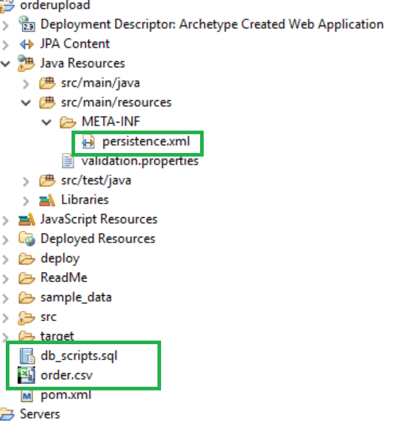

* Execute **db_scripts.sql** file available in the downloaded source code
* Change below properties in **persistence.xml**  file in the source code (**src/main/resources/META-INF**) folder as per environment.

<property name="hibernate.connection.url" value="jdbc:mysql://**localhost**/ordersdb" />

<property name="hibernate.connection.driver_class" value="com.mysql.jdbc.Driver" />

<property name="hibernate.connection.username" value="**root**" />

<property name="hibernate.connection.password" value="**root**" />

* Build the project using maven

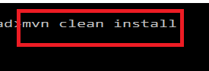

* Deploy war file (i.e. orderupload.war) on tomcat server
* Access the application using below url
* Change IP address and port as per the environment
* <http://192.168.1.5:7000/orderupload/file.htm>

Sample data file (**order.csv**) which is being used for my development in down loaded in the downloaded source code

