**Below are test scenarios to upload order**

**Application url to access home page (Please change host name and port as per environment)**

**http://192.168.1.5:7000/orderupload/**

1. User try to click on upload button without selecting any file, validation error should be displayed.

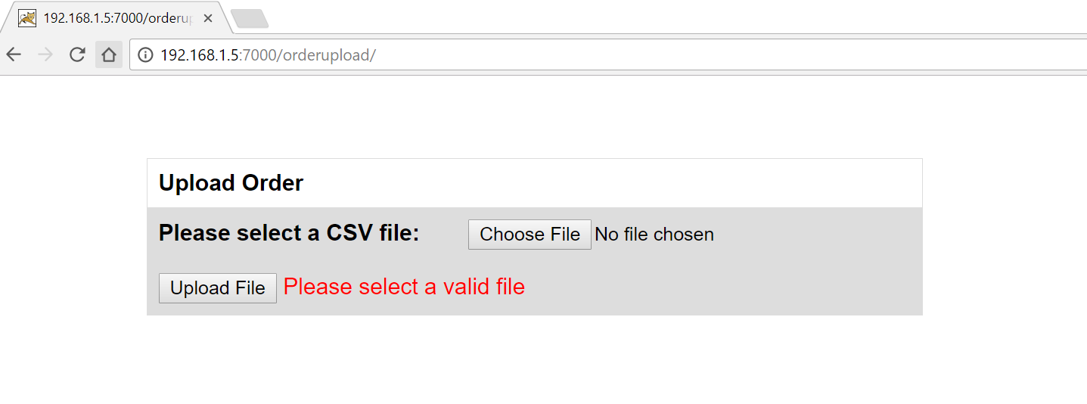

2. User tries to upload invalid file format

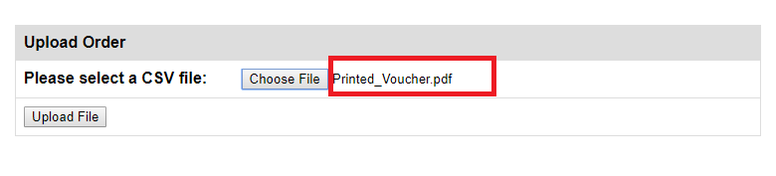

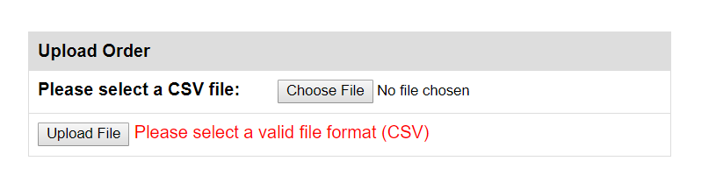

3. User uploaded proper file

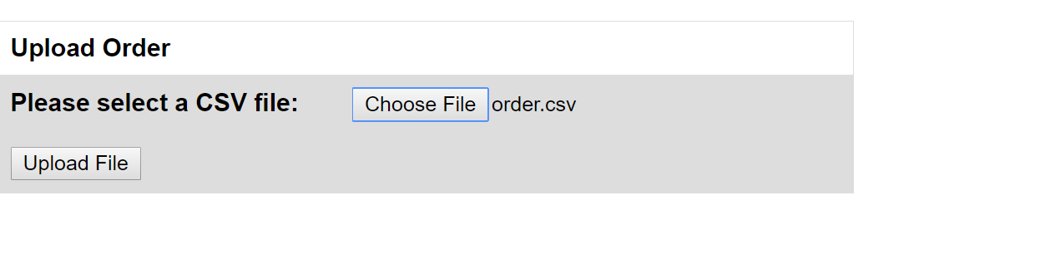

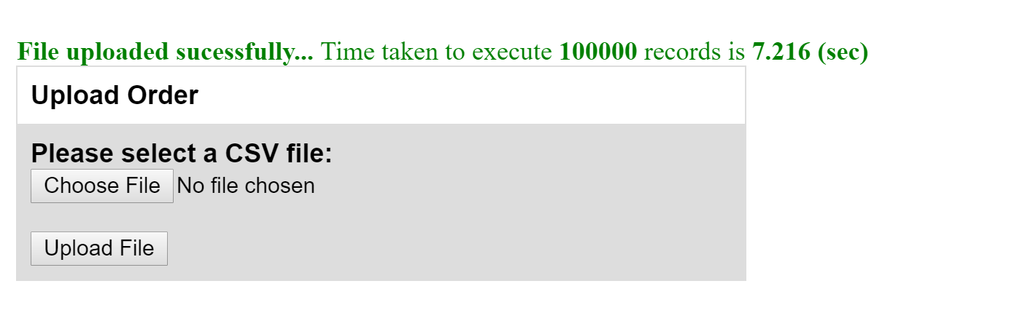

4. User trying to upload same file again, duplicate error file should be displayed.

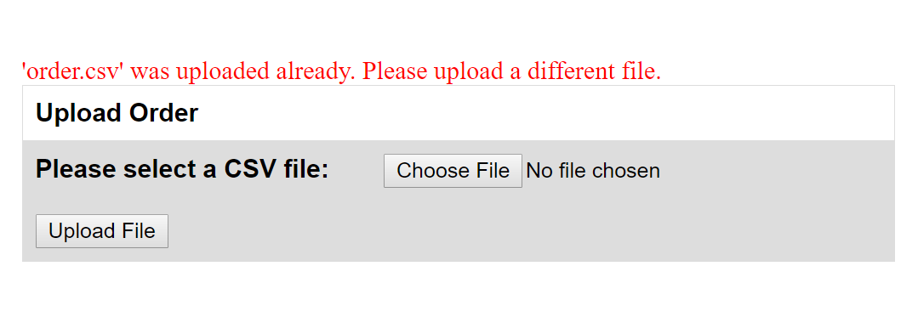

**Below are standard test classes developed for testing. These classes pick the sample data files under testdata folder.**

**Select java file in eclipse and run as java application.**

