Snowflake Cost Optimisation
Framework
Executive Solution Overview
Prepared for Thomson Reuters

Executive Summary
With 350+ source systems feeding billions of records into Snowflake daily, and multiple business units building their own data products and dbt contracts within isolated MDS workspaces, Thomson Reuters faces a familiar but acute challenge: compute costs are growing because users across verticals — with varying levels of Snowflake expertise — write and execute queries and contracts that are not optimized for cost efficiency.

Our Snowflake Cost Optimisation Framework transforms your existing Snowflake metadata into actionable cost intelligence — delivered in three phases across 12 weeks, with zero additional licence costs. The framework identifies exactly which data products, dbt contracts, stored procedures, and ad-hoc queries are consuming the most warehouse resources, pinpoints the root causes, and delivers concrete recommendations — so your platform team can inform business units precisely what to fix, with the evidence to drive action.

40-60% | 20-40% | $0
Typical Waste Identified | Average Savings Achieved | Additional Licence Cost

The framework follows a proven three-phase approach:
- Phase 1 — Identify & Solve: Diagnose exactly where money goes and why across all 350+ sources and MDS workspaces. Identify which data products and dbt contracts are eating your warehouses. Deliver a cost dashboard, root cause analysis, and a prioritised solution with recommendations.
- Phase 2 — Optimise: Implement the optimisations identified in Phase 1 — warehouse right-sizing, query tuning, storage cleanup, and data product contract improvements. Every change backed by before/after evidence.
- Phase 3 — Govern: Embed ongoing cost governance with automated anomaly alerts, chargeback by business unit, and FinOps review cadence — so savings persist and new contracts are written in an optimised way from day one.

The Challenge
Thomson Reuters operates a sophisticated data platform with data flowing from 350+ source systems through S3, AWS Glue, Fivetran, and Snowpipe into Snowflake. Across the four data layers — Raw/Role, TRIM (TR Enterprise Model), MDS (business workspaces), and the Broad/Data Products layer — costs accumulate at every stage. Based on our introductory discussion, six interconnected challenges stand out:
# | Challenge | Thomson Reuters Context
1 | No pinpointed cost attribution | Platform team knows costs are high but cannot tell each BU exactly which of their dbt jobs, contracts, or queries are driving spend
2 | Oversized warehouses | Warehouses configured for peak loads run at low utilisation during off-hours; suspend/resume tuning is manual and inconsistent
3 | Unoptimised dbt contracts & queries | Business teams writing data products in MDS prioritise delivery over performance — contracts with full scans, no partition awareness, inefficient joins
4 | Storage sprawl across layers | Data retained across Raw, TRIM, MDS, and Broad layers with excessive Time Travel, stale clones, and unused tables
5 | Serverless cost growth | Snowpipe ingestion, auto-clustering, and task execution costs growing with each new source system added
6 | Reactive cost management | Year-on-year platform costs increase; optimisation 'takes a back step when other commitments are priority' (your words)

Your team has already proven optimisation works: one business unit that prioritised code improvements showed 'considerable improvement' in cost savings. The challenge is scaling this across all 350+ sources — you need a tool that pinpoints problems automatically and gives business teams the exact evidence they need to act.

Savings Benchmarks by Category
Cost Category | Typical Waste | Achievable Savings | Common Root Cause
Warehouse Compute | 30-50% | 20-35% | Oversized, idle, poor auto-suspend
Query Efficiency | 15-40% | 10-25% | Full scans, spills, no caching
Storage | 20-30% | 15-25% | Unused tables, excessive Time Travel
Serverless | 10-25% | 10-20% | Over-clustering, unnecessary pipes
Data Transfer | 5-15% | 5-10% | Cross-region replication, external stages

The Root Cause — Uncontrolled Data Product Development
The six challenges on the previous page are symptoms. The underlying root cause is structural: your MDS workspaces give business units the freedom to create data products and dbt contracts — but without guardrails on how those contracts are written. Business teams prioritise delivery over performance. Not everybody is aware of partition columns, filter strategies, or warehouse sizing best practices. The result: contracts that work correctly but consume far more compute than necessary.
As discussed in our introductory call: 'We can't go through every single source data system and check their code to check the performance of their queries to analyse it.' You need a tool that does this automatically — pinpointing exactly which data products and contracts are expensive, why they're expensive, and how to fix them. That's what Phase 1 delivers.

Thomson Reuters: How the Cost Multiplier Works

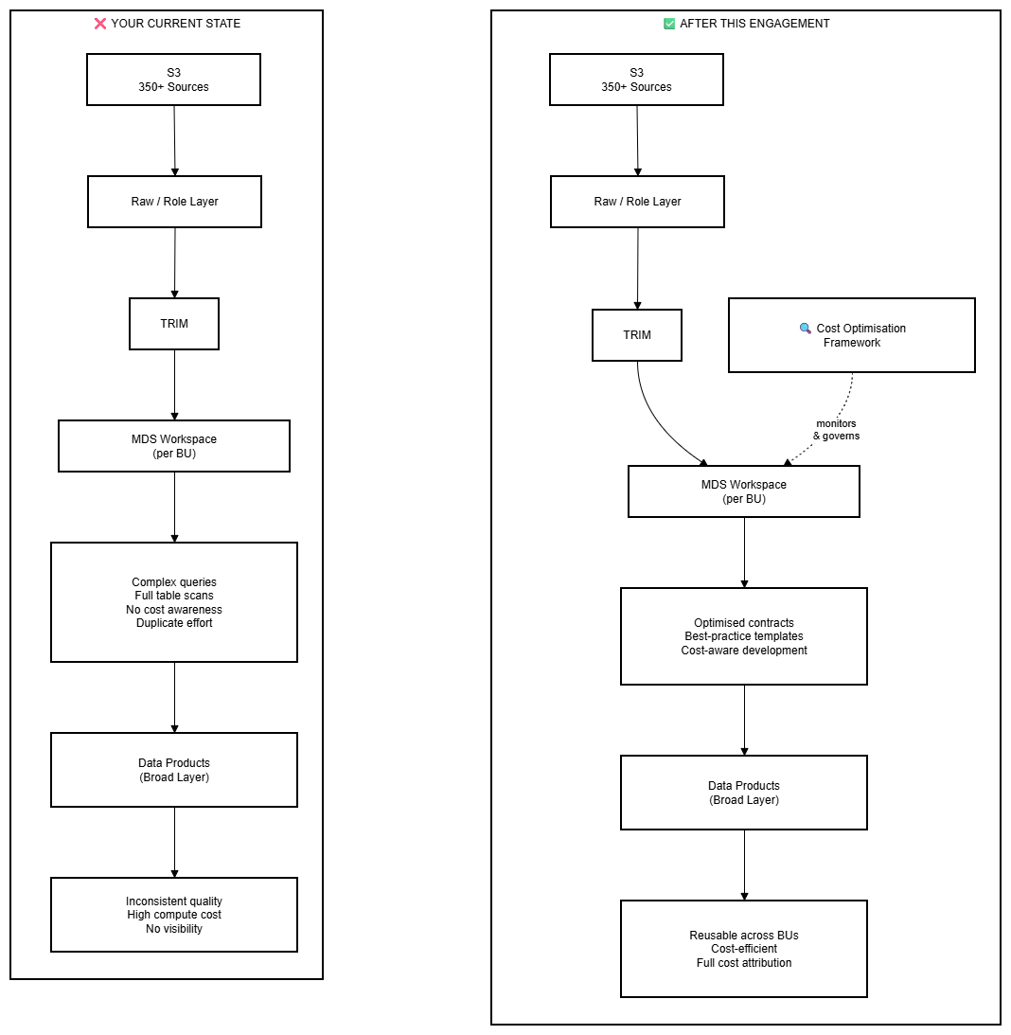

The Impact Across Your User Types
User Type | What They Do at TR Today | The Problem | What They Actually Need
Platform / Data Engineers  (your team) | Manage ingestion from 350+ sources, build TRIM models, configure warehouses, step in to help BUs with sizing and suspend times | Cannot go through every source system's code to check performance — bandwidth limited, no automated detection | A tool that automatically identifies expensive code and generates evidence-based recommendations to send to BU teams
BU Technical Users  (MDS workspace users) | Write dbt contracts and data products in MDS, create transforms, build models for their vertical | Prioritise delivery over performance — may not know partition columns, filter strategies, or optimal join patterns. '$100 query that an expert writes for $10' | Automated feedback on contract performance + optimised contract templates that follow TR guidelines
Business / Reporting Users | Run reports, build dashboards, query data products in the Broad layer, request ad-hoc data pulls | Depend on BU teams for data access — may write ad-hoc queries without understanding cost impact | Well-curated data products in the Broad layer + self-service dashboards — no raw table access needed

Our framework addresses the three needs identified in our discussion: (1) Identify which data products and contracts are eating your warehouses, (2) Optimise existing contracts with concrete before/after evidence, and (3) Establish a framework so new contracts are written in an optimised way from day one — breaking the cycle of optimise-then-regress.

Our Solution

How It Fits Into Your Architecture
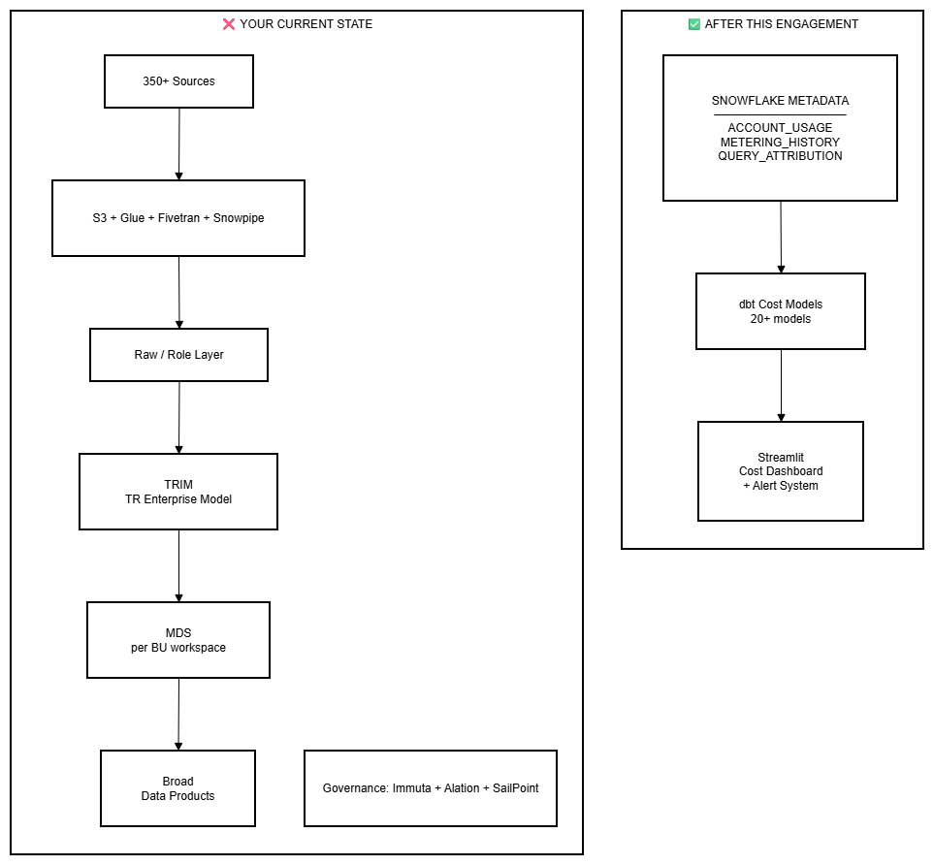

Three-Phase Approach
Phase | Focus | Duration | Key Outcome
Phase 1: Identify & Solve | Diagnose cost drivers, map user query patterns,  deliver cost dashboard + findings report  with root causes and solution recommendations | Weeks 1-4 | You know exactly what's wrong and have a concrete plan to fix it
Phase 2: Optimise | Implement deeper optimisations from Phase 1:  warehouse right-sizing, query tuning,  storage cleanup, data product POCs | Weeks 5-8 | Measurable savings delivered with before/after proof
Phase 3: Govern | Anomaly detection, chargeback model,  FinOps review cadence, drift prevention | Weeks 9-12 | Self-sustaining governance so savings persist long-term

Six Key Capabilities
- Unified Cost View — All cost categories in one dashboard: compute, storage, serverless, data transfer, and more
- Per-Query Cost Attribution — Exact dollar cost per query, per job, per data product — not just warehouse-level totals
- Root Cause Analysis — Understand why each expensive query or contract costs what it does, with actionable fix recommendations
- Automated Anomaly Detection — Cost spikes detected and alerted before they hit the invoice
- Tag-Based Chargeback — Cost ownership by team, vertical, and data product — each BU manages their own budget
- FinOps Maturity Assessment — Structured progression from reactive to proactive cost governance

What You Get
Each phase delivers tangible business outcomes — not just technical artifacts. Here is what changes for your organisation after each phase.

Phase 1: Identify & Solve — Your Immediate Priority
This is what you asked for in our introductory call: 'Identify what are the list of data products that have complex queries which are eating my warehouse.' Phase 1 does exactly that — and goes further. We scan every warehouse, every dbt job, every stored procedure, and every ad-hoc query across all your MDS workspaces. We deliver a complete diagnosis with evidence-based recommendations that your platform team can send directly to business unit owners — showing them exactly what's expensive, why, and how to fix it.

What We Deliver and Why It Matters
What We Deliver | Business Questions You Can Now Answer | Business Advantage
Interactive cost dashboard  (compute, storage, serverless,  cost by BU / MDS workspace) | What is our total spend across all layers?  Which BU / MDS workspace drives the most cost? | Single source of truth — shareable across teams. The 'matrix' your team asked to see.
Data product & contract  cost ranking  (the list you asked for) | Which data products and dbt contracts  are eating my warehouse?  How much does each one cost? | Exactly what you need: a ranked list of expensive data products with $ attribution — evidence to drive action with BU owners
Root cause analysis per  expensive contract  (why, not just what) | Why is this contract expensive?  Is it full scans, bad joins, missing filters,  or oversized warehouse? | Actionable detail — your team can email BU owners with: 'Here is the problem, here is the fix, here is the potential saving'
Automated alert framework  (cost spike notifications) | Did something unusual happen today?  Which warehouse or job spiked? | The notification system you asked for — auto-alerts when costs spike, sent via email / Slack / Teams so BU teams are informed immediately
Tiered Optimisation  Recommendations  (ranked by ROI) | What are users actually trying to get?  What's the fastest fix for each  expensive pattern? | Every expensive pattern is assigned the right-sized fix — from quick contract patches to curated data products. 80% of savings come from fixes that deploy in minutes. Each recommendation includes cost-benefit analysis.
Prioritised findings report  with quick-win recommendations | What should we fix this week?  What requires deeper Phase 2 work? | Immediate action — warehouse auto-suspend, sizing quick wins can be applied within days

Our Approach: Speed of Fix Matters
Not every problem needs a complex solution. Our framework assigns the right-sized fix to each problem — from quick contract patches to full curated data products. The key insight: 80% of savings come from fixes that deploy in minutes, not days.
Approach | Speed | Impact
Quick contract fixes  (targeted improvements to existing code) | Minutes | Addresses the top-20 most expensive contracts immediately — send evidence-based fix to BU owner
Platform configuration  (leverage built-in Snowflake capabilities) | Minutes | Zero-maintenance improvements — Snowflake handles the optimisation natively
Shared data access layers  (reduce duplicate effort across BUs) | Hours | Multiple users querying the same data in different ways → one optimised access path
Full curated data products  (only where ROI clearly justifies) | Days | Reserved for top 5-10 high-value cross-BU patterns — we prove ROI before investing build time
Phase 1 identifies which approach applies to each problem. Phase 2 implements them in priority order — quick wins first, bigger investments only where proven.

Phase 1 Outcome: You don't just see your costs — you understand exactly why they're high and have a concrete, prioritised plan to fix them. Quick wins can be applied within days for 5-15% savings. Larger investments are recommended only where ROI is proven. Phase 2 implements the full plan with before/after evidence.

Phase 2: Optimise — Implement the Savings
Phase 1 identified the problems and ranked them by cost impact. Phase 2 implements the deeper optimisations — reverse-engineering expensive dbt contracts to create optimised versions, right-sizing warehouses, cleaning up storage, and demonstrating before/after savings. For each optimisation, we provide the evidence: 'This contract used to cost $X/month, now it costs $Y/month — here's what changed.'

What We Deliver and Why It Matters
What We Deliver | Business Questions You Can Now Answer | Business Advantage
Warehouse right-sizing  execution with before/after testing | What size should each warehouse actually be?  What's the verified saving after resize? | Largest single saving — 20-35% of compute cost. We test in sandbox before applying to production.
Query-level optimisation  (anti-pattern fixes, QAS evaluation) | Which specific queries should be rewritten?  Would Query Acceleration Service help? | Targeted fixes — the top 10 expensive queries often account for 15-25% of compute spend
Storage cleanup execution  (unused tables, TT reduction, clone removal) | Which tables can we safely drop or archive?  What's the verified storage saving? | Immediate savings — unused tables and excessive Time Travel are pure waste
Per-query cost attribution  (exact $ per query via QUERY_ATTRIBUTION) | What does each scheduled job actually cost us?  Which pipelines have the worst ROI? | Data-driven decisions — retire or optimise jobs based on actual cost, not guesswork
Prioritised fix implementation  (ranked by speed and savings) | Which fixes deliver the  biggest savings fastest?  What's the verified before/after? | Quick wins deployed first for immediate impact. Larger investments only where ROI is proven — every change backed by before/after evidence.
Optimised contract templates  for new data products | Can new dbt contracts be  optimised from day one?  How do we prevent future waste? | New data products are built using optimised templates that follow best practices — so every new contract is efficient by default, without requiring deep Snowflake expertise from BU teams.

Phase 2 Outcome: Measurable, verified savings with before/after proof. Warehouse resizing, query fixes, and storage cleanup are implemented and validated. Quick wins delivered first, bigger investments only where ROI is proven. Optimised contract templates ensure every new data product is cost-efficient from day one.

How New Data Products Enter the System — Before and After
The biggest long-term impact of this framework is not fixing today's expensive queries — it's changing how new data products are created going forward. Today, there is no gate between 'BU team writes a dbt contract' and 'contract runs in production consuming credits.'
 | Today | After This Engagement
Before creating  a data product | No check: does this data already exist?  No cost estimate. No quality gate. | Automatic overlap check against existing contracts.  Cost estimate before deployment.  Optimised template provided.
Writing the  contract / query | Each BU writes their own SQL.  Varying expertise levels.  No best-practice enforcement. | Optimised contract templates follow TR guidelines.  BU teams get efficient code without needing  deep Snowflake expertise.
After deployment | No visibility until invoice.  No alert if costs spike.  Another BU may build the same thing. | Continuous cost tracking per contract.  Anomalies detected within hours.  Duplicate effort flagged automatically.
Cross-BU sharing | Each BU works in isolation.  Same data built multiple times  across MDS workspaces. | Shared data products in Broad layer.  One contract serves multiple BUs.  Cost shared, quality assured.

The key shift: users still have the freedom to create new data products — but the system now guides them toward efficient, governed, reusable outcomes. Every new contract is cost-estimated before deployment and checked for overlap. This is how you stop the cycle of 'optimise, then someone writes something unoptimised again' — without slowing anyone down.

Phase 3: Govern — Stop the Cycle of Regress
This addresses your third concern: 'How do I give users the luxury of still writing contracts and products, but with auto-optimisation behind the screen — sticking to TR guidelines and policies?' Phase 3 embeds cost-aware governance so that new data products are written in an optimised way from day one, anomalies are caught automatically, and each BU owns their cost budget.

What We Deliver and Why It Matters
What We Deliver | Business Questions You Can Now Answer | Business Advantage
Automated anomaly detection  and alerting | Did something unusual happen with our costs today?  Is this spike expected or a problem? | Cost incidents caught in hours, not weeks — auto-alerts via email/Slack/Teams before runaway spend hits the invoice
Chargeback by team  and vertical | How much is each team/vertical spending vs their budget?  Which cost centre is over/under? | True cost ownership — each vertical manages their spend like any other budget line item
FinOps review cadence  (weekly/monthly/quarterly) | Are we maintaining our savings?  What new optimisation opportunities have appeared? | Structured reviews prevent cost drift and catch new waste early — your team runs this independently after handover
Cost gate for new  data products | What will this new contract cost?  Does something similar already exist? | The gate you're missing today — new contracts are cost-estimated and checked for overlap before production deployment
Duplicate effort prevention | Are BUs building the same data products  in isolation? Can we consolidate? | Automatic detection of overlapping contracts across BUs — prevents wasted compute from 'N teams, N copies' problem
Cost drift detection | Has a warehouse been resized without approval?  Are costs creeping back up? | Configuration changes that cause cost regression are flagged automatically — policy enforcement without manual review

Query Governance by User Type
Different user groups at Thomson Reuters need different governance approaches — aligned with how Immuta already enforces policy-based access control.
User Type | Governance Approach | What We Deliver
Platform Team  (your engineers) | Automated detection, cost dashboards, alert management | Framework that automatically flags expensive code across all MDS workspaces + evidence reports to send to BU owners
BU Technical Users  (MDS workspace users) | Optimised dbt contract templates, cost feedback loops | TR-specific contract guidelines + automated cost scoring for new data products before they go to production
Business / Reporting Users | Self-service via curated data products in Broad layer | Governed data products with Alation cataloguing + Streamlit dashboards for common analyses

Phase 3 Outcome: Cost governance runs on autopilot. Anomalies are caught within hours, each vertical owns their budget, and regular reviews ensure savings persist. Every user type — from engineers to business users — has an appropriate, cost-efficient way to access data. The framework becomes a self-sustaining capability your team owns entirely.

Cumulative Value: How the Phases Build on Each Other
 | Before Engagement | After Phase 1  (Identify & Solve) | After Phase 2  (Optimise) | After Phase 3  (Govern)
Problem Understanding | Don't know where money goes or why | Full diagnosis: cost drivers, root causes, user patterns, data product opportunities | Validated with before/after proof | Continuously monitored with anomaly detection
Savings | None | Quick wins applied (5-15%)  Strategic roadmap for long-term savings | Deeper optimisations implemented (20-40% verified) | Savings sustained via governance + drift prevention
User Access | Everyone queries raw tables | User patterns mapped.  Tiered fix recommendations ranked by ROI. | Tiered fixes deployed + optimised contract templates in use | Each user type has cost-efficient access path
Decision Making | Gut feel and invoice review | Data-driven: dashboard + findings + solution plan | ROI-proven: before/after evidence for every change | Budget-managed with automated governance per vertical
Sustainability | N/A | Solution plan in hand | Optimisations implemented and validated | Self-sustaining — continuous improvement loop

Why This Approach

Comparison: Three Approaches to Snowflake Cost Management
Capability | Our Framework | Native Snowflake | SaaS Tools
Cost attribution | Full: compute + storage + serverless + per-query | Basic: budgets and resource monitors | Good: varies by vendor
Query-level costing | Yes — QUERY_ATTRIBUTION_HISTORY | No | Partial
Query plan analysis | Yes — GET_QUERY_OPERATOR_STATS() | Manual via EXPLAIN | Limited
Anomaly detection | Custom + Snowflake ANOMALY functions | Threshold alerts only | Yes
Chargeback / tags | Full tag-based allocation | Manual tag setup only | Partial
Customisation | Fully tailored to your org | One-size-fits-all | Limited to vendor UI
Data residency | Stays in your Snowflake | In your Snowflake | Sent to third-party
Ongoing licence cost | $0 (dbt + Streamlit included) | $0 | $500-$5,000+/month
Transparency | All logic visible in dbt SQL | Black-box | Black-box
Extensibility | Add models, metrics, dashboards | Limited | Vendor roadmap only

Key differentiator: Our framework combines the depth of custom engineering with the speed of open-source accelerators (dbt-snowflake-monitoring, Sundeck OpsCenter) — delivering enterprise-grade cost governance at zero ongoing licence cost.

Proven at Scale: Our Production Data Product Platform
We don't just recommend data products — we build and operate them in production. Our team runs a production-grade dbt + Snowflake + Streamlit platform that already demonstrates the exact capabilities we're proposing:
What We Operate | Scale | Relevance to This Engagement
Data Products in Production | 10+ across multiple domains | Proven three-layer architecture (staging → intermediate → publication)
Streamlit Dashboards | 13 production dashboards | Same approach for cost attribution and governance dashboards
Automated Alert Framework | 30+ alert types with episode tracking | Foundation for cost anomaly detection and drift alerting
External Integrations | Datadog, Incident.io, Jira — pull-based | Zero-maintenance integration with your monitoring stack
Data Quality Framework | 7 dimensions, RAG scoring, SLOs | Directly applicable to cost data quality and governance
Terraform Governance | 4 environments, per-product roles | Enterprise-grade access control and schema management
Data Contracts | Versioned public models, 30-day notice | Proven contract management for multi-team consumption
Refresh Cadence | 15-minute cycle, <10 min execution | Near-real-time cost monitoring capability

Your Data Maturity Journey
Thomson Reuters is already transitioning: your data product concept (MDS → Broad layer) is in the 'nascent stage' as your team described. This engagement accelerates the journey by adding cost governance and optimisation guardrails:
 | Era 1: Pipelines  (Parts of Current State) | Era 2: Data Products  (Where You're Heading) | Era 3: Intelligent Products  (Future Vision)
What you build | ETL jobs, batch loads, raw tables | Curated datasets with owners, SLAs, contracts, quality rules | Self-adapting products that detect drift and auto-remediate
How users get data | 'Can you pull this data?' — tickets and ad-hoc SQL | Self-service via catalogues, dashboards, governed access | Data finds the user — personalised, proactive delivery
Cost behaviour | Uncontrolled — every user queries raw tables | Managed — curated layers reduce compute 10-50x | Optimised — intelligent caching, auto-sizing, anomaly prevention
Quality approach | Manual checks, customer complaints | Automated testing, SLOs, RAG dashboards | ML-powered anomaly detection, self-healing pipelines
This engagement delivers the Era 2 foundation: cost visibility, optimised access patterns, and data product recommendations. The governance framework in Phase 3 sets the stage for the Era 3 capabilities as your platform matures.

Delivery Timeline
Phase 1: Identify & Solve | Phase 2: Optimise | Phase 3: Govern
Weeks 1-4 | Weeks 5-8 | Weeks 9-12

Key Milestones
Milestone | Week | Deliverable
Discovery & Quick Wins | Week 1 | Account profile, user landscape, initial findings, quick-win recommendations applied
Diagnosis & Dashboard | Week 3 | Interactive cost dashboard + root cause analysis + Data Product Opportunity Report
Solution Delivered | Week 4 | Prioritised findings report with concrete solution plan for Phases 2 & 3
Savings Verified | Week 8 | Before/after proof of optimisations: warehouse resizing, query fixes, storage cleanup
Governance Active | Week 11 | Anomaly detection, chargeback, FinOps cadence, drift prevention in place

Investment & Next Steps

Team Composition
Role | Allocation | Phases
Lead Engineer (Snowflake + dbt) | Full-time | All phases
Dashboard Developer (Streamlit) | Part-time | Weeks 3-4, 7-8, 11-12
Project Lead | Part-time | Throughout
FinOps Consultant | Part-time | Phase 3 (Weeks 9-12)

