DEPLOYMENT
Requirements:
- Server side deployment - Tomcat server, Apache Maven, Notepad++
- Client side deployment - Node.js(version 16.17.0), IIS server, JDK(version 17)
- Database - PostgreSQL (version 14)
- Frontend code & Backend code.(client & server side code)

Steps to deploy:
- Check whether IIS server is enabled or not .If not ,then enable it.( Control panel -> Programs -> Turn on windows features On or Off -> Internet Information Services )
- Set Environment Variables FOR ( JDK , MAVEN ) & Paths. For Example
Variable Name: JAVA_HOME
Variable value: C:\Program Files\Java\jdk-19,

Variable Name: MAVEN_HOME
Variable value: C:\apache-maven-3.9.1
- Install PostgrSQL.
- Create a Database and set the Database name in Property file ( application.properties ) in backend code.
- Change the port number to 8080 in Frontend Resources file.
- Build a war file in command prompt with command (mvn clean install).
- War file will be generated in target folder of the project structure.
- Copy the war file and Paste it in tomcat -> webapps.
- Go to tomcat -> bin and in command prompt enter the command (startup.bat) to run the server.
- Then, server will connect to Database and tables will be created.
- In Roles table set all Roles for login purpose.
- For client deployment, a Build Folder will be created with command (npm run build) from the VS code terminal or cmd.
- In IIS Server go to Desktop -> sites -> add website.
- Here, set the Site name without the extension .com
- And in physical path section set the Client Build Folder path.
- At the end we’ve to set the Host name with site name with an extension .com
- Next, we’ve to set the IP Address and Host name in hosts file for that go to
C -> Windows -> System32 -> drivers -> etc -> hosts
- In hosts file (open with Notepad++ ) set IP address & Host name (that we’ve already done in IIS Server) at the end of the file and save it.

Issues:
- In case of JS Stack Trace error while building client Build Folder. Go to environment variables set node options as shown below.
Variable Name: NODE_OPTIONS
Variable value: --max-old-space-size=4096 (1024 x 4)
- In case of above process is failed then go to command prompt or VS code Terminal and execute the command
$env:NODE_OPTIONS="--max-old-space-size=8192"

Note: If we deploying client software in Tomcat server we need .htaccess file and
In case of deploying client software in IIS Server we need web.config file in Build path.

Roles For Applications
NAAC

- ROLE_STUDENT,
- ROLE_FACULTY,
- ROLE_HOD,
- ROLE_DEAN,
- ROLE_PRINCIPAL,
- ROLE_QUALITYADVISOR

NIRF

- ROLE_FACULTY,
- ROLE_DEAN,
- ROLE_PRINCIPAL,
- ROLE_QUALITYADVISOR
- ROLE_MANAGEMENT

FACULTY DASHBOARD

- ROLE_FACULTY,
- ROLE_DEAN,

OBE

- ROLE_ADMIN,
- ROLE_FACULTY,
- ROLE_HOD,
- ROLE_ALUMNI,
- ROLE_PARENT,
- ROLE_EMPLOYER,
- ROLE_EXIT_STUDENT

EXAM CELL

- ROLE_STUDENT,
- ROLE_FACULTY,
- ROLE_HOD,
- ROLE_PRINCIPAL,
- ROLE_EXTERNALFACULTY,
- ROLE_CONDUCTION,
- ROLE_VALUATION,
- ROLE_COE,
- ROLE_PARENT,
- ROLE_SYSTEM,
- ROLE_AFF_STUDENT,
- ROLE_EXAMINATION

ERP

- ROLE_ADMIN,
- ROLE_STUDENT,
- ROLE_FACULTY,
- ROLE_HOD,
- ROLE_DEAN,
- ROLE_PRINCIPAL,
- ROLE_QUALITYADVISOR,
- ROLE_CHAIRMAN,
- ROLE_VICE_CHAIRMAN,
- ROLE_LIBRARY_INCHARGE,
- ROLE_LIBRARY_ASSISTANT,
- ROLE_ACCOUNTANT,
- ROLE_TRANSPORTATION_INCHARGE,
- ROLE_IQAC_INCHARGE,
- ROLE_IQAC_COORDINATOR

LIBRARY

- ROLE_ADMIN
- ROLE_LIBRARY_INCHARGE
- ROLE_LIBRARY_ASSISTANT

DIGITAL WALLET

- ROLE_ADMIN,
- ROLE_STUDENT,
- ROLE_ACCOUNTANT,
- ROLE_VENDOR,

Process of IIS Server Deployment

How to Enable IIS Server in Windows:-
Go to This Path In Control Panel
Control panel -> Programs -> Turn on windows features on or off
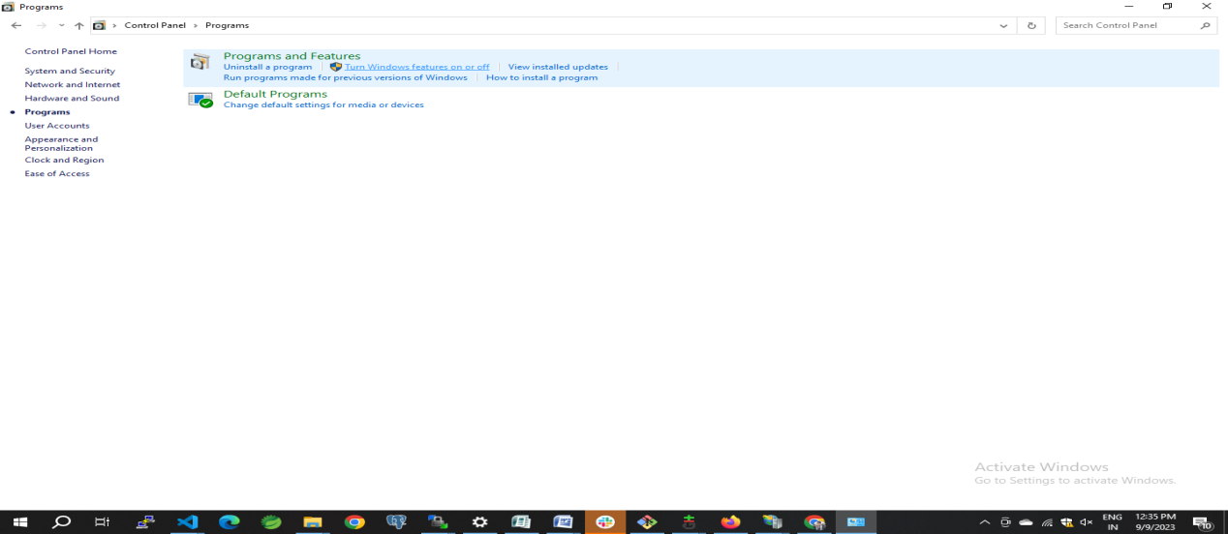
Click On Turn on windows features on or off And Opening a Window features Screen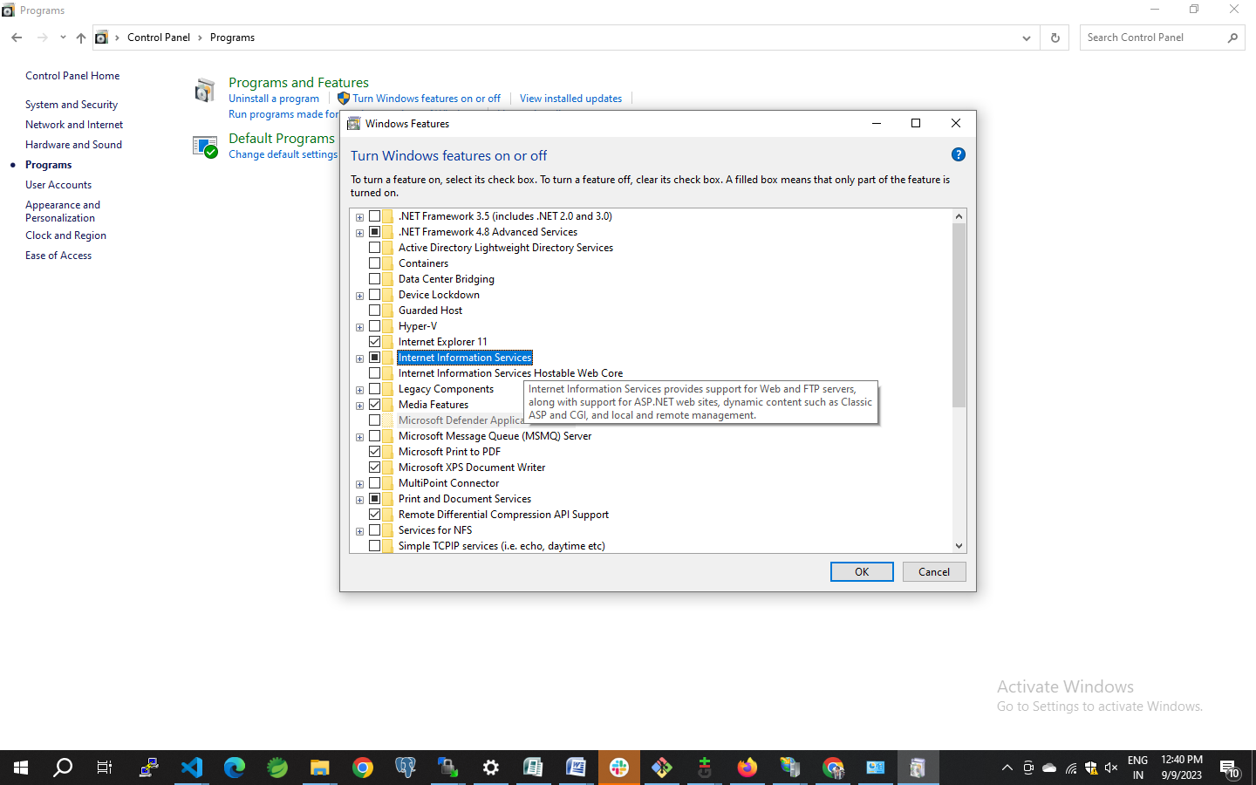
And Check Internet Information Services Incase it is Off Please Click On check Box
Then IIS Server Is Enabled
- Now go to windows search & search for IIS server,and open it
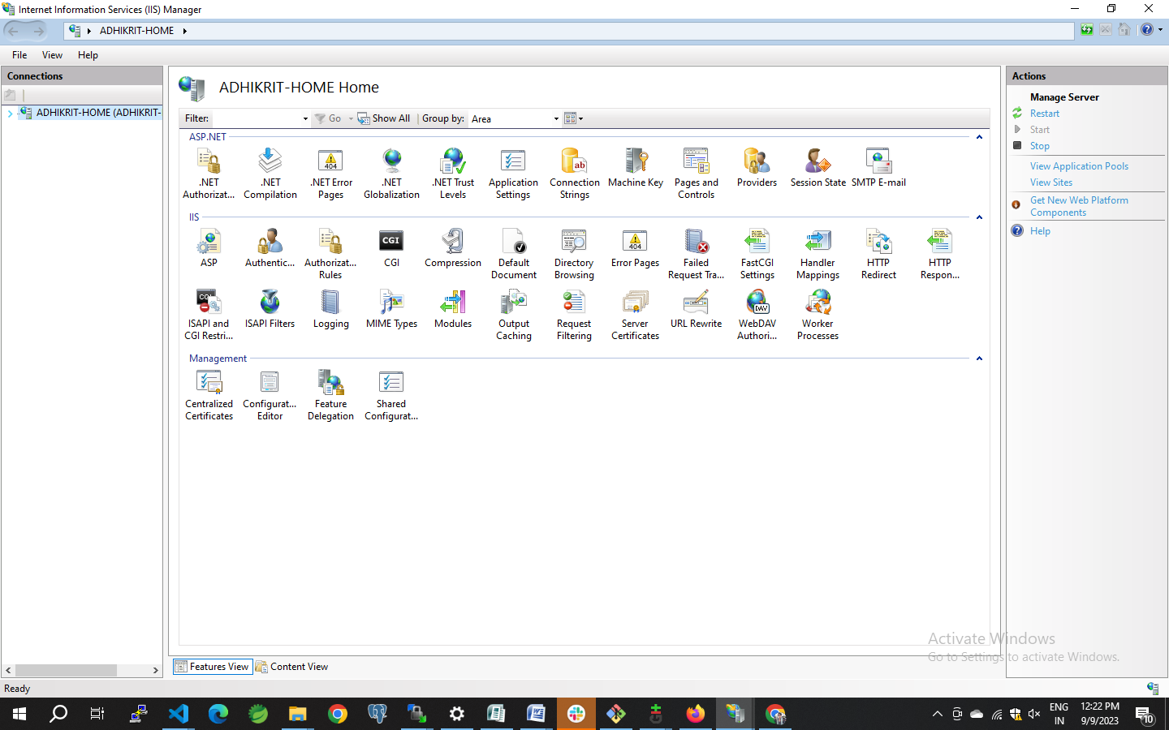
- Double Click on Your System Name

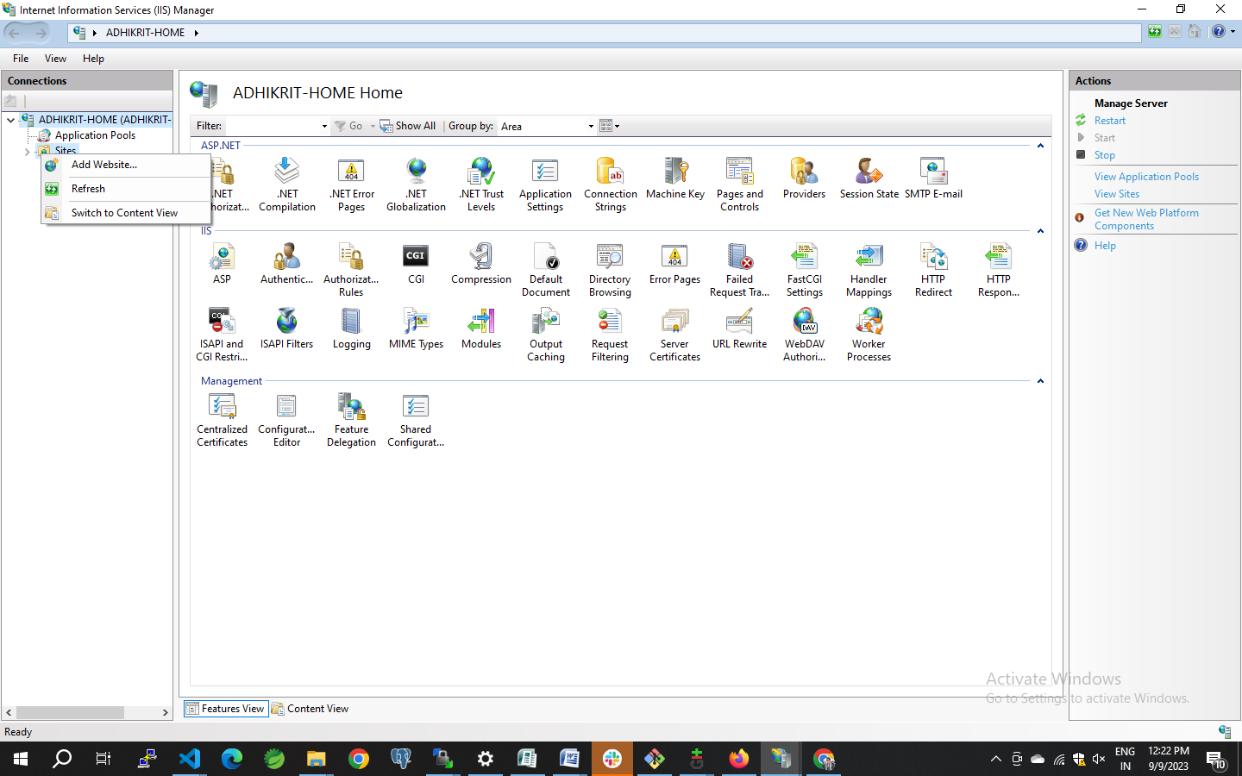
- Right Click On Sites And Click On Add Website
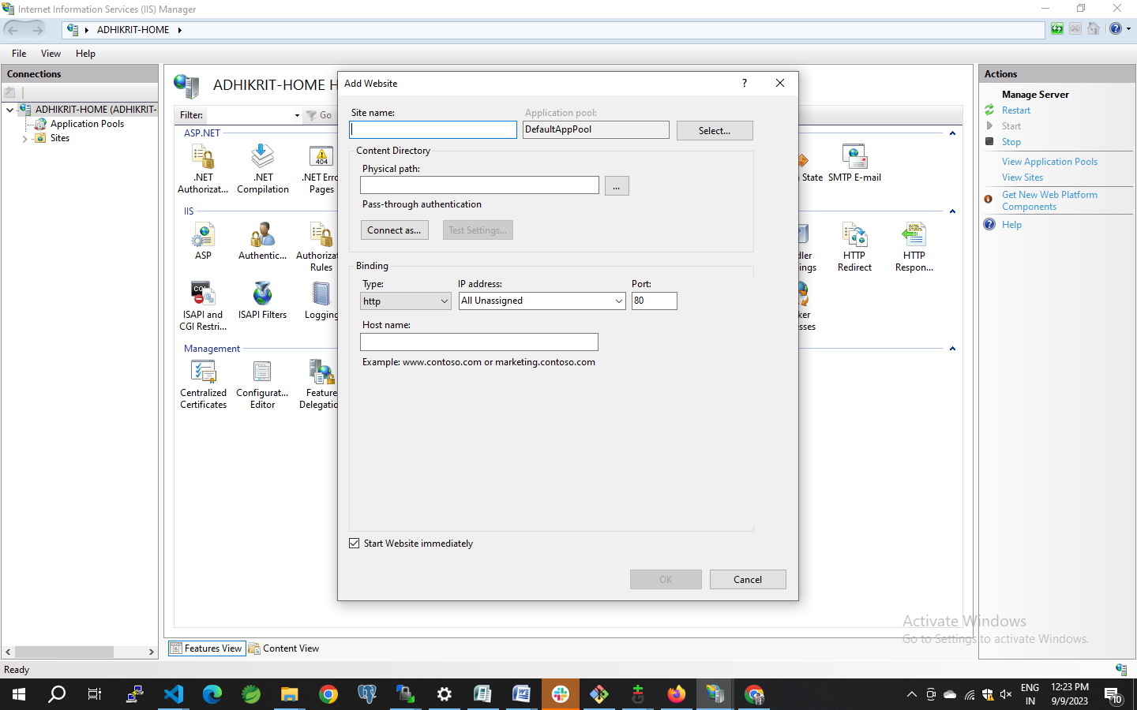

- Here, set the Site name without the extension .com

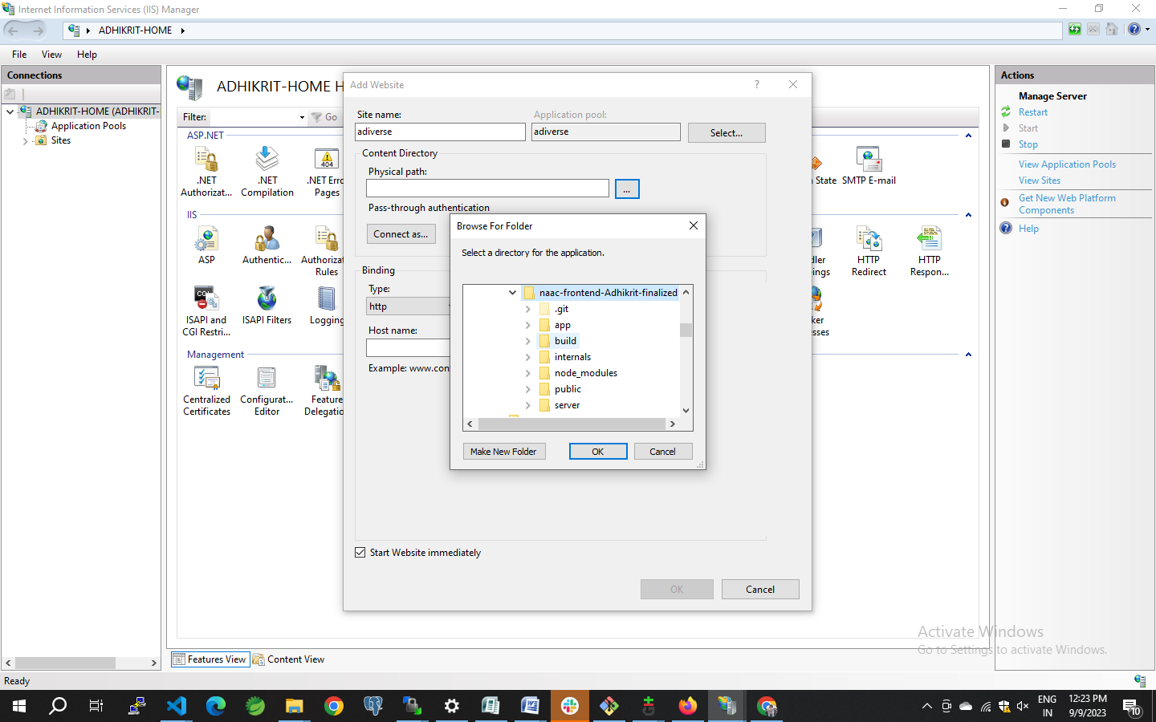
- And in physical path section set the Client Build Folder path as shown above And Click On Ok
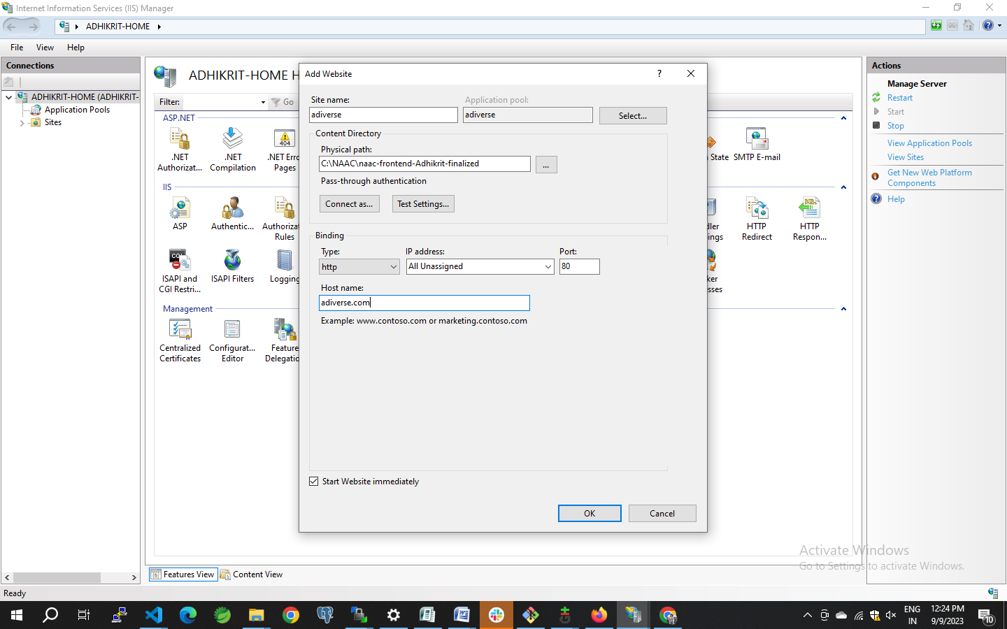

- At the end we’ve to set the Host name with site name with an extension .com
- And Give This Host Name In C -> Windows -> System32 -> drivers -> etc -> hosts
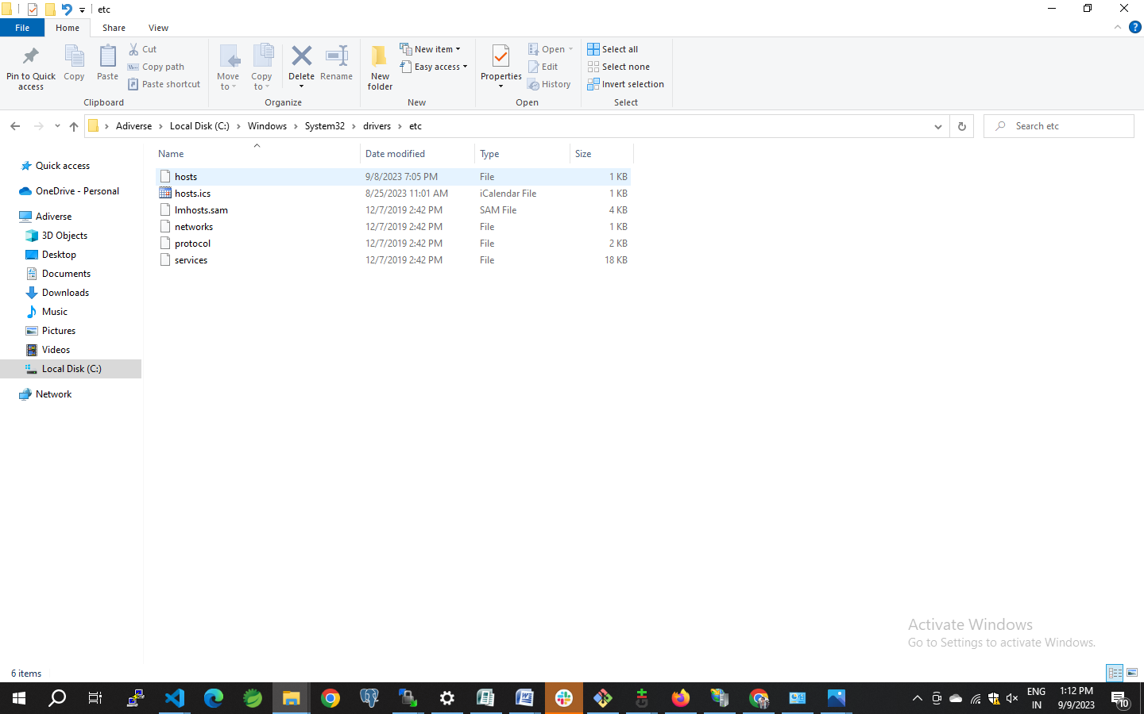

- Open Host In Notepad ++

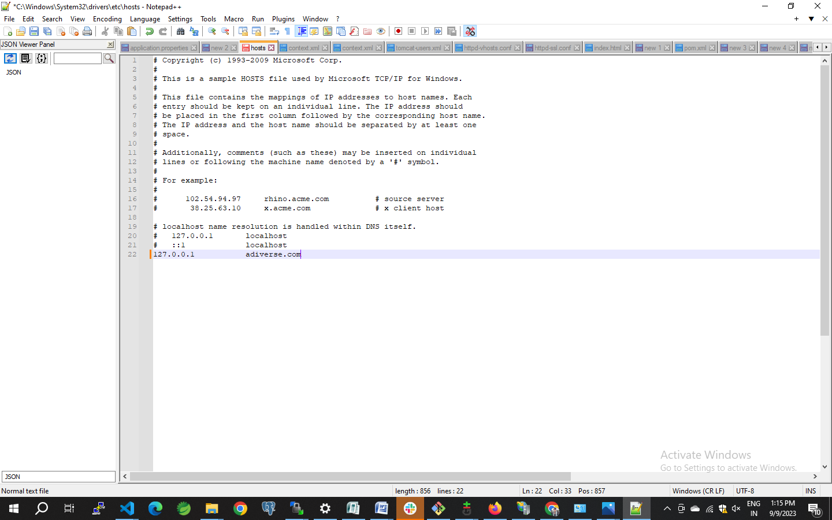

- And Give IP Address With Host Name And Save It
- Now access the host name from browser.

How to Run Backend In Tomcat
- Go To Backend Code type CMD In Backend Path
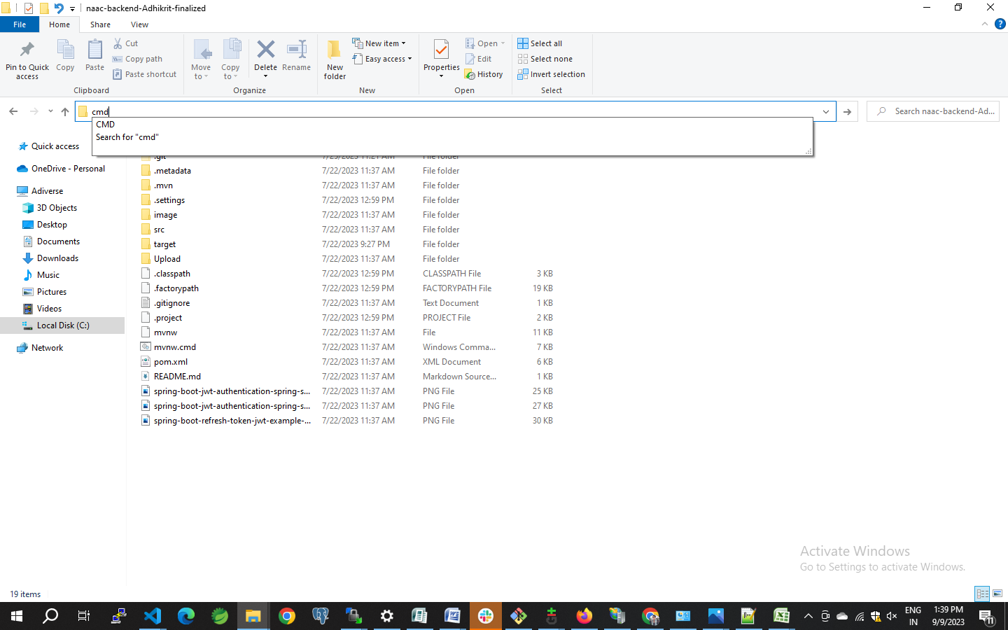
- Enter mvn clean install command in Command Prompt
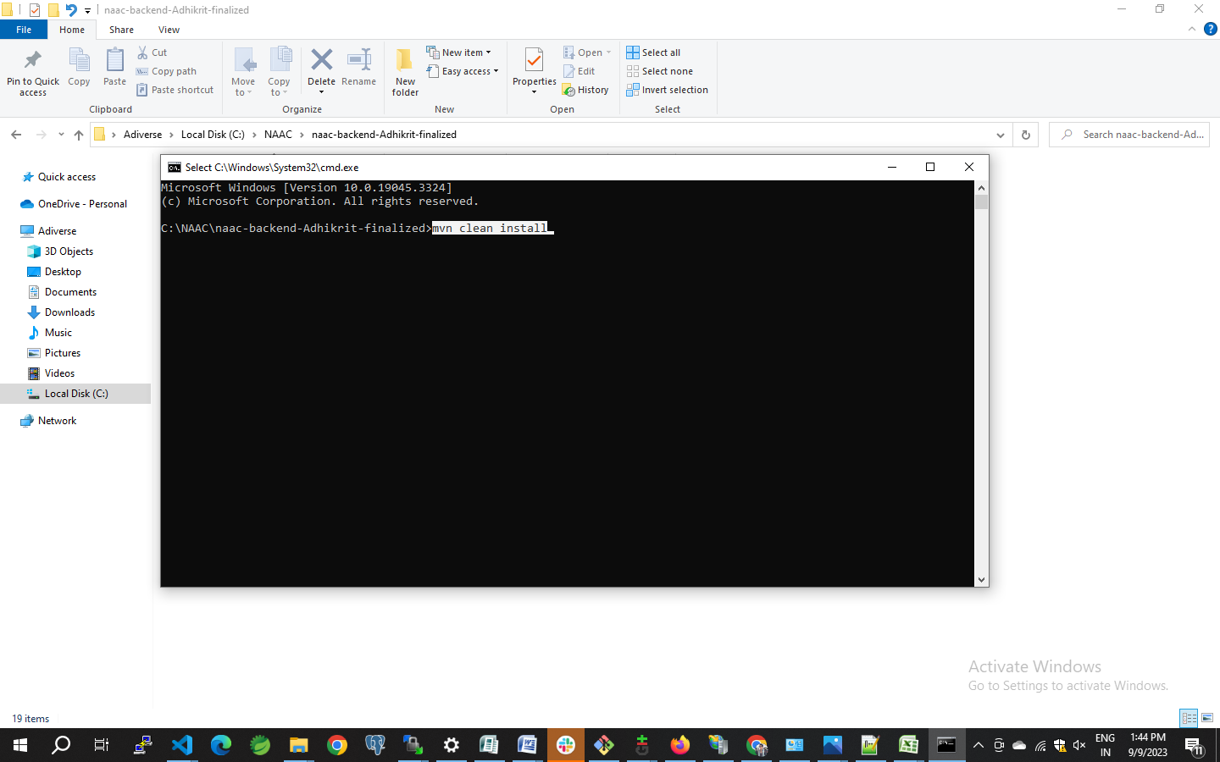
- After Build is completed it shows Build Success. Go to Backend File
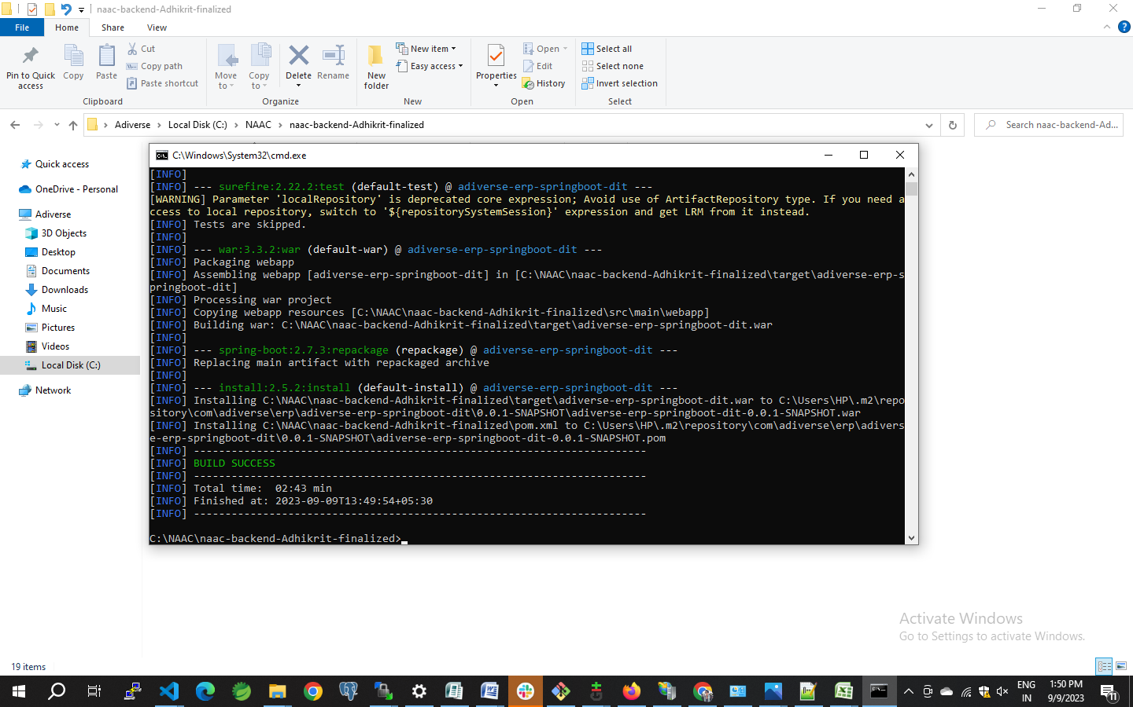
- The war file will be in target folder of the project structure.

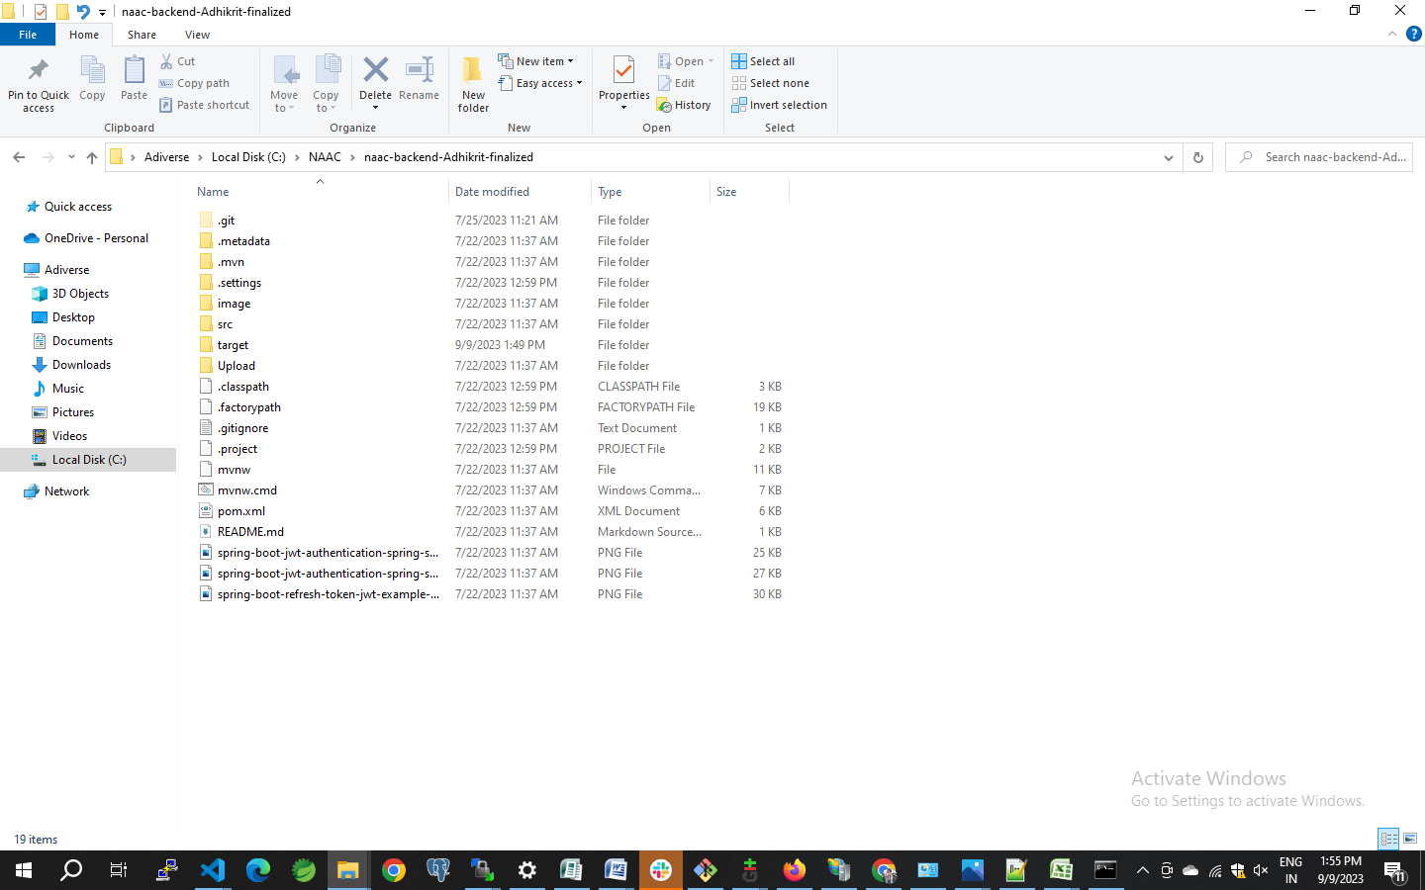
- And Copy The .war File
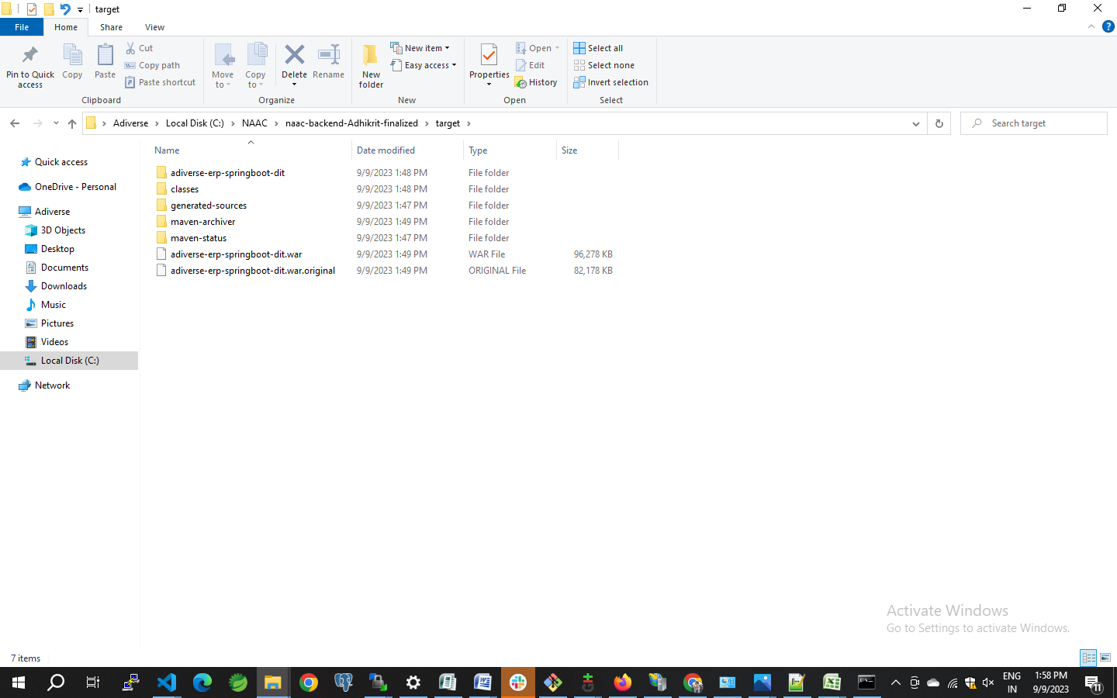
- Go to Tomcat webapps
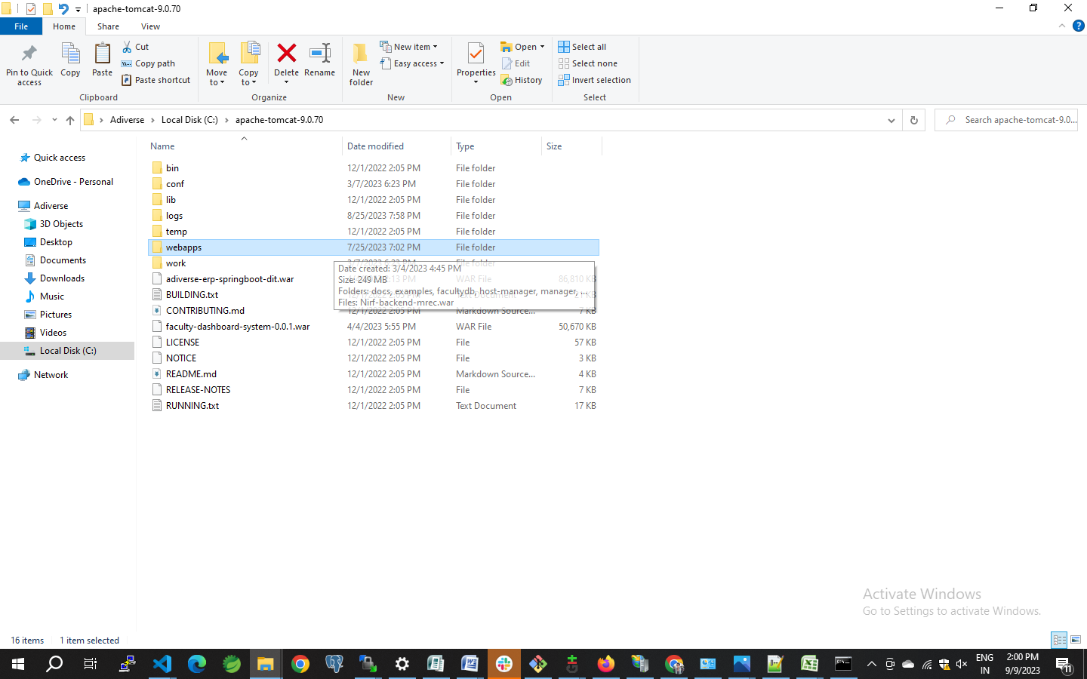

- Paste The War File In webapps folder.

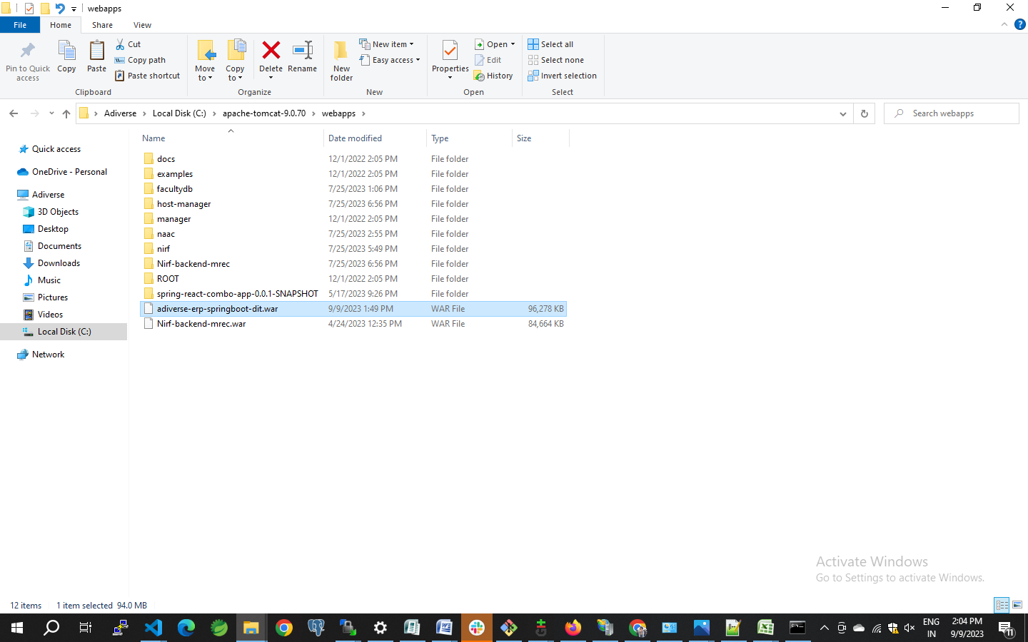
- Go to tomcat bin folder.
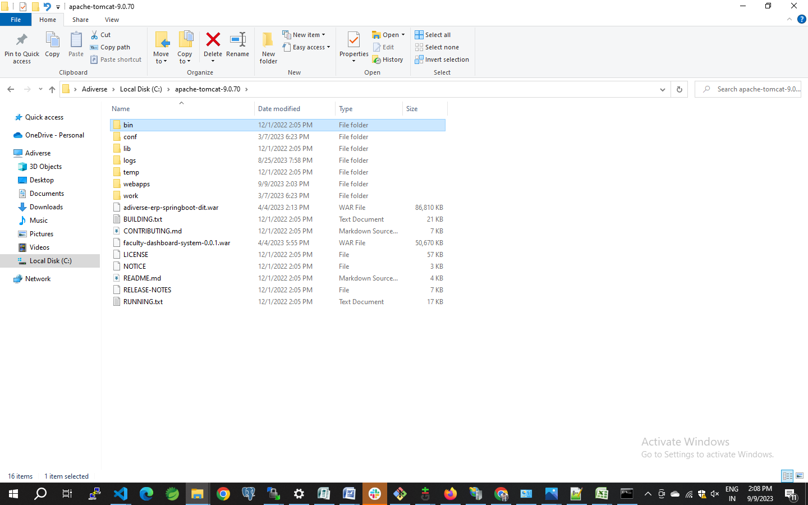
- open command prompt in bin path by using (CMD)

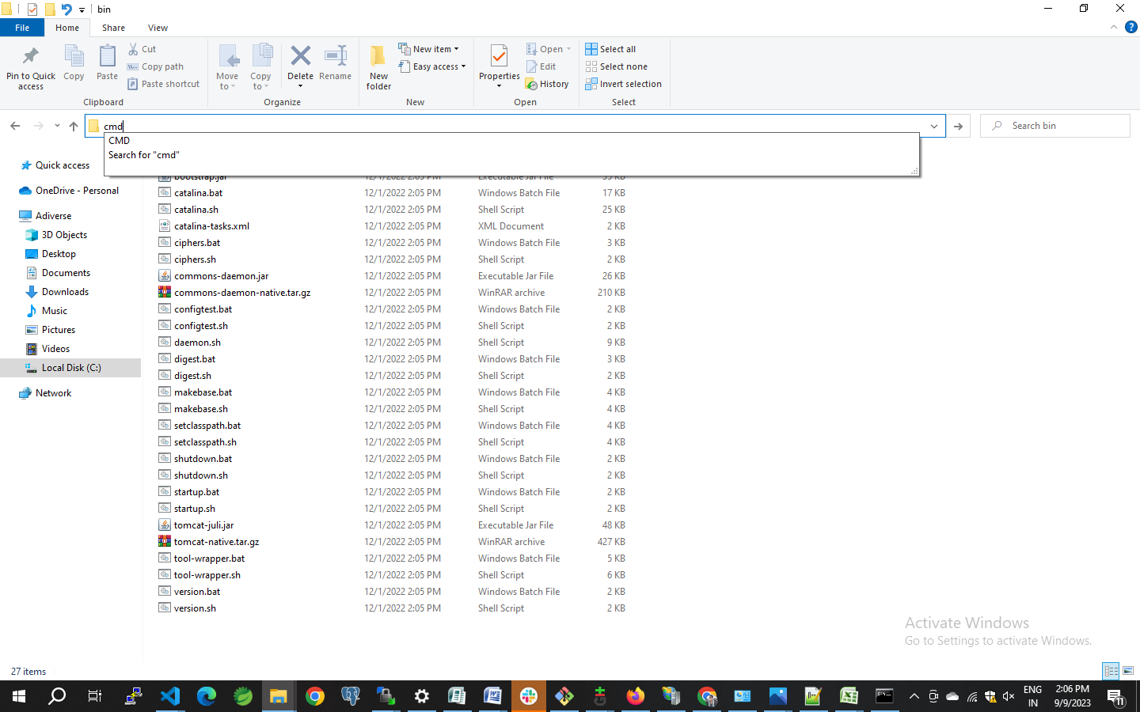

- To start the server execute the command (startup.bat) in command prompt.
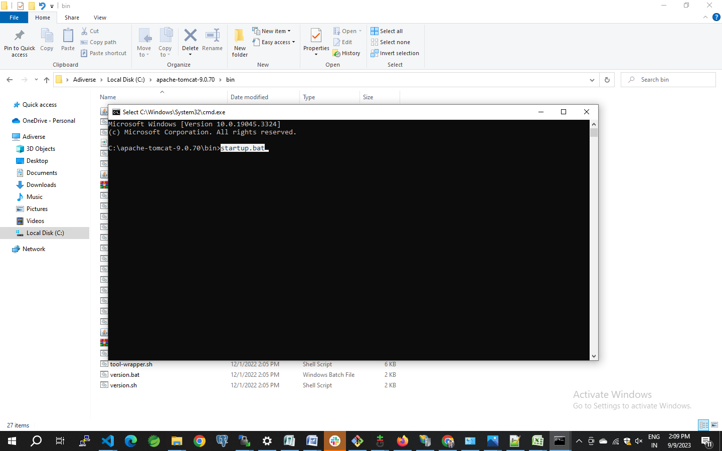

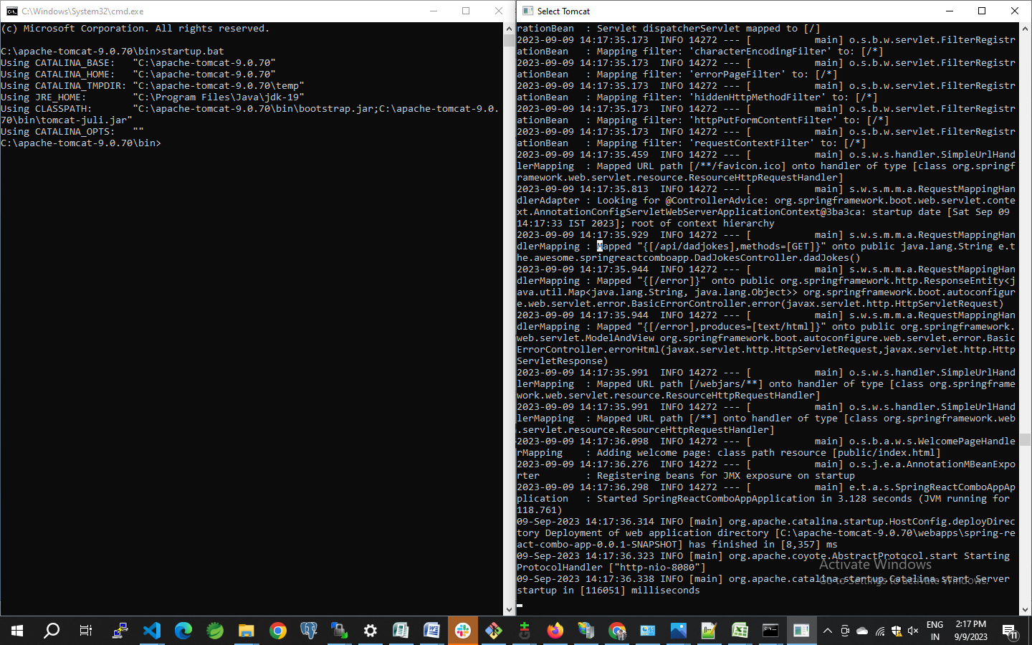
Then Tomcat Server Is Started

