TRAINER EDITION • HANDS-ON CLOUD LAB

AI Orchestrator
Azure AI Search
Retrieval-Augmented Generation
Current Microsoft Foundry UI • Azure portal RAG wizard • Cencora-style synthetic capstone
From zero to a grounded enterprise assistant using documents, hybrid retrieval, a knowledge base, and orchestration.
Version: 30 October 2026 | Level: Foundation to Intermediate | Delivery: instructor-led / student self-study
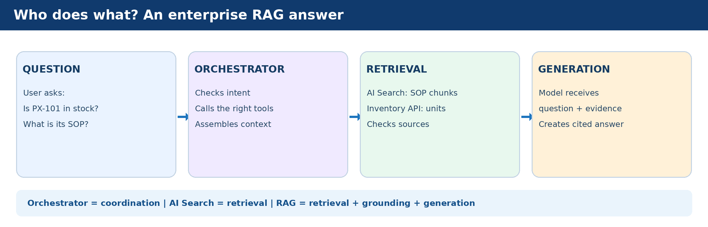
Scope The Azure portal portion is an actionable indexing lab. The Foundry knowledge-base and agent flow is conditional on project type, RBAC, region and preview availability. UI screenshots from official Microsoft Learn are linked; the included Azure advanced-settings screenshot came from the user. Illustrated navigation maps are clearly not real screenshots.

1 Teaching plan and learning outcomes
Suggested classroom sequence: 30 minutes concept walkthrough; 45 minutes setup and permissions; 60 minutes indexing; 30 minutes Search explorer; 45 minutes Foundry knowledge/agent; 30 minutes testing, extension and cleanup. Exact durations are instructor estimates, not service SLAs.
Module | What students should demonstrate | Evidence
A. Concepts | Explain the responsibility of orchestrator, indexer, index, Azure AI Search, RAG and LLM. | Annotated diagram and verbal explanation
B. Indexing | Upload source PDFs; run import wizard; inspect index, indexer and skillset. | Index populated with multiple chunks
C. Retrieval | Compare keyword, vector, hybrid and semantic results. | Search explorer outputs
D. Foundry | Attach knowledge source / knowledge base to an agent where supported. | Cited answer in playground
E. Orchestration | Show the API/search/LLM call sequence and a missing-data refusal. | Trace or Python sample output
F. Operations | Explain permissions, costs, freshness and failures. | Checklist signed off

2 Concepts from scratch

2.1 A simple analogy
Imagine a hospital pharmacy assistant. Azure AI Search is the librarian: it finds relevant indexed SOP passages. The LLM is the writer: it composes a response using supplied evidence. RAG is the pattern that connects retrieval to generation. The AI orchestrator is the coordinator: it decides which steps and business APIs to execute, passes results between them, and handles safeguards. An indexer is the background librarian assistant that reads source files and keeps the searchable index populated.
Term | In one sentence | Azure example
AI orchestrator | Developer-built or framework-supported workflow coordination. | Agent logic, Spring Boot service or Python function
Azure AI Search | Managed search engine for keyword, vector and hybrid retrieval. | Search index + Search explorer
Index | Search-ready structure with stored text, vector fields and metadata. | Training SOP chunks and source fields
Indexer | Pulls content from supported sources into an index. | Blob indexer scheduled Once / hourly
RAG | Retrieve evidence, augment prompt, generate grounded response. | Search → context → model → cited answer
LLM | Generates natural-language response using prompt and context. | Model deployed in Foundry
Foundry IQ | Knowledge-base experience using AI Search agentic retrieval. | Build → Knowledge → knowledge base

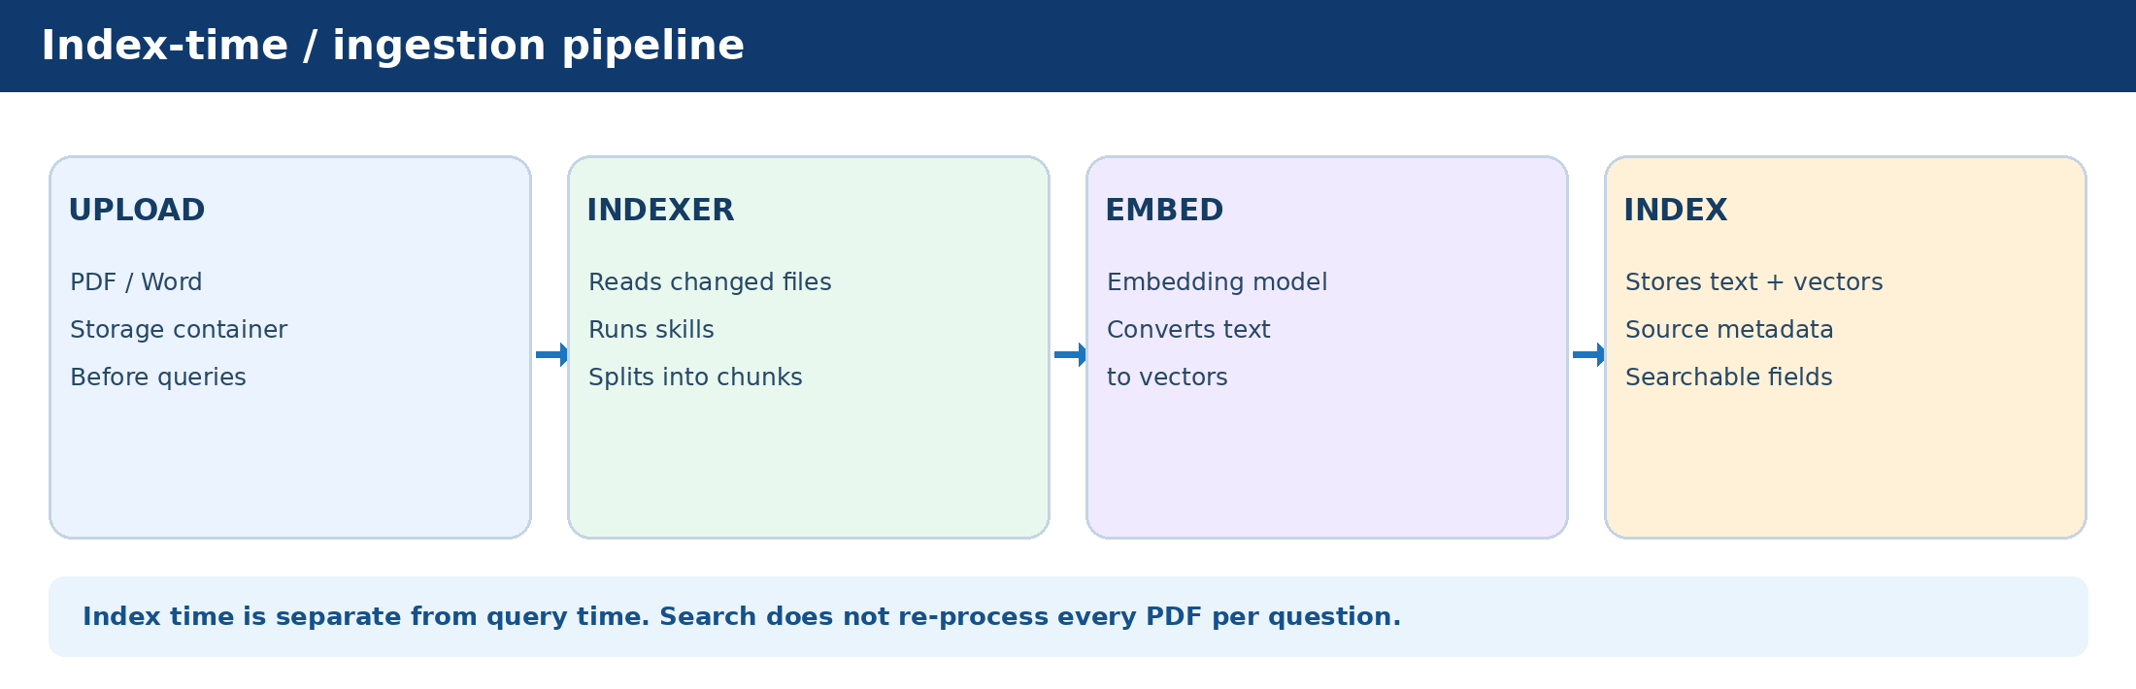
Figure 1. Indexing happens ahead of ordinary customer queries.

2.2 Why RAG appears in the Azure AI Search wizard
The Azure Portal offers an Import data scenario named RAG because it builds the data-ingestion and vector-search pipeline commonly used by RAG applications. Completing this wizard creates search objects; it does not, by itself, create your full chat UI, agent, prompt logic or business API integrations. Foundry IQ extends this with managed knowledge sources and knowledge bases, and Foundry Agent Service can connect to them.

2.3 Two separate execution paths
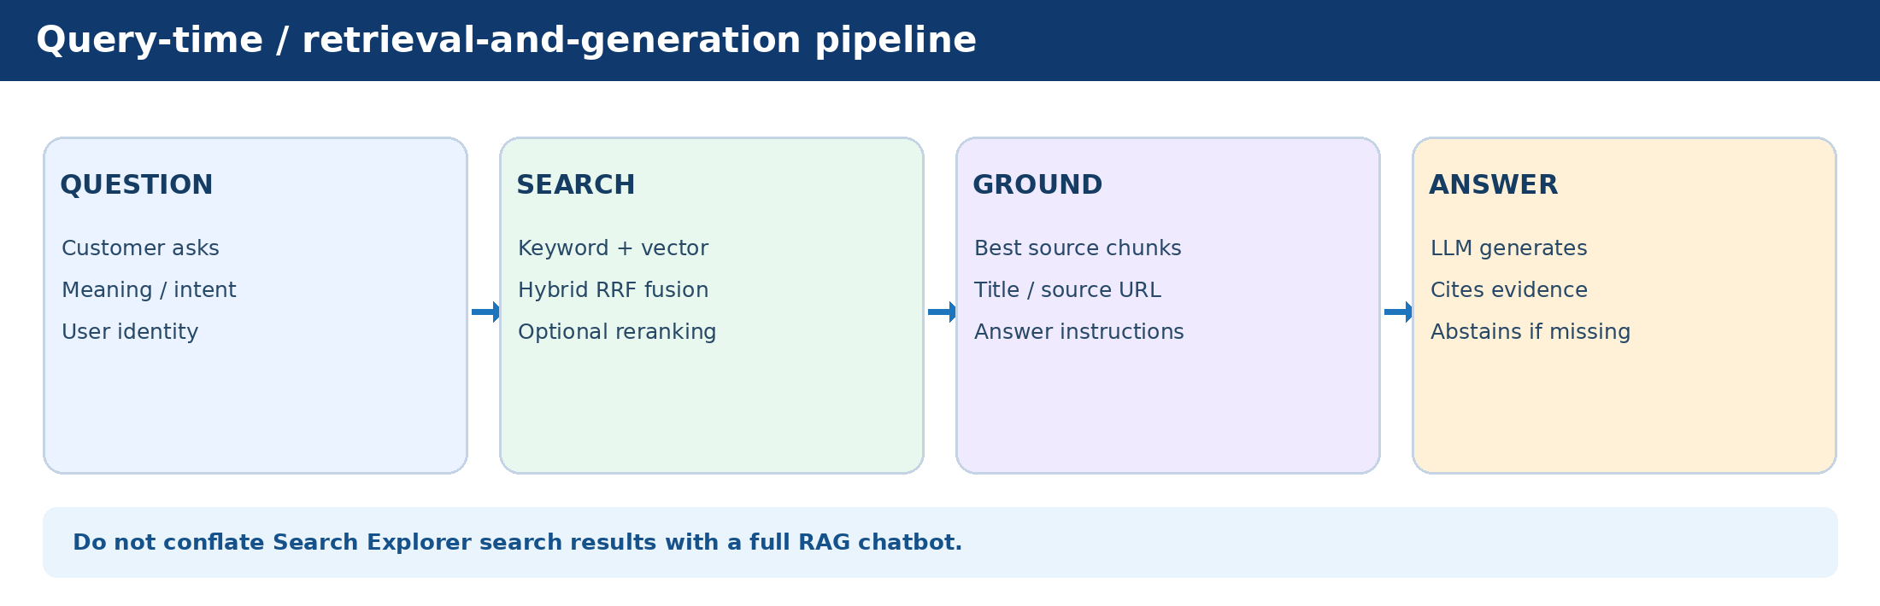
Figure 2. Query-time retrieval is separate from document ingestion.
Question | Correct teaching answer
Does indexing occur every customer query? | No. A query searches the existing index. Index updates run separately.
Is an indexer mandatory? | No. SDK/REST push APIs can upload indexed JSON directly.
Is semantic ranking RAG? | No. It reranks retrieved candidates; a separate generation stage is needed for typical RAG.
Does an orchestrator have to be an AI model? | No. It can be a deterministic application function or agent framework.
Can an agent use live stock counts? | Yes, with an authorized inventory/API tool, not by assuming a static SOP contains live state.

3 Prerequisites, choices and budget controls
This lab assumes permission to create resources and deploy models in an Azure subscription. For classroom environments, a trainer-managed subscription with explicitly delegated student access is preferable to unmanaged free trials. Never upload patient data, production credentials, or real business data into the demo.

3.1 Required resources and example names
Resource | Example | Notes
Resource group | rg-rag-training-01 | Use an approved group and region.
Storage account | straglab<unique> | General-purpose v2; unique lowercase name.
Blob container | rag-training-docs | Private container with three mock SOP PDFs.
Azure AI Search | srch-rag-lab-<unique> | Basic or above for this managed-identity quickstart.
Foundry project | prj-rag-training | Use new Foundry project if supported.
Embedding deployment | text-embedding-3-small | Supported embedding model; check region/quota.
Chat model deployment | gpt-5-mini (example) | Use any available model supported by your Foundry environment.
Index object prefix | rag-px101 | Wizard will generate related resource names.

3.2 Role checklist
Identity / role assignment | Scope | Purpose
Instructor: Search Service Contributor | Search service | Create/configure index and indexer
Instructor: Search Index Data Contributor + Reader | Search service | Index data operations and query
Search service MI: Storage Blob Data Reader | Storage account / container | Read uploaded training PDFs
Search service MI: Cognitive Services OpenAI User OR appropriate Foundry role | Embedding model resource | Call embedding deployment during indexing
Student/agent: Search Index Data Reader or feature-specific documented roles | Search service | Run retrieval; KB/agent configuration may require more roles
Student/agent: model invocation permission | Foundry / model resource | Call LLM at runtime

Managed identity reminder On the AI Search resource, enable System-assigned identity before role assignments. Use role-based access for production. Azure IAM role assignment requires adequate privilege, and propagation may take time. The Foundry IQ and agent connection roles vary by resource topology; follow linked Microsoft documentation.

3.3 Cost and availability
- Azure AI Search is provisioned compute billed independently of queries while the service exists; free tiers have constraints. An index and ingestion can consume storage and enrichment quota.
- Embedding generation, LLM requests, semantic ranking or AI enrichment may be billable. Model pricing, quotas, and free allowances vary by region and deployment.
- For a class, begin with three synthetic PDFs, choose Once indexer schedule, avoid image enrichment, monitor Cost Management, and clean up after evaluation.
- Some new Foundry IQ knowledge-base and agentic retrieval portal capabilities are preview-only. Do not assume they appear for every student tenant or region.

LAB 1 — Create Microsoft Foundry project and deploy models
Goal: create an authorized project, a chat model deployment, and an embedding deployment. Do not start with an agent until the models are available.
- Visit https://ai.azure.com. Sign in with the approved account and select the correct directory/subscription.
- Switch New Foundry ON if the toggle is shown. If the account shows only classic or hub-based projects, consult the migration guide and use the supported current project experience.
- Select the project name in the upper-left corner; choose Create new project. Enter prj-rag-training, select the approved resource group and location in Advanced options, and select Create project.
- Select Build → Models → Deploy → Deploy a base model. Choose an available chat-capable model (example: gpt-5-mini, subject to region/quota), then Deploy and record the deployment name.
- Deploy a supported embedding model (example: text-embedding-3-small). Record the deployment name, region and hosting resource; it is different from the chat model.
- Open Manage → Project details (or the equivalent current project details page). Record the project endpoint and validate your identity can use the models.
- Use the model playground to ask a simple non-sensitive question. This verifies model deployment but is not a RAG answer.
Checkpoint LAB 1 A chat model deployment and an embedding deployment are visible. Students can explain that the embedding model produces numbers and the chat model produces prose.

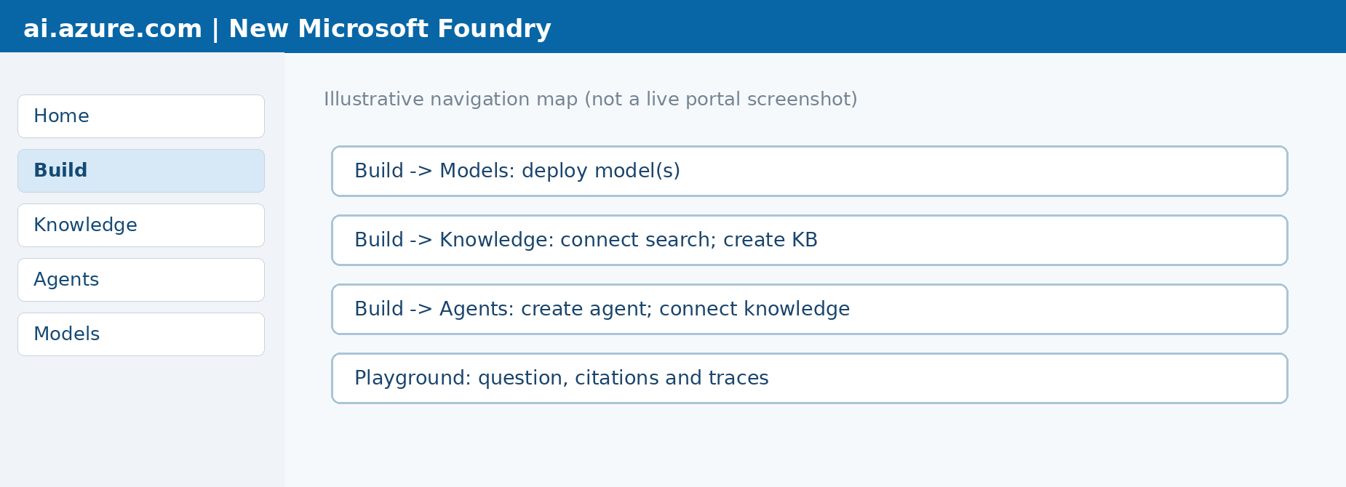
Illustrative current-navigation map only. It is NOT a screenshot from a live Foundry tenant.
Microsoft Learn current UI reference: https://learn.microsoft.com/en-us/azure/foundry/tutorials/quickstart-create-foundry-resources?tabs=portal

LAB 2 — Upload synthetic documents to Azure Blob Storage
- Open https://portal.azure.com → Storage accounts → Create. Use the approved subscription, resource group and region. Select Standard performance and general-purpose v2. Assign a globally unique lowercase name.
- After deployment, open the storage account → Data storage → Containers → + Container. Name it rag-training-docs and set public access to Private.
- Select the container → Upload. Upload the three PDFs from the companion ZIP: PX101_Cold_Chain_Training_SOP.pdf; PX101_Product_Catalog_Training.pdf; PX101_Quality_Exception_Training.pdf.
- Open each blob to verify it exists and its content matches synthetic training data. Do not make the container public for this lab.
- Confirm the blob service is reachable from Azure AI Search using approved network rules and RBAC. If the storage account is firewall-protected, coordinate with the admin.
Expected data SOP: PX-101 synthetic storage band 2–8 °C; Quality exception: if the demo sensor shows 10 °C, place mock batch on HOLD. Inventory CSV is NOT uploaded to the document index; it will be used later as an illustrative live-API substitute.

LAB 3 — Create Azure AI Search and configure identity
- Azure Portal → search for Azure AI Search → Create. Choose approved subscription/resource group, unique name and supported region. Select Basic tier or higher for the managed-identity steps in Microsoft’s vector quickstart.
- Open the created search service → Identity → System assigned → On → Save. Copy its principal ID if needed.
- On the storage account → Access control (IAM) → Add role assignment → Storage Blob Data Reader → select Managed identity → choose the AI Search resource identity → Assign.
- On the embedding resource, assign the documented invocation role to the search service managed identity. For an Azure OpenAI embedding resource, Microsoft lists Cognitive Services OpenAI User. For a Foundry project embedding provider, follow the current Foundry role mapping.
- On the search service, configure the instructor’s documented service and data permissions (Search Service Contributor, Search Index Data Contributor, Search Index Data Reader); enable role-based data access as appropriate.
- Verify networking: the import wizard requires access to storage and the embedding model. In restricted enterprise networks, use approved private networking and a programmatic ingestion fallback rather than disabling controls without authorization.
Checkpoint LAB 3 Search service is accessible, its system-assigned identity is enabled, and that identity can read the blob container and invoke the embedding model.

LAB 4 — Import data → RAG (Azure AI Search portal)
This lab follows Microsoft’s current unified Import data wizard. Use the screenshot supplied in the conversation as a UI example for Advanced settings. Button text may shift as the portal evolves.
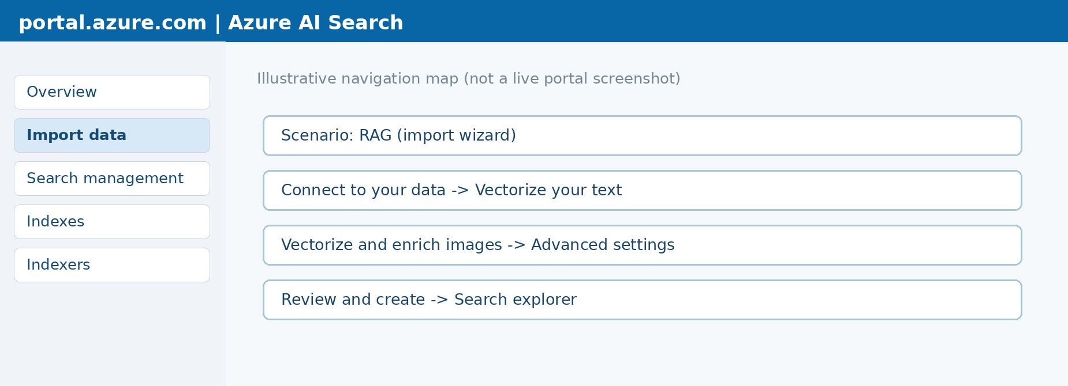
Illustrative Azure Portal navigation map (not an authentic screenshot).

Step A Start the wizard
- Open the Azure AI Search service → Overview → Import data. Choose the RAG scenario. Do not choose Multimodal RAG for this text-only lab.
- Choose Azure Blob Storage as the source. This corresponds to the training PDFs uploaded earlier.

Step B Connect to your data
- Choose subscription, storage account and rag-training-docs container. Select Authenticate using managed identity → System-assigned. Continue with Next.
- Enable deletion tracking only when you have deliberately configured supported soft-delete behavior. Otherwise leave it off for the introductory lab.

Step C Vectorize your text
- On Vectorize your text, select the correct embedding provider and model deployment. For a new Foundry project choose Microsoft Foundry where that option is offered, not a different resource type with an incompatible endpoint.
- Select system-assigned identity where supported, review the model-billing acknowledgment, and select Next.
- Discuss what happens internally: a skillset splits content into chunks and invokes the embedding model to write numeric vectors to the index.
Instructor detail: the Microsoft quickstart currently documents wizard-default Text Split settings around 2,000 characters with a 500-character overlap. These are characters, not tokens, and the particular portal version can change those defaults. Do not promise a tunable chunk-size control in this wizard.

Step D Vectorize and enrich your images
- For the text-only sample PDFs, leave image vectorization and OCR unchecked unless you intentionally want to demonstrate them and have the required additional resource/quota.

Step E Advanced settings
- Enable semantic ranker if the option and quota are available. This provides optional second-pass reranking at query time and may incur additional charges.
- Expand Preview and edit under Index fields. Locate generated fields such as chunk_id, chunk, title and text_vector; review searchable/retrievable properties. Avoid unneeded custom changes for this first lab.
- Under Schedule indexing select Once, so students can observe index freshness explicitly. Leave Microsoft-managed keys unless customer-managed-key requirements are part of an approved enterprise security lab.
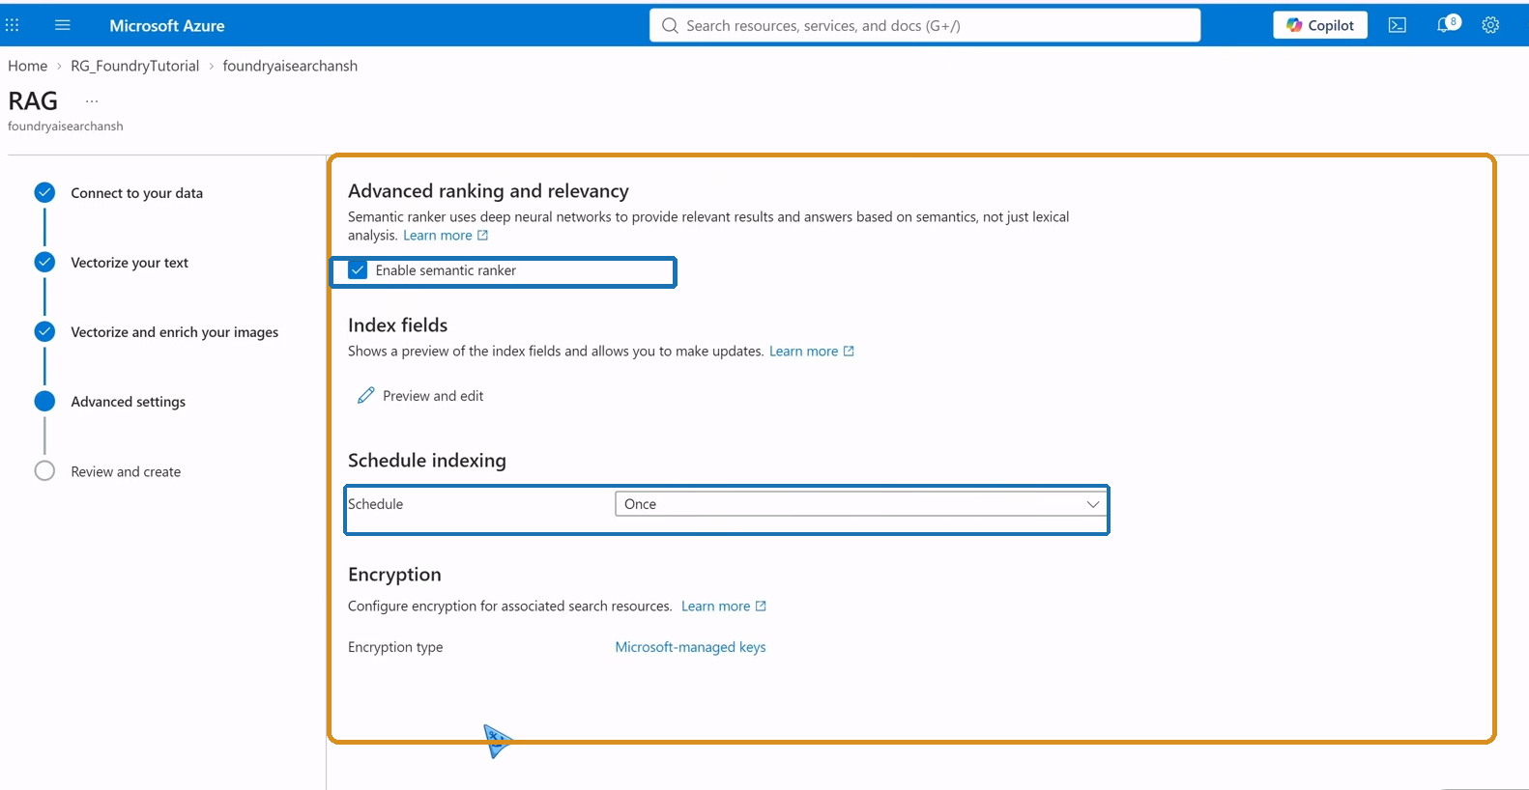
Actual Azure Portal advanced-settings screenshot provided by the user (Oct 2026); annotations added to semantic ranker and indexing schedule.

Step F Review and create
- Select Review and create → set object prefix rag-px101 → Create. Wait for the initial indexer run and inspect its status; creation alone is not proof that all data loaded successfully.
- Open Search management. Identify the index, data source, indexer and optional skillset. In Indexers, inspect execution status and errors/warnings.
Checkpoint LAB 4 At least one successful indexer run, a nonempty index, and a retrievable chunk from the mock SOP. The actual index field and generated object names may differ by wizard version.

Source: https://learn.microsoft.com/en-us/azure/search/search-get-started-portal-import-vectors

LAB 5 — Inspect index objects and understand what was created
- Search management → Indexes → open the generated index. Inspect the Fields tab. Identify the document key, source title, text content and vector field.
- Search management → Indexers → open the generated indexer. Check run history. Explain that the indexer pulls source changes and writes search documents to an index.
- Search management → Skillsets → open the generated skillset where available. Identify text splitting, embedding skill and index projections.
- Search management → Data sources → identify the connection to the training blob container. Explain that storage is the source of truth and the search index is optimized for retrieval.
- Have a student explain why deleting the source PDF alone may not immediately delete existing search chunks; deletion tracking/indexer behavior must be configured.

Index field vocabulary
Field (example) | Why important
chunk_id | Stable search document key
parent_id | Which source document chunk belongs to
chunk | Content returned to LLM for grounding
title | Human-readable document title / reference
text_vector | Stored embedding for vector retrieval
source URL / metadata | Citations, filtering, traceability

LAB 6 — Test keyword, vector and hybrid retrieval in Search Explorer
Before proceeding, verify the actual fields and semantic configuration names in your generated index. Query bodies below are templates; adjust to the generated schema.

Experiment 1 — Keyword query
- Azure Portal → search service → Indexes → open index → Search explorer. Change to JSON view if available.
- Submit the JSON below. Inspect document titles and returned chunk text. This is retrieval only; no generative chatbot is involved.
{
"search": "PX-101 storage temperature",
"select": "chunk,title",
"top": 5,
"count": true
}

Experiment 2 — Vector query (integrated vectorizer)
- Confirm that the index has a query-time text vectorizer assigned to text_vector. Then run a query such as the following. A vectorizer is required for kind=text; otherwise generate the vector separately.
{
"vectorQueries": [
{ "kind": "text", "text": "How cold should PX-101 be kept?",
"fields": "text_vector", "k": 5 }
],
"select": "chunk,title",
"top": 5
}

Experiment 3 — Hybrid query
- Combine a text search with a vectorizable-text vector query. Observe that the results can differ from pure keyword or vector search; Azure AI Search fuses their ranked lists using RRF.
{
"search": "PX-101 cold-chain requirements",
"vectorQueries": [
{ "kind": "text", "text": "How should PX-101 be refrigerated?",
"fields": "text_vector", "k": 5 }
],
"select": "chunk,title",
"top": 5
}

Experiment 4 — Semantic reranking (optional)
- Only if a semantic configuration exists: add queryType: semantic and semanticConfiguration: <actual-configuration-name> to a supported text or hybrid query. Compare result ordering and optional captions.
- Record top titles and evidence from the four modes. Do not compare raw @search.score values across different search types as if they were one universal probability; each ranking mechanism has its own score scale.
Expected observation Keyword favors lexical matches; vector can retrieve semantically similar paraphrases; hybrid combines both; semantic reranking may reorder a candidate set. None of these four steps inherently requires the LLM to write a final answer.

LAB 7 — Prove that indexing and query execution are separate
- Keep the indexer schedule as Once. Run a query about a new code, PX-404, which does not exist. Note absence of reliable evidence.
- Upload a new fictional PX-404 document into rag-training-docs (or update one of the demo PDFs) but do not run the indexer yet.
- Run the same query immediately. Explain that the uploaded file may not yet be searchable because the index has not been refreshed.
- Search management → Indexers → select the demo indexer → Run. Inspect execution history until success, then repeat the query.
- For a more realistic environment, configure a periodic indexer schedule or an approved event-driven ingestion pipeline. Discuss update and deletion latency.
Trainer demonstration An indexer does not run on every customer query. Index refresh and query execution are separate operations; RAG answers can therefore lag behind updates until the index catches up.

LAB 8 — New Microsoft Foundry → Knowledge → Agents
This is the managed-knowledge route (Foundry IQ). It adds a knowledge source and knowledge base on top of search, with an agent as the conversational layer. Availability depends on supported service/region, RBAC and feature stage. Portal workflows can use preview APIs, which can change.

Path A — New Foundry UI
- Open https://ai.azure.com → New Foundry ON → select your approved project → Build.
- Select Knowledge. If requested, connect to a compatible Azure AI Search resource using the resource selector and Connect. If the Search service does not support agentic retrieval in your region/tier, use the documented Azure portal alternative or complete Labs 1–7.
- Select Create knowledge base (name example: kb-px101-training). Add a knowledge source of type Azure AI Search index if exposed in your UI, and select the index created in LAB 4. Alternatively, choose supported Azure Blob Storage indexed source, which may automatically create separate ingestion objects.
- Verify model deployments and identity access required by that knowledge source and knowledge base. Select appropriate retrieval configuration (for example, lower reasoning effort for simple questions and supported output modes), then Save/Create.
- Use the knowledge base playground, if available, to ask “What temperature is PX-101 stored at?” and inspect the returned sources.
- Go to Build → Agents → create a new agent with a supported deployed chat model. In the agent setup find Knowledge → Add; connect kb-px101-training. This is not the same as simply attaching random text to a prompt.
- Configure the system instructions from LAB 9, save the agent, open Playground, and send questions from test_questions.txt. Inspect any source citations, trace steps and failed tool calls.
Illustrative navigation only: Foundry tab group labels may change between deployments.

Path B — Azure Portal Agentic retrieval fallback
- In your Azure AI Search service, look for Agentic retrieval → Knowledge sources. Choose Add knowledge source and reference an eligible existing search index or supported indexed Azure Blob source.
- Under Agentic retrieval → Knowledge bases, create a KB, select the knowledge source and an LLM deployment if requested, and configure supported retrieval/answer settings.
- Test in the knowledge-base playground if the feature is available. Then return to Microsoft Foundry to connect the knowledge base to an agent. KB creation by itself is not agent configuration.
Important distinction The Azure AI Search import wizard’s RAG scenario and Foundry IQ knowledge base are different capabilities. A traditional RAG solution can use an ordinary index without a knowledge base. Agentic retrieval may additionally plan subqueries and synthesize answers, depending on configuration.

Current Microsoft Learn: https://learn.microsoft.com/en-us/azure/foundry/agents/concepts/what-is-foundry-iq
Agent integration: https://learn.microsoft.com/en-us/azure/foundry/agents/how-to/foundry-iq-connect

LAB 9 — Write instructions for the agent
Set the agent instructions to the following example. Explain to learners that the agent still needs access to a real knowledge tool; instructions cannot themselves fetch PDFs.
You are a synthetic pharma training assistant.
Use connected knowledge sources for documented PX-101/PX-202 policies.
For each factual claim about the training SOP, cite the supporting document.
If retrieved documents do not answer a question, say you cannot verify it.
Never invent live stock levels or imply that cached PDFs are a real-time ERP.
For live stock, call an authorized inventory tool if connected.
Never provide real clinical decisions; this lab uses fictional training data.
- Test “What is PX-101 storage temperature?” The response should reference the training SOP and its synthetic 2–8 °C value.
- Test “Do we currently have 500 PX-101 units?” Without an authorized inventory tool, a correct answer is “I cannot verify live stock from the indexed SOP documents.”
- Test an unsupported topic; the system should abstain, not invent a source.

LAB 10 — Optional code: write the orchestrator (Azure Cloud Shell)
Use this extension after the portal route works. The script is included in the companion ZIP. It demonstrates a deterministic developer-written orchestrator: Search → context assembly → Azure OpenAI → response. This is not the managed Foundry IQ agent. It expects an index vectorizer and uses Microsoft Entra authentication.
- Open Azure Portal → Cloud Shell (Bash). Choose a storage-backed shell if required by your tenant or use the approved environment; ensure Python 3.10+ and pip are available.
- Copy rag_orchestrator_demo.py from the companion files into the shell using Cloud Shell Upload/Manage files. For the demo, do not paste credentials into code.
- Install supported packages (in a writable environment):
python -m pip install --user --upgrade azure-identity azure-search-documents openai
- Set environment variables using your actual resource values. Use the Azure OpenAI endpoint of the model hosting resource, not the Foundry project endpoint. This sample uses the AzureOpenAI-compatible chat endpoint.
export SEARCH_ENDPOINT="https://<your-search-service>.search.windows.net"
export SEARCH_INDEX="<actual-generated-index-name>"
export AZURE_OPENAI_ENDPOINT="https://<your-openai-resource>.openai.azure.com"
export CHAT_DEPLOYMENT="<your-chat-deployment-name>"
export AZURE_OPENAI_API_VERSION="2024-10-21"
- Verify identity permissions: current Cloud Shell user needs Search Index Data Reader and Cognitive Services OpenAI User (or corresponding model/resource access). The text_vector field must have a query-time vectorizer. For many users, Azure Cloud Shell can rely on Azure CLI identity under DefaultAzureCredential.
- Execute python rag_orchestrator_demo.py, ask the PX-101 question, and inspect retrieved source chunks and the generated answer. If vector query fails, check the index vectorizer and field name; try keyword-only Search Explorer first.
- Explain each line at a high level: credentials authenticate; SearchClient retrieves; the orchestrator builds a bounded context; AzureOpenAI generates text; printed sources help audit output.
Model / API compatibility This optional demo uses the AzureOpenAI SDK interface with an Azure OpenAI deployment and an API version compatible with that resource. For other Foundry-hosted models or v1 Responses APIs, adapt the client according to that model’s official endpoint documentation. Do not assume every model uses AzureOpenAI.

Optional business tool extension: mock inventory
The included demo_inventory.csv contains a fixed fictional snapshot: PX-101 = 520 units. It represents an ERP/API response for classroom discussion only. In production, a separately authorized inventory tool would fetch current data at query time; it should not be inferred from a vector index.

11 Troubleshooting playbook
Symptom | Likely reason | First action
No Foundry Knowledge tab | Wrong project type, feature or region | Switch New Foundry, check resource support, use documented Azure portal fallback
No agent creation for students | Missing project/model role or unsupported region | Confirm Foundry RBAC and model availability; ask tenant admin
Cannot select embedding model | Unsupported model provider, wrong region, quota | Deploy compatible embedding model and verify deployment/role
403 reading Blob | Search managed identity missing Storage Blob Data Reader | Assign role at correct scope and wait for propagation
Indexer failed | Network, skillset, quota, blob parsing | Open indexer execution history and inspect exact failure
Search Explorer has no documents | Indexer never completed or wrong index | Check document count and indexer execution
kind=text vector query fails | No query-time vectorizer or wrong text_vector field | Inspect index JSON and change query or add vectorizer
Missing citations | No retrievable title/source or no KB/tool link | Inspect index fields and agent knowledge configuration
Hallucination | Weak retrieval, broad prompt, low-quality corpus | Add abstention and test retrieved evidence
Answer is stale | Indexer not run since source changed | Rerun or schedule indexer; check freshness timestamps
Access denied to agent/KB | Cross-service RBAC / connection identity | Review knowledge source and Foundry roles
Unexpected bill | Search provisioned, model calls/enrichment | Use Cost Management; delete unused services

12 Assessment and student capstone acceptance checklist
☐ Can distinguish search index, indexer, Search Explorer, RAG and AI orchestrator.
☐ Can explain index time vs query time with an example.
☐ Has uploaded only synthetic documents and successfully indexed them.
☐ Can run keyword and vector or hybrid queries and interpret the retrieved chunks.
☐ Can explain why semantic ranking is not a generative chatbot.
☐ Can inspect the source title for a citation and refuse unknown answers.
☐ Has connected a knowledge base / agent if region and permissions permit.
☐ Has verified that live inventory is not fabricated from static PDFs.
☐ Has demonstrated at least one new-document index refresh.
☐ Has removed or stopped billable resources in accordance with instructor policy.

Sample evaluation rubric
Area | Weight | Pass criteria
Indexing and fields | 20% | Index populated with relevant chunks and source
Search relevance | 20% | Compares retrieval modes and explains results
RAG grounding | 25% | Answers cite evidence and abstain when missing
Orchestration | 20% | Describes tools/API/LLM flow and error handling
Security, cost and cleanup | 15% | RBAC explained; no secrets/real PHI; cleanup evidenced

13 Wrap-up: the six most important answers
- Azure AI Search does not intrinsically need RAG; it retrieves indexed documents.
- RAG is a pattern: retrieve, augment the prompt, then generate with a model.
- The AI orchestrator is the application coordination layer, often written by the developer.
- An indexer is for ingestion; an index stores search-ready content.
- Customer queries normally search an existing index, not all source PDFs.
- Foundry IQ can manage knowledge bases and agentic retrieval, but its UI and previews are distinct from the basic RAG import wizard.

14 Official Microsoft reference URLs and screenshot guidance
These links were checked for this guide on 30 October 2026. They include official UI imagery and changing details; refer to them if a portal screen differs from the navigation maps. The supplied Azure Advanced settings image is an actual user screenshot. The other two navigation maps are educational reconstructions and should not be presented as actual UI captures.
- New Foundry project and model deployment: https://learn.microsoft.com/en-us/azure/foundry/tutorials/quickstart-create-foundry-resources?tabs=portal
- New Foundry navigation / classic differences: https://learn.microsoft.com/en-us/azure/foundry/how-to/navigate-from-classic
- Azure AI Search unified import data wizard: https://learn.microsoft.com/en-us/azure/search/search-import-data-portal
- Azure AI Search integrated vectorization quickstart: https://learn.microsoft.com/en-us/azure/search/search-get-started-portal-import-vectors
- Foundry IQ workflow (Build > Knowledge > Agents): https://learn.microsoft.com/en-us/azure/foundry/agents/concepts/what-is-foundry-iq
- Foundry IQ knowledge bases with agents: https://learn.microsoft.com/en-us/azure/foundry/agents/how-to/foundry-iq-connect
- Azure AI Search agent tool in Foundry: https://learn.microsoft.com/en-us/azure/foundry/agents/how-to/tools/ai-search
- Agentic retrieval in Azure portal: https://learn.microsoft.com/en-us/azure/search/get-started-portal-agentic-retrieval
- RAG and indexes concept: https://learn.microsoft.com/en-us/azure/foundry/concepts/retrieval-augmented-generation
End of guide • Facilitator: use the companion synthetic PDFs, question bank, inventory CSV and Python demonstration.

