Ex. No. : 01A Date: 30-01-2026
Register No.: 231701054 Name: Srinivasan S

GUI Components
Aim
Develop an application to change the font and color of the text and display toast message when the user presses the button.
Procedure:

- Create a empty basic view in this android studio.
- In activity_main.xml go to designer tab and design the required components.
- After designing go to the code tab in activity_main.xml and change the code desired
- Make sure the application runs before moving forward or starting.
- After that go to mainactivity and edit the code.
- Change it into linear layout or other to the content.
- Add val and vars and give the application its function.
- After that run the application and test the application.
- If any problem or error rerun it or recheck the codes.

AndroidManifest.xml
<?xml version="1.0" encoding="utf-8"?>
<manifest xmlns:android="http://schemas.android.com/apk/res/android"
xmlns:tools="http://schemas.android.com/tools">
<application
android:allowBackup="true"
android:dataExtractionRules="@xml/data_extraction_rules"
android:fullBackupContent="@xml/backup_rules"
android:icon="@mipmap/ic_launcher"
android:label="@string/app_name"
android:roundIcon="@mipmap/ic_launcher_round"
android:supportsRtl="true"
android:theme="@style/Theme.MyApplication">
<activity
android:name=".MainActivity"
android:exported="true">
<intent-filter>
<action android:name="android.intent.action.MAIN" />
<category android:name="android.intent.category.LAUNCHER" />
</intent-filter>
</activity>
</application>
</manifest>

Activity_main.xml
<?xml version="1.0" encoding="utf-8"?>
<LinearLayout xmlns:android="http://schemas.android.com/apk/res/android"
xmlns:app="http://schemas.android.com/apk/res-auto"
xmlns:tools="http://schemas.android.com/tools"
android:id="@+id/main"
android:orientation="vertical"
android:layout_width="match_parent"
android:layout_height="match_parent"
tools:context=".MainActivity">
<TextView
android:id="@+id/textView"
android:layout_width="match_parent"
android:layout_height="wrap_content"
android:text="231701054 Srinivasan"
android:textAlignment="center" />
<Button
android:id="@+id/changesize"
android:layout_width="match_parent"
android:layout_height="49dp"
android:text="changesize"
tools:layout_editor_absoluteX="35dp"
tools:layout_editor_absoluteY="339dp" />
<Button
android:id="@+id/changecolor"
android:layout_width="match_parent"
android:layout_height="49dp"
android:text="changecolor"
tools:layout_editor_absoluteX="35dp"
tools:layout_editor_absoluteY="500dp" />
<Button
android:id="@+id/changebgcolor"
android:layout_width="match_parent"
android:layout_height="49dp"
android:text="changebgcolor"
tools:layout_editor_absoluteX="35dp"
tools:layout_editor_absoluteY="413dp" />
</LinearLayout>

MainActivity.kt
package com.example.myapplication
import android.graphics.Color
import android.os.Bundle
import android.provider.CalendarContract
import android.widget.Button
import android.widget.LinearLayout
import android.widget.TextView
import androidx.activity.enableEdgeToEdge
import androidx.appcompat.app.AppCompatActivity
import androidx.core.view.ViewCompat
import androidx.core.view.WindowInsetsCompat
class MainActivity : AppCompatActivity() {
override fun onCreate(savedInstanceState: Bundle?) {
super.onCreate(savedInstanceState)
enableEdgeToEdge()
setContentView(R.layout.activity_main)
val main : LinearLayout = findViewById(R.id.main)
val textView : TextView=findViewById(R.id.textView)
val changesize : Button = findViewById(R.id.changesize)
val changecolor : Button = findViewById(R.id.changecolor)
val changebgcolor : Button = findViewById(R.id.changebgcolor)
var size=50f
changesize.setOnClickListener {
textView.textSize= size
size=size+5
}
var count1 = 0
changecolor.setOnClickListener {
when(count1%6)
{
0 -> textView.setTextColor(Color.BLUE)
1 -> textView.setTextColor(Color.RED)
2 -> textView.setTextColor(Color.GREEN)
3 -> textView.setTextColor(Color.MAGENTA)
4 -> textView.setTextColor(Color.YELLOW)
5 -> textView.setTextColor(Color.BLACK)
}
count1++
}
var count2 = 0
changebgcolor.setOnClickListener {
when(count2%3)
{
0 -> main.setBackgroundColor(Color.LTGRAY)
1 -> main.setBackgroundColor(Color.RED)
2 -> main.setBackgroundColor(Color.CYAN)
}
count2++
}
}
}

Output
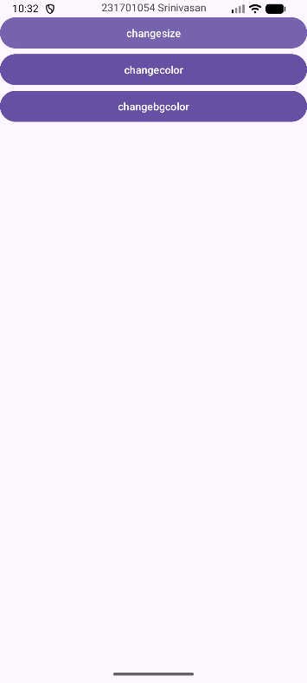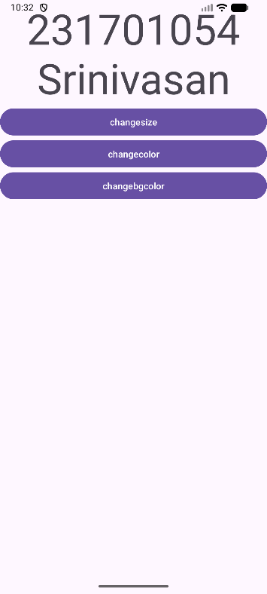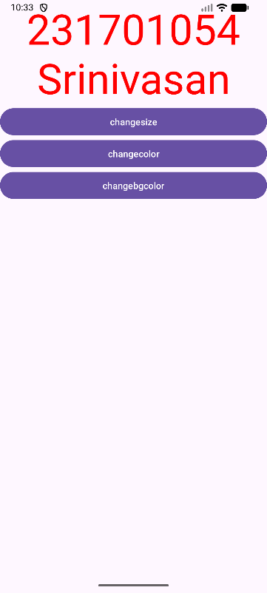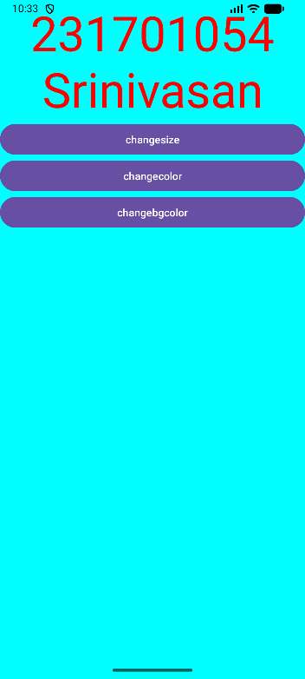

Result:
The desired GUI is created and tested. the application runs without error.

