Ex. No. : 01C Date: 30-01-2026
Register No.: 231701054 Name: Srinivasan S

BMI Calculator
Aim
Create an app that calculates the Body Mass Index (BMI) based on user input for weight and height in EditText fields. The result is displayed in a TextView after pressing a Button.

Procedure:

- Create a empty basic view in this android studio.
- In activity_main.xml go to designer tab and design the required components.
- After designing go to the code tab in activity_main.xml and change the code desired
- Make sure the application runs before moving forward or starting.
- After that go to mainactivity and edit the code.
- Change it into linear layout or other to the content.
- Add val and vars and give the application its function.
- After that run the application and test the application.
If any problem or error rerun it or recheck the codes

AndroidManifest.xml:
<?xml version="1.0" encoding="utf-8"?>
<manifest xmlns:android="http://schemas.android.com/apk/res/android"
xmlns:tools="http://schemas.android.com/tools">
<application
android:allowBackup="true"
android:dataExtractionRules="@xml/data_extraction_rules"
android:fullBackupContent="@xml/backup_rules"
android:icon="@mipmap/ic_launcher"
android:label="@string/app_name"
android:roundIcon="@mipmap/ic_launcher_round"
android:supportsRtl="true"
android:theme="@style/Theme.MyApplication">
<activity
android:name=".MainActivity"
android:exported="true">
<intent-filter>
<action android:name="android.intent.action.MAIN" />
<category android:name="android.intent.category.LAUNCHER" />
</intent-filter>
</activity>
</application>
</manifest>

Activity_main.xml:
<?xml version="1.0" encoding="utf-8"?>
<LinearLayout xmlns:android="http://schemas.android.com/apk/res/android"
xmlns:app="http://schemas.android.com/apk/res-auto"
xmlns:tools="http://schemas.android.com/tools"
android:id="@+id/main"
android:orientation="vertical"
android:layout_width="match_parent"
android:layout_height="match_parent"
tools:context=".MainActivity">
<EditText
android:id="@+id/weight"
android:layout_width="match_parent"
android:layout_height="wrap_content"
android:ems="10"
android:hint="weight"
android:textAlignment="center"
android:inputType="numberDecimal" />
<EditText
android:id="@+id/height"
android:layout_width="match_parent"
android:layout_height="wrap_content"
android:ems="10"
android:hint="height"
android:textAlignment="center"
android:inputType="numberDecimal" />
<RadioGroup
android:id="@+id/unitGroup"
android:layout_width="match_parent"
android:layout_height="wrap_content"
android:orientation="horizontal"
android:gravity="center">
<RadioButton
android:id="@+id/CM"
android:text="CM" />
<RadioButton
android:id="@+id/Meter"
android:text="Meter" />
</RadioGroup>
<Button
android:id="@+id/Calculate"
android:layout_width="match_parent"
android:layout_height="wrap_content"
android:text="Calculate"
android:textAlignment="center" />
<TextView
android:id="@+id/result"
android:layout_width="match_parent"
android:layout_height="wrap_content"
android:textAlignment="center"
android:textSize="48sp" />
</LinearLayout>

MainActivity.kt:
package com.example.myapplication
import android.os.Bundle
import android.widget.Button
import android.widget.RadioButton
import android.widget.TextView
import androidx.activity.enableEdgeToEdge
import androidx.appcompat.app.AppCompatActivity
import androidx.core.view.ViewCompat
import androidx.core.view.WindowInsetsCompat
class MainActivity : AppCompatActivity() {
override fun onCreate(savedInstanceState: Bundle?) {
super.onCreate(savedInstanceState)
enableEdgeToEdge()
setContentView(R.layout.activity_main)
val weight : TextView = findViewById(R.id.weight)
val height : TextView = findViewById(R.id.height)
val CM : RadioButton = findViewById(R.id.CM)
val Meter : RadioButton = findViewById(R.id.Meter)
val Calculate : Button = findViewById(R.id.Calculate)
val result : TextView = findViewById(R.id.result)
Calculate.setOnClickListener {
val weightValue = weight.text.toString().toFloat()
var heightValue = height.text.toString().toFloat()
if (CM.isChecked) {
heightValue /= 100
}
if (Meter.isChecked) {
heightValue = heightValue
}
val bmi = weightValue / (heightValue * heightValue)
result.text = String.format("%.2f Kg/m²", bmi)
}
}
}

Output:
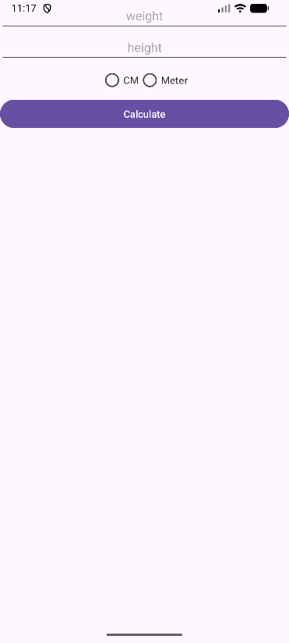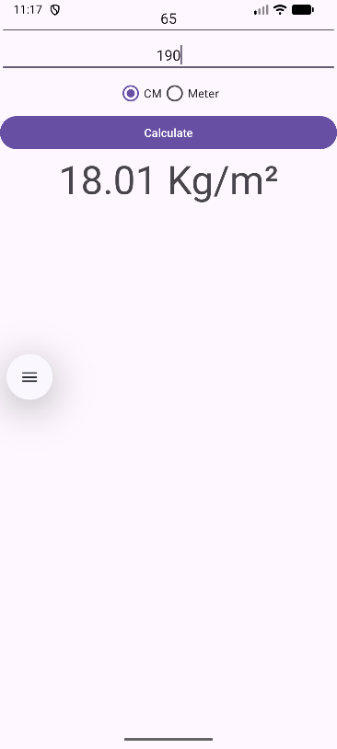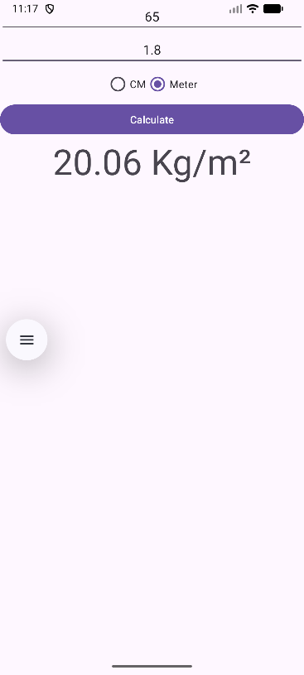

Result:
The desired BMI Calculator is created and tested. the application runs without error.

