Ex. No. : 01D Date: 30-01-2026
Register No.: 231701054 Name: Srinivasan S

Temperature Convertor
Aim
Create an app that converts temperatures between Celsius and Fahrenheit. Users can enter a temperature in an EditText, press a Button to perform the conversion, and see the result in a TextView.
Procedure:

- Create a empty basic view in this android studio.
- In activity_main.xml go to designer tab and design the required components.
- After designing go to the code tab in activity_main.xml and change the code desired
- Make sure the application runs before moving forward or starting.
- After that go to mainactivity and edit the code.
- Change it into linear layout or other to the content.
- Add val and vars and give the application its function.
- After that run the application and test the application.
If any problem or error rerun it or recheck the codes

AndroidManifest.xml:
<?xml version="1.0" encoding="utf-8"?>
<manifest xmlns:android="http://schemas.android.com/apk/res/android"
xmlns:tools="http://schemas.android.com/tools">
<application
android:allowBackup="true"
android:dataExtractionRules="@xml/data_extraction_rules"
android:fullBackupContent="@xml/backup_rules"
android:icon="@mipmap/ic_launcher"
android:label="@string/app_name"
android:roundIcon="@mipmap/ic_launcher_round"
android:supportsRtl="true"
android:theme="@style/Theme.TemperatureConverter">
<activity
android:name=".MainActivity"
android:exported="true">
<intent-filter>
<action android:name="android.intent.action.MAIN" />
<category android:name="android.intent.category.LAUNCHER" />
</intent-filter>
</activity>
</application>
</manifest>

Activity_main.xml:
<?xml version="1.0" encoding="utf-8"?>
<LinearLayout xmlns:android="http://schemas.android.com/apk/res/android"
xmlns:app="http://schemas.android.com/apk/res-auto"
xmlns:tools="http://schemas.android.com/tools"
android:id="@+id/main"
android:orientation="vertical"
android:layout_width="match_parent"
android:layout_height="match_parent"
tools:context=".MainActivity">
<TextView
android:id="@+id/toptitle"
android:layout_width="match_parent"
android:layout_height="wrap_content"
android:textAlignment="center"
android:textSize="25dp"
android:text="TEMPERATURE CONVERTER" />
<EditText
android:id="@+id/Entervalue"
android:layout_width="match_parent"
android:layout_height="wrap_content"
android:ems="10"
android:textAlignment="center"
android:textSize="20dp"
android:hint="ENTER VALUE"
android:inputType="number" />
<TextView
android:id="@+id/choosing"
android:layout_width="match_parent"
android:layout_height="wrap_content"
android:textAlignment="center"
android:textSize="15dp"
android:text="CHOOSE THE VALUE TYPE" />
<RadioGroup
android:id="@+id/unitGroup"
android:layout_width="match_parent"
android:layout_height="wrap_content"
android:orientation="horizontal"
android:gravity="center">
<RadioButton
android:id="@+id/Celsius"
android:text="Celsius" />
<RadioButton
android:id="@+id/Fahrenheit"
android:text="Fahrenheit" />
<RadioButton
android:id="@+id/Kelvin"
android:text="Kelvin" />
</RadioGroup>
<Button
android:id="@+id/Calculate"
android:layout_width="match_parent"
android:layout_height="wrap_content"
android:text="Calculate" />
<TextView
android:id="@+id/Cvalue"
android:textAlignment="center"
android:textSize="25dp"
android:layout_width="match_parent"
android:layout_height="wrap_content" />
<TextView
android:id="@+id/Fvalue"
android:textAlignment="center"
android:textSize="25dp"
android:layout_width="match_parent"
android:layout_height="wrap_content" />
<TextView
android:id="@+id/Kvalue"
android:textAlignment="center"
android:textSize="25dp"
android:layout_width="match_parent"
android:layout_height="wrap_content" />
<Button
android:id="@+id/clear"
android:layout_width="match_parent"
android:layout_height="wrap_content"
android:text="clear" />
</LinearLayout>

MainActivity.kt:
package com.example.temperatureconverter
import android.os.Bundle
import android.widget.Button
import android.widget.RadioButton
import android.widget.TextView
import androidx.activity.enableEdgeToEdge
import androidx.appcompat.app.AppCompatActivity
import androidx.core.view.ViewCompat
import androidx.core.view.WindowInsetsCompat
class MainActivity : AppCompatActivity() {
override fun onCreate(savedInstanceState: Bundle?) {
super.onCreate(savedInstanceState)
enableEdgeToEdge()
setContentView(R.layout.activity_main)
val Entervalue: TextView = findViewById(R.id.Entervalue)
val Celsius: RadioButton = findViewById(R.id.Celsius)
val Fahrenheit: RadioButton = findViewById(R.id.Fahrenheit)
val Kelvin: RadioButton = findViewById(R.id.Kelvin)
val Calculate: Button = findViewById(R.id.Calculate)
val Cvalue: TextView = findViewById(R.id.Cvalue)
val Fvalue: TextView = findViewById(R.id.Fvalue)
val Kvalue: TextView = findViewById(R.id.Kvalue)
val clear: TextView = findViewById(R.id.clear)
Calculate.setOnClickListener {
val input = Entervalue.text.toString().toDouble()
if (Celsius.isChecked) {
val c = input
val f = (c * 9 / 5) + 32
val k = c + 273.15
Cvalue.text = String.format("Celsius : %.2f °C",c)
Fvalue.text = String.format("Fahrenheit : %.2f °F",f)
Kvalue.text = String.format("Kelvin : %.2f K",k)
}
else if (Fahrenheit.isChecked) {
val f = input
val c = (f - 32) * 5 / 9
val k = c + 273.15
Cvalue.text = String.format("Celsius : %.2f °C",c)
Fvalue.text = String.format("Fahrenheit : %.2f °F",f)
Kvalue.text = String.format("Kelvin : %.2f K",k)
}
else if (Kelvin.isChecked) {
val k = input
val c = k - 273.15
val f = (c * 9 / 5) + 32
Cvalue.text = String.format("Celsius : %.2f °C",c)
Fvalue.text = String.format("Fahrenheit : %.2f °F",f)
Kvalue.text = String.format("Kelvin : %.2f K",k)
}
}
clear.setOnClickListener {
Cvalue.text = String.format("")
Fvalue.text = String.format("")
Kvalue.text = String.format("")
}
}
}

Output:
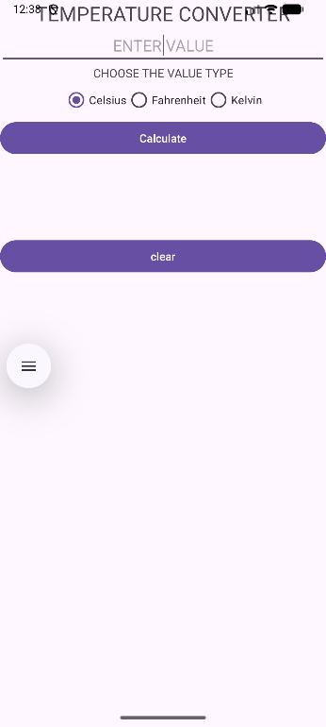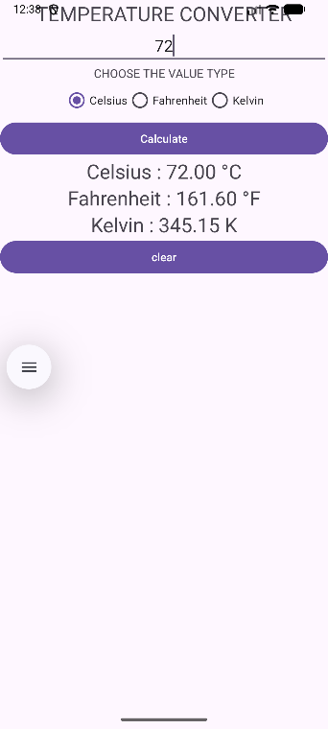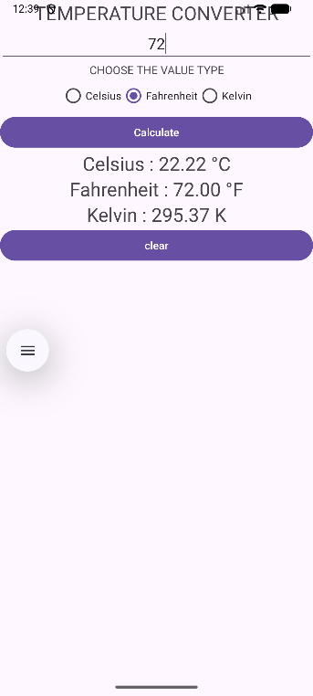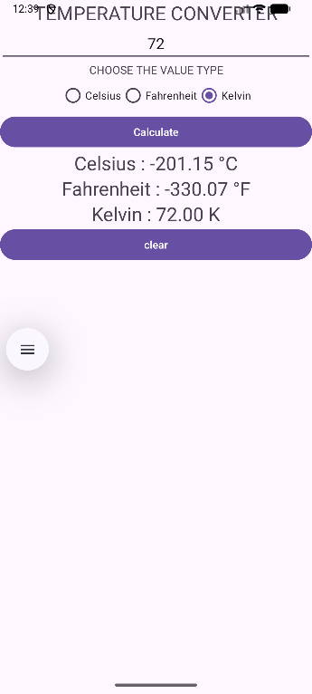

Result:
The desired TEMPERATURE Converter is created and tested. the application runs without error.

