Ex. No. : 01B Date: 30-01-2026
Register No.: 231701054 Name: Srinivasan S

Check In & Check Out
Aim
Develop an application for Tech Lounge Check in / Check out App. to count number of students inside the block.
Procedure:

- Create a empty basic view in this android studio.
- In activity_main.xml go to designer tab and design the required components.
- After designing go to the code tab in activity_main.xml and change the code desired
- Make sure the application runs before moving forward or starting.
- After that go to mainactivity and edit the code.
- Change it into linear layout or other to the content.
- Add val and vars and give the application its function.
- After that run the application and test the application.
If any problem or error rerun it or recheck the codes

AndroidManifest.xml
<?xml version="1.0" encoding="utf-8"?>
<manifest xmlns:android="http://schemas.android.com/apk/res/android"
xmlns:tools="http://schemas.android.com/tools">
<application
android:allowBackup="true"
android:dataExtractionRules="@xml/data_extraction_rules"
android:fullBackupContent="@xml/backup_rules"
android:icon="@mipmap/ic_launcher"
android:label="@string/app_name"
android:roundIcon="@mipmap/ic_launcher_round"
android:supportsRtl="true"
android:theme="@style/Theme.MyApplication">
<activity
android:name=".MainActivity"
android:exported="true">
<intent-filter>
<action android:name="android.intent.action.MAIN" />
<category android:name="android.intent.category.LAUNCHER" />
</intent-filter>
</activity>
</application>
</manifest>

Activity_main.xml
<?xml version="1.0" encoding="utf-8"?>
<LinearLayout xmlns:android="http://schemas.android.com/apk/res/android"
xmlns:app="http://schemas.android.com/apk/res-auto"
xmlns:tools="http://schemas.android.com/tools"
android:id="@+id/main"
android:orientation="vertical"
android:layout_width="match_parent"
android:layout_height="match_parent"
tools:context=".MainActivity">
<TextView
android:id="@+id/number"
android:layout_width="match_parent"
android:layout_height="wrap_content"
android:text="0"
android:textSize="200dp"
android:textAlignment="center" />
<Button
android:id="@+id/cincrease"
android:layout_width="match_parent"
android:layout_height="wrap_content"
android:text="cincrease" />
<Button
android:id="@+id/cdecrease"
android:layout_width="match_parent"
android:layout_height="wrap_content"
android:text="cdecrease" />
</LinearLayout>

MainActivity.kt
package com.example.myapplication
import android.os.Bundle
import android.widget.Button
import android.widget.TextView
import androidx.activity.enableEdgeToEdge
import androidx.appcompat.app.AppCompatActivity
import androidx.core.view.ViewCompat
import androidx.core.view.WindowInsetsCompat
class MainActivity : AppCompatActivity() {
override fun onCreate(savedInstanceState: Bundle?) {
super.onCreate(savedInstanceState)
enableEdgeToEdge()
setContentView(R.layout.activity_main)
val number : TextView = findViewById(R.id.number)
val cincrease : Button = findViewById(R.id.cincrease)
val cdecrease : Button = findViewById(R.id.cdecrease)
var count = 0
cincrease.setOnClickListener {
count++
var cc = count.toString()
number.setText(cc)
}
cdecrease.setOnClickListener {
count--
var cd = count.toString()
number.setText(cd)
}
}
}

Output
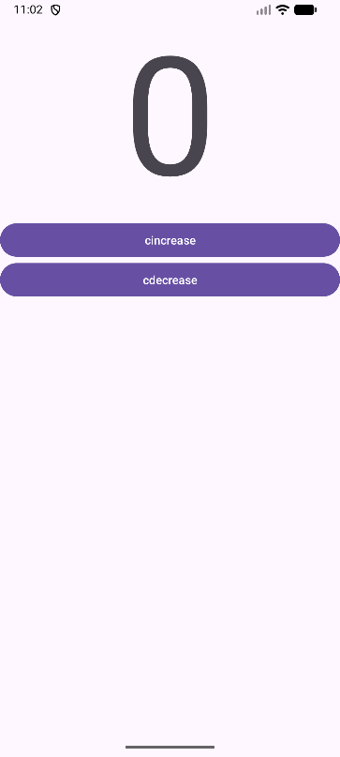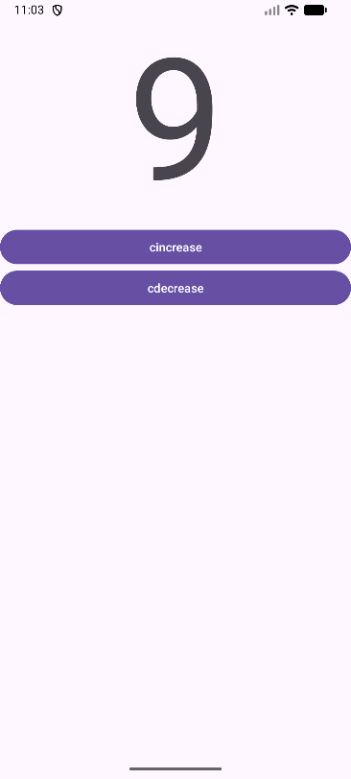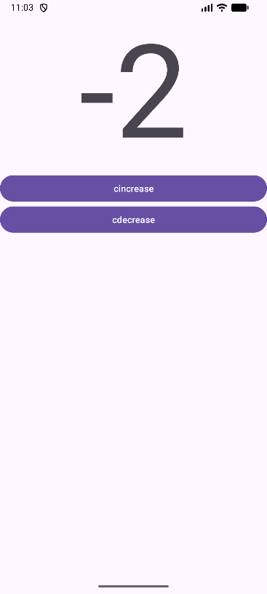

Result:
The desired Checker is created and tested. the application runs without error.

