Exp No:01 8 Queen problem

24/01/2025 srinivasan(231701054)

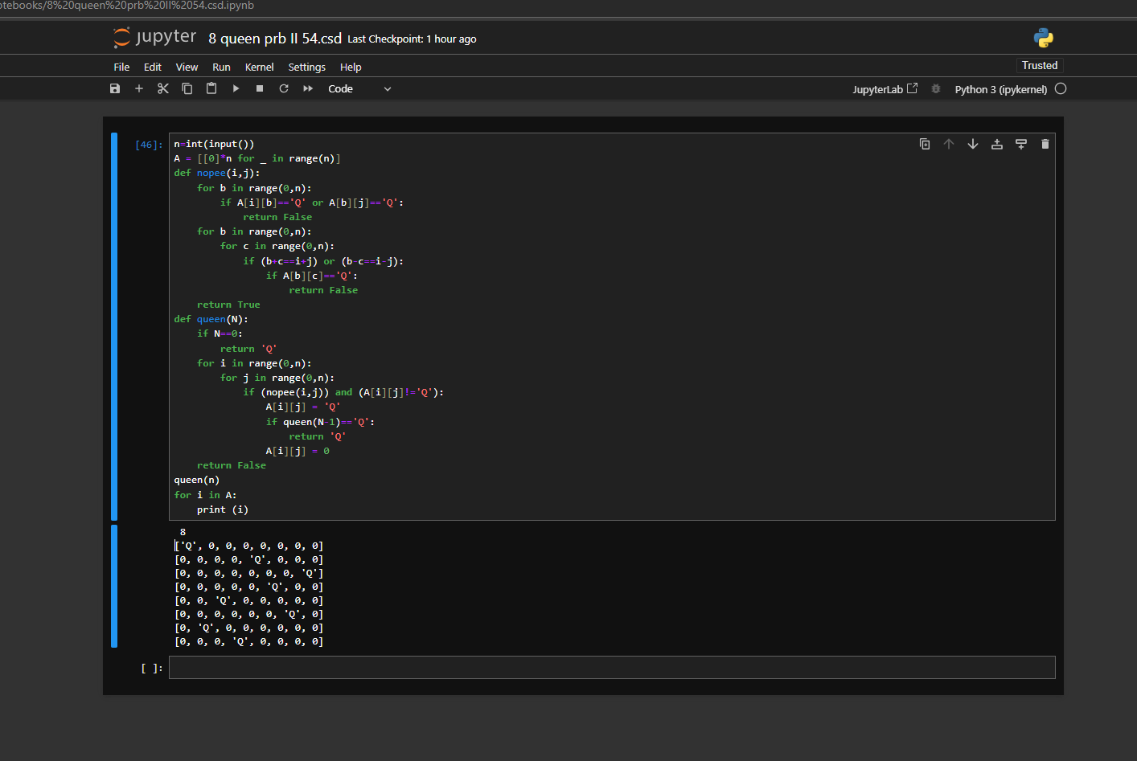

Code:

n=int(input())

A = [[0]*n for _ in range(n)]

def nopee(i,j):

for b in range(0,n):

if A[i][b]=='Q' or A[b][j]=='Q':

return False

for b in range(0,n):

for c in range(0,n):

if (b+c==i+j) or (b-c==i-j):

if A[b][c]=='Q':

return False

return True

def queen(N):

if N==0:

return 'Q'

for i in range(0,n):

for j in range(0,n):

if (nopee(i,j)) and (A[i][j]!='Q'):

A[i][j] = 'Q'

if queen(N-1)=='Q':

return 'Q'

A[i][j] = 0

return False

queen(n)

for i in A:

print (i)

output:

8

['Q', 0, 0, 0, 0, 0, 0, 0]

[0, 0, 0, 0, 'Q', 0, 0, 0]

[0, 0, 0, 0, 0, 0, 0, 'Q']

[0, 0, 0, 0, 0, 'Q', 0, 0]

[0, 0, 'Q', 0, 0, 0, 0, 0]

[0, 0, 0, 0, 0, 0, 'Q', 0]

[0, 'Q', 0, 0, 0, 0, 0, 0]

[0, 0, 0, 'Q', 0, 0, 0, 0]

Result:

The code is successfully excecuted and the desired output is got.