UI/UX

Experiment 1 roll no:231701054

AIM:

To create a log in page for a hobby app

Tools:

Figma

Procedure:

-> Change the color of the background .

-> Add shapes according to the app designing

-> insert images related to the app or design a log for that

-> create a normal log in page or a signup page

-> connect it with other pages using prototype

-> preview it and change if needed.

Output:

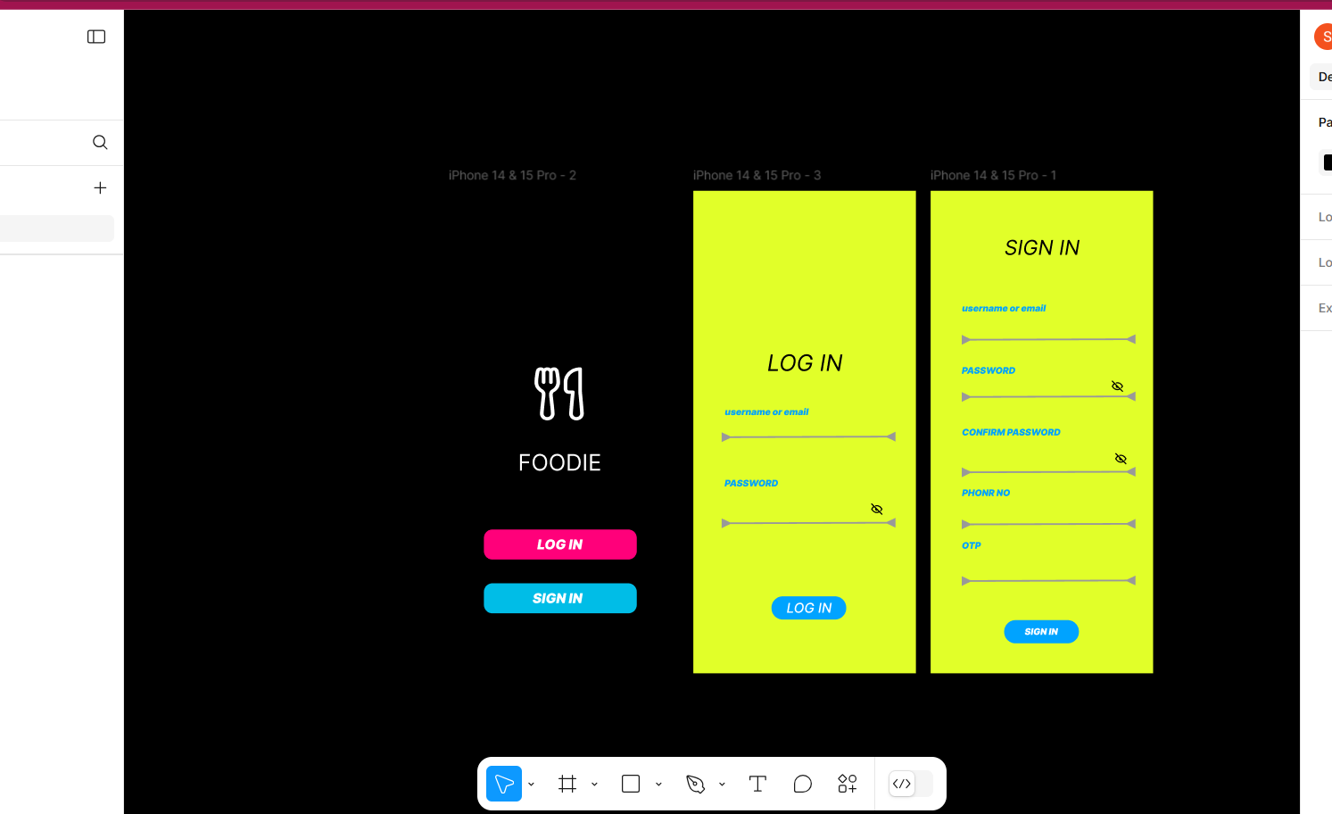

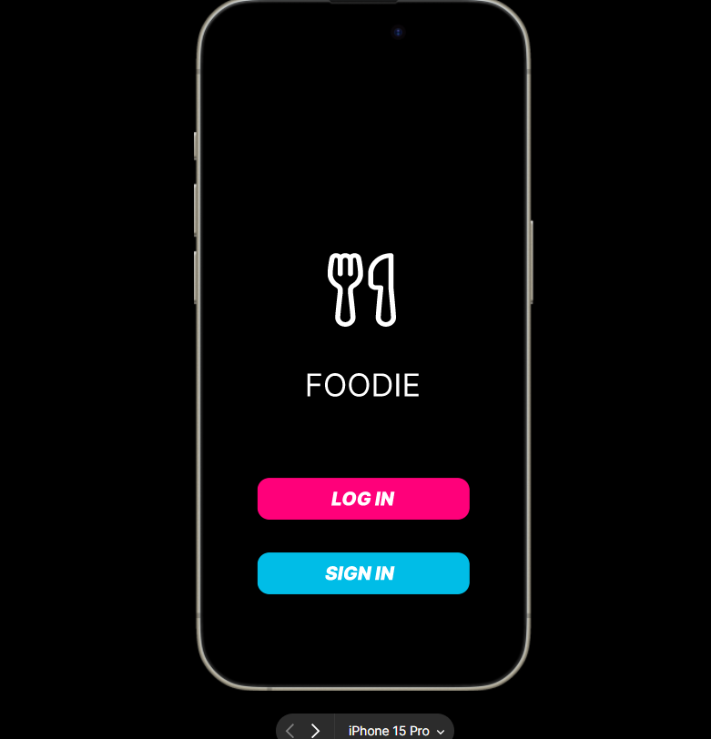

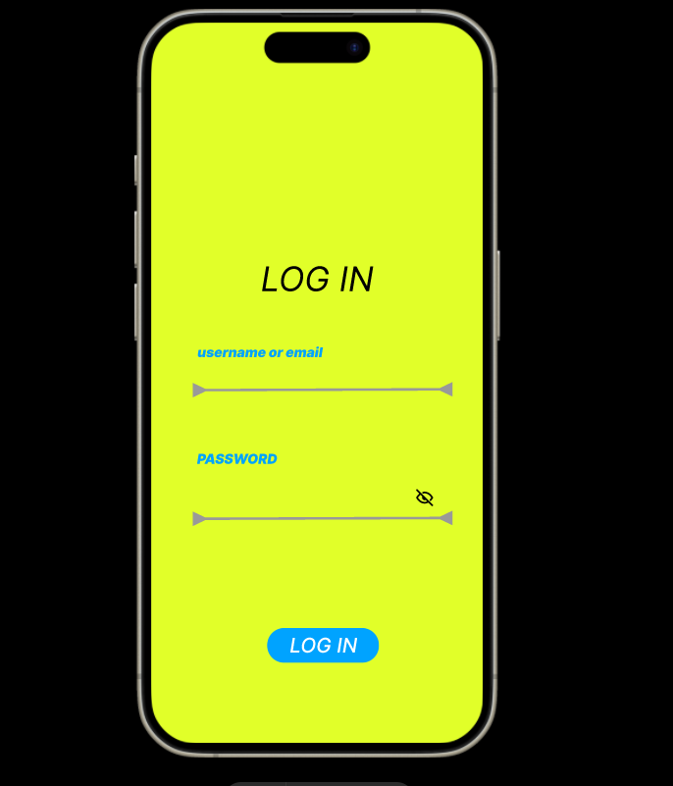

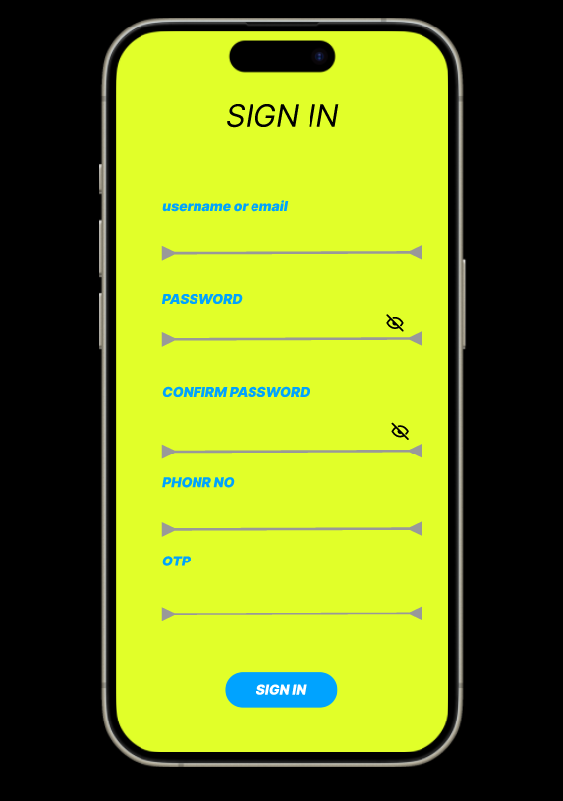

Result:

The desired user interface has been created and previewed.